Supplementary information
Title: A flea beetle can stick a perfect landing

Authors: Le Zong ^{1,2}, Jianing Wu^{1,3}, Pingping Yang ^{1,4}, Jing Ren¹, Guanya Shi⁵, Siqin Ge^{1,*}, David L. Hu^{6,*}
Affiliations:
¹Key Laboratory of Zoological Systematics and Evolution, Institute of Zoology, Chinese Academy of Sciences, Beijing, 100101, P.R. China
²University of Chinese Academy of Sciences, Beijing, 100049, P.R. China
³School of Aeronautics and Astronautics, Sun Yat-Sen University, Shenzhen, 518107, P.R. China
⁴ The Key Laboratory of Zoological Systematics and Application, School of Life Science, Institute of Life Science and Green Development, Hebei University, School of Life Sciences, Baoding, 071002, P.R. China
⁵Department of Computing and Mathematical Sciences, California Institute of Technology, USA 91125
⁶George W. Woodruff School of Mechanical Engineering and School of Biology, Georgia Institute of Technology, Atlanta, GA, USA 30332
* To whom correspondence should be addressed.
E-mail: gesq@ioz.ac.cn
hu@me.gatech.edu

Fig. S1, Fig. S2 shows orientations of the three typical cases by this method, we can measure the pitch and roll angles of other samples. Fig. S1 shows the wingless and semi-winged, and Fig. S2 shows the winged case.

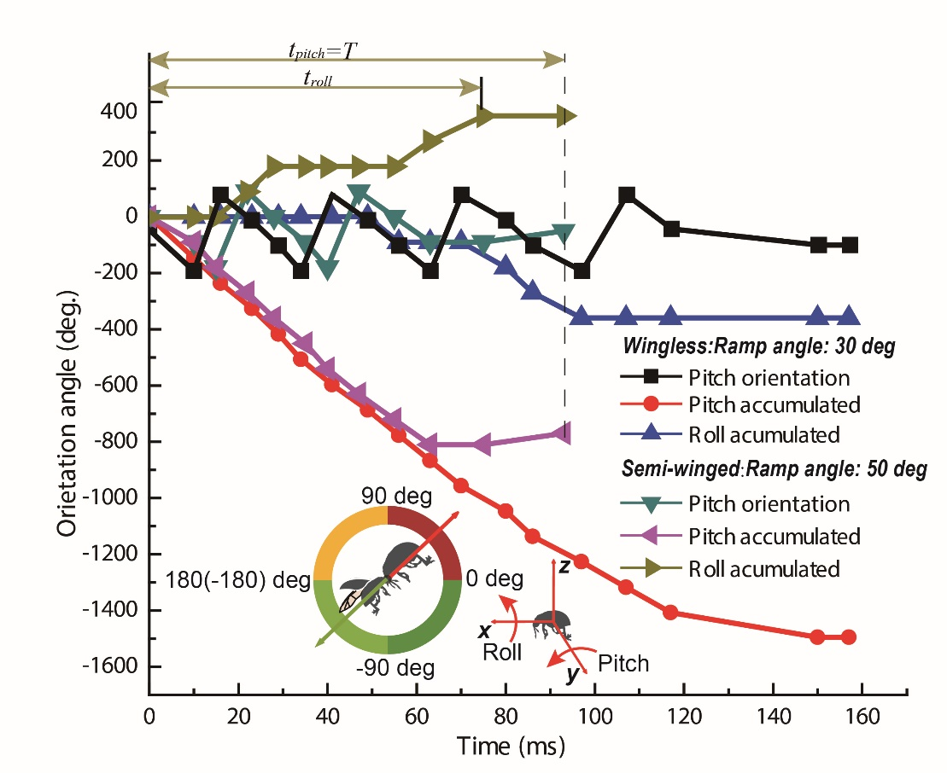
Fig. S1 Orientations of the cases of the wingless and semi-winged

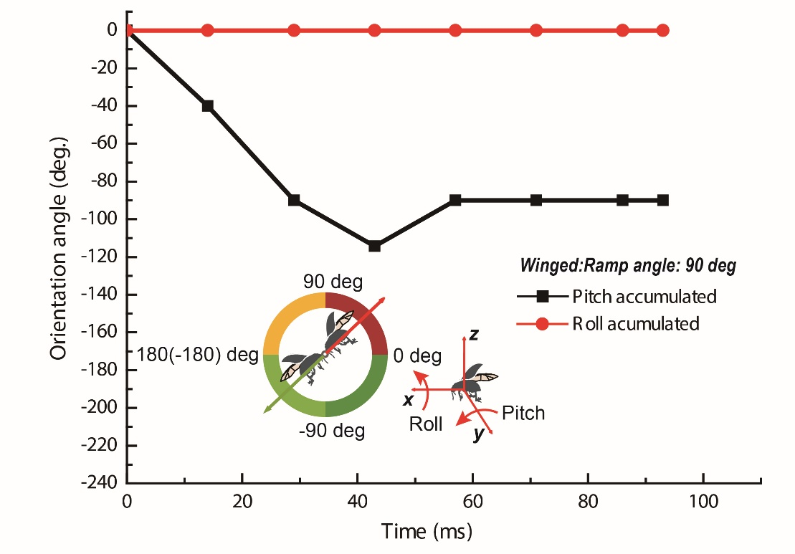
Fig. S2 Orientations of the case of the winged

