Appendix A: Supplemental Figures and Tables

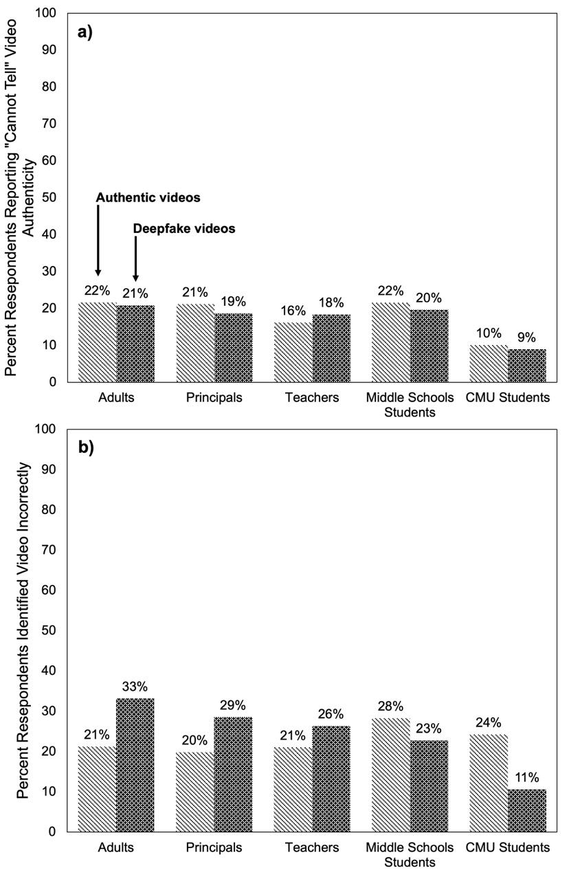
Figure A1: Percent of Participants a) Responding Cannot Tell and b) Incorrectly Identifying the Authenticity of Videos by Video Authenticity and Population

Notes: Each bar represents the percentage of responses that correctly identified the authenticity of videos by population and deepfake video status. Tabulations in the adult, principal, and teacher populations are weighted to be nationally representative.

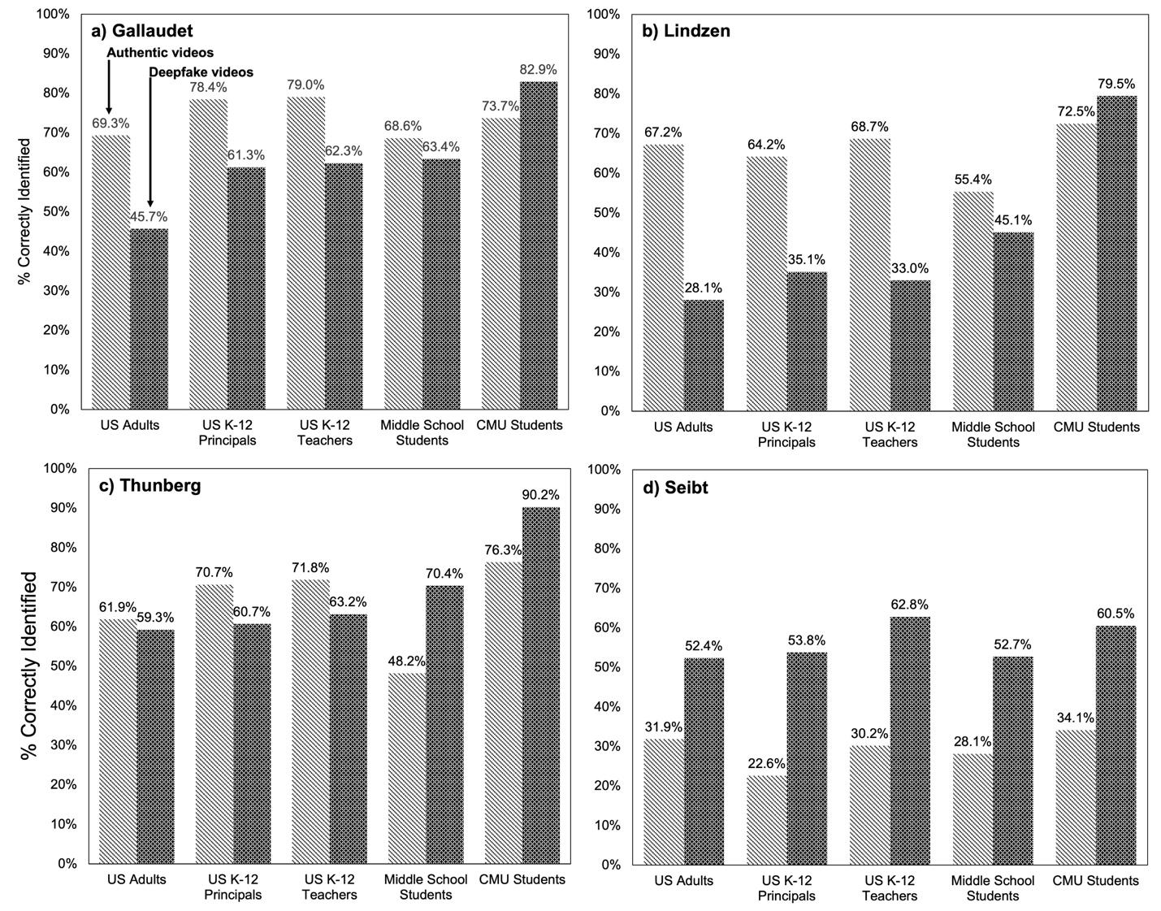
Figure A2: Percent of Reponses Correctly Identifying the Authenticity of Videos, by Video Authenticity, Population, and Speaker

Notes: Each bar represents the percentage of responses that correctly identified the authenticity of videos by population and deepfake video status. Tabulations in the adult, principal, and teacher populations are weighted to be nationally representative.
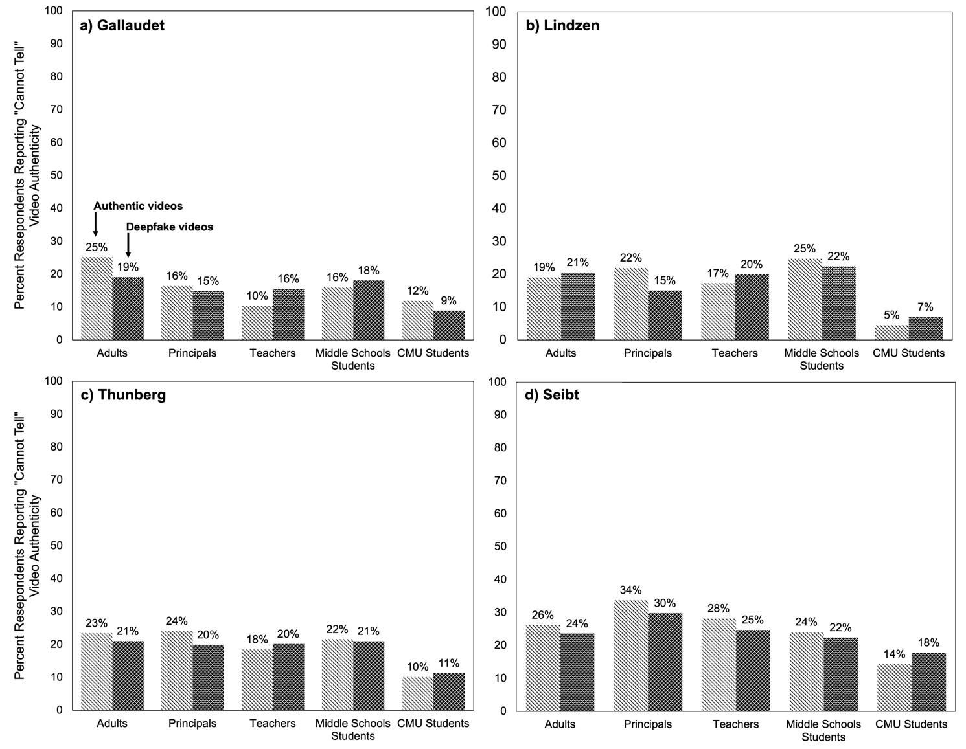
Figure A3: Percent of Responses Reporting “Cannot Tell” Video Authenticity, by Video Authenticity, Population, and Speaker

Notes: Each bar represents the percentage of responses that correctly identified the authenticity of videos by population and deepfake video status. Tabulations in the adult, principal, and teacher populations are weighted to be nationally representative.

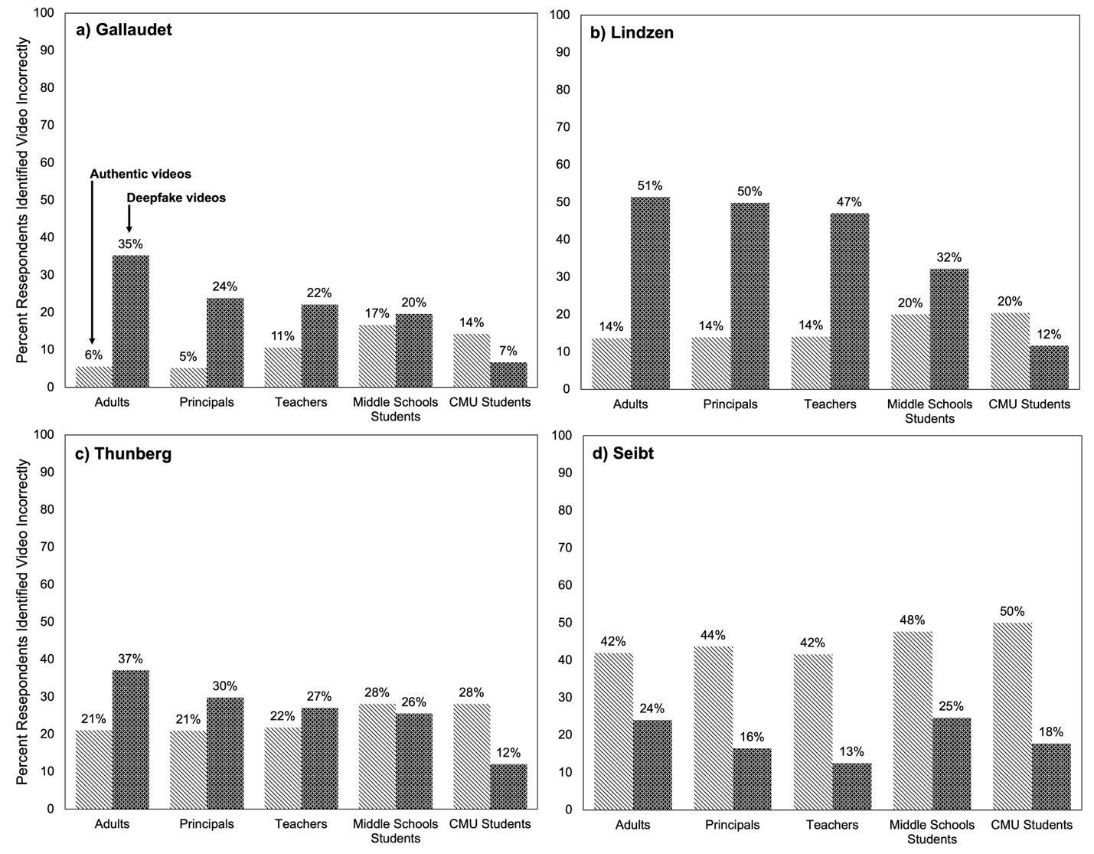
Figure A4: Percent of Responses Identifying Video Incorrectly, by Video Authenticity, Population, and Speaker

Notes: Each bar represents the percentage of responses that correctly identified the authenticity of videos by population and deepfake video status. Tabulations in the adult, principal, and teacher populations are weighted to be nationally representative.

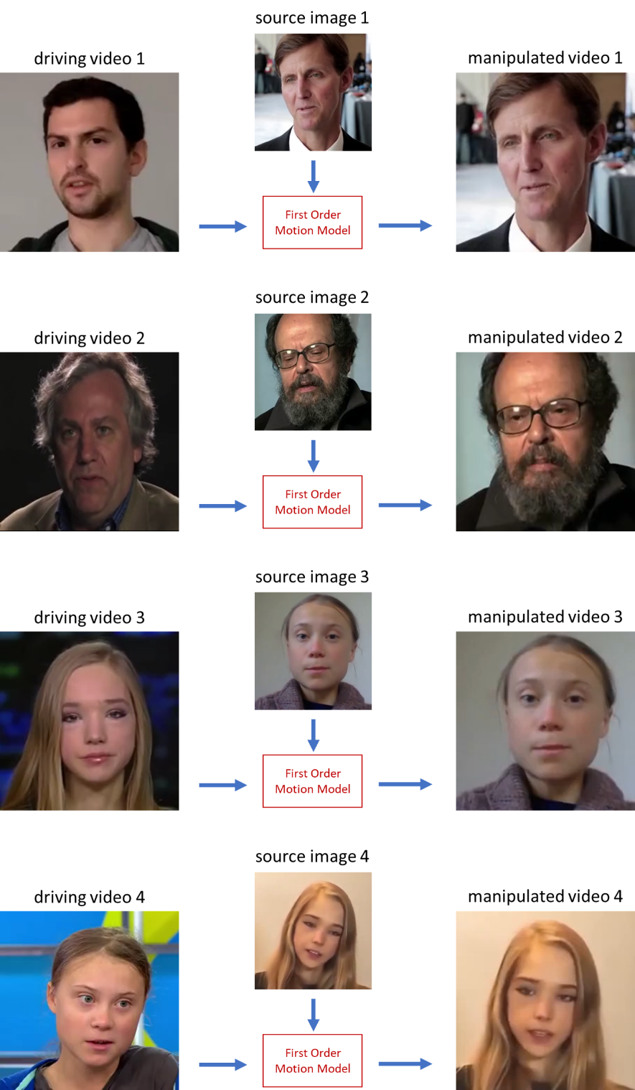

Figure A5: Deepfake Video Creation Using the First Order Motion Model for Survey Design

Notes: The deepfake video of Timothy Gallaudet (first row) was transformed from a driving video of Mitchell Ferguson (a graduate student from our research group). The deepfake video of Richard Lindzen (second row) was transformed from a driving video of Kerry Emanuel (a professor of meteorology at the Massachusetts Institute of Technology. T deepfake video of Greta Thunberg (third row) was transformed from a driving video of Naomi Seibt. The deepfake video of Naomi Seibt (fourth row) was transformed from a driving video of Greta Thunberg. These subjects were selected to display a range of opinions regarding climate change.

Table A1: Effect of Viewing a Deepfake Video on Responses Perceptions of Video Authenticity, All Speakers
 | Adults |  | Principals |  | Teachers |  | Middle School Students |  | CMU Students
Correct | -0.112** | -0.137** | -0.062** | -0.065** | -0.075** | -0.084** | 0.075** | 0.083** | 0.148** | 0.193**
Correct | (0.028) | (0.037) | (0.019) | (0.024) | (0.019) | (0.025) | (0.016) | (0.021) | (0.051) | (0.055)
Cannot Tell | -0.008 | 0.009 | -0.025+ | -0.017 | 0.022 | 0.016 | -0.019 | -0.031+ | -0.011 | -0.004
Cannot Tell | (0.021) | (0.028) | (0.015) | (0.018) | (0.015) | (0.020) | (0.014) | (0.018) | (0.030) | (0.035)
Incorrect | 0.119** | 0.128** | 0.087** | 0.082** | 0.053** | 0.068** | -0.055** | -0.052** | -0.136** | -0.189**
Incorrect | (0.026) | (0.034) | (0.016) | (0.020) | (0.017) | (0.022) | (0.015) | (0.019) | (0.040) | (0.042)
Fixed Effects |  | ✓ |  | ✓ |  | ✓ |  | ✓ |  | ✓
N(Respondent-by-Video) | 3044 |  | 2,960 |  | 2,568 |  | 3,220 |  | 348
N(Respondent) | 761 |  | 740 |  | 642 |  | 805 |  | 87
Notes: Each cell presents the results of a separate regression of an indicator for the respondent correctly identifying the authenticity of the video, incorrectly identifying the authenticity of the video, or stating that he or she cannot tell the authenticity of the video on an indicator for the video being a deepfake. Column headers indicate the population panels and row headers indicate the response. Unconditional models are presented as well as those with respondent fixed effects, speaker fixed effects, and order of presentation fixed effects. Regressions on adult, principal, and teacher samples are weighted to retain national representativeness. Standard errors are clustered by respondent. + indicates p < 0.10; ** p < 0.01

Table A2: Effect of Deepfake Videos on Perceptions of Video Authenticity, By Speaker
Panel A: Adults
 | Gallaudet | Lindzen | Thunberg | Seibt
Correct | -0.230** | -0.403** | -0.019 | 0.252**
 | (0.048) | (0.047) | (0.050) | (0.047)
Cannot Tell | -0.040 | 0.026 | 0.028 | -0.047
 | (0.043) | (0.040) | (0.039) | (0.040)
Incorrect | 0.270** | 0.377** | -0.009 | -0.205**
 | (0.035) | (0.045) | (0.041) | (0.047)
N(Respondent) | 761
Panel B: Principals
 | Gallaudet | Lindzen | Thunberg | Seibt
Correct | -0.190** | -0.282** | -0.085* | 0.311**
Correct | (0.033) | (0.036) | (0.035) | (0.035)
Cannot Tell | -0.003 | -0.076* | 0.017 | -0.034
Cannot Tell | (0.027) | (0.030) | (0.027) | (0.035)
Incorrect | 0.193** | 0.358** | 0.069* | -0.277**
Incorrect | (0.026) | (0.033) | (0.031) | (0.033)
N(Respondent) | 740
Panel C: Teachers
 | Gallaudet | Lindzen | Thunberg | Seibt
Correct | -0.173** | -0.360** | -0.074* | 0.337**
Correct | (0.037) | (0.039) | (0.037) | (0.038)
Cannot Tell | 0.053+ | 0.037 | 0.020 | -0.032
Cannot Tell | (0.028) | (0.033) | (0.027) | (0.035)
Incorrect | 0.120** | 0.324** | 0.054 | -0.304**
Incorrect | (0.030) | (0.036) | (0.034) | (0.034)
N(Respondent) | 642
Panel D: Middle School Students
 | Gallaudet | Lindzen | Thunberg | Seibt
Correct | -0.051 | -0.105** | 0.202** | 0.249**
Correct | (0.033) | (0.035) | (0.034) | (0.034)
Cannot Tell | 0.026 | -0.021 | -0.055* | -0.013
Cannot Tell | (0.026) | (0.029) | (0.027) | (0.030)
Incorrect | 0.025 | 0.126** | -0.147** | -0.236**
Incorrect | (0.027) | (0.031) | (0.028) | (0.033)
N(Respondent) | 805
Panel D: CMU Students
 | Gallaudet | Lindzen | Thunberg | Seibt
Correct | 0.149 | 0.184+ | 0.067 | 0.238+
Correct | (0.107) | (0.105) | (0.077) | (0.123)
Cannot Tell | -0.078 | -0.052 | -0.019 | 0.044
Cannot Tell | (0.091) | (0.070) | (0.052) | (0.094)
Incorrect | -0.071 | -0.132 | -0.048 | -0.282*
Incorrect | (0.069) | (0.098) | (0.069) | (0.107)
N(Respondent) | 87
Notes: Each cell presents the results of a separate regression of an indicator for the respondent correctly identifying the authenticity of the video, incorrectly identifying the authenticity of the video, or stating that he or she cannot tell the authenticity of the video on an indicator for the video being a deepfake. Panel headers indicate the population, column headers indicate the speaker video, and row headers indicate the response. Population specific covariates included are listed in Table 1 of the main manuscript. CMU and middle school student models also contain state fixed effects. Regressions on adult, principal, and teacher samples are weighted to retain national representativeness. Robust standard errors in parentheses. + indicates p < 0.10; ** p < 0.01

Table A3: Relationship Between Reported Aspect of Video Analyzed and Responding "I Can't Tell" Video Authenticity, By Video Deepfake Status
 | Adults |  | Principals |  | Teachers |  | Middle School Students |  | CMU Students
 | Real | Deepfake | Real | Deepfake | Real | Deepfake | Real | Deepfake | Real | Deepfake
Familiar With Person's Views | -0.245** | -0.277* | -0.228** | -0.175** | -0.142* | -0.090 | -0.198** | -0.090 | -0.240+ | -0.051
Familiar With Person's Views | (0.083) | (0.108) | (0.065) | (0.067) | (0.063) | (0.067) | (0.060) | (0.067) | (0.128) | (0.147)
Video Quality | -0.076 | -0.078 | -0.052 | -0.035 | -0.021 | 0.029 | -0.023 | -0.045 | 0.080 | 0.085
Video Quality | (0.068) | (0.086) | (0.044) | (0.048) | (0.047) | (0.044) | (0.044) | (0.041) | (0.104) | (0.088)
Background | 0.089 | -0.022 | 0.025 | -0.022 | 0.010 | 0.051 | -0.060 | -0.056 | 0.081 | -0.010
Background | (0.130) | (0.078) | (0.050) | (0.056) | (0.049) | (0.059) | (0.043) | (0.043) | (0.104) | (0.102)
Facial Features | -0.131+ | -0.126* | -0.083+ | -0.128** | -0.027 | -0.182** | -0.123* | -0.168** | -0.288* | -0.026
Facial Features | (0.072) | (0.064) | (0.048) | (0.045) | (0.047) | (0.052) | (0.048) | (0.042) | (0.131) | (0.142)
Audio | -0.103 | -0.067 | -0.022 | -0.058 | -0.020 | -0.004 | -0.044 | -0.027 | -0.050 | 0.087
Audio | (0.071) | (0.068) | (0.050) | (0.048) | (0.045) | (0.045) | (0.048) | (0.045) | (0.114) | (0.110)
Credibility of Content | -0.151* | -0.158* | -0.155** | -0.123** | 0.012 | -0.080 | -0.080 | -0.091+ | -0.213 | 0.021
Credibility of Content | (0.062) | (0.061) | (0.046) | (0.046) | (0.044) | (0.050) | (0.051) | (0.053) | (0.128) | (0.122)
N(Respondent-by-Video) | 1,600 | 1,444 | 1,514 | 1,446 | 1,283 | 1,285 | 1,600 | 1,620 | 169 | 179
N(Respondent) | 727 | 693 | 692 | 685 | 604 | 596 | 757 | 755 | 82 | 84
Notes: Each column presents the results of a separate regression of video authenticity on aspects respondents reported analyzing when making their decisions. All models include speaker, video order, and respondent fixed effects. Regressions on adult, principal, and teacher samples are weighted to retain national representativeness. Standard errors are clustered by respondent. + indicates p < 0.10; * p < 0.05; ** p < 0.01.

Table A4: Relationship Between Reported Aspect of Video Analyzed and Responding Incorrectly, By Video Deepfake Status
 | Adults |  | Principals |  | Teachers |  | Middle School Students |  | CMU Students
 | Real | Deepfake | Real | Deepfake | Real | Deepfake | Real | Deepfake | Real | Deepfake
Familiar With Person's Views | -0.136+ | 0.060 | -0.251** | -0.049 | -0.246** | -0.011 | -0.211** | 0.226** | -0.215 | 0.007
Familiar With Person's Views | (0.080) | (0.104) | (0.061) | (0.075) | (0.066) | (0.071) | (0.064) | (0.076) | (0.229) | (0.220)
Video Quality | 0.205* | -0.173* | 0.114* | -0.227** | 0.155** | -0.239** | 0.003 | -0.040 | -0.021 | 0.039
Video Quality | (0.081) | (0.076) | (0.048) | (0.051) | (0.059) | (0.048) | (0.048) | (0.047) | (0.160) | (0.096)
Background | 0.046 | -0.066 | 0.050 | -0.061 | -0.020 | -0.028 | 0.057 | -0.070 | 0.054 | 0.085
Background | (0.065) | (0.077) | (0.048) | (0.059) | (0.058) | (0.059) | (0.047) | (0.049) | (0.152) | (0.133)
Facial Features | 0.164* | -0.026 | 0.020 | -0.026 | 0.017 | 0.049 | 0.033 | -0.029 | 0.299+ | 0.180
Facial Features | (0.079) | (0.070) | (0.044) | (0.052) | (0.054) | (0.052) | (0.050) | (0.047) | (0.158) | (0.145)
Audio | -0.120+ | 0.068 | -0.200** | 0.144* | -0.220** | 0.105+ | -0.089+ | 0.136** | -0.101 | -0.013
Audio | (0.064) | (0.077) | (0.046) | (0.058) | (0.054) | (0.059) | (0.053) | (0.046) | (0.202) | (0.101)
Credibility of Content | -0.006 | 0.201** | -0.024 | 0.196** | -0.076 | 0.171** | -0.014 | 0.175** | -0.001 | 0.044
Credibility of Content | (0.052) | (0.066) | (0.043) | (0.051) | (0.049) | (0.049) | (0.057) | (0.060) | (0.132) | (0.114)
N(Respondent-by-Video) | 1,600 | 1,444 | 1,514 | 1,446 | 1,283 | 1,285 | 1,600 | 1,620 | 169 | 179
N(Respondent) | 727 | 693 | 692 | 685 | 604 | 596 | 757 | 755 | 82 | 84
Notes: Each column presents the results of a separate regression of video authenticity on aspects respondents reported analyzing when making their decisions. All models include speaker, video order, and respondent fixed effects. Regressions on adult, principal, and teacher samples are weighted to retain national representativeness. Standard errors are clustered by respondent. + indicates p < 0.10; * p < 0.05; ** p < 0.01.

Table A5: Additional Moderation Effects of Participant Background Characteristics on Correctly Identifying Deepfake Video
 | Adults |  |  | Principals |  | Teachers |  | Middle School |  |  |  | CMU
Male | -0.041 | -0.038 |  | -0.008 | 0.007 | 0.022 | 0.038 | 0.052 |  | 0.047 |  | 0.148 | 0.099
Male | (0.074) | (0.056) |  | (0.048) | (0.037) | (0.058) | (0.045) | (0.042) |  | (0.032) |  | (0.110) | (0.099)
Hispanic | 0.268* | 0.187* |  | 0.004 | 0.014 | -0.004 | -0.021 | 0.041 |  | 0.073 |  | -0.211 | -0.384+
Hispanic | (0.104) | (0.078) |  | (0.098) | (0.074) | (0.058) | (0.045) | (0.096) |  | (0.071) |  | (0.230) | (0.209)
Black | 0.085 | -0.031 |  | 0.094 | 0.122* | -0.099 | -0.055 | 0.093 |  | 0.017 |  | 0.192 | 0.467*
Black | (0.126) | (0.106) |  | (0.083) | (0.061) | (0.088) | (0.072) | (0.095) |  | (0.066) |  | (0.378) | (0.214)
Personal View of Global  Warming | -0.025 | -0.002 |  | -0.096 | -0.085 | 0.039 | 0.030 | -0.055 |  | -0.070+ |  | 0.298** | 0.218*
Personal View of Global  Warming | (0.078) | (0.060) |  | (0.069) | (0.053) | (0.067) | (0.051) | (0.050) |  | (0.037) |  | (0.085) | (0.091)
Perception of Scientific  View of Global Warming | -0.048 | -0.032 |  | 0.022 | 0.050 | -0.024 | -0.019 | -0.035 |  | -0.001 |  | 0.101 | -0.103
Perception of Scientific  View of Global Warming | (0.072) | (0.054) |  | (0.055) | (0.042) | (0.054) | (0.040) | (0.042) |  | (0.032) |  | (0.141) | (0.107)
Perceived Deepfake  Prevalence | 0.012 | 0.008 |  | 0.015 | 0.021 | 0.052* | 0.045* | -0.007 |  | -0.025 |  | 0.017 | 0.014
Perceived Deepfake  Prevalence | (0.036) | (0.029) |  | (0.025) | (0.019) | (0.024) | (0.019) | (0.022) |  | (0.017) |  | (0.054) | (0.047)
Perceived Ability to Detect  Deepfakes | 0.011 | -0.022 |  | -0.013 | -0.007 | 0.016 | 0.023 | 0.004 |  | 0.005 |  | -0.020 | -0.032
Perceived Ability to Detect  Deepfakes | (0.037) | (0.028) |  | (0.025) | (0.019) | (0.024) | (0.020) | (0.022) |  | (0.017) |  | (0.048) | (0.044)
Perceived Risk of  Deepfakes to Self | -0.037 | -0.028 |  | 0.007 | 0.013 | 0.019 | 0.013 | 0.055** |  | 0.026 |  | -0.062 | -0.068
Perceived Risk of  Deepfakes to Self | (0.034) | (0.025) |  | (0.024) | (0.019) | (0.025) | (0.019) | (0.021) |  | (0.016) |  | (0.052) | (0.045)
Perceived Risk of  Deepfakes to Society | 0.025 | 0.009 |  | 0.004 | 0.015 | 0.001 | 0.000 | 0.005 |  | 0.001 |  | -0.028 | -0.027
Perceived Risk of  Deepfakes to Society | (0.030) | (0.024) |  | (0.022) | (0.018) | (0.024) | (0.019) | (0.021) |  | (0.016) |  | (0.054) | (0.043)
Total Climate Change Quiz  Questions Correct | -0.003 | -0.004 |  | -0.012 | 0.004 | 0.015 | 0.011 | 0.006 |  | 0.006 |  | 0.053 | 0.054
Total Climate Change Quiz  Questions Correct | (0.038) | (0.030) |  | (0.029) | (0.022) | (0.031) | (0.023) | (0.022) |  | (0.017) |  | (0.079) | (0.072)
Number of Internet Devices  Used | -0.008 | -0.014 |  | -0.038 | -0.023 | 0.035 | 0.015 | -0.016 |  | 0.009 |  | -0.061 | -0.070
Number of Internet Devices  Used | (0.067) | (0.049) |  | (0.034) | (0.026) | (0.035) | (0.025) | (0.026) |  | (0.020) |  | (0.074) | (0.065)
Factor of Climate Change  Learning Habits | 0.019 | 0.006 |  | -0.017 | -0.024 | 0.026 | 0.019 | 0.006 |  | 0.014 |  | -0.060 | -0.078
Factor of Climate Change  Learning Habits | (0.038) | (0.028) |  | (0.025) | (0.019) | (0.026) | (0.022) | (0.026) |  | (0.019) |  | (0.067) | (0.051)
Factor of Social Media  Platform Use | 0.155** | 0.122** |  | -0.008 | -0.022 | -0.050 | -0.037 | -0.029 |  | -0.029 |  | -0.035 | -0.020
Factor of Social Media  Platform Use | (0.051) | (0.041) |  | (0.030) | (0.023) | (0.031) | (0.024) | (0.026) |  | (0.020) |  | (0.084) | (0.071)
U.S. Born | -0.167 | -0.094 |  | --- | --- | --- | --- | --- |  | --- |  | 0.168 | 0.065
U.S. Born | (0.140) | (0.108) |  | --- | --- | --- | --- | --- |  | --- |  | (0.120) | (0.116)
Above Median U.S. Income | 0.017 | 0.008 |  | --- | --- | --- | --- | --- |  | --- |  | --- | ---
Above Median U.S. Income | (0.074) | (0.055) |  | --- | --- | --- | --- | --- |  | --- |  | --- | ---
Live in an Urban Centric  Locale | 0.071 | 0.059 |  | --- | --- | --- | --- | --- |  | --- |  | --- | ---
Live in an Urban Centric  Locale | (0.081) | (0.057) |  | --- | --- | --- | --- | --- |  | --- |  | --- | ---
Work In a Science Related  Field | 0.081 | 0.092 |  | --- | --- | --- | --- | --- |  | --- |  | --- | ---
Work In a Science Related  Field | (0.135) | (0.094) |  | --- | --- | --- | --- | --- |  | --- |  | --- | ---
Title I Eligible School | --- | --- |  | -0.018 | 0.008 | -0.008 | -0.036 | --- |  | --- |  | --- | ---
Title I Eligible School | --- | --- |  | (0.055) | (0.043) | (0.054) | (0.040) | --- |  | --- |  | --- | ---
Years of Experience in  Educator Role | --- | --- |  | -0.000 | 0.000 | -0.000 | -0.002 | --- |  | --- |  | --- | ---
Years of Experience in  Educator Role | --- | --- |  | (0.004) | (0.003) | (0.003) | (0.002) | --- |  | --- |  | --- | ---
Works in Middle School  (vs. Elementary) | --- | --- |  | -0.107 | -0.096+ | 0.007 | 0.003 | --- |  | --- |  | --- | ---
Works in Middle School  (vs. Elementary) | --- | --- |  | (0.066) | (0.051) | (0.069) | (0.052) | --- |  | --- |  | --- | ---
Works in High School (vs.  Elementary) | --- | --- |  | -0.074 | -0.020 | 0.040 | 0.025 | --- |  | --- |  | --- | ---
Works in High School (vs.  Elementary) | --- | --- |  | (0.069) | (0.055) | (0.059) | (0.044) | --- |  | --- |  | --- | ---
Works in Other Type of  School (vs. Elementary) | --- | --- |  | -0.080 | -0.041 | -0.066 | -0.080 | --- |  | --- |  | --- | ---
Works in Other Type of  School (vs. Elementary) | --- | --- |  | (0.060) | (0.046) | (0.091) | (0.075) | --- |  | --- |  | --- | ---
Teach Social Studies  (vs. All Other Teachers Except Math/Science) | --- | --- |  | --- | --- | 0.002 | 0.010 | --- |  | --- |  | --- | ---
 | --- | --- |  | --- | --- | (0.086) | (0.082) | --- |  | --- |  | --- | ---
Teach Math/Science  (vs. All Other Teachers Except Social Studies) | --- | --- |  | --- | --- | 0.035 | -0.012 | --- |  | --- |  | --- | ---
 | --- | --- |  | --- | --- | (0.045) | (0.046) | --- |  | --- |  | --- | ---
Respondent Fixed Effects | ✓ |  |  | ✓ |  | ✓ |  | ✓ |  |  |  | ✓
Respondent Controls |  | ✓ |  |  | ✓ |  | ✓ |  |  | ✓ |  |  | ✓
N(Respondent-by-Video) | 3044 |  | 2,960 |  |  | 2,568 |  |  | 3,220 |  | 348
N(Respondent) | 761 |  | 740 |  |  | 642 |  |  | 805 |  | 87
Notes: Each cell presents the interaction term of a separate regression of whether a respondent correctly identified the authenticity of a video on the main effect for seeing a fake video and an interaction with the characteristic indicated by the row headers. All models include speaker and video order fixed effects. Models include respondent fixed effects or respondent controls as indicated in the table. Respondent controls are listed in Table 1 of the main manuscript. CMU and middle school student models additionally contain state fixed effects. Regressions on adult, principal, and teacher samples are weighted to retain national representativeness. Standard errors are clustered by respondent. + indicates p < 0.10; * p < 0.05; ** p < 0.01.

Table A6: Relationship Between Receiving Deepfake and Respondent Characteristics, Covariate Balance Across All Speakers
 | Adults | Principals | Teachers | Middle School Students | CMU Students
Gallaudet Video | 0.053 | 0.019 | -0.011 | -0.012 | 0.004
Gallaudet Video | (.033) | (.022) | (.024) | (.02) | (.066)
Lindzen Video | 0.012 | -0.009 | -0.001 | 0.008 | -0.027
Lindzen Video | (.035) | (.021) | (.023) | (.02) | (.059)
Thunberg Video | -0.037 | -0.016 | -0.010 | 0.008 | 0.019
Thunberg Video | (.034) | (.022) | (.024) | (.021) | (.068)
Seibt Video | -0.027 | 0.006 | 0.021 | -0.005 | 0.004
Seibt Video | (.035) | (.022) | (.023) | (.021) | (.059)
Male | .046+ | -0.026 | -0.009 | 0.028 | -0.051
Male | (.026) | (.019) | (.023) | (.017) | (.052)
Age in Years | 0.000 | 0.001 | -.002* | -0.005 | 0.015
Age in Years | (.001) | (.001) | (.001) | (.008) | (.018)
Hispanic | -0.043 | -0.007 | -.049* | -0.011 | -.132+
Hispanic | (.036) | (.038) | (.024) | (.039) | (.075)
Black | 0.075 | 0.045 | -0.011 | 0.001 | 0.181
Black | (.057) | (.036) | (.039) | (.04) | (.14)
Saw Video Before Questions | -0.025 | 0.021 | 0.018 | 0.014 | 0.035
Saw Video Before Questions | (.026) | (.019) | (.021) | (.017) | (.053)
Video Was First in Order | -0.037 | 0.012 | 0.004 | -0.025 | -0.027
Video Was First in Order | (.033) | (.022) | (.024) | (.021) | (.064)
Video Was Second in Order | 0.004 | 0.013 | -0.009 | -0.005 | 0.004
Video Was Second in Order | (.038) | (.022) | (.024) | (.02) | (.061)
Video Was Third in Order | 0.027 | -0.010 | -0.011 | .048* | -0.011
Video Was Third in Order | (.033) | (.022) | (.023) | (.02) | (.064)
Video Was Fourth in Order | 0.006 | -0.015 | 0.016 | -0.018 | 0.034
Video Was Fourth in Order | (.032) | (.022) | (.023) | (.021) | (.064)
Understood Cause of Climate Change | -0.032 | -0.040 | -0.034 | -0.024 | 0.101
Understood Cause of Climate Change | (.03) | (.026) | (.026) | (.02) | (.074)
Thought Climate Change Was Man Made | -0.026 | -0.011 | 0.028 | -0.001 | 0.121
Thought Climate Change Was Man Made | (.027) | (.021) | (.022) | (.017) | (.118)
Perceived Prevalence of Deepfakes | 0.013 | -0.005 | -0.013 | 0.001 | -0.007
Perceived Prevalence of Deepfakes | (.012) | (.01) | (.01) | (.008) | (.023)
Perceived Ability to Detect Deepfakes | 0.022 | -0.006 | -0.001 | 0.013 | 0.022
Perceived Ability to Detect Deepfakes | (.016) | (.01) | (.011) | (.008) | (.025)
Perceived Risk of Deepfakes to Self | 0.010 | -.019* | .018+ | -0.004 | 0.033
Perceived Risk of Deepfakes to Self | (.013) | (.01) | (.011) | (.009) | (.022)
Perceived Risk of Deepfakes to Society | -0.001 | -.019* | -0.001 | -0.010 | 0.000
Perceived Risk of Deepfakes to Society | (.011) | (.009) | (.011) | (.009) | (.028)
Total Climate Change Quiz Question Correct | 0.008 | -0.016 | -0.004 | -.020* | -0.014
Total Climate Change Quiz Question Correct | (.014) | (.013) | (.013) | (.009) | (.042)
Total Internet Devices at Home | 0.022 | 0.008 | -0.009 | 0.004 | 0.053
Total Internet Devices at Home | (.016) | (.014) | (.015) | (.012) | (.036)
Factor of Learning Frequency | -0.005 | 0.000 | .019+ | -0.005 | -0.038
Factor of Learning Frequency | (.015) | (.01) | (.011) | (.01) | (.03)
Factor of Trust in Information Sources | -.028* | -0.011 | -0.006 | -0.003 | -0.009
Factor of Trust in Information Sources | (.014) | (.011) | (.012) | (.01) | (.025)
Factor of Use of Online Platforms | 0.008 | .020+ | 0.017 | -0.011 | -0.045
Factor of Use of Online Platforms | (.013) | (.012) | (.013) | (.01) | (.037)
Identifies as Liberal | -0.017 | -0.027 | 0.002 | --- | -0.054
Identifies as Liberal | (.024) | (.02) | (.022) | --- | (.054)
Identifies as Conservative | 0.026 | .035+ | -0.027 | --- | -0.015
Identifies as Conservative | (.027) | (.021) | (.023) | --- | (.065)
Identifies as Moderate | -0.045 | -0.018 | 0.015 | --- | 0.097
Identifies as Moderate | (.034) | (.021) | (.024) | --- | (.072)
Prefers Not to Disclose Political Orientation | 0.046 | 0.025 | 0.022 | --- | -0.016
Prefers Not to Disclose Political Orientation | (.046) | (.033) | (.03) | --- | (.082)
Married | -0.019 | --- | --- | --- | ---
Married | (.03) | --- | --- | --- | ---
Born in the US | -0.058 | --- | --- | --- | -0.009
Born in the US | (.052) | --- | --- | --- | (.056)
Employed | -0.025 | --- | --- | --- | ---
Employed | (.028) | --- | --- | --- | ---
Has Medical Insurance | -0.058 | --- | --- | --- | ---
Has Medical Insurance | (.047) | --- | --- | --- | ---
Owns a House | -0.018 | --- | --- | --- | ---
Owns a House | (.028) | --- | --- | --- | ---
Urban Locale | 0.037 | --- | --- | --- | ---
Urban Locale | (.03) | --- | --- | --- | ---
Some College | -0.007 | --- | --- | --- | -0.074
Some College | (.029) | --- | --- | --- | (.056)
Bachelor's Degree | 0.023 | --- | -0.017 | --- | 0.050
Bachelor's Degree | (.029) | --- | (.022) | --- | (.062)
Masters Degree or Higher | -0.011 | --- | 0.017 | --- | ---
Masters Degree or Higher | (.029) | --- | (.022) | --- | ---
Income Below U.S. Median | -0.003 | --- | --- | --- | ---
Income Below U.S. Median | (.026) | --- | --- | --- | ---
Science Related Occupation | 0.045 | --- | --- | --- | ---
Science Related Occupation | (.034) | --- | --- | --- | ---
Title I Eligible School | --- | 0.002 | 0.028 | --- | ---
Title I Eligible School | --- | (.022) | (.022) | --- | ---
Years of Experience |  | .003+ | -.002+ | --- | ---
Years of Experience | --- | (.001) | (.001) | --- | ---
Elementary School Educator | --- | 0.026 | -0.014 | --- | ---
Elementary School Educator | --- | (.021) | (.021) | --- | ---
Middle School Educator | --- | 0.000 | -0.032 | --- | ---
Middle School Educator | --- | (.026) | (.027) | --- | ---
High School Educator | --- | -0.019 | 0.029 | --- | ---
High School Educator | --- | (.022) | (.021) | --- | ---
Educator in Other Type of School | --- | -0.012 | 0.032 | --- | ---
Educator in Other Type of School | --- | (.021) | (.041) | --- | ---
Math or Science Teacher | --- | --- | 0.010 | --- | ---
Math or Science Teacher | --- | --- | (.023) | --- | ---
Social Studies Teacher | --- | --- | -0.002 | --- | ---
Social Studies Teacher | --- | --- | (.038) | --- | ---
Teaches Other Subject | --- | --- | -0.007 | --- | ---
Teaches Other Subject | --- | --- | (.022) | --- | ---
N(Respondent-by-Video) | 3,032 - 3,044 | 2,832 - 2,960 | 2,528 - 2,568 | 2,756 - 3,220 | 316-348
N(Respondent) | 761-758 | 708-740 | 632-642 | 806-689 | 79-87
Notes: Each cell represents a separate regression of the respondent or video characteristic on an indicator for receiving a deepfake version of the video. Regressions on adult, principal, and teacher samples are weighted to retain national representativeness. Standard errors are clustered at the respondent level. + indicates p < 0.10; * p< 0.05; ** p< 0.01

Appendix B: Survey Instrument and Videos

Note: Numbers in brackets after a question indicate the study off which the question is based. See References for corresponding citation. If a question does not have a study referenced, that question was created by the study team.

You will be shown a series of videos. For each video, please tell us how confident you are that the video is either real or fake. For this survey, “fake” means that one or more things in the video have been changed and “real” means that nothing in the video has been changed.

1. Videos

1a. How likely is this video fake or real? [1]
1. Definitely Fake
2. Probably Fake
3. Cannot Tell
4. Probably Real
5. Definitely Real

1b. Which aspects of the video below helped you decide if the video was real or fake? (Check all that apply) [2]
a. I am familiar with this person’s views
b. Video quality
c. Background
d. Facial feature(s) (e.g., mouth, eyes, nose, etc.)
e. Audio (sound)
f. Credibility of content
g. Other: (Please specify)

2. Climate Change Beliefs

2a. Which comes closer to your own view? [3]
a. Most scientists think global warming is happening
b. Most scientists think global warming is not happening
c. There is a lot of disagreement among scientists about whether or not global warming is
happening
d. I don’t know enough to say

2b. Which of the following best describes your view of global warming? [3]
a. Global warming is happening and is caused mostly by human activities
b. Global warming is happening and is caused by both human activities and natural
changes in the environment
c. Global warming is happening and is caused mostly by natural changes in the
environment
d. Global warming isn’t happening
e. I don’t know enough to say
f. Other (Please specify)

3. Knowledge of Climate Science

3a. The “greenhouse effect” refers to: (Choose the best option) [3]
a. Gases in the atmosphere that trap heat
b. The Earth’s protective ozone layer
c. Pollution that causes acid rain
d. How plants grow
e. Don’t know

3b. What gas is produced by the burning of fossil fuels? (Choose the best option) [3]
- Oxygen
- Hydrogen
- Helium
- Carbon dioxide
- Don’t know

3c. Which of the following causes ocean acidification? (Choose the best option) [3]
a. Absorption of carbon dioxide by the ocean
b. Chemical spills in the ocean
c. Acid rain
d. Warmer ocean temperatures
e. Don’t know

4. Political Affiliation (asked of everyone except middle school students)

Which of the following best describes your political orientation? [4]
a. Very liberal
b. Liberal
c. Lean liberal
d. Moderate
e. Lean conservative
f. Conservative
g. Very conservative
h. Prefer not to say
i. Other

5. Learning Habits

5a. On average, how often do you learn about climate change from the following sources?
(Never, less than once a month, a couple times a month, weekly, daily, multiple times a day) [5]
a. Peers/colleagues
b. Teachers/Professors
c. Other adults
d. Social media (Facebook, Twitter, Instagram, Tik Tok, YouTube, blogs, etc.)
e. News sources (News Websites, News Programs, Newspapers, etc.)
f. Government agencies
g. Internet searches
h. Books or magazines
i. Other (please specify):

5b. How much do you trust the news and information about climate change that you learn from:
(Not at all, somewhat distrust, unsure, somewhat trust, absolutely trust, Not Applicable) [5]
a. Peers/colleagues
b. Teachers/Professors
c. Scientists
d. Other adults
e. Social media (Facebook, Twitter, Instagram, Tik Tok, YouTube, blogs, etc.)
f. News sources (News Websites, News Programs, Newspapers, etc.)
g. Government agencies
h. Internet searches
i. Books or magazines
j. Other (please specify):

6. Internet Use Habits

6a. During non-work hours, which device do you primarily use to access the internet? (check all that apply) [6]
a. Personal computer
b. Smartphone
c. Tablet
d. Public computer (e.g., at a library or community center)
e. No devices
f. Other (Please specify)

6b. How often do you use the following digital platforms for any reason? (Response Options: Never, Less Than Once a Month, A Couple Times a Month, Weekly, Daily, Multiple Times a Day) [7]
a. Facebook
b. Twitter
c. Instagram
d. Tik Tok
e. YouTube
f. Blogs
g. News Websites
h. Other: Please specify

6c. What device are you using to respond to this survey?
a. Computer
b. Smartphone
c. Tablet

7. Perceptions of Deep Fakes

7a. How commonly do you think fake science, fake technology, fake engineering, or fake math videos or images are seen on the Internet? [doesn’t exist, rare, somewhat rare, somewhat common, common, it’s everywhere]

7b. How much risk do you think fake science, fake technology, fake engineering, or fake math videos or images on the Internet pose to successfully completing your professional work? Response options: No risk, Slight risk, Moderate risk, Great risk, Not applicable

7c. How often do you think you are able to detect fake science, fake technology, fake engineering or fake math videos or images? Response Options: None of the time, Sometimes, Most of the time, All of the time

7d. How much risk does fake digital science, fake technology, fake engineering, or fake math videos or images pose to the overall functioning of society? Response options: No risk, Slight risk, Moderate risk, Great risk

8. Background Questions

Item | Population
Gender: (Male/Female) | All Populations
Date of birth (age) | All Populations
Household Income | General Adults
Educational attainment (less HS, HS/GED, some college, BA, MA or above) | Teachers, Principals, General Adults, Carnegie Mellon University Students
Occupation | General Adults
Race (White, African-American/Black, Asian or Pacific Islander, American Indian/Alaska Native, Other) | All Populations
Hispanic/Latino (yes/no) | All Populations
Grade Level Taught | Teachers
School level (elementary, middle, high, K-8) | Teachers, Principals
Title I school status | Teachers, Principals
Subject Taught | Teachers
Years of Experience | Teachers, Principals

Video Links
Please not the links may open a full screen video on your browser. Respondents saw the videos in a smaller window.

Timothy Gallaudet:

Fake: https://cmu.ca1.qualtrics.com/CP/File.php?F=F_6G5PaVsaY4bk8hU
Narrative: Video Timothy Gallaudet, Ph.D. in oceanography and former acting administrator (10.25.2017 - 02.28.2019) of the National Oceanic and Atmospheric Administration (NOAA), shares his opinion about climate change in the event of "Blue Tech Week".

Real: https://cmu.ca1.qualtrics.com/CP/File.php?F=F_9ozlhu5tQz7X314
Narrative: Timothy Gallaudet, Ph.D. in oceanography and former acting administrator (10.25.2017 - 02.28.2019) of the National Oceanic and Atmospheric Administration (NOAA). Prior to joining NOAA, Dr. Gallaudet explains why climate change matters to the Department of Defense (DOD) at the United States' 2017 Sea-Air-Space Exposition, while serving as the oceanographer and navigator of the Navy and commander of Naval Meteorology and Oceanography Command.

Richard Lindzen:

Fake: https://cmu.ca1.qualtrics.com/CP/File.php?F=F_eCJtfm1KHMDWKge
Narrative: Richard Lindzen, former professor at Massachusetts Institute of Technology (MIT), explains the potential threat of global warming in an interview with The Boston Globe.

Real: https://cmu.ca1.qualtrics.com/CP/File.php?F=F_3OeSJDVRC6pKG8e
Narrative: Richard Lindzen, former professor at Massachusetts Institute of Technology (MIT), explains why we shouldn't rush to a consensus about climate change from a scientific point of view in an interview with The Boston Globe.

Greta Thunberg:

Fake: https://cmu.ca1.qualtrics.com/CP/File.php?F=F_3xadkhokipbqXZk
Narrative: Greta Thunberg, a Swedish environmental activist who is internationally known for challenging world leaders to take immediate actions against climate change, alters her opinion on climate change when interviewed by a TV news channel.

Real: https://cmu.ca1.qualtrics.com/CP/File.php?F=F_3VF7d0A7yy51EdU
Narrative: Greta Thunberg, a Swedish environmental activist who is internationally known for challenging world leaders to take immediate actions against climate change, explains why we cannot wait to address the global warming crisis on an interview.

Naomi Seibt:

Fake: https://cmu.ca1.qualtrics.com/CP/File.php?F=F_3yjWbA5H9yDVMpg
Narrative: Naomi Seibt, a German climate change denier, reverses her opinion against climate change and calls for public awareness of the environment crisis on an interview.
Real: https://cmu.ca1.qualtrics.com/CP/File.php?F=F_7V4dE3qHpQPARwy
Narrative: Naomi Seibt, a German climate change denier, speaks on her journey to climate realism and the state of science.

References
- J T. Dobber, N. Metoui, D. Trilling, N. Helberger, and C. de Vreese, Do (microtargeted) deepfakes have real effects on political attitudes? The International Journal of Press/Politics 26, 1 (2020).
- S. Fan, R. Wang, T.-T. Ng, C. Y.-C. Tan, J. S. Herberg, and B. L. Koenig, Human perception of visual realism for photo and computer-generated face images. ACM Transactions on Applied Perception (TAP) 11, 2 (2014).
- A. Leiserowitz, N. Smith, and J. R. Marlon, American teens’ knowledge of climate change. Yale University. New Haven, CT: Yale Project on Climate Change Communication 5 (2011).
- S. K. Yeo, M. A. Xenos, D. Brossard, and D. A. Scheufele, Selecting our own science: How communication contexts and individual traits shape information seeking. The ANNALS of the American Academy of Political and Social Science 658, 1 (2015).
- H. Cheng and J. Gonzalez-Ramirez, Trust and the media: Perceptions of climate change news sources among US college students. Postdigital Science and Education 3, 1 (2021).
- K. Gay, J. Torous, A. Joseph, A. Pandya, and K. Duckworth, Digital technology use among individuals with schizophrenia: Results of an online survey. JMIR Mental Health 3, 2 (2016).
- K.-S. Kim, S.-C. J. Sin, and T.-I. Tsai, Individual differences in social media use for information seeking. The Journal of Academic Librarianship 40, 2 (2014).

Appendix C: Creation of Factors from Survey Items

When analyzing questions 5a (frequency of using various information sources to learn about climate change), 5b (trust in those information sources), and 6b (frequency of use of various social media platforms) in the survey detailed in Appendix B, we sought to investigate the potential number of underlying constructs within each question. For example, in question 5a we sought to investigate whether the different news sources were truly distinct or clustered into a smaller number of underlying types of news sources. To do so, we performed exploratory factor analysis on the response options of each question. Specifically, we employ principal components analysis and analyze the eigenvalues of potential factors. As is common practice, we retain factors whose eigenvalue is greater than 1¹. We choose to employ exploratory factor analysis, and not confirmatory factor analysis, because we did not have a firm hypothesis for the number of constructs that should underlie each question. Rather, we sought to explore the possible number of constructs. In each case, only one underlying construct was found. We then rotated the matrix and predicted the factor score that was used in the analysis.

Reference

1. R.K. Henderson and J.K. Roberts, Use of exploratory factor analysis in published research: Common errors and some comment on improved practice. Educational and Psychological Measurement 66, 3 (2006).

