Stress-induced alterations of mesocortical and mesolimbic dopaminergic pathways

Quessy F^{1,2}, Bittar T^{1,2}, Blanchette LJ^{1,2}, Lévesque M^{1,2*}, Labonté B^{1,2*}
1. CERVO Brain Research Centre, Québec, QC, Canada
2. Department of Psychiatry and Neuroscience, Faculty of Medicine, Université Laval, Québec, QC, Canada

* Equal contribution
Correspondence and requests for material should be addressed to benoit.labonte@fmed.ulaval.ca or martin.levesque@fmed.ulaval.ca

Supplemental Information
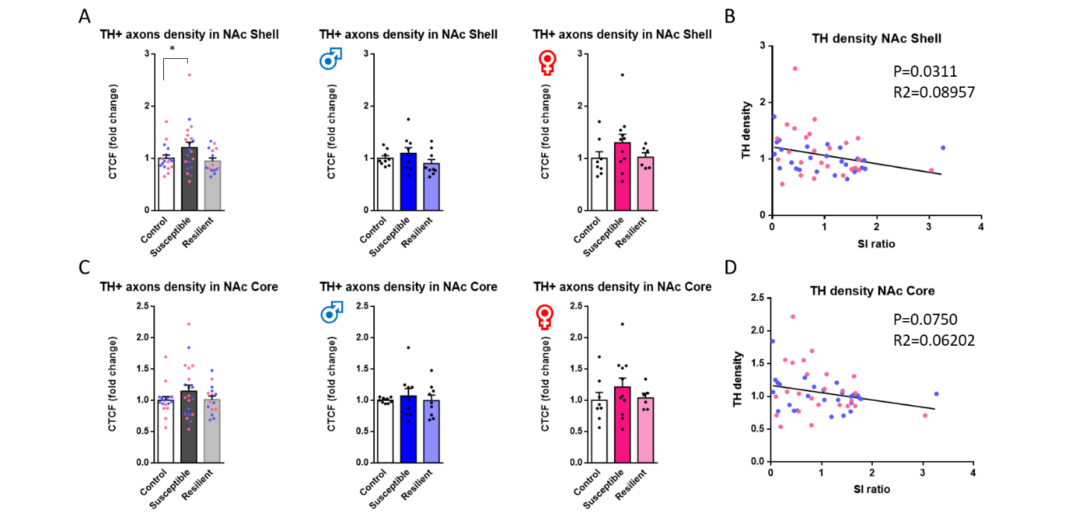
Figure S1
Figure S1. TH expression in NAc core and shell of males and females after CSDS (A) Fluorescence density of TH+ axons in the NAc shell (females in pink and males in blue [One-way ANOVA: Males and females combined (left panel): F_{(2,49)}=2.789; p<0.1, Males (middle panel): F_{(2,24)}=1.370; p=n.s., Females (right panel): F_{(2,22)}=1.353; p=n.s., Control (M/F): n=9/8, Susceptible (M/F): n=9/11, Resilient (M/F): n=9/6]). (B) Correlation between SI ratios and the CTCF values in the NAc shell [linear regression: R²=0.090; p<0.05, n=52]. (C) Fluorescence density of TH+ axons in the NAc shell (females in pink and males in blue [One-way ANOVA, males and females combined (left panel): F_{(2,49)}=1.174; p=n.s., Males (middle panel): F_{(2,24)}=0.2215; p=n.s., Females (right panel): F_{(2,22)}=0.7718; p=n.s., Control (M/F): n=9/8, Susceptible (M/F): n=9/11, Resilient (M/F): n=9/6]). (D) Correlation between SI ratios and the CTCF values in the NAc core [linear regression: R²=0.062; p<0.1, n=52]. Bar graphs show mean ± SEM. Data are represented as fold change from same group control values. Each dot represents one mouse. Values derived from at least three sections per brain.

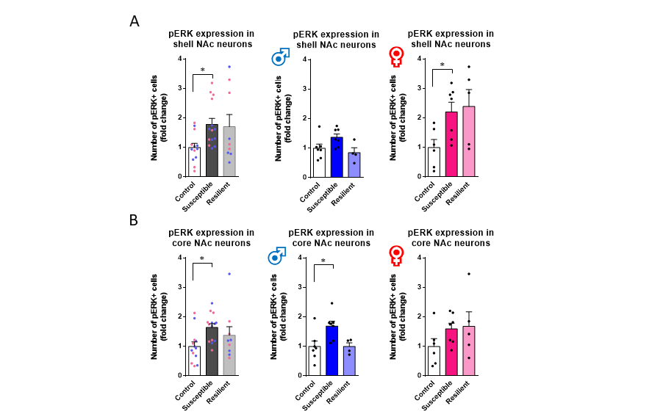
Figure S2
Figure S2. pERK expression in NAc core and shell of males and females after CSDS (A) Stereological counts of pERK+ neurons in NAc shell (females in pink and males in blue [One-way ANOVA, Males and females combined (left panel): F_{(2,33)}=3.470; p<0.05, Males (middle panel): F_{(2,15)}=3.575; p<0.1, Females (Right panel): F_{(2,15)}=3.779; p<0.05, Control (M/F): n=7/6, Susceptible (M/F): n=7/7, Resilient (M/F): n=4/5]). (B) Stereological count of pERK+ neurons in NAc core (females in pink and males in blue [One-way ANOVA, Males and females combined (left panel): F_{(2,33)}=3.719; p<0.05, Males (middle panel): F_{(2,24)}=5.340; p<0.05, Females (right panel): F_{(2,15)}=0.1.422; p=n.s., Control (M/F): n=7/6, Susceptible (M/F): n=7/7, Resilient (M/F): n=4/5]). Bar graphs show mean ± SEM. Data are represented as fold change from same group control values. Each dot represents one mouse. Values derived from at least three sections per brain.

Figure S3
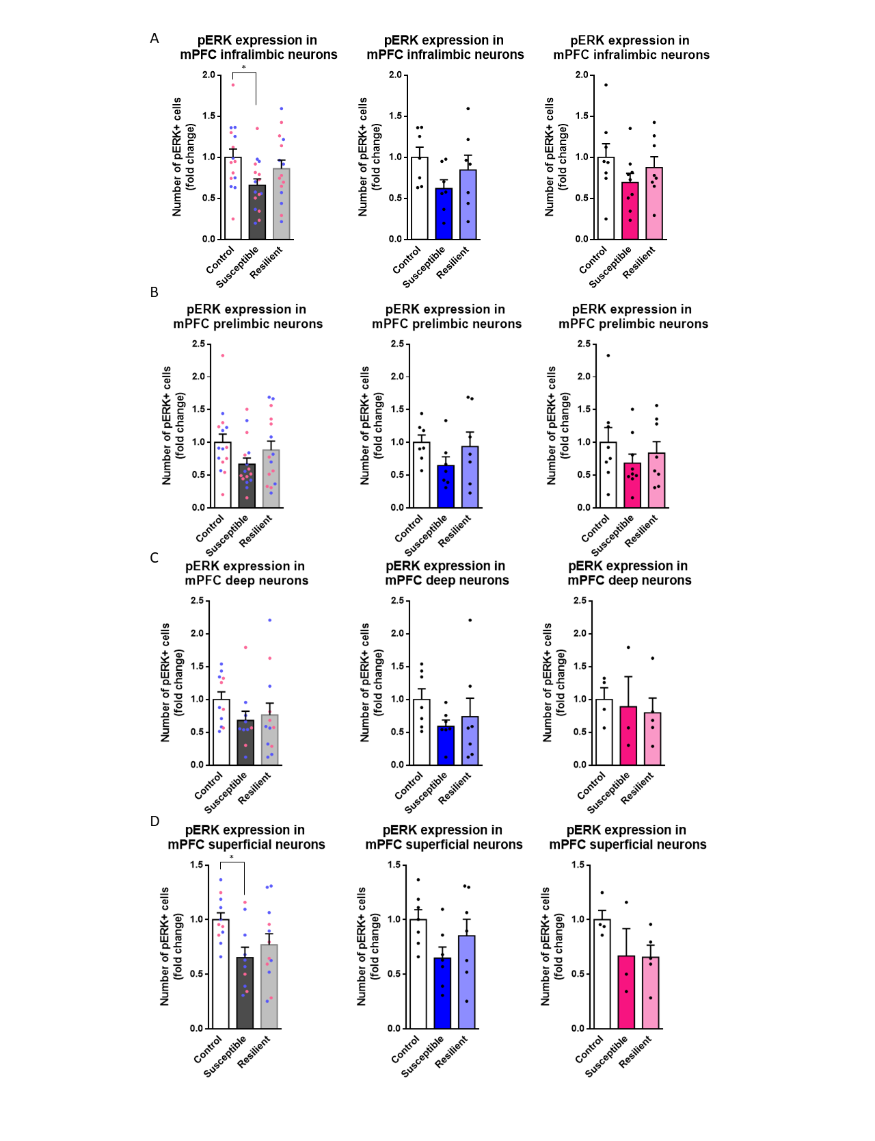
Figure S3. pERK expression in the mPFC of males and females after CSDS. (A) Stereological counts of pERK+ neurons in the infralimbic mPFC (females in pink and males in blue [One-way ANOVA, Males and females combined (left panel: F_{(2,43)}=3.258; p<0.05, Males (middle panel): F_{(2,18)}=1.846; p=n.s., Females (right panel): F_{(2,22)}=1.301; p=n.s., Control (M/F): n=7/8, Susceptible (M/F): n=7/9, Resilient (M/F): n=7/8]). (B) Stereological counts of pERK+ neurons in the prelimbic mPFC (females in pink and males in blue [One-way ANOVA, Males and females combined (left panel): F_{(2,43)}=2.041; p=n.s., Males (middle panel): F_{(2,18)}=1.354; p=n.s., Females (right panel): F_{(2,22)}=0.7774; p=n.s., Control (M/F): n=7/8, Susceptible (M/F): n=7/9, Resilient (M/F): n=7/8]). (C) Stereological counts of pERK+ neurons in deep layers of the mPFC (layer V and VI; females in pink and males in blue [One-way ANOVA, Males and females combined (left panel): F_{(2,30)}=1.154; p=n.s., Males (middle panel): F_{(2,18)}=1.124; p=n.s., Female: F_{(2,15)}=0.1541; p=n.s., Control (M/F): n=7/4, Susceptible (M/F): n=7/3, Resilient (M/F): n=7/5]). (D) Stereological counts of pERK+ neurons in superficial layers of the mPFC (layer II/III and I; females in pink and males in blue [One-way ANOVA, Males and females combined (left panel): F_{(2,30)}=3.814; p<0.05, Males (middle panel): F_{(2,18)}=2.233; p=n.s., Females (right panel): F_{(2,9)}=1.938; p=n.s, Control (M/F): n=7/4, Susceptible (M/F): n=7/3, Resilient (M/F): n=7/5]).

