Supplementary Table S1. Overall estimates of dispersion parameter (k) and proportion of cases responsible for infecting 80% (Prop80) and 0% (Prop0, i.e., no one) of cases for SARS and COVID-19 in Hong Kong given each of the resolved and unresolved datasets*
 | SARS |  |  | COVID-19
 | Resolved | Unresolved |  | Resolved | Unresolved
Dispersion k (95%CI) | 0.05 (0.04 – 0.07) | 0.05 (0.04 – 0.06) |  | 0.24 (0.23 – 0.26) | 0.22 (0.21 – 0.24)
Prop80 (95% CI) | 5.3 (4.4 – 6.2) | 5.03 (4.2 – 5.9) |  | 16.20 (15.6 – 16.7) | 15.40 (14.8 – 16.0)
Prop0 (95% CI) | 85.2 (83.3 – 86.9) | 85.60 (83.8 – 87.4) |  | 67.30 (66.5 – 68.1) | 68.30 (67.5 – 69.1)
* Datasets contains all resolved transmission pairs where the infector and infectee are known. The unresolved dataset contains all the resolved pairs in the resolved analysis and additional unresolved transmissions linked to superspreading events where the source infector was uncertain.

Supplementary Table S2. Linear regression model of the time-varying measures of overdispersion (k_{t}), the proportion of cases responsible for infecting 80% (Prop80_{t}), and probability of epidemic extinction proportion (ProbExt_{t}) overtime for SARS and COVID-19 in Hong Kong by epidemic period.
 | Parameter | Period | Slope (95% CI) | SE | r² | p value*
COVID-19 | k_{t} | Wave one | -0.008 (-0.018, 0.00) | 0.005 | 0.023 | 0.99
COVID-19 | k_{t} | Wave two | -0.087 (-0.157, -0.02) | 0.035 | 0.058 | 0.99
COVID-19 | k_{t} | Wave three | 0.101 (-0.002, 0.20) | 0.052 | 0.036 | 0.99
COVID-19 | Prop80_{t} | Wave one | -0.011 (-0.016, -0.01) | 0.002 | 0.185 | 0.003
COVID-19 | Prop80_{t} | Wave two | -0.107 (-0.145, -0.07) | 0.019 | 0.232 | < 0.001
COVID-19 | Prop80_{t} | Wave three | 0.169 (0.120, 0.22) | 0.025 | 0.305 | < 0.001
COVID-19 | ProbExt_{t} | Wave one | -0.007 (-0.009, 0.00) | 0.001 | 0.204 | < 0.001
COVID-19 | ProbExt_{t} | Wave two | -0.062 (-0.079, -0.04) | 0.009 | 0.227 | < 0.001
COVID-19 | ProbExt_{t} | Wave three | 0.071 (0.049, 0.09) | 0.011 | 0.193 | < 0.001
SARS | k_{t} | Overall | 0.019 (0.013, 0.03) | 0.003 | 0.227 | < 0.001
SARS | Prop80_{t} | Overall | 0.079 (0.048, 0.11) | 0.016 | 0.177 | 0.002
SARS | ProbExt_{t} | Overall | 0.119 (0.091, 0.15) | 0.014 | 0.420 | < 0.001

Supplementary Table S3: Results comparing the marginal bootstrapped distributions of k_{t} and Prop80_{t} between COVID-19 and SARS by dataset.
 |  | COVID-19 |  | SARS | p value*
 | Dataset | Median (90%CI) |  | Median (90%CI) | p value*
k_{t} | Composite | 0.20 (0.06, 0.71) |  | 0.05 (0.02, 0.47) | < 0.001
k_{t} | Resolved | 0.22 (0.09, 0.69) |  | 0.06 (0.02, 0.30) | < 0.001
k_{t} | Unresolved | 0.19 (0.05, 0.72) |  | 0.06 (0.03, 0.53) | 0.008
Prop80t | Composite | 0.14 (0.06, 0.28) |  | 0.06 (0.02, 0.17) | < 0.001
Prop80t | Resolved | 0.15 (0.08, 0.28) |  | 0.06 (0.02, 0.15) | < 0.001
Prop80t | Unresolved | 0.13 (0.05, 0.28) |  | 0.06 (0.03, 0.18) | < 0.001
* Two Sample t-test comparison of means. p value is the average of 1000 random samples from the marginal bootstrapped distribution of k_{t} and Prop80_{t} with each independent sample equivalent in size to the number valid dates for each respective dataset. Because k_{t} exhibits a skewed distribution (0 < k_{t} → ∞), estimates were transformed using the natural logarithm before t-tests were conducted, though k_{t} values and CIs shown in the table remained untransformed.

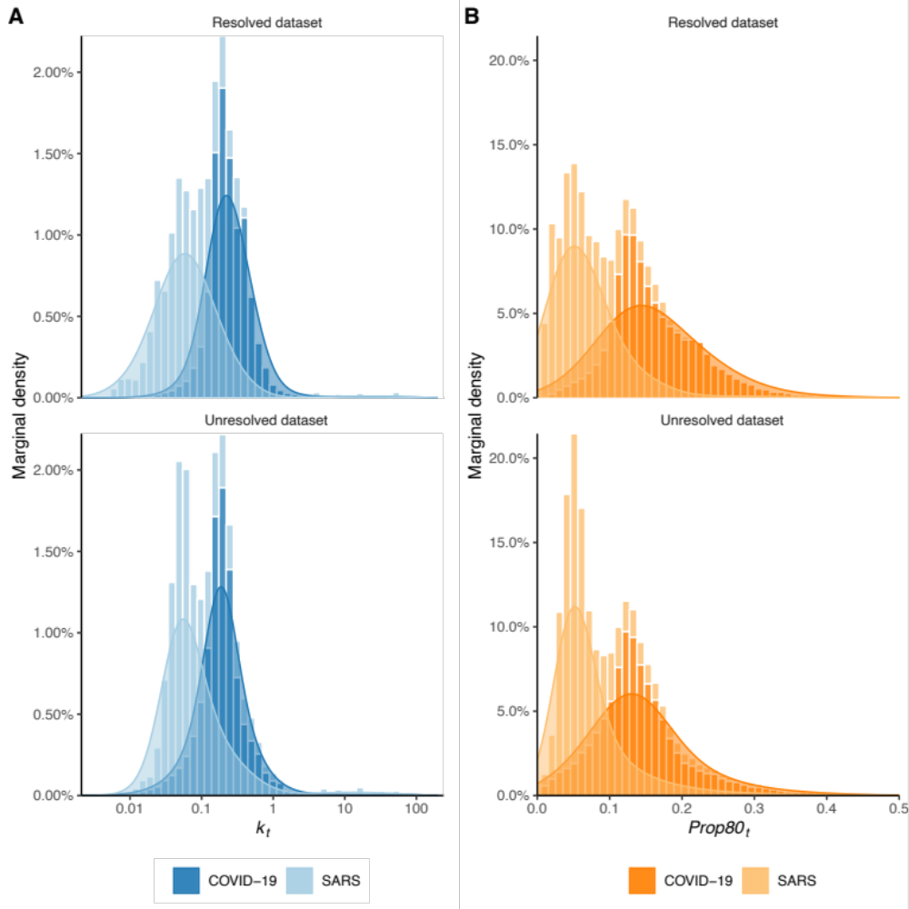

Supplementary Figure S1: Comparative marginal density estimates of (A) time-varying overdispersion (k_{t}) and (B) the proportion of cases responsible for 80% of onwards transmissions (Prop80_{t}) over-time for SARS and COVID-19 by dataset. Estimates are equivalent to datasets in Supplementary Table S3.

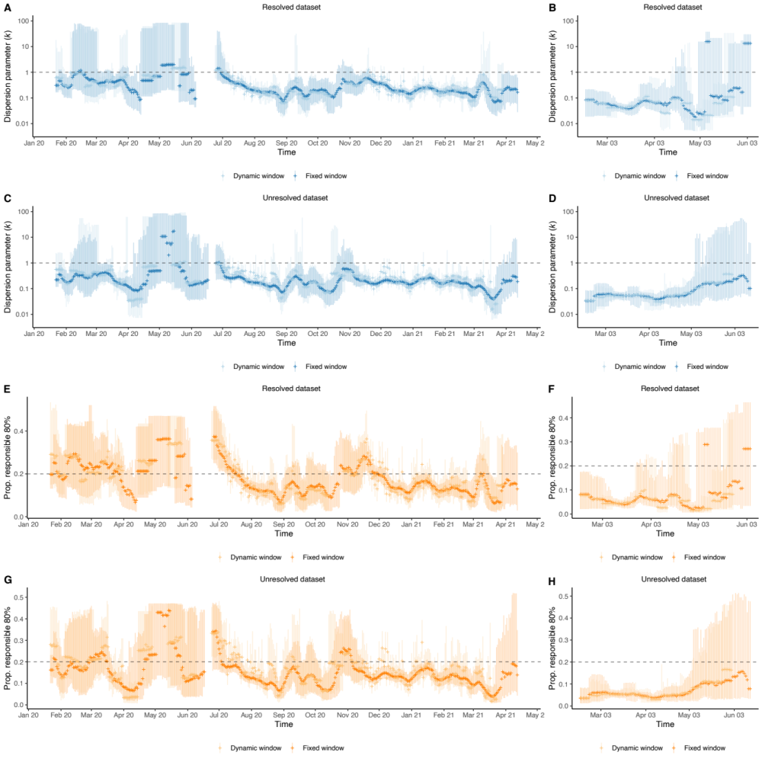
Supplementary Figure S2: Estimates of COVID-19 (left) and SARS (right) transmission heterogeneity over-time shown as the dispersion parameter k_{t} and proportion of cases responsible for infecting 80% (Prop80_{t}) by dataset and sliding window size including inter-wave periods (see methods for details). Error bars represent bootstrapped 90% CI of k_{t} and Prop80_{t}.

Supplementary Table S4. Linear regression model of the relationship between time-varying measures of overdispersion (k_{t}), the proportion of cases responsible for infecting 80% (Prop80_{t}), and probability of epidemic extinction proportion (ProbExt_{t}) with reproductive number (Rt) for SARS and COVID-19 in Hong Kong.
 |  | Slope (95% CI) | SE | r² | p value*
COVID-19 | Re_{t} ~ k_{t} | 0.66 (0.39, 0.94) | 0.142 | 0.057 | 0.003
COVID-19 | Re_{t} ~ Prop80_{t} | 9.28 (7.32, 11.23) | 0.993 | 0.188 | < 0.001
COVID-19 | Re_{t} ~ ProbExt_{t} | -23.80 (-25.39, -22.2) | 0.81 | 0.697 | < 0.001
SARS | Re_{t} ~ k_{t} | -0.14 (-0.29, 0.01) | 0.076 | 0.028 | 0.99
SARS | Re_{t} ~ Prop80_{t} | -0.42 (-1.09, 0.24) | 0.334 | 0.014 | 0.99
SARS | Re_{t} ~ ProbExt_{t} | -3.13 (-3.47, -2.78) | 0.172 | 0.758 | < 0.001
* Simple linear regression. p value is the average of 1000 random samples from the marginal bootstrapped distribution of k_{t} and corresponding Prop80_{t} and ProbEx_{t} with each independent sample equivalent in size to the number valid points estimates. Because k_{t} exhibits a skewed distribution (0 < k_{t} → ∞), estimates were transformed using the natural logarithm before regression was conducted, though k_{t} values and CIs shown in the table remained untransformed.

Supplementary Table S5. Linear regression model of the relationship between time-varying measures of overdispersion (k_{t}), the proportion of cases responsible for infecting 80% (Prop80_{t}), and probability of epidemic extinction proportion (ProbExt_{t}) with stringency of non-pharmaceutical interventions (NPI) for SARS and COVID-19 in Hong Kong.
 |  | Slope (95% CI) | SE | r² | p
COVID-19 | NPI ~ k_{t} | -0.03 (-0.04, -0.02) | 0.005 | 0.09 | < 0.001
COVID-19 | NPI ~ Prop80_{t} | -0.32 (-0.39, -0.25) | 0.036 | 0.176 | < 0.001
COVID-19 | NPI ~ ProbExt_{t} | 0.61 (0.53, 0.69) | 0.042 | 0.363 | < 0.001
SARS | NPI ~ k_{t} | 0.03 (-0.01, 0.06) | 0.016 | 0.024 | 0.99
SARS | NPI ~ Prop80_{t} | 0.09 (-0.05, 0.23) | 0.07 | 0.016 | 0.99
SARS | NPI ~ ProbExt_{t} | 0.51 (0.41, 0.62) | 0.055 | 0.472 | < 0.001
* Simple linear regression. p value is the average of 1000 random samples from the marginal bootstrapped distribution of k_{t} and corresponding Prop80_{t} and ProbEx_{t} with each independent sample equivalent in size to the number valid points estimates. Because k_{t} exhibits a skewed distribution (0 < k_{t} → ∞), estimates were transformed using the natural logarithm before regression was conducted, though k_{t} values and CIs shown in the table remained untransformed.

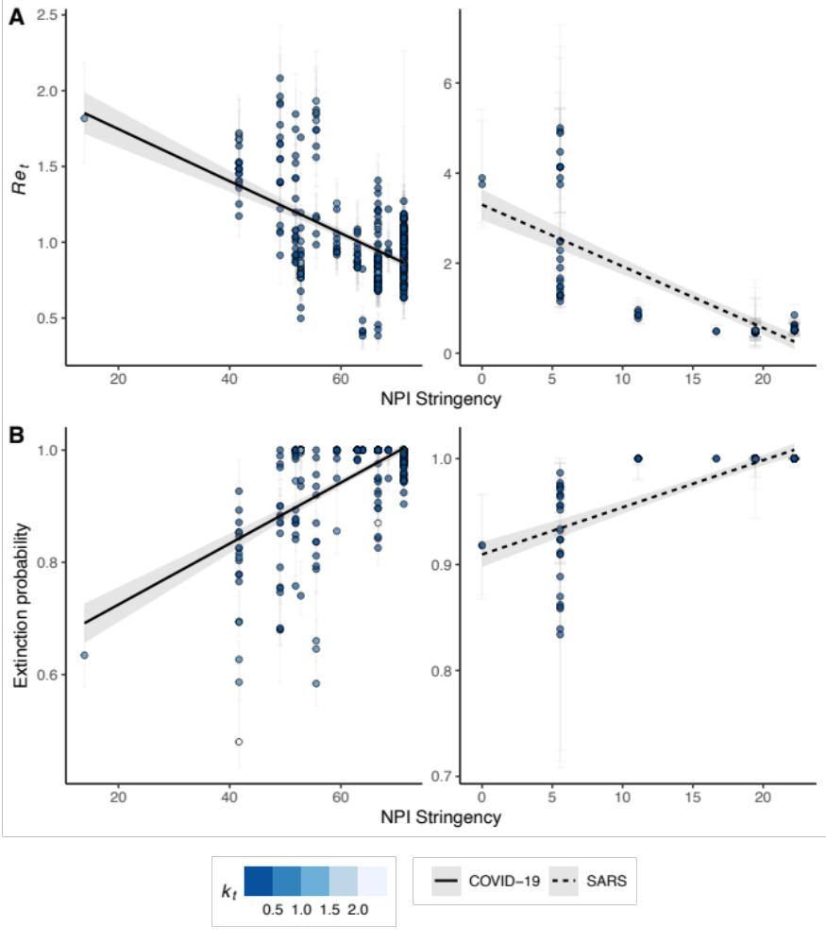
Supplementary Figure S3. Linear relationship between median Re_{t} and NPI stringency (A) for COVID-19 and SARS. Increasing NPI stringency is associated with reduced Re_{t}. (B) Linear model demonstrating increasing NPI stringency leads to greater probability of epidemic extinction given Re_{t} and k_{t}.

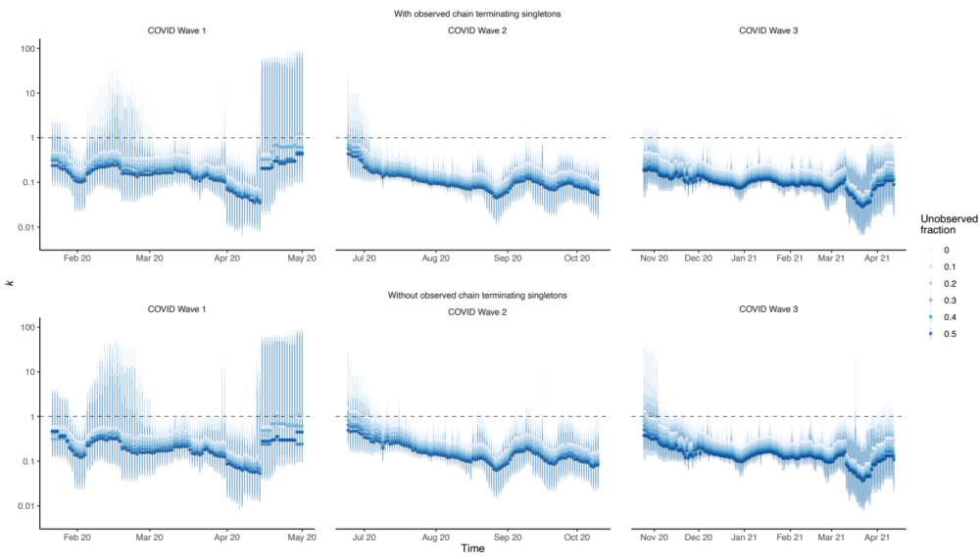
Supplementary Figure S4. Sensitivity of COVID-19 overdispersion parameter k_{t} given varying proportions of unobserved singleton cases (0% to 50% unobserved cases) with and without inclusion of observed chain terminating singletons. Demonstrates min and max under and overestimation of k under the proposed proportions.
Supplementary Table S6: Median bias of observed kt when accounting for additional unobserved singleton cases in the community.
Observation Probability | Median kt difference (90% CI)
Observation Probability | Without Singletons | With Singletons
0 | -0.07 (-0.03, -0.35) | NA*
0.1 | -0.03 (-0.01, -0.14) | 0.03 (0.01, 0.08)
0.2 | -0.01 (0, -0.02) | 0.05 (0.03, 0.17)
0.3 | 0.02 (0.01, 0.05) | 0.07 (0.03, 0.23)
0.4 | 0.04 (0.02, 0.12) | 0.09 (0.04, 0.27)
0.5 | 0.06 (0.03, 0.18) | 0.1 (0.05, 0.31)
*N/A: the observed kt dataset from which each other combination with and without observed chain terminating singleton cases is compared i.e., median kt difference is 0 (0,0).

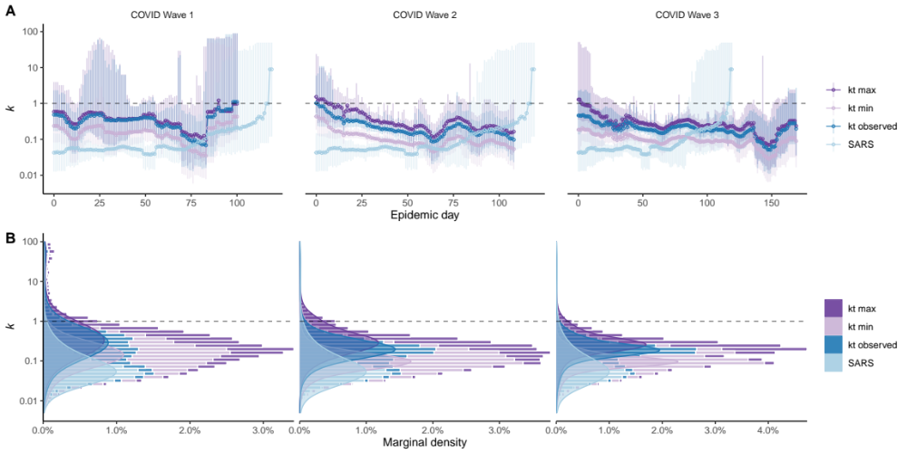
Supplementary Figure S5. A) Time-varying overdispersion for COVID-19 given maximum potential for overestimation (kt max) and contact tracing bias given 50% potential under detection (kt min) compared to the observed kt for COVID-19 and SARS by relative epidemic day and wave period.
B) Comparative marginal density estimates of kt equivalent to panel A.

Supplementary Table S7: Results comparing the marginal bootstrapped distributions of k_{t} COVID-19 observation probability and the observed SARS.
 | COVID-19 |  | SARS | p value | Adjusted p*
Observation Probability | Median k_{t} (90%CI) |  | Median k_{t} (90%CI) | p value | Adjusted p*
0 | 0.20 (0.06, 0.71) |  | 0.05 (0.02, 0.47) | < 0.001 | < 0.001
0.1 | 0.17 (0.06, 0.58) |  | 0.05 (0.02, 0.47) | < 0.001 | 0.009
0.2 | 0.15 (0.05, 0.47) |  | 0.05 (0.02, 0.47) | < 0.001 | 0.063
0.3 | 0.13 (0.04, 0.39) |  | 0.05 (0.02, 0.47) | 0.004 | 0.239
0.4 | 0.11 (0.04, 0.33) |  | 0.05 (0.02, 0.47) | 0.029 | 0.565
0.5 | 0.10 (0.03, 0.28) |  | 0.05 (0.02, 0.47) | 0.111 | 0.836
* Two Sample t-test comparison of means. p value is the average of 1000 random samples from the marginal bootstrapped distribution of k_{t} and Prop80_{t} with each independent sample equivalent in size to the number valid dates for each respective dataset. Because k_{t} exhibits a skewed distribution (0 < k_{t} → ∞), estimates were transformed using the natural logarithm before t-tests were conducted, though k_{t} values and CIs shown in the table remained untransformed.

Supplementary Figure S6. Relationship between the effective reproductive number (Re), dispersion parameter (k), and the proportion of cases responsible for 80% of transmission given values of k (A) and the probability of epidemic extinction (B) as a continuous heatmap.

Supplementary Methods & Results:

Characterization of offspring distributions and construction of transmission pairs for COVID-19 and SARS
Using case line lists and contact tracing data provided by the Centre for Health Protection (CHP) in Hong Kong we characterized clusters of COVID-19 infection and transmission pairs within clusters for cases confirmed between Jan 23, 2020 and Apr 5, 2021 (n=11,525). All cases of infection were laboratory confirmed via nasopharyngeal swab and reverse transcription polymerase chain reaction (RT-PCR). For SARS, historic case line lists were provided by the Department of Health and included all SARS cases confirmed in Hong Kong during the primary epidemic period from Feb 18, 2003 and May 31, 2003 (n=1,755). Cases of SARS were confirmed by either RT-PCR or by paired immunoglobulin (Ig) G to SARS-CoV at a later stage where RT-PCR failed (1). Separately, SARS contact tracing data was also provided by the Department of Health for n=1,481 (84.4%) cases. Further, this dataset lacked a common identifier to the demographic line list. Thus, where possible, contact tracing data was matched back to the demographic line list using age, sex, date of symptom onset, and date of hospital admission. Of the n=1,755 SARS cases confirmed in Hong Kong, contact tracing was matched to n=1,295 (73.8%) cases. COVID-19 cases were classified as imported if they had travelled within the prior 14-days preceding symptom onset or confirmation when asymptomatic, otherwise they were considered locally acquired cases. For SARS, cases were classified as imported if they had a history of travel to mainland China in the 10 days preceding reported symptom onset. Those without a history of travel to mainland China or travel beyond 10 days to onset, or with missing travel history, were characterised as locally acquired.
Characterization of COVID-19 transmission pairs was performed as per our previous study (2) with detail repeated here for clarity. Clusters of COVID-19 were defined as two or more confirmed infections with reported close contact to each other or a common setting in time. A COVID-19 close contact was defined as someone with prolonged interaction with a confirmed case or setting (with or without prior symptoms) in excess of two hours if both persons were wearing a mask, or 15 minutes without mask usage e.g., when dinning at a restaurant. Local COVID-19 cases not traced to any cluster were categorized as unlinked singleton cases. For cases within local COVID-19 clusters, probable infector-infectee transmission pairs and chains of transmission within clusters were determined from reported contact histories. Within clusters, the case with the earliest onset date was considered the source of subsequent cases where contact was confirmed within the primary identified cluster setting. Subsequent transmission between clusters and settings (secondary, tertiary and quaternary etc.) were traced back to the primary cluster case based on the reported contact histories only and did not rely on symptom onset dates. Symptom presentation was screened only at the time of confirmation and included retrospective self-report of onset dates. COVID-19 cases linked to large cluster settings where the source and chain of transmission were uncertain were excluded (unresolved transmissions) from the primary paired analysis (resolved dataset) however subsequent generations from such cases were not excluded for the second sensitivity analysis (unresolved dataset) which assigned the cluster setting as the source.
For SARS, contact tracing data was also used to characterise cases within transmission pairs as either an infector or an infectee (note that intermediate cases could be both) as before with reported close contact to each other or a common setting in time. At the time contact tracing was conducted, close contact was defined as someone caring for, living with, or having direct contact with body fluids of a probable SARS patient, e.g., working in the same medical ward or staying in the same household, within 10 days of initial symptom onset (1). To compliment contact tracing data where SARS data was unavailable, we reviewed prior literature and government reports (3) to identify transmission between known cases and clusters in Hong Kong. For example, within large sustained SARS hospital outbreaks where the index case was known, secondary cases including healthcare workers and healthcare workers as either visitors or patients were linked as direct infectees of the index if contact tracing data indicated the hospital as the confirmed source, and their onset date was within 10 days of the known exposure period (4). Cases within hospitals with onset dates beyond this window were not linked to any individual source case, however potential onward transmission from such cases were still considered where contact tracing identified external community transmission such as to social or family contacts within households. An exception was applied to secondary cases within Block E of the Amoy Gardens Housing Complex, which exhibited a single point-source exposure pattern (5). All block E cases were therefore linked to the index resident, while cases living in other blocks were not linked to the block E index regardless if their onset was within the incubation period of the known exposure date due to uncertainties in contact between residents between blocks. As before, where transmission from a single index case was uncertain (unresolved transmission) cases were instead linked as infectees to a common exposure site and included for subsequent sensitivity analyses. All remaining unlinked SARS cases were considered singleton cases as per COVID-19 excluding cases that could not be matched to contact tracing data.

Time-varying transmission heterogeneity of SARS and COVID-19
Modelling the non-negative count distribution of secondary cases or offspring in infectious disease transmission can be achieved via a number of discrete distributions. Following Lloyd Smith et al., (6) the offspring distribution can be considered a Poisson mixture model with three possible implementations: the (i) Poisson, (ii) Geometric, and (iii) Negative Binomial distributions. When individual variation in transmission is ignored, and the individual mean is equal to the variance and population mean i.e., the effective reproductive number (Re), a Poisson distribution can be considered. If the individual reproductive number is exponentially distributed, transmission instead yields a Geometric offspring distribution, and the variance is equal to $Re\left(1+Re\right)$. However, when the variance in transmission greatly exceeds that which would be normally expected, i.e., the distribution of secondary counts is overdispersed, a Negative Binomial distribution is ideal. Such overdispersed count data is indicative of heterogeneity in transmission, where the variation greatly exceeds the expected mean. Modelling overdispersed offspring counts therefore is conveniently achieved via the negative binomial distribution. In this case, the negative binomial distribution is best parameterized by the dispersion parameter (k) and sample mean, which can be considered equivalent to the effective reproductive number (Re). With the notation $Z\sim Negative Binomial(Re,k)$ the probability mass function is as:

$$f\left(y;Re,k\right)=\frac{Γ(y+k)}{Γ\left(k\right)y!} {\left(\frac{k}{Re+k}\right)}^{k}{\left(\frac{Re}{Re+k}\right)}^{y}$$

Conventionally, the parameterization is as $Negative Binomial(p,k)$ where $p={(1+\frac{Re}{k})}^{-1}$, though instead, the dispersion parameter, k, neatly describes the magnitude of overdispersion in the distribution, while the mean again is intuitively equivalent to the effective reproductive number (R). Under this parameterization, the variance is equal to $Re\left(1+\frac{Re}{k}\right)$, and thus, as k decreases, the variance increases, resulting in greater degrees of overdispersion. For low values of k (0 < k < 1), most individuals infect relatively few others, while a small minority rather infect many, which reflects the occurrence of real-world ‘superspreading events’ or large clusters of infection where the variance exceeds expectation (6, 7). When k = 1, $Negative Binomial(Re,k)$ is correspondingly geometric, $Z\sim Geometric(Re)$, i.e, $Re\left(1+Re\right)=R\left(1+\frac{Re}{1}\right)$, while for larger values of k (k > 1), the variance of the Negative Binomial distribution approaches the mean and therefore approaches a Poisson distribution. Negative Binomial is exactly Poisson, $Z\sim Poisson(Re)$, when k → ∞, i.e, $Re=Re\left(1+\frac{Re}{∞}\right)$.
Following the above parameterization with k, we first generated offspring distributions by counting the observed number of offspring (Z) for each infector in each of the transmission pair datasets for SARS and COVID-19 as the number of secondary cases per primary case for all resolved pairs (resolved dataset) and unresolved pairs linked to exposure settings (unresolved dataset). Sporadic cases and terminal infectees without traceable onward transmission were included in each distribution as terminating cases i.e., Z = 0. Positively biased estimation of k by maximum likelihood (ML) estimation is a known issue when fitting Negative Binomial distributions to small samples sizes (6, 8, 9). Thus in-order to vary our estimates overtime and increase our sample size during periods of limited transmission, we subset our paired datasets into one- and two-week window periods sliding each window forward by one day where data was available. Each window period was forecast from the known infector’s onset date or confirmation date when asymptomatic in the resolved transmission pair dataset. For additional pairs within the unresolved pairs dataset of the sensitivity analysis, windows were reforecast from each of the infectees onset date or confirmation date when asymptomatic. We also implemented a second estimation process by implementing dynamic window sizes based on minimum sample sizes and maximum window lengths. Dynamic window sizes were generated each for a minimum of n = (10, 20, 30, 40, 50) paired cases each extending to a maximum of one and two weeks in length. For both the dynamic and fixed window procedures, Negative Binomial distributions were fit by ML estimation to each subset offspring distribution using fitdistrplus v1.1-3 in R v4.0.4 (R Foundation for Statistical Computing, Vienna, Austria). In this case, only k was estimated from the observed data, with Re fixed to the effective reproductive number within each window estimated previously using EpiNow2 (10). 90% confidence intervals (CI) for k for all analyses were also generated using fitdistrplus v1.1-3 by parametric bootstrap resampling methods (n=1,000) within each of the subset window periods. We specified 90% CI instead of the typical 95% due to the established difficulty in estimating extreme values of k accurately (6, 11). Final and continuous results were generated as the median, upper, and lower 90% quantiles of the fixed and dynamic bootstrap results at each time point during the study period. Though 0 < k < 1 generally indicates increasing transmission heterogeneity and therefore potential for superspreading, interpretation is also dependent on the effective reproductive number (Re) in time, i.e., Re_{t}. We therefore relaxed the strict interpretation of k by calculating the proportion of individuals responsible for 80% of onward transmission (by analogy to the 80/20 rule) as per the formulas below (12):
$$1-P80\%= \int_{0}^{X}{\left\lfloor x\right\rfloor Negative Binomial\left(\left\lfloor x\right\rfloor ;k,\frac{k}{Re+k}\right)}dx$$
where X satisfies:
$$1-0.8= \frac{1}{Re}\int_{0}^{X}{\left\lfloor x\right\rfloor Negative Binomial\left(\left\lfloor x\right\rfloor ;k,\frac{k}{Re+k}\right)}dx$$
and:
$$\frac{1}{Re}\int_{0}^{X}{\left\lfloor x\right\rfloor Negative Binomial\left(\left\lfloor x\right\rfloor ;k,\frac{k}{Re+k}\right)}dx=\int_{0}^{X-1}{Negative Binomial\left(\left\lfloor x\right\rfloor ;k+1,\frac{k}{Re+k}\right)}dx$$

Lastly, with both Re_{t} and k_{t} known, we can calculated the instantaneous probability of epidemic extinction given the probability generating function of a negative binomial offspring distribution (2) denoted by $g\left(x\right)$:

$$g\left(x\right)= {\left(1+\frac{{Re}_{t}}{k_{t}}\left(1-x\right)\right)}^{-k_{t}}$$

Where the probability that an epidemic has gone extinct by the nth generation is $g^{n}\left(0\right)$. We also investigated the relationship between Re, k, and Prop80 by generating full factorial combinations of Re (Re = 0-8 incrementing every 0.05 steps) and k (a log-scaled sequence from k = 0.01 to k = 100 with 161 steps) and calculating Prop80 and probability of extinction as per the equations above.

Supplementary Methods References:

1. Chan LY, Lee N, Chan PKS, Wu A, Rainer TH, Li PKT, et al. Diagnostic criteria during SARS outbreak in Hong Kong. Emerg Infect Dis. 2004;10(6):1168-70.
2. Adam DC, Wu P, Wong JY, Lau EHY, Tsang TK, Cauchemez S, et al. Clustering and superspreading potential of SARS-CoV-2 infections in Hong Kong. Nature Medicine. 2020.
3. SARS Expert Committee SARS in Hong Kong: from experience to action. Report of the SARS Expert Committee.
4. Role of air distribution in SARS transmission during the largest nosocomial outbreak in Hong Kong. Indoor Air. 2005;15(2):83-95.
5. Health Do. Outbreak of Severe Acute Respiratory Syndrome (SARS) at Amoy Gardens, Kowloon Bay, Hong Kong—Main Findings of the Investigation. The Hong Kong Government Hong Kong; 2003.
6. Lloyd-Smith JO, Schreiber SJ, Kopp PE, Getz WM. Superspreading and the effect of individual variation on disease emergence. Nature. 2005;438(7066):355-9.
7. Galvani AP, May RM. Dimensions of superspreading. Nature. 2005;438(7066):293-5.
8. Saha K, Paul S. Bias‐corrected maximum likelihood estimator of the negative binomial dispersion parameter. Biometrics. 2005;61(1):179-85.
9. Gregory R, Woolhouse M. Quantification of parasite aggregation: a simulation study. Acta tropica. 1993;54(2):131-9.
10. Abbott S, Hellewell J, Thompson RN, Sherratt K, Gibbs HP, Bosse NI, et al. Estimating the time-varying reproduction number of SARS-CoV-2 using national and subnational case counts. Wellcome Open Research. 2020;5(112):112.
11. Lloyd-Smith JO. Maximum Likelihood Estimation of the Negative Binomial Dispersion Parameter for Highly Overdispersed Data, with Applications to Infectious Diseases. PLOS ONE. 2007;2(2):e180.
12. Endo A, Abbott S, Kucharski AJ, Funk S. Estimating the overdispersion in COVID-19 transmission using outbreak sizes outside China. Wellcome Open Res. 2020;5:67.

