ADDITIONAL FILES

Early Predictors of Functional Outcome in Poor-Grade Aneurysmal Subarachnoid Hemorrhage: A Systematic Review and Meta-Analysis.
Table of contents
Additional file; Table 1. PRISMA checklist 2
Additional file; Methods 1. Search strategy 5
Additional file; Methods 2. Eligibility criteria 7
Additional file; Methods 3. Risk of bias criteria for final verdict 8
Additional file; Figure 1. PRISMA Flow chart 9
Additional file; Table 2. Study characterization 10
Additional file; Table 3. Meta-analysis 19
Additional file; Table 4. Systematic review 22
Additional file; Figure 2A. Funnel plots of meta-analysis of age before trim-and-fill 26
Additional file; Figure 2B. Funnel plots of meta-analysis of age after trim-and-fill 27
Additional file; Figure 3. Risk of bias traffic light plot 28

Additional file; Table 1. PRISMA Checklist
Section/topic | # | Checklist item |  | Reported on page #
TITLE
Title | 1 | Identify the report as a systematic review, meta-analysis, or both. |  | 1
ABSTRACT
Structured summary | 2 | Provide a structured summary including, as applicable: background; objectives; data sources; study eligibility criteria, participants, and interventions; study appraisal and synthesis methods; results; limitations; conclusions and implications of key findings; systematic review registration number. |  | 2
INTRODUCTION
Rationale | 3 | Describe the rationale for the review in the context of what is already known. |  | 3
Objectives | 4 | Provide an explicit statement of questions being addressed with reference to participants, interventions, comparisons, outcomes, and study design (PICOS). |  | 3
METHODS
Protocol and registration | 5 | Indicate if a review protocol exists, if and where it can be accessed (e.g., Web address), and, if available, provide registration information including registration number. |  | 3
Eligibility criteria | 6 | Specify study characteristics (e.g., PICOS, length of follow-up) and report characteristics (e.g., years considered, language, publication status) used as criteria for eligibility, giving rationale. |  | Suppl
Information sources | 7 | Describe all information sources (e.g., databases with dates of coverage, contact with study authors to identify additional studies) in the search and date last searched. |  | 4
Search | 8 | Present full electronic search strategy for at least one database, including any limits used, such that it could be repeated. |  | Suppl
Study selection | 9 | State the process for selecting studies (i.e., screening, eligibility, included in systematic review, and, if applicable, included in the meta-analysis). |  | 4
Data collection process | 10 | Describe method of data extraction from reports (e.g., piloted forms, independently, in duplicate) and any processes for obtaining and confirming data from investigators. |  | 4
Data items | 11 | List and define all variables for which data were sought (e.g., PICOS, funding sources) and any assumptions and simplifications made. |  | Available on request
Risk of bias in individual studies | 12 | Describe methods used for assessing risk of bias of individual studies (including specification of whether this was done at the study or outcome level), and how this information is to be used in any data synthesis. |  | 5
Summary measures | 13 | State the principal summary measures (e.g., risk ratio, difference in means). |  | 4
Synthesis of results | 14 | Describe the methods of handling data and combining results of studies, if done, including measures of consistency (e.g., I²) for each meta-analysis. |  | 4
Section/topic | # | Checklist item |  | Reported on page #
Risk of bias across studies | 15 | Specify any assessment of risk of bias that may affect the cumulative evidence (e.g., publication bias, selective reporting within studies). |  | 5
Additional analyses | 16 | Describe methods of additional analyses (e.g., sensitivity or subgroup analyses, meta-regression), if done, indicating which were pre-specified. |  | 5
RESULTS
Study selection |  | 17 | Give numbers of studies screened, assessed for eligibility, and included in the review, with reasons for exclusions at each stage, ideally with a flow diagram. | 5
Study characteristics |  | 18 | For each study, present characteristics for which data were extracted (e.g., study size, PICOS, follow-up period) and provide the citations. | Suppl
Risk of bias within studies |  | 19 | Present data on risk of bias of each study and, if available, any outcome level assessment (see item 12). | Suppl
Results of individual studies |  | 20 | For all outcomes considered (benefits or harms), present, for each study: (a) simple summary data for each intervention group (b) effect estimates and confidence intervals, ideally with a forest plot. | 5-7, Suppl
Synthesis of results |  | 21 | Present results of each meta-analysis done, including confidence intervals and measures of consistency. | 5-7
Risk of bias across studies |  | 22 | Present results of any assessment of risk of bias across studies (see Item 15). | Suppl
Additional analysis |  | 23 | Give results of additional analyses, if done (e.g., sensitivity or subgroup analyses, meta-regression [see Item 16]). | 6
DISCUSSION
Summary of evidence |  | 24 | Summarize the main findings including the strength of evidence for each main outcome; consider their relevance to key groups (e.g., healthcare providers, users, and policy makers). | 8
Limitations |  | 25 | Discuss limitations at study and outcome level (e.g., risk of bias), and at review-level (e.g., incomplete retrieval of identified research, reporting bias). | 8-9
Conclusions |  | 26 | Provide a general interpretation of the results in the context of other evidence, and implications for future research. | 9
FUNDING
Funding |  | 27 | Describe sources of funding for the systematic review and other support (e.g., supply of data); role of funders for the systematic review. | 11

Additional file; Methods 1. Search strategy
Database searched | Via | Years of coverage | Records | After deduplication
Embase | Embase.com | 1971 - Present | 2787 | 2717
Medline ALL | Ovid | 1946 - Present | 1845 | 291
Web of Science Core Collection | Web of Knowledge | 1975 - Present | 989 | 56
Cochrane Central Register of Controlled Trials | Wiley | 1992 - Present | 212 | 51
Other sources: Google Scholar† |  |  | 200 | 49
Total |  |  | 6033 | 3164††
† In Google Scholar only the 200 most relevant articles, before deduplicating, were screened for eligibility.
†† The number of records of the updated search do not necessarily agree with the flowchart. There are several possible reasons for this: (1) an article is no longer within the 200 most relevant articles before deduplicating on Google Scholar, (2) the automatically generated thesaurus terms of an article are changed by specialized employees in the Embase database, (3) ahead of print articles previously found by searching Medline Ovid Epub which are now included in Embase and do not longer agree with the stricter search term. The results displayed in the flowchart are the sum of the articles screened after both searches.

Search strategy performed on 05/25/2020, updated on 11/30/2020
Embase.com
('subarachnoid hemorrhage'/de OR (((aneurysm*) NEAR/9 (subarachnoid-hemorrhage*))):ab,ti,kw) AND ('Glasgow outcome scale'/de OR 'modified rankin score'/de OR (Glasgow-outcome* OR modified-rankin):ab,ti,kw) NOT ('juvenile'/exp NOT 'adult'/exp) NOT ([Conference Abstract]/lim AND [1800-2017]/py)

Medline (Ovid)
(exp Subarachnoid Hemorrhage/ OR (((aneurysm*) ADJ9 (subarachnoid-hemorrhage*))).ab,ti,kf.) AND (Glasgow Outcome Scale/ OR (Glasgow-outcome* OR modified-rankin).ab,ti,kf.) NOT ((exp Child/ OR Adolescent/) NOT exp Adult/)

Web of Science
TS=(((((aneurysm*) NEAR/8 (subarachnoid-hemorrhage*)))) AND ( (Glasgow-outcome* OR modified-rankin))) AND DT=(Article OR Review)

Cochrane Central
((((aneurysm*) NEAR/9 (subarachnoid-hemorrhage*))):ab,ti,kw) AND ( (Glasgow-outcome* OR modified-rankin):ab,ti,kw)

Google Scholar (Top 200 relevant records)
“aneurysmal subarachnoid hemorrhage” “Glasgow outcome”|“modified rankin”

Additional file; Methods 2. Eligibility criteria
Inclusion criteria
- Studies that included adults with a subarachnoid hemorrhage (SAH) confirmed with computed tomography (CT) or lumbar puncture;
- With presence of a saccular intracranial aneurysm (IA) demonstrated by digital subtraction angiography (DSA) or computed tomography angiography (CTa), which is identified as the origin of SAH;
- Presenting in poor neurological condition (defined as Hunt and Hess grade IV-V or World Federation of Neurological Surgeons grade IV-V);
- Studies that measured functional outcome with Glasgow Outcome Scale (GOS) or modified Rankin Score (mRS);
- Studies that performed a multivariable regression analysis of the association of predictors during early admission and functional outcome.

Exclusion criteria
- Studies that report to include aSAH patients in a non-consecutive manner and;
- Studies that, in case of including all-grade aSAH patients, do not report and analyze poor-grade patients separately.

Additional file; Methods 3. Risk of bias criteria for final verdict
We used the following criteria to reach a final verdict on overall risk of bias (ROB): if at least one of the six QUIPS domains was scored as high ROB, or three domains deemed as moderate ROB, the overall ROB of the study was scored as “high”. If up to two domains were scored as moderate ROB, the overall ROB of the study was scored as “moderate”. In case a study had only one domain or less scored as moderate ROB, the overall ROB was scored as “low”.

Additional file; Figure 1. PRISMA Flow chart

Records identified through database searching
(n = 5683)

Records after duplicates removed (n = 2971)
Additional records identified after deduplicated re-run of search (n = 228)

Records screened for title and abstract
(n = 3199)

Records excluded
(n = 2894)

Full-text articles assessed for eligibility
(n = 305)

Reasons for exclusion (n = 277):
- Did investigate specifically or report separately poor-grade SAH (n = 196)
- No full-text available (n = 17)
- Predictors not pre-interventional (n = 13)
- No multivariate analyses (n = 17)
- Included non-aneurysmal, non-saccular or suspected aSAH
(n = 12)
- Other publication type (n = 6)
- Not in English (n = 7)
- Other (n = 9)

Studies included for analyses
(n = 28)

Additional file; Table 1. Study characterization
Study |  | Source of data |  | Participants |  |  | Outcome
Author and year of publication | Sample size | Period of study | Study design | Inclusion criteria | Exclusion criteria | Definition of poor-grade | Length of follow-up | Definition of favorable outcome | Scale | Predictors in multivariable analyses
Anqi  2019¹⁴ | 248 | 2012-2017 | Single-center retrospective case-control study | - Tibetans;  - Poor-grade SAH | - Diagnosis not confirmed radiologically;  - <18 years;  - Not choosing clipping;  - HBG <110;  - Lost to follow up | - H-H IV-V on admission | 6 months | 0-2 | mRS | - High hemoglobin concentration with propensity score matching for: age, hypertension, diabetes, coronary artery disease, hypercholesterolemia, prior aSAH, current smoking, and current alcohol abuse
Das  2017¹⁵ | 85 | 2012-2015 | Single-center retrospective cohort study | - Poor-grade SAH | - Angiogram negative SAH;  - Patients who died before Tx;  - Patients who refused Tx;  - Improvement to H-H <4 before Tx | - H-H IV-V | Median 11.6 months | 0-3 | mRS | - Age  - Sex  - Preoperative H-H grade  - Fisher grade  - ICH  - Hydrocephalus  - Admission leukocyt level
Fukuda  2015¹⁶ | 97 | 2008-2013 | Single-center retrospective cohort study | - Poor-grade aSAH | - Patients who died before Tx;  - Irreparable brainstem injury;  - Limits on therapeutic interventions;  - Died before evaluation for symptomatic vasospasm and chronic hydrocephalus | - WFNS IV-V | 6 months | 0-3 | mRS | - Age  - Initial cerebral edema  - Intrasylvian hematoma  - WFNS grade
Hsieh  2018¹⁷ | 148 | 2006-2017 | Single-center retrospective cohort study | - Poor-grade aSAH;  - Confirmed aneurysm;  - Tx with clipping or coiling | - <18 years;  - CTa negative SAH;  - Rebleeding before Tx;  - Tx-related complications with impact on outcome;  - Non-aneurysmal SAH | - H-H IV-V | 3 months | 0-2 | mRS | - Age  - H-H grade  - Fisher grade  - Focal mass  - Venous delay phenomenon
Inamasu  2016¹⁸ | 51 | 2006-2013 | Single-center retrospective cohort study | - Poor-grade with GCS 3;  - Received immediate treatment | - >80 years;  - Prolonged or unwitnessed cardiac arrest;  - Bilaterally fixed and dilated pupils after resuscitation;  - Intractable hypotension;  - Radiographic evidence of irreparable brain injury;  - Limits on therapeutic interventions;  - Patients presenting with convulsive seizures | - H-H V and  GCS 3 | 90 days | 4-5 | GOS | - Age  - Sex  - Intact respiratory pattern  - Isocoric pupils  - Intact pupillary light reflex  - Vertebral aneurysm  - Presence of IVH  - Presence of ICH  - Presence of pulmary edema  - Admission SBP
Ironside  2019¹⁹ | 139 | 2000-2015 | Single-center retrospective cohort study | - >18 years;  - Confirmed aSAH;  - Poor-grade;  - Functional outcome data available | - Patients who died during initial hospitalization | - WFNS IV-V | Mean 6.3 months | 0-2 | mRS | - Age  - H-H grade  - Acute hydrocephalus  - EVD placement  - Lack of cerebrospinalfluid shunt placement
Kaneko  2019²⁰ | 71 | 2013-2016 | Single-center retrospective cohort study | - Poor-grade aSAH | - Absent brainstem reflexes after resuscitation;  - Cardiopulmonary arrest upon arrival;  - aSAH confirmation with lumbar puncture or autopsy imaging | - WFNS IV-V | 6 months | 0-2 | mRS | - Age  - Sex  - Time from onset to aneurysm treatment  - Group 1: obstructive hydrocephalus  - Group 2: massive ICH with brain herniation  - Group 3: CT findings other than group 1/2
Konczalla  2018²¹ | 139 | 2005-2014 | Single-center retrospective cohort study | - Confirmed SAH;  - Comatose on admission | - Improvement in H-H;  - <24 hours after EVD insertion or after Tx | - H-H V | 6 months | 0-2 | mRS | - Age  - Bilateral intact corneal reflexes  - Pupils equally round and reactive to light  - Early hydrocephalus
Le Roux  1996²² | 159 | 1983-1993 | Single-center retrospective cohort study | - Confirmed SAH;  - Poor-grade | - Absent brainstem reflexes or function | - H-H IV-V on admission | 6 months | 4-5 | GOS | - H-H grade  - Blood glucose  - Fibrin degradation products  - Severity of IVH on admission  - Low density on admission CT  - No clinical improvement
Liu  2020²³ | 266 | 2010-2012; 2013-2016 | Multi-center prospective cohort study | - 18-75 years;  - Poor-grade;  - Confirmed aSAH | - No aggressive resuscitation;  - Conservative aneurysm treatment | - WFNS IV-V | 12 months | 0-3 | mRS | - Age  - Pupil reactivity  - GCS score  - modified Fisher grade
Mocco  2006²⁴ | 98 | 1996-2002 | Single-center retrospective cohort study | - Confirmed aSAH;  - Poor-grade | - NR | - H-H IV-V | 12 months | 0-3 | mRS | - Age  - Hyperglycemia  - Worst H-H grade  - Aneurysm size
Panni  2019²⁵ | 63 | 2014-2016 | Single-center retrospective cohort study | - Confirmed aSAH;  - Poor-grade | - NR | - Worst pre-obliteration WFNS grade IV-V | 12,5 months | 0-2 | mRS | - Sex  - WFNS grade  - Loss of consciousness global  - Loss of consciousness persistent  - Global volume  - Cisternal bleeding  - ICH bleeding  - IVH bleeding
Ridwan  2019²⁶ | 80 | 2001-2010 | Single-center retrospective cohort study | - Poor-grade;  - Cardiac arrest with CPR due to SAH | - Non-aneurysmal SAH;  - Irreparable brainstem injury despite EVD placement;  - Cardiac arrest or CPR for other reasons during admission | - H-H V | Discharge | 0-3 | mRS | - Aneurysm location
Schuss  2016²⁷ | 248 | 2004-2014 | Single-center retrospective cohort study | - Confirmed aSAH;  - Poor-grade | - Clinical condition not justifying further treatment | - WFNS IV-V | 6 months | 0-2 | mRS | - Age  - WFNS grade  - Aneurysm size  - Space-occupying hematoma  - Signs of cerebral hematoma
Schwartz  2017²⁸ | 97 | 2005-2010 | Single-center retrospective cohort study | - Poor-grade aSAH;  - Tx <72 hours after ictus | - NR | - Worst pre-obliteration grade  - WFNS IV-V | Median 3.2 years | 0-2 | mRS | - Age  - WFNS grade  - Sex  - Statin therapy prior to SAH  - Magnesium therapy prior to SAH  - Cerebral infarction
Shirao  2010²⁹ | 283 | 2003 | Multi-center retrospective cohort | - Poor-grade;  - Confirmed SAH | - Not sufficiently stable for aneurysm treatment;  - Limits on therapeutic interventions;  - Parent vessel trapping;  - Proximal occlusion of cerebral artery;  - Both GDC embolization and surgical clipping | - WFNS IV-V | Discharge | 4-5 | GOS | - Age  - Fisher grade  - WFNS grade  - Improvement in WFNS grade  - Low density area on CT
Starke  2009³⁰ | 160 | 1996-2005 | Single-center retrospective cohort study | - Poor-grade;  - GCS of 5-12 with H-H IV-V | - H-H III with GCS ≥10 | - H-H IV-V | 12 months | 0-3 | mRS | - Age  - Sex  - GCS
Szklener  2015³¹ | 101 | 2001-2010 | Single-center retrospective cohort study | - Spontaneous SAH;  - Poor-grade  - Tx = conservative; | - <18 years;  - Admission criteria >24 hours;  - Non-aneurysmal;  - Tx with clipping or coiling;  - Serious comorbidity | - WFNS IV-V | 30 days | 0-4 | mRS | - Age  - WFNS grade  - Fisher grade  - Leukocytosis
Tsuang  2012³² | 38 | 2007-2009 | Multi-center retrospective cohort study | - Confirmed aSAH;  - PCT <6hrs after ictus & <2 hours after admission;  - Poor-grade | - WFNS I-III after resuscitation;  - Irreparable brainstem or thalamic injury;  - Systemic hypotension that might have caused brain hypoperfusion;  - Angiogram-negative SAH;  - Non-aneurysmal SAH;  - Absent PCT data | - Worst WFNS grade during ictus and intervention of IV-V | 3, 6 or 12 months | 4-5 | GOS | - Age  - Prolonged mean transit time at bilateral thalami
Van Den Berg  2011³³ | 126 | 2000-2007 | Multi-center retrospective cohort study | - Confirmed SAH;  - Poor-grade | - NR | - WFNS V | 6 months | 4-5 | GOS | - Age  - Hydrocephalus
Wang  2019³⁴ | 104 | 2010-2017 | Single-center retrospective cohort study | - Poor-grade;  - Tx <3 days after onset | - WFNS I-III before Tx;  - Tx conservatively;  - Follow-up <6 months | - WFNS IV-V after resuscitation | 6 months | 0-2 | mRS | - WFNS grade  - Fisher grade  - Low density area on CT  - Hydrocephalus
Wostrack  2013³⁵ | 103 | 2006-2010. | Multi-center retrospective cohort study | - Confirmed aSAH  - Poor-grade;  - No improvement <48 hours after EVD placement  - Early occlusion and resuscitation | - Irreparable brainstem damage or severe systemic disorder | - WFNS V on admission | Median 20 months  (3-57) | 4-5 | GOS | - Age  - Sex  - Initial GCS  - Initial pupillary status  - Fisher grade  - ICH  - ICH volume  - aSDH  - IVH  - Midline shift  - Aneurysm location  - Aneurysm size
Zhao  2015³⁶ | 118 | 2010-2012  2012-2014 | Multi-center retrospective cohort study | - 18-75 years;  - Poor-grade without improvement after resuscitation;  - Tx with clipping; | - Neurological deterioration to poor-grade after admission;  - Tx with coiling  - Tx >21 days after ictus;  - Follow up <6 months;  - Withdrawal of care in ER | - WFNS IV-V after resuscitation | Mean 12.5 months (±3.4) | 0-1 | mRS | - Age  - Middle cerebral artery aneurysm location  - WFNS grade after resuscitation
Zhao  2016³⁷ | 118 | 2010-2012  2012-2014 | Multi-center retrospective cohort study | - 18-75 years;  - Poor-grade without improvement after resuscitation | - Died after resuscitation;  - Withdrawal of care in ER;  - Neurological deterioration to poor-grade after admission;  - Tx >21 days after ictus;  - Follow up <6 months | - WFNS IV-V after resuscitation | 6 months | 0-3 | mRS | - Age  - WFNS grade after resuscitation  - Brain herniation  - IVH  - Non-middle cerebral artery aneurysm location
Zhao  2017³⁸ | 136 | 2010-2012  2012-2014 | Multi-center retrospective cohort study | - 18-75 years;  - Confirmed aSAH;  - Poor-grade;  - Informed consent | - Abstaining management;  - Non-aneurysmal SAH;  - Tx before admission;  - Pregnancy or lactating;  - Loss of breath;  - Severe systemic disorder with <1yr life-expectancy | - WFNS IV-V after resuscitation | 12 months | 0-3 | mRS | - Age  - WFNS grade  - Modified Fisher grade  - Aneurysm neck size
Zheng  2018³⁹ | 104 | 2010-2013 | Multi-center prospective cohort study | - >60 years;  - Confirmed aSAH;  - Poor-grade | - Good-grade aSAH before Tx;  - Non-aneurysmal SAH;  - Tx in non-centered hospital;  - ICH not attributable to IA;  - Life-expectancy <1yr | - Pre-obliteration WFNS grade IV-V | 12 months | 4-5 | GOS | - Age  - WFNS grade  - Fisher grade  - Cerebral hernia
Zheng  2019⁴¹ | 324 | 2010-2012 | Multi-center prospective cohort study | - Confirmed aSAH;  - Poor-grade;  - Informed consent;  - Complete follow up and clinical information | - Good-grade aSAH before Tx;  - Non-aneurysmal SAH;  - Tx in non-centered hospital;  - ICH not attributable to IA;  - Life-expectancy <1yr;  - Pregnant or lactating women. | - (Pre-) admission grade  - WFNS IV-V | 12 months | 0-3 | mRS | - Age  - Model I: Breathing status  - Model II: Pupillary reactivity, GCS score, modified Fisher grade
Abbreviations: aSAH = aneurysmal subarachnoid hemorrhage; CPR = cardiopulmonary resuscitation; ER = emergency room; EVD = external ventricular drain; EVT = endovascular therapy; GCS = Glasgow Coma Scale; GOS = Glasgow Outcome Scale; H-H = Hunt and Hess grade; HBG = high hemoglobine; IA = intracranial aneurysm; ICH = intracerebral hematoma; LOC = loss of consciousness; mRS = modified Rankin Scale; NR = not reported; PCT = perfusion computed tomography; SDH = subdural hemorrhage; Tx = aneurysm treatment (clipping, coiling, no aneurysm treatment); WFNS = World federation of Neurological Surgeons grade.
Additional file; Table 2. Meta-analysis
Predictors | Studies (n) | Sample size (n) | Study - aOR (95% CI) | Pooled aOR (95% CI) | Heterogeneity | Publication bias†
Demographics
Age (per decade increase)†† | 7 | 865 | Inamasu 2016 – 0.2 (0.0 – 0.7)  Tsuang 2012 – 0.4 (0.0 – 132.5)  Liu 2020 – 0.6 (0.5 – 0.7)  van den Berg 2011 – 0.6 (0.4 – 0.9)  Fukuda 2015 – 0.6 (0.4 – 0.9)  Ironside 2019 – 0.8 (0.6 – 1.1)  Hsieh – 1.4 (1.0 – 1.8) | 0.7 (0.5-1.0)* | I² = 83%, p<0.0001 | Moderate funnel plot asymmetry; adjusted p-value was 0.10
Sex (male) | 5 | 427 | Das 2017 – 1.4 (0.5 – 4.0)  Starke 2009 – 1.1 (0.4 – 3.3)  Schwartz 2017 – 0.5 (0.1 – 1.9)  Inamasu 2016 – 0.1 (0.0 – 1.6)  Panni 2019 – 0.0 (0.0 – 0.3) | 0.5 (0.1-1.4) | I² = 65%, p=0.17 | Moderate funnel plot asymmetry; adjusting did not affect effect size estimate
Clinical condition on admission
Admission WFNS score and H-H score IV (vs. V) | 10 | 1471 | Szklener 2015 – 16.5 (3.9 – 69.1)  Zhao 2017 – 4.5 (2.1 – 10.0)  Wang 2019 – 3.8 (1.0 – 14.3)  Shirao 2010 – 3.4 (1.9 – 6.3)  Fukuda 2015 – 3.2 (8.3 – 1.2)  Le Roux 1996 – 2.6 (1.2 – 5.6)  Schuss 2016 – 2.1 (0.8 – 5.9)  Hsieh 2018 – 2.6 (1.1 – 6.3)  Das 2017 – 1.4 (0.2 – 10.0)  Ironside 2019 – 1.2 (0.7 – 2.2) | 2.9 (1.9-4.3)* | I² = 47%, p<0.05 | Egger’s test p=0.25; no funnel plot asymmetry
Presence of clinical improvement before aneurysm treatment | 3 | 560 | Zhao 2016 – 3.4 (1.4 – 8.7)  Le Roux 1996 – 3.2 (1.4 – 7.8)  Shirao 2010 – 3.2 (1.6 – 6.7) | 3.3 (2.0-5.3)* | I² = 0% | Not performed
Intact admission pupillary light reflex | 3 | 641 | Liu 2020 – 2.5 (1.2 – 5.3)  Zheng 2019 – 2.7 (1.2 – 5.9)  Inamasu 2016 21.7 (1.4 – 333.3) | 2.9 (1.6-5.1)* | I² = 11%, p=0.33 | Not performed
Admission imaging characteristics
Presence of hydrocephalus before aneurysm treatment | 3 | 321 | Ironside 2019 – 0.4 (0.0 – 3.6)  Das 2017 – 0.7 (0.4 – 1.3)  van den Berg 2011 – 2.9 (0.7 – 12.2) | 1.0 (0.3-2.7) | I² = 47%, p=0.15 | Not performed
Presence of admission intraventricular hemorrhage | 3 | 272 | Wostrack 2013 – 0.4 (0.1 – 1.2)  Zhao 2016 – 3.1 (1.2 – 8.0)  Inamasu 2016 – 32.8 (0.5 – 2285.3) | 1.8 (0.3-12.8) | I² = 80%, p<0.01 | Not performed
Presence of admission intercerebral hematoma | 3 | 355 | Das 2017 – 0.2 (0.1 – 0.8)  Schuss 2016 – 0.5 (0.3 – 1.0)  Inamasu 2016 – 2.0 (0.0 – 113.1) | 0.4 (0.2-0.8)* | I² = 0% | Not performed
Modified Fisher grade (per grade) | 3 | 726 | Zheng 2019 – 0.4 (0.3 – 0.5)  Zhao 2017 – 0.7 (0.3 – 0.7)  Liu 2020 – 0.4 (0.3 – 0.6) | 0.4 (0.3-0.5)* | I² = 0% | Not performed
Abbreviations: aOR = adjusted odds ratio; CI = confidence interval; GCS = Glasgow Coma Scale; H-H = Hunt & Hess grade; MCA = middle cerebral artery; WFNS = World Federation of Neurological Surgeons grade.
† Publication bias was only assessed if more than or equal to 5 studies were included in the meta-analysis.
†† We removed one study from the meta-analysis of age because we were not able to confirm if the reported aOR was based on a dichotomized or continuous analysis of age²⁶
* Significant
Additional file; Table 3. Systematic review
Study | Categorization | Sample Size | aOR (95% CI) – aOR (p-value)
Age†
Das 2017 | <60 (≥60) | 85 | 1.4 (0.5-4.1)
Mocco 2006 | ≥65(<60) | 98 | 0.2 (0.1-0.6) ††
Schwartz 2017 | ≤53 (53>) | 97 | 0.2 (0.1-0.5) ††
Schuss 2016 | NR | 248 | 0.4 (0.2-0.9) ††
Shirao 2010 | ≤ 49 (ref)  50-64  ≥65 | 283 | NA  0.4 (0.2-0.9) ††  0.2 (0.1-0.4) ††
Starke 2009 | ≤70 (ref)  >70 | 160 | NA  0.1 (0.0-0.6) ††
Szklener 2015 | Per tertile | 101 | 0.2 (p=0.0053) ††
Wostrack 2013 | Per year | 103 | 1.0 (p=0.003) ††
Zheng 2018 | 60-70 (ref)  >70 | 104 | NA  1.6 (0.9-2.7)
Sex†
Wostrack 2013 | Male sex | 103 | 1.4 (p=0.360)
Clinical grade
Mocco 2006 | Worst pre-operative H-H V | 98 | NR (p<0.001) ††
Zhao 2015 | Post resuscitation WFNS IV | 118 | 6.3 (2.4-16.6) ††
Zhao 2016 | Post resuscitation WFNS V | 118 | 0.2 (0.1-0.5) ††
GCS
Liu 2020 | GCS | 266 | 1.3 (1.1-1.5) ††
Starke 2009 | GCS 3-4  GCS 5-7  GCS 8-9  GCS 10-12 (ref) | 160 | 0.0 (0.0-0.2) ††  0.0 (0.0-0.2) ††  0.1 (0.0-0.7) ††  NA
Wostrack 2013 | GCS | 113 | 0.9 (p=0.675)
Zheng 2019 | GCS | 324 | 1.2 (1.1-1.4) ††
Hydrocephalus†
Konczalla 2018 | Presence of early hydrocephalus (defined as within 24 hours) | 139 | NS
Wang 2019 | Presence of Hydrocephalus | 103 | NR (p=0.849)
IVH†
Le Roux 1996 | Severity of IVH on admission CT | 159 | 0.5 (0.2-0.8) ††
Panni 2019 | Presence of IVH 11% (expressed of percentage of global volume) | 63 | NS
Wang 2019 | Presence of IVH | 104 | NR (p=0.254)
Wostrack 2013 | Presence of IVH | 103 | 2.5 (p=0.005) ††
ICH†
Hsieh 2018 | Focal mass | 148 | 0.40 (0.16-1.04)
Panni 2019 | Presence of ICH bleeding 10% (expressed of percentage of global volume) | 63 | NS
Wang 2019 | Presence of ICH | 104 | NR (p=0.447)
Wostrack 2013 | Presence of ICH  Presence of ICH (cm³) | 103 | 0.7 (p=0.456)  1.0 (p=0.625)
Other concomitant bleeding
Fukuda 2015 | Intrasylvian hematoma | 97 | 5.8 (1.4-24.3) ††
Panni 2019 | Cisternal bleeding 64% (expressed of percentage of global volume) | 63 | 0.1 (0.0-0.7) ††
Wostrack 2013 | Presence of acute subdural hematoma | 103 | 1.0 (p=0.954)
Fisher grade
Das 2017 | Fisher grade1-2  Fisher grade 3-4 (ref) | 85 | 1.7 (0.4-6.4)  NA
Hsieh 2018 | Fisher grade 4 | 148 | 0.7 (0.3-1.8)
Shirao 2010 | Fisher grade 1-2 (ref)  Fisher grade 3  Fisher grade 4 | 283 | NA  1.0 (0.1-8.6)  0.5 (0.1-4.6)
Szklener 2015 | Fisher grade | 101 | 0.2 (p=0.0051) ††
Wang 2019 | Fisher grade 1-2 | 103 | 12.1 (2.1-69.7) ††
Zheng 2018 | Fisher grade 1-2  Fisher grade 3-4 (ref) | 104 | 3.1 (1.1-8.4) ††  NA
Aneurysm size
Schuss 2016 | Continuously (mm) | 248 | 1.1 (1.0-1.2)
Wostrack 2013 | Continuously (mm) | 103 | 1.0 (p=0.09)
Location of the ruptured aneurysm
Inamasu 2016 | Vertebral artery | 51 | 11.5 (0.5-260.2) *
Ridwan 2019 | ACA/Acomm  ICA/Pcomm | 80 | NR (p=0.007) ††
Wostrack 2013 | MCA  ACA  ICA  Posterior circulation | 103 | 0.6 (p=0.322)  1.0 (p=0.912)  1.4 (p=0.503)  0.7 (p=0.502)
Zhao 2016 | MCA | 118 | 0.4 (0.1-1.0) ††
Brain infarction on admission imaging
Le Roux 1996 | Presence of brain infarction | 159 | 0.1 (0.0-0.5) ††
Schwartz 2017 | Presence of brain infarction | 97 | 0.3 (0.1-1.0) ††
Leukocytosis§
Das | Leukocytosis (WBC >15x10⁹/L) |  | 3.1 (1.1-8.5)
Szklener | Leukocytosis (WBC >15x10⁹/L) |  | 6.2 (2.6-14.8)
Abbreviations: aOR = adjusted odds ratio; ACA = anterior cerebral artery; Acomm = anterior communicating artery; CI = confidence interval; GCS = Glasgow Coma Scale; H-H = Hunt & Hess grade; ICH = intercerebral hematoma; IVH = intraventricular hemorrhage; MCA = middle cerebral artery; NA = not applicable; NR = not reported; NS = not significant; PC = posterior cerebral artery; Pcomm = posterior communicating artery; ref = reference category; VA = vertebral artery; WFNS = World Federation of Neurological Surgeons grade, WBC = White blood cell count.
† Because of categorization, dichotomization, poor or incomplete reporting these studies were not eligible to include in the meta-analysis.
†† Significant
* In this study in 17% of patients the aneurysm location was not verified with imaging due to poor clinical condition.
§ Although technically feasible we did not perform further meta-analysis of the predictor leukocytosis because of large methodological variation and because there were only two studies available.
Additional file; Figure 2A. Funnel plots of meta-analysis of age before trim-and-fill

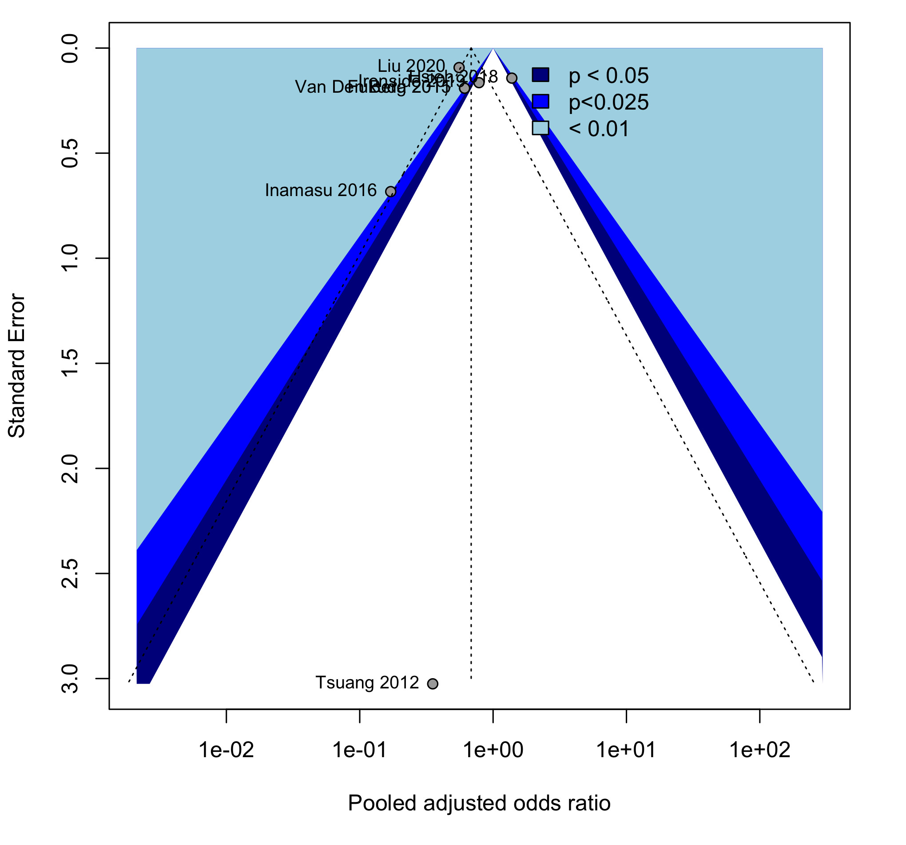

Additional file; Figure 2B. Funnel plots of meta-analysis of age after trim-and-fill

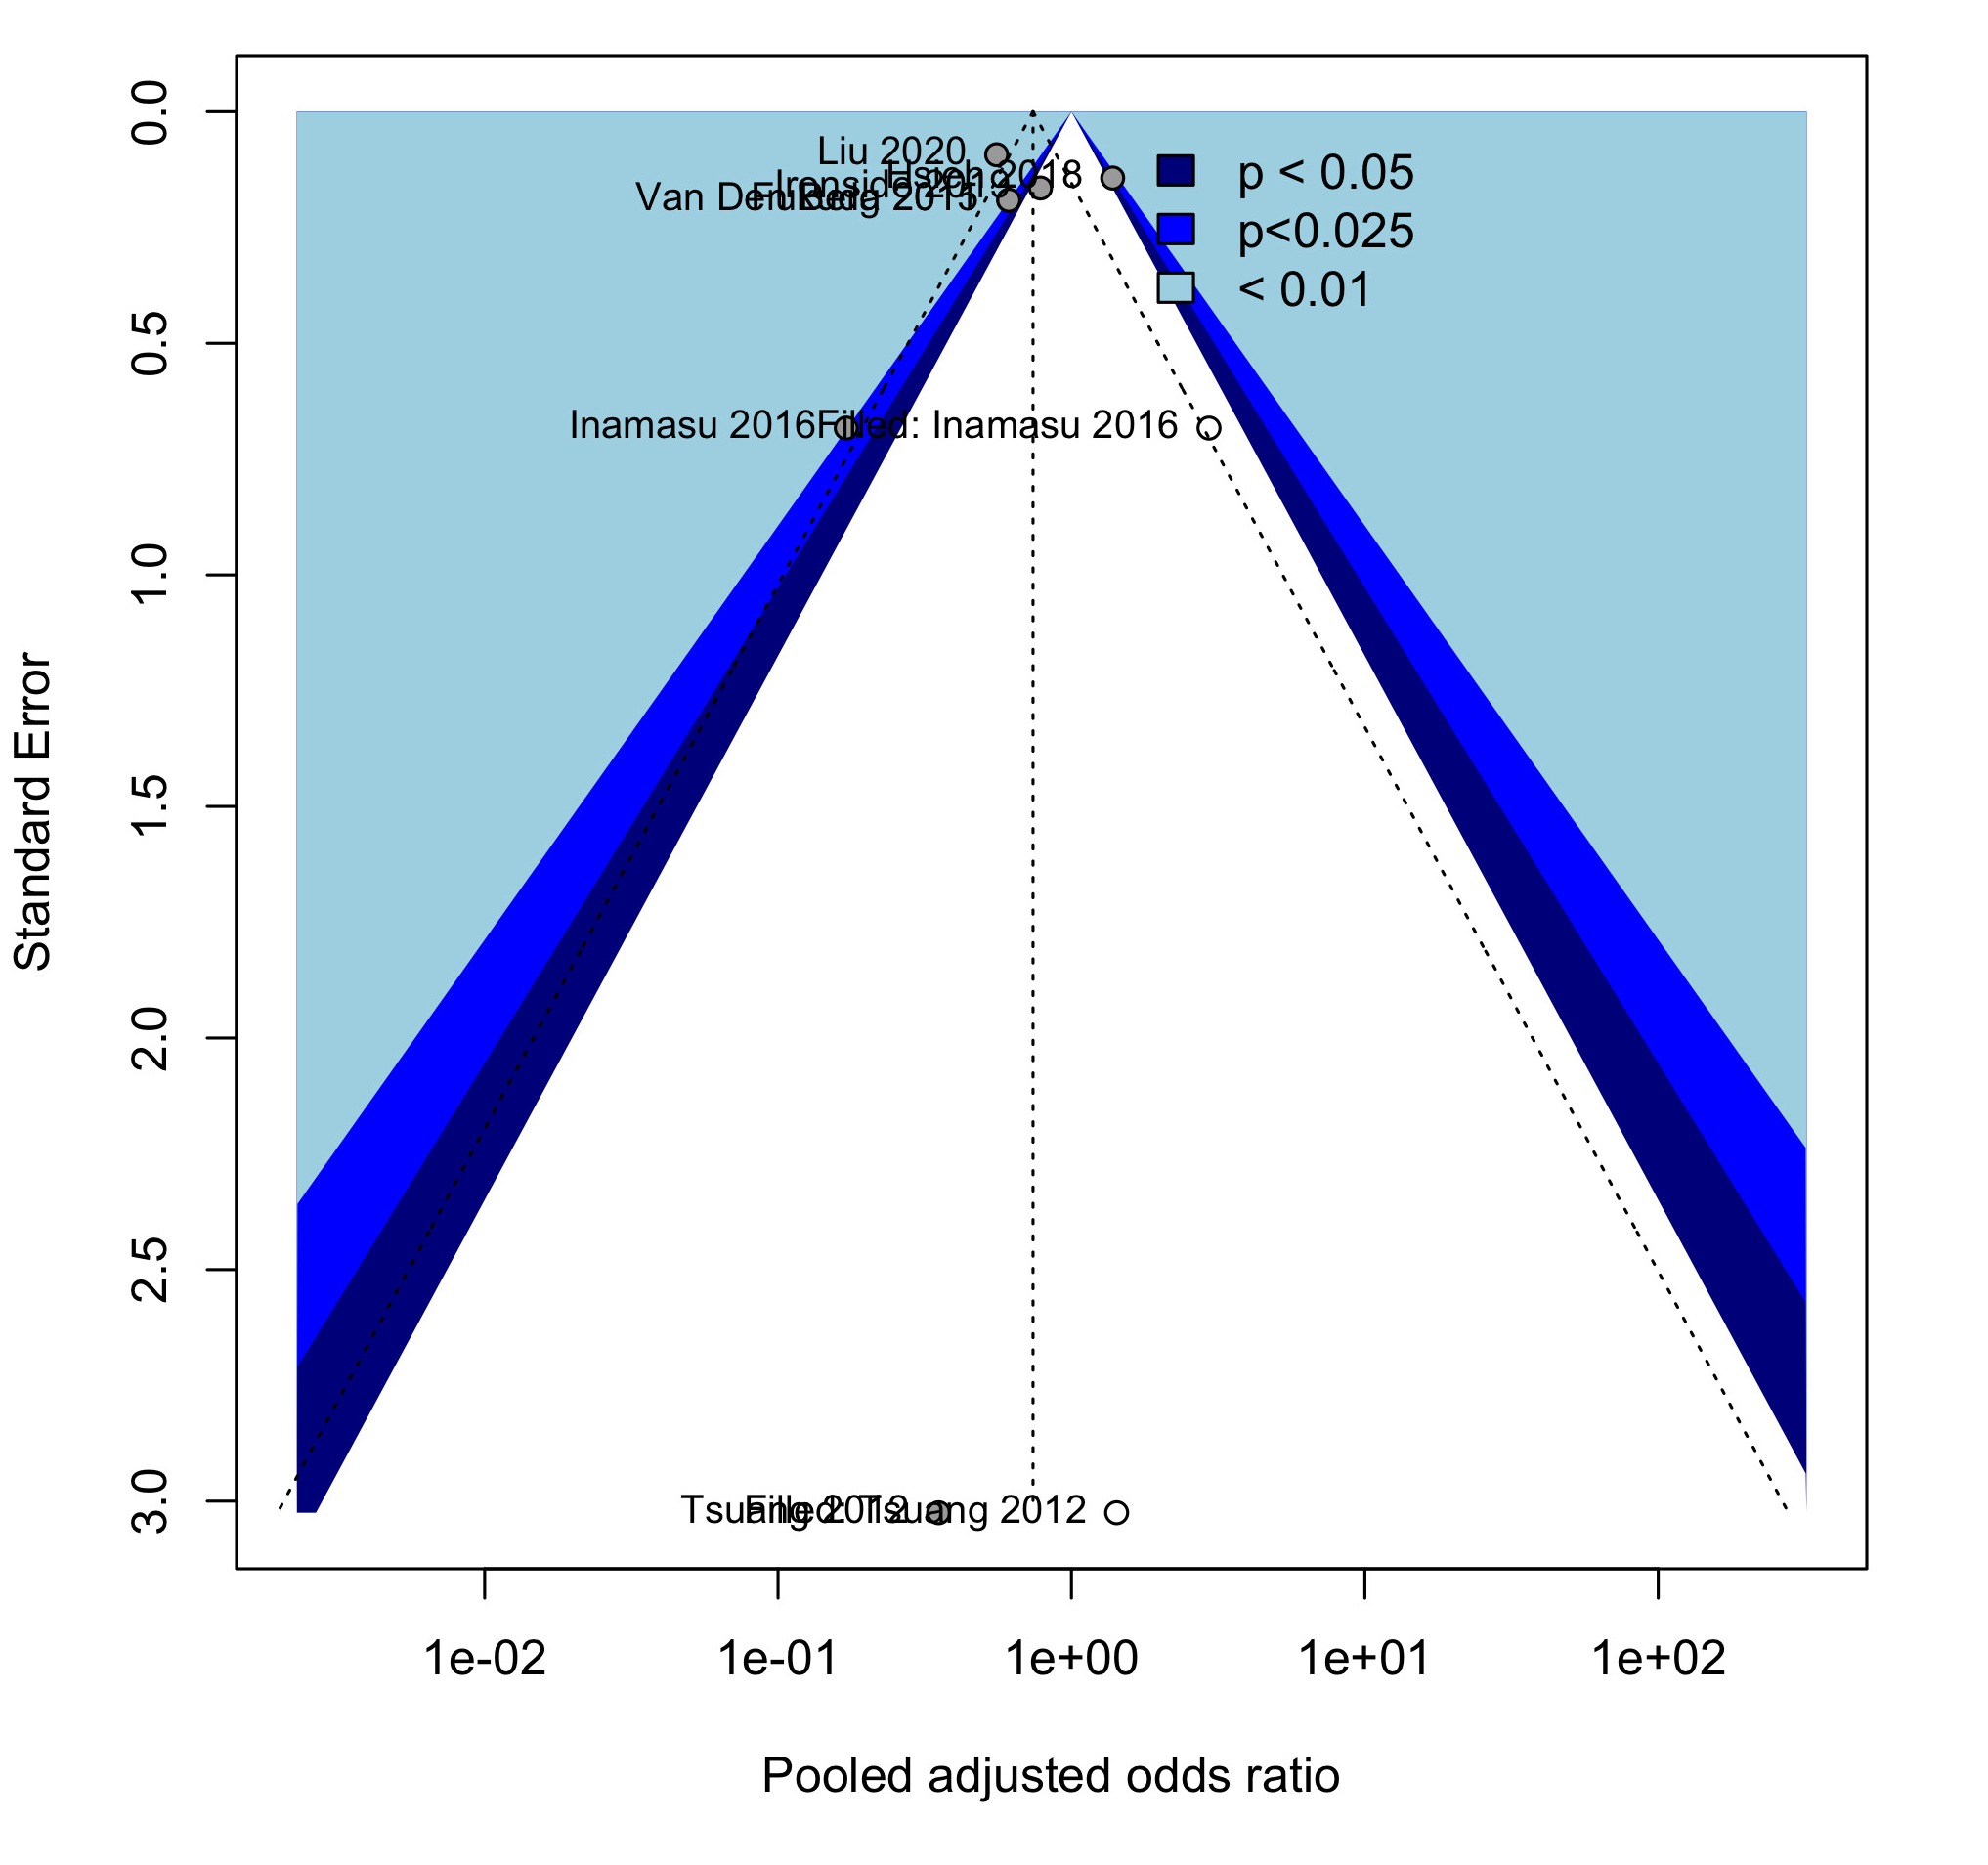
Additional file; Figure 3. Risk of bias traffic light plot
