Extended Data
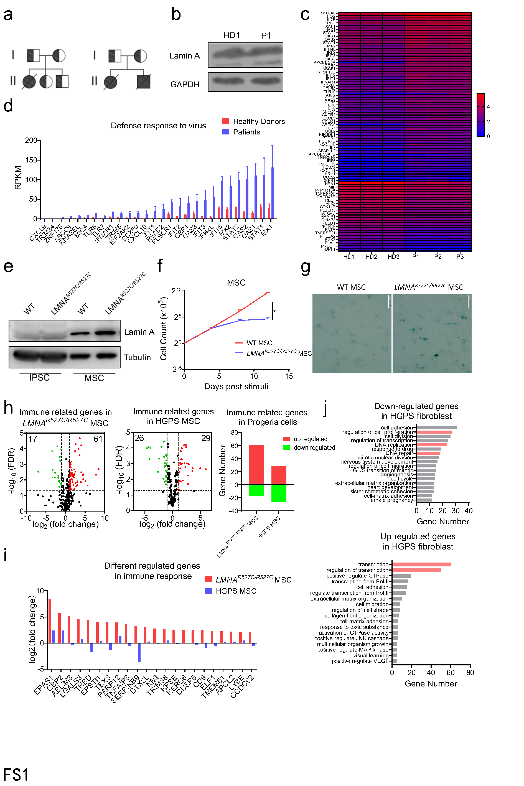
Extended Data Fig. 1. LMNA mutant R527C results in an atypical Hutchinson-Gilford progeria syndrome with aberrant inflammation
- Pedigrees for two of the three atypical progeria families. Carriers were shown as a half-filled symbol, and patients were shown as filled black symbol. Males were represented as squares, and females as circles.
- Western blot analysis of Lamin A expression level in the subcutaneous tissue of Patient 1 and Healthy Donor 1. n = 3.
- Heat map depicting the expression differences of immune-related genes and proliferation-related genes between patient-derived PBMCs (P1, P2, P3) and control PBMCs (HD1, HD2, HD3).
- Analysis of expression level of defense response to virus related genes which were increased in patient-derived PBMCs compared with healthy donors in RNA-seq data.
- Western blot analysis of Lamin A expression in iPSCs and MSCs. n = 3.
- Cell count analysis of the proliferation rates of control MSCs and patient-derived MSCs. n = 3.
- β-galactosidase staining analysis of the senescence level of control MSCs and patient-derived MSCs. Scale Bar, 50μM. n = 3.
- Volcano plots depicting the difference of immune-related genes between patients-derived LMNA^{R527C/R527C} MSCs and control (left), or between LMNA^{WT/G608G} MSCs and control (middle). Analysis of up-regulated and down-regulated gene numbers of volcano plots (right) (Fold Change (FC) > 4 or < 0.25, P value < 0.05).
- Analysis of immune related genes which up-regulated more robust in patients-derived LMNA^{R527C/R527C} MSCs than in LMNA^{WT/G608G} MSCs.
- GO analysis of the down-regulated (top) and up-regulated (bottom) genes in LMNA^{WT/G608G} fibroblasts compared with control ⁷⁴ (GEO ID 200150137; Fold Change (FC) >4 or < 0.25, P value < 0.05). (*P < 0.05)

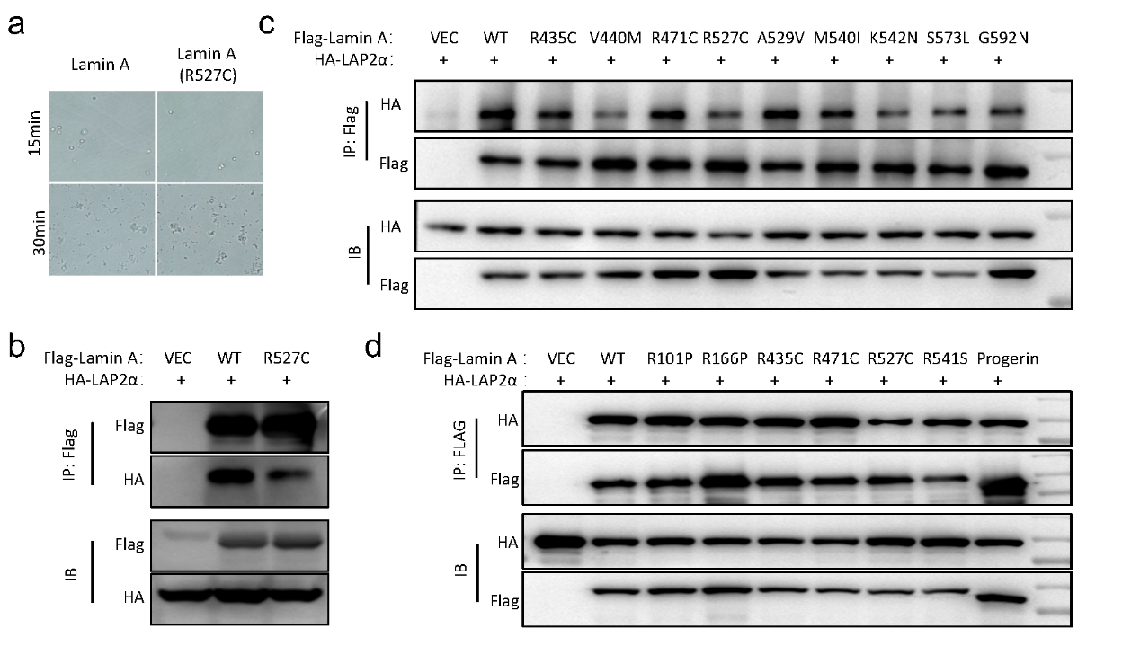
Extended Data Fig. 2. LMNA R527C mutation damps its interaction with DNA binding proteins
- Microscope analysis of droplet and filament formation of wild type and R527C mutant Lamin A proteins at 10 μM (150mM NaCl, 25mM MES PH=6.5). Scale Bar, 50μM. n = 3.
- Co-immunoprecipitation analysis of the interaction between exogenous HA-LAP2α and wild type, R527C mutant Flag-Lamin A. n = 3.
- Co-immunoprecipitation assay analysis of the interaction between exogenous HA- LAP2α and different pathogenic arginine mutant Flag-Lamin A or Flag-progerin. n = 3.
- Co-immunoprecipitation assay analysis of the interaction between exogenous HA-LAP2α and different homozygous pathogenic mutant Flag-Lamin A. n = 3.

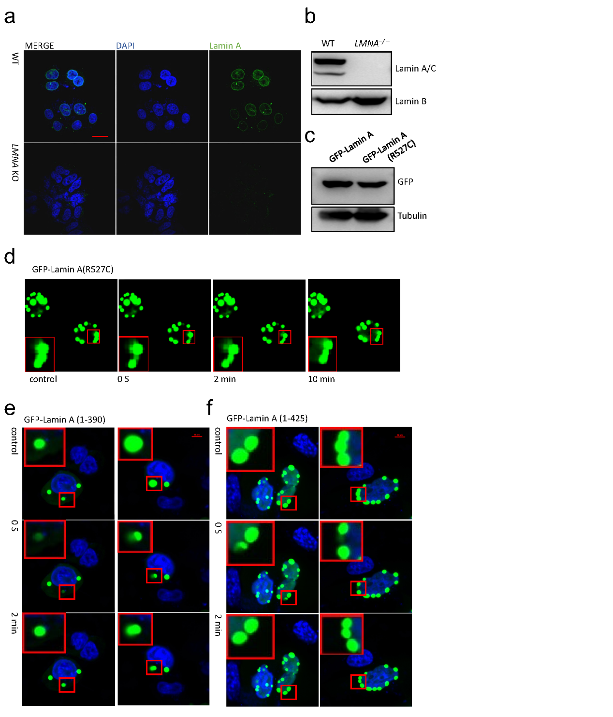
Extended Data Fig. 3. R527C mutation promotes self-aggregation of Lamin A
- LSCM analysis of endogenous Lamin A in LMNA^{-/-} Hela cells and wild type Hela cells. Scale Bar, 25μM. n = 3.
- Western blot analysis of endogenous Lamin A expression in LMNA^{-/-} Hela cells and wild type Hela cells. n = 3.
- Western blot analysis of exogenous GFP-Lamin A expression. wild type and R527C mutant GFP-Lamin A were overexpressed in LMNA^{-/-} Hela cells with the same amount of plasmids. n = 3.
- FRAP assay analysis of the dynamic ability of exogenous R527C mutant GFP-LMNA. R527C mutant GFP-LMNA were overexpressed in LMNA^{-/-} Hela cells. Scale Bar, 10μM. n = 3.
- FRAP assay analysis of the dynamic ability of exogenous GFP Lamin A (1-390aa). GFP- Lamin A (1-390aa) were overexpressed in LMNA^{-/-} Hela cells. Scale Bar, 10μM. n = 3.
- FRAP assay analysis of the dynamic ability of exogenous GFP- Lamin A (1-425aa). GFP- Lamin A (1-425aa) were overexpressed in LMNA^{-/-} Hela cells. Scale Bar, 10μM. n = 3.

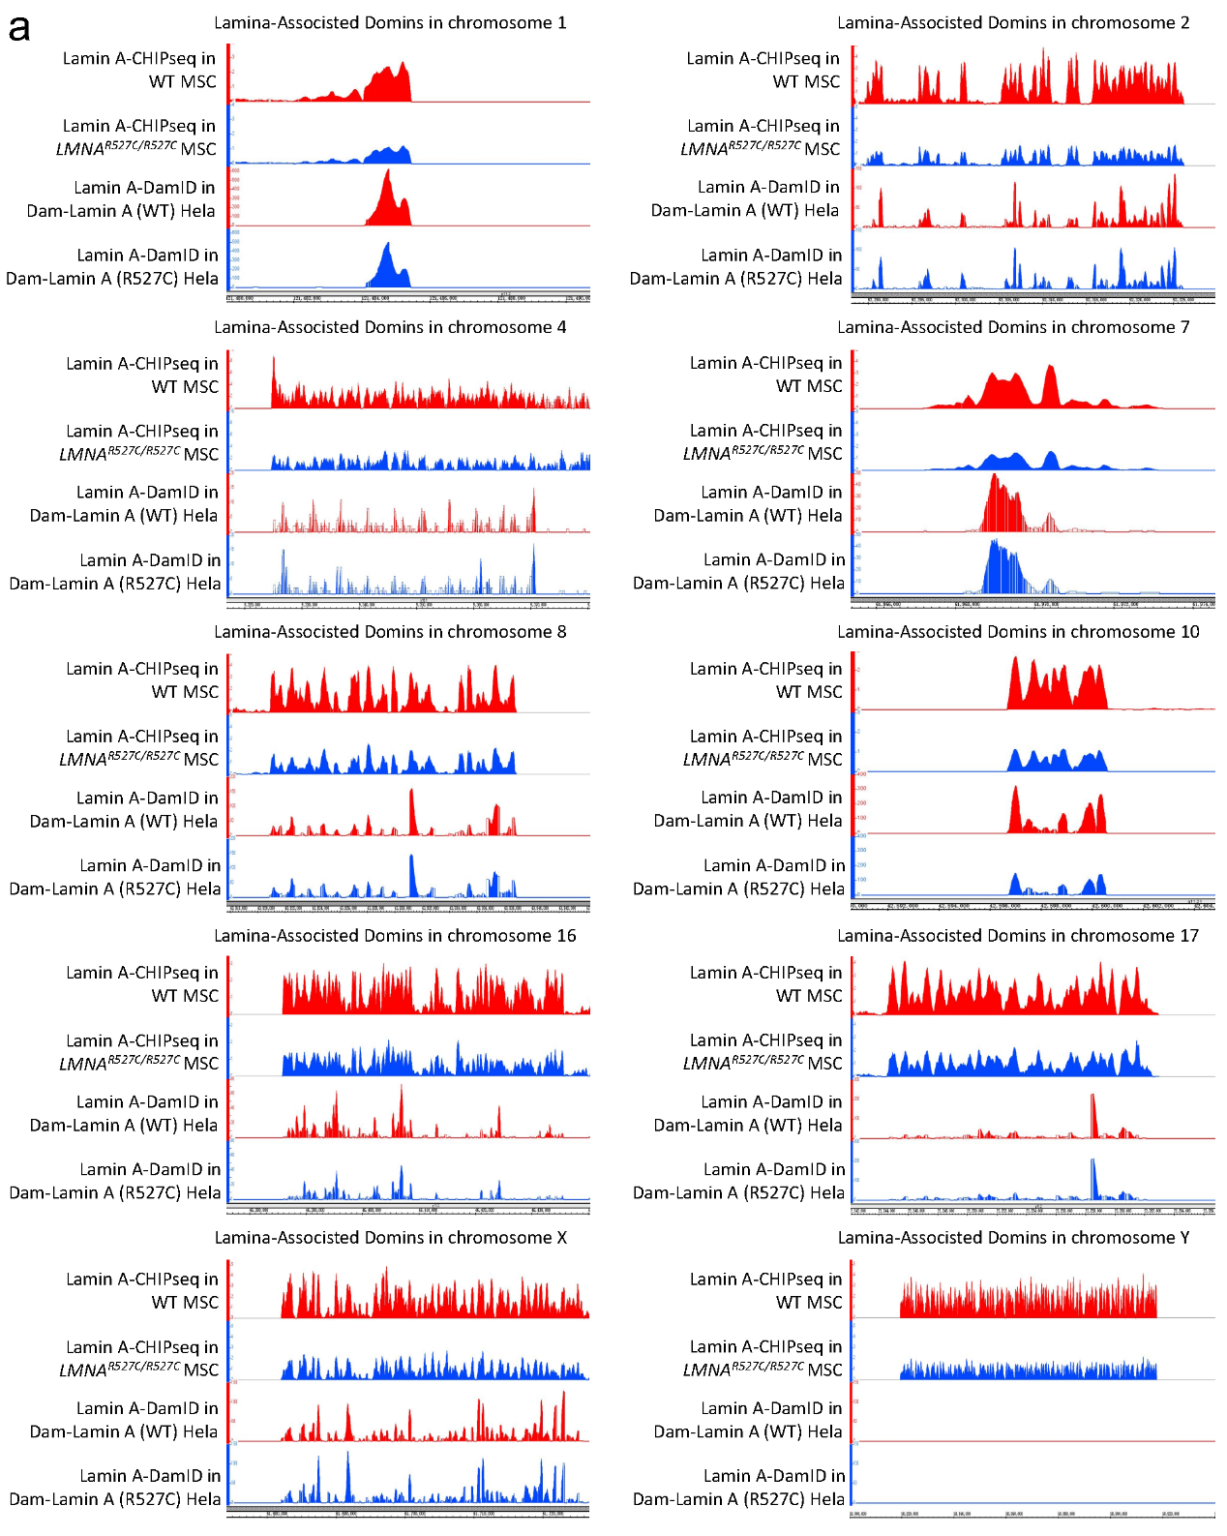
Extended Data Fig. 4. R527C mutation damps the interactions between LMNA and LADs
- A genome browser map depicting LADs and Lamin A-LADs binding affinity of different chromosomes in wild type and R527C Lamin A mutant cells. Ordinate of Lamin A Chip-seq were Chip/input signal ratio, ordinate of Lamin A DamID-seq were Dam-Lamin A/Dam signal ratio. Control cells were showed as red peaks and Lamin A R527C mutant cells were showed as blue peaks.
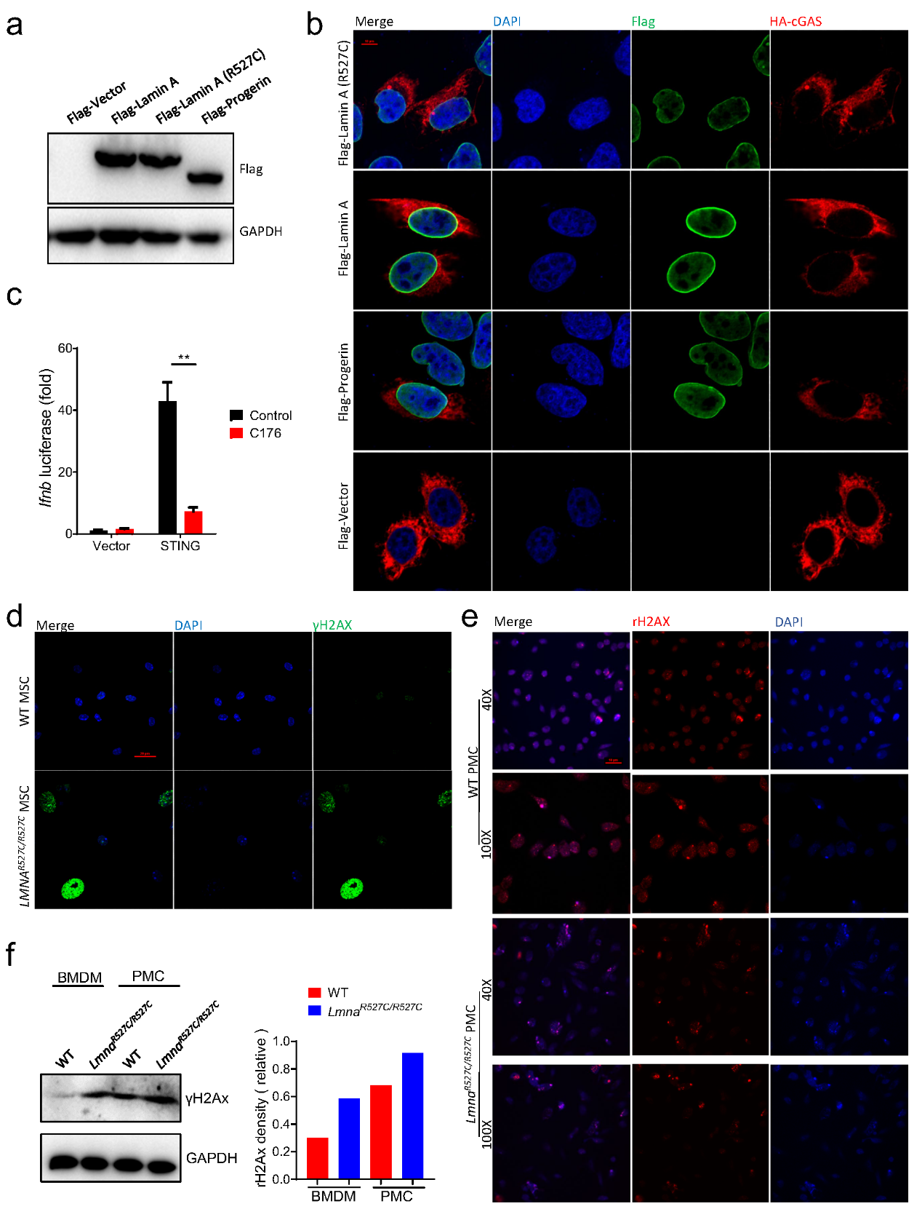
Extended Data Fig. 5. Hyperactivation of cGAS-STING pathway in R527C mutant cells
- Western blot analysis of Flag-Lamin A expression level in different Flag-Lamin A stabilized cells. Wild type or R527C mutant Flag-Lamin A were stabilized in LMNA^{-/-} Hela cells, Flag-Vector or Flag-Progerin were stabilized in wild type Hela cells. n = 3.
- LSCM analysis of exogenous Flag-Lamin A (green) morphology and exogenous HA-cGAS (red) activation. Wild type or R527C mutant Flag-Lamin A were stabilized in LMNA^{-/-} Hela cells, Flag-Vector or Flag-Progerin were stabilized in wild type Hela cells. Scale Bar, 10μM. n = 3.
- Dual-luciferase reporter assay analysis of IFN-β induction function of exogenous STING with or without C176 treatment.
- LSCM analysis of endogenous γH2Ax (green) level and DNA damage response activation level in patient-derived MSCs and control MSCs. Scale Bar, 20μM. n = 3.
- LSCM analysis of endogenous γH2Ax (red) level and DNA damage response activation level in peritoneal macrophages derived from wild type and Lmna^{R527C/R527C} mice. Scale Bar, 10μM. n = 3.
- Western blot analysis of the endogenous γH2Ax level and DNA damage response activation level in wild type and Lmna^{R527C/R527C} mice derived macrophages (left). Gray analysis of the western blot result (right). n = 3. (**P < 0.01)

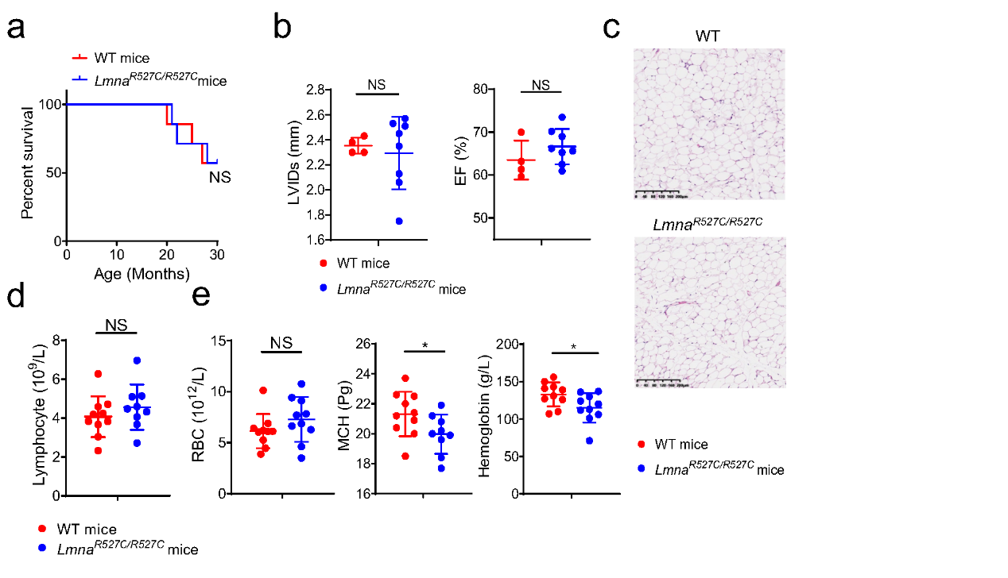
Extended Data Fig. 6. Lmna^{R527C/R527C} mice exhibit elevated inflammation but no typical progeria symptoms
- Analysis of survival curve of wild type and Lmna^{R527C/R527C} mice. n = 6.
- Echocardiographic analysis of left ventricular internal diameter at end-systole (LVIDs; left) and ejection fraction (EF; right) of wild type and Lmna^{R527C/R527C} mice at 8 months old. n = 4-8.
- H&E histochemical analysis of gonadal white adipose tissue of wild type and Lmna^{R527C/R527C} mice at 8 months old. n = 3.
- Hemanalysis of lymphocyte counts of wild type and Lmna^{R527C/R527C} mice at 6 weeks old. n = 9-10.
- Hemanalysis of red blood cell (RBC; left), hemoglobin (HB; middle) and mean corpuscular hemoglobin (MCH; right) of wild type and Lmna^{R527C/R527C} mice at 6 weeks old. n = 9-10.

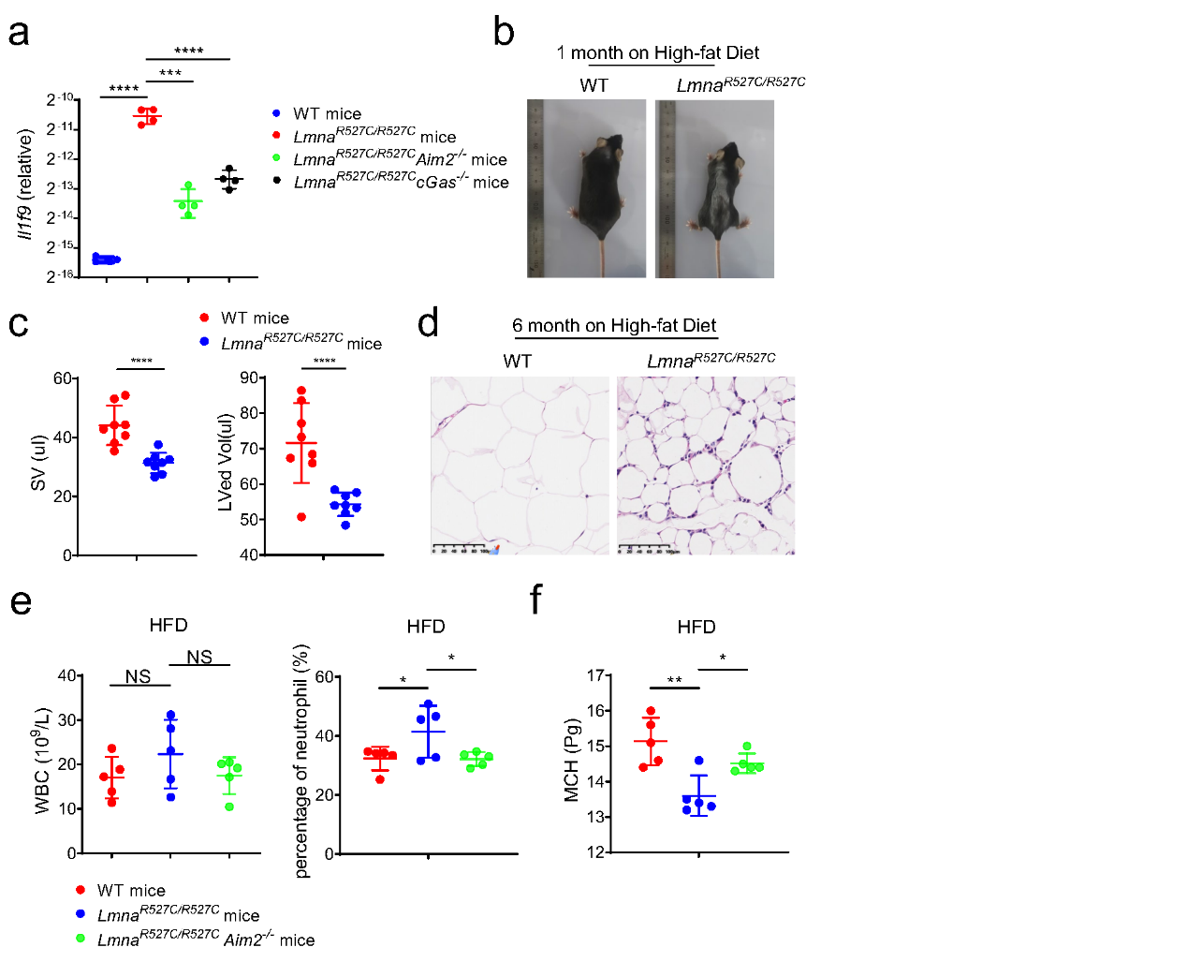
Extended Data Fig. 7. HFD causes premature aging of Lmna^{R527C/R527C} mice in a DNA sensing pathway dependent manner
- qRT-PCR analysis of Il1f9 expression in the spleen of wild type, Lmna^{R527C/R527C}, Lmna^{R527C/R527C}Aim2^{-/-} and Lmna^{R527C/R527C} cGas^{-/-} mice at 6 weeks old. n = 4.
- Picture depicting the body shape of wild type and Lmna^{R527C/R527C} mice at 1 month after high-fat diet.
- Echocardiographic analysis of stroke volume (SV; left) and left ventricular end-diastolic volume (LVed Vol; right) of wild type and Lmna^{R527C/R527C} mice at 8 months after high-fat diet. n = 4.
- H&E histochemical analysis of gonadal white adipose tissue of wild type and Lmna^{R527C/R527C} mice at 8 months after high-fat diet. n = 5.
- Hemanalysis of white blood cell (left) and neutrophil (right) of wild type, Lmna^{R527C/R527C} and Lmna^{R527C/R527C}Aim2^{-/-} mice at 1month after high-fat diet. n = 5.
- Hemanalysis of mean corpuscular hemoglobin (MCH) of wild type, Lmna^{R527C/R527C} and Lmna^{R527C/R527C}Aim2^{-/-} mice at 1month after high-fat diet. n = 5. (NS = No significant; *P < 0.05; **P < 0.01; ***P < 0.001; ****P < 0.0001)

