Supplementary Information
for
Towards white light laser emission based on strained Poly:(Si/Ge)
Mohamed A. Nawwar¹, Magdy S. Abo Ghazala¹, Lobna M. Sharaf El-Deen¹, Abdelhamid El-Shaer², Badawi Anis³, Abd El-hady B. Kashyout⁴

¹Physics Department, Faculty of Science, Menoufia University, Shebin El-Koom, Menoufia, Egypt,
²Physics Department, Faculty of Science, Kafrelsheikh University, KafrelSheikh, 33516, Egypt.
³Spectroscopy Department, Physics Division, National Research Centre, 33 El Bohouth st., Dokki, Giza, 12622, Egypt.
⁴Electronic Materials Department, Advanced Technology and New Materials Research Institute, City of Scientific Research and Technological Applications (SRTA-City), New Borg El-Arab City, Alexandria, Egypt.

Results and discussion:
- Field Emission Scanning Electron Microscopy:
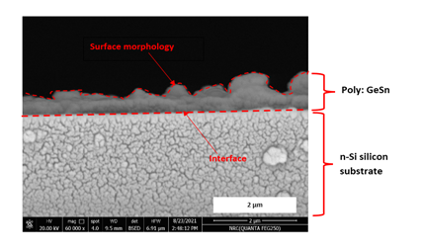
Figure S1. Cross sectionional SEM micrograph of Al/Ge/Sn/Ge/Sn on n-Si substrate
Figure (S1) shows the cross sectional view SEM micrograph of Al/Ge/Sn/Ge/Sn on n-Si substrate, which shows the formation of doped poly:Ge on n-Si via MIC process and the vertical growth of the crystallites. The observed humps and cones of the Ge crystallites assert the rough porous surface of the top view micrograph of the same sample.
- XRD analysis
Table S1. The lattice constants of the grown Si, Ge and strained GeSn crystallites via simple MIC technique.
Sample | planes | d-spacing(A) | Lattice constant (A)
Al/Si/Sn/Ge/Sn on FTO | GeSn (111) | 3.26 | 5.645
Al/Si/Sn/Ge/Sn on FTO | GeSn (400) | 1.49 | 5.96
Al/Si/Sn/Ge/Sn on FTO | GeSn (004) | 1.46 | 5.84
Al/Si/Sn/Ge/Sn on FTO | Ge (311) | 1.66 | 5.506
Al/Si/Sn/Ge/Sn on FTO | Si (111) | 3.057 | 5.295
Al/Ge/Sn/Ge/Sn on FTO | GeSn (111) | 3.262 | 5.65
Al/Ge/Sn/Ge/Sn on FTO | Ge (220) | 1.97 | 5.57
Al/Ge/Sn/Ge/Sn on FTO | GeSn (400) | 1.49 | 5.96
Al/Ge/Sn/Ge/Sn on n-Si | GeSn (400) | 1.515 | 6.06
Al/Si/Sn/Ge/Sn on p-Si | GeSn (400) | 1.515 | 6.06
Al/Si/Sn/Ge/Sn on p-Si | GeSn (004) | 1.454 | 5.816
Al/Ge/Sn/Ge/Sn on p-Si | GeSn (400) | 1.515 | 6.06
Al/Ge/Sn/Ge/Sn on p-Si | GeSn (004) | 1.45 | 5.8

Table (S1) summarize the lattice constants of the grown Si, Ge and strained GeSn crystallites via simple MIC technique. XRD analyses shows growth of Ge with lattice constant equal to 5.506 A and 5.57 A at different orientations for Al/Si/Sn/Ge/Sn and Al/Ge/Sn/Ge/Sn prepared on FTO respectively. In both configuration that prepared on FTO, it is observed that there is incorporation of Sn inside Ge network causes growth of GeSn crystallites with different orientations for both configurations [1,2]. As a result of interstitial incorporation, the lattice constants of the different orientation growth of Ge increased to positive tensile strained GeSnup to 5.96 A for the growth direction (400) since the lattice constant of Sn = 6.49 A is higher than the germanium [3]. It causes tensile force inside Ge network and increases the lattice constants [4]. On the other hand, it is observed preferred high orientation of the growth of strained GeSn with more increase in lattice constant up to 6.06 A referring to higher incorporation of Sn inside Ge network.

- Raman Microscope imaging
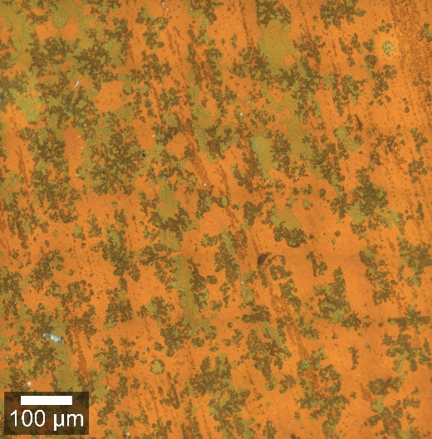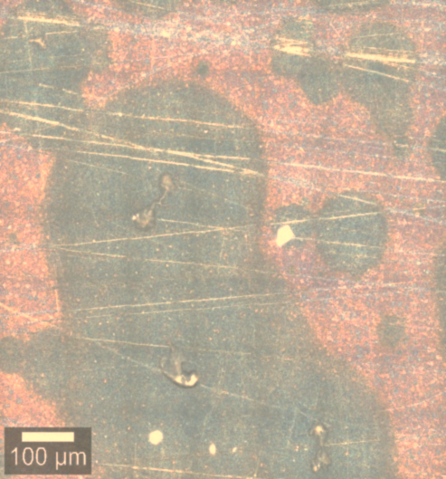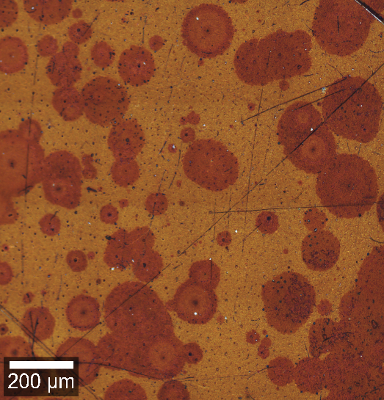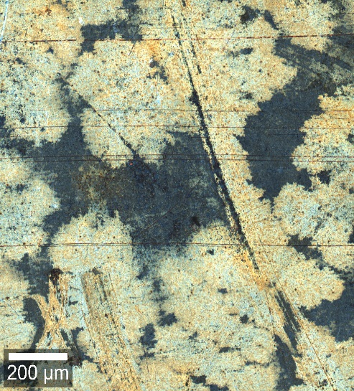
Al/Ge/Sn/Ge/Sn on FTO

Al/Ge/Sn/Ge/Sn on n-Si

Al/Si/Sn/Ge/Sn on p-Si
Al/Ge/Sn/Ge/Sn on p-Si

Figure S2: Raman Microscope images of of the fabricated Al/Si/Sn/Ge/Sn and Al/Ge/Sn/Ge/Sn on n-Si, p-Si and FTO substrates
Figure S2 shows Raman confocal microscope image of the fabricated heterostructures to investigate the effect of different substrate on the crystallization rate. For the heterostructure of Al/Si/Sn/Ge/Sn on p-Si, the formation of islands of the doped crystallites for both Si and Ge with different colors is observed which may be due to the metal induced crystallization of the deposited amorphous Si and Ge via aluminum and tin. But the crystallites size is small resulting in broad peaks in Raman spectrum as shown in Figure 7[5]. In the heterostructures of Al/Ge/Sn/Ge/Sn on n-Si, p-Si and FTO, it is observed that the crystallinity and crystallites island size of doped the poly:Ge in structures on FTO and P-Si is higher than the n-Si as a result of high rate segregation of aluminum atoms away from the highly doped p-Si wafer to the intrinsic germanium layers and the diffusion of low melting FTO layer due to the high annealing temperature [6,7]. These two reasons activate the metal induced crystallization of Ge and cause higher crystal growth and more incorporation of Sn in Ge networkas discussed in FESEM session [8,9,10,11,12].

- Direct transition investigation using diffuse reflectance spectroscopy
Table S2. Direct transitions optical band gaps of the prepared heterostructures.
Allowed Transition  Sample | 1St transition | 2nd transition | 3rd transition
Al/Ge/Sn/Ge/Sn on n-Si | 0.54 eV (GeSn) | 2.05 eV (GeO₂) | -----
Al/Ge/Sn/Ge/Sn on p-Si | 0.61 eV (GeSn) | 1.85 eV (GeO) | -----
Al/Si/Sn/Ge/Sn on p-Si | 0.43 eV (GeSn) | 1.15 eV (GeO) | 2.18 eV (GeO₂)
Al/Ge/Sn/Ge/Sn on FTO | 0.48 eV (GeSn) | 1.23 eV (GeO) | 2.73 eV (GeO₂)
Al/Si/Sn/Ge/Sn on FTO | 0.45 eV (GeSn) | 1.75 eV (GeO) | 2.02 eV (GeO₂)

The higher observed absorption for the heterostructures that interfaces p-Si and FTO substrates than the other one on n-Si. This can be explained as mentioned before:In the heterostructure on FTO, the diffusion rate of metals in Ge is higher since the surface area of interaction between Ge and metal layers increases as a result of the change of morphology of the bottom FTO layer as a result of the high annealing temperature near its melting point. In the case of heterostructure on p-Si, the Al atoms doesn't segregate in the p-doped substrate but these atoms of Al layer are rapidly segregating in the lower majority carriers concentration intrinsic Ge layer and thus increase the rate of crystallization and incorporation of Sn increasing GeSn direct allowed transition [6]. A direct transition of GeO for all heterostructures is ranged between 1.15 to 1.85 eV due to different level of oxygen incorporation in the samples [6]Another direct transition at Ge crystallites of higher level of oxidation is around 2.02 up to 2.73 eVoccurs in the structures prepar4ed on FTO and p-Si substrates. This is due to the diffusion of oxygen atoms of FTO layer in Ge layers under the influence of the annealing that causes vacancies in FTO layer and the low level of vacuum during annealing of the rapid diffusion of multilayers that is on p-Si substrate [7, 8]. Direct transition in the strained GeSn crystallites in all samples is ranged between 0.43 up to 0.61 eV.
- Diode parameters of the fabricated heterostructures junctions
Table S3 summarizes the calculated parameters of the prepared junctions.Figure 8 show there is no avalanche effect in the reverse biasing of the prepared junction and very small dark current in the order of 10⁻⁴ A. this makes the junctions able to use in rectification applications [5,59]. The ideality factor n was calculated using Schottky equation from the plot of Ln I versus V Figure 9. It is observed that the values of the ideality factor of the junctions in low voltage biasing region (Region 1) are around 1 near the value of the ideality. However, in the high voltage biasing region up to ±3 volt (Region 2), the values of the ideality factors are in range of 6 to 35 that are far from the ideal value. This is due to the tunneling of conduction electrons inside the cloud of metals that contains vacancies in which electrons recombine [ 13, 14 ,15 , 16 ]. From the values of ideality factor, we can observe the effect of the substrate as mentioned in Raman analysis. In the both configurations on p-Si substrate, Al atoms are segregate away from the highly doped p-Si wafer inside Si or Ge networks that cause the trapping effect at the low or high voltage biasing regions. Since the samples have very low dark leakage current that contributes as a noise current in the photodetection applications [17,18,19], they have good opportunity in photodetection applications. Rectification ratio RR calculations refers that the Al/Ge/Sn/Ge/Sn on (n-Si) substrate has lower dark current and higher rectification ratio near 100 that make this heterostructure is a promising junction in photodetection application. The barrier height values indicate that the samples can detect in near infrared NIR region since the height of the barrier is in the range of 0.6 to 0.8 eV for all samples[20, 21].

Sample | R_{s} (Ω) | R_{sh}(Ω) | V_{th} (volt) | I_{S} (A) |  | n |  | Ф_{b}  (eV) | RR  I_{f}/I_{D}
 |  |  |  | Region 1 | Region 2 | Region 1 | Region 2 | Ф_{b}  (eV) | RR  I_{f}/I_{D}
Al/Si/Sn/Ge/Sn on  (p-Si) substrate | 12.4 | 1×10⁴ | 1 | 1.67×10⁻⁵ | 4.52×10⁻³ | 1.2 | 35.4 | 0.68 | 14.1
Al/Si/Sn/Ge/Sn on  FTO substrate | 54.5 | 1.43×10⁴ | 1 | 1.24×10⁻⁶ | 1.84×10⁻⁴ | 0.97 | 6.42 | 0.745 | 5.22
Al/Ge/Sn/Ge/Sn on  (p-Si) substrate | 9.5214 | 1.47×10⁴ | 1.6 | 6.14×10⁻⁶ | 2.48×10⁻³ | 1.21 | 26.91 | 0.71 | 27
Al/Ge/Sn/Ge/Sn on  (n-Si) substrate | 16.7 | 5×10⁴ | 1.6 | 1.67×10⁻⁵ | 9.12×10⁻⁴ | 1.89 | 16.92 | 0.677 | 98
Table S3. The diode parameters of the fabricated junctions.

- References
- Albani, M., et al. Critical strain for Sn incorporation into spontaneously graded Ge/GeSn core/shell nanowires. Nanoscale, 10(15), 7250-7256 (2018).‏
- Doherty, J., et al. Influence of growth kinetics on Sn incorporation in direct band gap Ge _{1− x} Sn _{x} nanowires. J. Mater. Chem. C, 6(32), 8738-8750 (2018).‏
- Uchida, N., et al. Carrier and heat transport properties of polycrystalline GeSn films on SiO₂. Appl. Phys. Lett. 107(23), 232105 (2015).
- Ali, I., Kashyout, A. E. H. B., Tayel, M., Hassan, H. S., & Rizk, M. Ruthenium (Ru) doped zinc oxide nanostructure-based radio frequency identification (RFID) gas sensors for NH₃ detection. J. Mater. Res. Technol. 9(6), 15693-15704 (2020).
- Wang, T., et al. Polycrystalline silicon thin films by aluminum induced crystallization of amorphous silicon. Appl. Surf. Sci. 264, 11-16 (2013).
- Wakaki, M., Iwase, M., Show, Y., Koyama, K., Sato, S., Nozaki, S., &Morisaki, H. Raman spectroscopy of germanium films deposited with cluster-beam technique. Physica B Condens. Matter. 219, 535-537 (1996).
- Xia, W., Sun, J., Zeng, X., Wang, P., Luo, M., Dong, J., & Yu, H. FeO-Based Hierarchical Structures on FTO Substrates and Their Photocurrent. ACS omega, 5(5), 2205-2213 (2020). ‏
- Biswas, S., et al. Non-equilibrium induction of tin in germanium: towards direct bandgap Ge _{1− x} Sn _{x} nanowires. Nat. commun, 7(1), 1-12 (2016).
- Ferhat, M., & Zaoui, A. Band-gap bowing calculation of Si_{x}Sn_{1−x} alloy. Infrared Phys Technol. 42(2), 81-85 (2001).
- Kurosawa, M., Kato, M., Yamaha, T., Taoka, N., Nakatsuka, O., & Zaima, S. Near-infrared light absorption by polycrystalline SiSn alloys grown on insulating layers. Appl. Phys. Lett. 106(17), 171908 (2015).
- Soref, R. Mid-infrared photonics in silicon and germanium. Nat. photonics, 4(8), 495-497 (2010).
- Lee, C., et al. Interplay of strain and intermixing effects on direct-bandgap optical transition in strained Ge-on-Si under thermal annealing. Sci. Rep., 9(1), 1-9 (2019).
- Oehme, M., et al. Room-temperature electroluminescence from GeSn light-emitting pin diodes on Si. IEEE Photon. Technol. Lett. 23.23: 1751-1753 (2011).
- Huynh, H. Q., Pham, K. N., Phan, B. T., Tran, C. K., Lee, H., & Dang, V. Q. Enhancing visible-light-driven water splitting of ZnO nanorods by dual synergistic effects of plasmonic Au nanoparticles and Cu dopants. J. Photochem. Photobiol. 399, 112639 (2020). ‏
- Zhang, Y., He, S., Guo, W., Hu, Y., Huang, J., Mulcahy, J. R., & Wei, W. D. Surface-plasmon-driven hot electron photochemistry. Chem. Rev. 118(6), 2927-2954 (2017). ‏
- Onda, K., Li, B., Zhao, J., Jordan, K. D., Yang, J., & Petek, H. Wet electrons at the H₂O/TiO₂ (110) surface. Science, 308(5725), 1154-1158 (2005).
- Konstantatos, G., Clifford, J., Levina, L., & Sargent, E. H. Sensitive solution-processed visible-wavelength photodetectors. Nat. photonics, 1(9), 531-534 (2007).
- Lopez-Sanchez, O., Lembke, D., Kayci, M., Radenovic, A., & Kis, A. Ultrasensitive photodetectors based on monolayer MoS₂. Nat. nanotechnol, 8(7), 497-501 (2013). ‏
- Dehzangi, A., Li, J., & Razeghi, M. Band-structure-engineered high-gain LWIR photodetector based on a type-II superlattice. Light Sci. Appl, 10(1), 1-7 (2021).
- Hu, W., Cong, H., Huang, W., Huang, Y., Chen, L., Pan, A., & Xue, C. Germanium/perovskite heterostructure for high-performance and broadband photodetector from visible to infrared telecommunication band. Light Sci. Appl, 8(1), 1-10 (2019).
- Sheoran, H., Tak, B. R., Manikanthababu, N., & Singh, R. Temperature-dependent electrical characteristics of Ni/Au vertical Schottky barrier diodes on β-Ga₂O₃ epilayers. ECS J Solid State Sci Technol, 9(5), 055004 (2020).

