Table 1 Relationships between 1,5-AG and FPG, 2hPG and HbA1c in different diabetic retinopathy group
 | Total population |  | EDTRs≥21 |  | EDTRs≥31
 | r | p | r | p | r | p
FPG | -0.320 | <0.001 | -0.719 | <0.001 | -0.758 | <0.001
*2hPG | -0.169 | <0.001 | -0.208 | <0.001 | -0.753 | 0.003
HbA1c | -0.345 | <0.001 | -0.714 | <0.001 | -0.713 | <0.001
*OGTT tests were not practiced among patients who had already been diagnosed as diabetes or had FPG≥7.0mmol/L for the sake of safety.

Figure1 Receiver operating characteristics (ROC) curves for 1,5-AG to predict the presence of diabetic-specific retinopathy in population without hypoglycemic medication
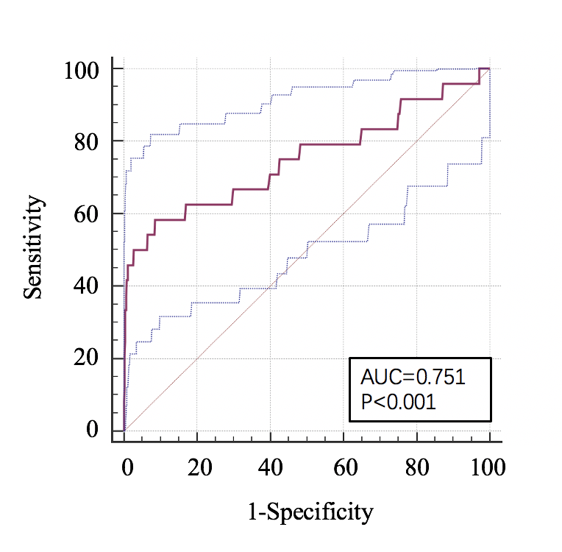

Figure2 Receiver operating characteristics (ROC) curves for 1,5-AG to predict the presence of moderate diabetic retinopathy (ETDRS≥43)
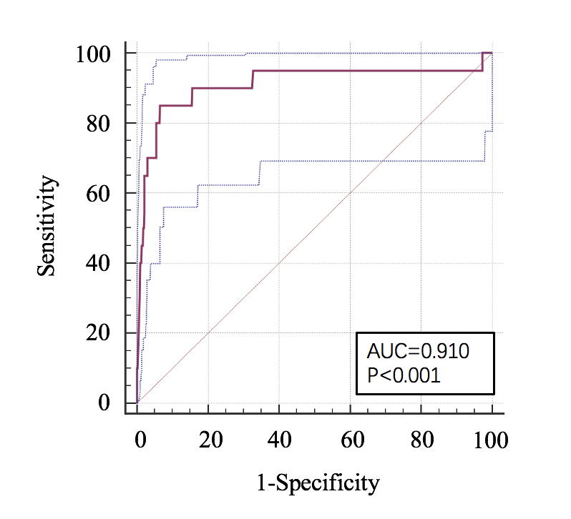

Figure3 Scatter diagrams of distribution of 1,5-AG by different diabetic retinopathy status. Red spots in DR groups indicated individuals without diabetes (including self-reported diabetes or newly-diagnosed diabetes)
