Figure S1 Flow chart of the present study.

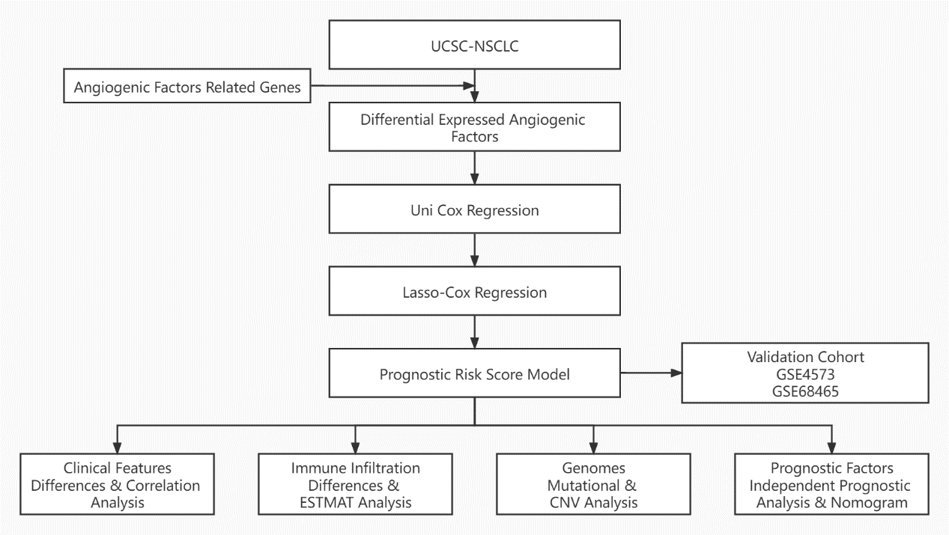

Figure S2 Lasso regression.

