Supplementary Data

A graph-based approach for the visualisation and analysis of bacterial pangenomes
Joshua D. Harling-Lee^{1*}, Gonzalo Yebra¹, James Gorzynski¹, Tim Angus², J. Ross Fitzgerald¹ and Tom C. Freeman^{1,2,3*}

Supplementary Table 1. Metadata for all L. pneumophila isolates used in Case Study 2
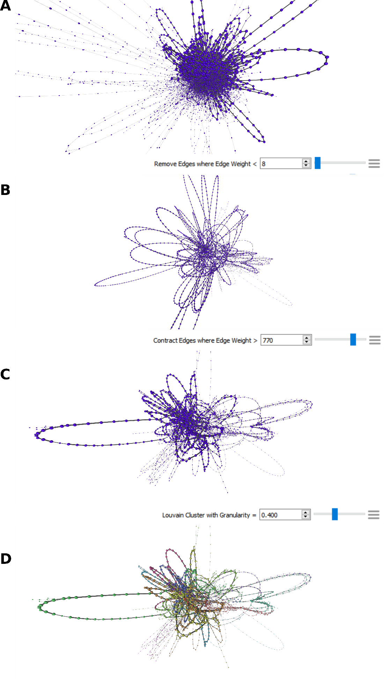

Supplementary Figure 1. Simplification of pangenome synteny graphs increases visual clarity and usability. In each panel, nodes represent genes and edges represent the syntenic arrangement of genes (occurrence next to one another in genomes). Nodes and edges are sized according to weight (the larger the node or thicker the edge, the more genomes in which that gene or relationship occur). Network node/edge counts are shown at each step to demonstrate simplification of the graph. (A) Full synteny graph, visualising the network file of the S. aureus pangenome on first import into Graphia. (B) Network after removal of low weight (n <8) edges. (C) High edge weights contracted, collapsing stretches of core gene nodes into single “multi-element” nodes. (D) Network clustered using Louvain clustering algorithm (LCi = 0.400), resulting in 18 clusters. Nodes coloured by LC.

