Bile duct stone size may influence the efficacy of endoscopic sphincterotomy with or without large-balloon dilation - A meta-analysis

Supplemental material

Figure S1. Pooled Rate Ratio for Procedure Time in RCT and non-RCT Analysis (left panel) and Subgroup Analysis (right panel) of EPT+EPBD vs EPT in Removing CBD Stones
Figure S2. Pooled Rate Ratio for Subgroup Analysis according CBD stone size in Mechanical Lithotripsy Usage Rate of EPT+EPBD vs EPT in CBD Stones in the RCTs (A) and non-RCTs(B)
Figure S3. Risk of Bias Summary. Two scoring systems were used to qualify and assess bias of the included articles; the Cochrane Risk of Bias assessment tool for RCTs (left panel), and the modified Newcastle-Ottawa Scale (NOS) according to Cummel 2010 for non-RCTs (right panel)
Figure S4. Pooled Rate Ratio for Publication Bias of EPT+EPBD vs EPT in RCTs and non-RCTs (right panel) Analysis

Fig S1A Procedure Time in RCT and non-RCT Analysis | Fig S1B Procedure Time in Subgroup
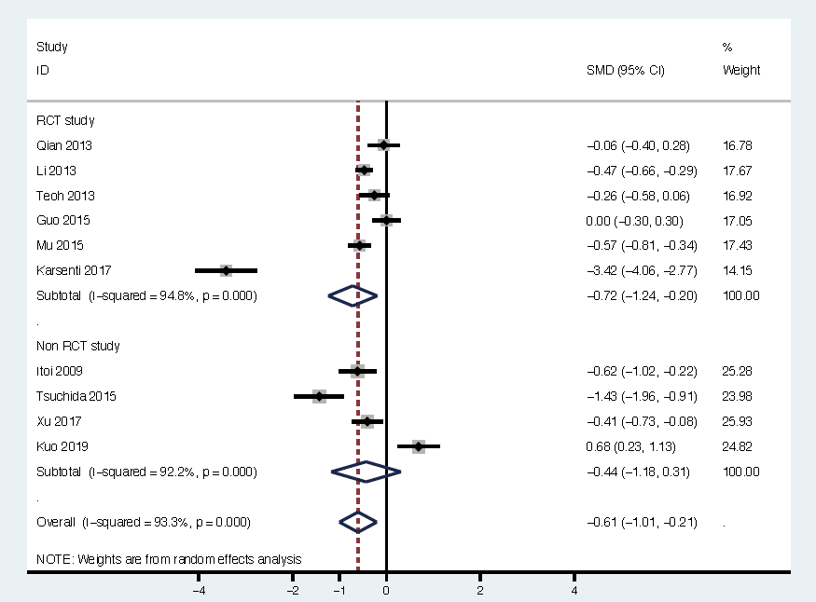 | 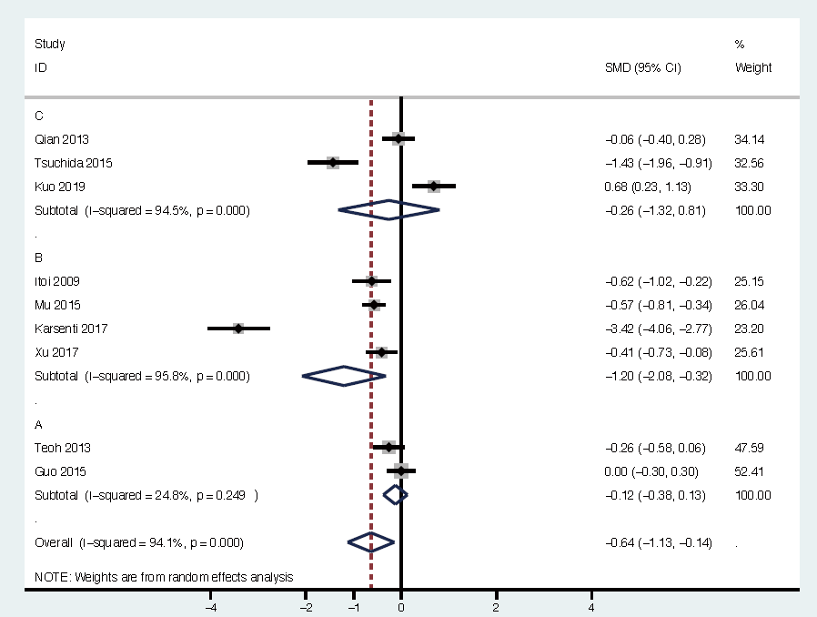
Favor EPT+EPBD Favor EPT | Favor EPT+EPBD Favor EPT

Figure S1. Pooled Rate Ratio for Procedure Time in RCT and non-RCT Analysis (left panel) and Subgroup Analysis (right panel) of EPT+EPBD vs EPT in Removing CBD Stones

Fig S2A Subgroup Analysis for ML usage Rate  in RCTs | Fig S2B Subgroup Analysis for ML usage Rate  in Non-RCTs
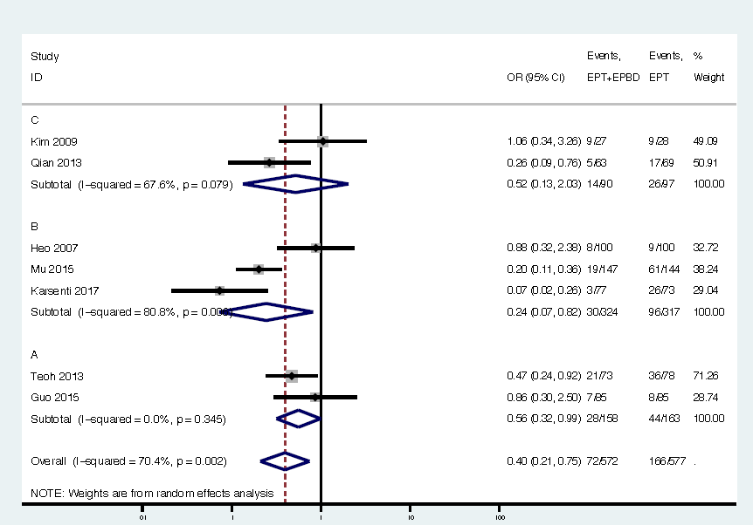
Favor EPT Favor EPT+EPBD | Favor EPT Favor EPT+EPBD

Figure S2. Pooled Rate Ratio for Subgroup Analysis according CBD stone size in Mechanical Lithotripsy Usage Rate of EPT+EPBD vs EPT in CBD Stones in the RCTs (A) and non-RCTs(B)

Fig S3A Cochrane Risk of Bias assessment tool for RCTs | Fig S3B The modified Newcastle-Ottawa Scale (NOS) according to Cummel 2010 for non-RCTs
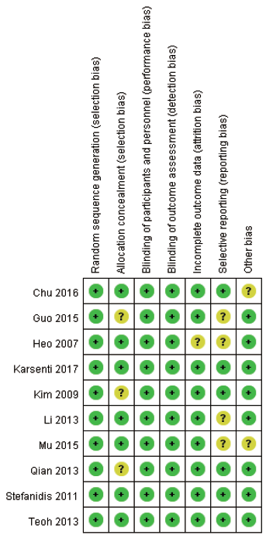 | 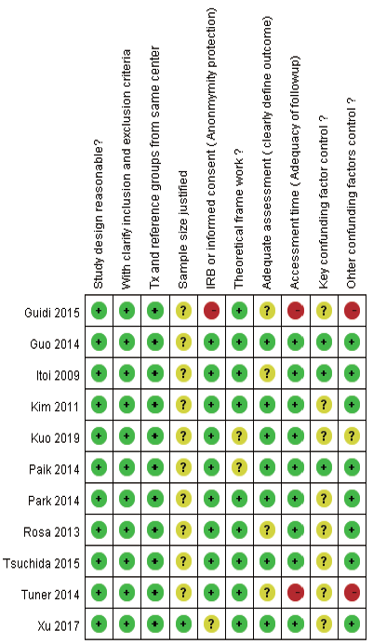

Figure S3. Risk of Bias Summary. Two scoring systems were used to qualify and assess bias of the included articles; the Cochrane Risk of Bias assessment tool for RCTs (left panel), and the modified Newcastle-Ottawa Scale (NOS) according to Cummel 2010 for non-RCTs (right panel)

Fig S4A Publication Bias of EPT+EPBD vs EPT  in RCTs | Fig S4B Publication Bias of EST+EPBD vs EPT  in non-RCTs
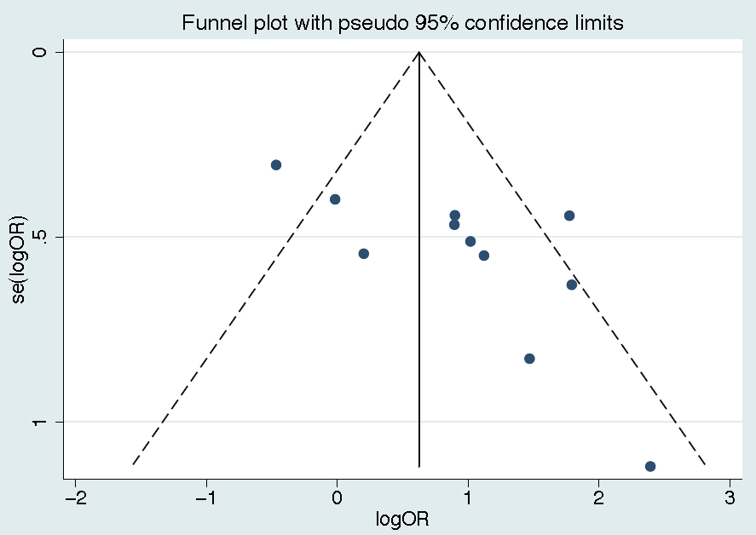 | 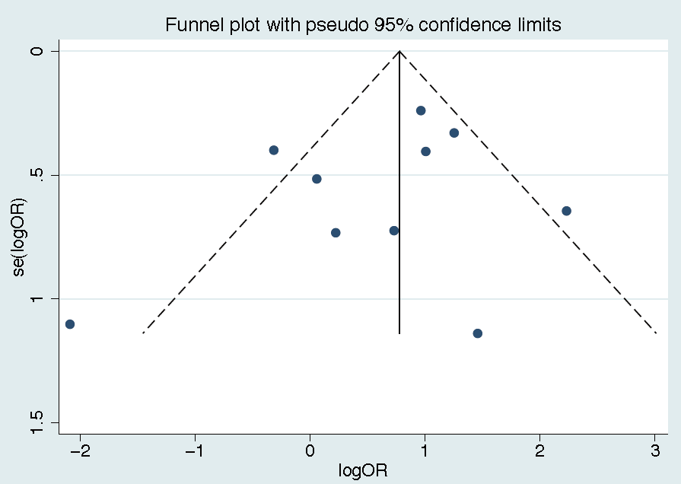

Figure S4. Pooled Rate Ratio for Publication Bias of EPT+EPBD vs EPT in RCTs and non-RCTs (right panel) Analysis

