Supporting Information
Molecular-sieving energy-efficient gas separation membranes enabled by multi-covalent-crosslinking of microporous polymer blends

Xiuling Chen^{a,b#}, Yanfang Fan^{c#}, Linzhou Zhang,^{c} Dong Guan,^{c} Canghai Ma^{d}, Nanwen Li^{a*}
ª State Key Laboratory of Coal Conversion, Institute of Coal Chemistry, Chinese Academy of Sciences, Taiyuan 030001
^{b} Hubei Key Laboratory of Radiation Chemistry and Functional Materials, Hubei University of Science and Technology, Xianning 437100, China
^{c} State Key Laboratory of Heavy Oil Processing, College of Chemical Engineering and Environment, University of Petroleum-Beijing, Beijing, 102249, China
^{d} State Key Laboratory of Fine Chemicals, School of Chemical Engineering, Dalian University of Technology, Dalian, Liaoning, 210023, China
# X. Chen, and Y. Fan are equally contributed to this work.
cma@dlut.edu.cn (C.Ma); linanwen@sxicc.ac.cn

1.Supplemental Experimental Procedures

Synthesis of PIM-BM-x and TB
Synthesis of polymer PIM-M. The PIM-M was synthesized according to the literature reported.¹ The flask was swept with argon for 30 min to remove the dissolved moisture and air. Equal molar ratio of 4,4'-dimethyl-3,3,3',3'-tetramethyl-2,2',3,3'-tetrahydro-1,1'-spirobi[indene]-5,5',6,6'-tetraol (TTSBI-Me, 10 mmol) and 2,3,5,6-tetrafluoroterephalonitrile (TFTPN, 10 mmol) with a stoichiometric amount of anhydrous K₂CO₃ (2.5 times compared to monomers) were dissolved in anhydrous NMP and toluene (volume ratio of 3:1) and the mixture quickly heated to 155 ºC for 4 h. After cooling to the room temperature, the solids were filtrated and washed with methanol and water. The yellow solid was washed in a 0.1wt.% HCl aqueous solution to remove the catalyst. The product then filtered, washed with deionized water, and washed again with methanol for removing the residual HCl. The collected yellow polymer was dried under vacuum at 80 ºC for 24 h prior to use (Figure S1).
Figure S1. Reaction scheme for PIM-M synthesis
Synthesis of polymer PIM-BM-70%.¹ The PIM-BM-70% was synthesized through free-radical bromination of PIM-M using differentratios of N-bromosuccinimide (NBS) and azodiisobutyronitrile (AIBN). PIM-M (4.88 g, 10 mmol) was dissolved in chlorobenzene (100 mL) under an inert atmosphere, then NBS (7 mmol) and AIBN (0.7 mmol n_{NBS} : n_{AIBN} = 10 : 1) were added to the reaction solution and refluxed at 135 ºC for 3-4 h. After cooling, the mixture was poured into methanol (500 mL) to obtain a yellowish powder. The polymer product was washed for 4-5 times using methanol and dried at 70 ºC for 24 h (Figure S2). The results of ¹H NMR were shown in Figure S3. The molecular weight was estimated with the results of Mw=56721.
Figure S2. Reaction scheme for PIM-BM-70% synthesis
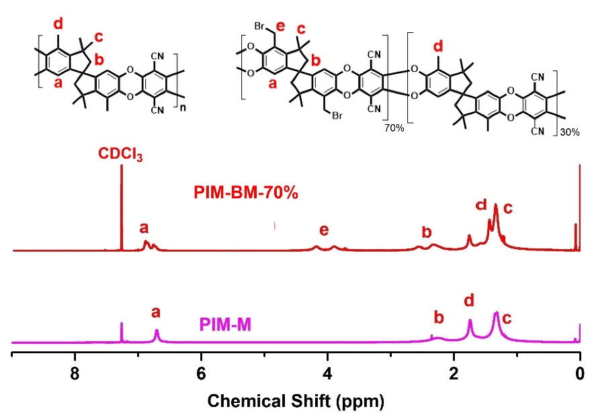
Figure S3. ¹H NMR of PIM-M and PIM-BM-70%

Synthesis of Tröger's Base. Tröger's Base polymer was prepared according to the previous report.² 4,4’-diamino-3,3’-dimethylbiphenyl (10g, 47.169 mmol) and diethoxymethane (21mL, 235.8mmol) were added into the three round bottom flask at 0 ºC. After fully dissolved, trifluoroacetic acid (80 mL) was added drop wise into the reaction mixture at 0 ºC. After the reaction mixture was further stirred at a room temperature for 4 days. The mixture was poured into ammonia aqueous solution. The solid product was filtered, and purified by redissolving and precipicating three times in chloroform and methanol (Figure S4). The result of ¹H NMR was shown in Figure S5. The molecular weight was estimated with the results of Mw=107900.
Figure S4. Reaction scheme for the synthesis of TB
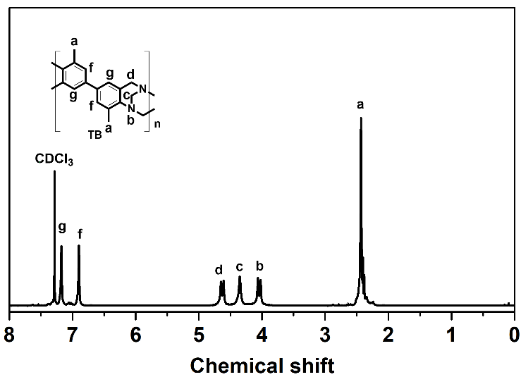
Figure S5. ¹H NMR of TB
Figure S6. Reaction scheme for opening ring TB
Preparation of membrane. Dense membranes were prepared by solution casting of filtered equimolar PIM-BM-70% and Tröger's Base (TB) in chloroform on clean glass substrate, with solvent slow evaporated in 2 days, the dry free-standing membranes were obtained and exposed to methanol soaking for overnight and further dried in a vacuum oven at 70 ºC for 24 h. The thickness of the PIM-BM/TB membrane were about 50 μm (±10 um).
Thermal analyses. Thermal analyses of PIM-BM/TB fresh and thermally treated membranes were performed in a TGA to study the thermal degradation in nitrogen atmosphere. Polymer membranes were dynamically heated from room temperature to 100 ºC at 5 ºC/min and held for 30 min then to 800 ºC at 5 ºC/min in nitrogen atmosphere. TG-MS were performed in TGA Q50 V20.10 Build 36 in nitrogen atmosphere.
Thermal Cross-Linking Treatments. The membrane of PIM-BM/TB was performed using a CenturionNeytechQex vacuum furnace under 200 ppm O₂ balanced with nitrogen. The vacuum furnace was swept for 60 min, then the temperature was raised to between 80 and 300 °C at a rate of 3 °C/min and held for a period of 5 to 20 h. After the thermal cross-linking treatment process, the membranes were cooled at a rate of 3 °C/min in the furnace to room temperature for further studies. The membrane was labeled as “XPIM-BM/TB-temperature (h)”, for example, XPIM-BM/TB-80 °C-20 h.
Characterization. X-ray diffraction (XRD) was intended to study the change of d-spacing. The results were recorded on a Bruker AXS GADDS apparatus using Cu radiation with wavelength of 1.54 Å (voltage: 40 KV, current: 30MA). d-spacing was computed following Bragg’s law (d=λ/2 sin θ). An X-ray photoelectron spectrometer (XPS) was utilized to monitor the chemical changes of PIM-BM/TB-fresh and thermally cross-linked PIM-BM/TB membranes. They were recorded on HSi spectrometer (Thermo Fisher ESCALAB 250 xi., England) using a monochromatic Al Kα X-ray source (1486.6 eV photons) at a constant dwell time of 100 ms and a pass energy of 40 eV under full vacuum. The anode voltage and anode current were 15 kV and 10 mA, respectively. All core-level spectra were obtained at a photoelectron takeoff angle of 90 ◦ with respect to the sample. To compensate for surface charging effects, all binding energies (BE’s) were referenced to the C1s hydrocarbon peak at 284.8 eV. Surface elemental stoichiometries were determined from the peak area ratios and were accurate to within ±5%.
SEM analysis of membranes was performed using a Hitachi S5500 microscope. The polymer films were fractured and coated with a thin layer of gold. Determination of polymer molecular weights were accomplished using gel permeation chromatography (GPC, Shimadzu LC-20A) with Ultrastyragel columns and tetrahydrofuran (THF) as the eluent flowing at a rate of 1 mL/min. The FTIR measurements were performed using an attenuated total reflection mode (FTIR-ATR), with a Perkin-Elmer Spectrum 2000 FTIR spectrometer. Each sample was scanned 32 times. Wide-angle X-ray scattering was performed with a DX-2700 machine operated at 30 mA and 40 kV using Cu Ka radiation with a step of 0.03 per second. Tensile tests of polymer films were carried out at Instron-1211 (Instron Co., USA) mechanical testing instrument at a cross head speed of 1 mm·min⁻¹. Polymer films were cut into thin slices with an effective length of 10 cm and a width of 1 cm, with the accurate value determined from high-resolution photos and calibrations from known length. The average value of Young’s modulus was derived from the initial slope. The tensile strength at break and elongation at break were also measured. The positron annihilation experiments were conducted by using a fast-fast coincidence PALS. A ²²Na source was used as positron source. The activity of the ²²Na source is about 10 mCi. Kapton film is used to encapsulate dry ²²Na source. The PALS measurements were performed at various relative hu-midities ranging from ∼0 %RH to ∼100 %RH. The membranes were cut into 1cm x 1cm slice, the thickness test slice was around 1.5 mm. Two slices of the same sample sandwiched a 20 μCi positron source (²²Na), which was sealed with two thin Kapton membranes of 7 μm. The positron lifetime spectrum of single-crystal Ni was used as a reference in order to subtract the source components of positron annihilation in Kapton membranes and ²²Na. The energy of positron annihilation is 1.28 MeV and the time difference of annihilation γ ray is about 0.5118 MeV accompanied by γ ray and the positron annihilation lifetime was obtained.
Gas permeation
Pure gas permeation tests were carried out at temperature of 35 ºC and 50 psi except for PIM-BM-TM-300 ºC-5 h (100psi, 35 ºC), using a constant-volume pressure-increase apparatus. The mixed gas permeation properties were measured in the same membrane cell using the same constant-volume pressure-increase apparatus. The membrane was exposed to certiﬁed gas mixtures of CO₂/CH₄ (50/50 vol.%) with feed pressures up to 50 psi-150psi at 35 ºC. The gas compositions were analyzed by a gas chromatograph (GC-7820A, Agilent).
Molecular simulation
The Molecular Dynamics (MD) simulation was constructed by the Forcite module in Materials Studio software package (Accelrys Inc., CA, USA). In one cubic simulation box, four polymer chains (2 PIM-BM-70% polymer chains and 2 TB polymer chains) with 10 repeating units were constructed. The initial density is 0.5 g/cm³ and the target densities is 1.177 g/cm³ before crosslinking. The force ﬁeld was PCFF. The Berendsen algorithm with a decay constant of 0.1 ps was used to control the temperature and pressure of each box. The speciﬁc procedures before crosslinking are as follows: (1) energy minimization; (2) 50ps NVT-MD simulation at 600 K; (3) 100ps NPT-MD simulation at 600 K at 1 GPa; (4) 100ps NPT-MD simulation at 298.15 K at 1 GPa; (5) 100ps NPT-MD simulation at 298.15 K at 0.1 MPa; (6) 50ps NVT-MD at 298.15K. The Ewald summation method was used to calculate the non-bond interactions with an accuracy of 0.001kcal·mol⁻¹.
After this, the final equilibrium structure was used to crosslink Br with N or C atoms, and the cubic simulation box with crosslinked polymers was used as the initial structure for molecular dynamics simulation. The speciﬁc procedures after crosslinking are as follows: (1) 100 ps NPT-MD simulation at 298.15 K at 2 GPa; (2) 100 ps NPT-MD simulation at 298.15 K at 0.1 MPa; (3) 50 ps NVT-MD simulation at 298.15 K. The force field and other parameters are the same as before crosslinking.

Possible mechanism as shown in Figure S7- Figure S9
Figure S7. Reaction scheme of tertiary amine with bromomethyl groups and ring opening reaction of TB
Figure S8. Reaction scheme of nucleophilic reactions between C-Br bonds and phenyl rings in TB
Figure S9. The reactions between C-Br bonds and phenyl rings in PIM-BM-70%

2. Characterization of polymer membranes

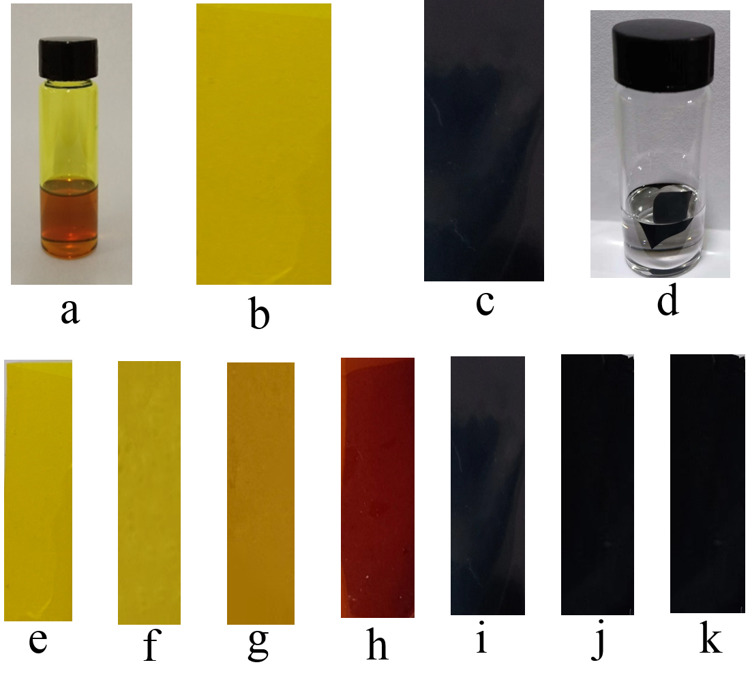
Figure S10. Characterization of polymer membranes
(a) Photo of XPIM-BM/TB polymer solution in chloroform. (b) Photo of as-prepared XPIM-BM/TB membrane. (c) Photo of thermal-crosslinked (300 ºC-5 h) XPIM-BM/TB membrane. (d) Photo of thermal-crosslinked (300 ºC-5 h) XPIM-BM/TB membrane solubility test in chloroform. (e) Photo of as-prepared XPIM-BM/TB membrane without thermal management. (f) Photo of XPIM-BM/TB membrane at 80 ºC for 20 h. (g) Photo of XPIM-BM/TB membrane at 120 ºC for 20 h. (h) Photo of XPIM-BM/TB membrane at 200 ºC for 20 h. (i) Photo of XPIM-BM/TB membrane at 250 ºC for 20 h. (j) Photo of XPIM-BM/TB membrane at 300 ºC for 2 h. (k) Photo of XPIM-BM/TB membrane at 300 ºC for 5 h.

Table S1 Simulation results for crosslinked membranes
Sample | Simulated density (g/cm³） | Experimental density  (g/cm³） | FFV
Sample | Simulated density (g/cm³） | Experimental density  (g/cm³） | FFV (H₂) | FFV (CO₂)
PIM-BM/TB | 1.141 | 1.177 | 0.228 | 0.194
PIM-BM | 1.129 | 1.090 | 0.341 | 0.313
120-ºC-20 h | 1.145 | 1.107 | 0.225 | 0.193
200-ºC-20 h | 1.159 | 1.136 | 0.214 | 0.189
250-ºC-10 h | 1.169 | 1.190 | 0.201 | 0.178
300-ºC-5 h | 1.214 | 1.223 | 0.187 | 0.163

2.1 XPS of fresh and the thermally cross-linked XPIM-BM/TB membranes
An X-ray photoelectron spectra of membranes
An X-ray photoelectron spectrometer (XPS) was utilized to monitor the chemical changes of thermally cross-linked XPIM-BM/TB membranes. They were recorded in HSi spectrometer (Thermo Fisher ESCALAB 250 xi., England) using a monochromatic Al Kα X-ray source (1486.6 eV photons) at a constant dwell time of 100 ms and a pass energy of 40 eV under full vacuum. The anode voltage and anode current were 15 kV and 10 mA, respectively. All core-level spectra were obtained at a photoelectron takeoff angle of 90 ◦ with respect to the sample. To compensate for surface charging effects, all binding energies (BE’s) were referenced to the C 1s hydrocarbon peak at 284.8 eV.³⁻⁴ Surface elemental stoichiometries were determined from the peak area ratios and were accurate to within ±5%. Figure S6 shows Br_{3d} XPS spectrum of the fresh PIM-BM/TB and thermally cross-linked XPIM-BM/TB membranes. The fresh PIM-BM/TB membranes reveals a symmetrical Br_{3d} core signal with the maximum peak at 70.4 eV which is ascribed to the C-Br covalent bonded.⁵⁻⁹
The crosslinking degree is calculated as follows (Table S2): 120 ºC-20 h: degree of alkylation reaction is not detected, degree of quaternary is 12% (area of the bromide ion / area of the original film). 200 ºC-20 h: degree of alkylation reaction is not detected, degree of quaternary is 18% (area of the bromide ion / area of the original film). 250 ºC-10 h: degree of alkylation reaction is 22% (area of the bromine lost / area of the original film), degree of quaternary is 25% (area of the bromide ion / area of the original film). 300 ºC-5 h: degree of alkylation reaction is 40% (area of the bromine lost / area of the original film), degree of quaternary is 45% (area of the bromide ion / area of the original film). 300 ºC-10 h: degree of alkylation reaction is 41% (area of the bromine lost / area of the original film), degree of quaternary is 57% (area of the bromide ion / area of the original film).
Table S2 The calculated degree of crosslinking XPIM-BM/TBª
Membranes | Degree of quaternary | Degree of alkylation reaction | Total degree
RT | 0 | 0 | 0
120-ºC-20 h | 12% | 0 | 12%
200-ºC-20 h | 18% | 0 | 18%
250-ºC-10 h | 25% | 22% | 47%
300-ºC-5 h | 40% | 45% | 85%
300-ºC-10 h | 57% | 41% | 98%
ª the calculated based on xps survey spectrum of Br

2.2 Characterization of the fresh and thermally cross-linked XPIM-BM/TB membranes
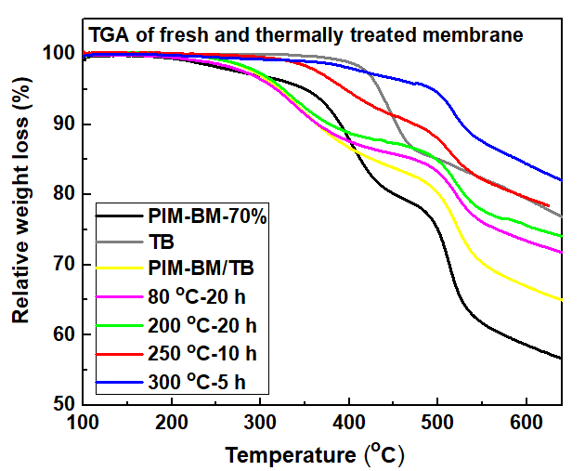
Figure S11. TGA curves of PIM-BM-70%, TB and PIM-BM/TB and the thermally cross-linked XPIM-BM/TB
TGA results revealed that pristine PIM-BM-70% and TB polymer blends shows a initial mass loss at 226 ºC, indicating the occurrence of thermal cross-linking of C-Br bonds and phenyl rings through alkylation reaction with the loss of HBr. The membranes treated at temperatures of above 250 ºC were thermally stable with initial mass loss at temperature above 320 ºC in N₂ atmosphere. This result reflected the majority of C-Br bonds have been consumed through alkylation reaction upon thermally treated at 250 ºC and 300 ºC.

2.3 IR of membranes
Figure S12-14 depicted the ATR-IR spectra for the original PIM-BM-70%, TB, PIM-BM/TB, and thermally treated XPIM-BM/TB. The ATR-IR spectrum of the crosslinked and uncrosslinked PIM-BM-Br-70 have been investigated, As shown in figure S12, the peak around 2247 cm⁻¹ which is attributed to nitrile stretching (C≡N) kept intact after thermal crosslinking, indicating the non-reaction between the CN groups.⁹ However, the characteristic peak of C-Br stretching vibration at 660 cm⁻¹ has been weakened after crosslinking.¹⁰ This result indicated that the thermal crosslinking of PIM-BM-70% has occurred by the loss of HBr to form the methylene groups. Moreover, the crosslinking mechanism has been further confirmed by TGA-MS, in which the intensities of atomic mass, m/z has determined to be 81 that could be attributed to the HBr emission (Figure 3f). Figure S13 shows TB-fresh and thermally treated TB, the results show that TB membrane gradually open ring with the temperature increasing. Peak at 1668 cm⁻¹ is attributed to –C-N of tertiary amine, peak at 1608 cm⁻¹ is attributed to –C-N of secondary amine¹¹⁻¹², 3360 cm⁻¹ is attributed to –N-H. Figure S14 shows PIM-BM/TB-fresh and thermally treated XPIM-BM/TB, the results shows that nitrile stretching (C≡N) also kept intact after thermal crosslinking, C-Br stretching vibration at 860 cm⁻¹ has been weakened after crosslinking and C-Br stretching vibration at 660 cm⁻¹ disappeared when the membrane was treated at 300 ºC for 5 h. Which ascribe to alkylation reaction and quaternary amination reactions (reactions of tertiary amine with bromomethyl groups) between PIM-BM-70% and TB.
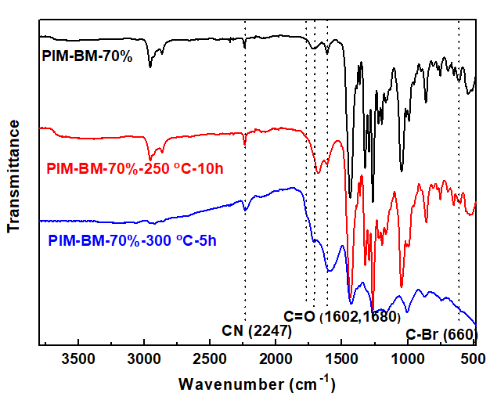
Figure S12. ATR-IR of PIM-BM-70%-fresh, PIM-BM-70%-250 ºC-10 h, PIM-BM-70%-300 ºC-5 h.
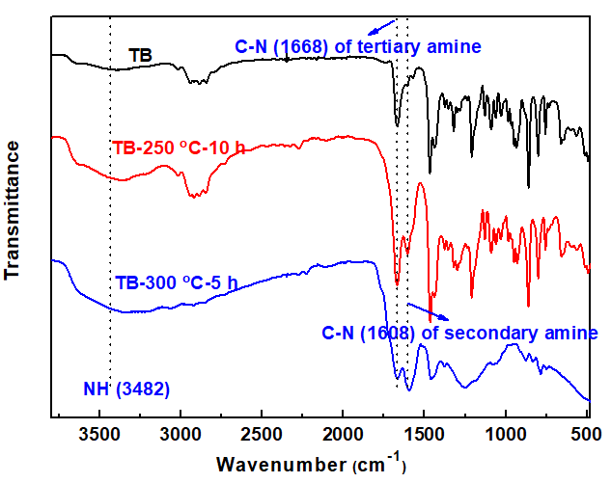
Figure S13. ATR-IR of TB-fresh, TB-250 ºC-10 h, TB-300 ºC-5 h
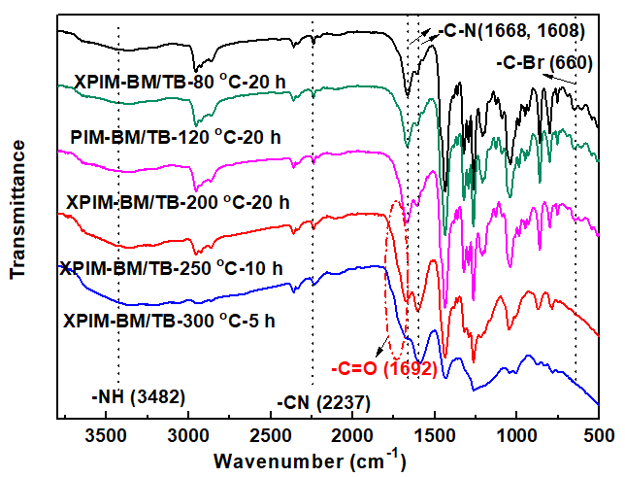
Figure S14. ATR-IR of PIM-BM/TB and thermal treated XPIM-BM/TB
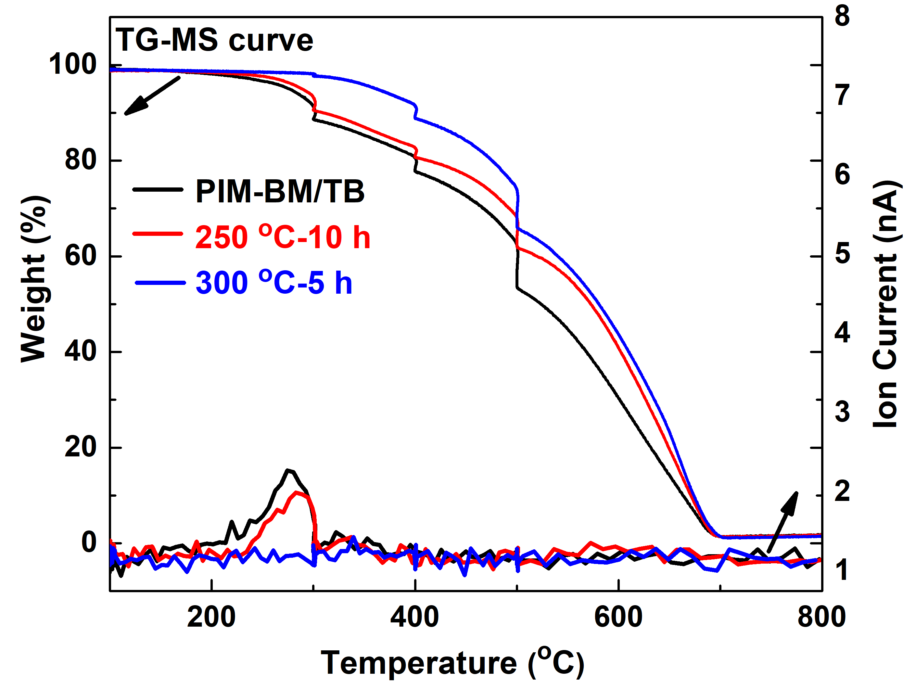
Figure S15. TGA-MS of PIM-BM/TB and thermal treated XPIM-BM/TB

2.4 SEM

Cross-sectional SEM images of PIM-BM/TB fresh polymer films
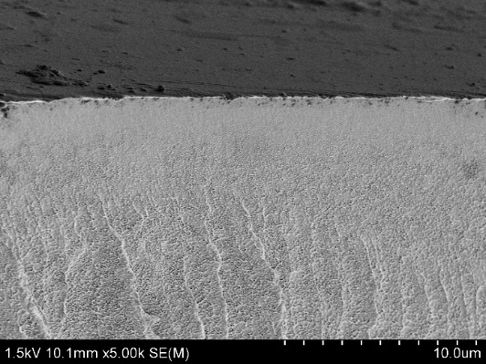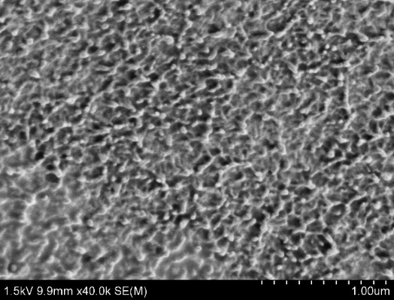
Cross-sectional SEM images of XPIM-BM/TB-200 ºC-20 h polymer films
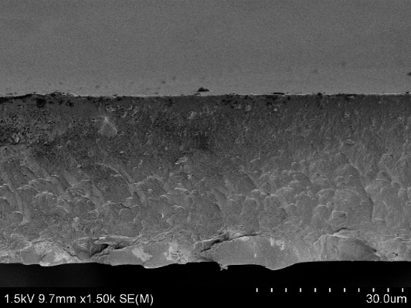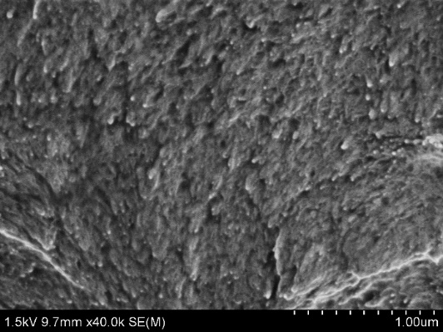
Cross-sectional SEM images of XPIM-BM /TB-250 ºC-10 h polymer films
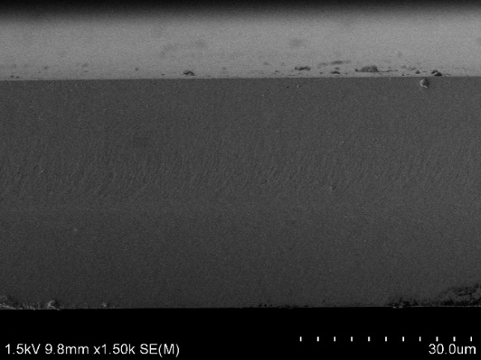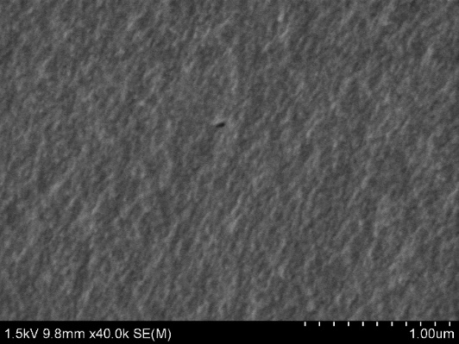
Cross-sectional SEM images of XPIM-BM/TB-300 ºC-5 h polymer films
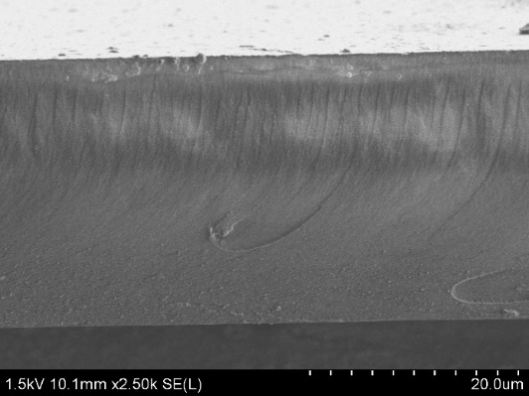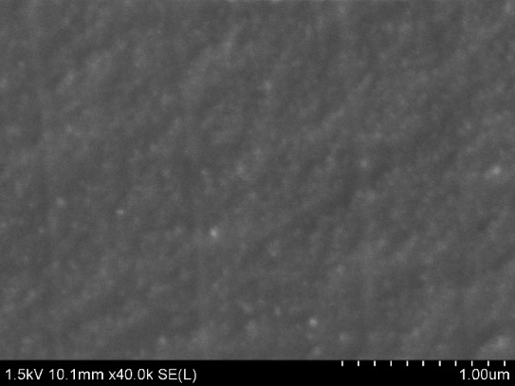
Figure S16. Cross-sectional SEM images of PIM-BM/TB fresh and thermally cross-linked XPIM-BM/TB

2.5 Raman spectra
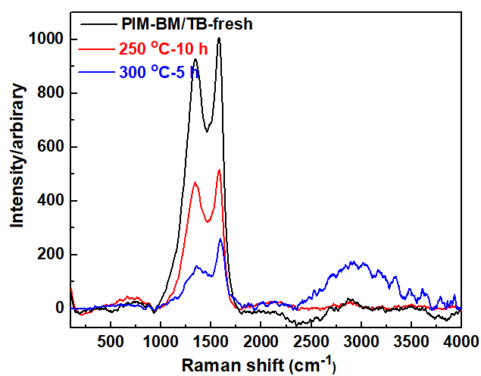
Figure S17. Raman spectra of PIM-BM/TB treated under varied conditions

2.6 Upper bounds
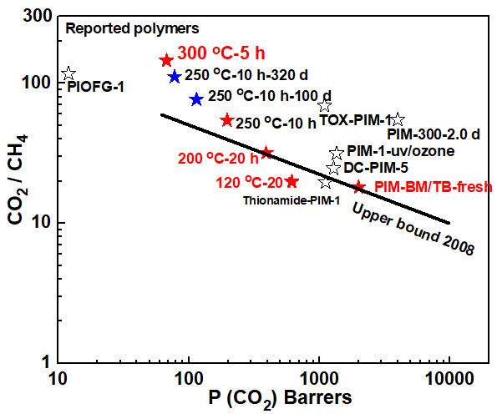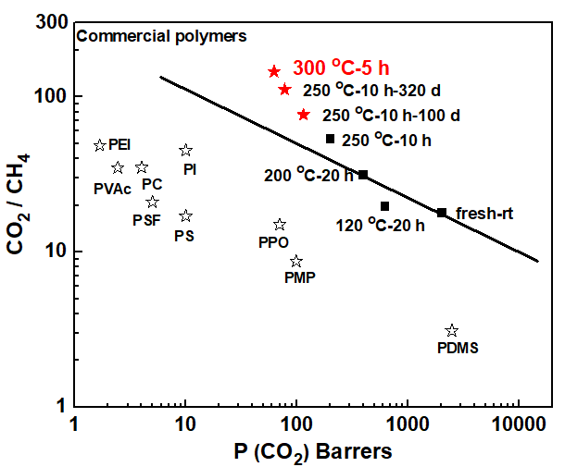
Figure S18. Robeson plot of CO₂/CH₄ selectivity versus CO₂ permeability
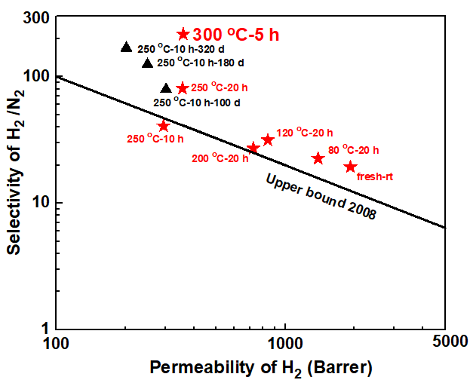
Figure S19. Robeson plot of H₂/N₂ selectivity versus H₂ permeability
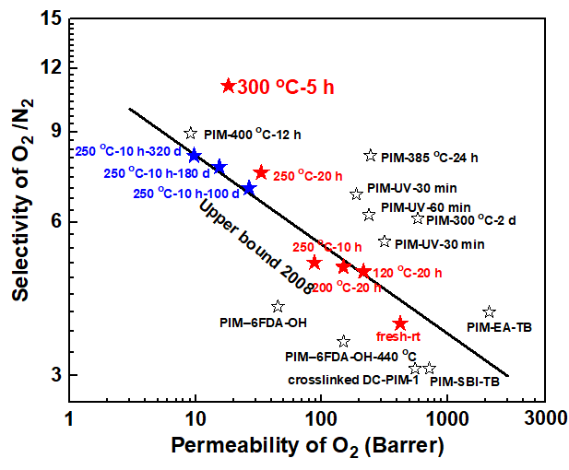
Figure S20. Robeson plot of O₂/N₂ selectivity versus O₂ permeability

2.7 Mechanical properties of membranes
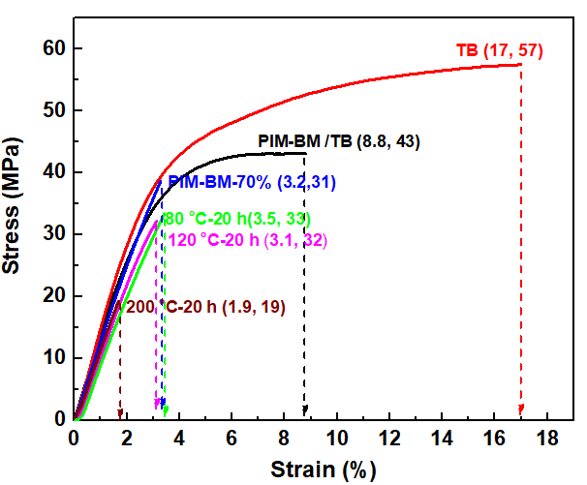
Figure S21. Stress-strain curve of PIM-BM-70%, TB and XPIM-BM /TB

Table S3: Mechanical properties of membranes tested at room temperature
Membrane | Tensile strength [MPa] | Elongation at break  [%] | Young’s modulus [GPa]
TB | 55.5±3.6 | 17.1±0.3 | 1.65±0.2 This work
PIM-BM-70% | 31.5±1.9 | 3.2±0.1 | 1.66±0.1 This work
PIM-BM/TB | 42.5±3.3 | 8.8±0.1 | 1.24±0.1 This work
XPIM-BM/TB（80 ºC-20 h） | 33.4±1.9 | 3.5±0.2 | 1.20±0.2 This work
XPIM-BM/TB-120 ºC-20 h | 32.4±2.6 | 3.1±0.2 | 1.32±0.1 This work
XPIM-BM/TB-200 ºC-20 h | 19.4±0.9 | 1.9±0.1 | 1.05±0.1 This work
PIM-1 | 47.5±2.3 | 14.3 | 1.43±0.15 13
TOX-PIM-1 385°C 1 mbar 8 h | 56.5±2.8 | 7.1 | 1.28±0.37 13
TOX-PIM-1 385°C 1 mbar 12 h | 60.0±3.0 | 5.8 | 1.45±0.05 13
spiroTR-PBO-6F | 82.3±1.3 | 20.0±4.0 | n.a. 14
PIOFG-1 | 83 | 3.1 | n.a. 15
TR-1-350 | 87 | 3.8 | n.a. 15
TR-1-400 | 95 | 3.5 | n.a. 15
TR-1-450 | 98 | 3.9 | n.a. 15

Gas transport properties of XPIM-BM-TB

Gas transport properties of PIM-BM/TB blending membranes

Table S4: Gas permeabilities and ideal selectivities of PIM-BM with a bromomethylation degree of 70%, TB and PIM-BM/TB blending membranes without crosslinking.
Polymer | P (Barrer) ª Selectivity ^{b}
Polymer | N₂ CH₄ O₂ H₂ CO₂ CO₂/N₂ CO₂/CH₄ O₂/N₂ H₂/N₂ H₂/CH₄
PIM-BM-70% | 407 | 575 | 1048 | 3531 | 6047 | 14.8 | 10.6 | 2.6 | 8.7 | 6.2
TB | 6.3 | 7 | 34 | 280 | 134 | 21.2 | 19.1 | 5.4 | 44.4 | 40.0
PIM-BM/TB =10:1 | 226 | 307 | 790 | 2850 | 4223 | 18.7 | 13.8 | 3.5 | 12.6 | 9.2
PIM-BM/TB =10:3 | 209 | 252 | 695 | 2478 | 3644 | 17.4 | 14.5 | 3.3 | 11.8 | 9.8
PIM-BM/TB =10:5 | 142 | 189 | 501 | 1904 | 2532 | 17.8 | 13.4 | 3.5. | 13.4 | 10.1
PIM-BM/TB =10:7 | 131 | 164 | 471 | 1886 | 2327 | 17.8 | 14.2 | 3.6 | 14.4 | 11.5
PIM-BM/TB =1:1 | 110 | 112 | 423 | 1925 | 2007 | 18.2 | 17.9 | 3.8 | 17.5 | 17.2
ª Permeability coefficients measured at 35 ºC and 50 psi feed pressure. 1 barrer = 10 ⁻¹⁰ [cm³ (STP) cm]/(cm² s cmHg)
^{b} Ideal selectivityɑ = (P_{a})/(P_{b})

Table S5: Gas permeabilities and ideal selectivities of PIM-BM-70% and TB at different temperature under the nitrogen flow with 200 ppm O₂.
Polymer | P (Barrer) ª Selectivity ^{b}
Polymer | N₂ CH₄ O₂ H₂ CO₂ CO₂/N₂ CO₂/CH₄ O₂/N₂ H₂/N₂ H₂/CH₄
PIM-BM-70% | 407.0 | 575.1 | 1048.1 | 3531.1 | 6047.2 | 14.8 | 10.6 | 2.6 | 8.7 | 6.2
PIM-BM-70%-250 ºC-10 h | 51.1 | 69.5 | 183.4 | 747.7 | 1228.8 | 24.0 | 17.6 | 3.6 | 14.6 | 10.8
PIM-BM-70%-300 ºC-5 h | 53.0 | 42.1 | 212.1 | 1003.3 | 1158.1 | 21.8 | 27.6 | 4.0 | 18.9 | 23.9
Troger's base | 6.3 | 7.0 | 34.2 | 280.0 | 134.2 | 21.2 | 19.1 | 5.4 | 44.4 | 40.0
Troger's base-250 ºC-10 h | 2.02 | 1.25 | 11.13 | 113.8 | 36.49 | 18.1 | 29.2 | 5.5 | 56.3 | 91.04
Troger's base-300 ºC-5 h | 3.5 | 1.9 | 16.3 | 149 | 52 | 14.9 | 27.4 | 4.7 | 42.6 | 78.4
PIM-BM/TB = 1:1-rt | 109.9 | 111.8 | 422.5 | 1925.1 | 2007.0 | 18.2 | 18.0 | 3.8 | 17.5 | 17.2
ª Permeability coefficients measured at 35 ºC and 50 psi feed pressure. 1 barrer = 10 ⁻¹⁰ [cm³ (STP) cm]/(cm² s cmHg)
^{b} Ideal selectivityɑ = (P_{a})/(P_{b})
Table S6: Gas permeabilities and ideal selectivities of copolymer PIM-BM-70%, TB and thermally cross-linked PIM-BM /TB membranes under the nitrogen flow with 200 ppm O₂.

Polymer | P (Barrer) ª |  |  |  |  |  |  |  | Selectivity ^{b}
Polymer | N₂ | CH₄ | O₂ | H₂ | CO₂ |  |  | CO₂/N₂ |  | CO₂/CH₄ | O₂/N₂ | H₂/N₂ | H₂/CH₄
80 ºC-20 h | 44.2 | 46.8 | 215.8 | 1392 | 987.4 |  |  | 22.3 |  | 21.1 | 4.8 | 31.5 | 29.7
120 ºC-20 h | 32.5 | 31.2 | 149.5 | 839.2 | 617.5 |  |  | 19 |  | 19.8 | 4.6 | 25.8 | 26.9
200 ºC-20 h | 17.6 | 12.4 | 87.8 | 720.9 | 391.3 |  |  | 22.4 |  | 31.7 | 5.0 | 41.2 | 58.5
250 ºC-5 h | 25.2 | 15.7 | 103.7 | 582.4 | 430.7 |  |  | 17.1 |  | 27.5 | 4.2 | 23.0 | 37.1
250 ºC-10 h | 9.1 | 3.6 | 46.8 | 427.1 | 197 |  |  | 21.9 |  | 54.1 | 5.3 | 46.9 | 118.6
250 ºC-20 h | 4.4 | 1.8 | 33.2 | 355.8 | 148.5 |  |  | 33.7 |  | 79.9 | 7.5 | 80.7 | 197.7
250 ºC-40 h | 9.6 | 4.6 | 56.9 | 518.9 | 267.2 |  |  | 27.8 |  | 57.8 | 5.9 | 54.1 | 112.4
300 ºC-2 h | 9.4 | 4.0 | 58.8 | 455 | 218.4 |  |  | 23.2 |  | 63.4 | 6.3 | 48.3 | 132.0
300 ºC-5 h | 1.6 | 0.44 | 18.2 | 358.2 | 67.6 |  |  | 42.8 |  | 155.7 | 11.1 | 223.8 | 814.1
300 ºC-10 h | 15.7 | 5.9 | 96.9 | 739.4 | 366.1 |  |  | 23.4 |  | 61.9 | 6.1 | 47.0 | 124.7
ª Permeability coefficients measured at 35 ºC and 50 psi feed pressure. 1 barrer = 10 ⁻¹⁰ [cm³ (STP) cm]/(cm² s cmHg)
^{b} Ideal selectivityɑ = (P_{a})/(P_{b})

The plasticization resistance of the membranes
Table S7: CO₂ plasticization resistance and selectivity of CO₂ / CH₄
Total feed ª |  |  |  | Total feed
Polymer | P (psi) | P(Barrer) | Selectivity^{b} | Polymer | P (psi) | P (Barrer) | Selectivity
fresh-rt | CO₂ | CO₂ | CO₂/CH₄ | 80 ºC-20 h | CO₂ | CO₂ | CO₂/CH₄
fresh-rt | 50 | 2007 | 18.9 | 80 ºC-20 h | 50 | 987.4 | 21.1
fresh-rt | 100 | 1989 | 17.8 | 80 ºC-20 h | 100 | 867 | 18.5
fresh-rt | 150 | 1847 | 16.5 | 80 ºC-20 h | 150 | 714 | 15.3
fresh-rt | 250 | 1545 | 13.8 | 80 ºC-20 h | 250 | 626.6 | 13.4
fresh-rt | 350 | 1439 | 12.8 | 80 ºC-20 h | 350 | 626.3 | 13.4
fresh-rt | 450 | 1363.2 | 12.2 | 80 ºC-20 h | 450 | 647.1 | 13.8
fresh-rt | 500 | 1320 | 11.8 | 80 ºC-20 h | 500 | 649.1 | 13.9
 | Total feed |  |  |  | Total feed
Polymer | P (psi) | P(Barrer) | Selectivity | Polymer | P (psi) | P (Barrer) | Selectivity
200 ºC-20 h | CO₂ | CO₂ | CO₂/CH₄ | 250 ºC-10 h | CO₂ | CO₂ | CO₂/CH₄
200 ºC-20 h | 50 | 391.3 | 31.6 | 250 ºC-10 h | 50 | 197 | 54.7
200 ºC-20 h | 100 | 378.2 | 30.5 | 250 ºC-10 h | 100 | 142.7 | 39.6
200 ºC-20 h | 150 | 364.8 | 29.4 | 250 ºC-10 h | 150 | 128.4 | 35.7
200 ºC-20 h | 250 | 347.1 | 28.0 | 250 ºC-10 h | 250 | 115.6 | 32.1
200 ºC-20 h | 350 | 330.1 | 26.6 | 250 ºC-10 h | 350 | 105.3 | 29.3
200 ºC-20 h | 450 | 324.2 | 26.1 | 250 ºC-10 h | 450 | 95.8 | 26.6
200 ºC-20 h | 500 | 293.2 | 23.6 | 250 ºC-10 h | 500 | 89.9 | 25.0
 | Total feed |  |  |  | Total feed
Polymer | P (psi) | P (Barrer) | Selectivity | Polymer | P (psi) | P (Barrer) | Selectivity
300 ºC-2 h | CO₂ | CO₂ | CO₂/CH₄ | 300 ºC-5 h | CO₂ | CO₂ | CO₂/CH₄
300 ºC-2 h | 50 | 218.4 | 54.6 | 300 ºC-5 h | 50 | 79 | 179.5
300 ºC-2 h | 100 | 205.1 | 51.3 | 300 ºC-5 h | 100 | 67.6 | 153.6
300 ºC-2 h | 150 | 195.7 | 48.9 | 300 ºC-5 h | 150 | 62 | 140.9
300 ºC-2 h | 250 | 162.8 | 40.7 | 300 ºC-5 h | 250 | 60 | 136.4
300 ºC-2 h | 350 | 149.2 | 37.3 | 300 ºC-5 h | 350 | 59.1 | 134.3
300 ºC-2 h | 450 | 138.6 | 34.7 | 300 ºC-5 h | 450 | 58.3 | 132.5
300 ºC-2 h | 500 | 135.7 | 33.9 | 300 ºC-5 h | 500 | 57.9 | 131.6
ª Permeability coefficients measured at 35 ºC and transform psi feed pressure. 1 barrer = 10 ⁻¹⁰ [cm³ (STP) cm]/(cm² s cmHg)
^{b} Ideal selectivityɑ = (P_{a})/(P_{b})

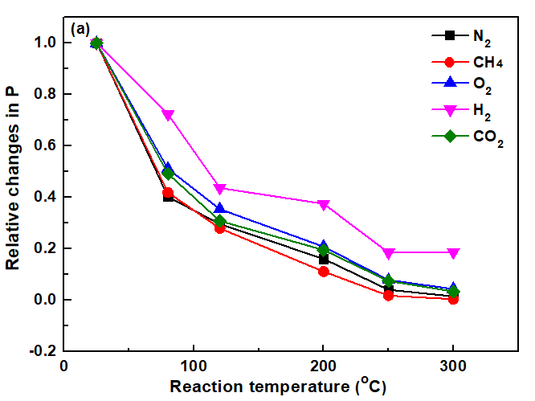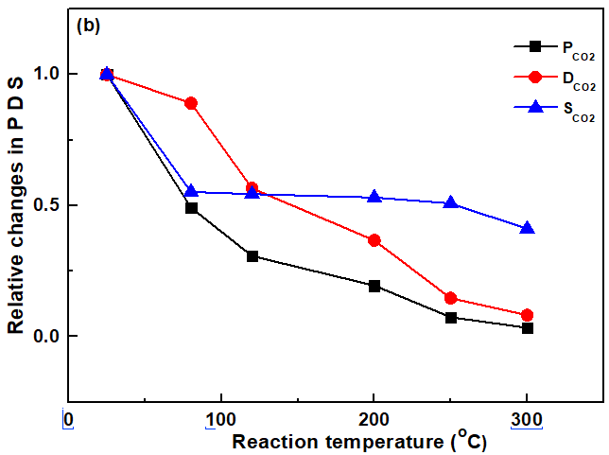
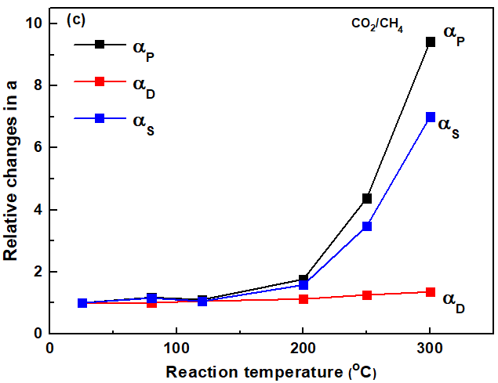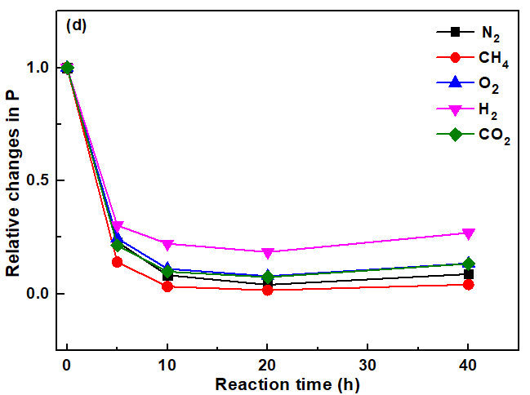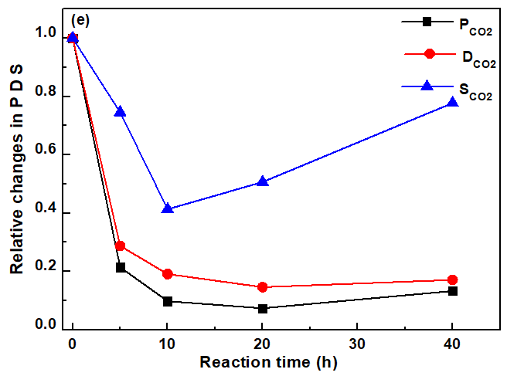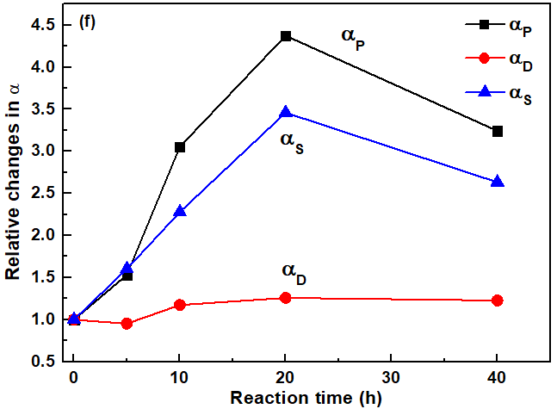
Figure S22 Relative changes in P for various gases and selectivities of gas pairs.

The aging of thermal cross-linking XPIM-BM/TB

Table S8 The aging of thermal cross-linking XPIM-BM/TB (250 ºC-10 h) at air for 0-320 day under 35 ºC and 50 psi.
 | P (Barrer) ª |  |  |  |  |  | Selectivity ^{b}
Aged time | CH₄ | N₂ | O₂ | CO₂ | H₂ |  | CO₂/CH₄ | CO₂/N₂ | O₂/N₂ | H₂/CH₄ | H₂/N₂
1 day | 3.6 | 9.1 | 46.8 | 197 | 427.1 |  | 54.1 | 21.9 | 5.3 | 118.6 | 46.9
10 day | 3.5 | 7.8 | 42.9 | 181.4 | 407.6 |  | 51.8 | 23.2 | 5.5 | 116.5 | 52.3
20 day | 2.9 | 7.2 | 39.7 | 158.6 | 293.8 |  | 54.3 | 21.7 | 5.5 | 101.3 | 40.8
30 day | 2.8 | 7.7 | 43.6 | 156.7 | 410.2 |  | 55.9 | 20.4 | 5.7 | 146.5 | 53.2
40 day | 3.2 | 9.1 | 48.1 | 177.6 | 380.3 |  | 55.5 | 19.5 | 5.3 | 118.8 | 41.9
60 day | 2.2 | 5.9 | 32.5 | 123.3 | 270.4 |  | 56.4 | 20.9 | 5.5 | 122.9 | 45.8
100 day | 1.5 | 3.8 | 26.6 | 114.9 | 301.3 |  | 76.6 | 30.0 | 7.0 | 200.9 | 79.3
180 day  320 day | 1.0  0.7 | 2.0  1.2 | 15.4  9.7 | 99.2  77.8 | 249.9  202.1 |  | 99.2  111.1 | 49.6  64.8 | 7.7  8.1 | 249.9  288.7 | 124.9  168.4

ª Permeability coefficients measured at 35 ºC and 50 psi feed pressure. 1 barrer = 10 ⁻¹⁰ [cm³ (STP) cm]/(cm² s cmHg)
^{b} Ideal selectivityɑ = (P_{a})/(P_{b})

Diffusion coefficients and solubility coefficients

Table S9: CO₂ and CH₄ diffusion coefficients and solubility coefficients for XPIM-BM-TB at different temperature

Polymer |  | diffusion coefficient solubility coefficient
Polymer |  | (10⁻⁸ cm² s⁻¹) (10⁻² cm (STP) cm⁻³ cmHg)
Polymer | CO₂ CH₄ (α)_{D} CO₂ CH₄ (α)_{S}
PIM-BM/TB | 10.7 |  | 2.2 | 4.9 |  | 753.6 | 348.6 | 2.2
PIM-BM/TB-250ºC-10 h | 5.4 |  | 0.98 | 5.5 |  | 394.6 | 159.2 | 2.5
PIM-BM/TB -300ºC-5 h | 2.1 |  | 0.36 | 5.8 |  | 551.4 | 116.7 | 4.7
TB-rt | 21.3 |  | 4.3 | 5.0 |  | 6.3 | 1.6 | 3.9
TB-250 ºC-10 h | 11.9 |  | 2.7 | 4.4 |  | 5.0 | 0.78 | 6.4
TB-300 ºC-5 h | 7.1 |  | 1.1 | 6.5 |  | 7.3 | 1.7 | 4.3
nPIM-BM-70%:nTB=10:1 | 7.34 |  | 1.82 | 4 |  | 575.3 | 168.7 | 3.4
nPIM-BM-70%:nTB= 10:3 | 7.06 |  | 1.63 | 4.3 |  | 516.1 | 154.6 | 3.3
nPIM-BM-70%:nTB= 10:5 | 6.74 |  | 1.13 | 5.9 |  | 375.7 | 167.3 | 2.24
nPIM-BM-70%:nTB= 10:7 | 5.15 |  | 0.62 | 8.3 |  | 451.8 | 264.5 | 1.7
nPIM-BM-70%:nTB= 1:1 | 4.03 |  | 0.43 | 9.2 |  | 498.0 | 260.0 | 1.9
1:1-80 ºC-20 h | 3.59 |  | 0.38 | 9.4 |  | 275.0 | 123.2 | 2.3
1:1-120 ºC-20 h | 2.28 |  | 0.23 | 9.8 |  | 270.8 | 135.6 | 2.0
1:1-200 ºC-20 h | 1.48 |  | 0.14 | 10.8 |  | 264.3 | 88.5 | 2.9
1:1-250 ºC-5 h | 1.16 |  | 0.13 | 8.9 |  | 371.3 | 120.7 | 3.1
1:1-250 ºC-10 h | 0.77 |  | 0.07 | 11 |  | 206.0 | 47.1 | 4.9
1:1-250 ºC-20 h | 0.59 |  | 0.05 | 11.8 |  | 252.3 | 38 .0 | 6.8
1:1-250 ºC-40 h | 0.69 |  | 0.06 | 11.5 |  | 387.2 | 76.6 | 5.0
1:1-300 ºC-2 h | 0.36 |  | 0.035 | 10.3 |  | 606.7 | 114.3 | 6.2
1:1-300 ºC-5 h^{b} | 0.33 |  | 0.026 | 13.8 |  | 204.8 | 15.4 | 11.3
ª Determined from D = P/S (D measured by D = l²/6θ), 35 ºC, 50 psi.

Table S10: O₂ and N₂ diffusion coefficients (D) and solubility coefficients (D) for XPIM-BM-TB at different temperature

Polymer | D ª (10⁻⁸ cm² s⁻¹) S ª (10⁻² cm (STP) cm⁻³ cmHg)
Polymer | O₂ N₂ (a)_{D} O₂ N₂ (a)_{S}
PIM-BM/TB | 1.6 | 0.38 | 4.2 | 264.1 | 286.8 | 0.92
1:1-80 ºC-20 h | 1.4 | 0.30 | 4.6 | 154.1 | 147.3 | 1.04
1:1-120 ºC-20 h | 1.1 | 0.25 | 4.4 | 135.9 | 130.0 | 1.05
1:1-200 ºC-20 h | 0.82 | 0.17 | 4.8 | 107.1 | 103.5 | 1.03
1:1-250 ºC-10 h | 0.55 | 0.11 | 5.0 | 85.1 | 82.7 | 1.03
1:1-300 ºC-2 h | 0.49 | 0.083 | 5.9 | 120.0 | 113.3 | 1.06
1:1-300 ºC-5 h^{b} | 0.45 | 0.071 | 6.3 | 40.4 | 22.5 | 1.79
ª Determined from D = P/S (D measured by D = l²/6θ), 35 ºC, 50 psi.

Comparison of CO₂ permeabilities and CO₂/CH₄ selectivities

Table S11: A comparison of CO₂/CH₄ gas separation data for PIM-1 related membranes (data in the parentheses are for pure polymer membranes)
Polymer | P_{CO2}(Barrer) | P_{CO2}/P_{CH4} | T (ºC) | Pressure (psi) | Ref.
TOX-PIM-1 | 1100 | 69 | 385ºC-24h | 60 | 16
PIM-EA-TB | 7140 | 10.2 | rt | 50 | 17
Crosslinked-PIM-1 | 4000 | 54.8 | 300 ºC-2d | 100 | 18
PIM-1-uv | 1364 | 31.5 | rt | 60 | 19
PIM-BM | 1689 | 22.8 | 35 ºC | 50 | 20
PIM-M | 4370 | 17.2 | 35 ºC | 50 | 20
PIM-1 | 4259 | 16.5 | 25 ºC | 50 | 20
DC-PIM-5 | 1291 | 24.6 | 375 ºC-40min | 50 | 21
VinylatedPIM-1 CO50 | 1370 | 26 | rt | 30-100 | 22
Thioamide-PIM-1 | 1120 | 19.6 | rt | 14.5 | 23
PIOFG-1 | 12 | 117 | 35 | 33 | 24
PIM-BM/TB | 2007 | 20.1 | rt | 50 | This work
PIM-BM/TB | 618 | 21.5 | 120ºC-20h | 50 | This work
PIM-BM/TB | 391 | 31.7 | 200 ºC-20h | 50 | This work
PIM-BM/TB | 159 | 543 | 250 ºC-10h | 50 | This work
PIM-BM/TB | 149 | 79.9 | 250 ºC-20h | 50 | This work
PIM-BM/TB | 68 | 144.8 | 300 ºC-5h | 100 | This work

Table S12: A comparison of H₂/CH₄ gas separation data for PIM-1 related membranes (data in the parentheses are for pure polymer membranes)
Polymer | P_{H2}(Barrer) | P_{H2}/P_{CH4} | T (ºC) | Pressure (psi) | Ref.
TOX-PIM-1 | 2204 | 74 | 385ºC-12 h | 60 | 13
TOX-PIM-1  TOX-PIM-1-30d | 1820  1649 | 114  250 | 385ºC-24 h  385ºC-24 h | 60  60 | 13  13
PIM-EA-TB | 7760 | 11.1 | rt | 50 | 25
Crosslinked-PIM-1 | 1666 | 17.2 | 300 ºC-0.5d | 50 | 26
Crosslinked-PIM-1 | 3872 | 53 | 300 ºC-2d | 50 | 26
PIM-UV 1hr | 1488 | 112.7 | rt | 50 | 27
PIM-UV 4hr | 452 | 173.8 | rt | 50 | 27
TB | 400 | 40.1 | rt | 50 | 28
PIM-1 | 7072 | 6.5 | rt | 50 | 28
PIM/TB (2:8) | 1032 | 22.9 | rt | 50 | 28
PIM-1, UV in air, 60 min | 1427 | 33.6 | rt | 60 | 19
PIM-1, UV in quar,60 min | 1509 | 50.3 | rt | 60 | 19
PIM-PI-3 | 360 | 13.3 | 35 ºC | 20 | 29
PIM-PMDA-OH | 190 | 24.7 | 35 ºC | 30 | 30
PIM-6FDA-OH | 259 | 28.5 | 35 ºC | 30 | 30
vinylated PIM-1 | 1081 | 4.2 | 30 ºC | -- | 31
tPBO | 4194 | 28 | -- | -- | 32
aPBO | 408 | 35 | -- | -- | 32
cPBO | 3612 | 14 | -- | -- | 32
sPBO | 3585 | 14 | -- | -- | 32
PIM-BM/TB | 1925 | 17.2 | rt | 50 | This work
PIM-BM/TB | 839.2 | 26.9 | 120ºC-20h | 50 | This work
PIM-BM/TB | 720.9 | 58.5 | 200 ºC-20h | 50 | This work
PIM-BM/TB | 427.1 | 118.6 | 250 ºC-10h | 50 | This work
PIM-BM/TB | 355.8 | 197.7 | 250 ºC-20h | 50 | This work
PIM-BM/TB | 358.2 | 814.1 | 300 ºC-5h | 100 | This work

Effect of N₂, O₂ and air atomosphere on PIM-BM, TB and XPIM-BM/TB at 250 ºC for 10 h
Table S13: Gas transport properties of membranes under N₂, O₂ and air atomosphere at 250 ºC for 10 h
Polymer | P (Barrer) ª Selectivity ^{b}
Polymer | N₂ CH₄ O₂ H₂ CO₂ CO₂/N₂ CO₂/CH₄ O₂/N₂ H₂/N₂ H₂/CH₄
PIM-BM-70%-0 ppm (O₂/N₂) | 110.0 | 156.0 | 413.1 | 1744.1 | 2131.2 | 19.4 | 13.7 | 3.8 | 15.9 | 11.2
PIM-BM-70%-200 ppm (O₂/N₂) | 51.1 | 69.5 | 183.4 | 747.7 | 1228.8 | 24.0 | 17.6 | 3.6 | 14.6 | 10.8
PIM-BM -air | 2.0 | 1.4 | 6.7 | 27.2 | 17.3 | 8.3 | 12.1 | 3.3 | 13.1 | 19.0
TB-0 ppm (O₂/N₂) | 4.2 | 2.1 | 22.1 | 176.1 | 59.2 | 14.1 | 28.2 | 5.4 | 44.4 | 40.0
TB-200 ppm (O₂/N₂) | 2.0 | 1.2 | 11.1 | 113.8 | 36.5 | 18.1 | 29.2 | 5.5 | 56.3 | 91.1
TB-air | 0.19 | 0.17 | 1.3 | 17.7 | 2.7 | 14.4 | 16.1 | 6.6 | 93.3 | 104.2
PIM-BM/TB-0 ppm (O₂/N₂) | 46.4 | 36.1 | 178.6 | 886.6 | 876.1 | 18.9 | 24.2 | 3.8 | 19.2 | 24.6
PIM-BM/TB-50 ppm (O₂/N₂) | 37.6 | 23.9 | 138.9 | 747.1 | 586.3 | 15.6 | 24.5 | 3.7 | 19.8 | 31.2
PIM-BM/TB-200 ppm (O₂/N₂) | 9.1 | 3.6 | 46.8 | 427.1 | 197 | 21.9 | 54.1 | 5.3 | 46.9 | 118.6
PIM-BM/TB-500 ppm (O₂/N₂) | 11.1 | 6.2 | 46.4 | 267.7 | 218.8 | 18.7 | 34.9 | 4.2 | 24.0 | 42.7
PIM-BM/TB-air | 0.67 | 0.95 | 2.50 | 54.0 | 5.82 | 8.7 | 6.2 | 3.7 | 80.6 | 57.0
ª Permeability coefficients measured at 35 ºC and 50 psi feed pressure. 1 barrer = 10 ⁻¹⁰ [cm³ (STP) cm]/(cm² s cmHg)
^{b} Ideal selectivityɑ = (P_{a})/(P_{b})

Effect of temperature on the XPIM-BM/TB (250 ºC-10 h) membranes
Table S14: gas permeation data of XPIM-BM/TB (250 ºC-10 h) at various temperatures
Polymer  250 ºC-10 h | P (Barrer) ª Selectivity ^{b}
Polymer  250 ºC-10 h | N₂ CH₄ O₂ H₂ CO₂ CO₂/N₂ CO₂/CH₄ O₂/N₂ H₂/N₂ H₂/CH₄
35 ºC | 9.1 | 3.6 | 46.8 | 427.1 | 197 | 21.9 | 54.1 | 5.3 | 46.9 | 118.6
45 ºC | 9.9 | 4.1 | 53.2 | 422.3 | 214.5 | 21.7 | 52.3 | 5.4 | 42.7 | 103.0
55 ºC | 9.3 | 4.1 | 51.8 | 490.2 | 216.0 | 23.2 | 52.7 | 5.6 | 52.7 | 119.6
0 ºC | 0.3 | 0.2 | 4.9 | 46.6 | 26.9 | 89.7 | 134.5 | 16.3 | 154.3 | 233.0
-20 ºC | 0.14 | 0.06 | 3.6 | 24.5 | 10.5 | 75.0 | 175.0 | 25.7 | 175.0 | 408.3
ª Permeability coefficients measured at 35 ºC and 50 psi feed pressure. 1 barrer = 10 ⁻¹⁰ [cm³ (STP) cm]/(cm² s cmHg)
^{b} Ideal selectivityɑ = (P_{a})/(P_{b})
Table S15. Cavity diameters and intensities measured by positron annihilation lifetime spectroscopy (PALS)ª

Polymers | Smaller cavity |  |  | Larger cavity
Polymers | Lifetime τ3 (ns) | Cavity diameter (Å) | Intensity I4 (%) | Lifetime τ4 (ns) | Cavity diameter (Å) | Intensity I4 (%)
PIM-BM/TB | 1.510±0.148 | 2.349 | 5.13±0.34 | 5.283±0.125 | 4.870 | 4.60±0.29
250 ºC-10 h | 1.729±0.195 | 2.586 | 3.91±0.25 | 5.345±0.562 | 4.898 | 1.94±0.35
300 ºC-5 h | 2.023±0.129 | 2.870 | 5.45±0.20 | 6.883±0.886 | 5.525 | 1.47±0.27
ª Measured at 300K
Supplemental References
(1) X. Chen, Z. Zhang, L. Wu, X. Liu, S. Xu, J. E. Efome, X. Zhang, N. Li, ACS Appl. Polym. Mater., 2020, 2, 987-995.
(2) S. Zhao, J. Liao, D. Li, X. Wang, N. Li, J. Membr. Sci., 2018, 566, 77-86.
(3) B. Yue, Y. Ma, H. Tao, L. Yu, G. Jian, X. Wang, X. Wang, Y. Luc and Z. Hu, J. Mater. Chem., 2008, 18, 1747-1750.
(4) C.Y. Li, W. C. Wang, F.J. Xu, L.Q. Zhang, W.T. Yang, J. Membr. Sci., 2011, 367, 7-13.
(5) E. Papirer, R. Lacroix, J. B. Donnet, G. Nanse, P. Fioux, Carbon, 1994, 32, 1341-1358.
(6) J-F. Colomer, R. Marega, H. Traboulsi, M. Meneghetti, V. Tendeloo, D. Bonifazi, Chem. Mater., 2009, 21, 4747-4749.
(7) R. Gutzler, L. Cardenas, J. Lipton-Duffin, M. E. Garah, Laurentiu E. Dinca, C. E. Szakacs, C. Fu, M. Gallagher, M. Vondrácek, M. Rybachuk, D. F. Perepichk, F. Roseim, Nanoscale, 2014, 6, 2660-2668
(8) A. Basagni, L. Ferrighi, M. Cattelan, L. Nicolas, K. Handrup, L. Vaghi, A. Papagni, F. Sedona, C. D. Valentin, S. Agnoli, M. Sambi, Chem. Commun., 2015, 51, 12593-12596.
(9) F. Li, Y. Xiao, T. Chung, S. Kawi, Macromolecules, 2012, 45, 1427-1437.
(10) K. Halder, P. Georgopanos, S. Shishatskiy, V. Filiz ,V. Abetz, J. Polym. Sci., Part A: Polym. Chem., 2018, 56, 2752-2761.
(11) S. Mukai, Tetrahedron: Asymmetry, 1996, 7, 2671-2674.
(12) F. Ishiwari, N. Takeuchi, T. Sato, Hiroshi Y. Ryota Osuga, J. N. Kondo, T. Fukushima, ACS Macro Lett. 2017, 6, 775-780
(13) Q. Song, S. Cao, R. H. Pritchard1, B. Ghalei, S. A. Al-Muhtaseb, E. M. Terentjev, A. K. Cheetham, E. Sivaniah, Nature Communications, 2014, 5, 4813-4824.
(14) Li, S. H. J. Jo, S. H. Han, C. H. Park, S. Kim, P. M. Budd, Y. M. Lee, J. Membr. Sci., 2013, 434, 137-147.
(15) H. B. Park, C. H. Jung, Y. M. Lee, A. J. Hill, S. J. Pas, S. T. Mudie, E. V. Wagner, B. D. Freeman, D. J. Cookson, Science, 2007, 318, 254-258.
(16) Q. Song, S. Cao, R. H. Pritchard1, B. Ghalei, S. A. Al-Muhtaseb, E. M. Terentjev, A. K. Cheetham, E. Sivaniah, Nature Communications, 2014, 5, 4813-4824
(17) M. Carta, R. Malpass-Evans, M. Croad, Y. Rogan, J. C. Jansen, P. Bernardo, F. Bazzarelli, N. B. McKeown, Science, 2013, 339, 303-307.
(18) F. Li, Y. Xiao, T-S. Chung, S. Kawi, Macromolecules, 2012, 45, 1427-1437.
(19). Q. Song, S. Cao, P. Zavala-Rivera, L.P. Lu1, W. Li, Y. Ji, S. A. Al-Muhtaseb, A. K. Cheetham, E. Sivaniah, Nature Communications, 2014, 4, 1918-1926.
(20) S. Zhao, J. Liao, D. Li, X. Wang, N. Li, J. Membr. Sci., 2018, 566, 77-86.
(21) N. Du, M. M. Dal-Cin, G. P. Robertson, M. l. D. Guiver, Macromolecules, 2012, 45, 5134-5139.
(22) K. Halder, S. Neumann, G.a Bengtson, M. Munir Khan, V. Filiz, V. Abetz, Macromolecules, 2018, 51, 7309-7319.
(23) C. R. Mason, L. Maynard-Atem, K. W. J. Heard, B. Satilmis, P. M. Budd, K. Friess, M. Lanc̆, P. Bernardo, G. Clarizia, J. C. Jansen, Macromolecules, 2014, 47, 1021-1029.
(24) H. B. Park, C. H. Jung, Y. M. Lee, A. J. Hill, S. J. Pas, S. T. Mudie, E. V. Wagner, B. D. Freeman, D. J. Cookson, Science, 2007, 318, 254-258.
(25) M. Carta, R. Malpass-Evans, M. Croad, Y. Rogan, J. C. Jansen, P. Bernardo, F. Bazzarelli, N. B. McKeown, Science, 2013, 339, 303-307.
(26) F. Li, Y. Xiao, T-S. Chung, S. Kawi, Macromolecules, 2012, 45, 1427-1437.
(27) F. Y. Li, Y. Xiao, Y. K, Ong, T.S. Chung, Adv Energy Mater., 2012, 2, 1456-1466.
(28) S. Zhao, J. Liao, D. Li, X. Wang, N. Li, J. Membr. Sci., 2018, 566, 77-86.
(29). B. S. Ghanem, N. B. McKeown, P. M. Budd, J. D. Selbie, D. Fritsch, Adv. Mater., 2008, 20, 2766−2771.
(30) Xiaohua. Ma, R. S. Youssef Belmabkhout, Y. Zhu, E. Litwiller, M. Jouiad, I. Pinnau, Y. Han, Macromolecules, 2012, 459, 3841-3849.
(31) K. Halder, S. Neumann, G.a Bengtson, M. Munir Khan, V. Filiz, V. Abetz, Macromolecules, 2018, 51, 7309-7319.
(32) S. H. Han, N. Misdan, S. Kim, C. M. Doherty, A. J. Hill, Y. M. Lee, Macromolecules, 2010, 43, 7657-7667.

