Table 1. The mean length of chemotherapeutic treatment was 12.17 ± 1.88 months (range, 6 months – 53 months). Seven patients were non-responders and their treatment modified to Ifosamide (2.8 g/m²) and Etoposide (100 mg/m²) in accordance with the AOST 0331 study. Of these patients, one went on to receive Nivolumab, another patient was further treated with Sorafenib tosylate (400 mg daily), Pazopanib (600 mg daily) and denosumab (120 mg for one month) and other patients also received either Mifamuride, Gemcitabine (675 mg/m²), Docetaxel (100 mg/m²), Imatinib (300 mg twice a day), Cyclophosphamide (50 mg/m²) or Oxoplatin. Due to complications, 8 patients did not receive the full 12 cycles of methotrexate and 5 patients did not receive 12 cycles of doxorubicin.
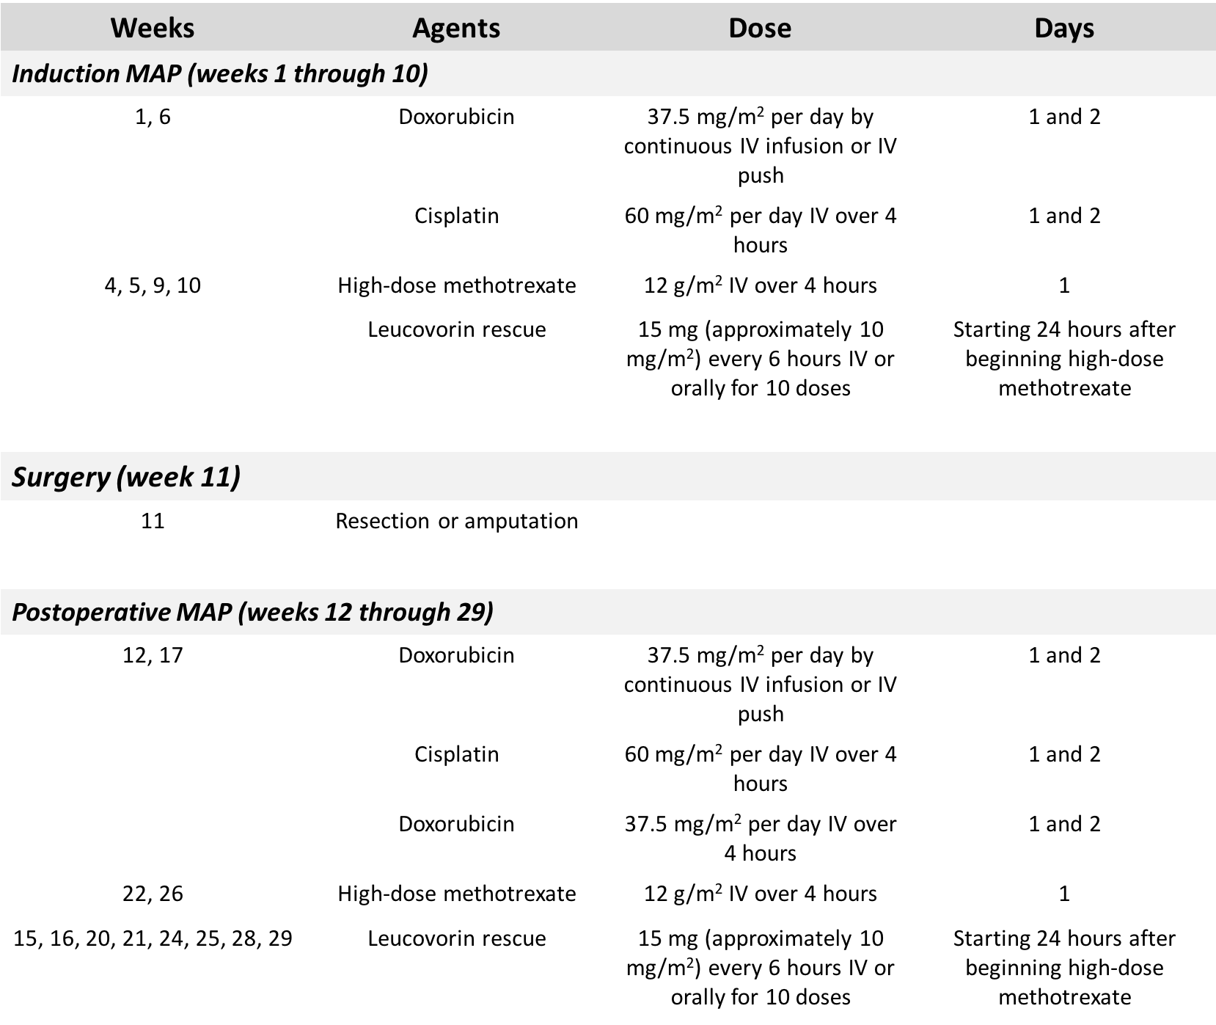

Table 2. A description of the features of each of the implant designs investigated, highlighting the differences in ingrowth surface parameters at the bone implant shoulder
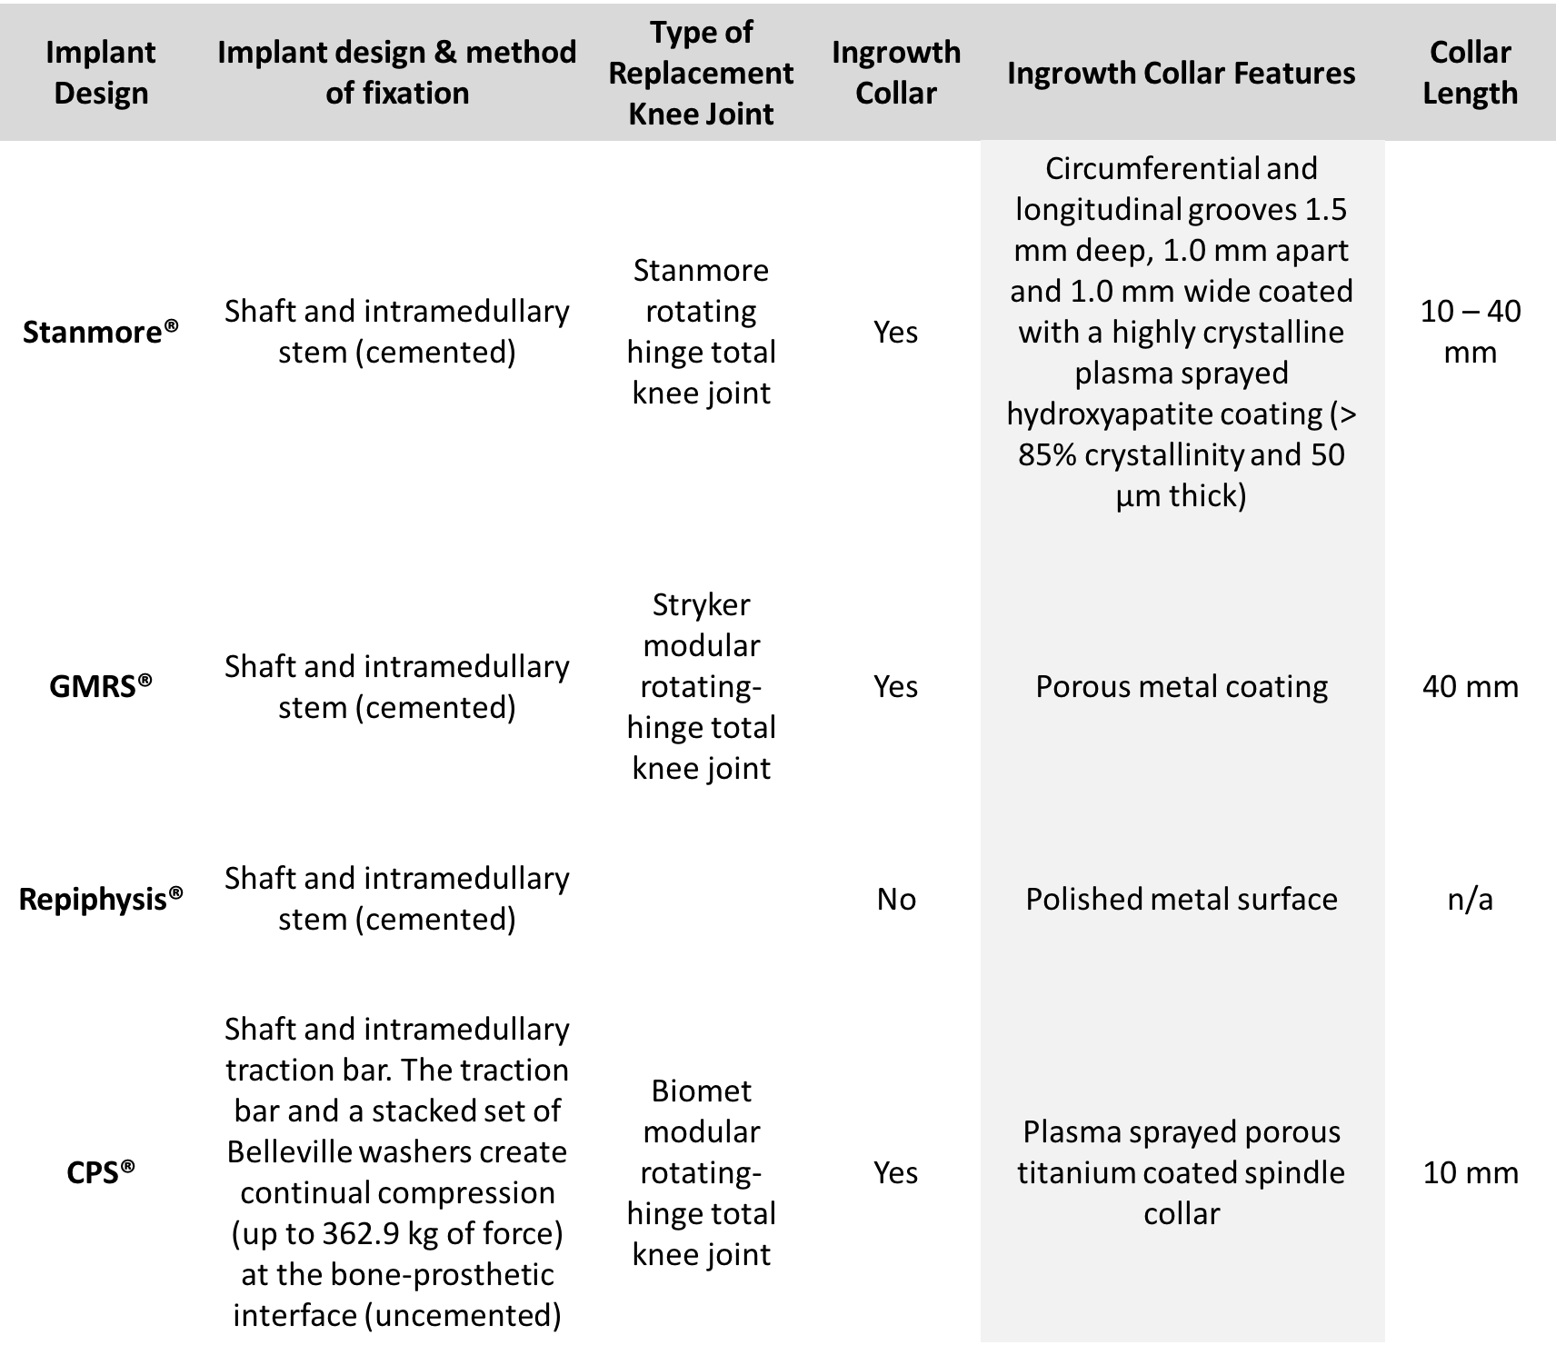

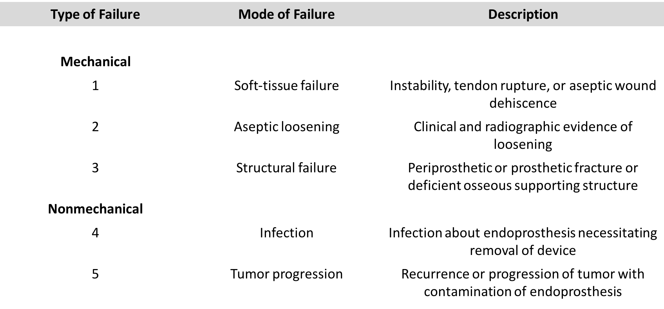
Table 3. Classification of segmental endoprosthetic failure

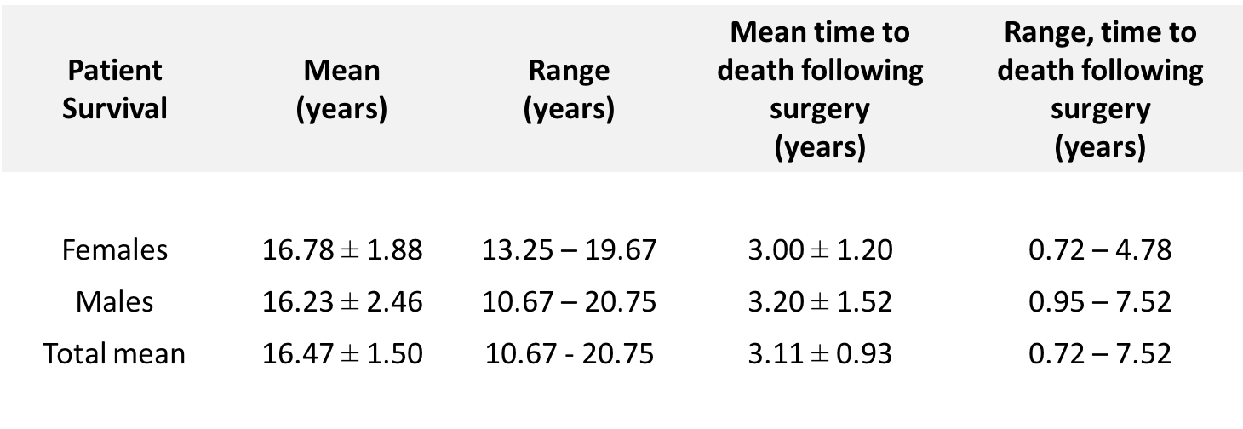
Table 4. Patient survival

Table 5: Endoprosthetic failure and complications over the follow up period. Data is presented using the Henderson Classification criterion. Additionally, 3 patients (10.3%) were identified with complications due to infection and all were readmitted to hospital for treatment. Infections necessitating surgical management through washout, incision and drainage or removal and replacement of parts occurred in 2 patients and aseptic wound dehiscence in a further 2 patients (6.9%). Prolonged pain that was non-responsive to physical therapy or non-steroidal anti-inflammatory medication was seen in 8 patients. Four patients were noted to have pain associated with leg-length discrepancies and three underwent a contralateral epiphysiodesis procedure.
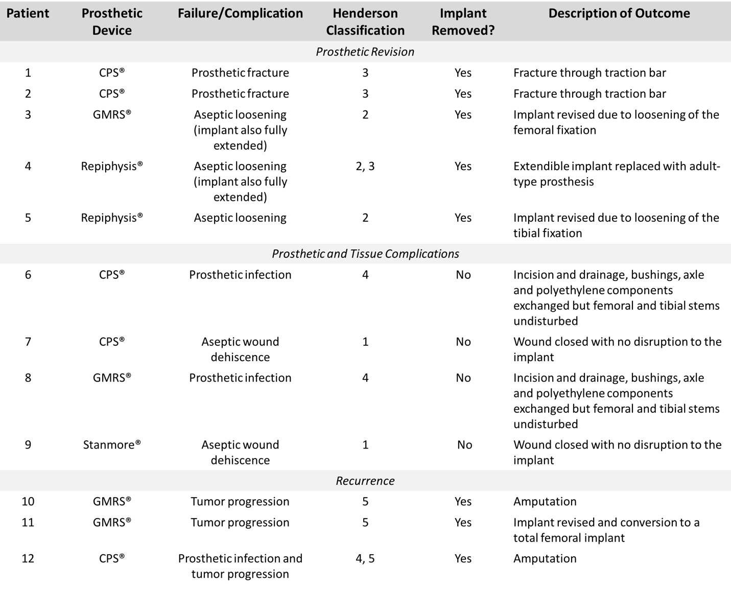

Table 6. The mean duration of chemotherapy given to patients in each of the implant groups. Also presented are the number of non-responders in each group and the percentage of patients whose MAP treatment was modified due to a poor response or clinical complications. No significant differences between implant groups was found
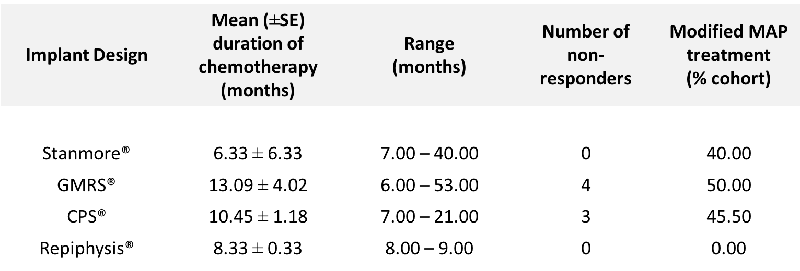

Table 7. When compared with the GMRS® implant group, significantly increased levels of bone resection were measured in the CPS® (p = 0.013) and Stanmore-given patients (p = 0.028).
