A multi-component reaction for covalent immobilization of lipases on amine-functionalized magnetic nanoparticles: production of biodiesel from waste cooking oil

Yalda Aminiª, Zohreh Habibi ª*, Maryam Yousefi ^{b}*, Maryam Ashjari ^{a,c}, Mehdi Mohammadi ^{c}, Mansour Shahediª
ª Department of Organic Chemistry and Oil, Faculty of Chemistry, Shahid Beheshti University, Tehran, Iran
^{b} Nanobiotechnology Research Center, Avicenna Research Institute, ACECR, Tehran, Iran
^{c} Bioprocess Engineering Department, Institute of Industrial and Environmental Biotechnology, National Institute of Genetic Engineering and Biotechnology (NIGEB), Tehran, Iran

Table 1S Sequential Model Sum of Squares (RML)

Source | Sum of Squares | df | Mean  Square | F value | Prob > F
Mean vs Total | 72404.28 | 1 | 72404.28
Linear vs Mean | 410.11 | 5 | 82.02 | 1.89 | 0.1181
2FI vs Linear | 1165.36 | 10 | 116.54 | 6.42 | < 0.0001 | Suggested
Quadratic vs 2FI | 70.70 | 5 | 14.14 | 0.75 | 0.5975
Cubic vs Quadratic | 167.98 | 15 | 11.20 | 0.35 | 0.9647 | Aliased
Residual | 287.42 | 9 | 31.94
Total | 74506.12 | 45 | 1655.69

Table 2S Sequential Model Sum of Squares (CALB)
Source | Sum of Squares | df | Mean  Square | F value | Prob > F
Mean vs Total | 73071.74 | 1 | 73071.74
Linear vs Mean | 237.87 | 5 | 47.57 | 1.13 | 0.3627
2FI vs Linear | 1249.81 | 10 | 124.98 | 9.12 | < 0.0001 | Suggested
Quadratic vs 2FI | 113.08 | 5 | 22.62 | 1.91 | 0.1304
Cubic vs Quadratic | 118.69 | 15 | 7.91 | 0.43 | 0.9288 | Aliased
Residual | 165.82 | 9 | 18.42
Total | 74957.01 | 45 | 1665.71

Table 3S experimental design for five-level five-factor surface response design on transesterification of waste cooking oil using immobilized RML
Run | A:Reaction | B:Water | C:Enzym | D:t-butanol | E:Methanol | FAME yield
 | Temperature | absorbent |  |  | to oil | %
1 | 40 | 50 | 20 | 20 | 4 | 59.9
2 | 40 | 50 | 20 | 50 | 4 | 47.1
3 | 55 | 40 | 15 | 35 | 5 | 32.1
4 | 35 | 40 | 15 | 35 | 5 | 40.8
5 | 40 | 30 | 20 | 50 | 4 | 42.5
6 | 45 | 40 | 15 | 35 | 3 | 35.8
7 | 40 | 50 | 10 | 50 | 6 | 42.3
8 | 40 | 50 | 10 | 20 | 6 | 30.6
9 | 50 | 50 | 10 | 50 | 4 | 39.8
10 | 45 | 40 | 15 | 35 | 5 | 40.9
11 | 45 | 60 | 15 | 35 | 5 | 37.8
12 | 50 | 50 | 20 | 50 | 4 | 39.2
13 | 40 | 30 | 10 | 20 | 4 | 35.3
14 | 45 | 40 | 15 | 35 | 7 | 43.6
15 | 50 | 30 | 10 | 50 | 6 | 60.9
16 | 50 | 30 | 20 | 50 | 6 | 41.5
17 | 50 | 50 | 10 | 50 | 6 | 39.1
18 | 50 | 30 | 10 | 20 | 4 | 34.9
19 | 40 | 30 | 20 | 20 | 6 | 44.2
20 | 50 | 30 | 10 | 50 | 4 | 47.6
21 | 45 | 40 | 15 | 35 | 5 | 35.8
22 | 50 | 30 | 20 | 50 | 4 | 33.1
23 | 40 | 30 | 10 | 50 | 4 | 42.1
24 | 45 | 40 | 5 | 35 | 5 | 33.1
25 | 45 | 40 | 25 | 35 | 5 | 42.5
26 | 40 | 30 | 10 | 50 | 6 | 47.5
27 | 50 | 30 | 10 | 20 | 6 | 41.9
28 | 50 | 50 | 20 | 20 | 6 | 30.6
29 | 50 | 50 | 20 | 50 | 6 | 39.8
30 | 40 | 50 | 20 | 20 | 6 | 47.9
31 | 40 | 30 | 10 | 20 | 6 | 37.8
32 | 45 | 40 | 15 | 35 | 5 | 35.2
33 | 50 | 50 | 20 | 20 | 4 | 35.3
34 | 50 | 30 | 20 | 20 | 6 | 43.6
35 | 40 | 50 | 10 | 50 | 4 | 45.9
36 | 45 | 40 | 15 | 5 | 5 | 32.7
37 | 40 | 50 | 20 | 50 | 6 | 49.1
38 | 50 | 30 | 20 | 20 | 4 | 34.9
39 | 45 | 40 | 15 | 65 | 5 | 44.2
40 | 50 | 50 | 10 | 20 | 6 | 34.6
41 | 50 | 50 | 10 | 20 | 4 | 31.2
42 | 40 | 30 | 20 | 50 | 6 | 35.4
43 | 45 | 20 | 15 | 35 | 5 | 35.8
44 | 40 | 50 | 10 | 20 | 4 | 46.5
45 | 40 | 30 | 20 | 20 | 4 | 30.2

Table 4S experimental design for five-level five-factor surface response design on transesterification of waste cooking oil using immobilized TLL

Run | A: Reaction | B: Water | C: Enzyme | D: t-butanol | E: Methanol | FAME yield
 | Temperature |  |  |  | to oil | %
1 | 40 | 10 | 20 | 20 | 4 | 38.2
2 | 50 | 30 | 20 | 20 | 6 | 44.9
3 | 40 | 10 | 20 | 20 | 6 | 61.9
4 | 45 | 0 | 15 | 35 | 5 | 50.3
5 | 50 | 30 | 20 | 50 | 6 | 40.9
6 | 50 | 30 | 20 | 20 | 4 | 49.4
7 | 45 | 20 | 5 | 35 | 5 | 29.3
8 | 50 | 30 | 10 | 50 | 6 | 54.3
9 | 50 | 10 | 10 | 50 | 4 | 38.5
10 | 40 | 10 | 20 | 50 | 4 | 30.4
11 | 50 | 10 | 20 | 50 | 6 | 51.5
12 | 45 | 20 | 15 | 35 | 5 | 46.8
13 | 40 | 30 | 10 | 50 | 6 | 42.8
14 | 40 | 10 | 20 | 50 | 6 | 28.2
15 | 50 | 10 | 10 | 20 | 4 | 25.3
16 | 45 | 40 | 15 | 35 | 5 | 30.3
17 | 50 | 30 | 10 | 20 | 4 | 22.1
18 | 45 | 20 | 15 | 65 | 5 | 41.2
19 | 50 | 30 | 10 | 20 | 6 | 19.0
20 | 45 | 20 | 15 | 35 | 3 | 30.9
21 | 40 | 10 | 10 | 50 | 4 | 33.7
22 | 50 | 10 | 20 | 20 | 6 | 53.1
23 | 55 | 20 | 15 | 35 | 5 | 37.8
24 | 45 | 20 | 15 | 35 | 5 | 38.8
25 | 40 | 10 | 10 | 20 | 4 | 23.4
26 | 45 | 20 | 25 | 35 | 5 | 56.0
27 | 40 | 30 | 20 | 20 | 4 | 48.3
28 | 40 | 30 | 20 | 20 | 6 | 44.4
29 | 40 | 30 | 10 | 20 | 6 | 22.2
30 | 40 | 30 | 10 | 50 | 4 | 33.2
31 | 50 | 10 | 10 | 20 | 6 | 46.2
32 | 40 | 10 | 10 | 50 | 6 | 40.4
33 | 50 | 30 | 20 | 50 | 4 | 42.2
34 | 40 | 30 | 20 | 50 | 6 | 26.0
35 | 40 | 30 | 10 | 20 | 4 | 13.3
36 | 40 | 10 | 10 | 20 | 6 | 42.1
37 | 45 | 20 | 15 | 5 | 5 | 32.0
38 | 50 | 10 | 20 | 20 | 4 | 35.3
39 | 45 | 20 | 15 | 35 | 5 | 38.8
40 | 40 | 30 | 20 | 50 | 4 | 31.4
41 | 45 | 20 | 15 | 35 | 7 | 44.3
42 | 50 | 10 | 20 | 50 | 4 | 28.6
43 | 35 | 20 | 15 | 35 | 5 | 24.7
44 | 50 | 30 | 10 | 50 | 4 | 39.6
45 | 50 | 10 | 10 | 50 | 6 | 54.1

Table 5S experimental design for five-level five-factor surface response design on transesterification and esterification of waste cooking oil using immobilized CALB
Run | A:Reaction | B:Water | C:Enzyme | D:t-butanol | E:Methanol | FAME yield
 | Temperature | absorbent |  |  | to oil | %
1 | 40 | 50 | 20 | 20 | 4 | 49.0
2 | 40 | 50 | 20 | 50 | 4 | 49.0
3 | 55 | 40 | 15 | 35 | 5 | 35.6
4 | 35 | 40 | 15 | 35 | 5 | 34.1
5 | 40 | 30 | 20 | 50 | 4 | 42.4
6 | 45 | 40 | 15 | 35 | 3 | 43.0
7 | 40 | 50 | 10 | 50 | 6 | 48.9
8 | 40 | 50 | 10 | 20 | 6 | 52.2
9 | 50 | 50 | 10 | 50 | 4 | 28.6
10 | 45 | 40 | 15 | 35 | 5 | 50.6
11 | 45 | 60 | 15 | 35 | 5 | 38.1
12 | 50 | 50 | 20 | 50 | 4 | 27.6
13 | 40 | 30 | 10 | 20 | 4 | 35.3
14 | 45 | 40 | 15 | 35 | 7 | 44.5
15 | 50 | 30 | 10 | 50 | 6 | 39.4
16 | 50 | 30 | 20 | 50 | 6 | 31.9
17 | 50 | 50 | 10 | 50 | 6 | 41.4
18 | 50 | 30 | 10 | 20 | 4 | 34.0
19 | 40 | 30 | 20 | 20 | 6 | 29.0
20 | 50 | 30 | 10 | 50 | 4 | 41.5
21 | 45 | 40 | 15 | 35 | 5 | 39.6
22 | 50 | 30 | 20 | 50 | 4 | 45.4
23 | 40 | 30 | 10 | 50 | 4 | 47.1
24 | 45 | 40 | 5 | 35 | 5 | 41.0
25 | 45 | 40 | 25 | 35 | 5 | 40.3
26 | 40 | 30 | 10 | 50 | 6 | 36.4
27 | 50 | 30 | 10 | 20 | 6 | 45.9
28 | 50 | 50 | 20 | 20 | 6 | 40.9
29 | 50 | 50 | 20 | 50 | 6 | 33.0
30 | 40 | 50 | 20 | 20 | 6 | 47.1
31 | 40 | 30 | 10 | 20 | 6 | 32.0
32 | 45 | 40 | 15 | 35 | 5 | 40.3
33 | 50 | 50 | 20 | 20 | 4 | 34.1
34 | 50 | 30 | 20 | 20 | 6 | 44.3
35 | 40 | 50 | 10 | 50 | 4 | 49.0
36 | 45 | 40 | 15 | 5 | 5 | 42.4
37 | 40 | 50 | 20 | 50 | 6 | 36.0
38 | 50 | 30 | 20 | 20 | 4 | 37.5
39 | 45 | 40 | 15 | 65 | 5 | 38.7
40 | 50 | 50 | 10 | 20 | 6 | 49.4
41 | 50 | 50 | 10 | 20 | 4 | 31.4
42 | 40 | 30 | 20 | 50 | 6 | 33.1
43 | 45 | 20 | 15 | 35 | 5 | 38.6
44 | 40 | 50 | 10 | 20 | 4 | 49.0
45 | 40 | 30 | 20 | 20 | 4 | 42.4

Table 6S analysis of variance (ANOVA) for fitted quadratic polynominal model for optimization of transesterification parameters (RML)

 | Sum of squares | df | Mean square | F value | p-value  Prob>F
Model | 1575.47 | 15 | 105.03 | 5.79 | < 0.0001 | Significant
A-Temprature | 134.54 | 1 | 134.54 | 7.42 | 0.0108
B-Water adsorbance | 2.28 | 1 | 2.28 | 0.13 | 0.7258
C-Enzyme | 5.58 | 1 | 5.58 | 0.31 | 0.5834
D-t-butanol | 233.87 | 1 | 233.87 | 12.89 | 0.0012
E-Methanol to oil | 33.84 | 1 | 33.84 | 1.87 | 0.1825
AB | 331.74 | 1 | 331.74 | 18.29 | 0.0002
AC | 112.54 | 1 | 112.54 | 6.20 | 0.0187
AD | 37.12 | 1 | 37.12 | 2.05 | 0.1633
AE | 80.17 | 1 | 80.17 | 4.42 | 0.0443
BC | 206.66 | 1 | 206.66 | 11.39 | 0.0021
BD | 15.13 | 1 | 15.13 | 0.83 | 0.3687
BE | 215.20 | 1 | 215.20 | 11.86 | 0.0018
CD | 159.19 | 1 | 159.19 | 8.77 | 0.0060
CE | 0.056 | 1 | 0.056 | 3.089E-003 | 0.9561
DE | 7.54 | 1 | 7.54 | 0.42 | 0.5241
Residual | 526.10 | 29 | 18.14
Lack of Fit | 506.97 | 27 | 18.78 | 1.96 | 0.3935 | not significant
Pure Error | 19.13 | 2 | 9.56 | 1.96 | 0.3935
Cor Total | 2101.57 | 44 |  | 1.96 | 0.3935

Table 7S. Analysis of variance (ANOVA) for fitted quadratic polynominal model for optimization of transesterification parameters (TLL)
 | Sum of squares | df | Mean square | F value | p-value  Prob>F
Model | 4346.32 | 15 | 289.75 | 8.80 | < 0.0001 | significant
A-Temprature | 310.02 | 1 | 310.02 | 9.42 | 0.0046
B-Water | 234.49 | 1 | 234.49 | 7.12 | 0.0123
C-Enzyme | 622.96 | 1 | 622.96 | 18.92 | 0.0002
D-t-butanol | 50.77 | 1 | 50.77 | 1.54 | 0.2242
E-Methanol to oil | 686.48 | 1 | 686.48 | 20.85 | < 0.0001
AB | 8.31 | 1 | 8.31 | 0.25 | 0.6193
AC | 3.64 | 1 | 3.64 | 0.11 | 0.7420
AD | 210.88 | 1 | 210.88 | 6.41 | 0.0171
AE | 22.40 | 1 | 22.40 | 0.68 | 0.4162
BC | 104.41 | 1 | 104.41 | 3.17 | 0.0854
BD | 140.39 | 1 | 140.39 | 4.26 | 0.0480
BE | 374.62 | 1 | 374.62 | 11.37 | 0.0021
CD | 1504.35 | 1 | 1504.35 | 45.70 | < 0.0001
CE | 63.13 | 1 | 63.13 | 1.92 | 0.1767
DE | 10.07 | 1 | 10.07 | 0.31 | 0.5844
Residual | 954.64 | 29 | 32.92
Lack of Fit | 911.82 | 27 | 33.77 | 1.58 | 0.4618 | not significant
Pure Error | 42.81 | 2 | 21.41
Cor Total | 5300.96 | 44

Table 8S analysis of variance (ANOVA) for fitted quadratic polynominal model for optimization of transesterification parameters (CALB)

 | Sum of squares | df | Mean square | F value | p-value  Prob>F
Model | 1486.95 | 13 | 114.38 | 8.90 | < 0.0001 | significant
A-Temprature | 116.85 | 1 | 116.85 | 9.09 | 0.0051
B-Water adsorbance | 58.01 | 1 | 58.01 | 4.51 | 0.0417
C-Enzyme | 40.31 | 1 | 40.31 | 3.14 | 0.0864
D-t-butanol | 22.70 | 1 | 22.70 | 1.77 | 0.1935
AB | 421.55 | 1 | 421.55 | 32.81 | < 0.0001
AD | 37.54 | 1 | 37.54 | 2.92 | 0.0974
AE | 281.34 | 1 | 281.34 | 21.90 | < 0.0001
BC | 23.65 | 1 | 23.65 | 1.84 | 0.1847
BD | 98.91 | 1 | 98.91 | 7.70 | 0.0093
BE | 132.87 | 1 | 132.87 | 10.34 | 0.0030
CD | 26.29 | 1 | 26.29 | 2.05 | 0.1626
CE | 119.94 | 1 | 119.94 | 9.33 | 0.0046
DE | 107.00 | 1 | 107.00 | 8.33 | 0.0070
Residual | 398.31 | 31 | 12.85
Lack of Fit | 322.56 | 29 | 11.12 | 0.29 | 0.9531 | not significant
Pure Error | 75.76 | 2 | 37.88
Cor Total | 1885.27 | 44

a

b

Fig.1S. Stability of immobilized derivatives MNPs-RML (a) and MNPs-TLL (b) in the presence of 10, 20 and 50% of various co-solvents

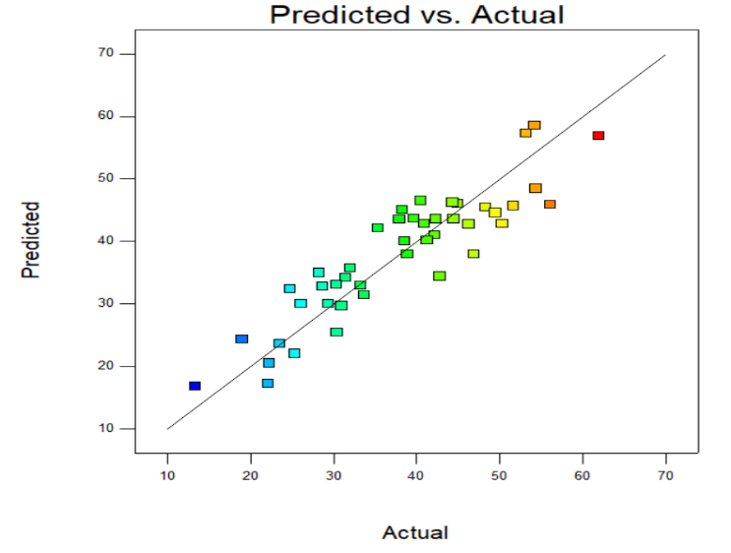
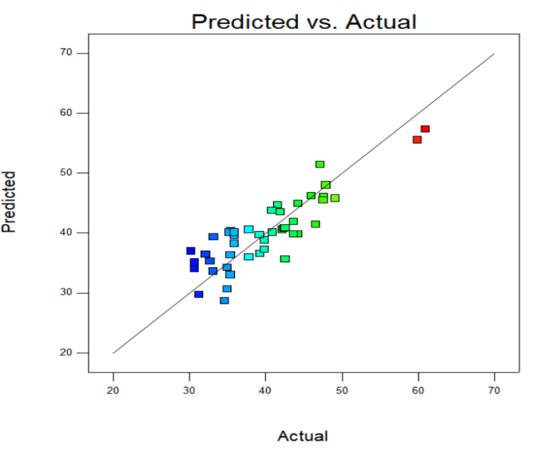
a b

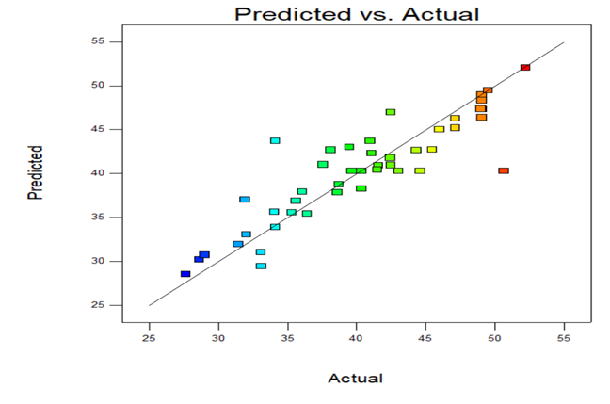
c

Fig.2S. Predicted fatty acid methyl ester yield versus experimental fatty acid methyl ester yield for MNPs-RML (a), MNPs-TLL (b) and MNPs-CALB(c)

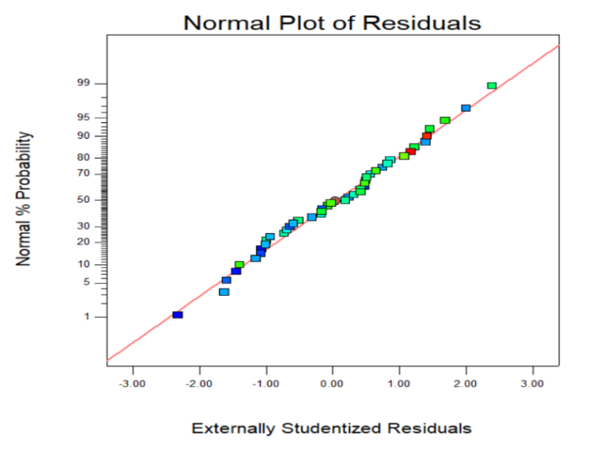
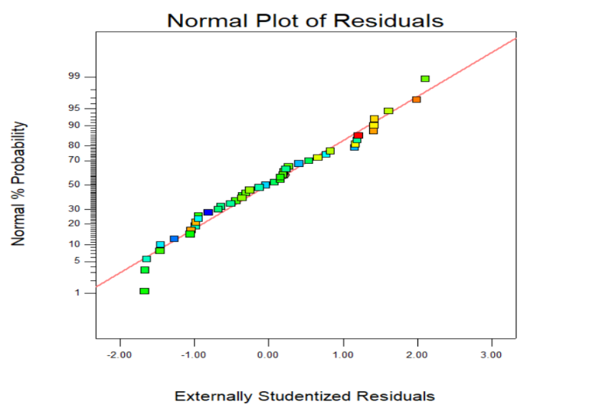
a b

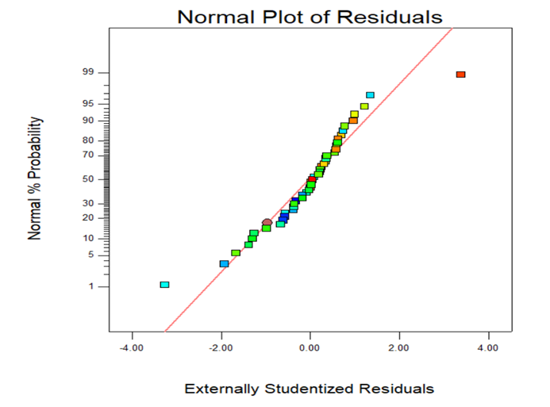
c
Fig.3S. Normal probability plots of residuals for (a) MNPs-TLL (b), MNPs-RML and MNPs-CALB(c).

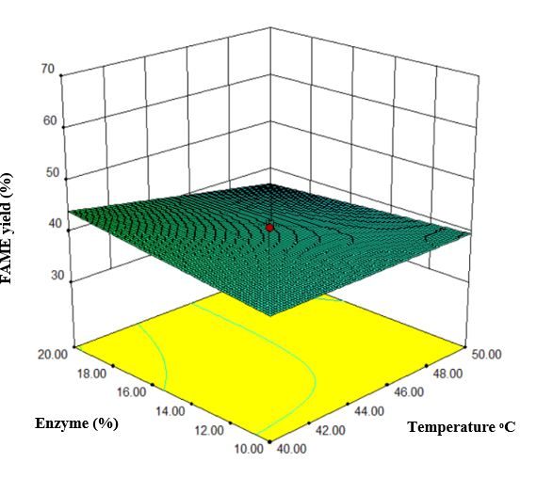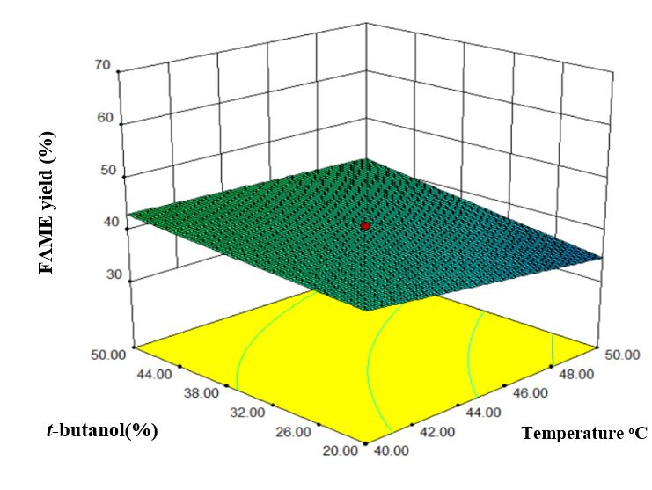

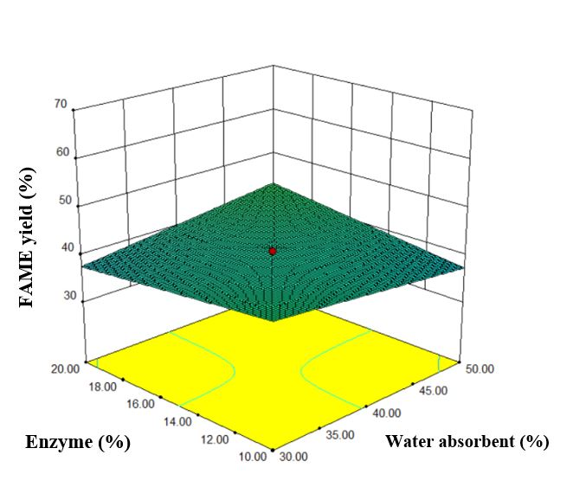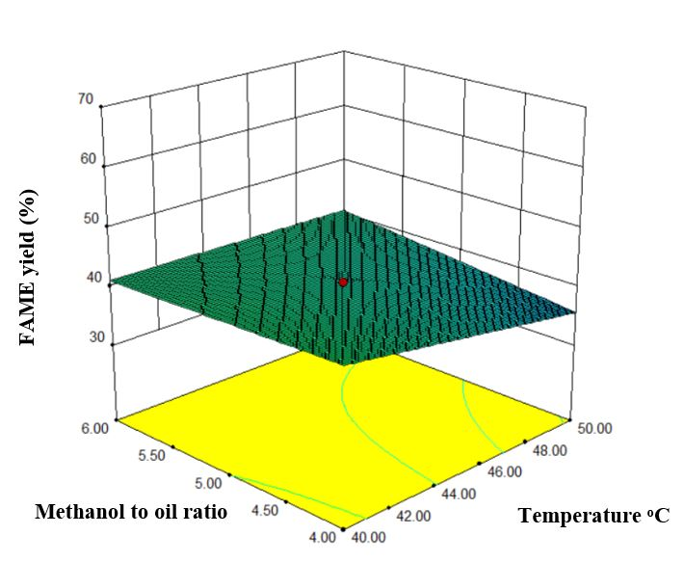

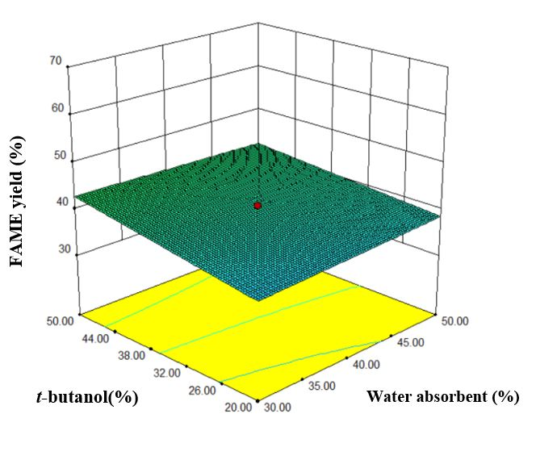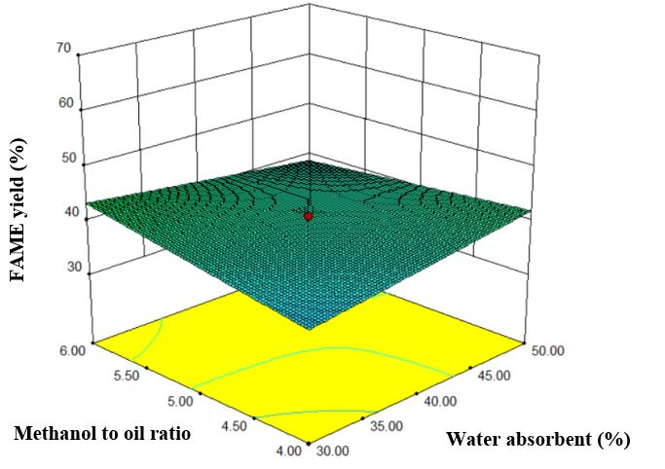
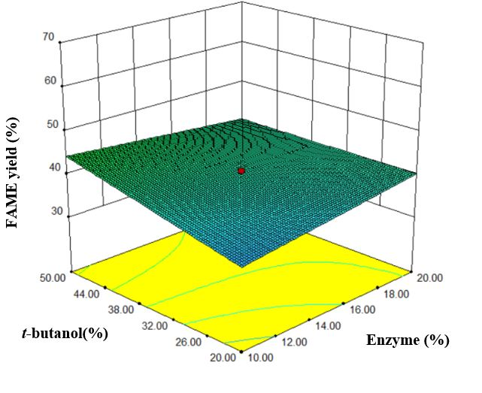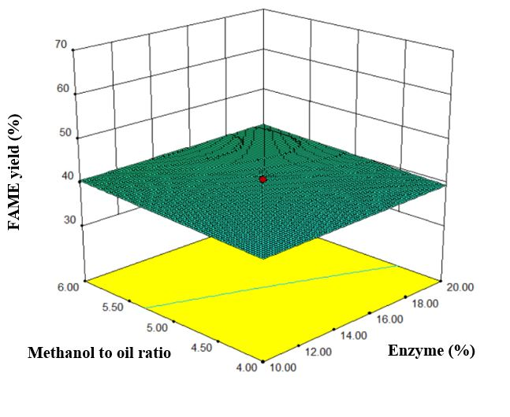

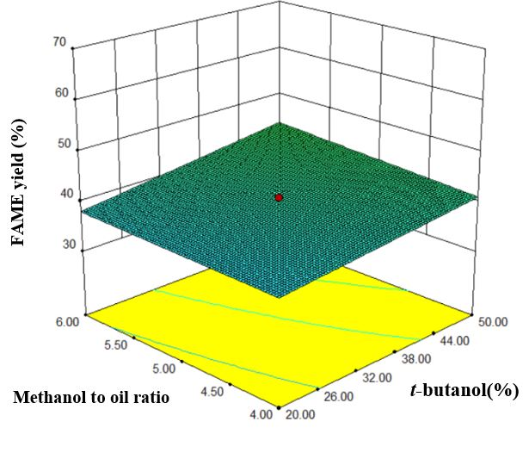

Figure 4S. Response surface curves showing the interactions for RML

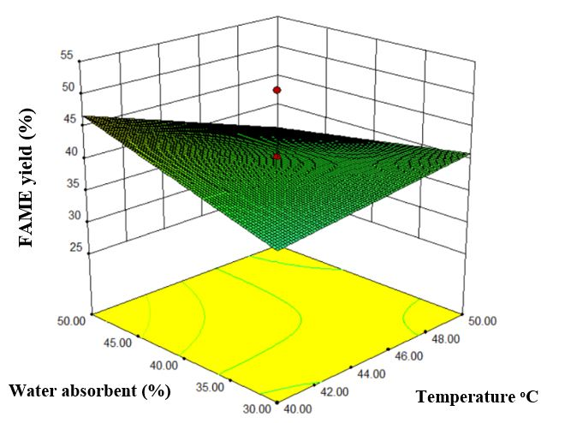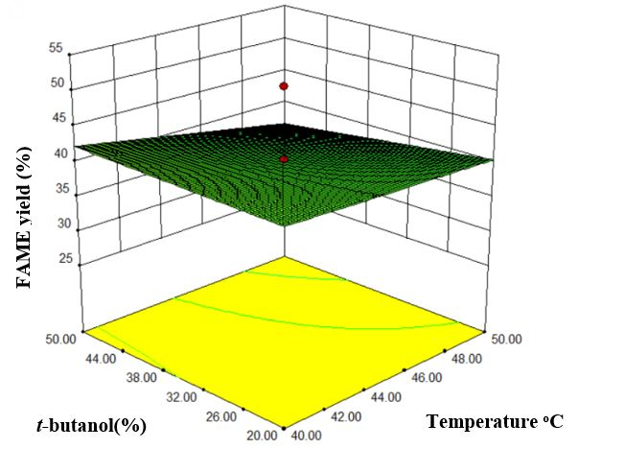

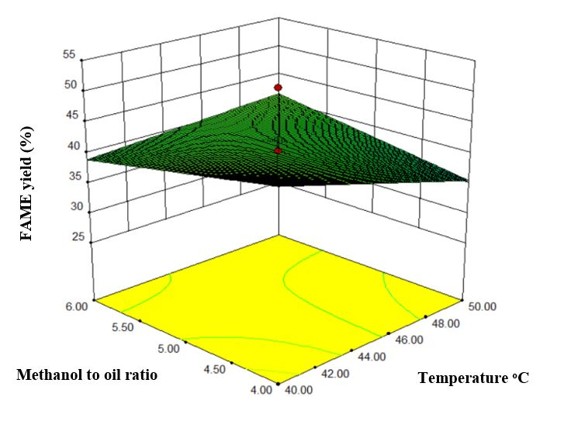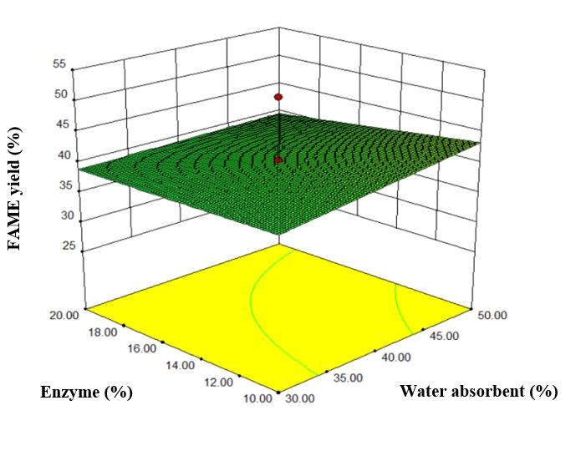

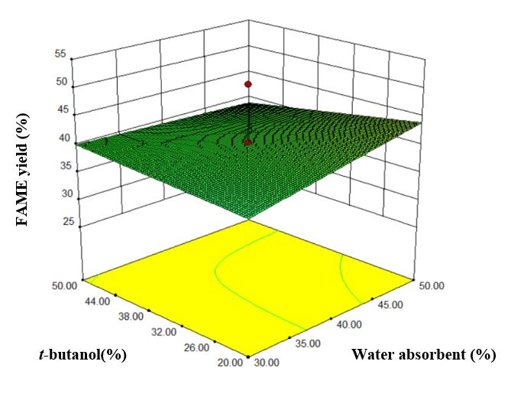
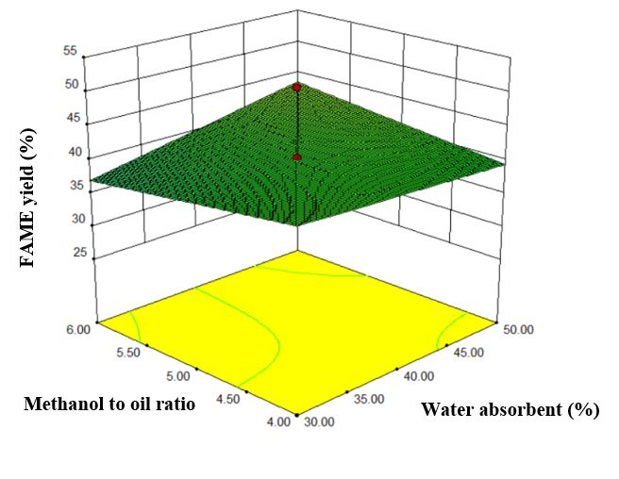
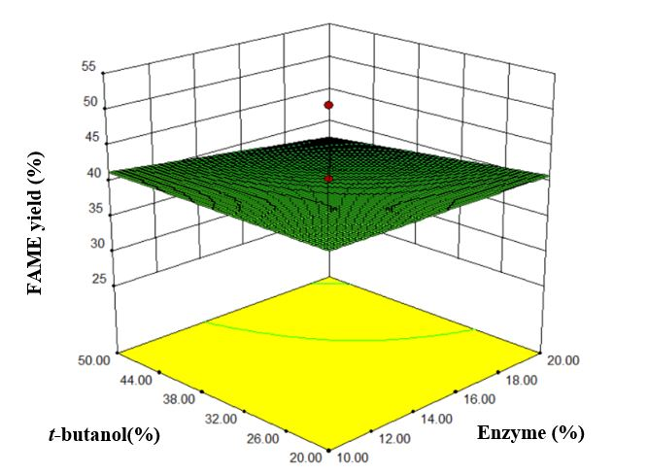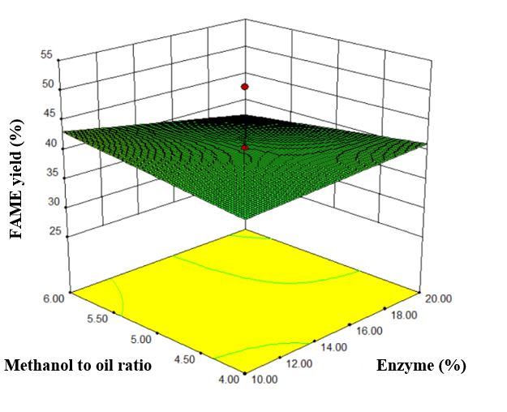

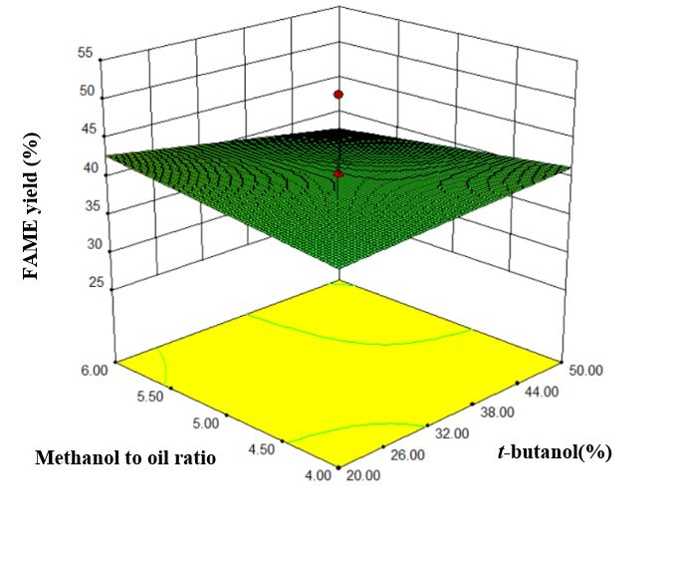

Fig.5S. Response surface curves showing the interactions for CALB

