Automated radiolabeling procedures for the preparation of OncoFAP-based radiopharmaceuticals for cancer imaging and therapy

Francesco Bartoli¹, Philip Elsinga², Luiza Reali Nazario², Aureliano Zana³, Andrea Galbiati³, Jacopo Millul³, Francesca Migliorini³, Samuele Cazzamalli³, Dario Neri^{4,5}, Riemer H.J.A. Slart^{2,6} and Paola Anna Erba^{1,2}

¹Nuclear Medicine, Department of Translational Research and Advanced Technologies in Medicine and Surgery, University of Pisa and Azienda Ospedaliero Universitaria Pisana, 56126 Pisa, Italy; francesco.bartoli@med.unipi.it (F.B.); paola.erba@unipi.it (P.A.E.)

²University of Groningen, University Medical Center Groningen, Medical Imaging Center, Groningen, The Netherlands

³Philochem AG, R&D department, Libernstrasse 3, CH-8112 Otelfingen (ZH), Switzerland

⁴Swiss Federal Institute of Technology, Department of Chemistry and Applied Biosciences, CH-8093 Zurich, Switzerland

⁵Philogen S.p.A., 53100 Siena, Italy

⁶Biomedical Photonic Imaging Group, Faculty of Science and Technology, University of Twente, Enschede, The Netherlands.

Chemical synthesis

All reagents and solvents were purchased from Sigma Aldrich, VWR, CheMatech, and Combi-Blocks and used as supplied.

High Pressure Liquid Chromatography/Mass-Spectrometry (HPLC-MS) spectra presented were recorded on an Agilent 6100 Series Single Quadrupole MS system combined with an Agilent 1200 Series LC, using an InfinityLab Poroshell 120 (EC-C18 column, 4.6 × 50 mm, particle size: 2.7 μm, pore size: 120 Å) at a flow rate of 0.8 mL/ min.

Time (min) | Water + 0.1% HCOOH | ACN + 0.1% HCOOH | Flow (mL/min)
0.00 | 90.0 % | 10 % | 0.800
0.50 | 90.0 % | 10 % | 0.800
3.00 | 0.0 % | 100 % | 0.800
3.50 | 0.0 % | 100% | 0.800

Reversed-phase high-pressure liquid chromatography (RP-HPLC) were performed on an Agilent 1200 Series RP-HPLC with PDA UV detector, using a Synergi MAX-RP (C18 column, 10 × 250 mm, particle size: 10 μm, pore size: 80 Å) at a flow rate of 5 mL/min with linear gradients of solvents A and B (A = Millipore water with 0.1% TFA, B = ACN with 0.1% TFA).

General synthetic scheme of OncoFAP-NOTA
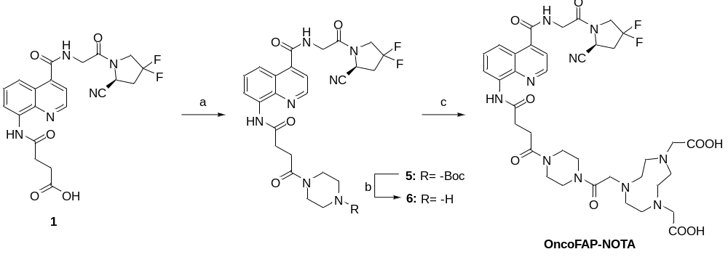

a) N-Boc-piperazine, HATU, DIPEA, DMF, r.t., 30 min; b) TFA/DCM 30% v/v, r.t., 3h; c) NOTA-NHS, DIPEA, DMF, r.t., 1h.

Synthesis of tert-butyl (S)-4-(4-((4-((2-(2-cyano-4,4-difluoropyrrolidin-1-yl)-2-oxoethyl)carbamoyl)quinolin-8-yl)amino)-4-oxobutanoyl)piperazine-1-carboxylate (5)

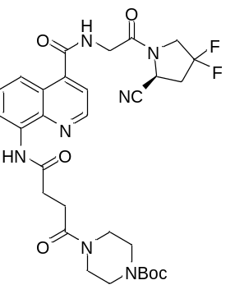

(S)-4-((4-((2-(2-cyano-4,4-difluoropyrrolidin-1-yl)-2-oxoethyl)carbamoyl)quinolin-8-yl)amino)-4-oxobutanoic acid (compound 1) (50 mg, 0.11 mmol, 1 eq), N-Boc-piperazine (24 mg, 0.13 mmol, 1.2 eq) and HATU (49 mg, 0.13 mmol, 1.2 eq) were dissolved in DMF (1 mL). DIPEA (0.08 mL, 0.44 mmol, 4 eq) was added dropwise and the mixture was stirred for 30 min at room temperature. The mixture was purified via RP flash chromatography (Büchi Sepacore 40 µm irregular column) using a gradient of 2:98 to 100:0 ACN + 0.1% HCOOH/water + 0.1% HCOOH in 40 min. The desired fractions were collected and lyophilized to afford a white solid. (40 mg, 58%)
MS (ESI+) m/z 627.9 [M+H]

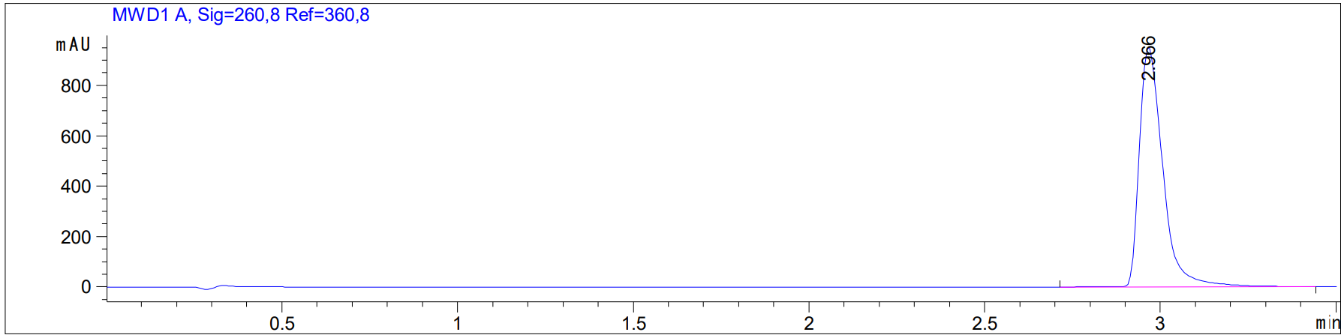

Synthesis of (S)-N-(2-(2-cyano-4,4-difluoropyrrolidin-1-yl)-2-oxoethyl)-8-(4-oxo-4-(piperazin-1-yl)butanamido)quinoline-4-carboxamide (6)

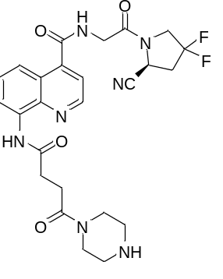

Compound 5 (40 mg, 0,06 mmol, 1 eq.) was dissolved in DCM (1 mL) and TFA (0.5 mL) was added dropwise. The mixture was stirred at room temperature for 3h then solvent was evaporated, and the crude was purified via RP flash chromatography (Büchi Sepacore 40 µm irregular column) using a gradient of 2:98 to 100:0 ACN + 0.1% HCOOH/water + 0.1% HCOOH in 40 min. The desired fractions were collected and lyophilized to afford a colorless oil. (17 mg, 51%)
MS (ESI+) m/z 527.9 [M+H]⁺

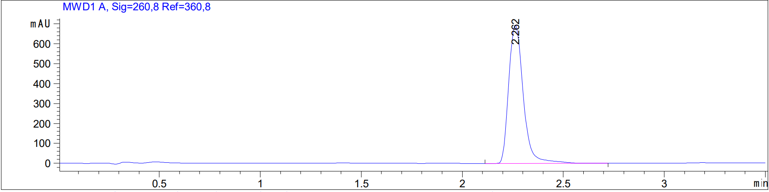

Synthesis of (S)-2,2'-(7-(2-(4-(4-((4-((2-(2-cyano-4,4-difluoropyrrolidin-1-yl)-2-oxoethyl)carbamoyl)quinolin-8-yl)amino)-4-oxobutanoyl)piperazin-1-yl)-2-oxoethyl)-1,4,7-triazonane-1,4-diyl)diacetic acid, OncoFAP-NOTA (4)

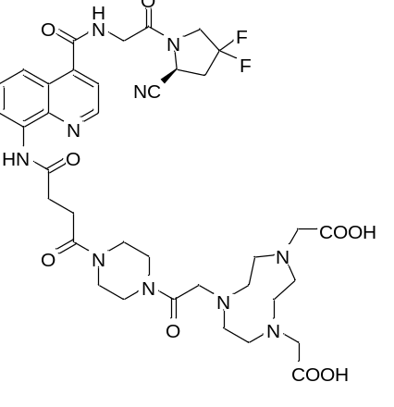

Compound 6 (8 mg, 0.02 mmol, 1 eq) and NOTA-NHS (19 mg, 0.04 mmol, 2 eq) were dissolved in DMF (0.2 mL). DIPEA (0.01 mL, 0.08 mmol, 4 eq) was added to the mixture and stirred for 1h at room temperature. The mixture was purified via RP-HPLC (90:10 to 0:100 water + 0.1% TFA/ACN + 0.1% TFA in 12 min). The desired fractions were collected and lyophilized to afford a white solid. (4 mg, 25%)
MS (ESI+) m/z 812.7 [M+H]⁺

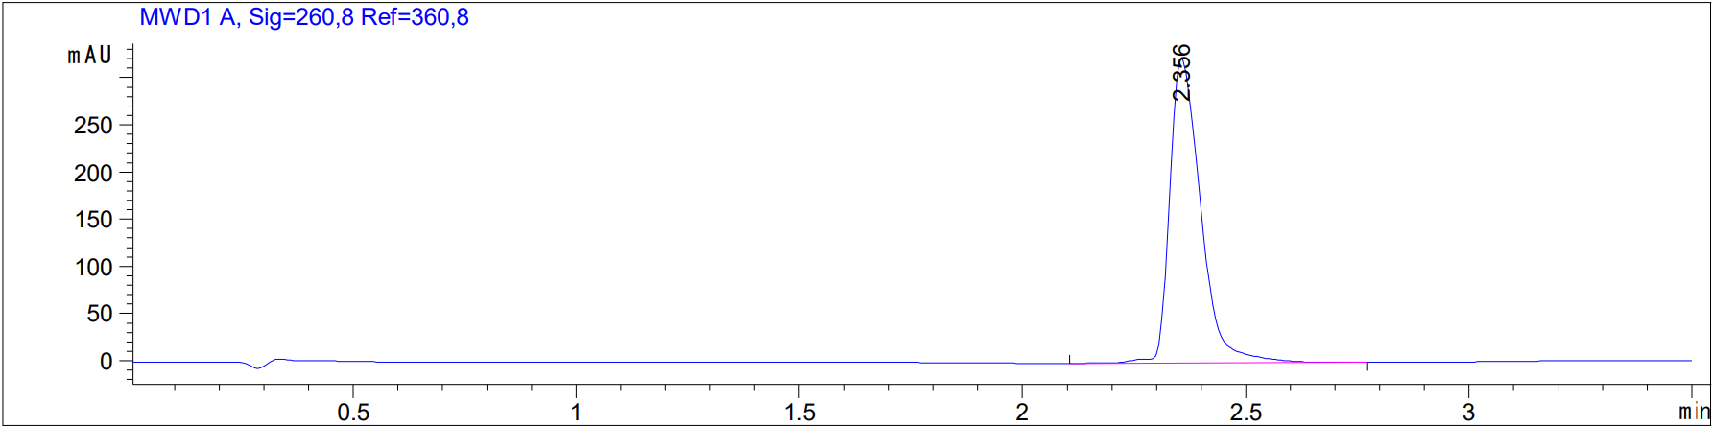

General scheme and synthesis of OncoFAP-NODAGA (3)

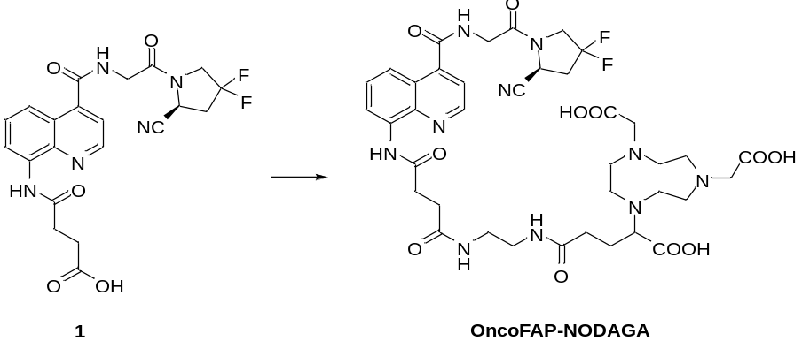

To a solution of compound 1 (50 mg, 0.11 mmol, 1 eq) in dry DMSO (1 mL) were added N-hydroxy succinimide (19 mg, 0.16 mmol, 1.5 eq), HATU (61 mg, 0.16 mmol, 1.5 eq) and DIPEA (57 µL, 0.44 mmol, 4 eq), the mixture at room temperature. After 30 min NODA-GA-NH2 (46 mg, 0.22 mmol, 2 eq) and water (0.3 mL) were added and the mixture was stirred for 2h. The reaction mixture was directly purified via RP-HPLC (90:10 to 0:100 water + 0.1% TFA/ACN + 0.1% TFA in 12 min). The desired fractions were collected and lyophilized to afford a white solid. (30 mg, 32%)
MS (ESI+) m/z 859.4 [M+H]⁺

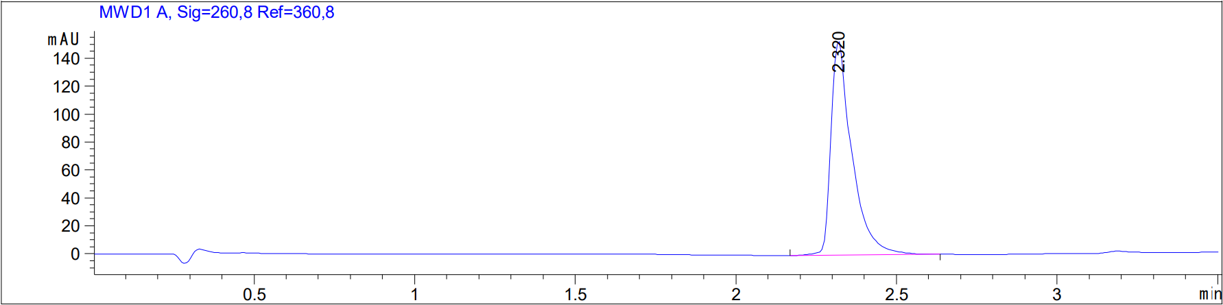

OncoFAP-NODAGA labeling with ¹⁷⁷Lu and characterization

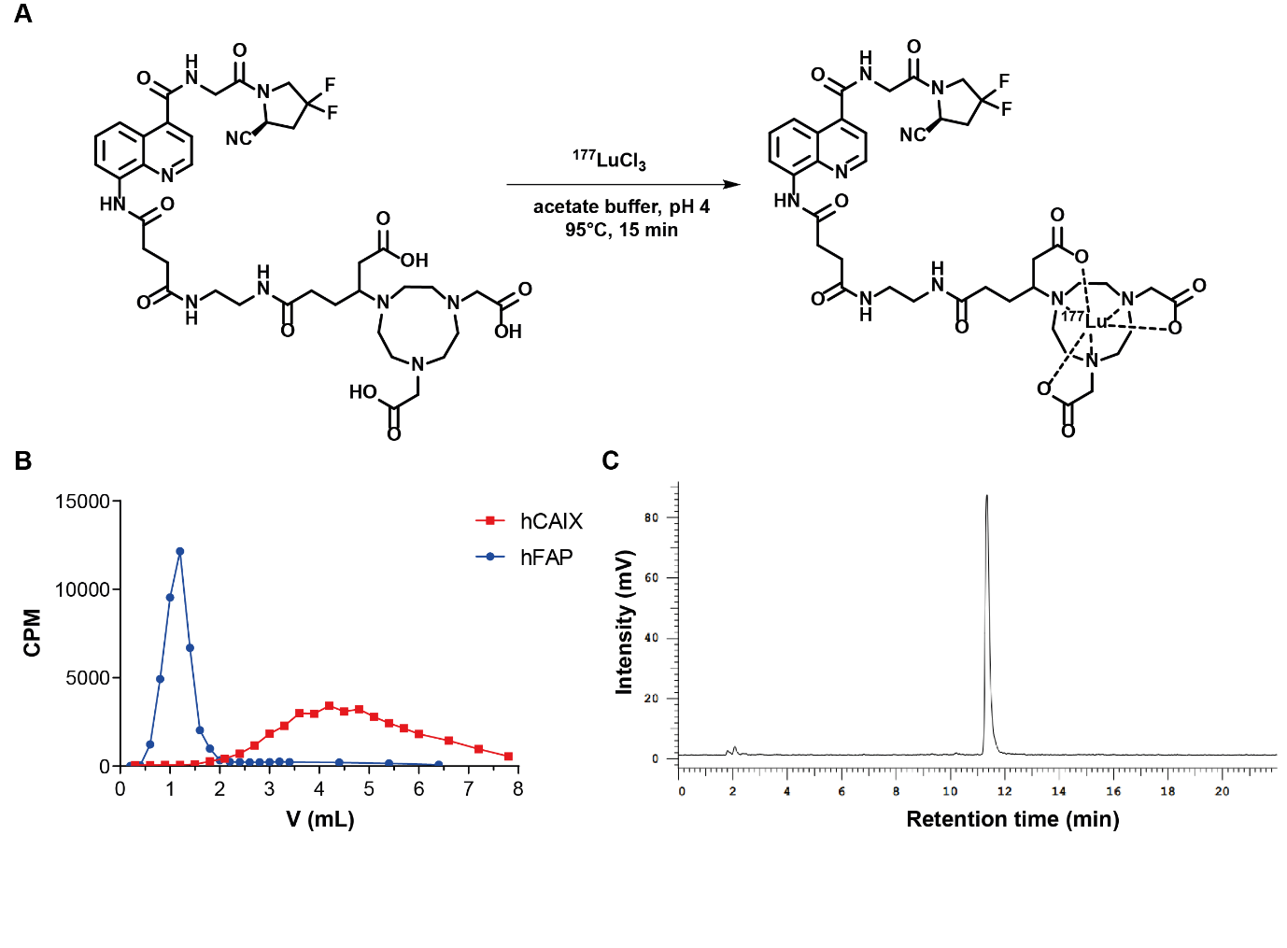
Figure S1. (A) Radiolabeling reaction scheme of OncoFAP-NODAGA with ¹⁷⁷Lu in acetate buffer (pH=4) at 95°C for 15 min. (B) Coelution experiment of [¹⁷⁷Lu]Lu-OncoFAP-NODAGA with hFAP and hCAIX on PD-10 size exclusion chromatography columns. (C) Radio-HPLC analysis performed after labeling reaction.

OncoFAP-NODAGA can be efficiently labeled with ¹⁷⁷Lu by heating at 95°C in acetate buffer (pH=4) for 15 min. [Figure S1A] After labeling with 1 MBq activity the Radio-HPLC trace shows complete incorporation of ¹⁷⁷Lu and a single peak profile (no product degradation observed) [Figure S1B]. The coelution experiment confirms the strong affinity of [¹⁷⁷Lu]Lu-OncoFAP-NODAGA for hFAP, while no significant interaction with hCAIX, as a non-target protein, has been observed. [Figure S1C]

Radiosynthesis of [⁶⁸Ga]Ga-OncoFAP
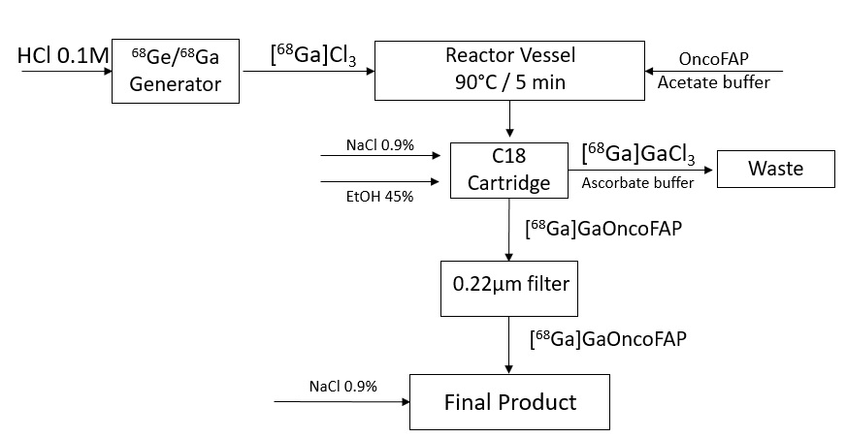
Figure S2. flow chart for radiosynthesis of [⁶⁸Ga]Ga-OncoFAP

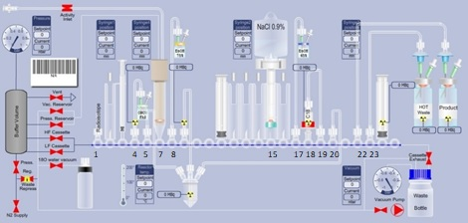
Figure S3. Layout of the cassette for radiosynthesis of [⁶⁸Ga]Ga-OncoFAP derivatives. Position: 1) Generator; 4) Vial containing precursor dissolved in 0.7 M sodium acetate solution (650 µL); 5, 8, 20) Reactor; 7) Awaking solution (75% EtOH); 15) 0.9% NaCl solution; 17) Eluent solution (45% EtOH); 18, 19) C18 cartridge; 22) Product vial; 23) Hot waste.
Radiosynthesis of [¹⁸F]AlF-OncoFAP-NOTA
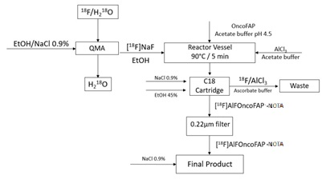

Figure S4. Flow chart for radiosynthesis of [¹⁸F]AlF-OncoFAP

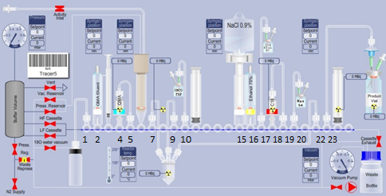
Figure S5. Layout of the cassette for radiosynthesis of [¹⁸F]AlF-OncoFAP-NOTA; 1) Recovery H₂¹⁸O; 2) QMA Eluent; 4,5) QMA cartridge; 6) Conical vial connected to vial with ¹⁸F; 7, 9, 22) Reactor; 10) OncoFAP-NOTA solution dissolved in acetate buffer pH 4.1; 15) 0.9% NaCl solution; 16) Awaking solution (75% EtOH); 17) Eluent solution (45% EtOH); 18-19) C18 cartridge; 20) Hot Waste; 22) Product Vial.
Radiosynthesis of [¹⁷⁷Lu]Lu-OncoFAP-DOTAGA
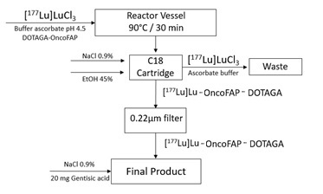
Figure S6. Flow chart for radiosynthesis of [¹⁷⁷Lu]Lu-OncoFAP-DOTAGA

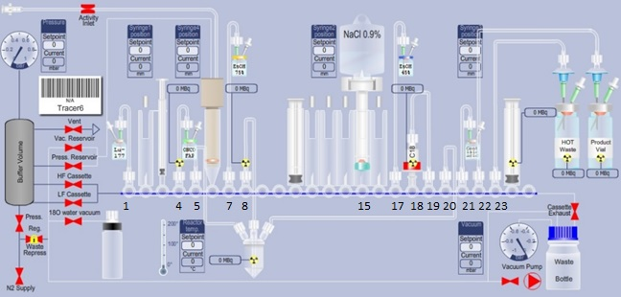
Figure S7. Layout of the cassette for radiosynthesis of [¹⁷⁷Lu]Lu-OncoFAP-DOTAGA; Position: 1). Vial of ¹⁷⁷Lu in acetate buffer pH 4.5; 4) OncoFAP-DOTAGA in acetate buffer pH 4.5; 5, 8, 20) Reactor; 7) Awaking solution (75% EtOH); 15) 0.9% NaCl solution; 16) Awaking solution (75% EtOH); 17) Eluent solution (45% EtOH); 18,19) C18 cartridge; 21) Gentisic Acid dissolved in 0.9% NaCl solution; 22) Product vial; 23) Hot Waste.

Radio-HPLC analysis before and after labelling reaction of [⁶⁸Ga]Ga-OncoFAP-DOTAGA
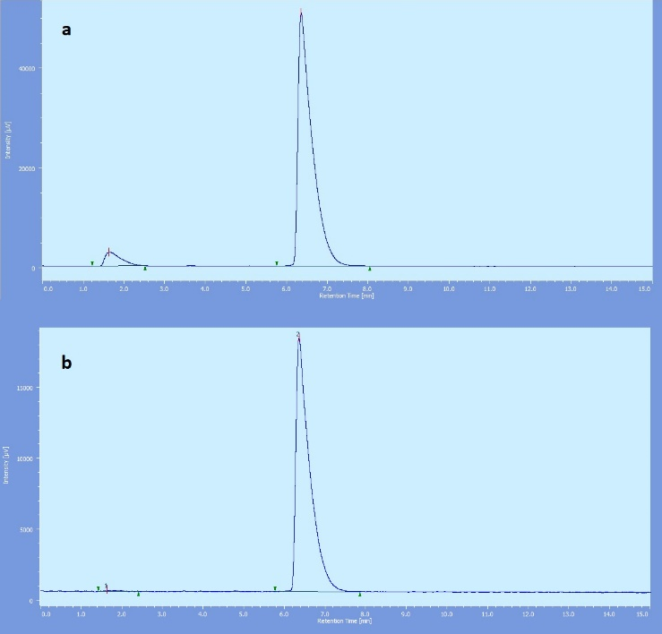
Figure S8. Radio-HPLC trace performed after radiosynthesis of [⁶⁸Ga]Ga-OncoFAP-DOTAGA (A) before purification with C18 cartridge and (B) after purification with C18.

Radio-HPLC analysis after labelling reaction of [⁶⁸Ga]Ga-OncoFAP-NODAGA with simple kit
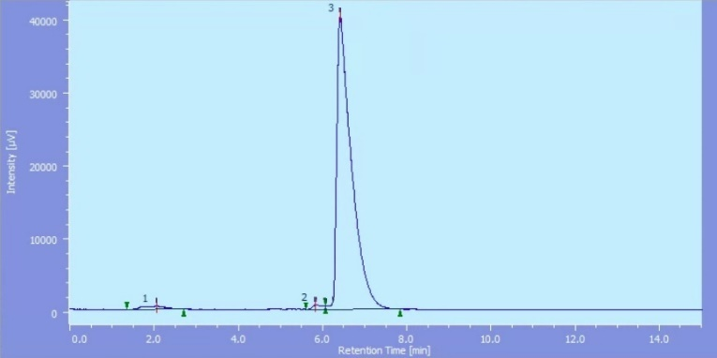
Figure S9. Radio-HPLC on simple preparation of [⁶⁸Ga]Ga-OncoFAP-NODAGA.

Radio-HPLC analysis after labelling reaction of [¹⁷⁷Lu]Lu-OncoFAP-DOTAGA
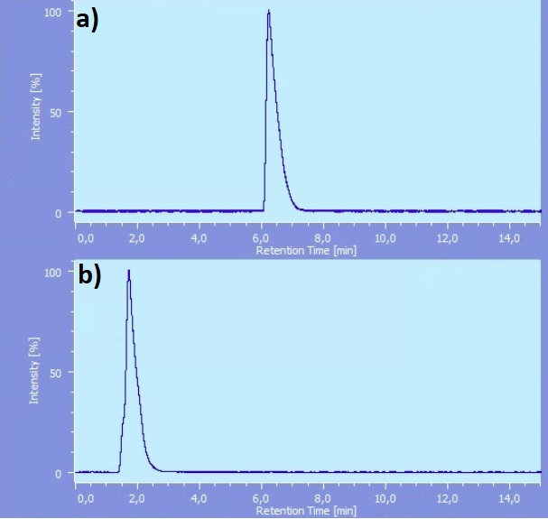
Figure S10. Radio-HPLC trace performed after radiosynthesis of [¹⁷⁷Lu]Lu-OncoFAP-DOTAGA (A) product (B) “Hot” waste of the synthesis
Assessment of in vitro lipophilicity
Product | LogP | LogD_{7.4}
[⁶⁸Ga]Ga-OncoFAP-NOTA | -2.38± 0.11 | -2.19± 0.11
[⁶⁸Ga]Ga-OncoFAP-NODAGA | -2.68± 0.14 | -2.48± 0.09
[⁶⁸Ga]Ga-OncoFAP-DOTAGA | -2.57± 0.15 | -2.39 ± 0.12
[¹⁸F]AlF-OncoFAP-NOTA | -2.15± 0.18 | -2.01± 0.25
[¹⁸F]AlF-OncoFAP-NODAGA | -3.02± 015 | -2.88±0.16
[¹⁷⁷Lu]Lu-OncoFAP-DOTAGA | -2.01± 0.08 | -1.85± 0.05

Table S1. LogP and LogD_{7.4}

Co-elution experiments of [⁶⁸Ga]Ga-OncoFAP-NOTA; [⁶⁸Ga]Ga-OncoFAP-NODAGA, [¹⁷⁷Lu]Lu-OncoFAP-DOTAGA and [¹⁸F]AlF-OncoFAP-NOTA with hFAP
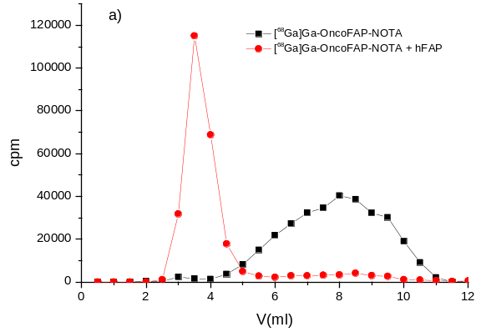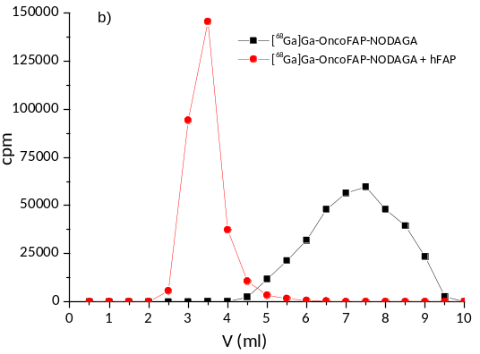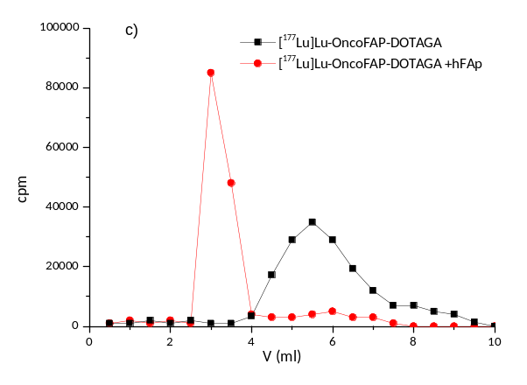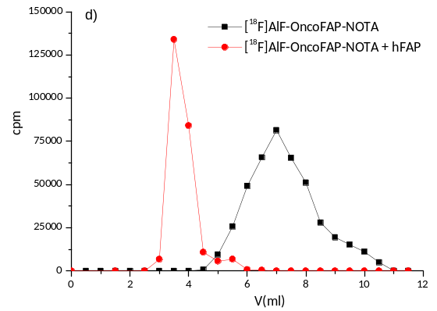
Figure S11. Co-elution experiment of radiolabelled preparations of (A) [⁶⁸Ga]Ga-OncoFAP-NOTA; (B) [⁶⁸Ga]Ga-OncoFAP-NODAGA (C) [¹⁷⁷Lu]Lu-OncoFAP-DOTAGA (D) [¹⁸F]AlF-OncoFAP-NOTA with hFAP and without hFAP on PD-10 size exclusion chromatography columns.

