Table 3 Summary of three-dimensional greening forms
Three-dimensional greening form | Concept | Features | Greenway | Real picture
Green Roof | A green form in which plants cover the top surface of a structure or building (Xiaoying, 2015). | - Alleviate the contradiction between building facilities and green space  - Improve urban green coverage | ①Covered  ②Planting  ③Garden style | 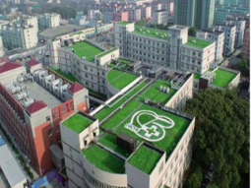
green wall | Use plants to climb or attach to the facade of the building(Qiming, 2019). | - Vacuuming and noise reduction  - Add architectural art effects | ①Wall top flower trough  ②Wall flower bucket | 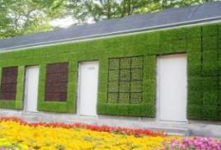
Balcony greening | Use plants to embellish buildings and play a role in decorating buildings(Qiming, 2019). | - Dress up balcony  - Purifying air | ①Screen type  ②Ladder type  ③Wrapped  ④Hanging type | 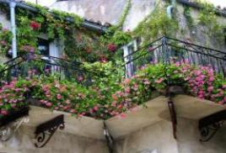
Three-dimensional flower bed greening | A hybrid of building materials and plant materials(Qiming, 2019). | - Make the most of space  - Strengthen the greening effect | ①Architectural landscaping  ②Plant landscaping | 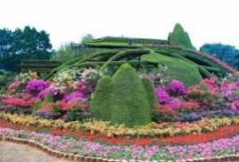
Green trellis | Use climbing plants to attach to a structure to form(Yue Yin, 2019). | - Divide space  - Rich in shape  - Add aesthetic effect | ①Bamboo rope structure  ②Masonry concrete structure  ③Mixed structure class | 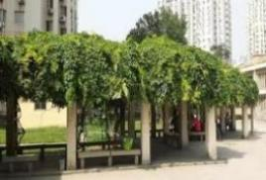
Slope greening | Using plants to protect the greening forms of slopes and sections with a certain drop(Jianhua, Zhen and Lianfang, 2018). | - Wide applicability  - Good protection effect  - Simple construction | ①Slope type  ②Covered  ③Natural | 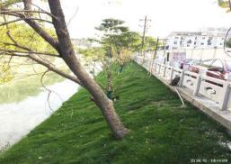
green fence | A greening method in which plants grow with the help of railings and divide the space range(Qiming, 2019). | - Separate space  - Protective effect | ①Natural  ②Regular | 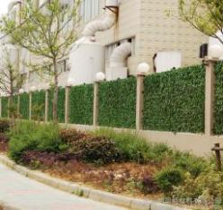

Table 6 Plants commonly used in traditional greening systems(Note: The distribution range of this table is limited to the distribution area, and does not mean the origin)

Plant type | Environmental requirements | Height | Distribution area
Latin name: Hedera helix var. cavendishii K. Koch.  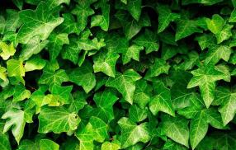 | - Likes warm and humid, strong cold resistance  - Likes moist, loose, fertile soil, not salt-alkali-tolerant. | - | China, Vietnam, etc.
Latin name: Campsis grandiflora (Thunb.) Schum.  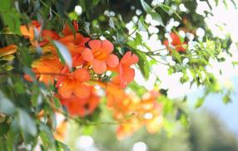 | - Strong in nature, warm in nature  - Grows in full sun, but is also more shade tolerant  - Deep, fertile, well-drained slightly acidic soil is preferred | - | China, Japan, etc.
Latin name: Parthenocissus tricuspidata (Sieb.et Zucc.)  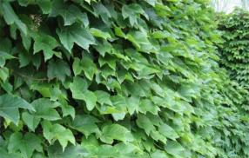 | - Often climbs in sparse woods, walls and rocks | - | China, etc.

Table 7 Plants commonly used in modular greening systems(Note: The distribution range of this table is limited to the distribution area, and does not mean the origin)
Plant type | Plant traits | Environmental requirements | Growth height(m) | Distribution area
Latin name: Sedum lineare Thunb.  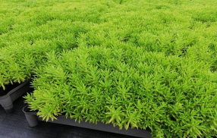 | - Crassulaceae perennial herb, glabrous | - Can grow on thinner substrates  - It has strong drought resistance and strong cold resistance. | 0.1-0.2 | China, Japan, etc.
Latin name: Sedum sarmentosum Bunge  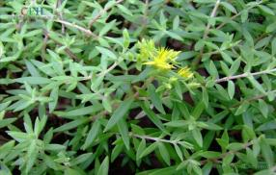 | - Perennial herbaceous succulents | - Sexual preference warm, humid, semi-shady environment, strong adaptability  - It is more drought-tolerant and cold-resistant, and does not choose soil. It grows better in loose sandy loam.  - Not strict with light requirements | - | China, etc.
Latin name: Sedum aizoon L.  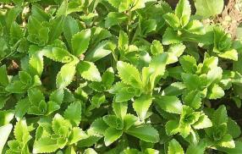 | - Perennial herb | - Positive plant, slightly shade tolerant, cold hardy  - Resistant to drought and barrenness, it can grow vigorously on hillside rocks and wasteland. | 0.5 | China, Japan, North Korea, etc.

Table 8 Plants commonly used in paving greening systems(Note: The distribution range of this table is limited to t he distribution area, and does not mean the origin)
Plant type | Environmental requirements | Height(m) | Distribution area
Latin name: Ophiopogon japonicus(Linn. f.) Ker-Gawl.  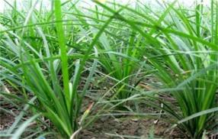 | - Likes warm and moist.  - The growing process requires a large amount of water and requires sufficient light.  - It is suitable for slightly alkaline sandy loam with loose soil, fertile moist and well-drained soil. | - | China, Japan, Vietnam, India, etc.
Latin name: Lolium perenne L.  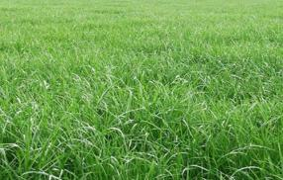 | - Prefers cool and humid climate.  - Cold and heat resistance are poor, not shade.  - More tolerant to humidity, not drought tolerant.  - Intolerant of soil fertility. | 0.3-0.9 | Pakistan, Europe, warm temperate Asia, northern Africa, etc.
Latin name: Nephrolepis biserrata (Sw.) Schott  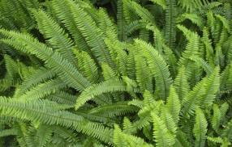 | - Likes a cool environment and can adapt to large temperature changes.  - Can withstand high humidity | - | China, Japan, India, Indochina, etc.

Table 9 Plants commonly used in planting trough greening systems
Plant type | Environmental requirements | Height(m) | Distribution area
Latin name: Epipremnum aureum  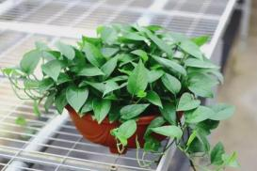 | - Hot and humid environment, avoid direct sunlight, like shade  - Likes humus-rich, loose and fertile, slightly acidic soil | 0.3-0.4 | China, tropical regions of Asia, etc.
Latin name: TradescantiazebrinaBosse  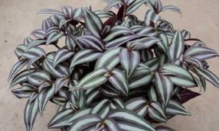 | - Intolerant of cold, afraid of heat  - Intolerant of drought and moisture | - | China, etc.
Latin name: Ipomoea batatas 'Golden Summer'  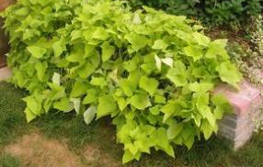 | - Good heat resistance, rapid growth in midsummer, not cold-resistant | - | Central America etc.

Table 10 Plants commonly used in planting trough greening systems
Plant type | Environmental requirements | Height(m) | Distribution area
Latin name: Bidensalba(L.) DC.  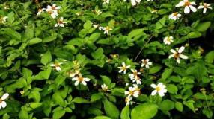 | - Kimitsu.  - Cultivated in loose, breathable, soft, sandy loam rich in organic matter. | 0.3-1 | East China, Central South, Southwest China and Tibet, etc.
Latin name: Tulbaghia violacea  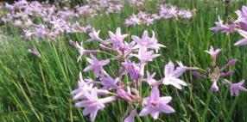 | - Kimitsu.  - Likes high temperature, heat resistance.  - Not strict on soil, resistant to barrenness. | 0.3-0.5 | South Africa, Jiangsu, China, etc.
Latin name: Alopecurus aequalis Sobol.  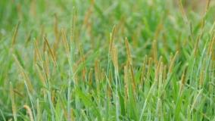 | - Likes cold and humid climates, not resistant to drought and heat.  - Cold resistance, antifreeze.  - Clay loam that prefers moist and organic matter content. | 0.15-0.4 | Cold and warm regions of China and Eurasia and North America, etc.

