Supplemental Information
Fig. 1 Asthma patient information.
Fig. 2 Flow cytometry gating strategies for mouse eosinophils and ILC2s.
Fig. 3 Exogenous rIL-33 supplementation blunts the alleviation of inflammation observed in Gsdmd-/- mice.
Fig. 4 Construction of airway epithelial cell lines constitutively expressing IL-33 or Gsdmd.
Fig. 5. IL-33 is expressed in murine type 2 airway epithelial cells.
Fig. 6 Papain stimulation generated a p35 hNT-GSDMD fragment that promoted IL-33 release.
Fig. 7 The truncated amino acid fragment 1-290 hNT-GSDMD promoted IL-33 release in human cells.

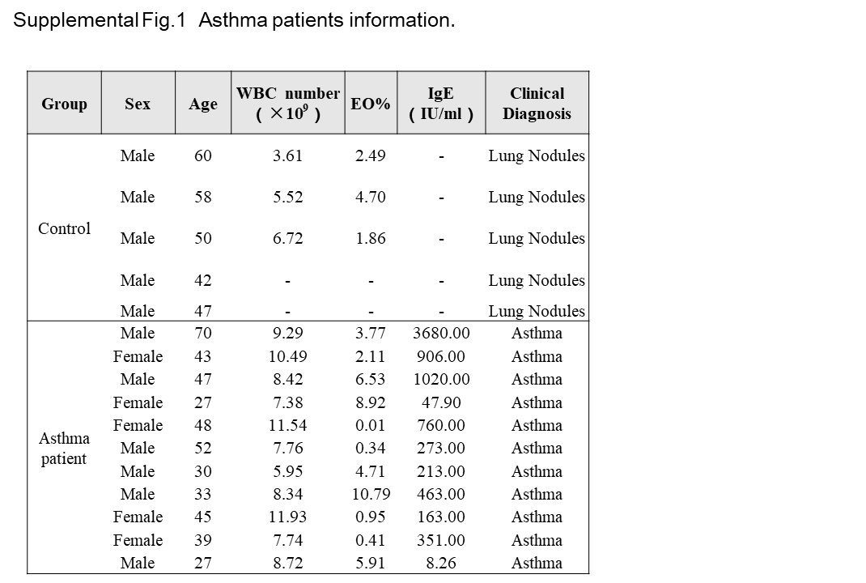
Supplementary Figure 1. Asthma patient information.
WBC: White blood cells; EO%: percentages of eosinophils.

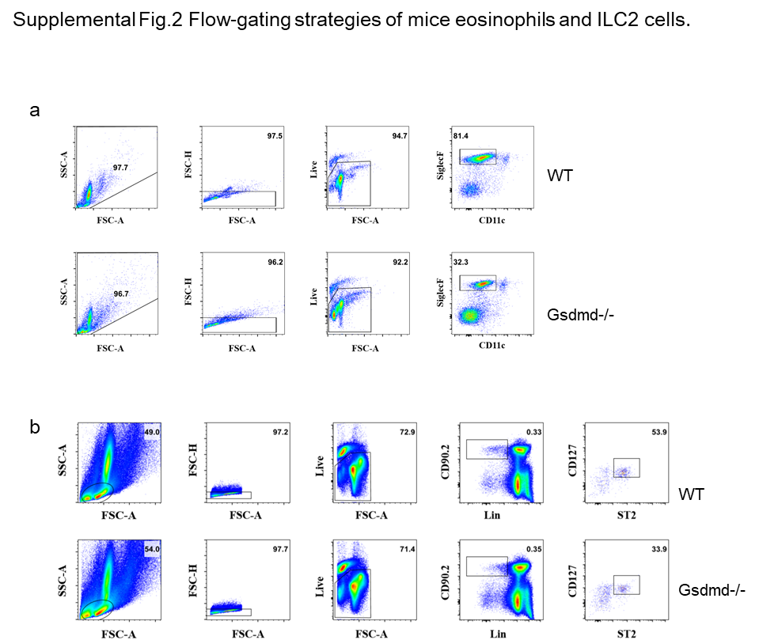
Supplementary Figure 2. Flow cytometry gating strategies for mouse eosinophils and ILC2s after 3 weeks of HDM exposure. a. Representative flow cytometry gating scheme for Siglec F⁺CD11c⁺ eosinophils in the bronchoalveolar lavage fluid (BALF) of WT C57BL/6 mice and Gsdmd-/- mice. b. Gating strategy for Lin⁻CD90.2⁺ST2⁺ ILC2s in the lungs.

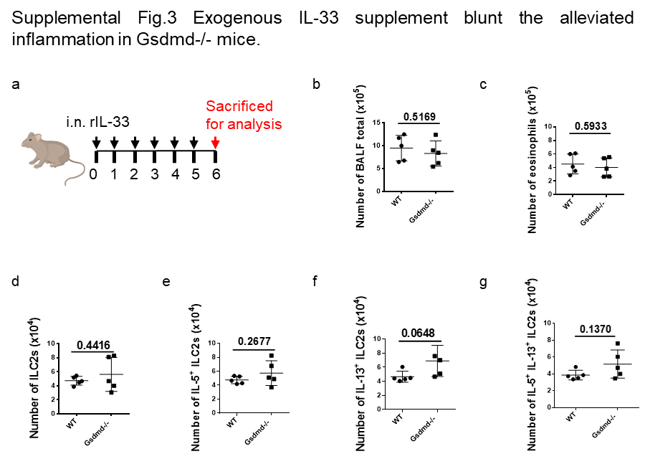
Supplementary Figure 3. Exogenous IL-33 supplementation blunts the alleviation of inflammation in Gsdmd-/- mice. a. Scheme for inducing acute airway inflammation in Balb/c mice intraperitoneally injected with recombinant murine IL-33. Mice were sacrificed for analysis 5 days after the first exposure. b-g. Flow cytometry was used to analyse total cell numbers in the BALF of mice treated as in (a). The numbers of SiglecF⁺CD11c– eosinophils in the BALF (c), Lin–CD90.2⁺ST2⁺ ILC2s (d), and numbers of IL-5⁺ (e), IL-13⁺ (f), and IL-5⁺ IL-13⁺ cells (f) in the Lin–CD90.2+ST2+ ILC2S population were determined by flow cytometry after papain exposure. Each point represents one mouse, and 5-6 mice were used per group. Results are depicted as the mean ± SEM. *P < 0.05, **P < 0.01, ***P < 0.001, and ****P < 0.0001 using the Mann-Whitney test.
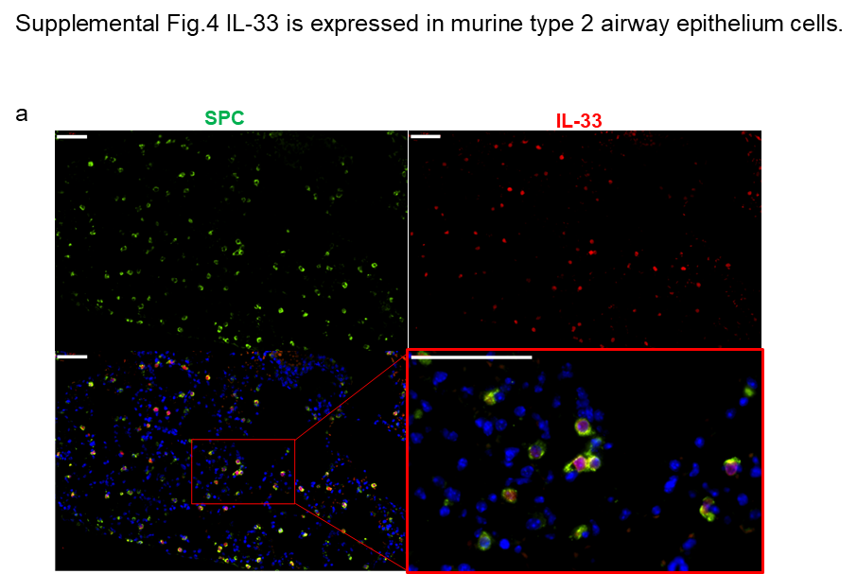
Supplementary Figure 4. IL-33 is expressed in murine type 2 airway epithelial cells. a. Microscopy imaging of immunofluorescence (IF) staining of SPC (green)-expressing AT2 cells and IL-33 (red)-expressing cells in bronchial tissue from WT Balb/c mice without any stimulation. Scale bars (a, c), 50 μm.

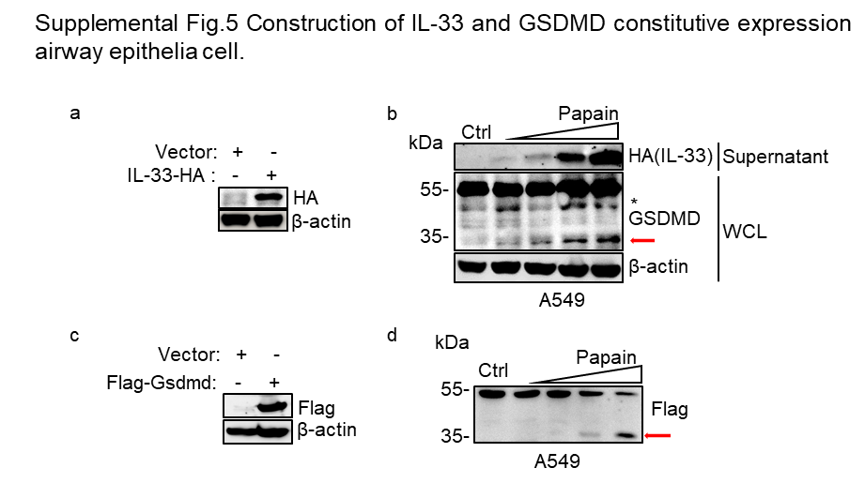
Supplementary Figure 5. Construction of airway epithelial cells constitutively expressing IL-33 and GSDMD. a. Immunoblot analysis of whole-cell lysates of C-terminal HA-tagged IL-33-expressing A549 cells constructed with a lentiviral overexpression vector. b. Immunoblot analysis of whole-cell lysates and cell culture supernatants of constructed IL-33-expressing A549 cells (a) after treatment with different doses of papain (0 µg, 1 µg, 5 µg, and 10 µg per well in 24-well plates with a cell density of 80%). c. Immunoblot analysis of N-terminal Flag-tagged GSDMD-expressing epithelial A549 cells constructed with lentiviral infection. d. Immunoblot analysis of A549-flag-GSDMD cells exposed to different concentrations of papain (0 µg, 5 µg, 10 µg and 50 µg per well) for 30 min. The red arrow indicates the activated form of Gsdmd. Asterisk-marked nonspecific fragments were not discussed in our work.

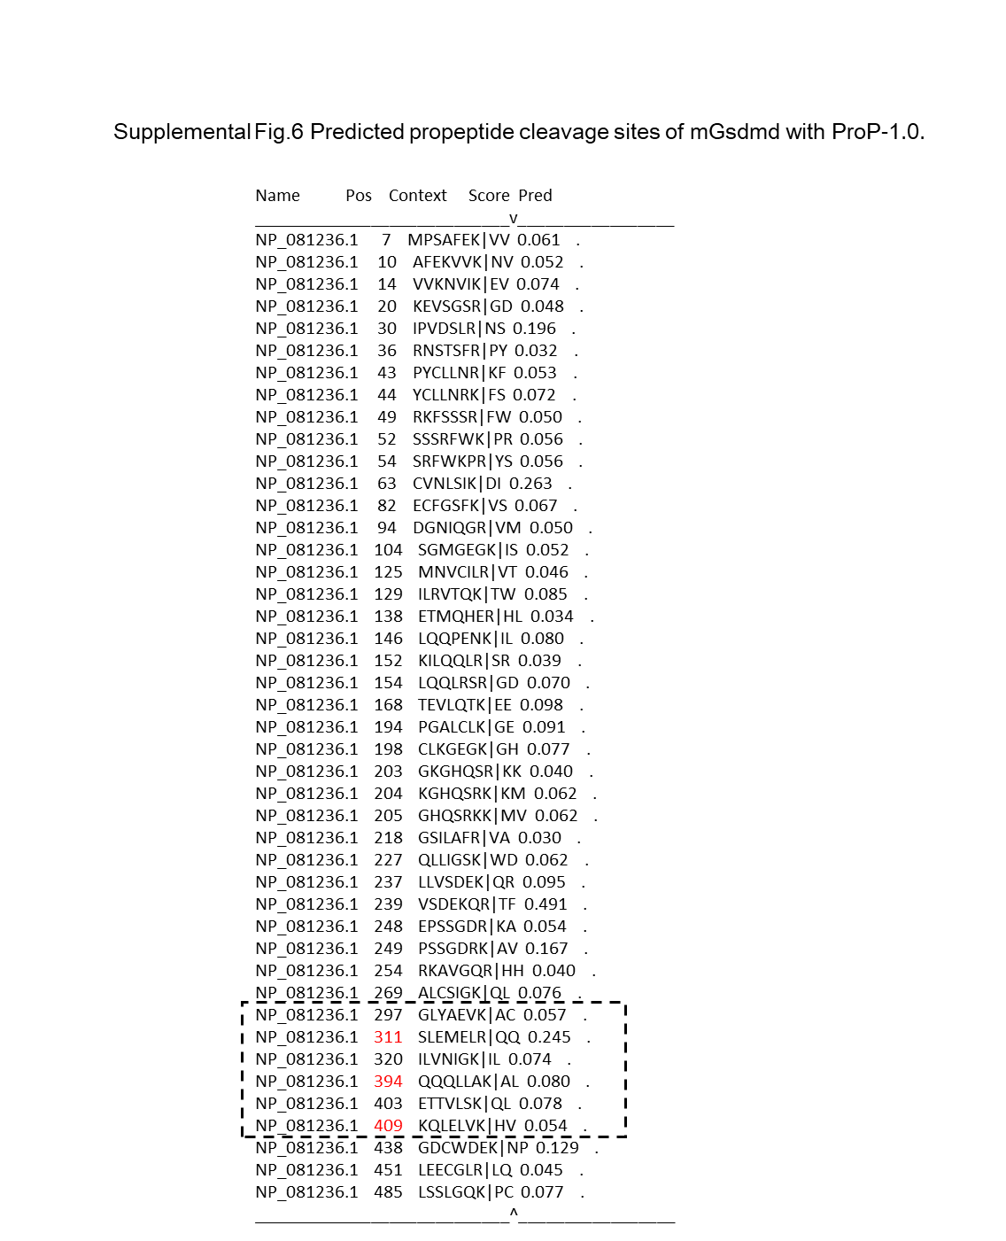
Supplementary Figure 6. Pro-peptide cleavage sites in mGsdmd predicted with ProP-1.0. The amino acid sequence of murine Gsdmd was analysed with the online pro-protein conversion prediction tool ProP-1.0 to predict possible cleavage sites (https://services.healthtech.dtu.dk/service.php?ProP-1.0). The predicted cleavage sites with different cleavage scores are presented in the figure. The black dashed box indicates sites that are possible in the predicted p40 fragment, and red sites were chosen for functional analysis.
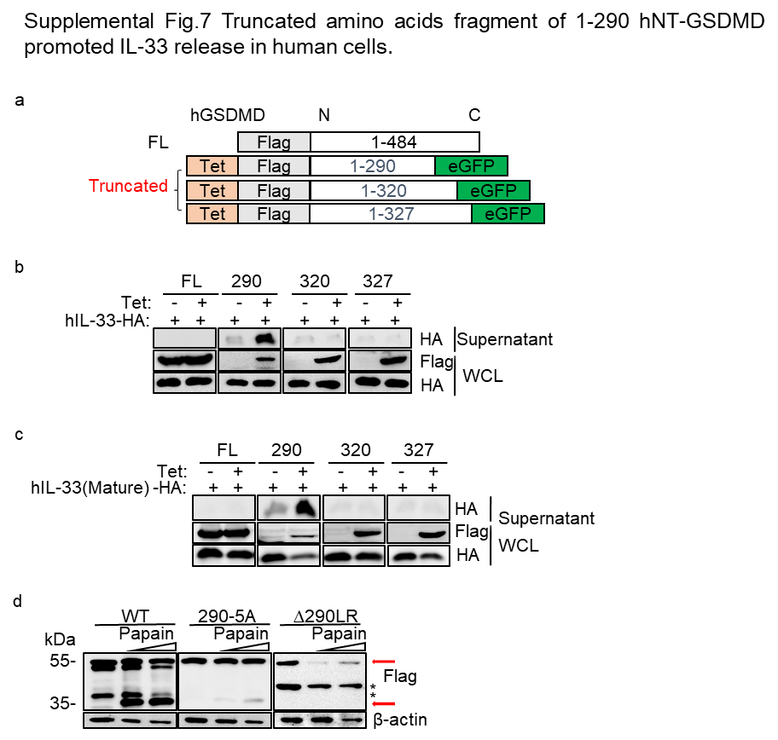
Supplementary Figure 7. The truncated fragment 1-290 hNT-GSDMD promoted IL-33 release in human cells. a. Truncation scheme for hGSDMD with N-terminal Flag-tagged fragment expression vectors. A tetracycline-responsive element sequence was added to control the expression of the hGSDMD fragments. b. Different truncated hGSDMD fragments were co-expressed with human C-terminal HA-tagged full-length IL-33 in HEK293T cells, and whole-cell lysates and cell culture supernatants were collected for immunoblot analysis 12 hours after the cells were induced with tetracycline (2 µg/ml). c. Different truncated hGSDMD fragments were co-expressed with the human C-terminal HA-tagged mature form of IL-33 in HEK293T cells, and whole-cell lysates and cell culture supernatants were collected for immunoblot analysis 12 hours after the cells were induced with tetracycline (2 µg/ml). d. hGSDMD-/- HeLa cells were transfected and subsequently expressed the indicated mutant forms of full-length hGSDMD with an N-terminal Flag tag, and whole-cell lysates were collected for immunoblot analysis after exposure to different doses of papain for 1 hour. 290-5A represents the substitution of 5 amino acids around residue 290 (GLRAE) to AAAAA in the Flag-tagged WT full-length hGSDMD sequence; R290A indicates a hGSDMD mutant containing the substitution of arginine at position 290 with alanine; ∆290LR represents full-length hGSDMD with deletion of the amino acids arginine and leucine in positions 289 and 290.

