Supplement figure
Fig. 1 Compared with normal tissues, regardless of race, gender, and age (41-60, 61-80, 81-100), the expression of SSBP1 increased
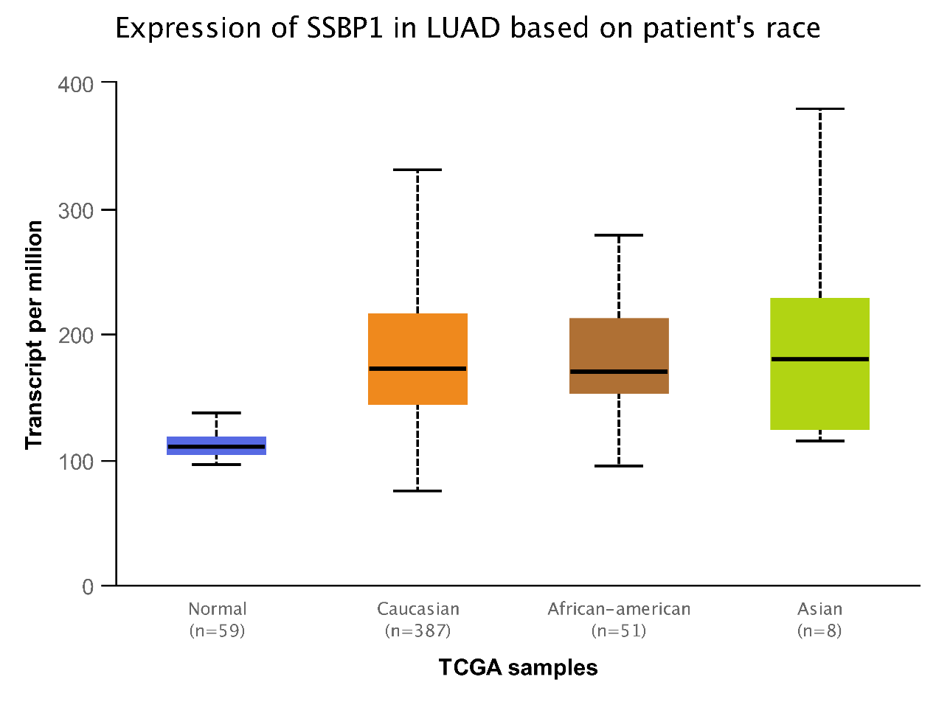
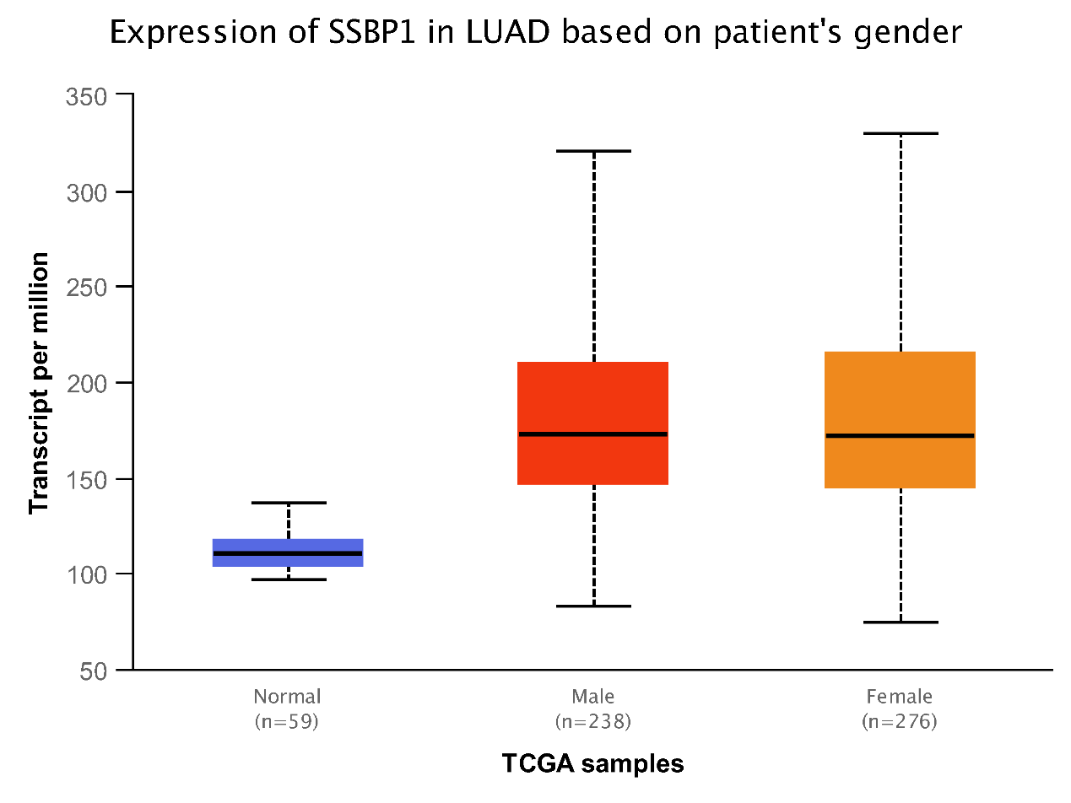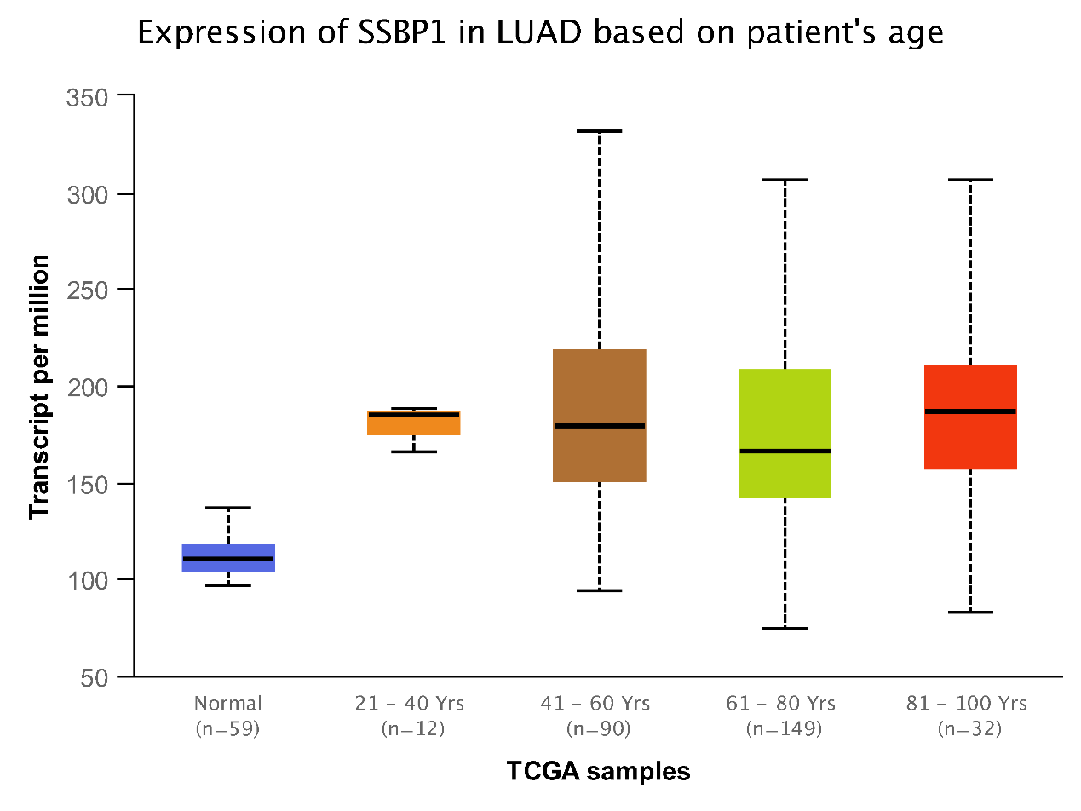

Fig. S2 the landscape of correlation between SSBP1 expression and 28 TILs across multiple cancer types based on the TISIDB database
