FBXL17/spastin axis as a novel therapeutic target
of hereditary spastic paraplegia
Hyun Mi Kang¹, Mijin Kim^{1,3}, Yoohong Min^{1,4}, Bohyeon Jeong^{1,2}, Kyung Hee Noh¹, Da Yong Lee^{1,2}, Hyun-Soo Cho^{1,2}, Dae Hun Kim^{1,2}, Nam-Soon Kim^{1,2},
Cho-Rok Jung^{1,2*} and Jung Hwa Lim^{1*}

¹ Korea Research Institute of Bioscience and Biotechnology (KRIBB), 125 Gwahak-ro, Daejeon, Republic of Korea.
² Department of Functional Genomics, Korea University of Science and Technology (UST), 217 Gajeong-ro, Daejeon, Republic of Korea.
³ Department of Microbiology, Chungbuk National University, 28644, Chungbuk, Republic of Korea.
⁴ Department of Biology, Chungnam National University, 34134 Daejeon, Republic of Korea.

*Correspondence to Cho-Rok Jung (crjung@kribb.re.kr) and Jung Hwa Lim (jhwa@kribb.re.kr), KRIBB, Daejeon 34141, Republic of Korea, Tel: 82 42 879 8175, Fax: 82 42 860 4597

Supplementary figure legends

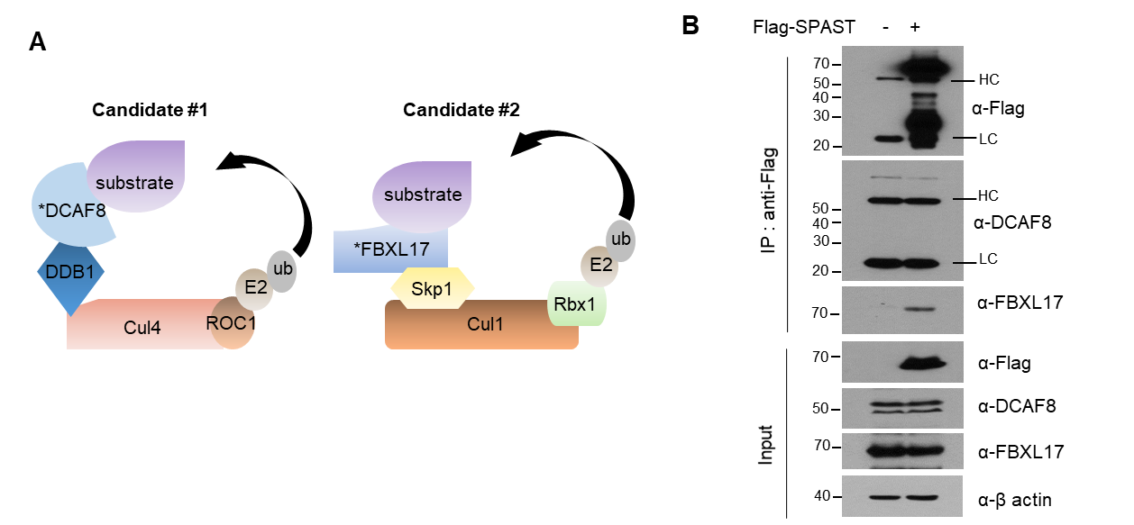

Supplementary Figure 1. SPAST interacted with FBXL17, the substrate recognition component of the SCF E3 ubiquitin ligase. (A) Schematic image of the E3 ubiquitin ligase candidates of SPAST. (B) After transfection with the Flag-SPAST-M1 construct, HEK293 cells were immunoprecipitated, and analyzed using western blotting.

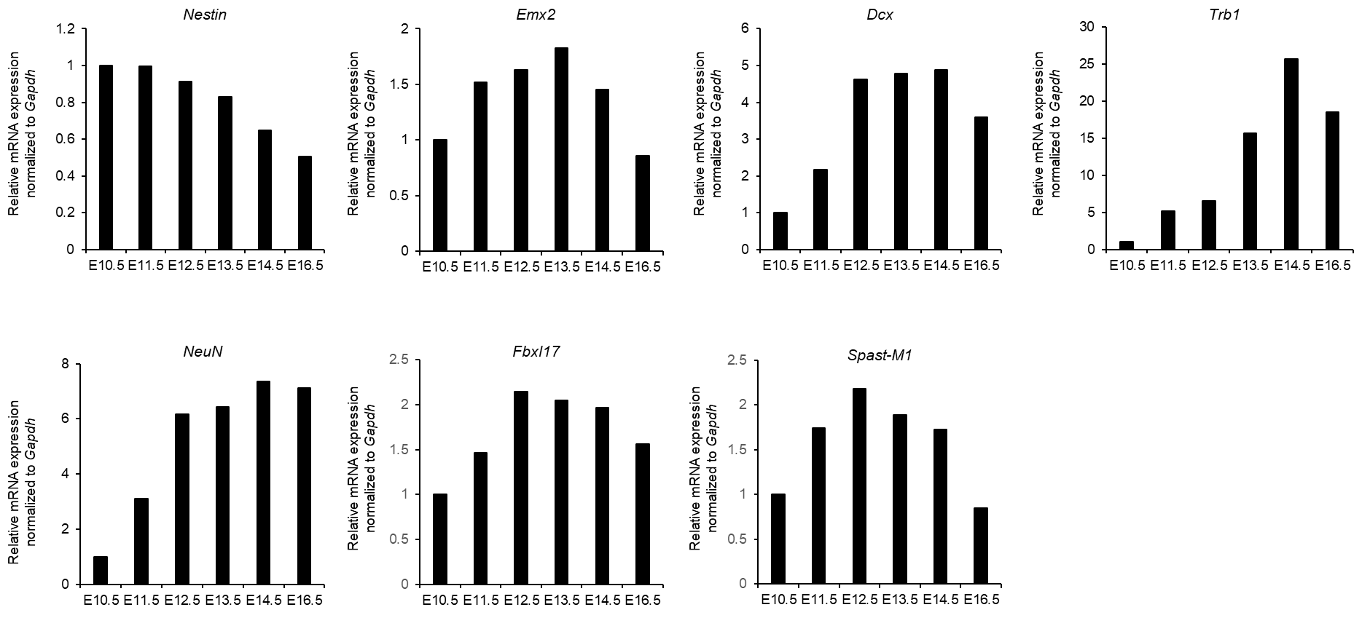

Supplementary Figure 2. The RT-PCR band density in Figure 1D is generated using ImageJ software.

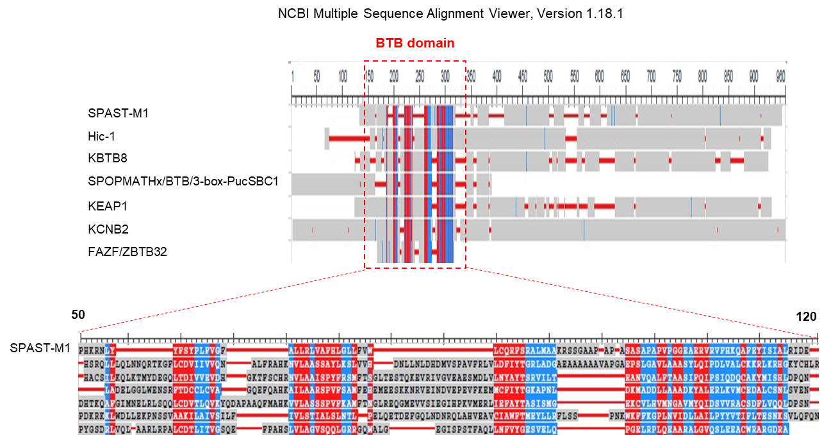

Supplementary Figure 3. BTB domain sequences of the identified BTB proteins and SPAST-M1 were represented by multiple sequence alignments

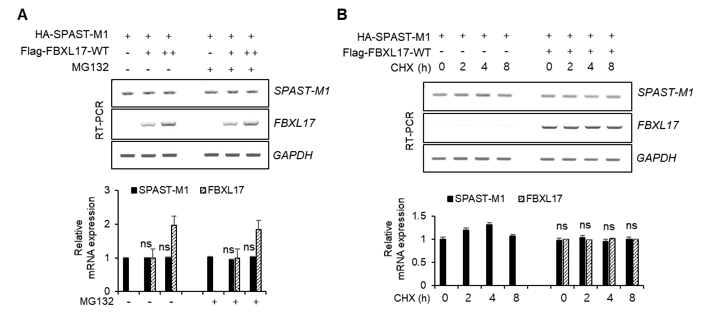

Supplementary Figure 4. (A) mRNA expression was analyzed under the conditions shown in Figure 3A and quantified using ImageJ software. (B) mRNA expression was analyzed under the conditions shown in Figure 3C. (*p <0.05; **p < 0.01; ns, not significant)

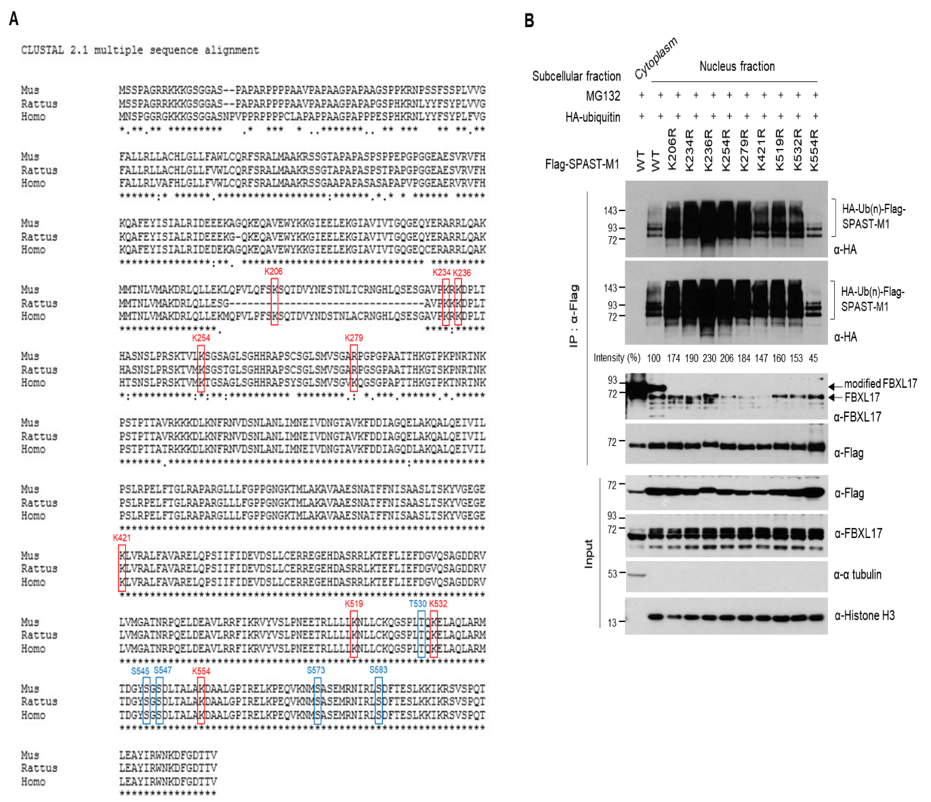

Supplementary Figure 5. (A) Multiple sequence alignment of SPAST proteins in three species. The nine lysine residues or the predicted phosphorylation sites of SPAST confirmed its interspecies functional conservation using multiple alignment software (lysine residues, marked in red boxes; predicted S/T residues, marked in blue boxes). (B) For in vivo ubiquitination assay, HEK293 cells were transfected with indicated plasmids followed by MG132 treatment, and total cell lysates immunoprecipitated with anti-Flag-agarose gel followed by western blotting with indicated antibodies.

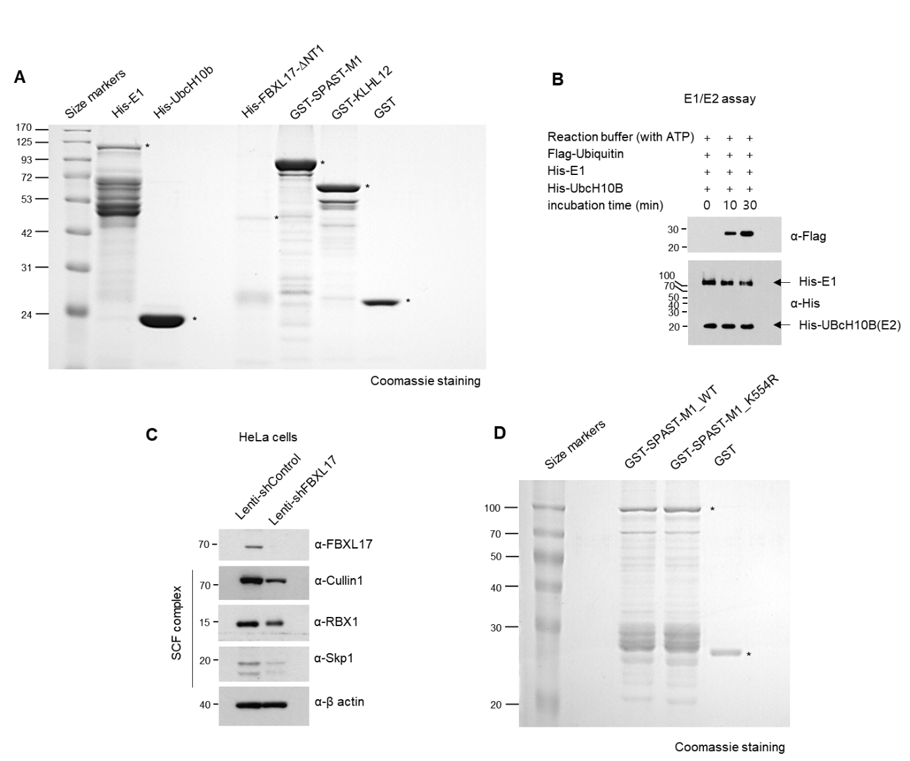

Supplementary Figure 6. Preparation for in vitro SPAST ubiquitination assay (A) SDS-PAGE analysis of purified His-E1, His-UbcH10b, His-FBXL17-ΔNT1 (317-717a.a.), GST-SPAST-M1, GST-KLHL, and GST. All human recombinant proteins were expressed in E. coli and purified as described in the Materials and Methods section. Purified proteins were separated using SDS-PAGE gel and visualized using Coomassie Blue staining. (B) The E1/E2 thioester assay with His-E1, His-UbcH10b, and Flag-ubiquitin. (C) HeLa cells were transduced with scrambled shRNA control lentivirus or shRNA lentivirus targeted against FBXL17. After incubation for 72 h, S-100 cytosolic extract was prepared from the cells and analyzed via western blotting using antibodies against SCF^{FBXL17} components. (D) SDS-PAGE analysis of purified WT or K554R of GST-SPAST-M1 and GST proteins from the E.coli recombinant protein expression system.

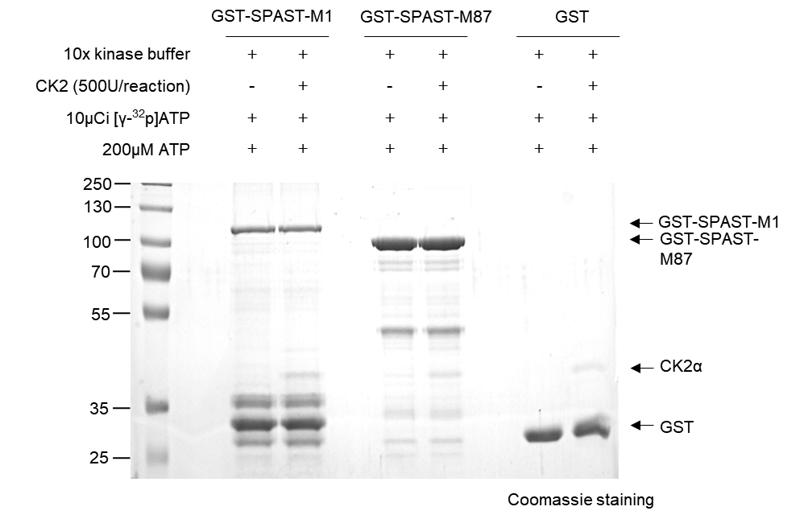

Supplementary Figure 7. In vitro CK2 kinase assay against SPAST. Proteins were separated using SDS-PAGE after the in vitro kinase assay in the presence or absence of CK2 and stained with Coomassie Blue staining demonstrating equal loading of the substrate.

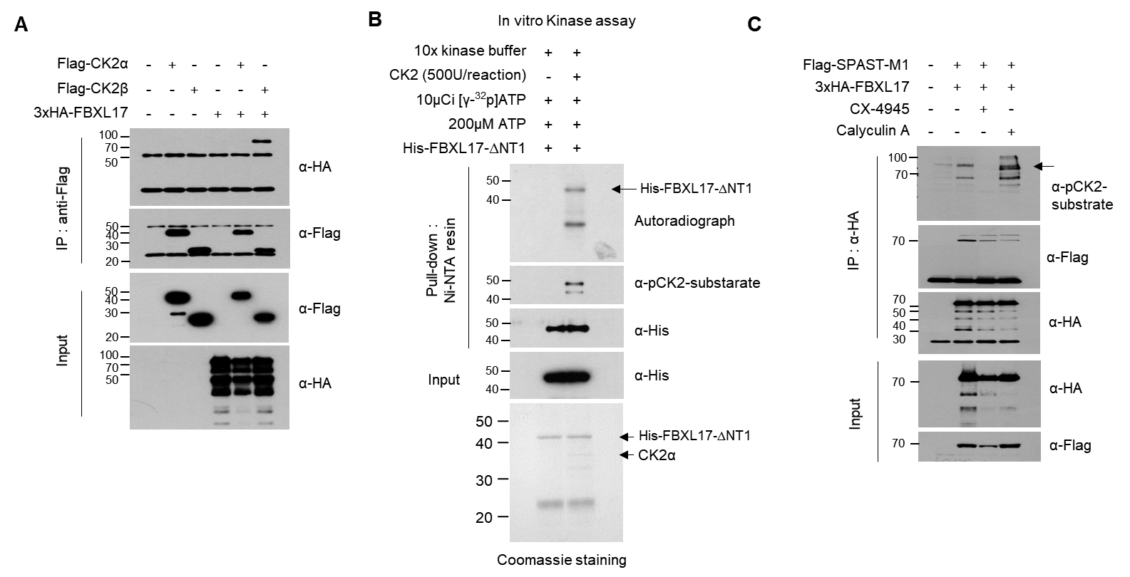

Supplementary Figure 8. (A) HEK293 cells were transfected with indicated plasmids, immunoprecipitated with anti-Flag agarose gel, and analyzed using western blotting. (B) The His-tagged FBXL17-ΔNT1 protein was purified from the E. coli expression system for in vitro kinase assay. The purified His-FBXL17-ΔNT1 was incubated with recombinant CK2 protein, and the GST pull-down assay was performed. Autoradiography shows phosphorylated His-tagged FBXL17-ΔNT1 indicated with the arrow. (C) HEK293 cells were transfected with indicated plasmids and then treated with 5 μM CX-4945 for 24 h or 10 nM calyculin A for 15 min at 37 ℃ and analyzed using immunoprecipitation with anti-HA magnetic beads followed by western blotting with indicated antibodies.

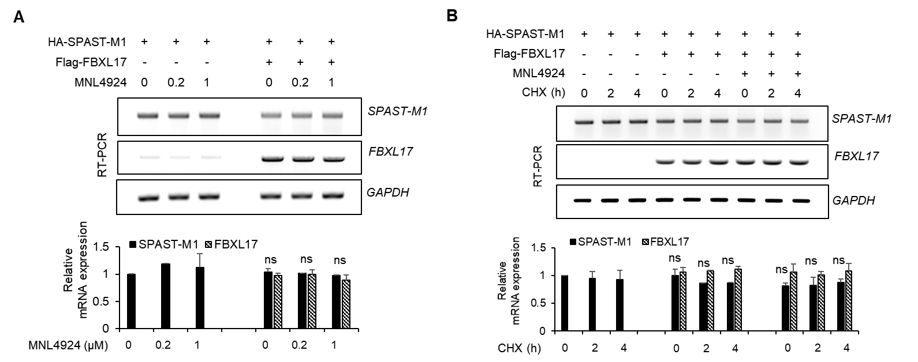

Supplementary Figure 9. (A) mRNA expression was analyzed and quantified using RT-PCR under the conditions shown in Figure 5B. (B) mRNA expression was analyzed using RT-PCR under the conditions shown in Figure 5C and quantified. (*p <0.05; **p < 0.01; ns, not significant)

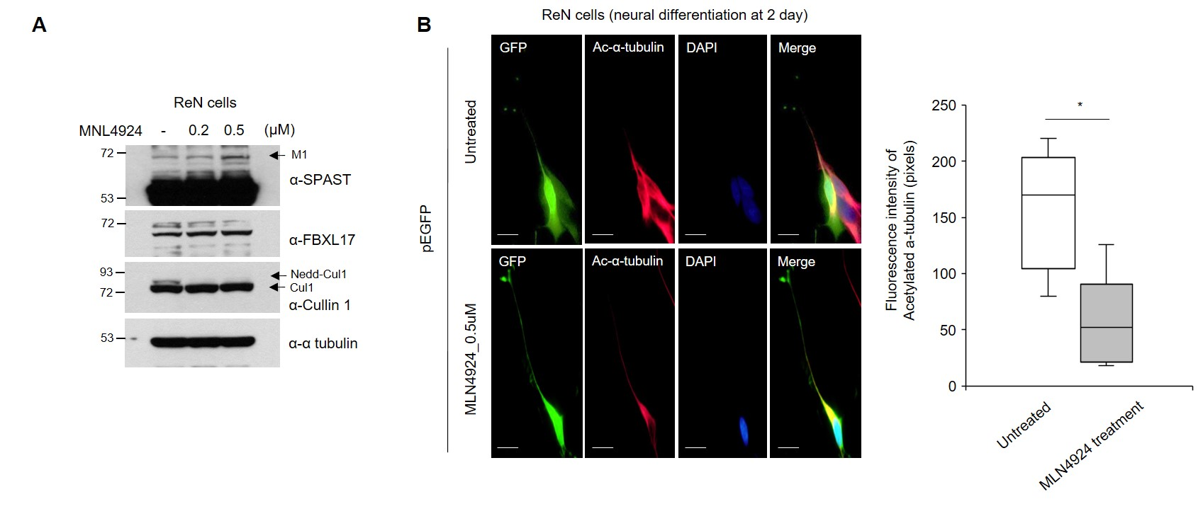

Supplementary Figure 10. The reduction of microtubule stability through increased endogenous SPAST-M1 following MLN4924 treatment (A) Rencell CX cells were treated with 0.2, 0.5 μM MLN4924 for 2 d, and analyzed using western blotting with the indicated antibodies. (B) After transfection with pEGFP plasmid, the cells were differentiated for 2 d in the presence or absence of 0.5 μM MLN4924 and stained with GFP and acetylated α-tubulin antibodies. Fluorescence intensities of acetylated α-tubulin quantified with ImageJ software. Scale bar: 20 μm (*p < 0.05; **p < 0.01; ns, not significant)

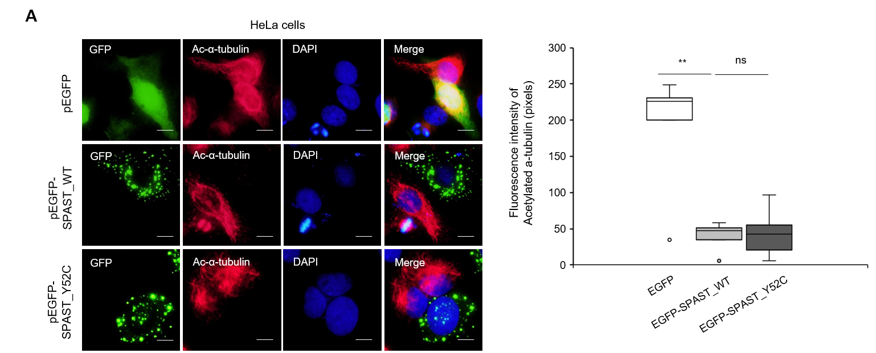

Supplementary Figure 11. The pathogenicity of SPAST-Y52C mutation identified from HSP patient (A) Immunostaining of GFP and Acetylated α-tubulin in HeLa cells transfected with GFP empty or GFP-SPAST-M1 plasmids, and fluorescence intensities of acetylated α-tubulin quantified using ImageJ software. Scale bar: 50 μm (*p <0.05; **p < 0.01; ns, not significant)

