Supplementary Figure 1

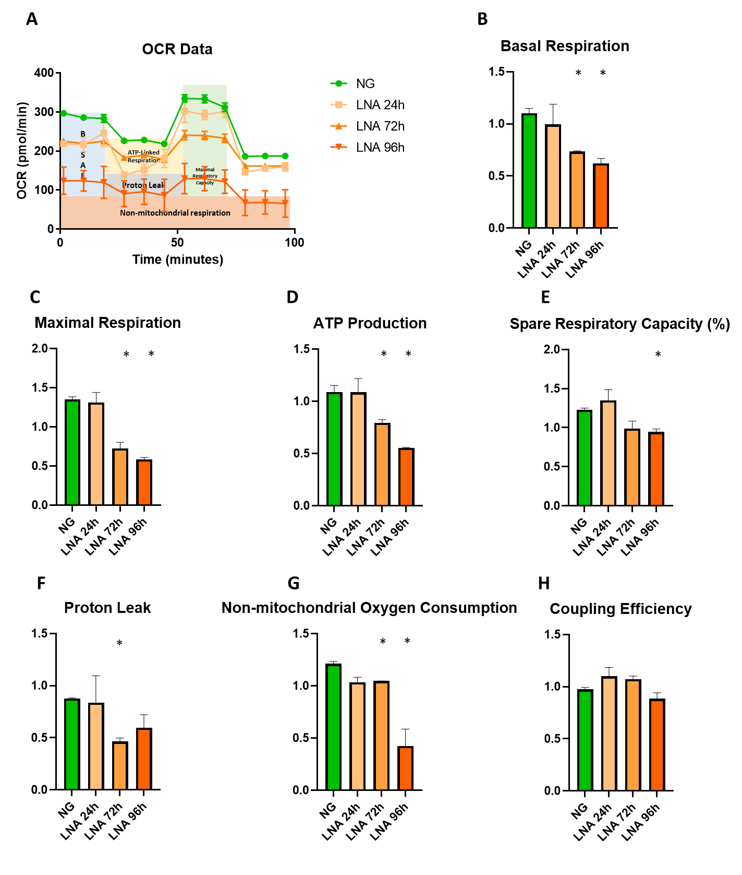
Metabolic response to LNA-anti-miR-21: A) Graph shows the time course of Oxygen Consumption Rate (OCR) of AC16 cardyomyocites in normal glucose (NG) plus LNA-anti-miR-21 for 24h, 72h and 96h. B) Basal Respiration C) Maximal Respiration, D) ATP production, E) Spare Respiratory Capacity %, F) Proton Leak, G) Non-mitochondrial Oxygen Consumption and H) Coupling Efficiency %. Values are reported as OCR (pmol/min) and are normalized on scramble. Data are mean ± SEM. Statistical significance has been calculated as t-test and reported as * P < vs NG.

RESULTS

To confirm miRNA-21 involvement in cardiac tropism and plasticity, cellular metabolism and mitochondrial function were measured following LNA-mediated miRNA-21 inhibition.
Cardiomyocytes' metabolic activity was changed after inhibition of miRNA-21 LNA-mediated (Supplementary Fig. 1A). Globally, miRNA-21 inhibition reduces basal and maximal respiration in a time-dependent manner (Supplementary Fig. 1B-C) together with a drop in ATP production (Supplementary Fig. 1D). The difference between 24 and 72/96h can be justified by the time required for the "naked" delivery, also known as gymnosis of LNA. The “naked” delivery, if on a hand, allowed us to assess the consequences of miRNA silencing without worrying about confounding side effects from the transfection reagents, on the other hand, it implies that the LNA uptake kinetics is generally slower than when using transfection reagents. The choice of testing times was therefore made to allow simultaneously the complete inhibition of miRNA-21 and to recapitulate the condition in Figures 5 and 7 (24h of induction with LNA plus 48h of HG treatment).
Here indeed, spare respiratory capacity and proton leak resulted impaired in later time (Supplementary Fig. 1E-F). Non-mitochondrial Oxygen Consumption was reduced while no effect, regardless of the duration of LNA-anti-miR-21 treatment, was observed in coupling efficiency, that measures the amount of ATP turnover in the mitochondria, compared to a baseline reading (Supplementary Fig. 1G-H).
Coupling efficiency is the ratio between ATP production rate and basal respiration rate. This value represents the proportion of the oxygen consumed to drive ATP synthesis compared with that driving proton leak and is calculated as the fraction of basal mitochondrial OCR used for ATP synthesis (ATP-linked OCR/basal OCR). The observed trend demonstrated that, although the energy balance was changed with the LNA-anti- miRNA-21, most of the respiration is still committed to supporting oxidative phosphorylation during the time.
As well as prolonged exposure to high glucose concentrations induced the expression of genes involved in pro-inflammatory pathways and an overall decrease in metabolic capacity mediated by the down-regulation of miRNA-21 (as reported in main Figures 1, 6, 7), in the same way, the silencing of miRNA-21 functions under physiological level of glucose induced the global decrease in OCR, maximal and basal respiration, and spare respiratory capacity. Therefore, functional inhibition of miRNA-21 has the same metabolic effect as prolonged pro-inflammatory exposure to high glucose concentrations. Moreover, the loss of metabolic plasticity is observed more rapidly (72 and 96 hours post LNA treatment compared to 7 days when glucose is the stressor).

Discussion
Our data help to clarify the function of miRNA-21 and to define the fine line that separates its detrimental from protective role in cardiomyocytes, and therefore in pathologies affecting the myocardium (1-4).. In our scenario, miRNA-21 is one of the actors involved in cardiac metabolic plasticity. Its level of expression modulates according to the availability and type of energy source. In the face of the limited stimulation over time, the level of miRNA-21 rises and the detrimental effects on energy metabolism are compensated. However, when the duration of the inflammatory stimulation exceeds the adaptive capacity of myocardial cells, miRNA-21 decreases and the energy metabolism has a drop. By inhibiting miRNA-21 activity with LNA antisense, even in physiological conditions of glucose, the same metabolic impediment is observed following to a more rapid decrease of the total OCR. In this experimental configuration, the induction time of 72h with LNA-anti- miRNA-21 perfectly mimics the high-dose glucose induction time of 2 days shown in Fig. 5. Then, it is possible to compare the metabolic evolution in two experimental settings in which the abundance of miRNA-21 is alternatively regulated by the quantity of glucose (Fig. 5) and by the interference with the miRNA inhibitor (Supplementary Fig. 1). The choice of extending the measurement of metabolic flux up to 96 hours in physiological glucose concentration and with LNA-anti-miRNA-21 responds to two different technical and functional needs. Technically, because LNA-anti-miRNA-21 antisense effects are generally assessed 24–96 hours after transfection and cellular stability is ensured only in this time interval, the 96 hours of treatment constituted the longest time that could be compared to the 7 days of treatment with high concentration of glucose (Fig. 5). CRISPR /CAS9 approach to stably deplete miRNA-21 (5-8) (5), (6) could be suitable to monitor the longer time effect of miRNA-21 downregulation on energy production and OCR in cardiomyocytes, in a further and prospective study. Functionally, the measurement of metabolic flux at 96h in the presence of LNA-anti- miRNA-21 highlights myocardial cell plasticity. In this case, the prolonged downregulation of miRNA-21 depletes cells of energy capacities, as the chronic exposure (7 days) to a high glucose concentration in the culture medium does. The functional exhaustion of cardiac cells following exposure to high dose of glucose for a long period of time, rather than the condition of pharmacological inhibition of miRNA-21, allows us to speculate on the detrimental and proinflammatory role that glucose plays in cardiomyocytes (7-9). In particular, the mechanism by which "cardiac complication" is often observed in the diabetic patients becomes clear, especially if patients do not monitor the glyco-metabolic load and if the pharmacological intervention is not tailored on their glycemic values. Diabetic cardiomyopathy and heart failure in diabetic patients can therefore be seen as two sides of the same coin. In the absence of coronary artery disease and hypertension (conditions in which the severity of the insult determines the loss of cardiac function), the adaptive capacities of the heart to glucose inflammatory stimulation are overcome in diabetic cardiomyopathy and heart failure in diabetic patients. It is therefore only time of the metabolic insult that decides which side of the coin wins.

REFERENCES

1. Yang L, Wang B, Zhou Q, Wang Y, Liu X, Liu Z, et al. MicroRNA-21 prevents excessive inflammation and cardiac dysfunction after myocardial infarction through targeting KBTBD7. Cell Death Dis. 2018;9(7):769.
2. Tu Y, Wan L, Fan Y, Wang K, Bu L, Huang T, et al. Ischemic postconditioning-mediated miRNA-21 protects against cardiac ischemia/reperfusion injury via PTEN/Akt pathway. PLoS One. 2013;8(10):e75872.
3. Krzywinska O, Bracha M, Jeanniere C, Recchia E, Kedziora Kornatowska K, Kozakiewicz M. Meta-Analysis of the Potential Role of miRNA-21 in Cardiovascular System Function Monitoring. Biomed Res Int. 2020;2020:4525410.
4. Song Y, Zhang C, Zhang J, Jiao Z, Dong N, Wang G, et al. Localized injection of miRNA-21-enriched extracellular vesicles effectively restores cardiac function after myocardial infarction. Theranostics. 2019;9(8):2346-60.
5. Chang H, Yi B, Ma R, Zhang X, Zhao H, Xi Y. CRISPR/cas9, a novel genomic tool to knock down microRNA in vitro and in vivo. Sci Rep. 2016;6:22312.
6. Huo W, Zhao G, Yin J, Ouyang X, Wang Y, Yang C, et al. Lentiviral CRISPR/Cas9 vector mediated miR-21 gene editing inhibits the epithelial to mesenchymal transition in ovarian cancer cells. J Cancer. 2017;8(1):57-64.
7. Filardi T, Ghinassi B, Di Baldassarre A, Tanzilli G, Morano S, Lenzi A, et al. Cardiomyopathy Associated with Diabetes: The Central Role of the Cardiomyocyte. Int J Mol Sci. 2019;20(13).
8. Dai B, Li H, Fan J, Zhao Y, Yin Z, Nie X, et al. MiR-21 protected against diabetic cardiomyopathy induced diastolic dysfunction by targeting gelsolin. Cardiovasc Diabetol. 2018;17(1):123.

