Supplementary Information for:

Site-Specific Chemical Doping Reveals Electron Atmospheres at the Surfaces of Organic Semiconductor Crystals

Tao He^{1,2}*, Matthias Stolte³, Yan Wang^{1,4}, Rebecca Renner³, P. Paul Ruden⁵,
Frank Würthner³ and C. Daniel Frisbie¹*

¹ Dr. T. He, Y. Wang, Prof. C. D. Frisbie
Department of Chemical Engineering and Materials Science, University of Minnesota, Minneapolis, Minnesota 55455, USA

² Dr. T. He
State Key Laboratory of Crystal Materials, Shandong University, 250100, Jinan, Shandong, People’s Republic of China

³ Dr. M. Stolte, R. Renner, Prof. F. Würthner
Universität Würzburg, Institut für Organische Chemie & Center for Nanosystems Chemistry, Am Hubland, 97074 Würzburg, Germany

⁴ Y. Wang
Department of Chemistry, University of Minnesota, Minneapolis, Minnesota 55455, USA

⁵ Prof. P. P. Ruden
Department of Electrical and Computer Engineering, University of Minnesota, Minneapolis, MN 55455, USA

* Correspondence should be addressed to Tao He (E-mail: the@sdu.edu.cn) and
C. Daniel Frisbie (E-mail: frisbie@umn.edu)

Contents:

I. Selection of amine dopant molecules and determination of dose volumes
II. FET transport results
III. Crystal characterization
IV. Characterization of SKPM images as a function of scanning conditions and mode
V. Ultraviolet photoelectron spectroscopy; Step-edge doping density
VI. Electrostatic model for surface doping at a step edge

I. Selection of amine dopant molecules and determination of dose volumes
Due to a lone pair of electrons on the nitrogen atom, amines have strong electron-donating ability and can be used as electron donors in organic semiconductors¹. For example, they have been used to modifiy the electronic properties of graphene², P3HT³ and PCDTPT⁴. Additionally, amines are known to reduce substituted naphthalene diimides (NDI molecules)⁵⁻⁷. Thus, we examined the use of NH₃ and vapors of four alkylated-amines with different molecular weights as potential dopants for Cl₂-NDI and PDIF-CN₂ (Supplementary Fig. 1).
Ultimately, the selection of the best amine for our studies was based on its apparent redox activity with Cl₂-NDI and PDIF-CN₂ surfaces, the presence or absence of surface damage (eg., etching), the performance of single crystal FETs after doping, and the temperature necessary to vaporize the liquid in less than an hour under reduced pressure (0.1 Torr). [3-(2-Aminoethylamino)propyl]trimethoxysilane (N-silane) stood out from a series of amine-terminated molecules based on these criteria. We then determined the optimum doping dose of the N-silane by measuring the FET electron mobility versus the volume of N-silane liquid loaded into the doping chamber (see Method). 100 μL and 60 μL of N-silane were found to be optimum for Cl₂-NDI and PDIF-CN₂ single crystals (see Supplementary Fig. 2 and Fig. 3).

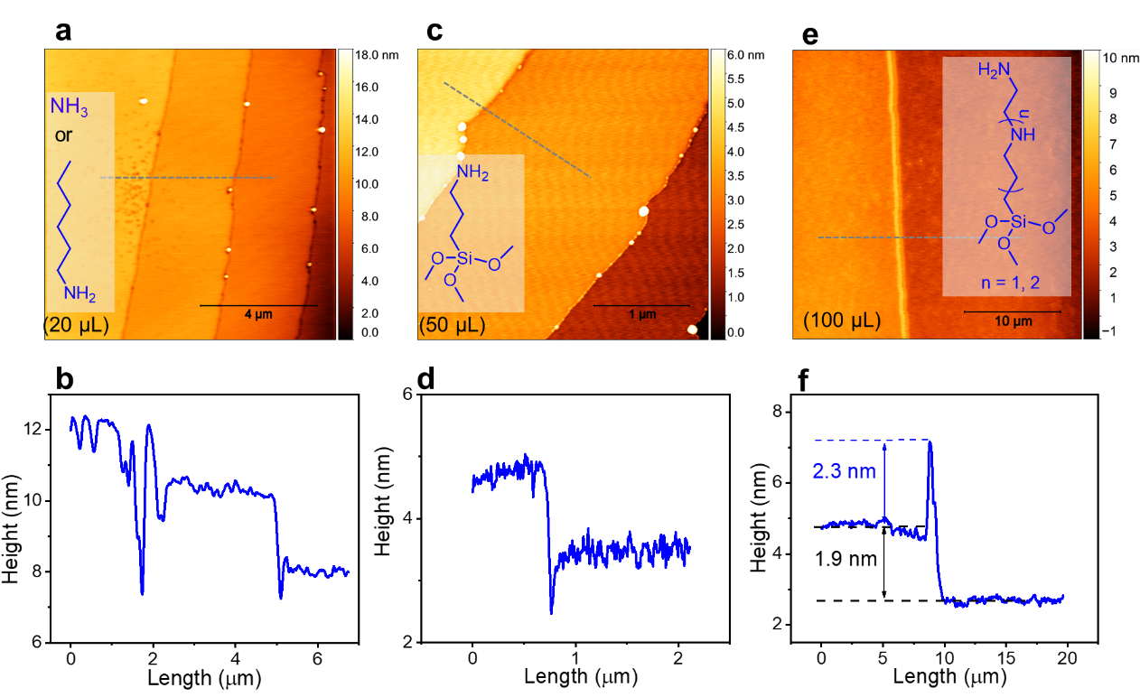
Supplementary Figure 1. AFM images of Cl₂-NDI single crystals exposed to vapor-phase amine-terminated dopants and corresponding height profiles along the grey dashed lines. a, b, Cl₂-NDI single crystals exposed to 20 μL NH₄OH (aq) solution (28% ammonia in water) or hexylamine vapor at room temperature (vapor produced from 20 μl of liquid; see Method). Vapor-phase NH₃ and hexylamine seem to etch the crystal surface, leading to significant structural damage. c, d, Cl₂-NDI single crystals exposed to 3-(aminopropyl)triethoxysilane vapor (vapor produced from 50 μl of liquid; see Method) at 50 °C. Here it appears that the step edges become etched. e, f, Cl₂-NDI single crystals exposed to N-silane ([3-(2-aminoethylamino)propyl]trimethoxysilane) and 2N-silane (3-[2-(2-aminoethylamino)ethylamino]propyltrimethoxysilane) vapors (vapor produced from 100 μl of liquid; see Method). Notably, the ridge structure suggests selective reaction at the step edges. There is no evidence of etching. The height of the ridge also suggests that the N-silanes create a multilayer as is common with silane coupling agents⁸; hydrolysis of the siloxy groups can create Si-O-Si bonds and lead to oligomerization⁹.
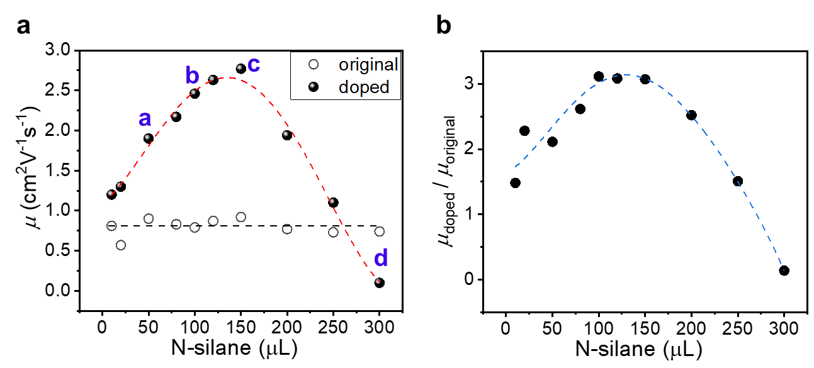
Supplementary Figure 2. Dose response of the FET electron mobility for Cl₂-NDI single crystal upon exposure to varying amounts of N-silane. a, Ten original, undoped devices (open circles) exhibited a FET electron mobility between 0.5 cm²V⁻¹s⁻¹ and 1 cm²V⁻¹s⁻¹. The electron mobility for doped crystals was optimized at a dopant dose corresponding to ~100-150 μL of liquid N-silane. b, Ratio μ_{doped}/μ_{original} as a function of dose. We used the same method to obtain the optimum dose for PDIF-CN₂ to be 60 μL of liquid N-silane.
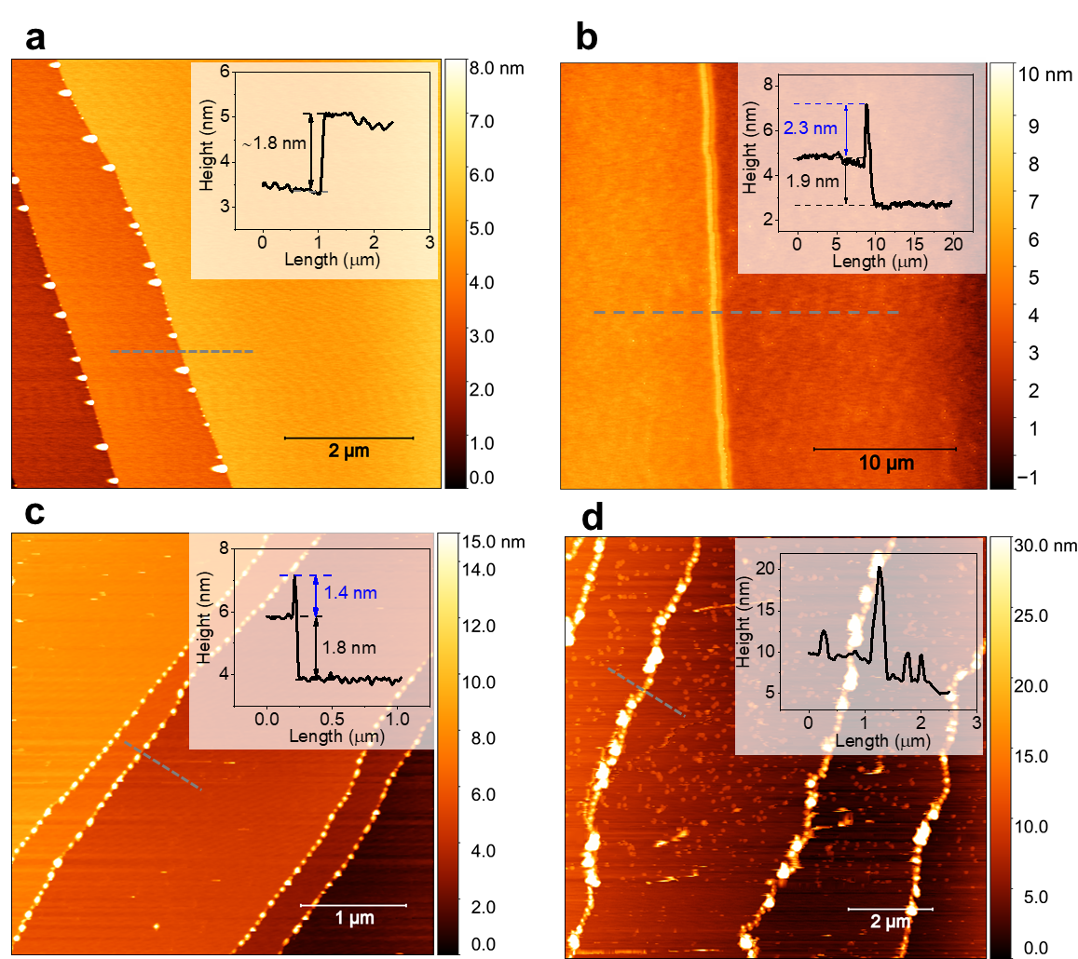
Supplementary Figure 3. AFM images of doped Cl₂-NDI single crystal surfaces corresponding to doses evident in Supplementary Figure 2a. a, Crystal exposure to 50 μL N-silane. Discrete N-silane nanoparticles with a height of 1 - 4 nm selectively grow at crystal step edges. Inset: height profile along the dashed line. Step edge without dopant incorporation shows the original Cl₂-NDI molecular height of 1.8 nm. b, Crystal exposure to 100 μL N-silane. Multilayer N-silane dopants with a height of ~ 2.3 nm selectively grows at the step edges. Note that there is apparently no dopant incorporation on the crystal terraces even for overnight exposure. c, Crystal exposure to 150 μL N-silane. Clusters of the dopant with a heights from 1.4 nm to 13 nm appear along step edges and sporadically on the crystal terraces. d, Crystal exposure to 300 μL N-silane. The dopant apparently randomly reacts/nucleates on the crystal surface, resulting in significantly increased off-current, an unmodulated I_{D}-V_{G} plot, and overall compromised device performance as shown in the mobility data in Supplementary Fig. 2.
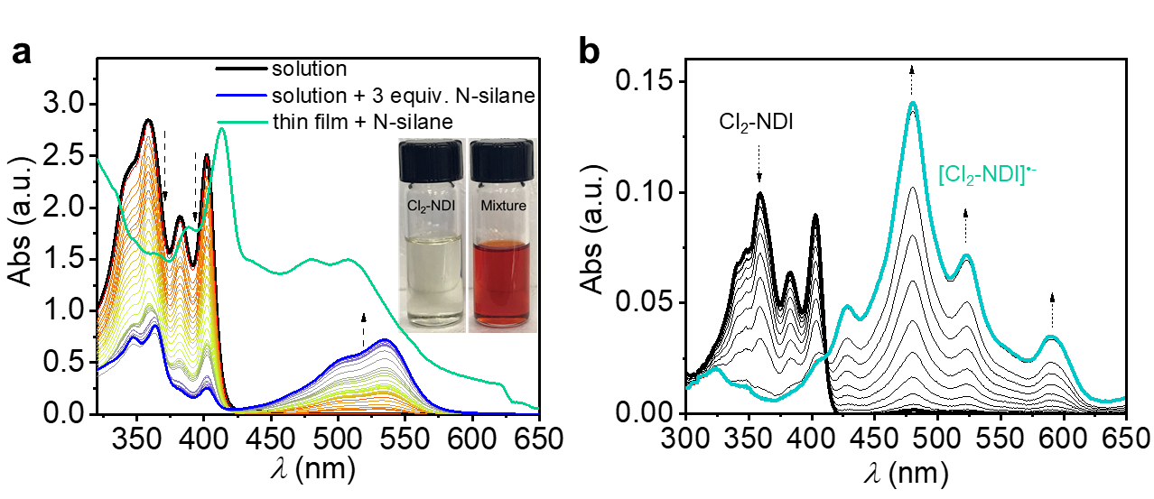
Supplementary Figure 4. Doping of Cl₂-NDI. a, The evolution of UV-vis absorption spectra for Cl₂-NDI in CHCl₃ solution upon addition of N-silane and the drop-casted Cl₂-NDI thin film exposed to vapor-phase N-silane. Inset: photo images of Cl₂-NDI solution and the mixture with N-silane. b, UV/Vis/NIR spectroelectrochemistry upon electrochemical reduction of [Cl₂-NDI] to [Cl₂-NDI]^{•−} (in steps of 20 mV) at potentials from 0 to −280 mV vs Ag/AgCl reference electrode (c₀ = 9 x 10⁻⁴ M, 0.1 M [tetrabutylammonium]⁺[hexafluorophospate]⁻ (TBAHFP) in CHCl₃). The absorption spectrum of Cl₂-NDI thin films exposed to N-silane in (a) matches well with that of [Cl₂-NDI]^{•-} generated by electrochemical reduction (b). In contrast, in the titration experiment where N-silane is added to Cl₂-NDI in solution, a further reaction takes place where the chlorine is replaced by the amine nucleophile. This reaction, leading to 2-amino-6-chloro-substituted naphthalene diimides (with a characteristic band at 540 nm), has been described in literature⁷. Obviously, in the absence of a solvent, such chemical reaction does not take place in thin films.

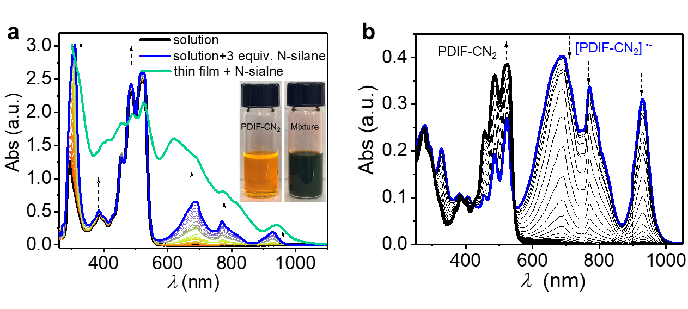
Supplementary Figure 5. Doping of PDIF-CN₂. a, The evolution of UV-vis absorption spectra for PDIF-CN₂ in CHCl₃ solution upon addition of N-silane and the drop-casted PDIF-CN₂ thin film exposed to vapor-phase N-silane. Inset: photo images of PDIF-CN₂ solution and the mixture with N-silane. b, UV/Vis/NIR spectroelectrochemistry upon electrochemical oxidation of [PDIF-CN₂] ^{•−} to [PDIF-CN₂] (in steps of 20 mV) at potentials from 0 to +900 mV vs Ag/AgCl (c₀ = 6 x 10⁻⁴ M, 0.1 M TBAHFP, CHCl₃). The absorption spectrum of thin film PDIF-CN₂ in the presence of N-silane in (a) matches well with that of [PDIF-CN₂]^{•−}, which strongly suggests that [N-silane]^{•+} [PDIF-CN₂]^{•-} forms when PDIF-CN₂ single crystal is exposed to vapor-phase N-silane^{10,11}.

II. FET transport results
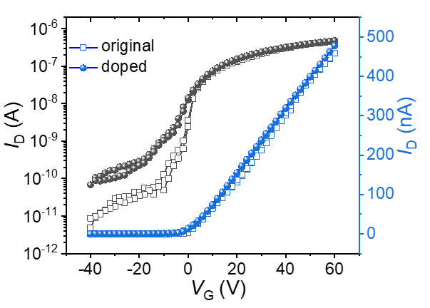
Supplementary Figure 6. Transfer characteristics of a thin Cl₂-NDI single crystal FETs before (open squares) and after (solid circles) exposure to N-silane vapor (100 μL for 1 h). V_{D} = 10 V. The thickness and step density of thin single crystal are 2.9 μm and ~1 step/10 μm, respectively.

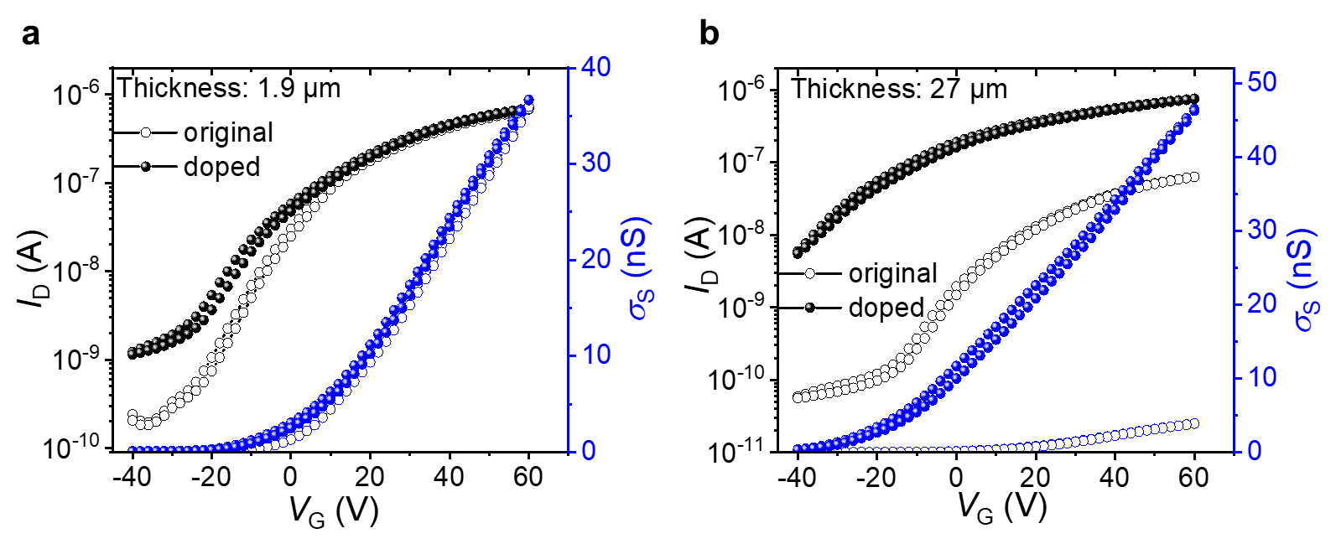
Supplementary Figure 7. Crystal thickness dependence of transfer characteristics for doped PDIF-CN₂ single crystal FETs. V_{D} = 10 V for original and doped devices. Both single crystal devices were exposed to 60 μL N-silane vapor for 1 h. (a) A small doping effect is observed for the thin PDIF-CN₂ single crystal having a low step density. Essentially, only the off current increases a bit upon doping. (b) By contrast, there is significant improvement in the sheet conductance σ_{s} and a negative shift in V_{T} for the thick single crystal with high step density. Crystal thickness and step densities are 1.9 μm and ~1 step/10 μm for a and 27 μm and 15 steps/10 μm for b, respectively.
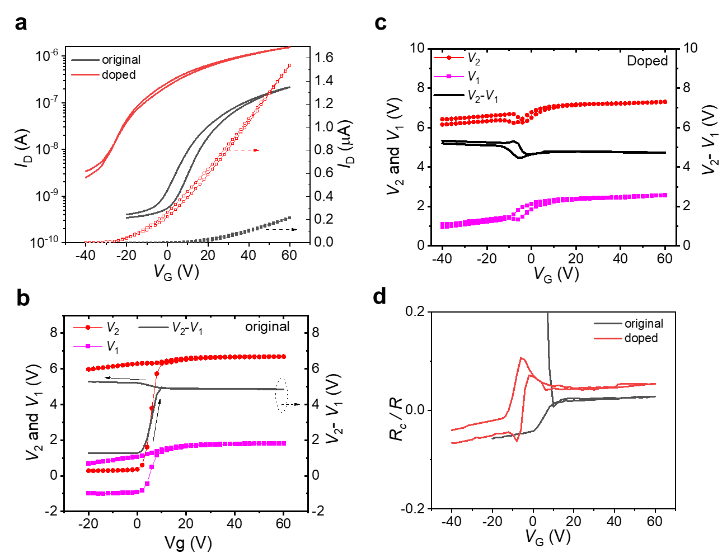
Supplementary Figure 8. Four terminal measurements for Cl₂-NDI single crystal FETs before and after doping. a, Transfer characteristics (I_{D}-V_{G}) for a thick Cl₂-NDI single crystal FET before (black) and after (red) doping. V_{D} = 10 V. b, c, The channel sensing electrode voltages and their difference (V₂ − V₁) as a function of V_{G} for the original (b) and doped (c) device. V₂ and V₁ are two voltage sensing channel electrodes with a separation distance (ΔL) of 150 μm. The channel length (L_{channel}) is 300 μm. Thus, the real source-drain bias voltage applied in the channel is (L_{channel} /ΔL) × (V₂ − V₁) = 2(V₂ − V₁). d, Rc/R as a function of V_{G}. R and Rc are device resistance (contact resistance + channel resistance) and contact resistance, which are extracted using V_{D}/I_{D} and [V_{D}/I_{D} - 2(V₂ − V₁)/I_{D}], respectively. At V_{D} = -10 V, Rc/R is 2.6% and 5.8% for original and doped devices, corresponding to 1.3×10⁶ Ω and 3.6×10⁵ Ω, respectively.
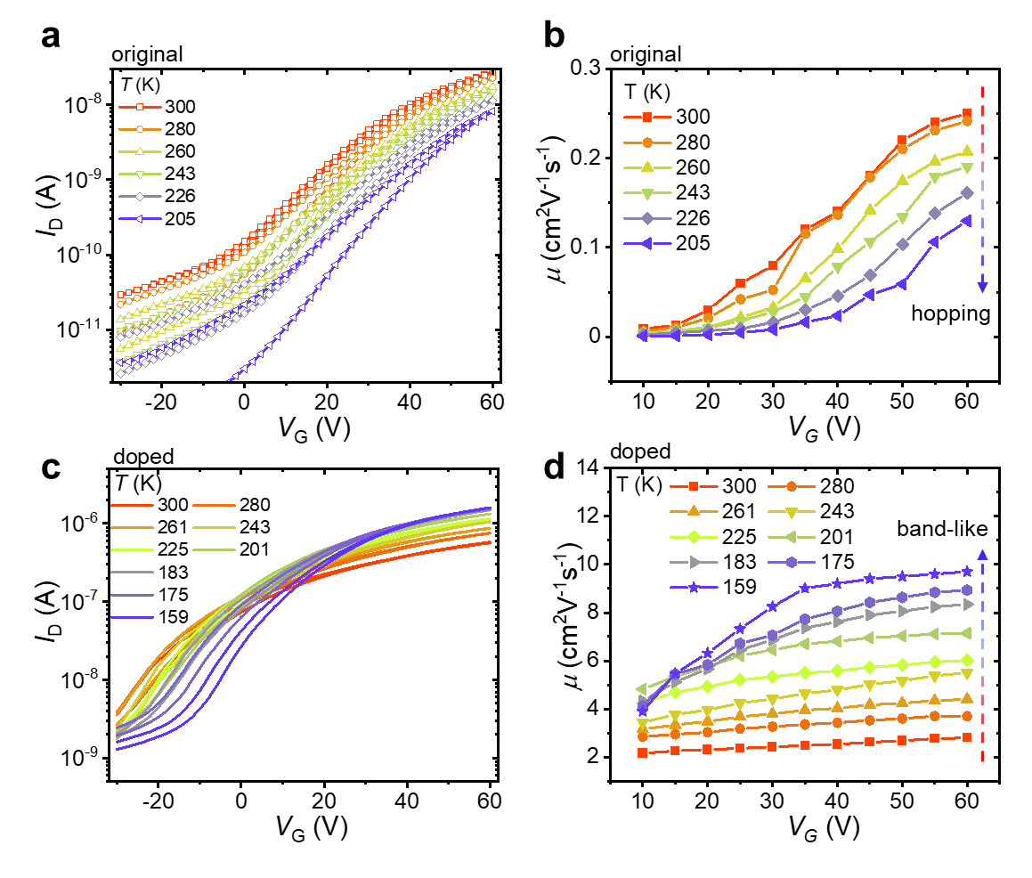
Supplementary Figure 9. The temperature-dependent electron transport for an individual thick Cl₂-NDI crystal FET with a step density of 25 steps/10 μm. The log version of the I_{D}-V_{G} plots before (a) and after (b) doping that correspond to Figure 3c, d. Corresponding μ extracted from linear fits to the I_{D}-V_{G} characteristic at different V_{G} and temperatures before (c) and after (d) doping.
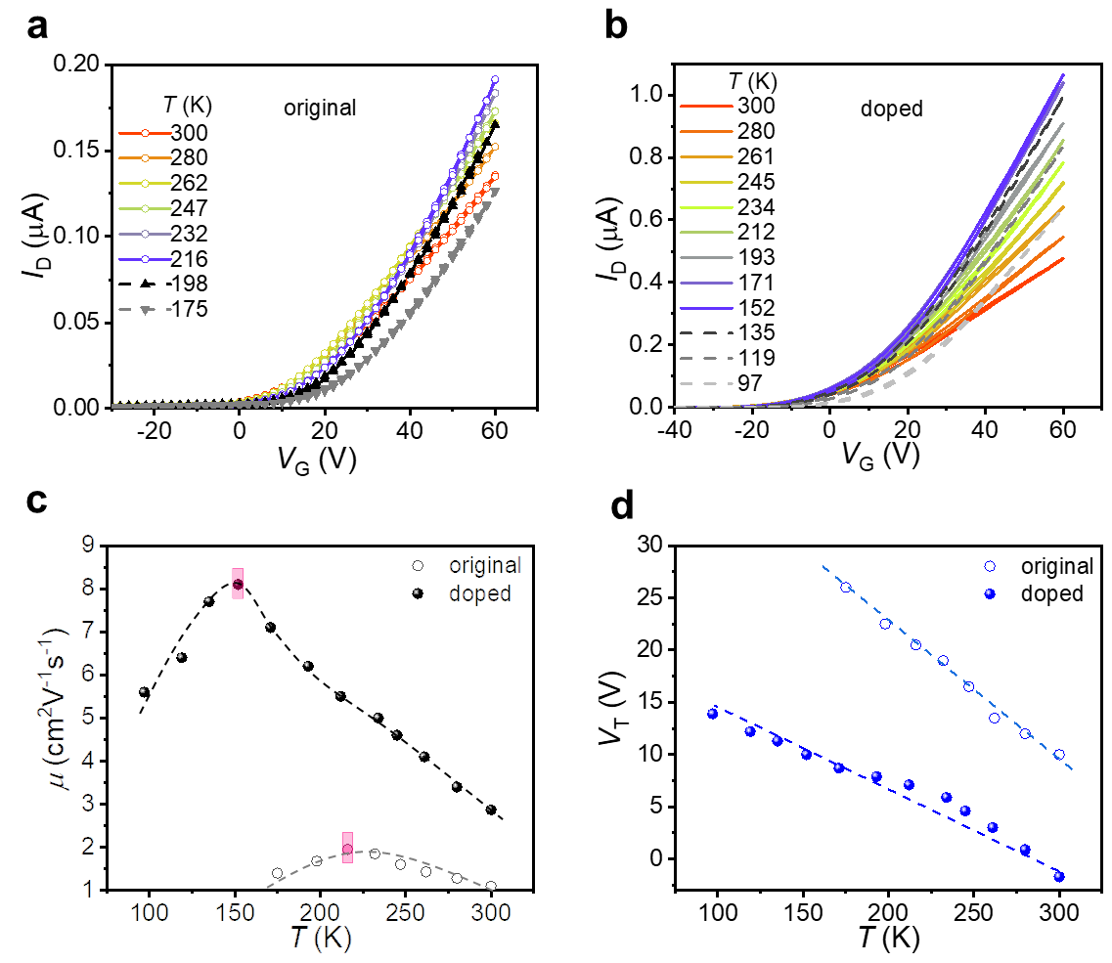
Supplementary Figure 10. Temperature dependence of electron transport for a Cl₂-NDI single crystal (intermediate thickness) FET before and after doping, and corresponding μ and V_{T} vs temperature. a, I_{D}-V_{G} characteristics of the original device with cooling. As expected, due to step edge traps, weak band-like charge transport is observed with a negative dμ/dT holding only over a small temperature window. b, I_{D}-V_{G} characteristics of the doped device with cooling. A significantly enhanced room temperature electron mobility from 1.12 cm²V⁻¹s⁻¹ to 2.78 cm²V⁻¹s⁻¹is observed, accompanied by a V_{T} shift from +10 V to -1.7 V. c, d, corresponding μ (c) and V_{T} (d) as a function of temperature. The doped device shows a much steeper μ-T plot with a significantly lower T*, the temperature corresponding to the crossover from band-like to trap-limited transport marked by the red rectangle in c. Correspondingly, the peak mobility is 8.17 cm²V⁻¹s⁻¹at 152 K for the doped device, far larger than the peak undoped value of 1.95 cm²V⁻¹s⁻¹at 216 K. The crystal step density is 11.3/10 μm. The channel dimensions are W = 300 μm, L = 410 μm.
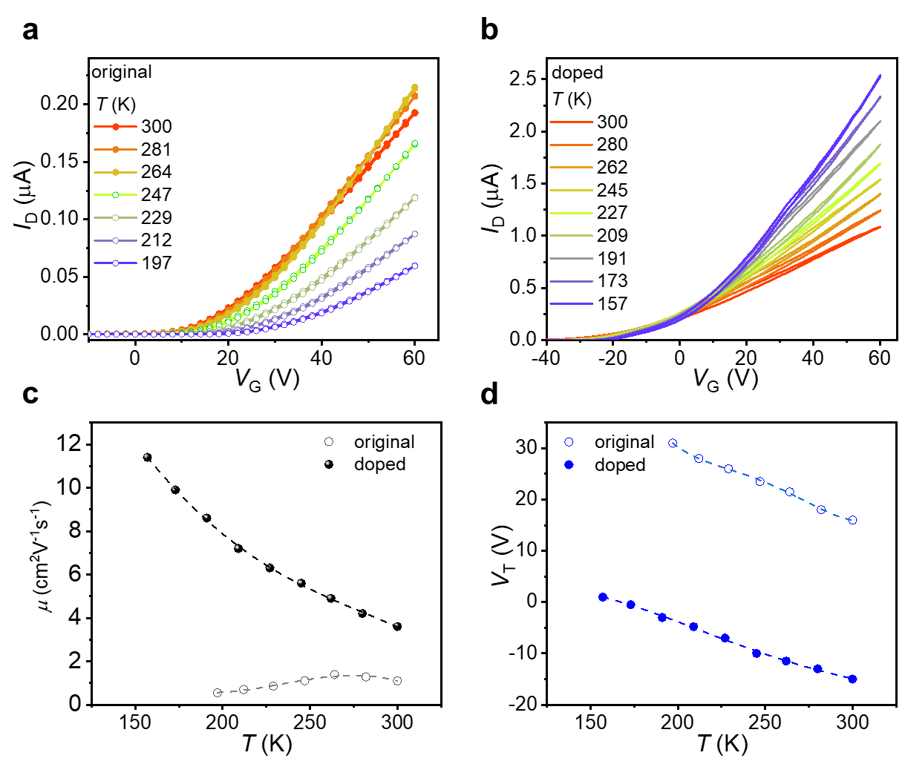
Supplementary Figure 11. Temperature dependence of electron transport for a PDIF-CN₂ single crystal FET before and after doping. a, I_{D}-V_{G} characteristics of the original crystal FET with cooling. There is a slight increase in I_{D} with cooling over the temperature range 300 K to 264 K, and then transport becomes trap dominated and thermally activated below 265 K leading to decreased I_{D}. b, I_{D}-V_{G} characteristics of the doped crystal with cooling. A monotonic increase in I_{D} upon cooling is evident down to 157 K upon which the crystal broke. c, d, corresponding μ (c) and V_{T} (d) as a function of temperature. Compared to the original device, the doped device shows more pronounced band-like behavior with the highest mobility of 11 cm²V⁻¹s⁻¹ and smaller trap density reflected by a more moderate V_{T}-T slope. V_{D} = 10 V for original and doped devices. The crystal thickness was 13.8 μm.

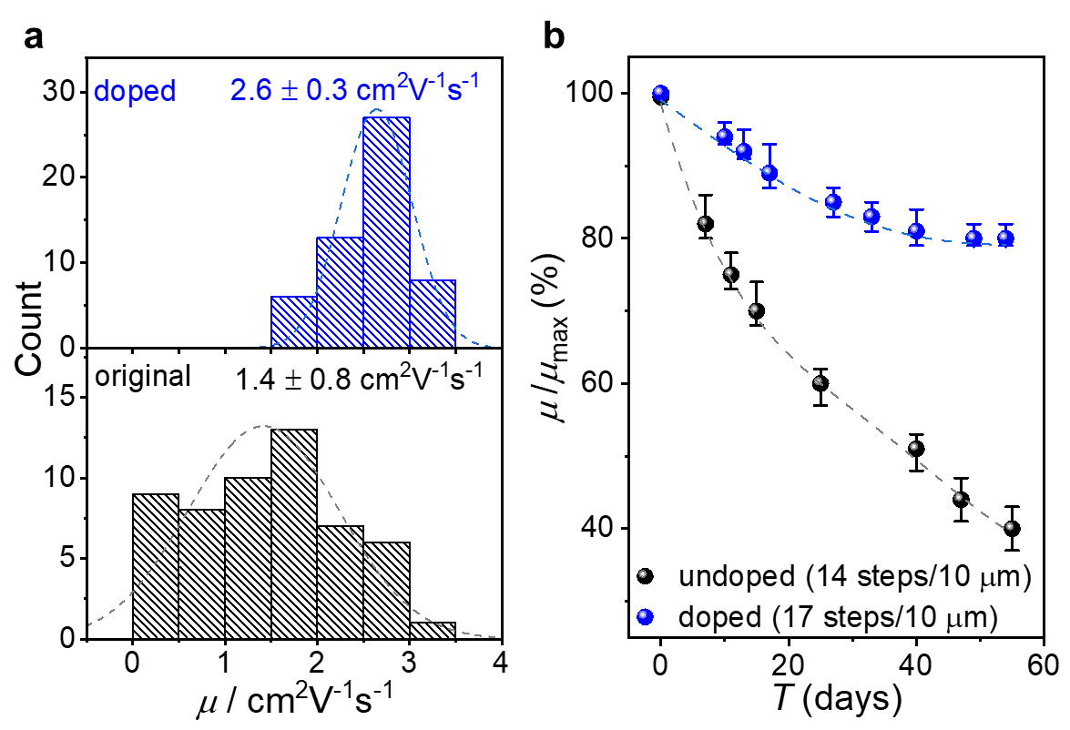
Supplementary Figure 12. Improved FET mobility and air-stability for Cl₂-NDI single crystals upon N-silane doping. a, The average room temperature electron mobility of 50 FETs increases from 1.4 cm²V⁻¹s⁻¹to 2.6 cm²V⁻¹s⁻¹upon doping, accompanied by a narrower mobility distribution of 10% for doped devices compared to 60% for original devices. b, A significantly enhanced environmental stability is also evident for a doped device. There is ~18% degradation in mobility compared to 60% for an undoped device upon storage in ambient for approximately two months. In order to make a comparison of test results, the two devices employed have similar step density and initial mobility.

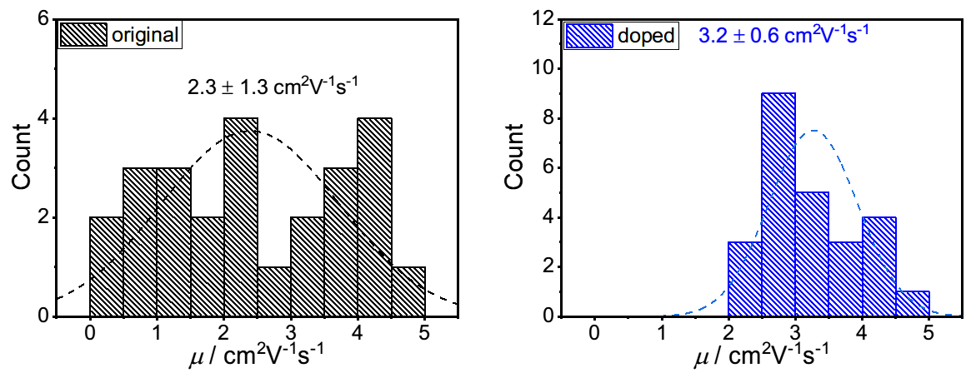
Supplementary Figure 13. Comparison of electron mobilities for 25 PDIF-CN₂ single crystal FETs before and after doping. After doping, the average electron mobility increases 40% from 2.3 cm²V⁻¹s⁻¹to 3.2 cm²V⁻¹s⁻¹. Importantly, doped devices also exhibit a narrower mobility distribution.
III. Crystal characterization

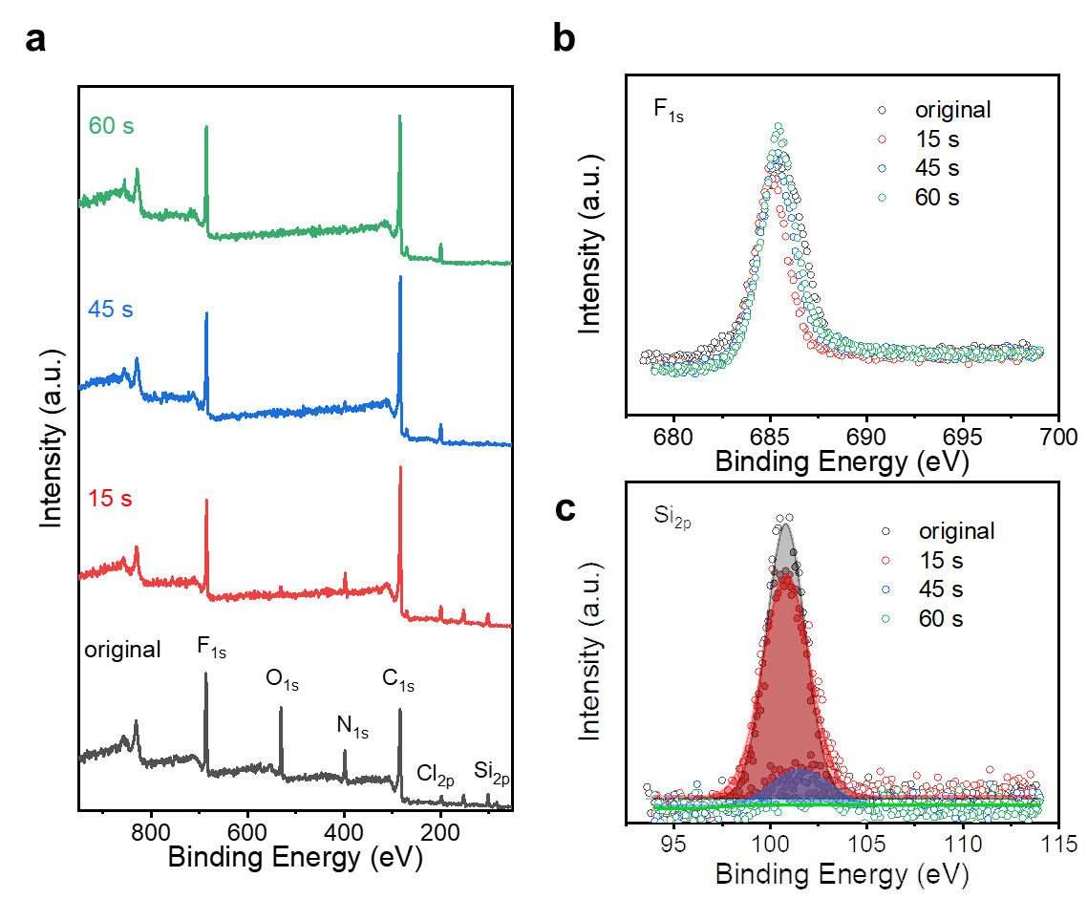
Supplementary Figure 14. XPS depth profiling spectra of a Cl₂-NDI single crystal after doping with N-silane. a, Survey spectra of the Cl₂-NDI single crystal for different sputtering times by 5 kV Ar ion beam (black, 0 s; red, 15 s, blue, 45 s and green, 60 s). b,c, High-resolution XPS F_{1s} (b) and Si_{2p} (c) core level spectra. F_{1s} on Cl₂-NDI is utilized as a reference. The Si_{2p} signal for N-silane completely disappears by Ar ion beam sputtering for 60 s, suggesting surface doping of N-silane rather than penetration into the crystal. The sputtering rate is ~ 1 Å s⁻¹.

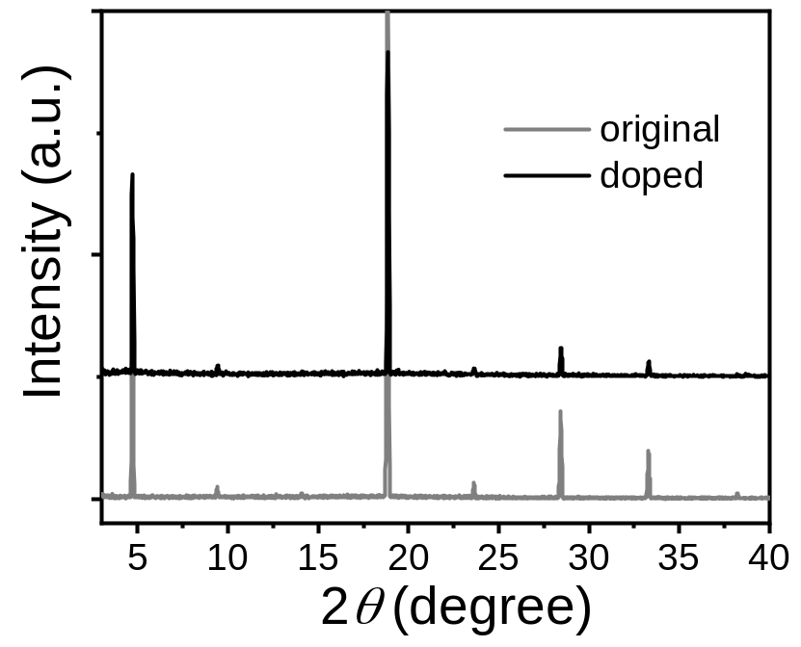
Supplementary Figure 15. X-ray diffraction of Cl₂-NDI single crystals before and after doping (100 μL for 1 h). Identical X-ray diffraction peaks with smooth baselines are shown in both original and doped crystals, suggesting well-ordered structures and no dopant penetration into the doped crystal.

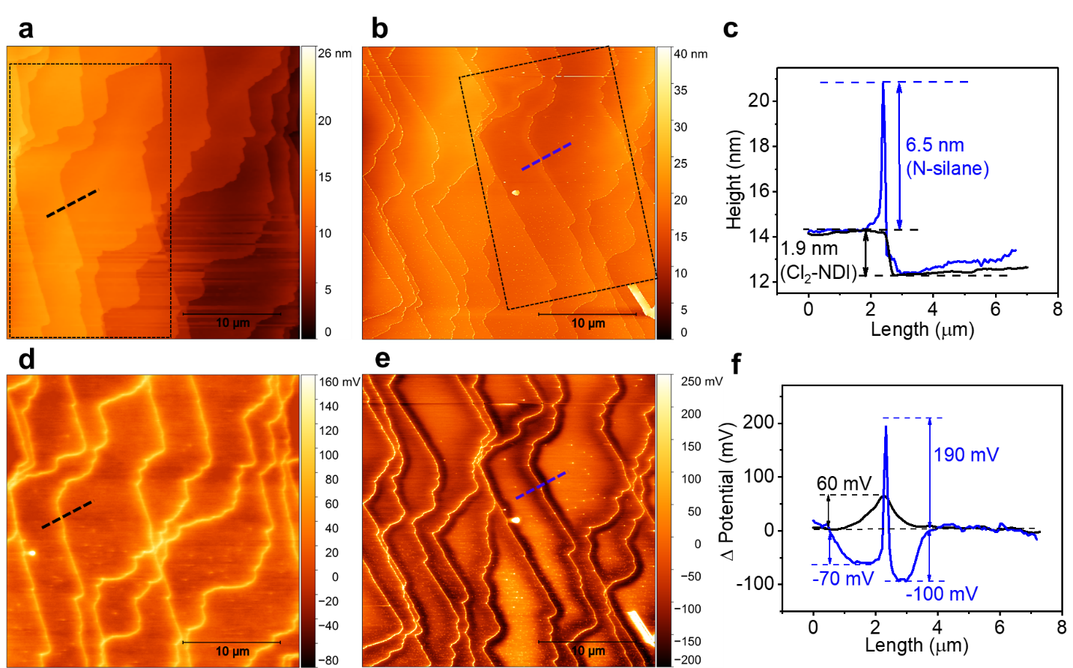
Supplementary Figure 16. AFM and SKPM in the exact same location for a Cl₂-NDI single crystal before and after N-silane doping. AFM height images for the original (a) and doped (b) crystal. The dashed square shows the exact same region of the crystal surface before and after doping. (c) Corresponding height profile along the dashed lines (black: original; blue: doped). Corresponding SKPM potential images for the original (d) and doped (e) crystal. (f) Corresponding potential profile along the dashed lines. A thick single crystal sample with intersecting step edges was chosen to easily find the same site after N-silane treatment. The strong difference in step edge potentials for the original and doped crystal is evident in panels d, e, and f.

IV. Characterization of SKPM images as a function of scanning conditions and mode

Overview: In order to assess the robustness of the SKPM imaging results in Figure 4 in the main text, and to rule out possible artifacts,^{12,13,14} we have carried out extensive SKPM imaging experiments as a function of the tip lift height, AC bias voltage, operation mode and scan angle. While there are quantitative differences in the step edge potential profiles depending on parameters such as tip lift height and bias voltage, the overall shape of the potential profiles is generally not affected by the AC bias and lift height^{15,16}. In fact, we are able to acquire potential maps at very small AC biases < 1 V and at the very high lift height of 100 nm, and the shape of the potential profile holds. Together with qualitatively very similar step edge potential images for different scan angles and imaging modes (AM-SKPM vs single-pass FM-SKPM), we have a large body of evidence that the step edge profiles we measure for doped crystals are real and not an artifact of a spurious tip-sample interaction.

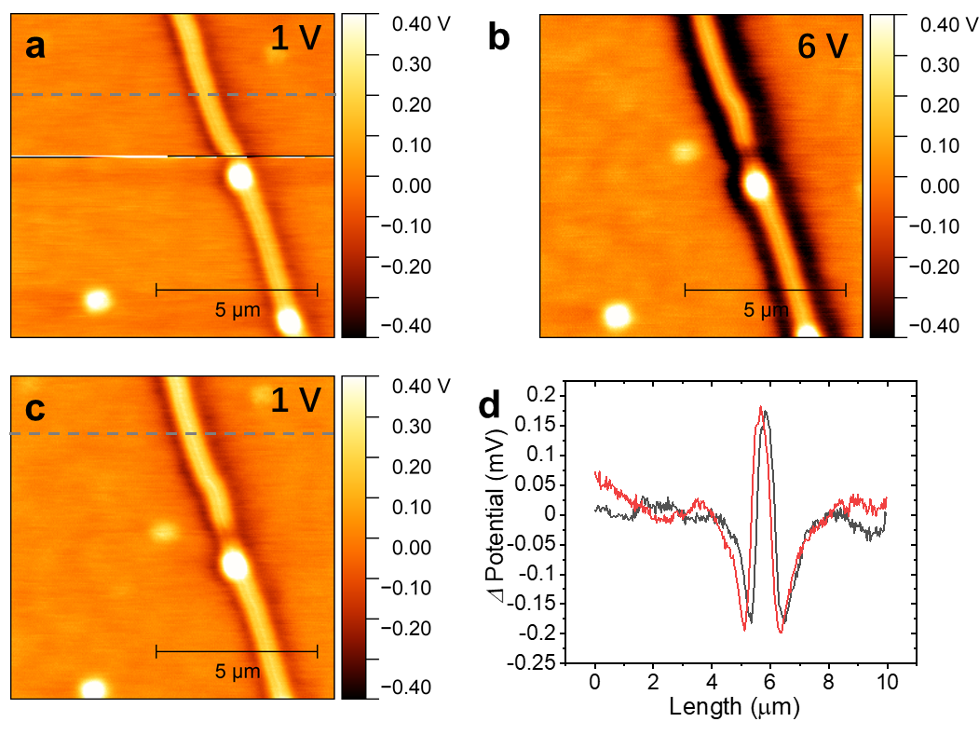
Supplementary Figure 17. a, SKPM potential image at a bias voltage of 1 V on the surface of N-silane doped Cl₂-NDI single crystal before (a) and after (c) application of an AC bias of 6 V. d, corresponding potential profiles along the dashed lines before (black) and after (red) application of an AC bias of 6 V.

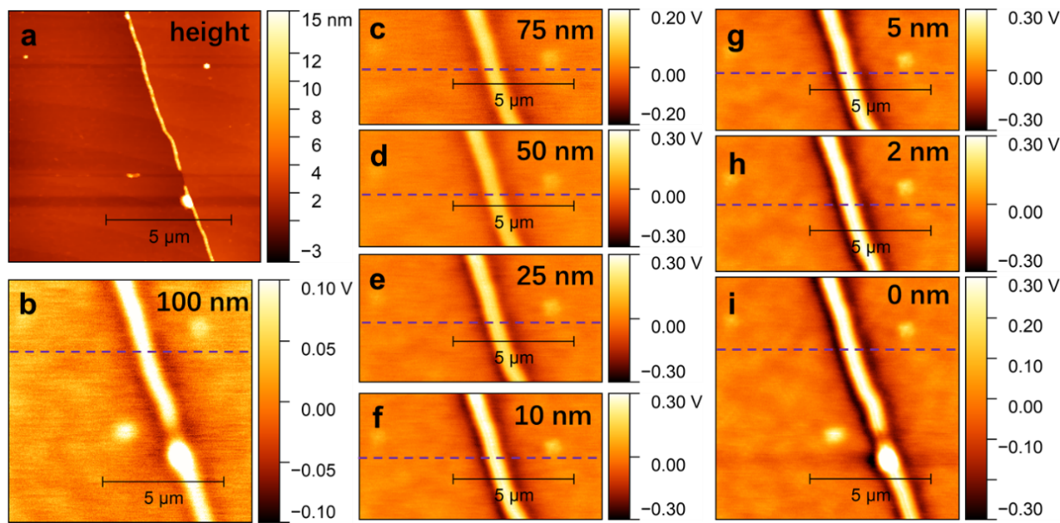
Supplementary Figure 18. SKPM potential as a function of lift height on the N-silane doped Cl₂-NDI single crystal. a, AFM height image. b-i, SKPM potential images with the lift height decreasing from 100 nm to 0 nm under AC bias voltage of 1 V. Note the difference in the potential scale bars. The scan rate is 0.3 Hz.
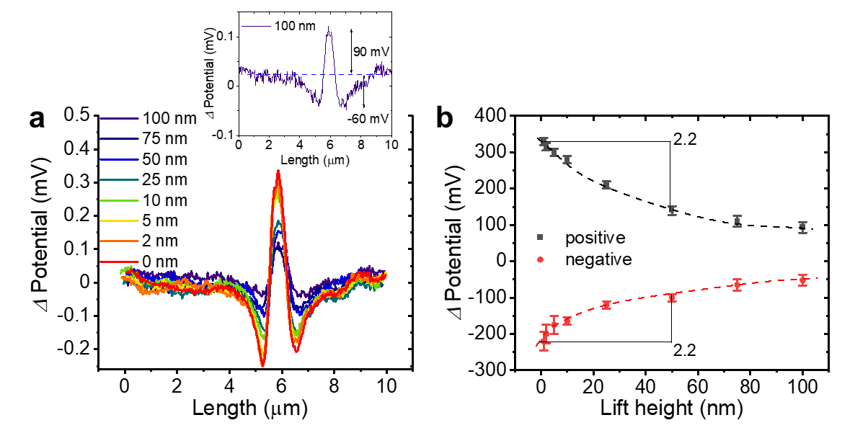
Supplementary Figure 19. a, Corresponding potential profile along the dashed lines in the Supplementary Figure 18. Inset: step edge potential profile at a lift height of 100 nm. b, Step edge potential as a function of lift height. The positive and negative step edge potential have nearly the same variance with lift height.

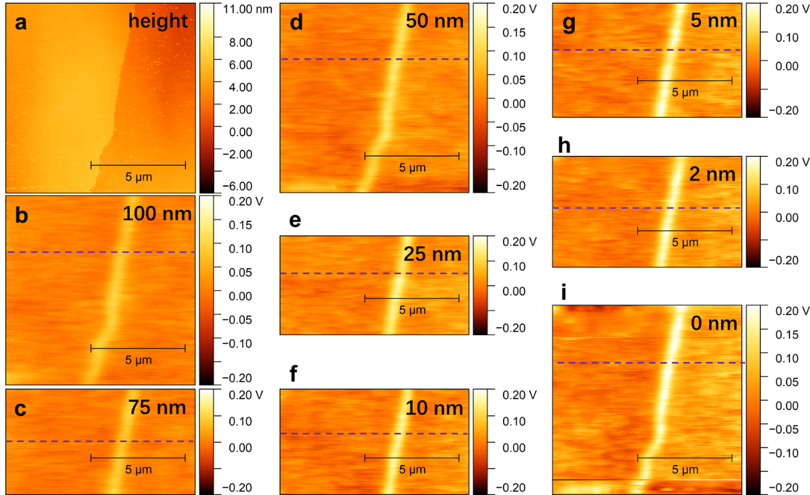
Supplementary Figure 20. SKPM potential as a function of lift height on the undoped Cl₂-NDI single crystal. AC bias voltage of 1 V.

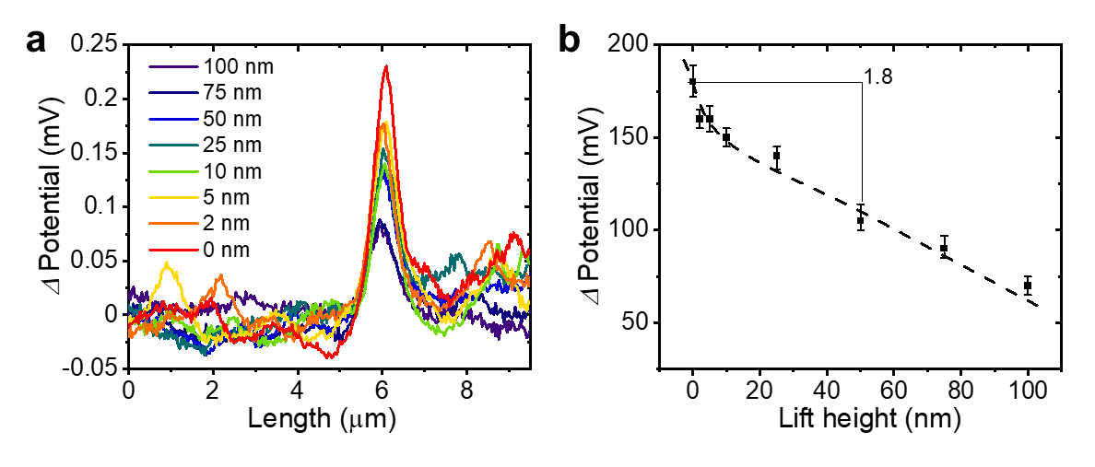
Supplementary Figure 21. a, corresponding potential profiles along the dashed lines in Supplementary Figure 20. b, lift height dependence of step edge positive potential.
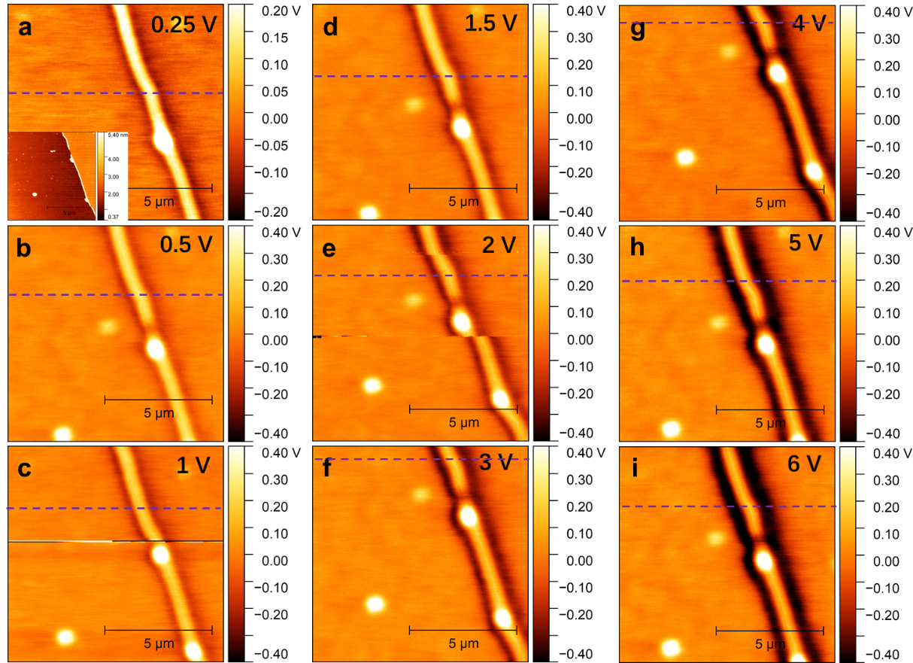
Supplementary Figure 22. SKPM potential images as a function of AC bias increasing from 0.25 V to 6 V for a N-silane doped Cl₂-NDI single crystal. Inset to a: AFM height image. The lift height is 10 nm.
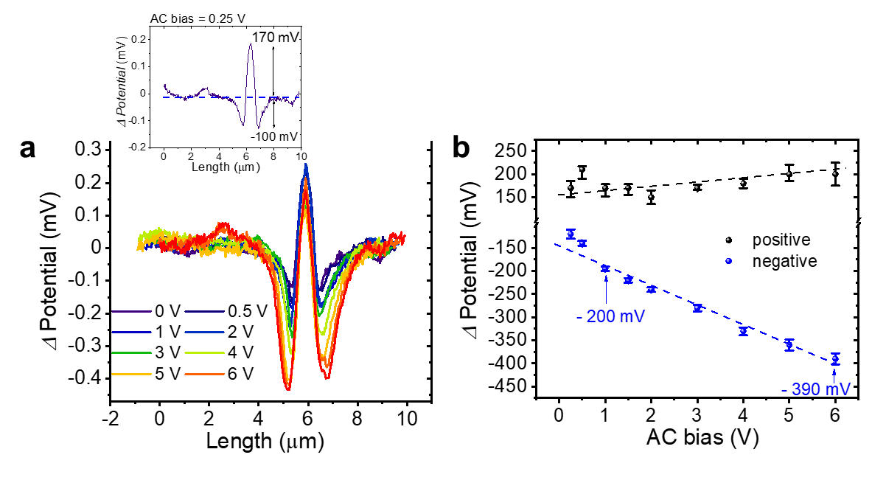
Supplementary Figure 23. a, Corresponding potential profiles along the dashed lines in Figure 22. Inset: step edge potential profile at the AC bias voltage of 0.25 V. b, AC bias voltage dependence of step edge positive and negative potential.

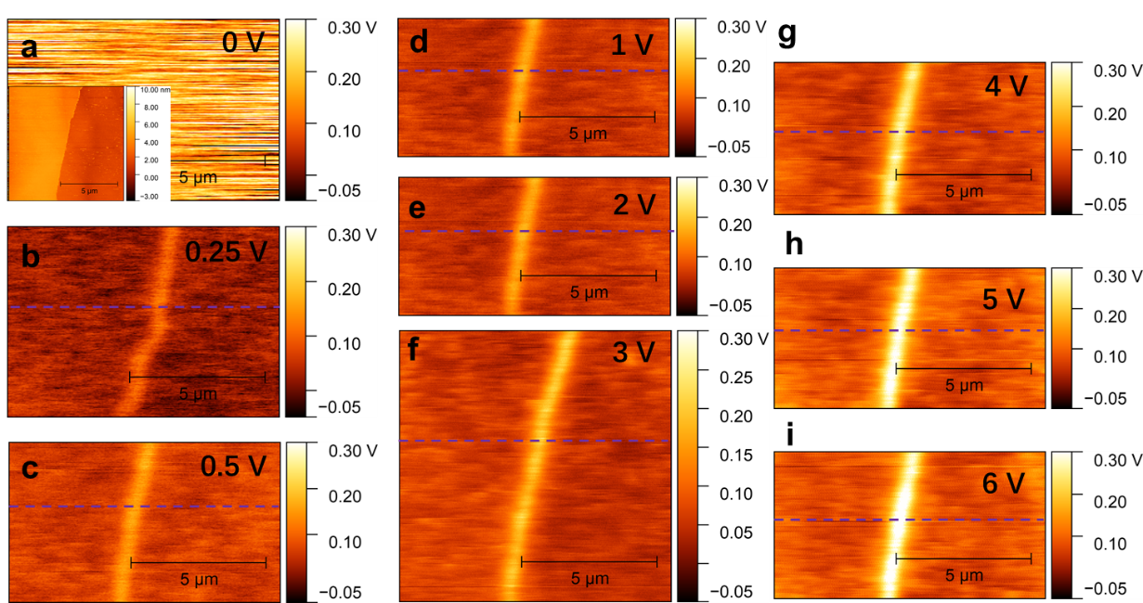
Supplementary Figure 24. SKPM potential images as a function of AC bias voltage increasing from 0 V to 6 V on the surface of an undoped Cl₂-NDI single crystal. Inset to a, AFM height image. The lift height is 10 nm.

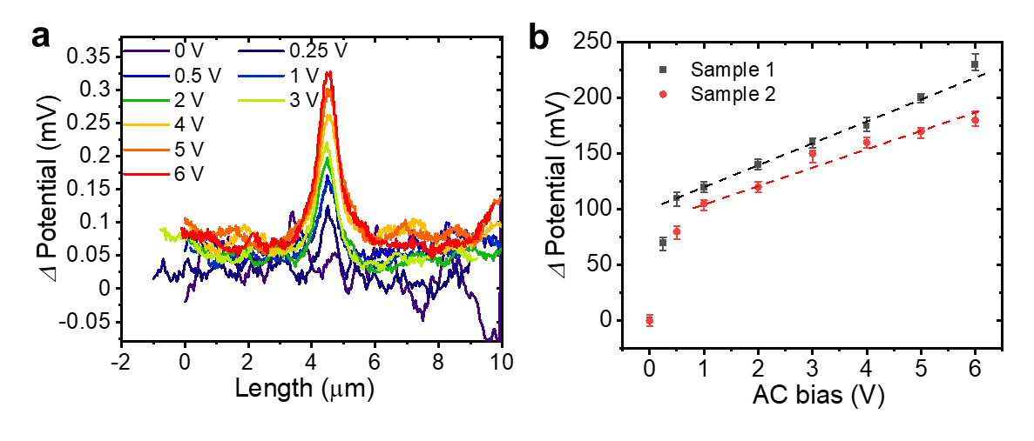
Supplementary Figure 25. a, corresponding potential profiles along the dashed lines in Figure 25. b, AC bias voltage dependence of step edge potential extracted from two samples.

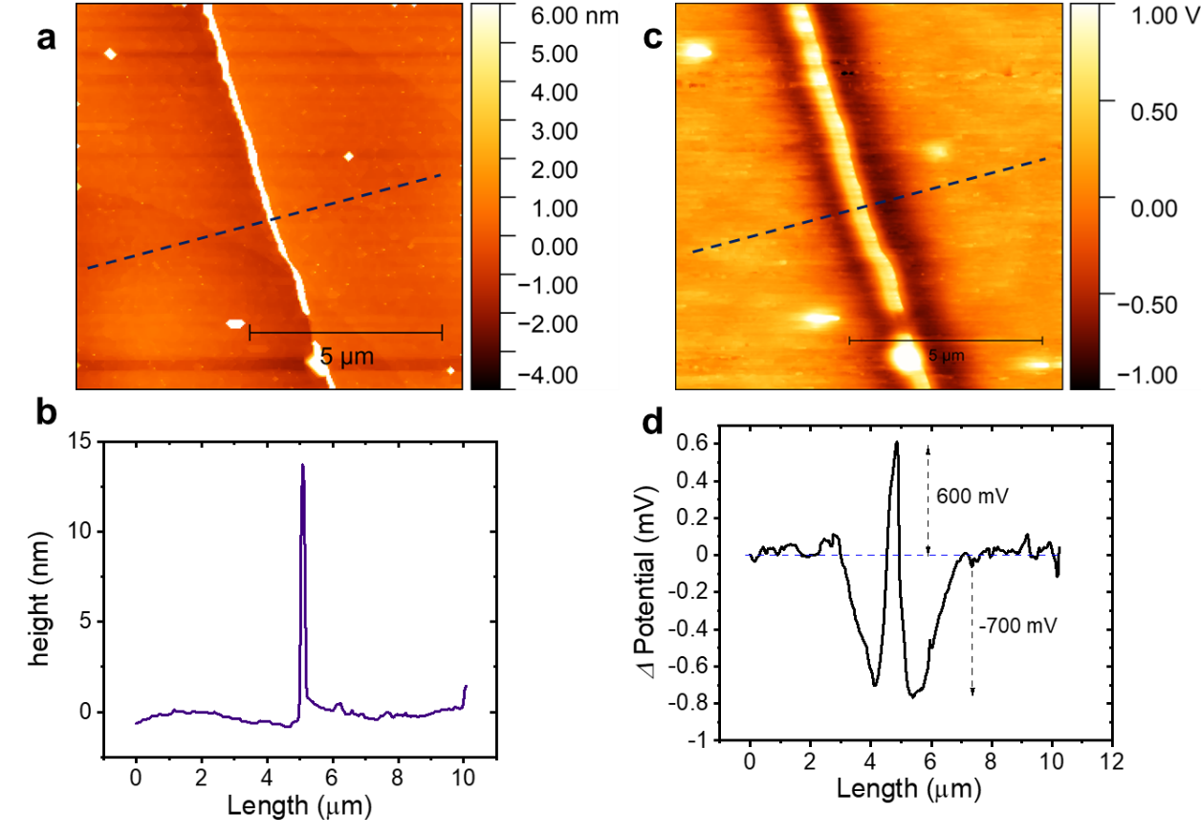
Supplementary Figure 26. AFM height image (a) and SKPM potential image (b) in single pass frequency modulation mode. AC voltage = 4 V; f_{mod} = 2 kHz. b, d, corresponding height profile and potential profiles along the dashed lines, respectively.
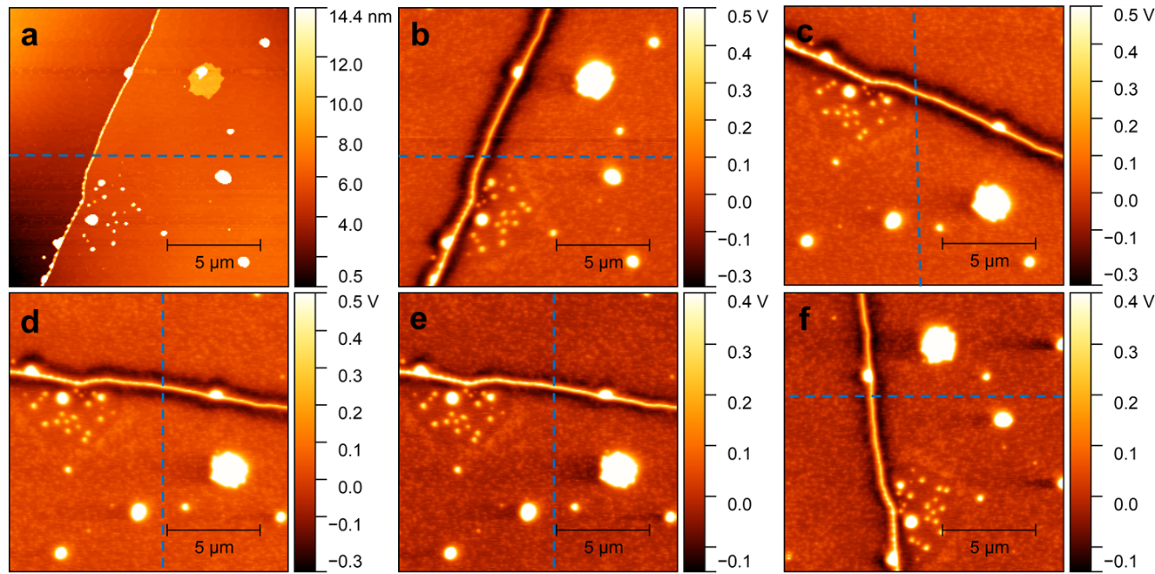
Supplementary Figure 27. Scan angle dependence of potential images of an N-silane doped Cl₂-NDI single crystal. a) height image. Corresponding potential images at scan angle of b) 0 degrees, c) 90 degrees, d) 75 degrees at an AC bias voltage of 3 V. Corresponding potential image at scan angle of e) 75 degree, f) 345 degrees at AC bias voltage of 1 V.

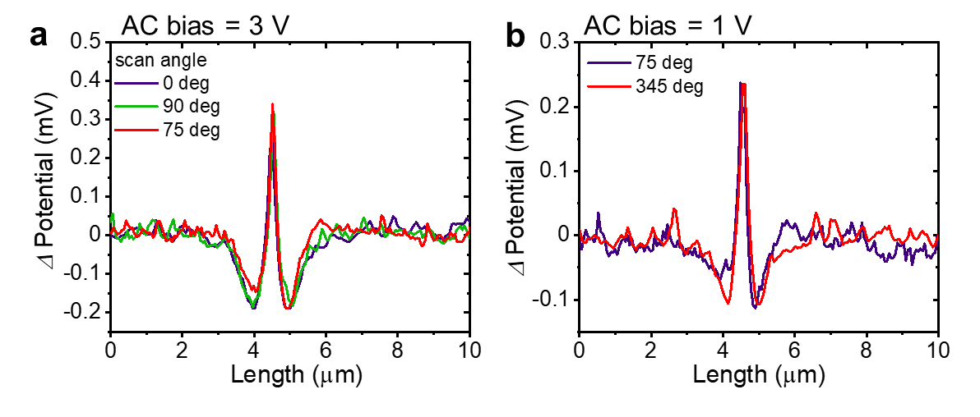
Supplementary Figure 28. Scan angle dependence of potential profiles along the dashed lines in Figure 27 at AC bias voltages of a) 3 V and b) 1 V.

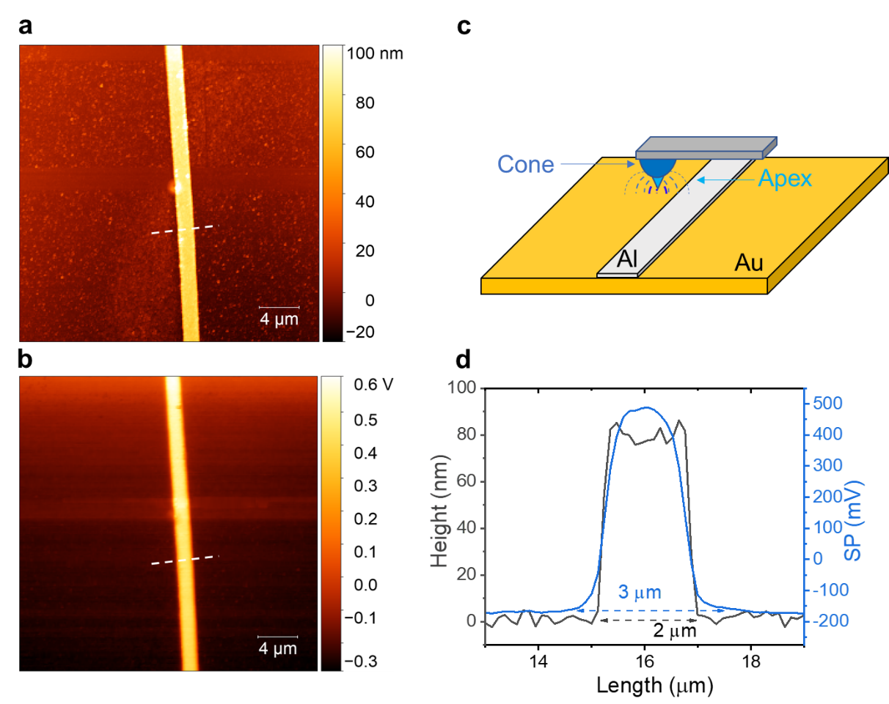
Supplementary Figure 29. Tip broadening effect¹⁷⁻¹⁹. AFM height (a) and SKPM potential (b) images of a 2 μm wide Al strip on an Au substrate. c, The schematic diagram of the probe geometry and electric field line distribution of the probe apex and cone. d, Corresponding AFM height and SKPM potential profiles along the dashed lines. The 2 μm wide Al strip is estimated by AFM topography, whereas the width of the SKPM potential profile is approximately 3 μm, which originates from convolution of the potential with the probe cone shape.
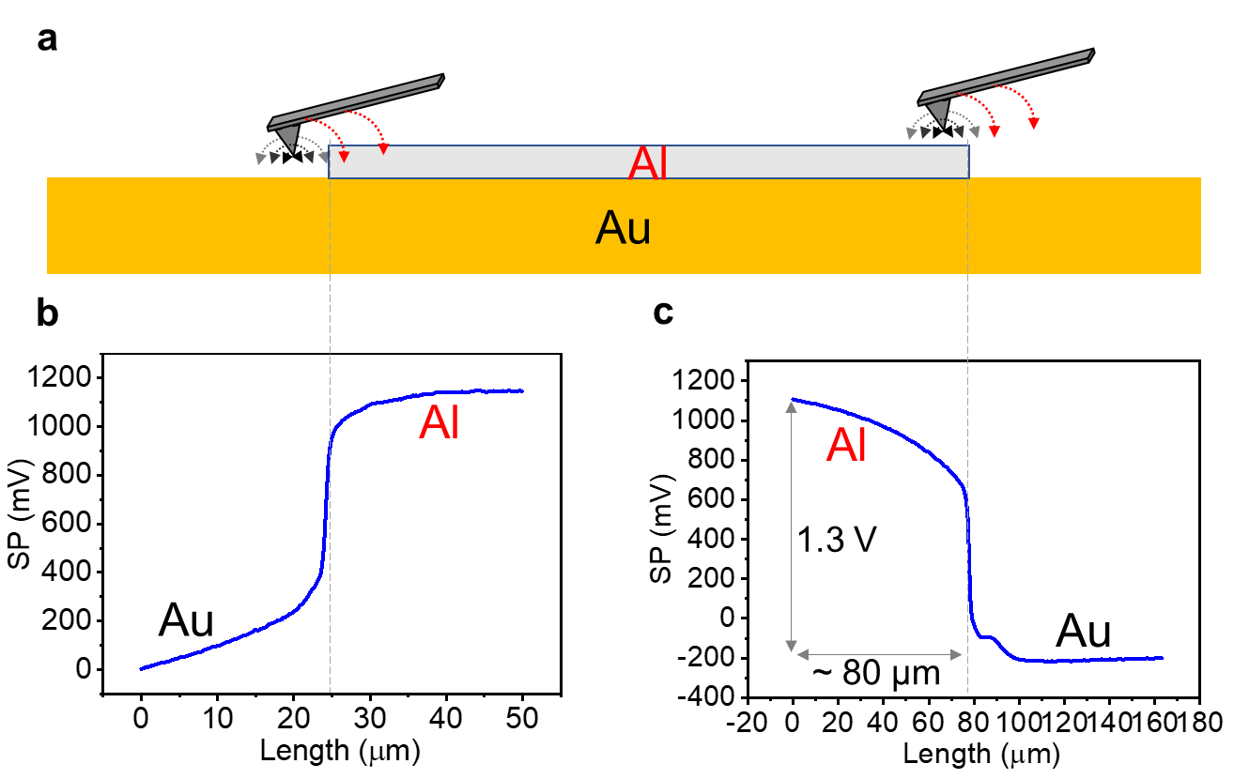
Supplementary Figure 30. Cantilever effect. a, The schematic diagram of the Al-Au sample and electric field line distribution of probe apex (black), cone (grey) and cantilever (red). The corresponding Al-Au potential profiles are shown with the cantilever on the top of Al (b) and Au (c). A constant “background” force is generated by the probe cantilever that contributes to the total sensed electrostatic force, leading to a gradually changing potential on the opposite (left) side of the probe cantilever and surface potential artifacts. This interpretation is consistent with the observation that the negative potential on the left side of step edges is always smaller than at the right side (Fig. 4 and Supplementary Fig. 16). Notably, the Au-Al potential difference is only 0.65 V in Supplementary Fig. 29 and this is far less than the anticipated value of 1.3 V based on work function differences. Such cone and cantilever contributions vanish when the probe apex is about 80 μm to the left of the Al-Au interface, at which point the measured potential corresponds to the real Al-Au potential difference of 1.3 V, as shown in c.

V. Ultraviolet electron spectroscopy; Step-edge doping density

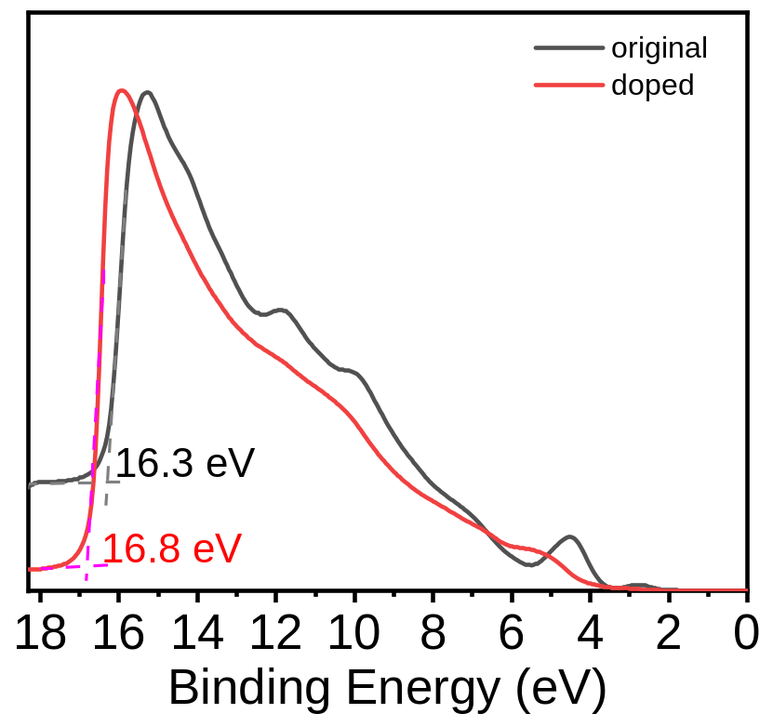
Supplementary Figure 31. Representative UPS spectra of a thick PDIF-CN2 single crystal before and after N-silane doping (dose: 50 μL N-silane for 1 h). The results are similar to UPS results for Cl₂-NDI (see Figure 5b in the main text).

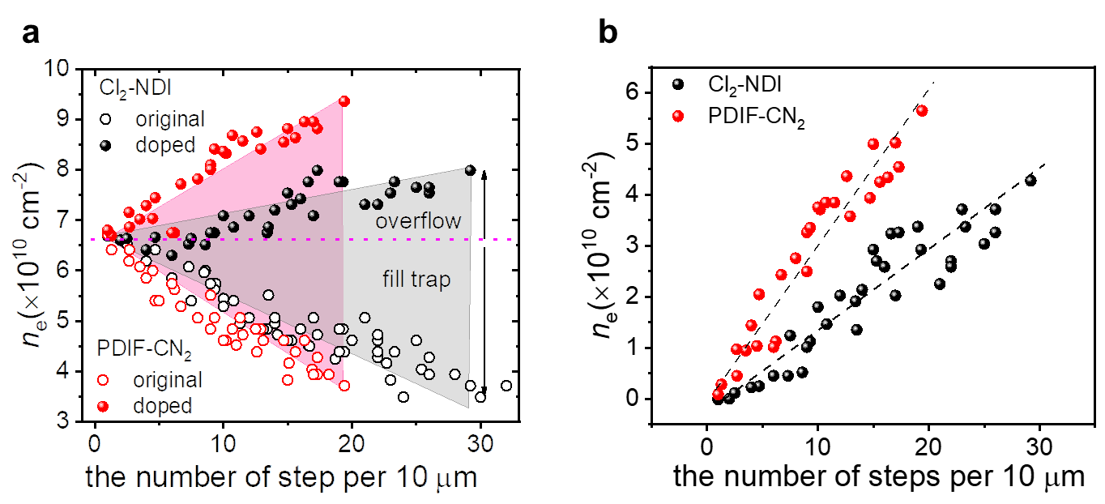
Supplementary Figure 32. Combined doping- and gate-induced charge density as a function of step density for Cl₂-NDI (black circles) and PDIF-CN₂ (red circles) single crystals at V_{G} of 60 V. n_{e} is estimated at fixed V_{G} = 60 V by the equation n_{e} = C_{i}(V_{G}−V_{th})/e, where C_{i} is the specific capacitance of 1.8×10⁻¹⁰ F cm⁻² and e is the elementary charge. a, Total doping- and gate-induced charge density for original (open circles) and doped (solid circles) devices as a function of crystal step density. For an ideal device without step-edge-traps, the charge density is about 6.5×10¹⁰ cm⁻² for both Cl₂-NDI and PDIF-CN₂ single crystals at V_{G} = 60 V. So, the negative slope for the undoped devices reflects step edge trapping. In contrast, a significantly higher n_{e} (solid circles) with a positive trend is evident for the doped devices, suggesting the incorporation of the dopant not only can fill step-edge-traps but also induces free mobile electrons. b, Doping-induced charge density as a function of crystal step density obtained by finding the differences in n_{e} between original and doped devices in (a). The slopes of these plots allow estimates of the doping-induced electron densities along the crystal steps; these values are 0.15 e nm⁻¹ for Cl₂-NDI (gray color) and 0.29 e nm⁻¹ for PDIF-CN₂ (purple color) single crystals, respectively. According to the crystal structure, the width of Cl₂-NDI and PDIF-CN₂ molecules along crystal steps are 9.4 Å and 7.4 Å, respectively. Consequently, the electron density is estimated to 0.14 e per Cl₂-NDI molecule and 0.22 e per PDIF-CN₂ molecule. Note the crystal step direction is perpendicular to [110] direction for Cl₂-NDI and [100] for PDIF-CN₂ according to AFM analysis and Grazing Incidence X-ray Diffraction (GIXRD) results in our previous studies.

VI. Electrostatic model for surface doping at a step edge
To explore further the SKPM profiles near step edges of the surface doped organic semiconductor samples we constructed a simple, two-dimensional, macroscopic electrostatic model. The model domain consists of two concentric semicircles ($r_{0}=20 μm$) for the cross-sectional region of air and Cl₂-NDI (Supplementary Fig. 33), where the upper semicircle corresponds to air (dielectric constant $ε_{r, air}=1)$and the lower one to the semiconductor ($ε_{r, SC}=3)$. An infinite, straight, positive line charge, perpendicular to the 2D plane, was placed at the origin to simulate the doped step edge. We set the charge density along the line to be uniformly 0.1 e/nm, which is consistent with the observed V_{T} differences of the undoped and doped structures in Supplementary Fig. 32.
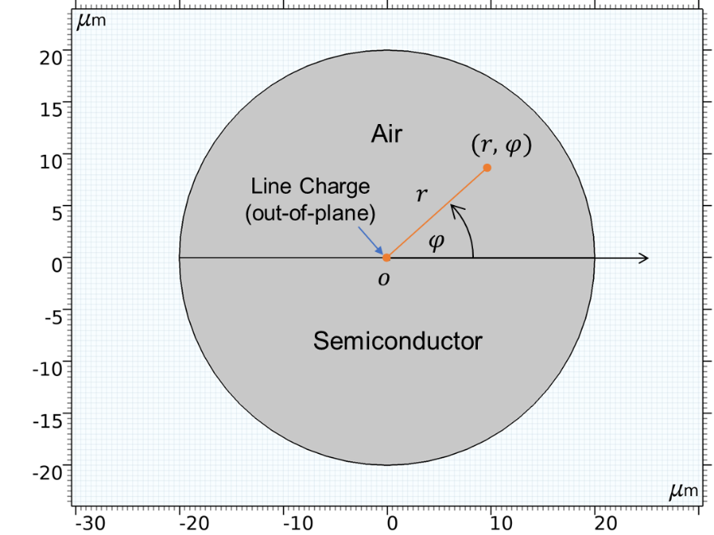
Supplementary Figure 33. 2D geometry of the simulation model.

Poisson’s equation was solved throughout the geometry in a polar coordinate system:
$∇^{2}V(r,φ)=-\frac{ρ (r,φ)}{{ε_{0}ε}_{r}(φ)}$ (Equation S1)
where $V$ is the electric potential, $ρ$is the charge density per volume, $ε_{0}$ is the vacuum permittivity, and $ε_{r}$is the dielectric constant.
Electrons in the semiconductor accumulate near the positive line charge. Hence, in the lower semicircle domain$(-π<φ<0)$, we allowed
$ρ(r,φ)=-{en}_{0}∙[exp\left(\frac{eV(r,φ)}{kT}\right)-1]$ (Equation S2)
to account for the non-linear screening in the semiconductor, where $n_{0}$ is the intrinsic charge concentration in Cl₂-NDI crystals, which results from unintentional doping. We set $n_{0}$ to be $1×{10}^{13} {cm}^{-3},$consistent with our previous work²⁰.
In the upper semicircle domain$(0<φ<π)$,
$ρ(r,φ)=0$ (Equation S3)
At the domain boundary ($r=r_{0})$, we assumed that there is no radial component of the electric field, consistent with overall charge neutrality:
$\frac{∂V(r,φ)}{∂r}|_{r_{0}}=0$ (Equation S4)
Numerical simulations in the framework of the Finite Element Method were performed using COMSOL Multiphysics v5.3a. For convenience, we subsequently converted the simulation results ($ρ\left(r,φ\right), V\left(r,φ\right), etc.)$ into Cartesian coordinates.
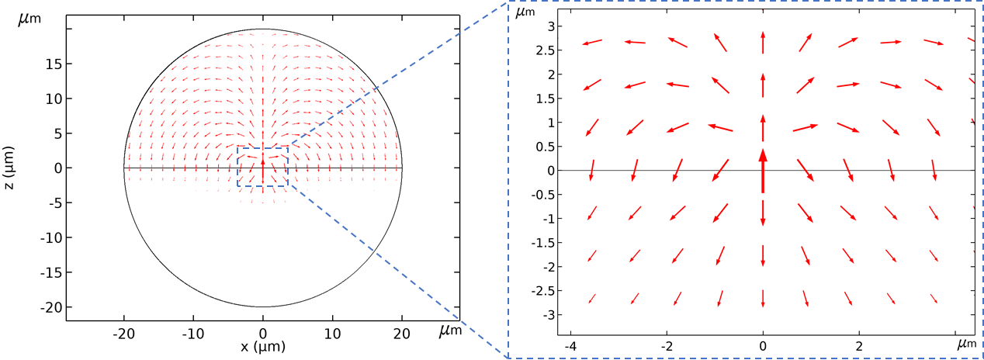

Supplementary Figure 34. Calculated electric field distribution in the z-x plane. Note that the electric field has significant twist. That twist (specifically the x-component of the field) is not detected by the SKPM instrument.
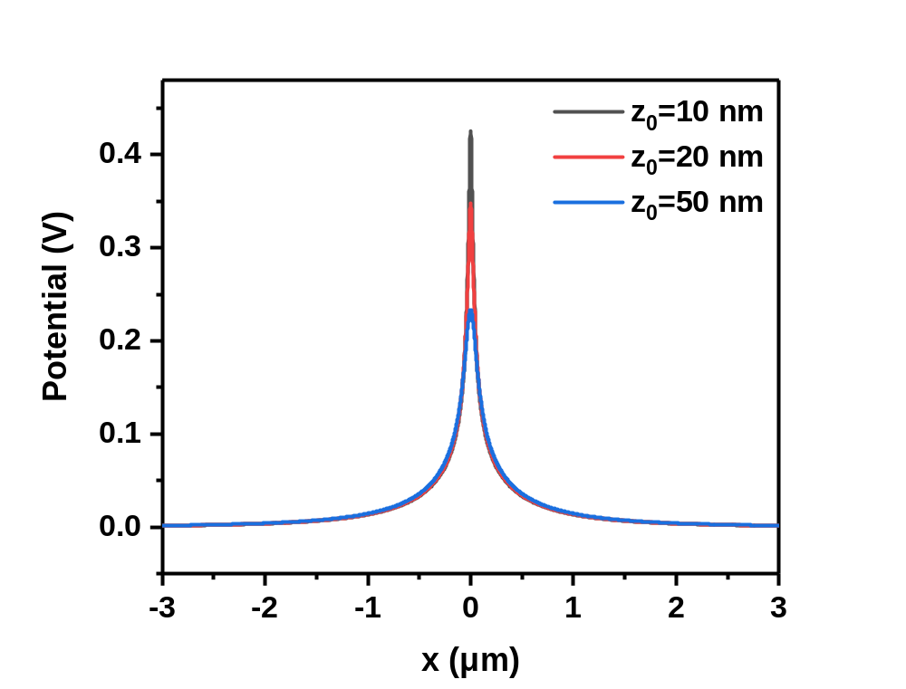
Supplementary Figure 35. Simulated electrostatic potential profile. The potential above the surface of the semiconductor falls off monotonically with distance from the line charge, as does also the potential directly on the surface. However, for comparison with the SKPM signal profiles, see the z-component of the electric field plot in Figure 5d of the main text. (Similar arguments in the analysis of SKPM data were also used in a pior report¹³.) Clearly our current, simple, macroscopic model does not address details in the immediate vicinity of the physical step edge. It does, however, at least qualitatively reflect the features of the SKPM signal profile at macroscopic distances from the step edge.

1. Kwon, O. et al. Aromatic Amines: A Comparison of Electron-Donor Strengths. J Phys. Chem. A 109, 9346-9352 (2005).
2. Park, J. et al. Single-gate bandgap opening of bilayer graphene by dual molecular doping. Adv. Mater. 24, 407-411 (2012).
3. Jacobs, I. E. et al. Quantitative Dedoping of Conductive Polymers. Chem. Mater. 29, 832-841 (2017).
4. Lee, B. H., Bazan, G. C. & Heeger, A. J. Doping-Induced Carrier Density Modulation in Polymer Field-Effect Transistors. Adv. Mater. 28, 57-62 (2016).
5. Röger, C. & Würthner, F. Core-Tetrasubstituted Naphthalene Diimides: Synthesis, Optical Properties, and Redox Characteristics. J. Org. Chem. 72, 8070-8075 (2007).
6. Quinn, S. et al. Core-Substituted Naphthalene Diimides: Influence of Substituent Conformation on Strong Visible Absorption. ChemPlusChem 82, 489-492 (2017).
7. Weißenstein, A., Grande, V., Saha-Möller, C. R. & Würthner, F. Water-soluble naphthalene diimides: synthesis, optical properties, and colorimetric detection of biogenic amines. Org. Chem. Front. 5, 2641-2651 (2018).
8. Aswal, D. K., Lenfant, S., Guerin, D., Yakhmi, J. V. & Vuillaume, D. Self assembled monolayers on silicon for molecular electronics. Anal. Chim. Acta 568, 84-108 (2006).
9. Calhoun, M. F., Sanchez, J., Olaya, D., Gershenson, M. E. & Podzorov, V. Electronic functionalization of the surface of organic semiconductors with self-assembled monolayers. Nat. Mater. 7, 84-89 (2008).
10. Goodson, F. S. et al. Tunable electronic interactions between anions and perylenediimide. Org. Biomol. Chem. 11, 4797-4803 (2013).
11. Schmidt, D., Bialas, D. & Würthner, F. Ambient Stable Zwitterionic Perylene Bisimide-Centered Radical. Angew. Chem. Int. Ed. 54, 3611-3614 (2015).
12. Polak, L., Man, S. d. & Wijngaarden, R. J. Note: Switching crosstalk on and off in Kelvin probe force microscopy. Rev. Sci. Instrum. 85, 046111 (2014).
13. Axt, A., Hermes, I. M., Bergmann, V. W., Tausendpfund, N. & Weber, S. A. L. Know your full potential: Quantitative Kelvin probe force microscopy on nanoscale electrical devices. Beilstein J Nanotechnol 9, 1809-1819 (2018).
14. Charrier, D. S., Kemerink, M., Smalbrugge, B. E., de Vries, T. & Janssen, R. A. Real versus measured surface potentials in scanning Kelvin probe microscopy. ACS Nano 2, 622-626 (2008).
15. Wang, K. et al. Determination of electrostatic force and its characteristics based on phase difference by amplitude modulation atomic force microscopy. Nanoscale Res. Lett. 11, 548, (2016).
16. Henning, A. K. et al. Two‐dimensional surface dopant profiling in silicon using scanning Kelvin probe microscopy. J. Appl. Phys. 77, 1888-1896 (1995).
17. Shen, Y., Barnett, D. M. & Pinsky, P. M. Simulating and interpreting Kelvin probe force microscopy images on dielectrics with boundary integral equations. Rev. Sci. Instrum. 79, 023711 (2008).

18. Melitz, W., Shen, J., Kummel, A. C. & Lee, S. Kelvin probe force microscopy and its application. Surf. Sci. Rep. 66, 1-27 (2011).
19. Charrier, D. S., Kemerink, M., Smalbrugge, B. E., de Vries, T. & Janssen, R. A. Real versus measured surface potentials in scanning Kelvin probe microscopy. ACS Nano 2, 622-626 (2008).
20. He, T. et al. Crystal step edges can trap electrons on the surfaces of n-type organic semiconductors. Nat. Commun. 9, 2141 (2018).

