Prospects of Ocimum gratissimum Linn. (Lamiaceae) to control Exorista sorbillansWiedemann (Diptera: Tachinidae) menace of silkworm in seriecosystem

BulbuliKhanikor¹ and Dipsikha Bora^{2*}
¹BulbuliKhanikor, Assistant Professor, Department of Zoology, Gauhati University, Guwahati-781014, Assam, India, khanikorbulbuli@yahoo.co.in
^{2*}Dipsikha Bora, Professor, Department of Life Sciences, Dibrugarh University, Dibrugarh, Assam, India, dipsikhabora03@yahoo.com

1
0
-1
6
5
4
3
2
1
0
Log concentration->
R-Sq = 0.980
Y = 3.49198 + 2.06379X
Probit mortality→

mmmm mom
Supplementary Fig.1: Regression plot of probit mortality of E.sorbillans against log concentration of petroleum ether extract of O.gratissimum

-0.5
-1.0
-1.5
-2.0
5
4
3
2
1
0
Log concentration->
R-Sq = 0.941
Y = 6.06912 + 2.81403X
Probitmortality→
Supplementary Fig.2: Regression plot of probit mortality of E.sorbillans against log concentration of essential oil of O. gratissimum.

Template Proteins | Model of ACHE | Ramachandran Plot
1dx4,  1qo9,  5ydi,  6arx,  6ary | 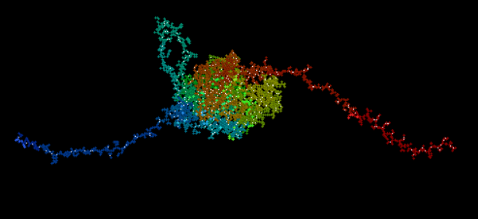 | 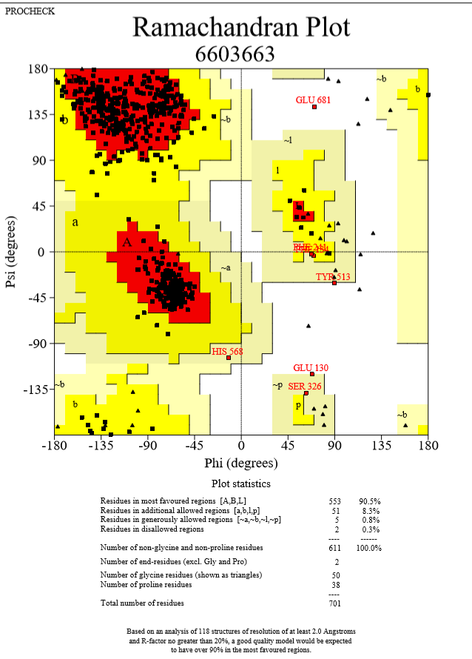

Supplementary Fig 3: Model protein of ACHE(middle) constructed based on template protein (left) and Ramachandron plot (right) of the protein in PROCHECK

