Additional File 1
File format: .docx
Title: Contraindication for prone positioning
Description of data:
a. Intracranial pressure > 30 mm Hg or cerebral perfusion pressure < 60 mmHg
b. Massive haemoptysis requiring an immediate surgical or interventional radiology procedure
c. Tracheal surgery or sternotomy during the previous 15 days
d. Serious facial trauma or facial surgery during the previous 15 days
e. Deep venous thrombosis treated for less than 2 days
f. Cardiac pacemaker inserted in the last 2 days
g. Unstable spine, femur, or pelvic fractures
h. Mean arterial pressure lower than 65 mm Hg
i. Pregnant women
j. Single anterior chest tube with air leaks

Additional File 2
File format: .docx
Title: Drug administration strategy in the study protocol
Description of data:
Medications for coronavirus disease 2019 (COVID-19) pneumonia were as follows:
(ⅰ) Immune-based agent: We administered dexamethasone, dose was 0.15 mg/kg, and the duration of administration was from 7 days to 10 days [23].
(ii) Antiviral agent: Remdesivir was administered at a dose of 200 mg on the first day and 100 mg thereafter; the duration of administration was from 7 days to 10 days [24].
(ⅲ) Thromboprophylaxis agent: We administered subcutaneous low-molecular-weight heparin 10,000 units until the patients could move automatically [25].
In addition, as a preventative antibiotic for ventilator-associated pneumonia (VAP), we chose tazobactam-piperacillin based on previous reports regarding the frequency of VAP occurrence due to the causative bacteria and used it until the patient was extubated [12].

Additional File 3
Title: Multiple linear regression analysis of duration of ventilation
File format: .docx
Description of data:
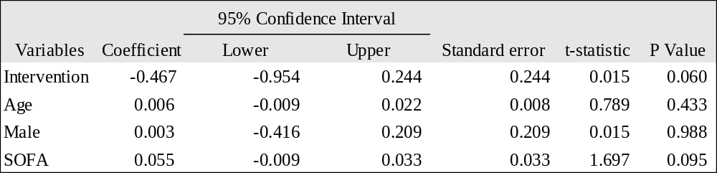
Definition of abbreviations: SOFA=Sequential Organ Failure Assessment
The multi variable analysis was conducted with age, sex and SOFA: these are considered a risk factor for severe COVID-19 pneumonia. The duration of ventilation was log-transformed before the multivariate analysis. Pre-introduction group included 17 and post-introduction group included 50 patients.

Additional File 4
Title: Multiple linear regression analysis of length of ICU stay
File format: .docx
Description of data:
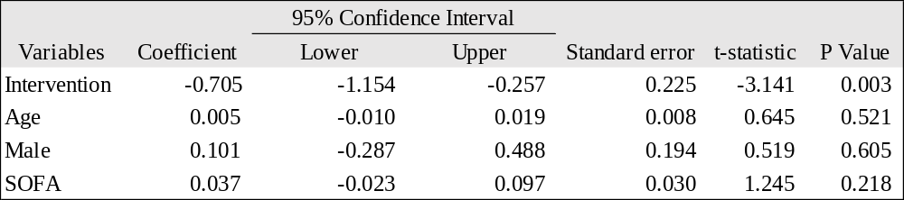
Definition of abbreviations: SOFA=Sequential Organ Failure Assessment
The multi variable analysis was conducted with age, sex and SOFA: these are considered a risk factor for severe COVID-19 pneumonia. The length of ICU stay was log-transformed before the multivariate analysis. Pre-introduction group included 18 and post-introduction group included 50 patients.

