Additional File 3: Supplemental Figure 2:
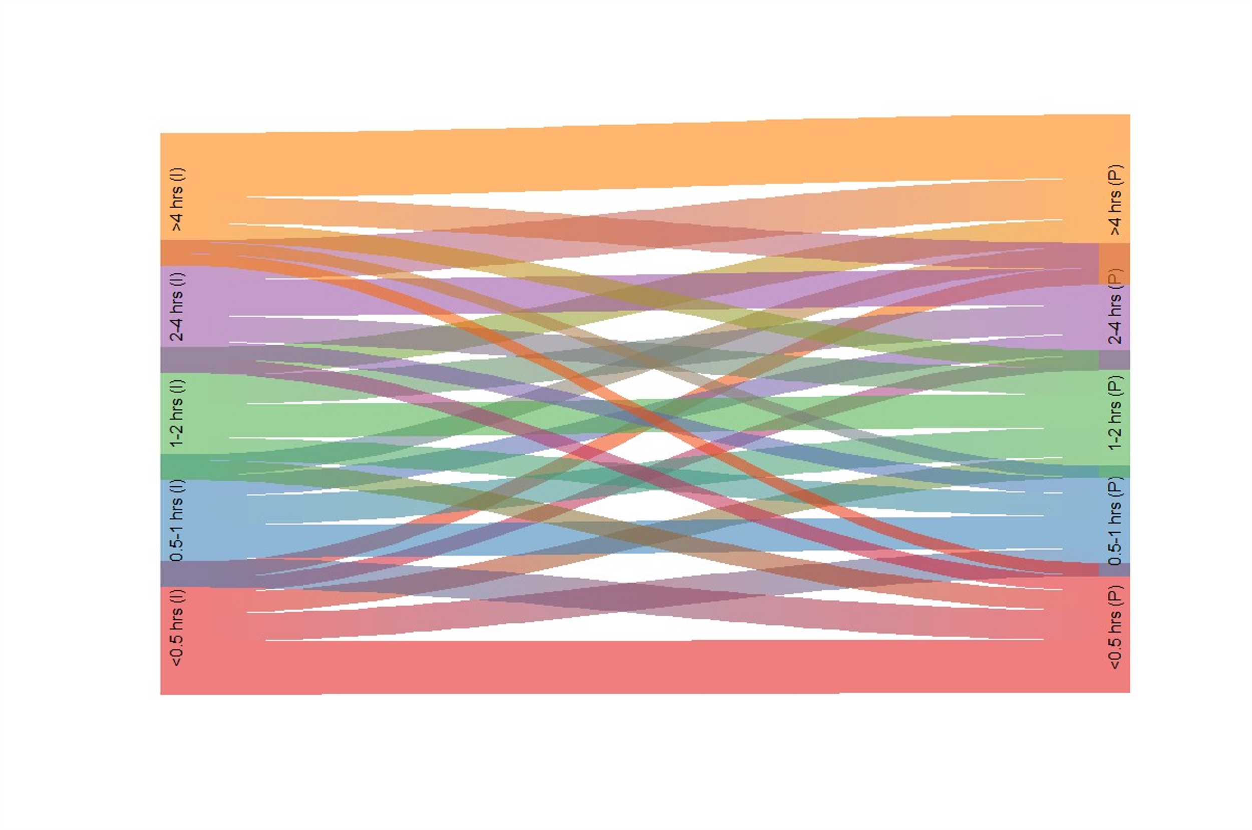
Supplemental Figure 2: Sankey diagram river plot of the changes in DRT from ≤180 days FDD to >730-to-≤910 days FDD. (I)= incident DRT from ≤180 days FDD on left; (P)=second year prevalent DRT from >730-to-≤910 days FDD on right.

