Supplementary Methods

RNA-Seq data retrieval
RNA-Seq data of 14 samples from nine Flaveria species, including F. cronquistii juvenile leaf (J) and mature leaf (M), F. angustifolia J and M, F pubescens J and M, F. sonorensis J, F. palmeri J, F. vaginata J, F. bidentis J and M, F. trinervia J and M, F. kochiana M, were downloaded from the Sequence Read Achieve (SRA) of the National Center for Biotechnology Information (NCBI). Growth conditions in greenhouses at the University of Toronto and sample extraction were carried out as described by Lyu et al. [1]. These sequences were from an Illumina paired-end sequencing strategy [1]. Other plants were grown in greenhouses at Heinrich-Heine University (HHU) [1]. RNA-Seq data of these plants were from 13 leaf samples from 13 Flaveria species, including F. robusta, F. angustifolia, F. floridana, F. pubescens, F. chloreafolia, F. anomala, F. ramosissima, F. brownii, F. palmeri, F. vaginata, F. bidentis, F. trinervia and F. australasica, and were downloaded from SRA. RNA-Seq data from HHU were based on an Illumina single-end sequencing strategy. RNA-Seq data for stem and root samples of F. robusta and F. bidentis from HHU were generated from the same plants and with the same strategy as the HHU leaf samples. These data were downloaded from SRA. 454 RNA-Seq of 4 Flaveria species, including F. robusta, F. ramosissima, F. trinervia and F. bidentis, were downloaded from SRA [2]. All accession numbers for RNA-Seq data are shown in Table S1.

Amino acid sequence extraction and alignment
Predicted amino acid changes between C₃ and C₄ species were investigated transcriptome-wide as follows (Fig. S7): (1) Predict peptide sequence from assembled contigs. Both OrfPredictor [3] and Portrait [4] were applied independently to predict the most possible open reading frames (ORF) in a six-frame way. (2) Filter short protein sequences. Protein sequences from all species were gathered and categorized into two datasets according to their length. Sequences that were no less than 80 % and no more than 120 % of the length of the Arabidopsis reference were classified into dataset 1. Those that were less than 80 % but no less than 50 % of the length of the Arabidopsis reference were classified into dataset 2. (3) Filter out incorrectly assembled sequences from dataset 1. We performed an all against all BLASTP (BLAST+ 2.2.28) [5] with an E-value cutoff of 1.0 E-10 in dataset 1. Protein sequences without any similar sequences in dataset 1 were filtered out. The remaining sequences from dataset 1 generated dataset 3. At the same time, the sequence that was targeted as the best hit by the most number of sequences in dataset 1 was used as a reference (RF). (4) Recall next-best sequence from dataset 2 by applying BLASTP [5] using RF as reference. Sequences recalled from dataset 2 generated dataset 4. (5) Generate the final protein sequences from each gene by combining dataset 4 and dataset 3, termed as dataset 5. If there were multiple sequences present in dataset 5 for one species, then the one with the highest BLASP bit score with RF was saved and all others discarded. (6) Align sequences in dataset 5 using MUSCLE [6]. Finally, the predicted amino acid sequences from the C₄ species were compared to those of the C₃ species to identify changes. A difference was classified as a change if the homologues from the two C₃ species (F. robusta and F. cronquistii) contained the same predicted amino acid at a position, but was different to the predicted amino acid at the corresponding position in homologues from at least two C₄ species (among F. kochiana, F. bidentis, F. trinervia and F. australasica). An in-house Perl script was used to make the comparisons.

Estimation of accuracy of predicted protein sequences
To estimate the accuracy of the predicted sequences of identified proteins, we conducted a systematic comparison between the sequences of proteins from Flaveria species available in the UniProt KnowledgeBase (UniProtKB) database (http://www.uniprot.org/) with the corresponding sequences predicted using our pipeline. A total number of 20 protein sequence pairs were compared. For each pair, after aligning with MUSCLE [6], the number of equivalent amino acids was calculated.

Transcript comparison and gene ontology enrichment analysis
Principle component analysis was conducted by applying the princomp package in R [7]. Heatmaps of transcript abundance were viewed using Pheatmap package (version 0.7.7) in R. Identification of enriched gene ontology (GO) terms of the 205 genes was achieved by searching for overrepresented GO terms in the web tool DAVID [8] (http://david.abcc.ncifcrf.gov), with a P value <0.05 (“BH” adjusted). We identified the overlap of the 205 genes with the genes that respond to low CO₂ treatment in Arabidopsis [9], and orthologous genes showing MCs- and BSCs- specific expression patterns in Gynandropsis gynandra [10], Zea mays (maize) [11] and Setaria viridis [12]. To test whether the observed number of overlapping genes was higher than by chance, we evaluated the false discovery rate (FDR) by Monte Carlo simulation. For each simulation, we randomly selected 205 genes from the 13,081 expressed genes in Flaveria and calculated the number of genes overlapping the differentially expressed genes under low CO₂ in Arabidopsis and between MCs and BSCs in the C₄ species. The rate was calculated from one million simulations.

Identification of amino acid under positive selection
To identify positively selected amino acid site in the C₄ related genes in Flaveria C₄ species, we used Flaveria non-C₄ species (including C₃ and C₃-C₄ species) as background. For each gene, only these species with completely assembled sequence were included in the analysis. Firstly, protein sequences of orthologous genes were aligned using the software Muscle [13]. Then aligned protein sequences were used to guide the codon-wise alignment of CDS using PAL2NAL [14]. After removing gaps and stop codons, the multiple sequence alignment results were inputted into PAML software (version 4.8) for positive selection tests [15]. In this study, the positive selection test was conducted using the branch-site model (model=2, NSsites=2) under the nucleotide substitution conditions of CodonFreq=2 (4 distinct frequencies are used for each position, named F3X4). The likelihood of the null hypothesis was calculated under this branch-site model with fixed dN/dS ratio (ω=1, neutral). The maximum likelihood of the alternative hypothesis was calculated under this branch-site model with flexible dN/dS ratio (ω>1, positive selection). Then, the likelihood ratio test (LRT) was conducted between the null hypothesis and the alternative hypothesis under chi-square distribution to accept or reject the alternative hypothesis. Significant genes (p-value < 0.05, Benjamini Hochberg (BH) adjusted) confirmed by tests under these two different nucleotide substitution conditions were considered as genes under positive selection.

Supplementary Results

Investigate the possibility of species used in this study being hybrid
Considering that intermediacy of traits in the intermediate species may result from a possible hybrid between species with one parent being C₃ and another parent being C₄ or intermediate species [16], we investigated whether the intermediate species used in this study are naturally evolved intermediate species or hybrid species used the strategy as described in [1]. It is expected that hybrid species will have more DNA sites expressing two different alleles from both parents. Therefore, we calculated the percentage of DNA sites that expressed two different alleles, termed as mixed site, which was compared to the positive background generated by pair-wisely mixing two of RNA-Seq data of 16 Flaveria species used in this study. Our result showed that the knowing hybrid sample F. pringlei* of original F. pringlei ×F. angustiflolia in [1] showed significantly higher percentage of mixed site than background (Binomial test, P<0.001), while other species showed significantly lower percentage of mixed site than background (Binomial test, P<0.001) (Fig. S6). Thus, all species used in this study are from natural evolution and can be used for this evolutionary study.

Investigate the accuracy of predicted peptide sequence comparing with those from UniprotKB
To estimate the accuracy of the predicted peptide sequences from our data, we conducted a comparative study of protein sequences from UniProtKB (http://www.uniprot.org) with those from our data. We obtained all of the Flaveria protein sequences available in UniProtKB, 20 of which were assembled as full-length proteins in our dataset. Among these 20 proteins, 14 showed full identity with homologues in UniProtKB (Table S3). Our assembled F. bidentis NADP-ME protein sequence showed four amino acids that were inconsistent with the corresponding sequence from UniProtKB, namely N232, V428, G521 and A634 versus I232, A428, S521 and T634 in the UniProtKB entries (Table S3). Considering that the UniProtKB proteins are based on both manual and automatic annotation and consequently may be prone to error, we examined these residues in our assembled sequences from other Flaveria species. F. australasica and F. ramosissima NADP-ME isoforms were predicted to have the same amino acids as the F. bidentis NADP-ME generated from our data, suggesting that our predicted sequences are correct. A similar situation was also found in three other proteins, F. ramosissima maturase K (matK), F. trinervia matK and F. bidentis PPDK (Table S3). In the case of the F. brownii and F. trinervia predicted PEPC sequences, we found five and six amino acids, respectively, that were inconsistent between the UniProtKB sequences and our data; however, about half of the amino acids were consistent with sequences from two other species (Table S3). These inconsistencies between our assembled sequences and those in UniProtKB may be a result of assembly artifacts or the presence of multiple alleles in the different Flaveria species.

The expression pattern of orthologous genes of 205 C₄ related genes in other species
We investigated the overlap of the 205 Flaveria genes with genes known or having the potential to be related to C₄ photosynthesis or C₄₌evolution. Specifically, we compared the 205 genes with genes showing differential expression under long-term low CO₂ treatment in Arabidopsis thaliana (Arabidopsis) [9] since low CO₂ has been recognized as an important environmental factor influencing C₄ evolution [9]. Among the 205 Flaveria genes, we found that 102 overlapped with ai orthologues responding to low CO₂ treatment, of which 56 and 46 showed significantly (P<0.05) increased and decreased transcript abundance, respectively (Figure S7). Monte Carlo simulation results indicated that this number of common genes is higher than by chance, with a marginal false discovery rate (FDR=0.07). We further compared the 205 Flaveria genes with publically available datasets of BSCs- and MCs-specific expressed genes in three C₄ lineages. In Gynandropsis gynandra [10], 108 orthologues of the 205 Flaveria genes showed cell-specific expression patterns (P<0.05), among which 65 and 43 showed MCs- and BSCs-specific expression patterns (Figure S8; FDR<0.001). In Zea mays and Setaria viridis [11, 12], 70 orthologues of the 205 Flaveria genes showed conserved cell-specific expression patterns, among which 39 and 31 showed MCs- and BSCs-specific expression patterns, respectively (Figure S9; FDR<0.001). Furthermore, comparison of the 205 Flaveria genes with Zea mays (Maize) leaf section transcript data [17] revealed expression of 109 Maize orthologues in all three eaf sections, and 24 of these 109 genes showed consistent cell-specific expression patterns in the three sections (FDR<0.01; Figure S10).

Supplementary figures and tables

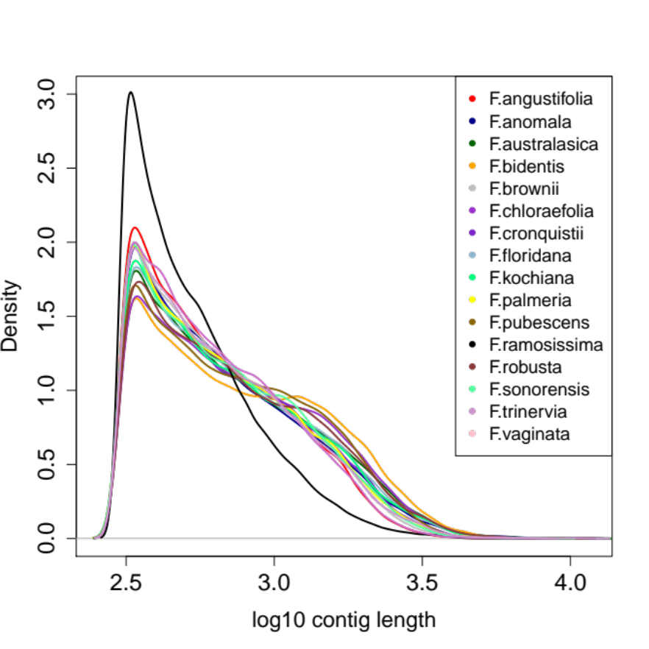
Figure S1. Contig-length distribution of 16 Flaveria species
All species displayed a peak at around 316 nucleotides (10^{2.5}).
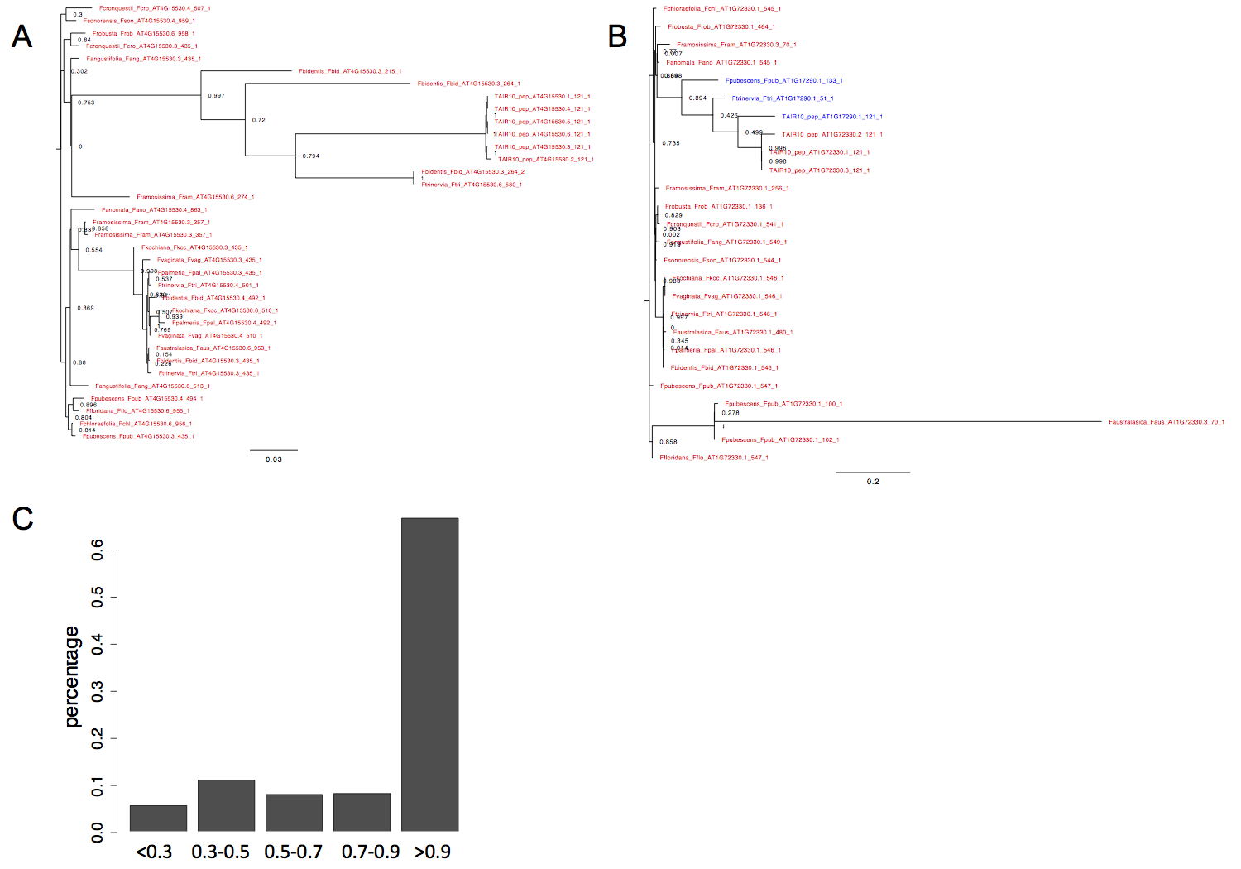

Figure S2. The consistency between gene annotation based Blast and Orhtologous groups based on OrthoFinder
A: The consistence between annotation using Blast and orthologous groups was calculated in two categories: (1) If the orthologous group contains Arabidopsis genes, the consistency was calculated as the percentage of genes that have the same annotation with Arabidopsis gene, such as PPDK showed in (A). (2) If the orthologous group contains no Arabidopsis gene, the percentage of each annotated gene ID in this group was calculated, and the highest percentage was assigned as the consistency, such as AlaAT showed in (B). The form of the Flaveria gene in the gene trees was as: SpeciesName_SpeciesAbbrevation_Annotation_AssembledProteinLength_SerialNumber. The distribution of the consistency of total 28164 orthologous groups is showed as (C).

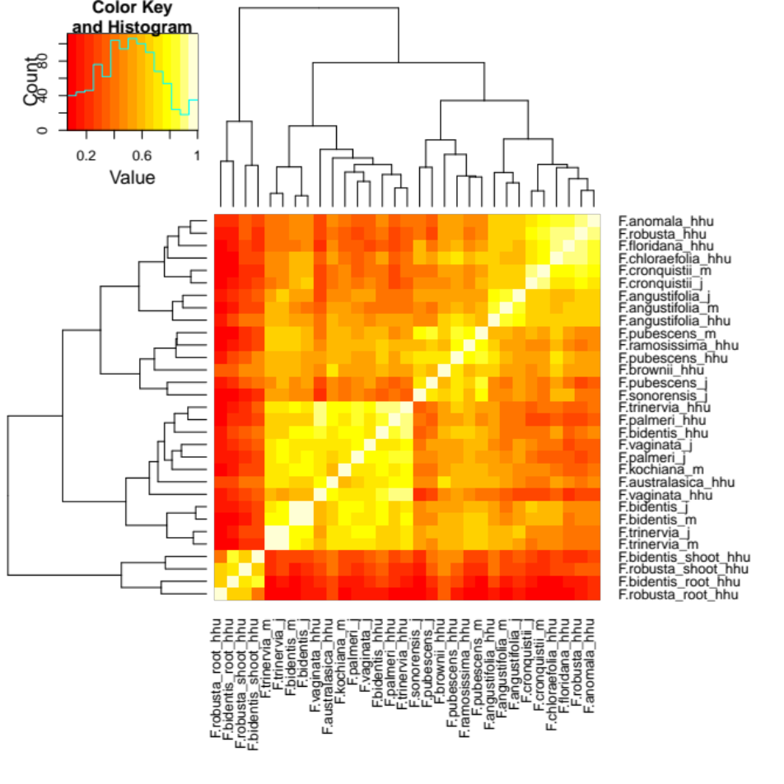
Figure S3. Pair-wise Pearson correlations of 31 Flaveria samples.
Transcriptomic profiles from juvenile (j) and mature (m) leaves of the same species showed the highest similarity. In addition, transcriptomic profiles between the same organs from different species were more similar than that between different organs from a same species. (Abbreviations: j/m: juvenile/mature leaf sample from University of Toronto, hhu/shoot_hhu/root_hhu: leaf/shoot/root/ samples from Heinrich-Heine-University.)

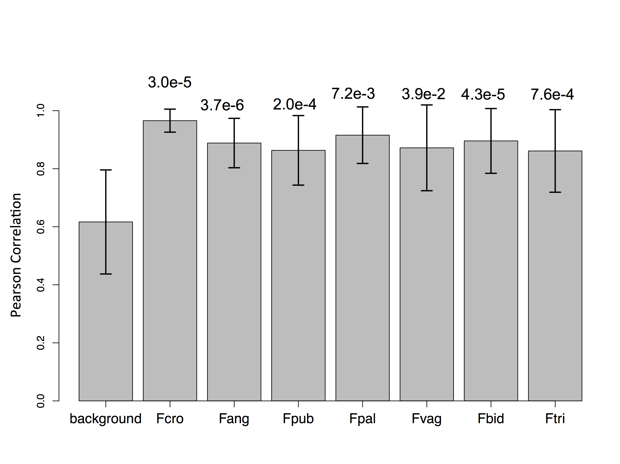
Figure S4. Pearson correlations between leaf samples from the same species are higher than mean Pearson correlations among leaf samples
The first bar shows the mean correlations among 29 leaf samples, while the second to the eighth bars show the Pearson correlation between samples of a same species. Error bars show standard deviation. Student tests were conducted to test whether the Pearson correlation within each species is higher than that of background, which was the Pearson correlations of all pair-wise samples, and the P-values are shown at the top of the corresponding bar. Abbreviations: Fcro: F.cronquistii, Fang: F. angustifolia, Fpub: F. pubescens, Fpal: F. palmeri, Fvag: F.vaginata, F bid: F. bidentis, Ftri; F. trinervia.

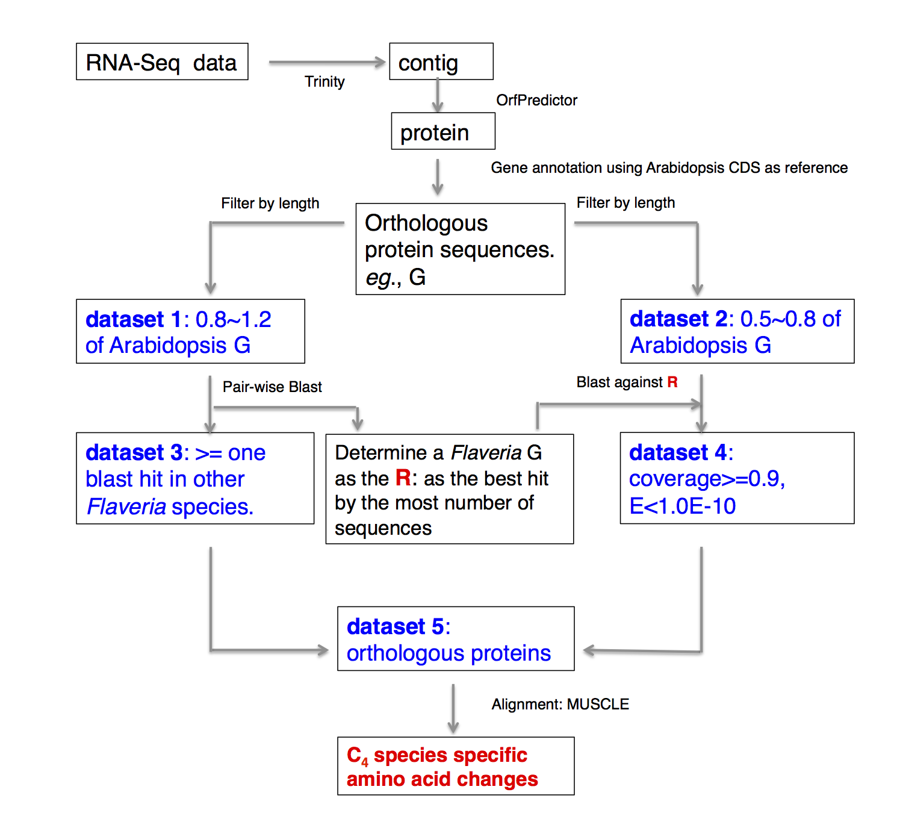
Figure S5. Workflow to identify amino acid changes between C₃ and C₄ species from RNA-Seq data.
Transcripts were first assembled based on RNA-Seq data. Open reading frame (ORF) and protein sequences were then predicted from assembled transcripts. Proteins were annotated as the best hit of Blast against Arabidopsis CDS reference. Orthologous genes, eg., “G”, from all Flaveria species formed the orthologous group of “G”, the orthologous group of “G” were classified into two groups according to their length: dataset 1 contained protein sequences that had similar lengths to “G” in Arabidopsis, and dataset 2 contained relatively short protein sequences which may result of incompletely assembly. By all against all BLASTP among dataset 1, the sequences in dataset 1 that had no similar sequence in dataset 1 were discarded, these sequences may result from mis-annotation or mis-assembly, and the remaining sequence from dataset 1 formed dataset 3. Meanwhile, the protein sequence from dataset 1 that was the best target of the most number of sequences by BLASTP in dataset 1 was chosen as reference (R) to retrieve good sequence from dataset 2 by using BLASTP. This step resulted in dataset 4, which form dataset 5 together with dataset 3. Mutations were determined from alignment of protein sequences in dataset 5, where the sequences of at least two C₄ species were consistent, but differed from the two C₃ species.

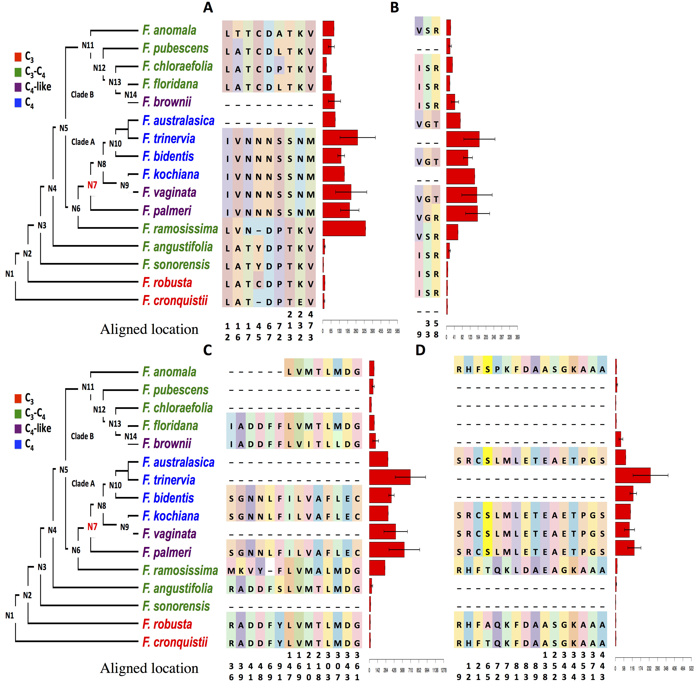
Figure S6. Predicted changes in amino acid residues and transcript abundances of C₄-associated aminotransferases and transporters
The changes in amino acid residues and levels of transcripts (FPKM) encoding alanine aminotransferase (AlaAT) (A), aspartate aminotransferase 5 (AspAT5) (B), sodium symporter family protein 2 (C) and sodium:hydrogen (Na⁺/H⁺) antiporter (D) are shown for C₄ and C₃ Flaveria species. Only the amino acid residues predicted to be different between C₃ and C₄ species are superimposed on the Flaveria phylogenetic tree (Lyu et al., 2015). The colors of amino acid residues have no meaning and are only for visualization purposes. Numbers below the amino acids indicate the location site in the multiple sequence alignments. FPKM values are represented to the right of the amino acid changes as red bars.

Table S1. The Flaveria samples and RNA-Seq data used in this study
C₃ | Type I C₃-C₄ | TypeII C₃-C₄ | C₄-like | C₄
Pair-end RNA-Seq from Illumina HiSeq 2000, read length: 90 nucleotides. Plants were grown at the University of Toronto. Mature leaves were taken as the newest fully expanded leaf, and juvenile leaves were taken as the most recently starting to expand from the main stem. Each sample was pooled from 2-4 plants. Raw data were downloaded from NCBI Short Read Archive (SRA).
F. cronquistii (jª,m^{b}) SRX447412,  SRX447413 | F. angustifolia (jª, m^{b})  SRX447406,  SRX447407  F. pubescens (jª,m^{b})  SRX447418,  SRX447419  F. sonorensis (jª)  SRX447420 |  | F. palmeria (jª)  SRX447415  F. vaginata (jª)  SRX447423 | F. bidenits (jª,m^{b}) SRX447408,  SRX447409  F. trinervia (jª,m^{b})  SRX447421, SRX447422  F. kochiana (m^{b}) SRX447414
Single-end RNA-Seq from Illumina HiSeq 2000, read length: 100 nucleotides. Plants were grown at Heinrich-Heine University. Leaf samples were taken from 2nd and 4th leaf. Root and shoot samples were taken from corresponding plants. SAR accession number underlined were generated in this study and submitted to NCBI SRA, others were downloaded from NACI SRA.
F. robusta(lª,r^{c},s^{d})  SRX468650,  SRX794075，  SRX794076， | F. pubescens(lª)  SRX468638  F. chloreafolia(lª),  SRX467630  F. angustifolia(lª),  SRX794138 | F. anomala(lª)  SRX467620  F. floridana (lª),  SRX794148  F. ramosissima (lª)  SRX468646 | F. brownii(lª)  SRX467625  F. vaginata(lª)  SRX794153  F. palmeri (lª)  SRX794162 | F. bidenits(lª,r^{c},s^{d})  SRX467614,  SRX794053，  SRX794064  F. trinervia(lª)  SRX468662  F. australasica(lª)  SRX794172
454 RNA-Seq from GS FLX, read length: 200 nucleotides. Plants were grown at Heinrich-Heine University. Leaf samples were taken from the second and fourth leaves.
F. robusta  SRX052096 |  | F. ramosissima  SRX052095 |  | F. bidentis  SRX052090  F. trinervia  SRX052094
ª : juvenile leaf, ^{b}: mature leaf, ^{c}: root sample, ^{d}: shoot sample.

Table S2. Assembly and mapping statistics of 16 Flaveria species
Species | #Contig | N50 | %Reads mapping to Arabidopsis | #Unique mapping | #Splitting mapping | Proportion Splitting mapping
F. angustifoliaª | 34,710 | 914 | 68.15% | 23,036 | 620 | 2.62%
F. anomala^{b} | 48,969 | 1,067 | 46.99% | 21,413 | 1,598 | 6.94%
F. australasica^{b} | 47,577 | 1,168 | 52.02% | 23,698 | 1,050 | 4.24%
F. bidentisª | 42,574 | 1,316 | 58.96% | 24,372 | 728 | 2.90%
F. browniiª | 44,794 | 974 | 58.17% | 24,920 | 1,135 | 4.36%
F. chloraefolia^{b} | 41,203 | 1,208 | 56.56% | 22,280 | 1,025 | 4.40%
F. croqustiiª | 42,323 | 1,049 | 62.09% | 25,446 | 832 | 3.17%
F. floridana^{b} | 44,561 | 1,119 | 53.42% | 22,622 | 1,181 | 4.96%
F. kochianaª | 35,534 | 1,100 | 63.98% | 22,165 | 571 | 2.51%
F. palmeriª | 36,931 | 1,015 | 65.53% | 23,583 | 618 | 2.55%
F. pubesensª | 39,741 | 1,158 | 64.77% | 25,051 | 689 | 2.68%
F. ramosissima^{b} | 55,618 | 658 | 38.55% | 19,025 | 2,418 | 11.28%
F. robusta^{b} | 44,807 | 1,181 | 53.46% | 22,739 | 1,217 | 5.08%
F. sonorensisª | 39,286 | 1,016 | 64.24% | 24,568 | 671 | 2.66%
F. trinerviaª | 30,698 | 903 | 69.74% | 20,800 | 608 | 2.84%
F. vaginataª | 38,424 | 987 | 65.85% | 24,635 | 666 | 2.63%
Mean | 417,34 | 1052.0625 | 58.91% | 23,147 | 976.69 | 4.11%
ª: contigs were assembled suing pair-end Illumina RNA-Seq reads. ^{b}: contigs were assembled suing single-end Illumina RNA-Seq reads. Splitting mapping: isoforms in Flaveria mapping to different reference gene loci in Arabidopsis.

Table S3. Comparison of 20 protein sequences from UniProtKB with those assembled in this study
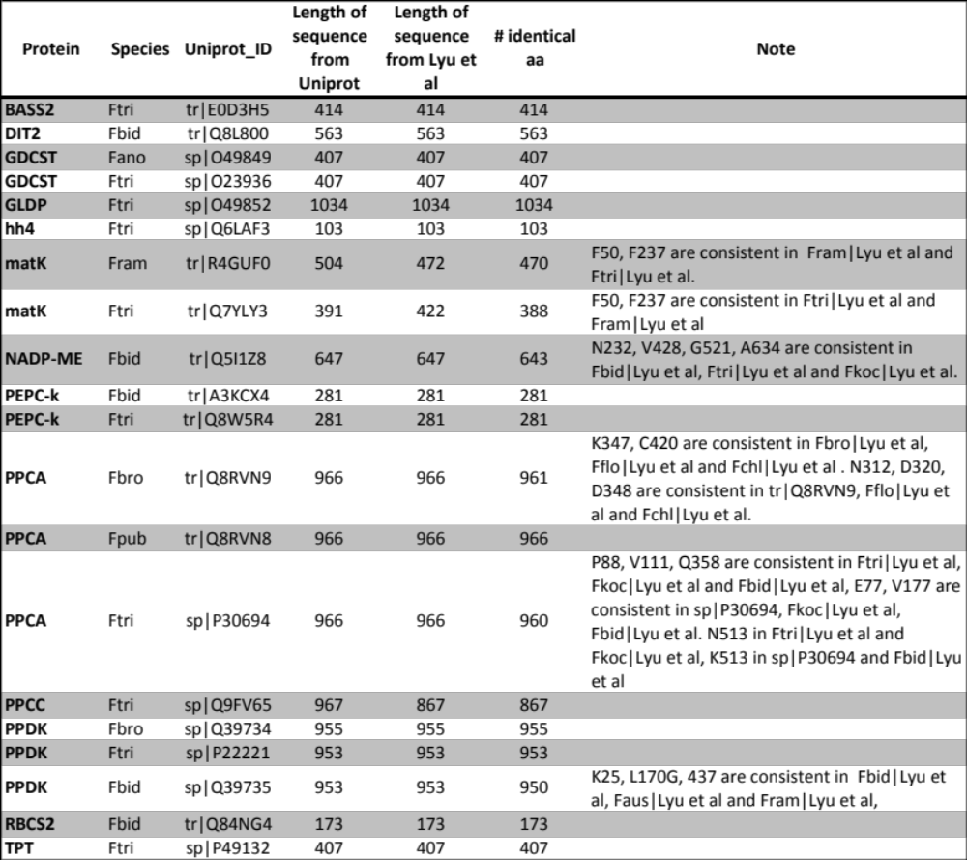
Abbreviations: #: number, aa: amino acid; Ftri: F. trinervia; Fbid: F. bidentis; Fano: F. anomala; Fram: F. ramosissima; Fkoc: F. kochiana; Fbro: F. brownii; Fflo: F. floridana; Fchl: F. chloraefolia; Fpub: F. pubescens.

Reference
1. Lyu MJ, Gowik U, Kelly S, Covshoff S, Mallmann J, Westhoff P, Hibberd JM, Stata M, Sage RF, Lu H et al: RNA-Seq based phylogeny recapitulates previous phylogeny of the genus Flaveria (Asteraceae) with some modifications. BMC evolutionary biology 2015, 15(1):116.
2. Gowik U, Brautigam A, Weber KL, Weber AP, Westhoff P: Evolution of C4 photosynthesis in the genus Flaveria: how many and which genes does it take to make C4? Plant Cell 2011, 23(6):2087-2105.
3. Min XJ, Butler G, Storms R, Tsang A: OrfPredictor: predicting protein-coding regions in EST-derived sequences. Nucleic acids research 2005, 33(Web Server issue):W677-680.
4. Arrial RT, Togawa RC, Brigido Mde M: Screening non-coding RNAs in transcriptomes from neglected species using PORTRAIT: case study of the pathogenic fungus Paracoccidioides brasiliensis. BMC bioinformatics 2009, 10:239.
5. Shiryev SA, Papadopoulos JS, Schaffer AA, Agarwala R: Improved BLAST searches using longer words for protein seeding. Bioinformatics 2007, 23(21):2949-2951.
6. Edgar RC: MUSCLE: multiple sequence alignment with high accuracy and high throughput. Nucleic acids research 2004, 32(5):1792-1797.
7. Sánchez J: MARDIA, K. V., J. T. KENT, J. M. BIBBY: Multivariate Analysis. Academic Press, London-New York-Toronto-Sydney-San Francisco 1979. Biometrical Journal 1982, 24(5):502-502.
8. Jiao XL, Sherman BT, Huang DW, Stephens R, Baseler MW, Lane HC, Lempicki RA: DAVID-WS: a stateful web service to facilitate gene/protein list analysis. Bioinformatics 2012, 28(13):1805-1806.
9. Li Y, Xu J, Haq NU, Zhang H, Zhu XG: Was low CO2 a driving force of C4 evolution: Arabidopsis responses to long-term low CO2 stress. J Exp Bot 2014, 65(13):3657-3667.
10. Aubry S, Kelly S, Kumpers BM, Smith-Unna RD, Hibberd JM: Deep evolutionary comparison of gene expression identifies parallel recruitment of trans-factors in two independent origins of C4 photosynthesis. PLoS genetics 2014, 10(6):e1004365.
11. Chang YM, Liu WY, Shih AC, Shen MN, Lu CH, Lu MY, Yang HW, Wang TY, Chen SC, Chen SM et al: Characterizing regulatory and functional differentiation between maize mesophyll and bundle sheath cells by transcriptomic analysis. Plant physiology 2012, 160(1):165-177.
12. John CR, Smith-Unna RD, Woodfield H, Covshoff S, Hibberd JM: Evolutionary convergence of cell-specific gene expression in independent lineages of C4 grasses. Plant physiology 2014, 165(1):62-75.
13. Edgar RC: MUSCLE: multiple sequence alignment with high accuracy and high throughput. Nucleic Acids Res 2004, 32(5):1792-1797.
14. Suyama M, Torrents D, Bork P: PAL2NAL: robust conversion of protein sequence alignments into the corresponding codon alignments. Nucleic Acids Res 2006, 34:W609-W612.
15. Yang ZH: PAML 4: Phylogenetic analysis by maximum likelihood. Mol Biol Evol 2007, 24(8):1586-1591.
16. Kadereit G, Bohley K, Lauterbach M, Tefarikis DT, Kadereit JW: C3 -C4 intermediates may be of hybrid origin - a reminder. The New phytologist 2017, 215(1):70-76.
17. Tausta SL, Li P, Si Y, Gandotra N, Liu P, Sun Q, Brutnell TP, Nelson T: Developmental dynamics of Kranz cell transcriptional specificity in maize leaf reveals early onset of C4-related processes. J Exp Bot 2014, 65(13):3543-3555.

