Formation and Activity Enhancement of Surface Hydrides by the Metal-Oxide Interface

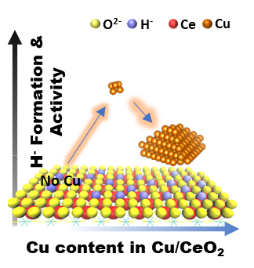
In-situ ambient-pressure X-ray photoelectron spectroscopy (PES) and resonance PES on the activation of H₂ over Cu/CeO₂ catalysts demonstrated that sub-nanometer clusters of Cu on CeO₂ with strong metal-support interaction exhibited the maximum capacity in the formation and activity of Cu hydrides species, as well as Ce⁴⁺-H⁻, as also evidenced by temperature-programmed desorption.

Supporting Information

Formation and Activity Enhancement of Surface Hydrides by the Metal-Oxide Interface

Beibei Wang, Lunjia Zhang, Jun Cai, Zheng Peng, Peihong Cheng, Xiaobao Li, Hui Zhang*, Fan Yang*, and Zhi Liu*

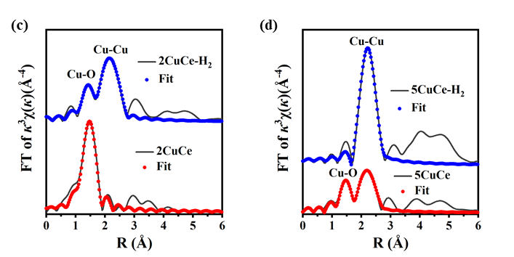
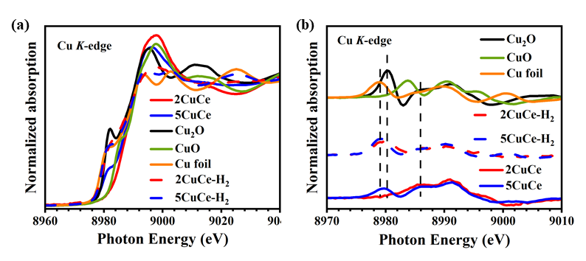

Figure S1. In-situ (a) Cu K-edge XANES spectra, and (b) the first derivation of Cu K-edge XANES spectra for 2CuCe/2CuCe-H₂ and 5CuCe/5CuCe-H₂ samples, plus Cu foil, Cu₂O and CuO as reference. In-situ condition: flowing 1 bar H₂, 260 ℃, 1 h. (c) and (d) Fourier-transform of Cu K-edge k³-weighted EXAFS spectra for 2CuCe/2CuCe-H₂ and 5CuCe/5CuCe-H₂ samples in R space.
For as-prepared 2CuCe and 5CuCe catalysts, XANES spectra and the corresponding first derivative curves gave adsorption features similar to those of Cu₂O and Cu foil, respectively. A blue shift of the Cu K-edge adsorption peak was observed for 2CuCe, which was even higher than that of CuO owing to the size effect of small Cu clusters.^{[1]} Fourier transform of k³-weighted Cu K-edge EXAFS (Figure 1d) showed the dominant peak of Cu-O for 2CuCe. The absence of nearest and next-nearest neighbor Cu-Cu peaks indicated that Cu species were highly dispersed on 2CuCe, consistent with XANES measurements. In comparison, both nearest neighbor Cu-O and Cu-Cu peaks were observed for 5CuCe, which is consistent with PXRD results suggesting the presence of Cu NPs.

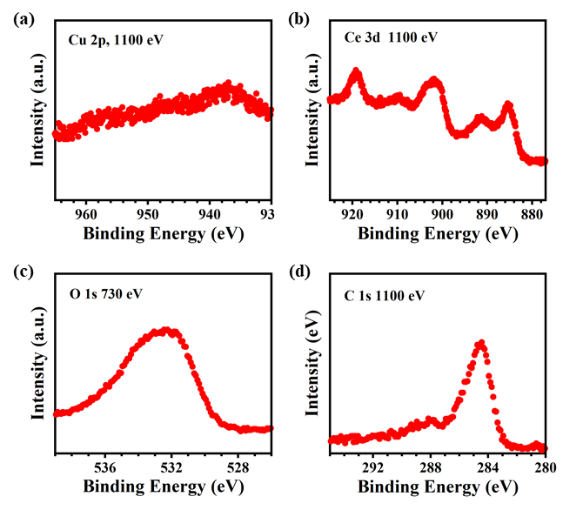

Figure S2. In-situ AP-XPS spectra of (a) Cu 2p, (b) Ce 3d, (c) O 1s, and (d) C 1s for 2CuCe sample collected in 0.3 mbar O₂ at 260 ℃.

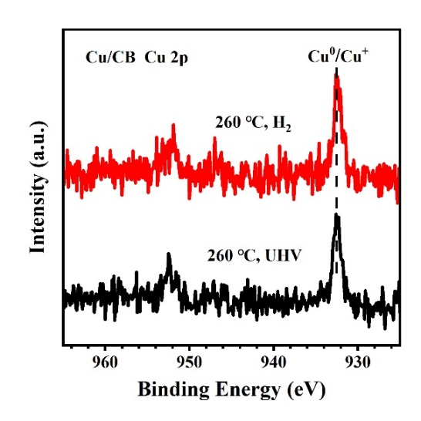

Figure S3. In-situ Cu 2p XPS spectra measured after thermally-reduced at 260 ℃ for 2 h and reacted with 0.3 mbar H₂ at 260 ℃ for 1 h on Cu/CB. Since the C KVV auger peak is close to Cu 2p when took XPS at an incident photon energy of 1100 eV on Cu/CB, the photon energy was adjusted to 1300 eV.

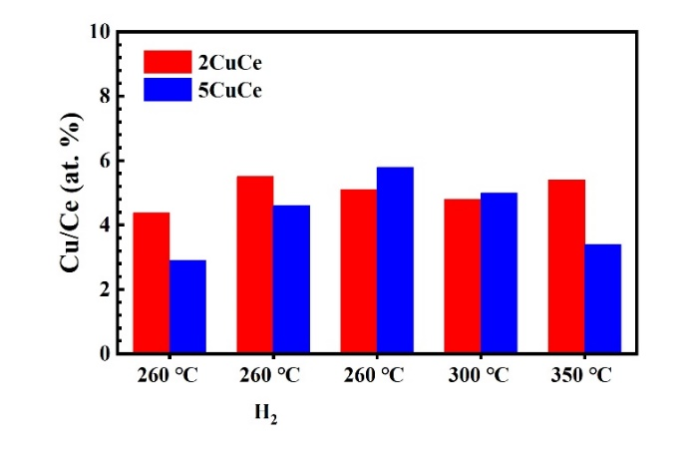

Figure S4. Evolution of molar ratio of Cu/Ce on 2CuCe and 5CuCe respectively during the in-situ AP-XPS experiments. The peak intensities of Cu 2p and Ce 3d were used to determine the surface atomic fractions of Cu and Ce after calibrated using photoionization cross section corresponding to the X-ray energies.

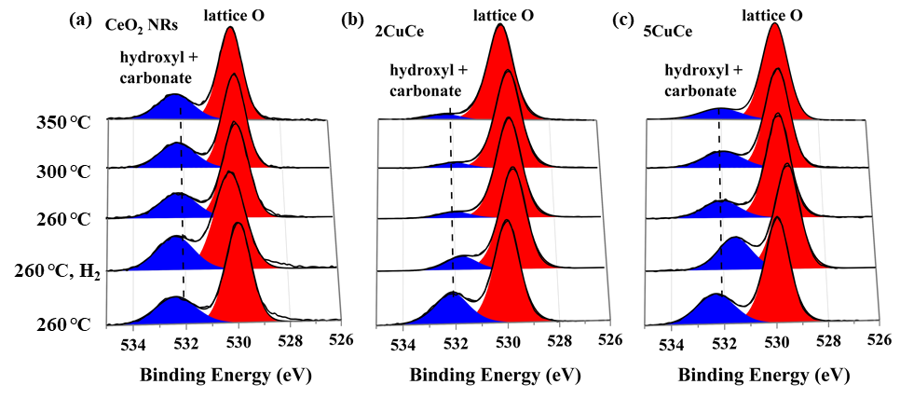

Figure S5. In-situ O 1s XPS spectra for (a) CeO₂ NRs, (b) 2CuCe and (c) 5CuCe. All spectra were normalized by the peak intensity of lattice O.

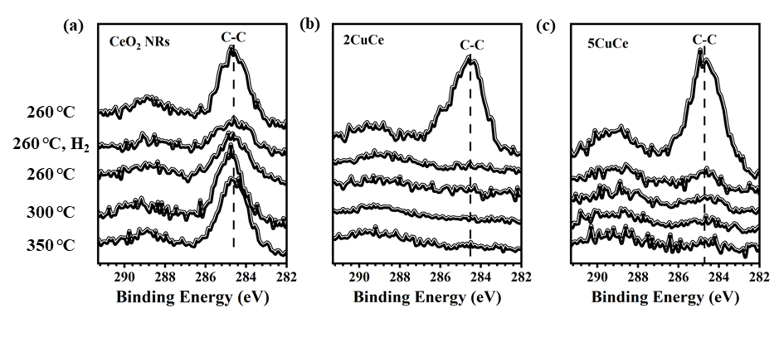Figure S6. In-situ C 1s XPS spectra for (a) CeO₂ NRs, (b) 2CuCe and (c) 5CuCe.

Table S1. Curve Fitting Results of k³-weighted Cu K-edge EXAFS spectra.

Sample | Shells | C.N.^{[a]} | R (Å) ^{[b]} | σ² (10⁻³ Å²) ^{[c]} | ∆E₀ (eV) ^{[d]} | R factor (%)
2CuCe | Cu-O | 3.7 | 1.94 | 5 | -1.7 | 0.9
2CuCe | Cu-Cu | - | - | - | - | 0.9
2CuCe-H₂ | Cu-O | 1.4 | 1.89 | 8 | 5.3 | 0.5
2CuCe-H₂ | Cu-Cu | 3.1 | 2.51 | 10 | 1.5 | 0.5
5CuCe | Cu-O | 2.0 | 1.94 | 5 | -0.5 | 1.6
5CuCe | Cu-Cu | 3.6 | 2.55 | 9 | -5.5 | 1.6
5CuCe-H₂ | Cu-O | - | - | - | - | 2.1
5CuCe-H₂ | Cu-Cu | 7.9 | 2.54 | 8 | 3.6 | 2.1
[a] Coordination Number. [b] Atomic distance. [c] Debye-Waller factor.
[d] Difference of potential of sample and standard.

[1] B. Zandkarimi, G. Sun, A. Halder, S. Seifert, S. Vajda, P. Sautet, A. N. Alexandrova, Journal of Physical Chemistry C 2020, 124, 10057.

