Supplementary Information

Universal strategy towards high–energy aqueous multivalent ion batteries
Tang et al.

Supplementary Figures
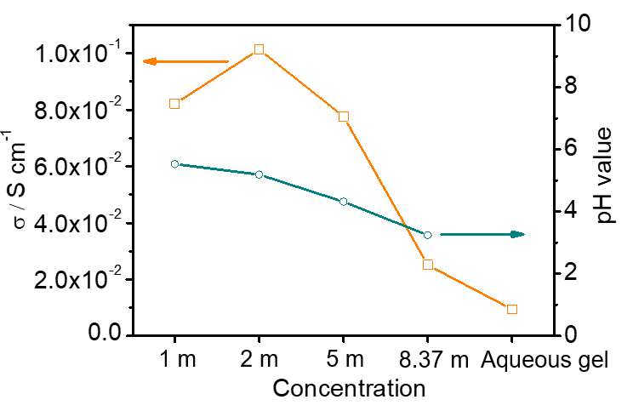
Supplementary Figure 1. The electrochemical conductivities and pH values of the 1 m, 2 m, 5 m, Sat. (8.37 m) Ca(NO₃)₂ aqueous solutions, and gel electrolyte.

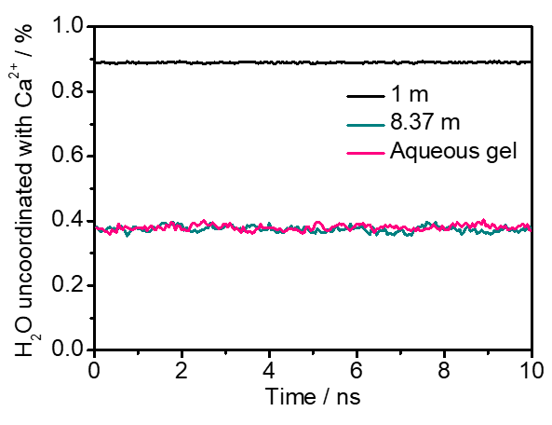
Supplementary Figure 2. The percentage of water molecular uncoordinated with Ca²⁺ in the three electrolyte samples based on MD simulation.

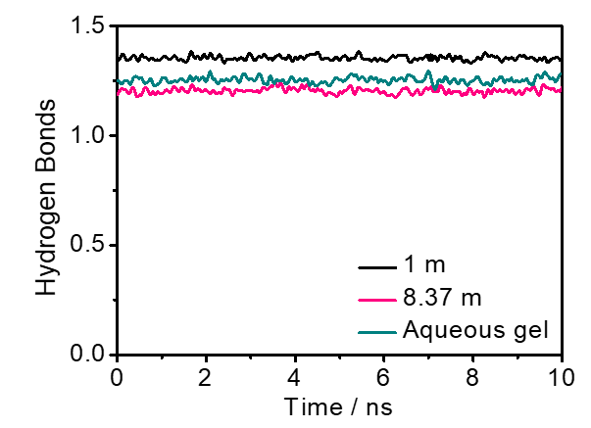
Supplementary Figure 3. The hydrogen bonds of the three electrolyte samples based on MD simulation.

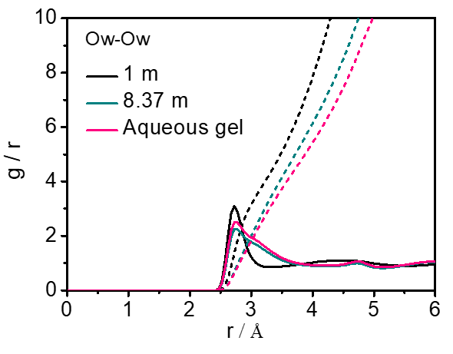
Supplementary Figure 4. The radial distribution functions (solid line) and its number integral (dash line) of the distance between two oxygen atoms in water molecules in different electrolytes.
Supplementary Fig. 4 shows the radial distribution functions of distance between two oxygen atoms in water molecules in different electrolytes. It can be observed that a sharp peak located at ≈2.75 Å in dilute solution represents the d(O_{w}–O_{w}) between two nearest water molecules connected by a hydrogen bond, while this peak become broader and weaker in Sat. solution and gel electrolyte, which means the two nearest water molecules may be coordinated with a Ca²⁺ ion to form a Ca²⁺–H₂O complex.

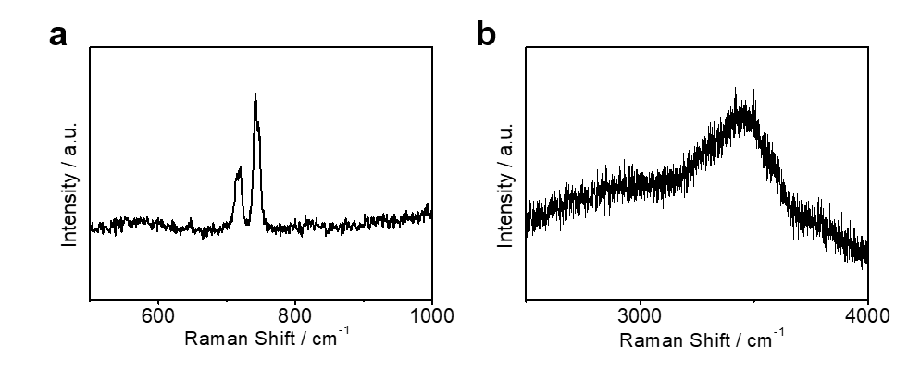
Supplementary Figure 5. The Raman spectra of the crystalline Ca(NO₃)₂·4H₂O.

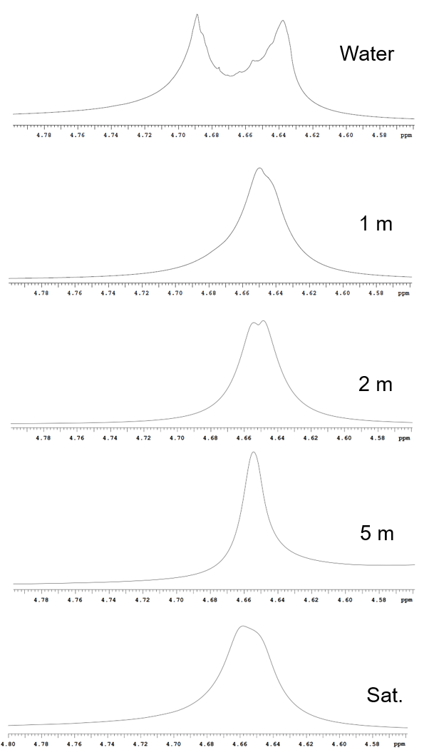
Supplementary Figure 6. ¹H NMR of the pure water, 1 m, 2 m, 5 m, Sat. Ca(NO₃)₂ aqueous solutions.

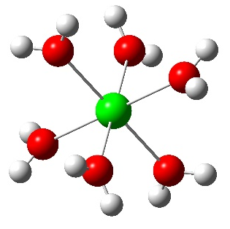
Supplementary Figure 7. DFT calculation of the binding energy between one water molecule and Ca²⁺.
The average binding energy between one water molecule and Ca²⁺ is about 0.78 eV, while the average water–water binding energy is only about 0.27 eV¹. Therefore, the water molecules are preferentially bonded by Ca²⁺, which significantly decrease the free water molecules and increase Ca²⁺–O_{H} (water oxygen) interaction. This result is well consistent with the ¹H NMR spectra in Supplementary Fig. 6.

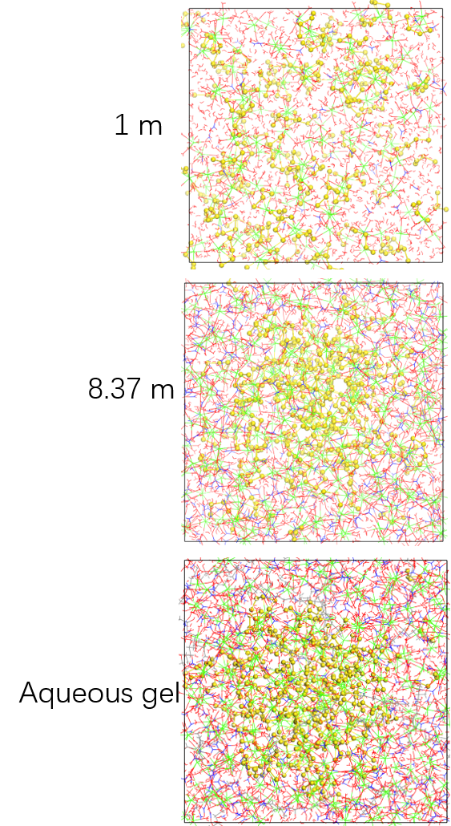
Supplementary Figure 8. Snapshots of CaS₄ diffusion in 1 m, Saturated Ca(NO₃)₂ solution, and gel electrolyte based on MD simulation in 5 ns.

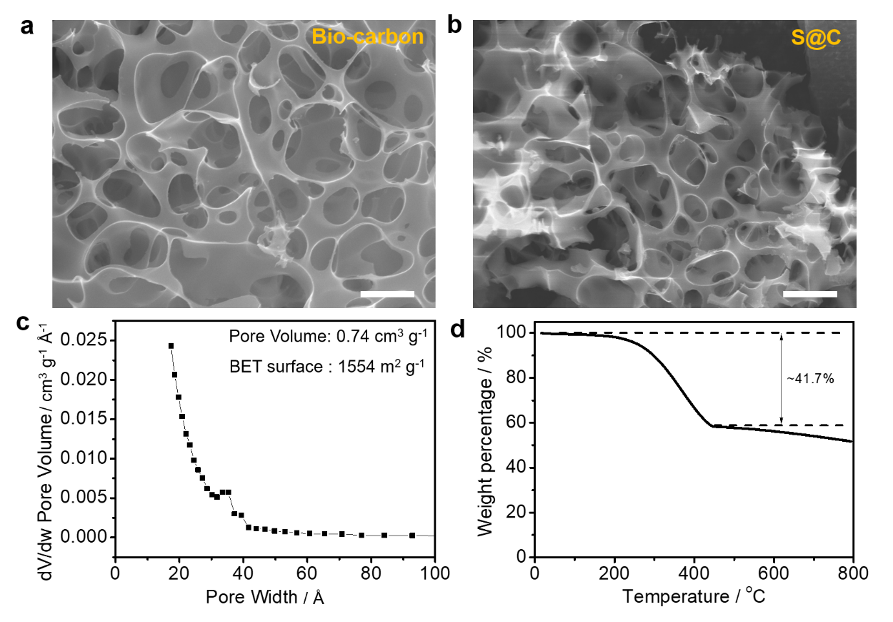
Supplementary Figure 9. Scanning electron microscope (SEM) images of a biomass–derived porous carbon host and b S@C composite. Scale bars are 2 μm in Supplementary Fig. 9a–b. c Pore distribution of the porous carbon host. d The thermogravimetry analysis (TGA) curve of the S@C composite under N₂ flow.
The sulfur loading in the S@C was set as ≈40 wt% (Supplementary Fig. 9d), which is close to the maximum loading value (48 wt%) that guarantees the CaS as reaction product fully confined in the carbon host (considering the density of CaS is 2.83 g cm^{–3} and the pore volume of porous carbon is 0.74 cm³ g^{–1} according to the BET results).

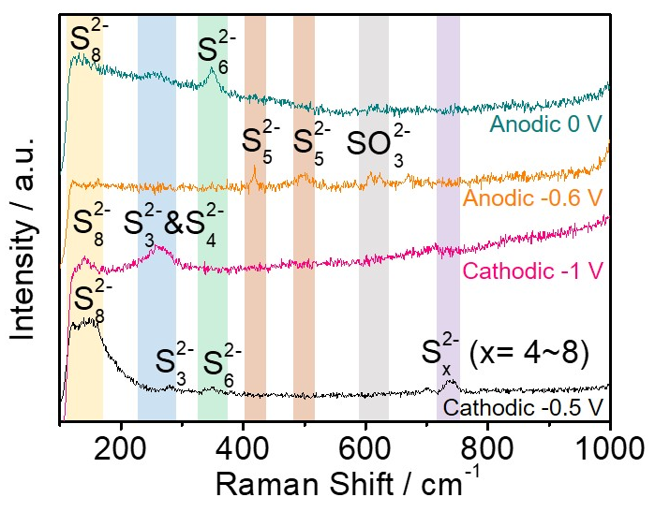
Supplementary Figure 10. Ex situ Raman spectra of the S@C electrodes at different discharge/charge states corresponding to Fig. 3c.

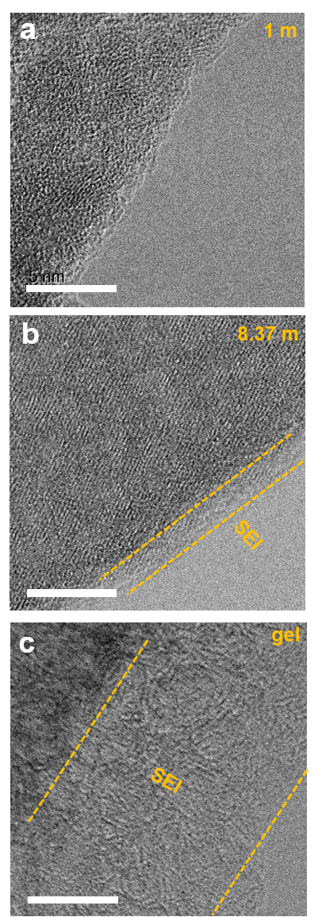
Supplementary Figure 11. HADDF–STEM images of the S@C electrode after a CV scanning in a 1 m, b 8.37 m Ca(NO₃)₂ aqueous electrolytes, and c aqueous gel electrolyte. The scale bars are 10 nm in Supplementary Fig. 11a–c.

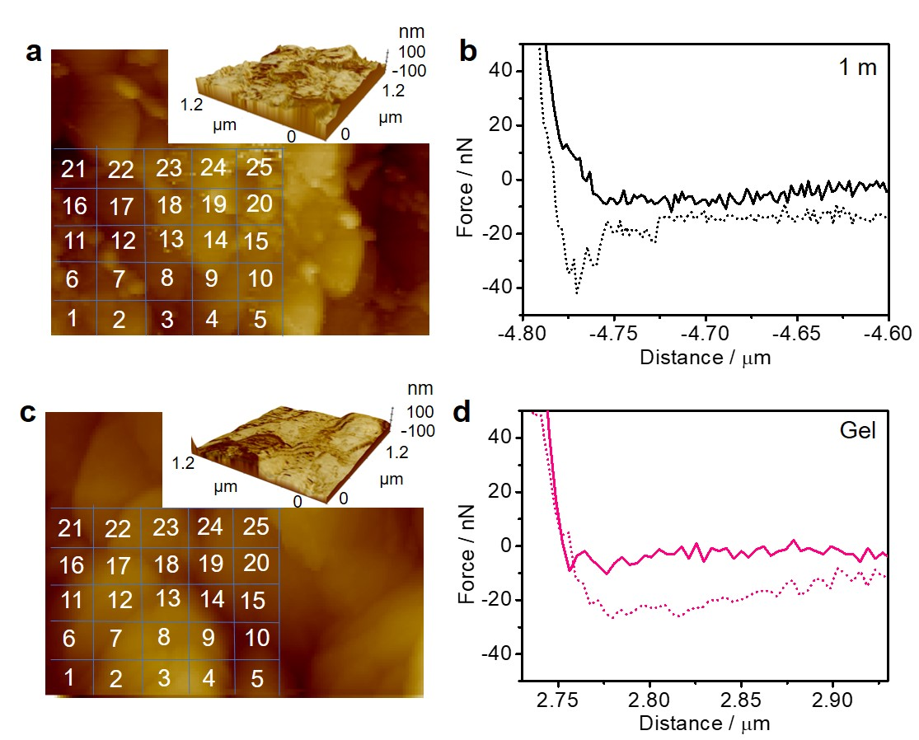
Supplementary Figure 12. a The AFM scanning images of S@C anodes tested in 1 m Ca(NO₃)₂ electrolyte. The corresponding three–dimensional AFM scanning images is shown in inset. b The corresponding force−displacement plots of area 18 in supplementary Fig. 12a. c The AFM scanning images of S@C anodes tested in aqueous gel electrolyte. The corresponding three–dimensional AFM scanning image is shown in inset. d The corresponding force−displacement plots of area 18 in supplementary Fig. 12c.

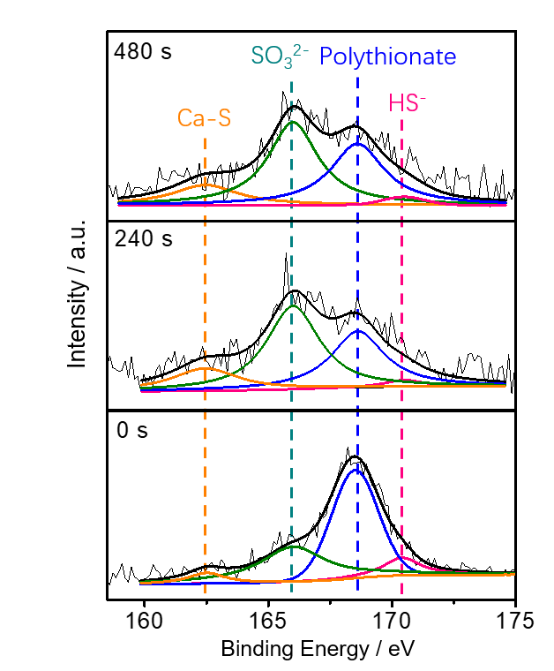
Supplementary Figure 13. The in–depth S 2p XPS of the S@C anode after the cathodic CV scanning process.
As can be seen from Supplementary Fig. 13, the S 2p XPS spectra can be fitted into four peaks at 162.3, 166.3, 168.2, 170.7 eV, which can be attributed to the CaS, SO₃^{2–}, polythionate complex, and HS–, respectively²⁻⁴. Particularly, the polythionate complex and SO₃^{2–} may result from the interfacial chemistry.

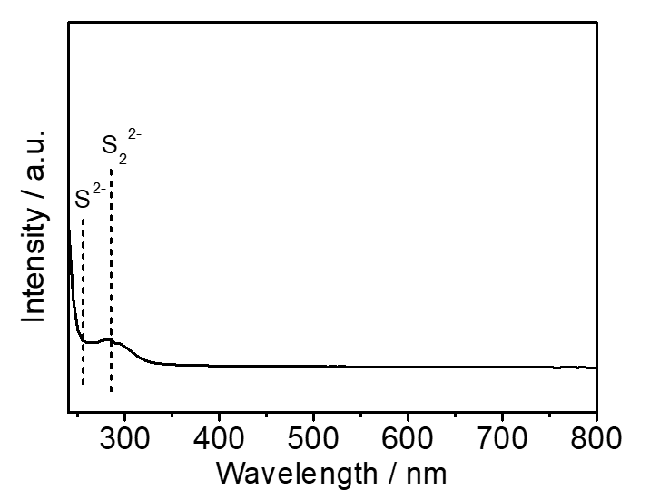
Supplementary Figure 14. The UV–vis spectrum of the sulfur electrode after cathodic scanning process. The as–obtained sulfur electrode was washed with 1,3–Dioxolane (DOL), and the DOL/calcium polysulfides mixture was collected for UV–vis characterization.
As shown in Supplementary Fig. 14, various Ca polysulfides (S²⁻ and S₂²⁻ at 220~280 nm⁵) appear in the UV–Vis spectrum of DOL/Ca polysulfides mixture, which is highly consistent with the Raman and in–depth S 2p XPS spectra results.


Supplementary Figure 15. The DFT calculations of reduction of isolated NO₃–.

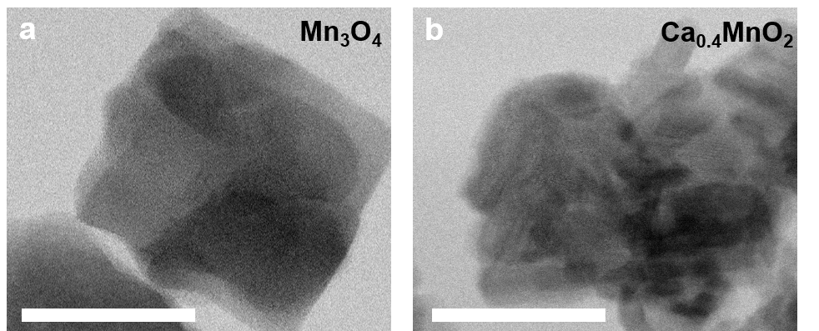
Supplementary Figure 16. The TEM images of the as–prepared a Mn₃O₄ precursor and b Ca_{0.4}MnO₂ cathode material. Scale bars: 50 nm.

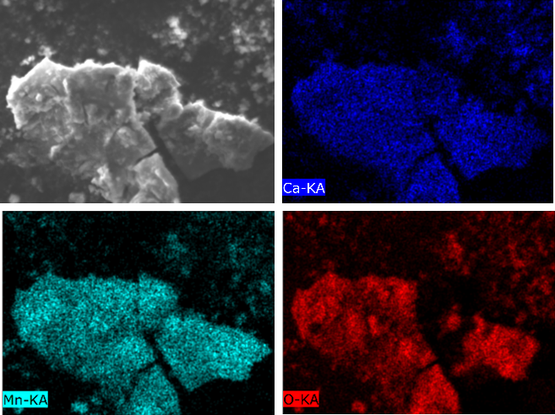
Supplementary Figure 17. The elemental mapping of Ca, Mn, O in the Ca_{0.4}MnO₂ cathode material.

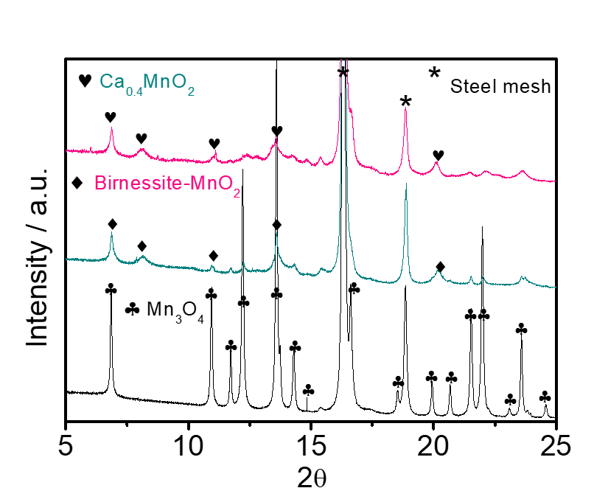
Supplementary Figure 18. The synchrotron X–ray powder diffraction patterns of Mn₃O₄, birnessite MnO₂ and Ca_{0.4}MnO₂.

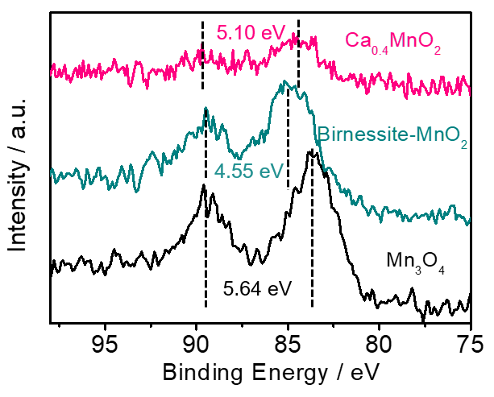
Supplementary Figure 19. The Mn 3s XPS spectra of the Mn₃O₄, birnessite MnO₂ and Ca_{0.4}MnO₂.

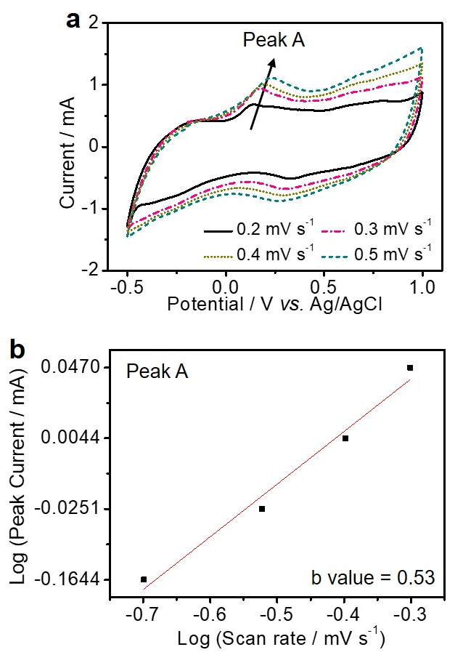
Supplementary Figure 20. a The CV curves of the Ca_{0.4}MnO₂ cathode collected at scan rates of 0.2~0.5 mV s^{–1}. b Plot of log(peak current) as function of log(scan rate) obtained from Supplementary Figure 17a.
Supplementary Fig. 20a displays the CV curves of the cell at various scan rates from 0.2 to 0.5 mV s^{–1}. From these CV curves, we can obtain a plot of log(peak current) as function of log(scan rate) based on equation (S1) and (S2)⁶:
i = aν^{b} (S1)
log(i) = blog(ν) + log(a) (S2)
where i is peak current, ν is scan rate, a and b are adjustable parameters. The value of b is determined by the slope in the log(ν)–log(i) plots. The b values in Supplementary Fig. 20b are calculated to be 0.53 for anodic peak, indicating that the capacity at peak voltage is dominated by the non–capacitive behaviour^{6,7}.

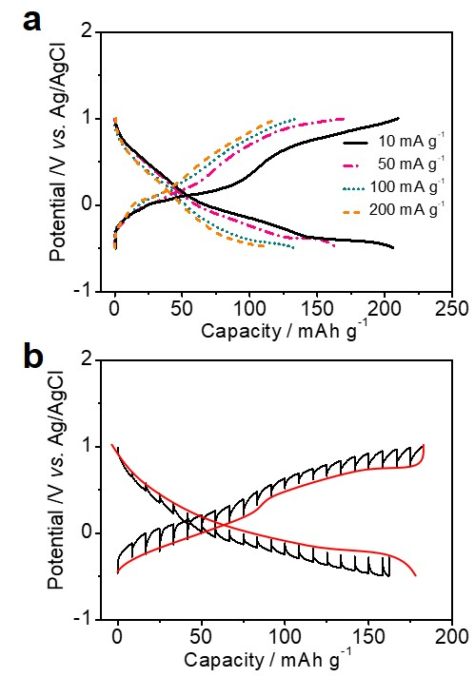
Supplementary Figure 21. a Voltage profiles of the Ca_{0.4}MnO₂ cathode in 8.37 m Ca(NO₃)₂ aqueous electrolyte at different current densities. b The GITT curves of the Ca_{0.4}MnO₂ cathode.
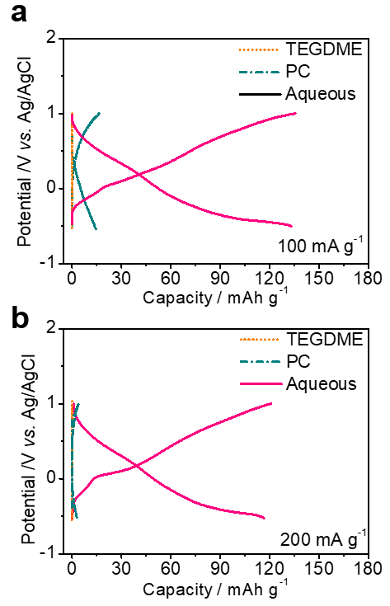
Supplementary Figure 22. Voltage profiles of the Ca_{0.4}MnO₂ cathode tested in 0.5 m Ca(OTf)₂ in TEGDME, 0.5 m Ca(OTf)₂ in PC, and 8.37 m Ca(NO₃)₂ aqueous electrolytes at a current density of 100 mA g^{–1} and b 200 mA g^{–1}.
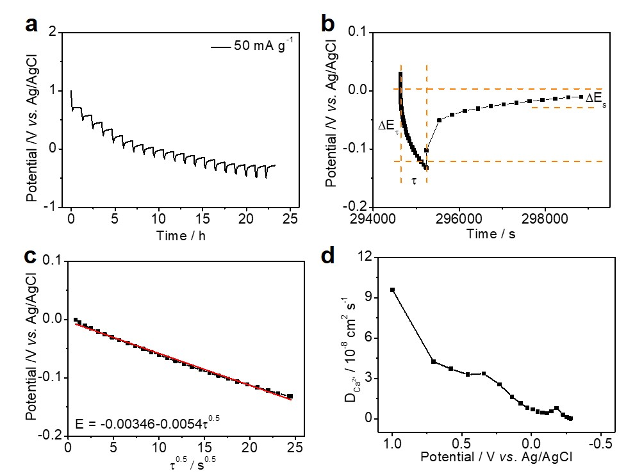
Supplementary Figure 23. Characterization of the Ca²⁺ diffusion co–efficiency in Ca_{0.4}MnO₂ cathode. a–b GITT curves of the Ca_{0.4}MnO₂ cathode. c Plot of potential as function of τ^{0.5} obtained from Supplementary Fig. 23b. d Plot of Ca²⁺ diffusion co–efficiency as function of potential.
Galvanostatic intermittent titration technique (GITT) has been applied to examine the Ca²⁺ diffusion in the Ca_{0.4}MnO₂ cathode materials. The obtained GITT curve of Ca_{0.4}MnO₂ cathode is shown in Supplementary Fig. 21b and 23a. The $D_{{Ca}^{2+}}$ can be obtained via the following equation^{8,9}:
$D_{{Ca}^{2+}}= \frac{4}{πτ}{(\frac{m_{B}V_{M}}{M_{B}S})}^{2}{(\frac{{△E}_{s}}{{△E}_{τ}})}^{2}$ (S3)
where the weight of active material (i. e. Ca_{0.4}MnO₂), 𝑚_{B}, is 10.24 mg, and molar mass (𝑀_{B})/molar volume (𝑉_{M}) are calculated to be about 3.4¹⁰. 𝑆 is the contact area between electrolyte and electrode, which is approximated as the surface area of electrode (0.385 cm²). 𝛥𝐸_{s} is IR drop and 𝛥𝐸_{τ} is the potential change in the time range of τ (s) during the discharge process (Supplementary Fig. 23b). As shown in Supplementary Fig. 23c, τ^{0.5} shows a good linear relationship with potential, which is the pre–condition of the equation S3. The Ca²⁺ diffusion co–efficiency is as high as 9.58 $×$ 10^{–8} at 1 V vs. Ag/AgCl, domanstrating a rapid Ca²⁺ diffusion in the layered MnO₂. This value slightly decreases to 1.23 $×$ 10^{–10} at –0.29 V, which is asbribed to the intercalation of Ca²⁺ into the layered structure of cathode materials.

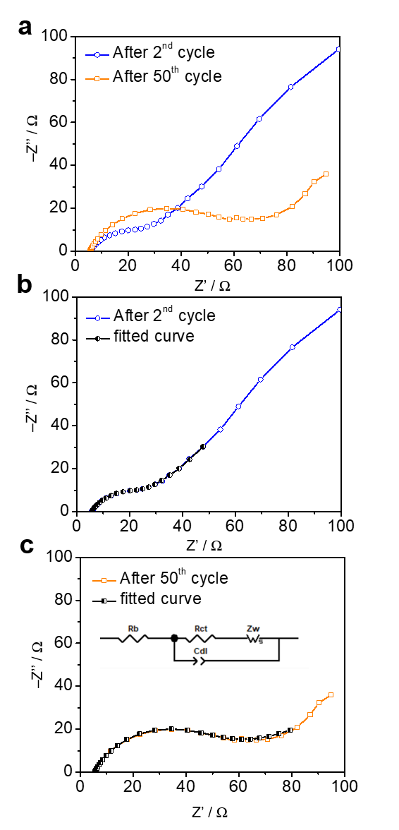
Supplementary Figure 24. a The EISs of the Ca_{0.4}MnO₂ cathode after different cycles. b–c The fitted EIS curves of the as–prepared Ca_{0.4}MnO₂ cathode based on an equivalent circuit shown as inset^{11,12}.
EIS is applied to evaluate the interfacial stability of the cathode after different cycles. Supplementary Fig. 24 presents the Nyquist plots of the cathode materials after 2nd cycle and 50th cycle. The Nyquist plots exhibit a semicircle in the high–frequency region and a slope line at the low–frequency region. The slope line with an angle of about 45° suggests the diffusion–control process. The diameter of semicircles reflects the charge–transfer resistance (R_{ct}) between electrolyte and cathode materials. Additionally, the intercept at real axis represents the bulk resistance (R_{b})^{11,12}. Only a small increase of R_{ct} from 20 to 60 Ω is observed after 50 cycles. These EIS results further confirm the good interfacial stability of the cathode electrode.

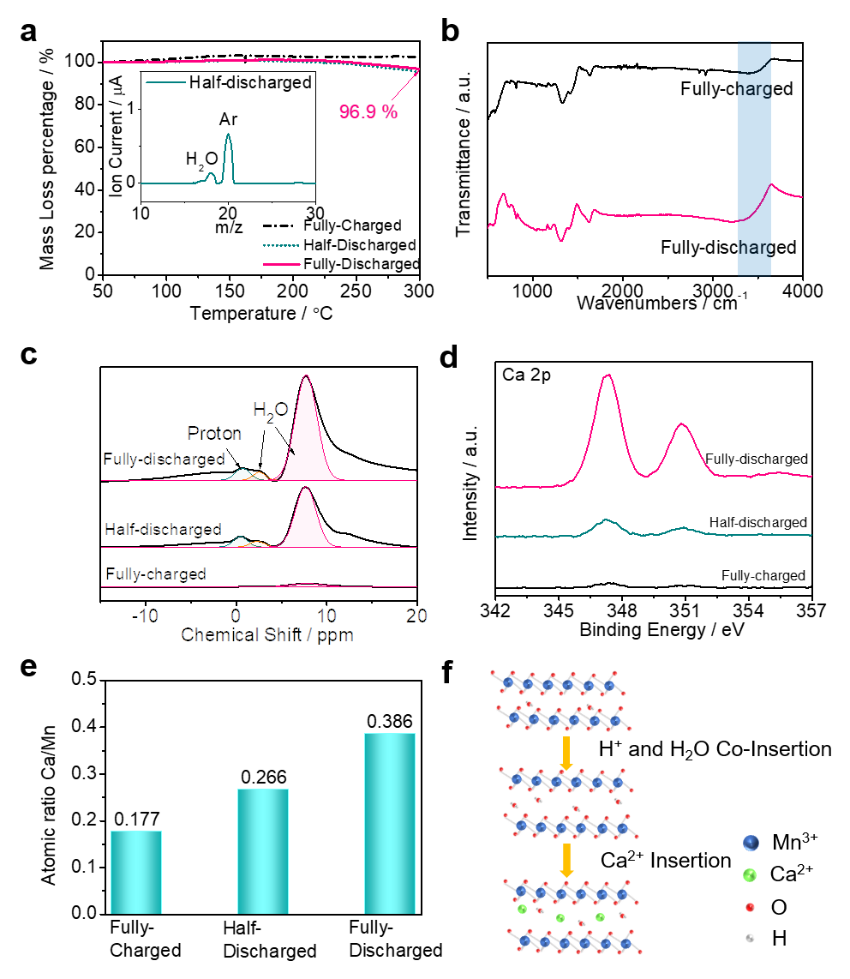
Supplementary Figure 25. H⁺/Ca²⁺ co–intercalation chemistry in Ca_{0.4}MnO₂ cathode in aqueous gel electrolyte. The cathode samples were pre–heated at 80 °C for one day before characterizations. a The TGA curves of the Ca_{0.4}MnO₂ cathode materials after discharge to different states of charge at 100 mA g^{–1} at under Ar flow. The inset is the mass spectrum of the evaporating gas flow from the cathode at the half–discharged state. b The FTIR spectra of the cathode materials at fully–charged and fully–discharged states. c ¹H SSNMR spectra of the cathode materials at different states of charge. d XPS spectra of the cathode materials at different states of charge. e The Ca/Mn atomic ratio of the cathode materials at different states of charge according to the ICP results. f Schematic illustration the electrochemical mechanism of the Ca_{0.4}MnO₂ cathode.
We employed multiple characterization methods to clarify the cation intercalation/de–intercalation mechanism of Ca_{0.4}MnO₂ cathode in aqueous gel electrolyte. According to the thermogravimetry analysis (TGA) in Supplementary Fig. 25a, the mass loss in the range from 150 ~300 ºC is attributed to the evaporation of lattice water molecules, which is confirmed by the mass spectrum result shown in the inset of Supplementary Fig. 25a¹³. During the discharge process, the lattice water content of cathode increases to 3.1 % in the fully–discharged state, indicating the co–insertion of water molecules. This is consistent with the Fourier–transform infrared spectroscopy (FTIR) results (Supplementary Fig. 25b), in which the peak at 3500 cm^{–1} ascribed to the aggregated H₂O molecules becomes stronger after the discharge process¹⁴. Additionally, as seen from the ¹H solid state nuclear magnetic resonance (SSNMR) spectra in Supplementary Fig. 25c, the peak at ≈1.0 ppm can be attributed to the co–intercalated proton in the cathode lattice, meanwhile the peaks at ≈2.5 and 7.2 ppm are assigned to the inserted H₂O molecules^{15,16}. The intensities of both the proton and H₂O peaks gradually increase during the discharge process, demonstrating the co–intercalation of protons into the cathode lattice.
Furthermore, XPS measurements were also conducted on the Ca_{0.4}MnO₂ cathodes after cycled in the aqueous gel electrolyte. We find that the intensity of the Ca²⁺ peak at 347.4 and 350.8 eV gradually increases during the discharge process of cathode (Supplementary Fig. 25d), and the calculated specific capacity generated from the reversible intercalation of Ca²⁺ in the cathode is ≈ 109 mAh g^{–1} based on the Ca/Mn atomic ratio change from the inductively coupled plasma (ICP) results (Supplementary Fig. 25e). According to above discussions, the electrochemical mechanism of Ca_{0.4}MnO₂ cathode is presented in Supplementary Fig. 25f. During the discharge process, protons and H₂O molecules first co−insert into the lattice, which contributes a small proportion of the capacity. Particularly, the presence of water molecules in the cathode lattice efficiently decreases the cation diffusion barrier, thus improving the kinetics of batteries¹⁷. As a result, the Ca²⁺ ions can reversibly intercalate into the cathode during the discharge process with improved kinetics, which contributes a major proportion of the total capacity (≈ 80.7 %). This mechanism has been proved by the recent operando pH measurements for aqueous multivalent ion batteries by S. Passerini et al.¹⁸. This confirms that protons and multivalent metal cations co-participate in the co–intercalation process and the reversible insertion/extraction of multivalent metal cations in the manganese oxide cathodes makes a major contribution to the battery capacities.

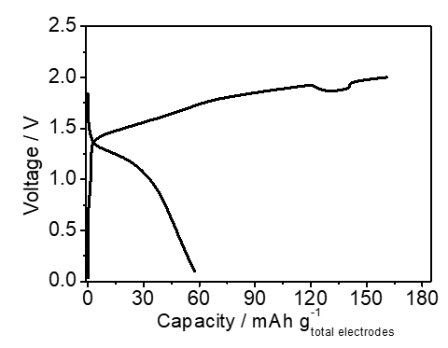
Supplementary Figure 26. The pre–activated charge/discharge profile of S@C||Ca_{0.4}MnO₂ full cells assembled with gel electrolyte at 0.5 C.

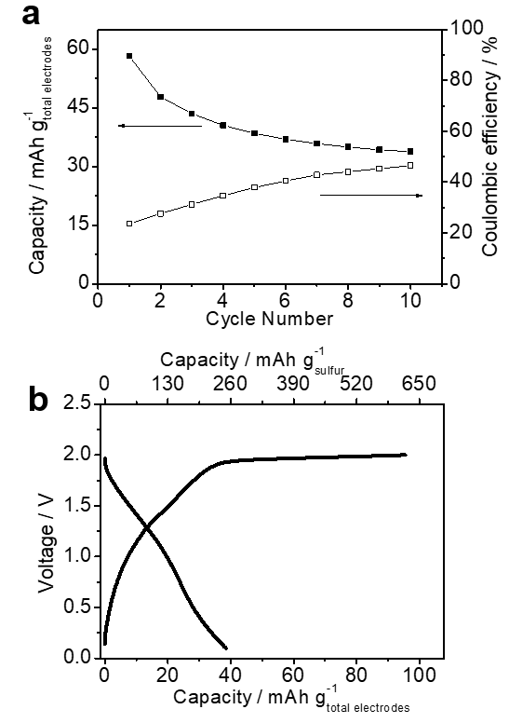
Supplementary Figure 27. a The cycling stability of the full cells at a current density of 0.1 C. b The voltage profile of the S@C||Ca_{0.4}MnO₂ full cells assembled with 1 m Ca(NO₃)₂ electrolytes at 0.1 C.

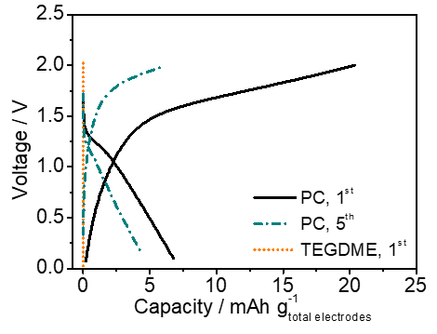
Supplementary Figure 28. Voltage profiles of the S@C|0.5 M Ca(OTf)₂ in TEGDME|Ca_{0.4}MnO₂ and S@C|0.5 M Ca(OTf)₂ in PC|Ca_{0.4}MnO₂ cells at different cycles at 0.5 C rate. The cell S@C||Ca_{0.4}MnO₂ cell cannot be cycled in the TEGDME–based electrolyte.

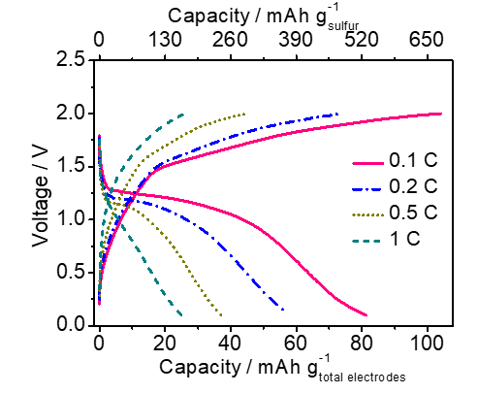
Supplementary Figure 29. The voltage profiles of the S@C||Ca_{0.4}MnO₂ full cells assembled with 8.37 m Ca(NO₃)₂ electrolytes.
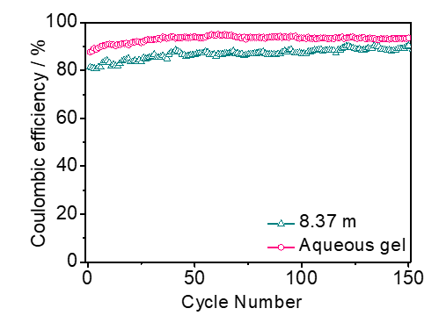
Supplementary Figure 30. The Coulombic efficiency of the S@C||Ca_{0.4}MnO₂ full cells assembled with different electrolytes at 0.2 C.

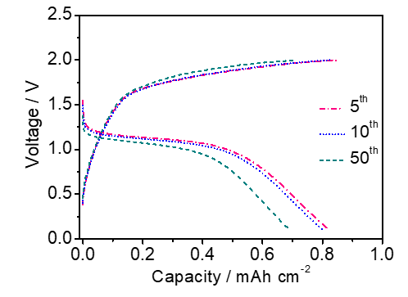
Supplementary Figure 31. The voltage profiles of the S@C|gel electrolyte|Ca_{0.4}MnO₂ pouch cell during 50 cycles at 0.2 C. The mass ratio of Ca_{0.4}MnO₂ cathode to S@C anode is about 1.6: 1.
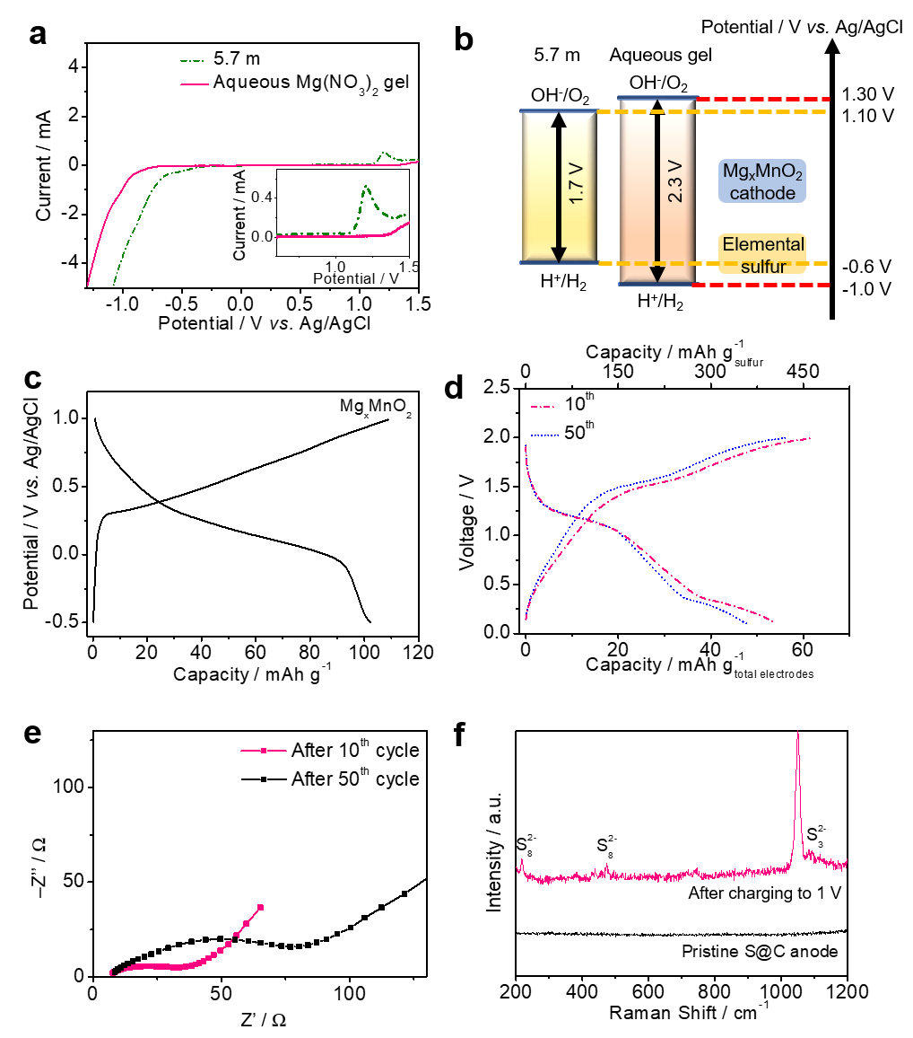
Supplementary Figure 32. The performances of the aqueous Mg ion–sulfur||metal oxide batteries. a Linear voltammetry curves recorded at 1 mV s^{–1} in saturated (5.7 m) Mg(NO₃)₂ electrolyte, and saturated Mg(NO₃)₂ aqueous solution with 10 wt% PVA gel electrolyte (aqueous Mg(NO₃)₂ gel electrolyte). A magnified view of the region outlined near the cathodic extreme is shown in inset. b The electrochemical stability windows of electrolytes, and the redox voltages of Mg_{x}MnO₂ cathode and sulfur anode. c Voltage profiles of the Mg_{x}MnO₂ cathode at a current density of 100 mA g^{–1}. The Mg_{x}MnO₂ cathode was prepared by pre–magnesiating the Mn₃O₄ electrodes by charging–discharging the electrochemical cell within a voltage window of –0.5~1.0 V vs. Ag/AgCl at 50 mA g^{–1} for 10 cycles in the presence of saturated aqueous Mg(NO₃)₂. The Mg_{x}MnO₂ cathode can deliver a reversible capacity of about 100 mAh g^{–1}. d The voltage profiles of S@C|aqueous Mg(NO₃)₂ gel electrolyte|Mg_{x}MnO₂ cell at 0.2 C rate (1 C = 1675 mAh g^{–1} based on the sulfur mass). The aqueous cells were assembled following a same procedure as that of the ACSB with a mass ratio (cathodes to anodes) of about 2: 1. The full cell can deliver a reversible capacity of 360 mAh g^{–1} based on sulfur mass after 50 cycles. e The EISs of the S@C|aqueous Mg(NO₃)₂ gel electrolyte|Mg_{x}MnO₂ cell after different cycles. The full cell maintains stable electrode|electrolyte interfaces with small resistance during cycling. f Raman spectra of pristine S@C anode, and the S@C anode disassembled from the S@C|aqueous Mg(NO₃)₂ gel electrolyte|Mg_{x}MnO₂ cell after charging to 1 V. The Raman spectra confirm the conversion chemistry of sulfur anode in the aqueous Mg ion–sulfur||metal oxide batteries.

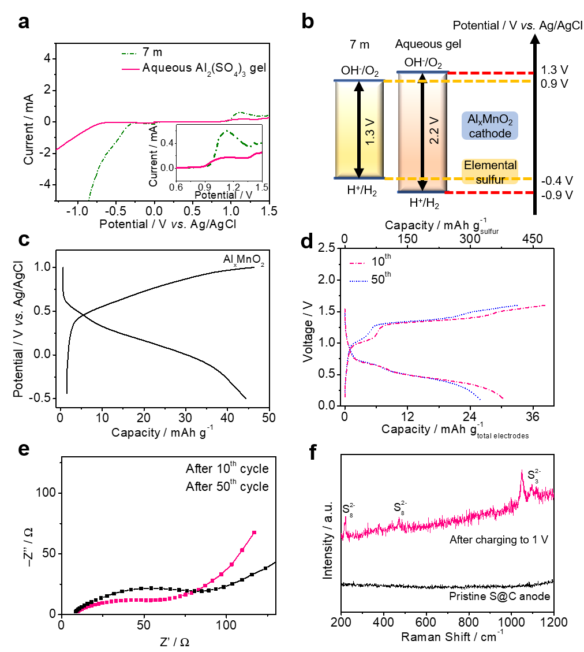
Supplementary Figure 33. The performances of the aqueous Al ion–sulfur||metal oxide batteries. a Linear voltammetry curves recorded at 1 mV s^{–1} in saturated (7 m) Al₂(SO₄)₃ electrolyte, and saturated Al₂(SO₄)₃ aqueous solution with 10 wt% PVA gel electrolyte (aqueous Al₂(SO₄)₃ gel electrolyte). A magnified view of the region outlined near the cathodic extreme is shown in inset. b The electrochemical stability windows of electrolytes, and the redox voltages of Al_{x}MnO₂ cathode and sulfur anode. c Voltage profiles of the Al_{x}MnO₂ cathode at a current density of 100 mA g^{–1}. The Al_{x}MnO₂ cathode was prepared by pre–aluminating the Mn₃O₄ electrodes by charging–discharging the electrochemical cell within a voltage window of –0.5~1.0 V vs. Ag/AgCl at 50 mA g^{–1} for 10 cycles in the presence of saturated aqueous Al₂(SO₄)₃. The Al_{x}MnO₂ cathode can deliver a reversible capacity of about 45 mAh g^{–1}. d The voltage profiles of S@C|aqueous Al₂(SO₄)₃ gel electrolyte|Al_{x}MnO₂ cell at 0.2 C rate (1 C = 1675 mAh g^{–1} based on the sulfur mass). The aqueous cells were assembled following a same procedure as that of the ACSB with a mass ratio (cathodes to anodes) of about 4: 1. The full cell can deliver a reversible capacity of 315 mAh g^{–1} based on sulfur mass after 50 cycles. e The EISs of the S@C|aqueous Al₂(SO₄)₃ gel electrolyte|Al_{x}MnO₂ cell after different cycles. The full cell maintains stable electrode|electrolyte interfaces with small resistance during cycling. f Raman spectra of pristine S@C anode, and the S@C anode disassembled from the S@C|aqueous Al₂(SO₄)₃ gel electrolyte|Al_{x}MnO₂ cell after charging to 1 V. The Raman spectra confirm the conversion chemistry of sulfur anode in the aqueous Al ion–sulfur||metal oxide batteries.

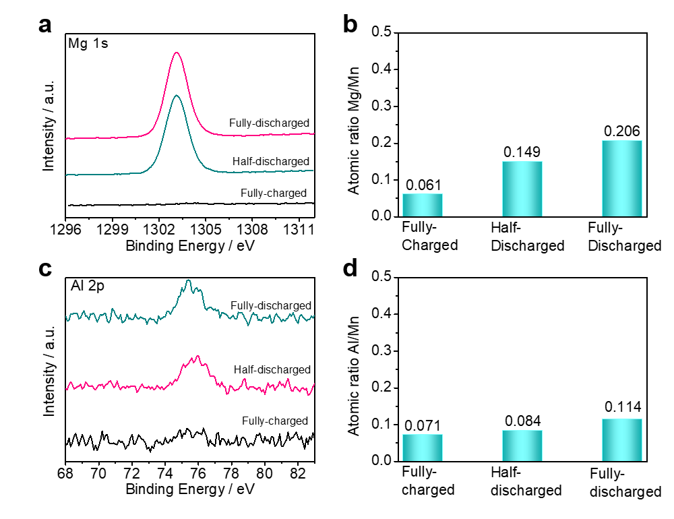
Supplementary Figure 34. a The XPS spectra of the Mg_{x}MnO₂ cathode at different states of charge. b The atomic ratio of Mg and Mn according to ICP results. c The XPS spectra of the Al_{x}MnO₂ cathode at different states of charge. d The atomic ratio of Al and Mn according to ICP results. The cathode samples were pre–heated at 80 °C for one day before characterizations.
Supplementary Tables
Supplementary Table S1. Force field parameters used for Ca(NO₃)₂ aqueous solution in molecular dynamics simulations.
Atom type | Charge (e) | σ (Å) | ε (kcal mol^{–1})
H | 0.4238 | 0 | 0
O (water) | –0.8476 | 3.166 | 0.1553
Ca | 1.5 | 2.412 | 0.450
O (NO^{3–}) | –0.4485 | 2.771 | 0.1456
N | 0.5955 | 3.059 | 0.08066

The compositions of simulated electrolytes are given in the following table. The velocity–Verlet algorithm is applied to integrate the equations of motion with a time step equalled to 1 fs. First, NPT runs were performed at 500 K for 2 ns and then 298 K for 7 ns to ensure that the equilibrium salt dissociation had been reached. Then, the NPT runs were controlled by Nose–Hooven thermostat and barostat with a 100 fs damping parameter. Then, the NVT runs were 10 ns long at 298K. At this state, all simulated systems were surely equilibrated. The hydrogen bonds are defined by a distance cutoff of 3.5 Å and an angle cutoff of 30°.

Supplementary Table S2. Compositions of simulated electrolytes.
 | 1 m Ca(NO₃)₂ | Sat. Ca(NO₃)₂ | Gel electrolyte
Number of H₂O per box | 1913 | 1434 | 1429
Number of Ca(NO₃)₂ per box | 34 | 216 | 215
Equilibrium volume(Å3) | 59822 | 62254 | 72715
T(K) | 298 | 298 | 298
MD, density(g cm^{–3}) | 1.11 | 1.63 | 1.55

Supplementary Table S3. ICP results of the cathode material after electrochemical transformation.
 | Ca | Mn
Molar ratio | 0.398 | 1

Supplementary References
1 Zheng, J. et al. Understanding thermodynamic and kinetic contributions in expanding the stability window of aqueous electrolytes. Chem 4, 2872-2882 (2018).
2 Liang, X. et al. A highly efficient polysulfide mediator for lithium–sulfur batteries. Nat. Commun. 6, 1-8 (2015).
3 Franzen, H. F., Umaña, M. X., McCreary, J. & Thorn, R. XPS spectra of some transition metal and alkaline earth monochalcogenides. J. Solid State Chem. 18, 363-368 (1976).
4 Cavell, R. G. & Sodhi, R. N. Absolute total static relaxation and extra-atomic relaxation terms for volatile phosphorus compounds obtained from the Auger parameter and relativistic. J. Electron. Spectros. Relat. Phenomena 41, 25-35 (1986).
5 Manan, N. S. et al. Electrochemistry of sulfur and polysulfides in ionic liquids. J. Phys. Chem. B 115, 13873-13879 (2011).
6 Brezesinski, T., Wang, J., Tolbert, S. H. & Dunn, B. Ordered mesoporous α-MoO₃ with iso-oriented nanocrystalline walls for thin-film pseudocapacitors. Nat. Mater. 9, 146-151 (2010).
7 Wang, J., Polleux, J., Lim, J. & Dunn, B. Pseudocapacitive contributions to electrochemical energy storage in TiO₂ (anatase) nanoparticles. J. Phys. Chem. C 111, 14925-14931 (2007).
8 Zhu, Y. & Wang, C. Galvanostatic intermittent titration technique for phase-transformation electrodes. J. Phys. Chem. C 114, 2830-2841 (2010).
9 Dees, D. W., Kawauchi, S., Abraham, D. P. & Prakash, J. Analysis of the galvanostatic intermittent titration technique (GITT) as applied to a lithium-ion porous electrode. J. Power Sources 189, 263-268 (2009).
10 Bach, S., Pereira-Ramos, J. & Baffier, N. A new MnO₂ tunnel related phase as host lattice for Li intercalation. Solid State Ionics 80, 151-158 (1995).
11 Zhang, X. et al. Rapid hydrothermal synthesis of hierarchical nanostructures assembled from ultrathin birnessite-type MnO₂ nanosheets for supercapacitor applications. Electrochim. Acta 89, 523-529 (2013).
12 Gao, H., Xiao, F., Ching, C. B. & Duan, H. High-performance asymmetric supercapacitor based on graphene hydrogel and nanostructured MnO₂. ACS Appl. Mater. Interfaces 4, 2801-2810 (2012).
13 Meija, J., Mester, Z. & D’Ulivo, A. Mass spectrometric separation and quantitation of overlapping isotopologues. H₂O/HOD/D₂O and H₂Se/HDSe/D₂Se mixtures. J. Am. Soc. Mass Spectrom. 17, 1028-1036 (2006).
14 Scatena, L., Brown, M. & Richmond, G. Water at hydrophobic surfaces: Weak hydrogen bonding and strong orientation effects. Science 292, 908-912 (2001).
15 Sa, N. et al. Is alpha-V₂O₅ a cathode material for Mg insertion batteries? J. Power Sources 323, 44-50 (2016).
16 Fărcaşiu, D., Lukinskas, P. & Hâncu, D. The hydronium tetrafluoroborate dimer in nonpolar media and its proton NMR spectrum. J. Mol. Model. 6, 171-176 (2000).
17 Wang, F. et al. How water accelerates bivalent ion diffusion at the electrolyte/electrode interface. Angew. Chem. Int. Ed. 57, 11978-11981 (2018).
18 Liu, X. et al. Operando pH measurements decipher H⁺/Zn²⁺ intercalation chemistry in high-performance aqueous Zn/δ-V₂O₅ batteries. ACS Energy Lett. 5, 2979-2986 (2020).

