Supporting Information
Understanding Potential-dependent Competition Between Electrocatalytic Dinitrogen and Proton Reduction Reactions
Changhyeok Choi^{1‡}, Geun Ho Gu^{1‡}, Juhwan Noh¹, Hyun S. Park², and Yousung Jung¹*
¹Department of Chemical and Biomolecular Engineering Korea Advanced Institute of Science and Technology (KAIST) 291 Daehak-ro, Yuseong-gu, Daejeon 34141, Republic of Korea
²Center for Hydrogen and Fuel Cell Research, Korea Institute of Science and Technology (KIST), Seoul 02792, Republic of Korea

Supplementary Note 1. General trend of the potential-dependent NH₃ yield rate

Supplementary Table 1 | Summary of the reported catalysts for NRR at low temperature. The maximum yield rate, maximum faradaic efficiency (FE) and the electrode potential (U) at the maximum yield rate are shown.
Catalyst | Electrolyte | NH₃ yield | FE (%) | U vs. RHE  (V)
Rh nanosheet¹ | 0.1 M KOH | 23.88 μg h⁻¹mg_{cat}⁻¹ | 0.217 | -0.2
(110)-oriented Mo² | 0.5 M H₂SO₄ | 3.09 × 10⁻¹¹ mol s⁻¹ cm⁻² | 0.72 | -0.49
Fe/Fe₃O₄³ | 0.1 M PBS | 0.19 μg cm⁻² h⁻¹ | 8.29 | -0.3
Ru NP⁴ | 0.01 M HCl | 5.5 mg h⁻¹ m⁻² | 5.4 | -0.1
THH Au nanorods⁵ | 0.1 M KOH | 1.648 µg h⁻¹ cm⁻² | 4.02 | -0.2
Ru@NC⁶ | 0.1 M HCl | 3.665 mg h⁻¹mg_{Ru}⁻¹ | ~ 9 | -0.21
VN nanowire⁷ | 0.1 M HCl | 2.48 × 10⁻¹⁰ mol s⁻¹ cm⁻² | 3.58 | -0.3
VN⁸ | 0.05 M H₂SO₄ | 3.3 × 10⁻¹⁰ mol s⁻¹ cm⁻² | 6.0 | -0.2
Mo₂N⁹ | 0.1 M HCl | 78.4 μg h⁻¹ mg_{cat.}⁻¹ | 4.5 | -0.3
1T-MoS₂ NDs/g-C₃N₄¹⁰ | 0.1 M HCl | 29.97 μg h⁻¹ mg_{cat.}⁻¹ | 20.48 | -0.3
Fe-N/C-CNT¹¹ | 0.1 M KOH | 34.83 μg h⁻¹ mg_{cat.}⁻¹ | 9.28 | -0.2
Fe-N-C¹² | 0.1 M KOH | 7.48 μg h⁻¹ mg⁻¹ | 56.55 | 0.0
ISAS-Fe/NC¹³ | 0.1 M PBS | 62.9 μg h⁻¹ mg_{cat.}⁻¹ | 18.6 | -0.40
SA-Ag/NC¹⁴ | 0.1 M HCl | 270.9 μg h⁻¹ mg⁻¹ | 21.9 | -0.65
Mo-doped FeS₂¹⁵ | 0.1 M KOH | 26.15 μg h⁻¹ mg⁻¹ | 14.41 | -0.2
Defective TiO₂¹⁶ | 0.5 M H₂SO₄ | 3.0 μg h⁻¹ mg_{cat.}⁻¹ | 6.5 | -0.12
ZIF-derived carbon¹⁷ | 0.1 M KOH | 3.4 × 10⁻⁶ mol cm⁻² h⁻¹ | 10.2 | -0.3
B-doped graphene¹⁸ | 0.05 M H₂SO₄ | 9.8 μg h⁻¹ cm⁻² | 10.8 | -0.5
DrGO¹⁹ | 0.1 M HCl | 7.3 μg h⁻¹mg⁻¹ | 22.0 | -0.116

Supplementary Note 2. Effect of pH on barrier for proton-coupled electron transfer step.
The chemical potential of H⁺ is obtained from the CHE relation^{20,21}.
$μ\left(H^{+}\right)=\frac{1}{2}μ\left(H_{2}\right)+U_{SHE}-0.059pH$ (1)
where the μ(H₂) is equal to the Gibbs free energy of H₂ gas at 1 bar.
When pH ≠ 0, we convert the SHE scale electrode potential into the RHE scale by
U (vs. RHE) = U (vs. SHE) + 0.059 pH (2)
Before proceeding the electrochemical reaction at the surface-electrolyte interface, the proton (H⁺) must be brought from somewhere in the bulk electrolyte to near the surface (Helmholtz plane). This step is known as a proton-shuttling step. The proton-shuttling accompanies fractional charge transfer and reaction energy. Thus, we chose reference state as * + H⁺(bulk) rather than * + H⁺(HP) in calculating ∆G_{a}‡(*H) and ∆G(*H), where the H⁺(bulk) and H⁺(HP) represent H⁺ in bulk electrolyte and H⁺ in Helmholtz plane, respectively^{20,22}. In the cases of calculating ∆G_{a}‡(*NNH) and ∆G(*NNH), we chose *N₂ + H⁺(bulk) as a reference state, where *N₂ indicates adsorbed N₂ (Supplementary Fig. 1).
In proton transfer reaction by H₂O, the solvated H₂O in the Helmholtz plane (HP) is considered as a reference state and a proton donor. The accurate calculation of solvation energy of OH⁻ in implicit solvation model is still challenging²³, and hence, we further correct the electronic energy of OH⁻ ²⁴. For electrochemical reaction of 2H₂O + 2e⁻ → H₂(g) + 2OH⁻ (bulk), we compare the calculated free energy with the experimentally determined free energy (2U + 1.652 eV at standard state). We considered solvated OH⁻ above the 3 Å from the equilibrium position in the OH⁻(HP) as a OH⁻(OHP) (Supplementary Fig. 2). Previous study showed that the sum of the net charge of H₂O layer including one OH⁻ converges at -1 e⁻ when the electrolyte layer is apart from more than 2 Å from the equilibrium position in the HP²⁵. Consequently, we correct -0.712 eV for solvated OH⁻. For estimating the activation energy in the CHE model, the activation energy obtained at the neutral state (net charge = 0) is used as a activation energy at 0 V (vs. SHE) at standard state. When the external potential is applied, we corrected the activation energy with 0.5 of symmetric factor.
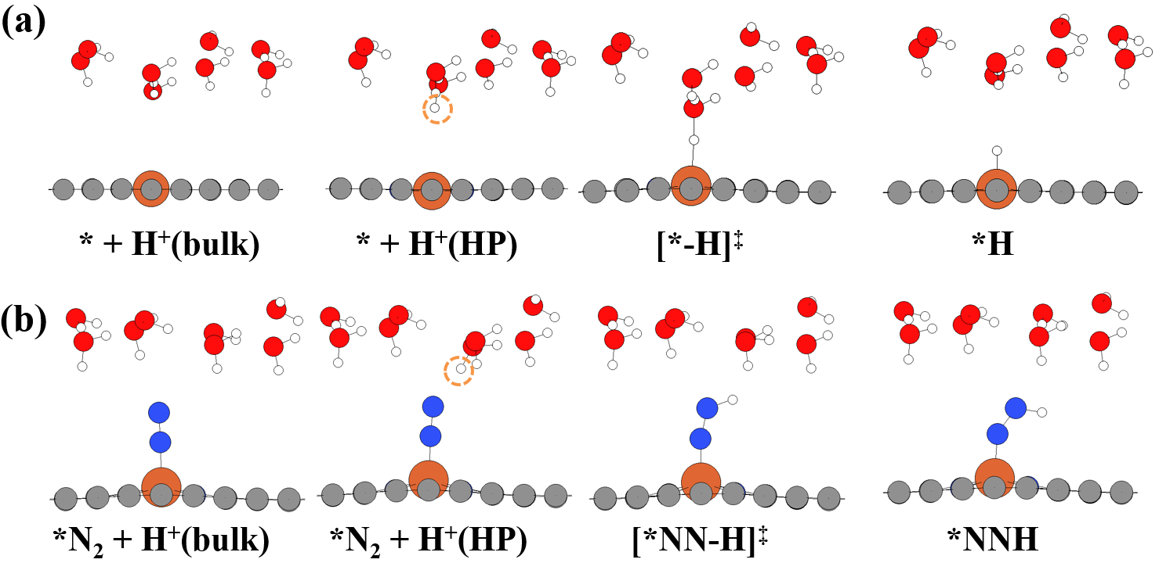
Supplementary Fig. 1 | The optimized geometries of reaction intermediates. (a) *H formation and (b) *NNH formation. The H⁺(bulk) is omitted for clarity. The H⁺(HP), transferred to surface or adsorbate is highlighted in a yellow circle.

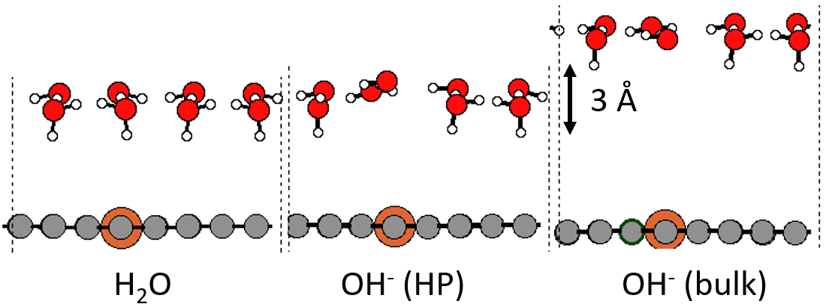
Supplementary Fig. 2 | The optimized structures of solvated H₂O and OH⁻ to correct the OH⁻ energy. The electrolyte layer is OH⁻(bulk) is apart from the OH⁻(HP) by 3 Å in c-axis.

Supplementary Note 3. Potential-dependent free energy diagram for NRR and HER on Fe@N₄.
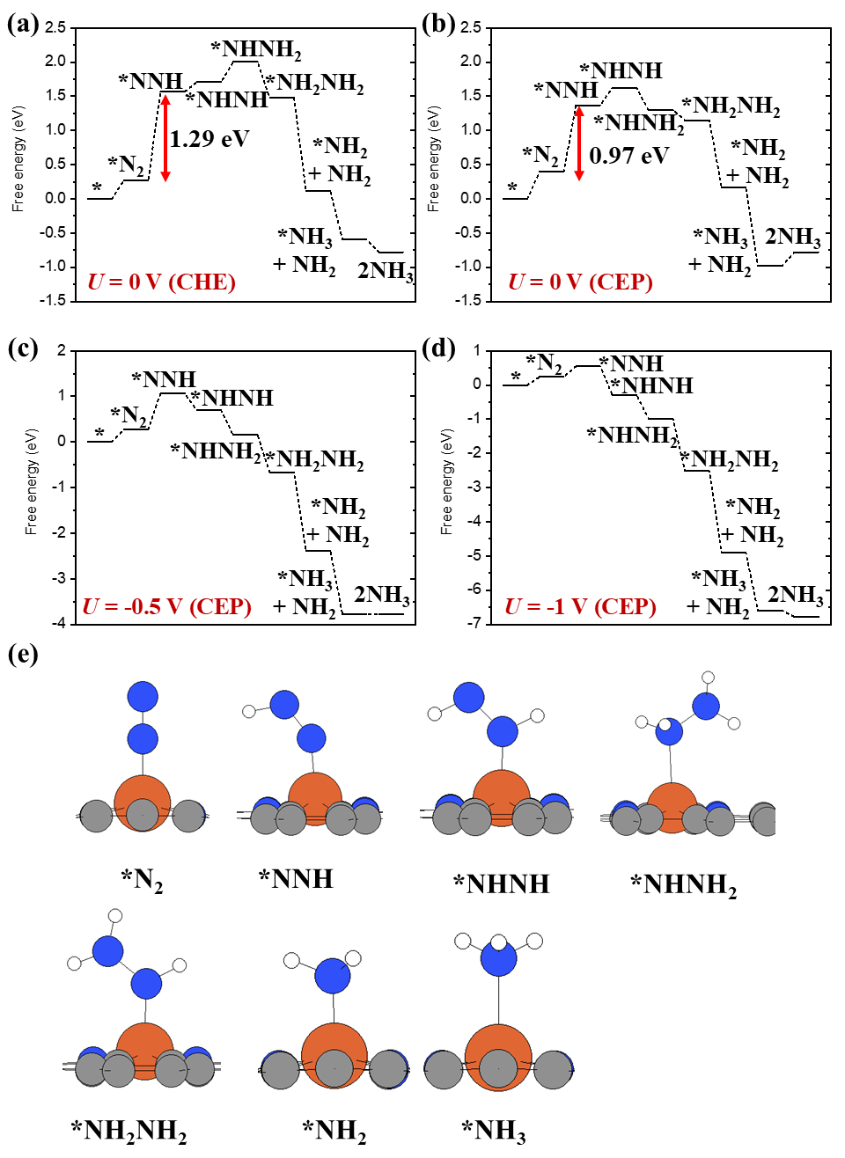
Supplementary Fig. 3 | Free energy diagram and reaction intermediates. (a) Free energy diagram of NRR on Fe@N₄ obtained by the CHE model at 0 V. Free energy diagram obtained by the CHE model at (b) 0 V, (c) -0.5 V and (d) -1 V (vs. SHE). (e) The optimized geometries of reaction intermediates of NRR. Orange, blue, grey, and white balls represent Fe, N, C, and H atoms, respectively. In this calculation, the explicit water layer is not included. The explicit water layer is not included here.

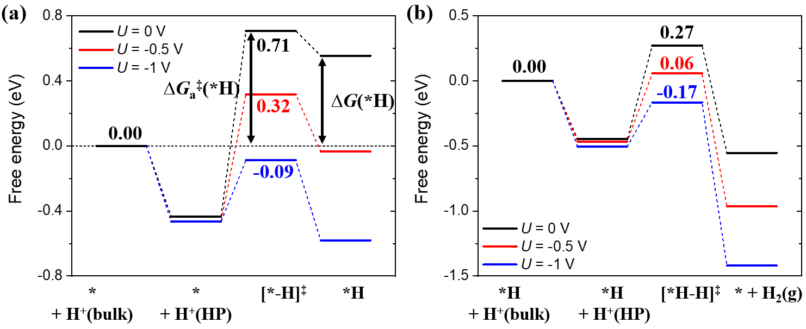
Supplementary Fig. 4 | Free energy diagram for HER under acidic condition. (a) *H formation from * + H⁺(bulk) and (b) H₂(g) formation from *H + H⁺(bulk). The reference energy for ∆G_{a}‡(*H) and ∆G(*H) is G of * + H⁺(bulk).

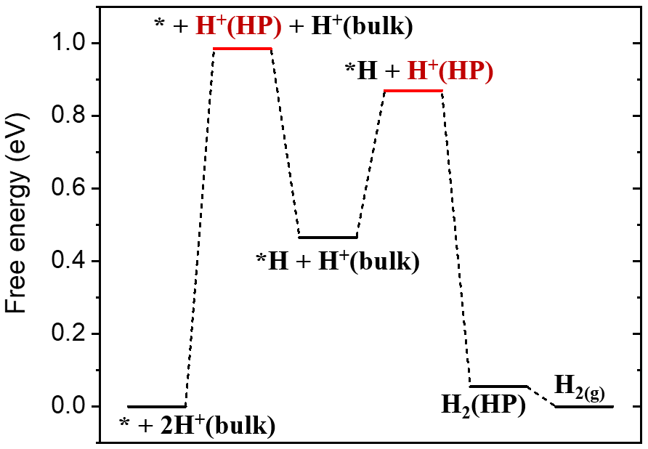
Supplementary Fig. 5 | Free energy diagram of HER (acidic condition) at 0 V on Fe@N₄ obtained by the CHE model. The transition states of the Volmer and the Heyrovsky are omitted since these reactions proceed without barrier in the CHE model.

Based on the free energy diagram obtained by the CEP model, the proton shuttling reaction (H⁺(bulk) → H⁺(HP)) is exothermic (Supplementary Fig. 4). However, the proton shuttling step is highly endothermic in the CHE model. The H⁺(HP) is in ionic state, and hence, the electronic energy of H⁺(HP) obtained by the CHE model (in neutral state) is highly unstable (Supplementary Fig. 5). We find a saddle point in interface reaction between H⁺(HP) and * (or *H) in the CEP model. However, the interface reaction proceed without barrier in the CHE model since the instability of H⁺(HP). Thus, the RDS of HER in the CHE model is proton shuttling step rather than interface reaction.

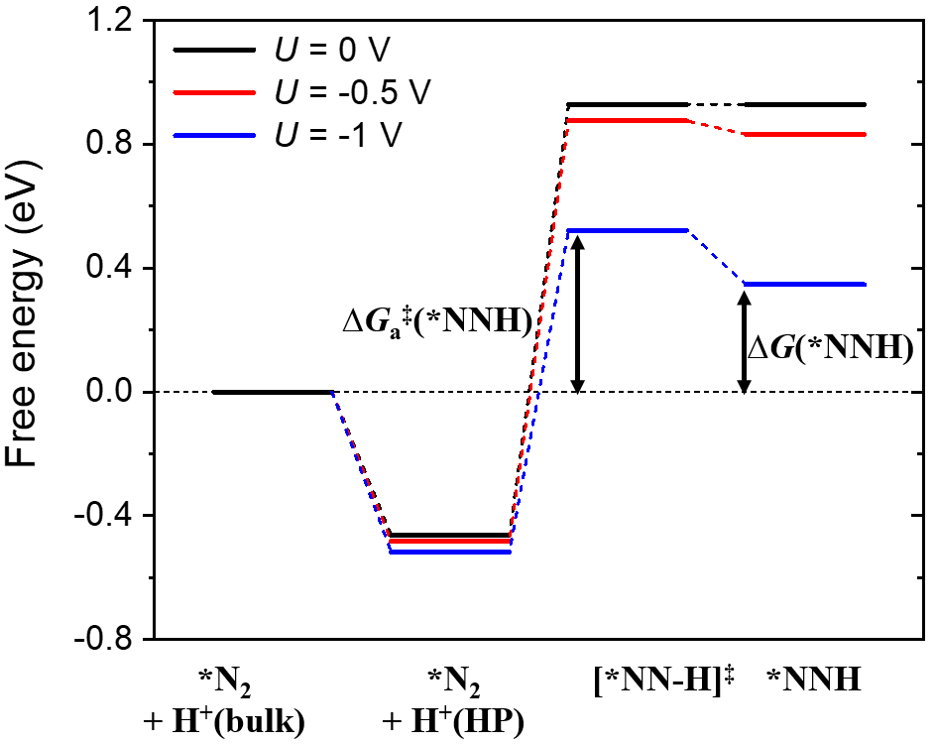
Supplementary Fig. 6 | Free energy diagram for *NNH formation under acidic condition. The reference state for ∆G_{a}‡(*NNH) and ∆G(*NNH) is *N₂ + H⁺(bulk).

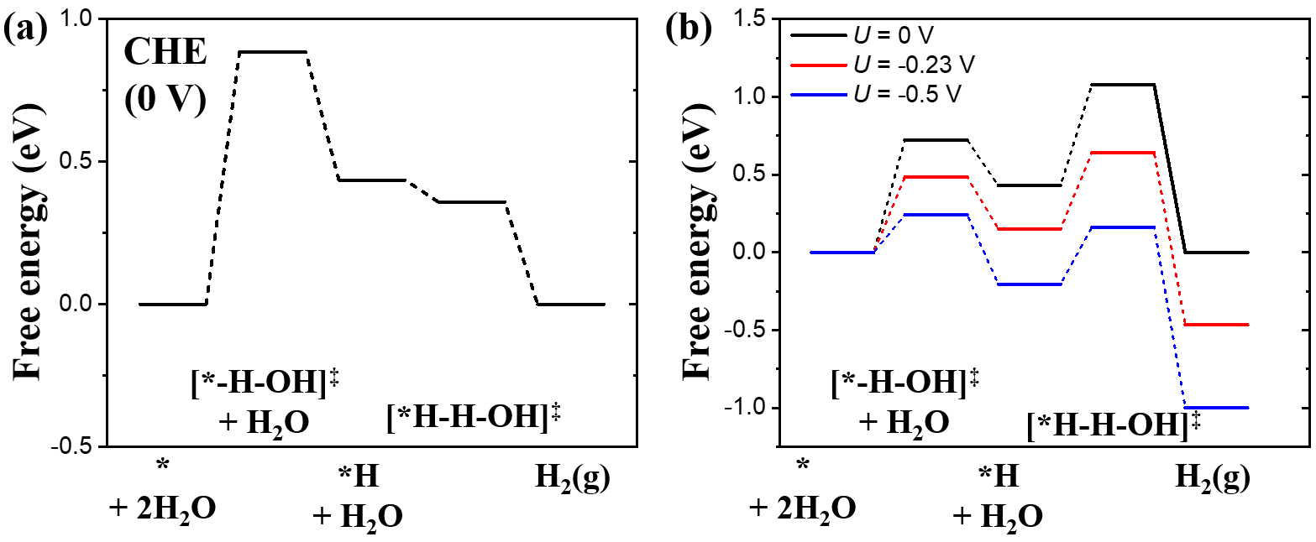
Supplementary Fig. 7 | Free energy diagram for HER on Fe@N₄ under alkaline condition. Free energy diagram obtained by (a) the CHE model and (b) the CEP model. All energies and U are in RHE scale at pH = 13.

Supplementary Note 4. Potential-dependent ∆∆G and ∆∆G_{a}‡.
The ∆G_{a}‡(*NNH) - ∆G_{a}‡(*H) and ∆G(*NNH) - ∆G(*H) increases with more negative potential (Supplementary Fig. 8 and Supplementary Fig. 9). This result indicates that the difference between reaction rates of NRR (r_{NRR}) and that of HER (r_{HER}) would increase with more negative potential. The decrease of relative r_{NRR} compared to r_{HER} thus also contributes to the decrease in faradaic efficiency with more negative potential, in addition to decreasing N₂ coverage.

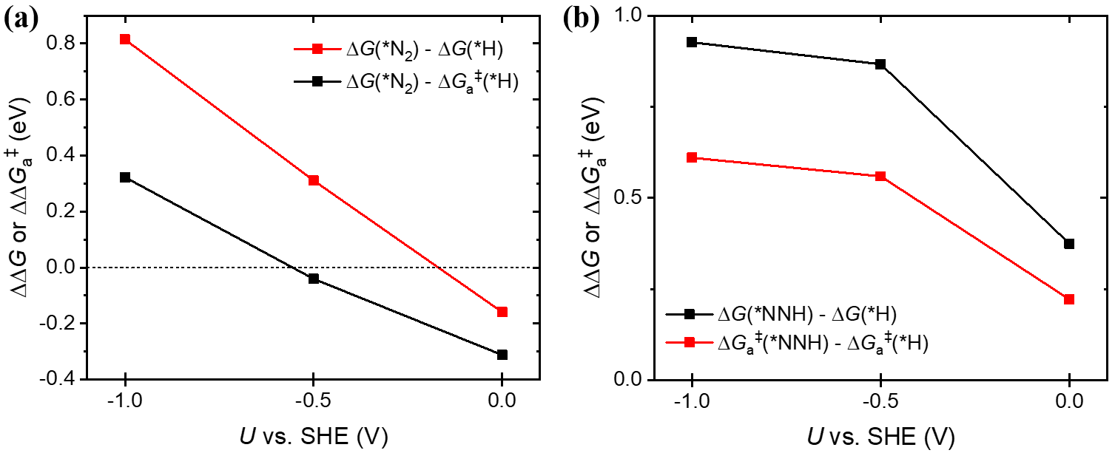
Supplementary Fig. 8 | Potential-dependent changes in ∆∆G and ∆∆G_{a}‡ under acidic condition. Changes in (a) ∆G(*N₂) - ∆G_{a}‡(*H) and ∆G(*N₂) - ∆G(*H) and (b) ∆G_{a}‡(*NNH) - ∆G_{a}‡(*H) and ∆G(*NNH) - ∆G(*H) by U under acidic condition. Solvated H₃O⁺ is used as a proton donor.

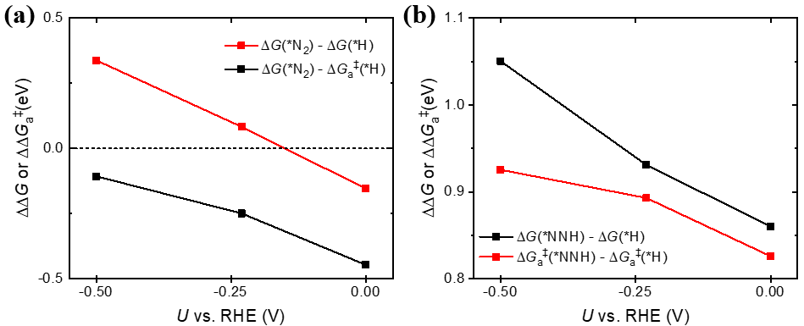
Supplementary Fig. 9 | Potential-dependent changes in ∆∆G and ∆∆G_{a}‡ under alkaline condition. Changes in (a) ∆G(*N₂) - ∆G_{a}‡(*H) and ∆G(*N₂) - ∆G(*H) by U and (b) Changes in ∆G_{a}‡(*NNH) - ∆G_{a}‡(*H) and ∆G(*NNH) - ∆G(*H) by U under alkaline condition. All energies and U are in RHE scale at pH = 13. H₂O is used as a proton donor for obtaining activation energy.

Supplementary Note 5. Microkinetic Modeling
In Wang et al.¹² electrochemical ammonia synthesis performed with Fe-N-C where Fe is a single atom site. The synthesis is performed in an N₂ gas flow and water batch system, where N₂ gas is bubbled in 30 mL liquid, and the excess pressure in the gas is flown out of the system for sampling. To model this system, we set up the reactor as a mix of a continuous stirred tank reactor (CSTR) and a batch reactor. The gas is simulated in a CSTR which is in contact with the liquid in the batch reactor as shown in Supplementary Fig. 10. In the synthesis, 1 mg of the catalyst is with 1.09 wt% Fe. We assumed that each Fe atom is a single atom catalyst as evidenced by high-angle annular dark-field scanning transmission electron microscopy (HAADF-STEM) image. The reaction is performed at 298 K with the N₂ gas velocity of 1 cm³/s and 1 bar of pressure at pH = 13 as in the experiment. The volume of the gas compartment (CSTR) is 10 mL. The synthesized ammonia is set to accumulate in liquid, the chemical potential of which is calculated using the vapor pressure of ammonia and ammonia gas energetics calculated using DFT. The list of species and reactions are shown in Supplementary Table 2 and Supplementary Table 3. We also included the water autoionization reaction with a rate constant of 2.4 × 10⁻² mol m⁻³ s⁻¹. We compute the yield following the procedure described in Wang et al¹². For Lü et al.¹³, we also assume that every Fe in Fe/NC is a single atom catalytic site as HAADF-STEM image suggests. For the electrochemical measurement, 4.2 wt% Fe 1 mg catalyst is loaded to 1 cm² carbon paper. Here, H-type electrochemical cell is used where the configuration can be assumed the same as in Supplementary Fig. 10. The reaction is performed at 298 K and pH = 7.2, with continuously fed1 bar N₂. We assumed that the gas and liquid control volumes are the same as it was not specified. Since the NRR measurement under the acidic condition has not been reported, we use same reaction conditions reported by Wang et al.¹² for acidic conditions, but the proton donor and pH are changed into H₃O⁺ and 0, respectively.

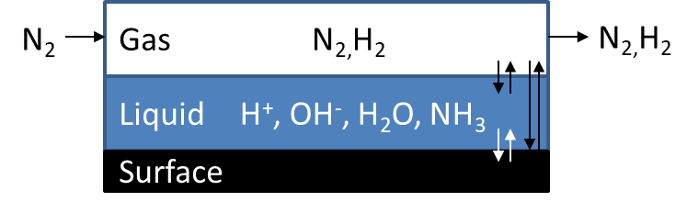
Supplementary Fig. 10 | The reactor system of the microkinetic model. Each box represents the control volume.

Supplementary Table 2 | List of species in the microkinetic model
Species | Phase
H_{2(g)} | gas
N_{2(g)} | gas
H⁺_{(aq)} | liquid
*NH_{3(aq)} | liquid
*H | surface
*N₂ | surface
*NNH | surface
*NHNH | surface
*NHNH₂ | surface
*NH₂NH₂ | surface
*NH₂ | surface
*NH₃ | surface
* | surface

Supplementary Table 3 | List of reactions in the microkinetic model
Reactions
H₂O_{(l)} → H⁺_{(aq)} + OH⁻_{(aq)}
H₂O_{(l)} + e⁻ + * → *H + OH⁻_{(aq)}
H₂O_{(l)} + e⁻ + *H → H_{2(g)} + * + OH⁻_{(aq)}
N_{2(g)} + e⁻ + * → *N₂
H₂O_{(l)} + e⁻ + *N₂ → *NNH + OH⁻_{(aq)}
H₂O_{(l)} + e⁻ + *NNH → *NHNH + OH⁻_{(aq)}
H₂O_{(l)} + e⁻ + *NHNH → *NHNH₂ + OH⁻_{(aq)}
H₂O_{(l)} + e⁻ + *NHNH₂ → *NH₂NH₂ + OH⁻ _{(aq)}
H₂O_{(l)} + e⁻ + *NH₂NH₂ → *NH₂ + NH_{3(aq)} + OH⁻_{(aq)}
H₂O_{(l)} + e⁻ + *NH₂ → *NH₃ + OH⁻_{(aq)}
*NH₃ → NH_{3(aq)}+*

We compute the reaction constants using the transition state theory and thermodynamic equilibrium:

 | $$k_{f,i}=\frac{k_{b}T}{h}\exp\left(\frac{-G_{a,f,i}}{k_{b}T}\right)$$  $$k_{r,i}=\frac{k_{f,i}}{K}$$  $$K_{i}=\exp\left(\frac{-∆_{r}G_{i}}{k_{b}T}\right)$$ | (3)

where k_{f,i}, and k_{r,i} are the forward and reverse reaction constant of reaction i, K_{i} is the equilibrium constant of reaction i, k_{b} is the Boltzmann constant, T is the temperature, h is the Planck constant $G_{a,f,i}$ is the Gibbs free energy of activation for reaction i, and ∆_{r}G_{i} is the Gibbs free energy of reaction for reaction i. For the reactions where we have not computed transition sate, we assumed that the $G_{a,f,i}$ is 0 for exothermic reactions, and ∆_{r}G_{i} for endothermic reactions. The rate is computed using the law of mass action and normalized to the surface site density:

 | $$r_{i}^{S}=k_{f,i}/σ_{den}\prod_{j}{α^{υ_{j}}}-k_{r,i}/σ_{den}\prod_{j}{α^{υ_{j}}}$$ | (4)

The ordinary differential equations (ODEs) are set up following the implementation of CHEMKIN²⁶ for CSTR (gas), batch (liquid) and surface species. We solved ODEs using MatLab software.

Supplementary Table 4 | Summary of U_{cross}, U at maximum $θ_{N_{2}}$ and U at maximum NH₃ yield rate obtained on Fe@N₄ by the CEP model and MKM simulations.
pH | U_{cross}  (V vs. RHE) | U at maximum $θ_{N_{2}}$  (V vs. RHE) | U at maximum NH₃ yield rate  (V vs. RHE)
13 | -0.15 | -0.15 | -0.25
7.2 | -0.15 | -0.45 | -0.58
0 | -0.15 | -0.20 | -0.25

Supplementary Note 6. Calculation of $∆\overline{N_{e}}$ and slope
The ∆G and ${∆N}_{e}$ at U = 0, -0.5, -1 V (vs. SHE) are used to obtain the calculated slope and $∆\overline{N_{e}}$, respectively. Here, we use the number of electrons added (or extracted) to the slab model to tune the potential (or workfunction) of the slab surface as $N_{e}$. The charge neutrality is kept by ionic countercharges via the linearized Poisson-Boltzmann equation.
We tested the effect of explicit water on ∆G and $∆\overline{N_{e}}$ for *NNH and *H formation. The ∆G does not change significantly by explicit water (Supplementary Fig. 11a). Thus, the explicit water layer is not included in estimating the free energy diagram for NRR on Fe@N₄. We also found that the $∆\overline{N_{e}}$ does not change by explicit water significantly (< 0.05 e⁻) (Supplementary Fig. 11b). Hence, the explicit water layer is not included in calculating ∆G, slope and $∆\overline{N_{e}}$ on Fe(110), Ru(0001), Rh(111), Fe@N₃, Ru@NC₂, Ru@N₃ and Ag@N₄. The $∆\overline{N_{e}}$ and slope are obtained by using ∆G and ${∆N}_{e}$ at 0 V, -0.5 V, -1 V (vs. SHE).

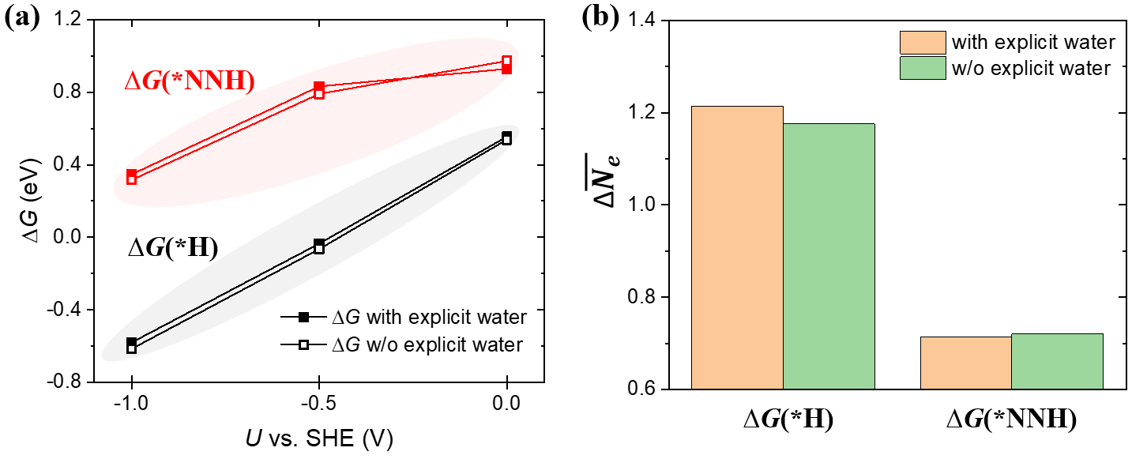
Supplementary Fig. 11 | Effect of explicit water on ∆G and $∆\overline{N_{e}}$. Change of (a) ∆G and (b) $∆\overline{N_{e}}$ on Fe@N₄ with or without explicit water (acidic).

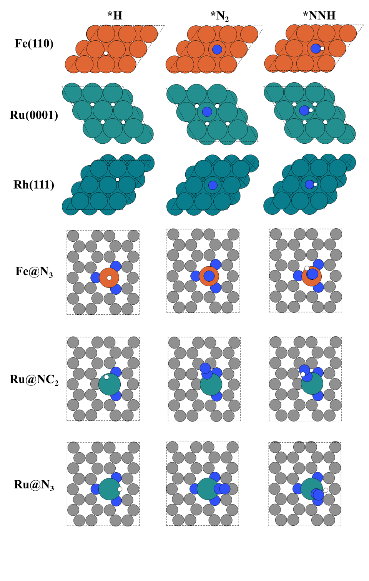
Supplementary Fig. 12 | The top-view of the optimized structures for *H, *N₂ and *NNH on Fe(110), Ru(0001), Rh(111), Fe@N₃, Ru@NC₂, and Ru@N₃. On the metal surfaces, top site adsorption is considered for *N₂ and *NNH, while the hollow-site is considered for *H.
References
1. Liu, H.-M. et al. Surfactant-free atomically ultrathin rhodium nanosheet nanoassemblies for efficient nitrogen electroreduction. J. Mater. Chem. A 6, 3211-3217 (2018).
2. Yang, D., Chen, T. & Wang, Z. Electrochemical reduction of aqueous nitrogen (N₂) at a low overpotential on (110)-oriented Mo nanofilm. J. Mater. Chem. A 5, 18967-18971 (2017).
3. Hu, L. et al. Ambient electrochemical ammonia synthesis with high selectivity on Fe/Fe oxide catalyst. ACS Catal. 8, 9312-9319 (2018).
4. Wang, D. et al. Energy‐Efficient Nitrogen Reduction to Ammonia at Low Overpotential in Aqueous Electrolyte under Ambient Conditions. ChemSusChem 11, 3416-3422 (2018).
5. Bao, D. et al. Electrochemical reduction of N₂ under ambient conditions for artificial N₂ fixation and renewable energy storage using N₂/NH₃ cycle. Adv. Mater. 29, 1604799 (2017).
6. Tao, H. et al. Nitrogen fixation by Ru single-atom electrocatalytic reduction. Chem 5, 204-214 (2019).
7. Zhang, X., Kong, R.-M., Du, H., Xia, L. & Qu, F. Highly efficient electrochemical ammonia synthesis via nitrogen reduction reactions on a VN nanowire array under ambient conditions. Chem. Commun. 54, 5323-5325 (2018).
8. Yang, X. et al. Mechanistic insights into electrochemical nitrogen reduction reaction on vanadium nitride nanoparticles. J. Am. Chem. Soc. 140, 13387-13391 (2018).
9. Ren, X. et al. Electrochemical N₂ fixation to NH₃ under ambient conditions: Mo₂N nanorod as a highly efficient and selective catalyst. Chem. Commun. 54, 8474-8477 (2018).
10. Xu, X. et al. 1 T-phase molybdenum sulfide nanodots enable efficient electrocatalytic nitrogen fixation under ambient conditions. Appl. Catal. B, 118984 (2020).
11. Wang, Y. et al. Rational design of Fe–N/C hybrid for enhanced nitrogen reduction electrocatalysis under ambient conditions in aqueous solution. ACS Catal. 9, 336-344 (2018).
12. Wang, M. et al. Over 56.55% Faradaic efficiency of ambient ammonia synthesis enabled by positively shifting the reaction potential. Nat. Commun. 10, 1-8 (2019).
13. Lü, F. et al. Nitrogen-coordinated single Fe sites for efficient electrocatalytic N₂ fixation in neutral media. Nano Energy 61, 420-427 (2019).
14. Chen, Y. et al. Highly Productive Electrosynthesis of Ammonia by Admolecule-Targeting Single Ag Sites. ACS Nano 14, 6938-6946 (2020).
15. wang, h. et al. Bionic Design of Mo (IV) Doped FeS2 Catalyst for Electroreduction of Dinitrogen to Ammonia. ACS Catal. 10, 4914−4921 (2020).
16. Han, Z. et al. Activated TiO₂ with tuned vacancy for efficient electrochemical nitrogen reduction. Appl. Catal. B 257, 117896 (2019).
17. Mukherjee, S. et al. Metal-organic framework-derived nitrogen-doped highly disordered carbon for electrochemical ammonia synthesis using N₂ and H₂O in alkaline electrolytes. Nano Energy 48, 217-226 (2018).
18. Yu, X. et al. Boron-doped graphene for electrocatalytic N₂ reduction. Joule 2, 1610-1622 (2018).
19. Zhang, M. et al. Reduced graphene oxides with engineered defects enable efficient electrochemical reduction of dinitrogen to ammonia in wide pH range. Nano Energy 68, 104323 (2020).
20. Lindgren, P., Kastlunger, G. & Peterson, A. A. A Challenge to the G∼ 0 Interpretation of Hydrogen Evolution. ACS Catal. 10, 121-128 (2019).
21. Hörmann, N. G., Andreussi, O. & Marzari, N. Grand canonical simulations of electrochemical interfaces in implicit solvation models. J. Chem. Phys. 150, 041730 (2019).
22. Lamoureux, P. S., Singh, A. R. & Chan, K. pH effects on hydrogen evolution and oxidation over Pt (111): Insights from first-principles. ACS Catal. 9, 6194-6201 (2019).
23. Garcia-Ratés, M. & López, N. Multigrid-based methodology for implicit solvation models in periodic DFT. J. Chem. Theory Comput. 12, 1331-1341 (2016).
24. Liu, L., Liu, Y. & Liu, C. Enhancing the understanding of hydrogen evolution and oxidation reactions on Pt (111) through ab initio simulation of electrode/electrolyte kinetics. J. Am. Chem. Soc. 142, 4985-4989 (2020).
25. Gauthier, J. A., Chen, L. D., Bajdich, M. & Chan, K. Implications of the fractional charge of hydroxide at the electrochemical interface. Phys. Chem. Chem. Phys. 22, 6964-6969 (2020).
26. Coltrin, M. E., Kee, R. J. & Rupley, F. Surface CHEMKIN (Version 4. 0): A Fortran package for analyzing heterogeneous chemical kinetics at a solid-surface---gas-phase interface. (Sandia National Labs., Livermore, CA (United States), 1991).

