Supporting Information

Tranilast-tyrosine hybrid molecule exhibits dual activity:
Suppression of epithelial-mesenchymal transition and induction of cytotoxicity in cancer cells

Tsugumasa Toma¹, Junpei Yamashita¹, Masahiro Kamo¹, Ryoko Koga¹,
Yoshinari Okamoto², Hiroshi Tateishi¹, Masami Otsuka^{1,3}, Mikako Fujita¹

¹Medicinal and Biological Chemistry Science Farm Joint Research Laboratory, Faculty of Life Sciences, Kumamoto University, 5-1 Oe-honmachi, Chuo-ku, Kumamoto 862-0973, Japan
²Department of Instrumental Analysis, Faculty of Life Sciences, Kumamoto University, 5-1 Oe-honmachi, Chuo-ku, Kumamoto 862-0973, Japan
³Science Farm Ltd., 1-7-30 Kuhonji, Chuo-ku, Kumamoto 862-0976, Japan

These authors contributed equally: Tsugumasa Toma, Junpei Yamashita

Correspondence
Masami Otsuka, motsuka@gpo.kumamoto-u.ac.jp
Mikako Fujita, mfujita@kumamoto-u.ac.jp

¹H NMR and ¹³C NMR Spectra of TNL-T

TNL-T

¹H NMR
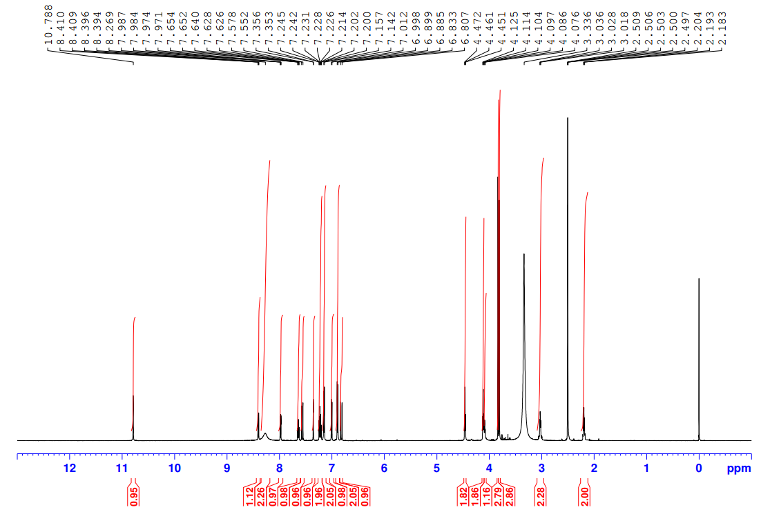

¹³C NMR
