Supplementary Information for
Waveguide-integrated PdSe₂ photodetector with high responsivity and speed in the near-infrared range across the O+E+S+C bands Jianghong Wu^{1,2,3#}, Hui Ma^{1#}, Chuyu Zhong^{1#}, Maoliang Wei¹, Chunlei Sun^{2,3}, Yuting Ye^{2,3}, Yan Xu^{2,3}, Bo Tang⁴, Ye Luo^{2,3}, Boshu Sun¹, Jialing Jian^{2,3}, Hao Dai¹, Hongtao Lin^{1*}, and Lan Li^{2,3*}
¹ State Key Laboratory of Modern Optical Instrumentation, College of Information Science and Electronic Engineering, Zhejiang University, Hangzhou 310027, China
² Key Laboratory of 3D Micro/Nano Fabrication and Characterization of Zhejiang Province, School of Engineering, Westlake University, Hangzhou 310024, China
³ Institute of Advanced Technology, Westlake Institute for Advanced Study, 18 Shilongshan Road, Hangzhou 310024, China
⁴ Institute of Microelectronics, Chinese Academic Society, Beijing 100029, China
# J.W., H.M., and C.Z. contributed equally to this work.
E-mail: lilan@westlake.edu.cn
E-mail: hometown@zju.edu.cn

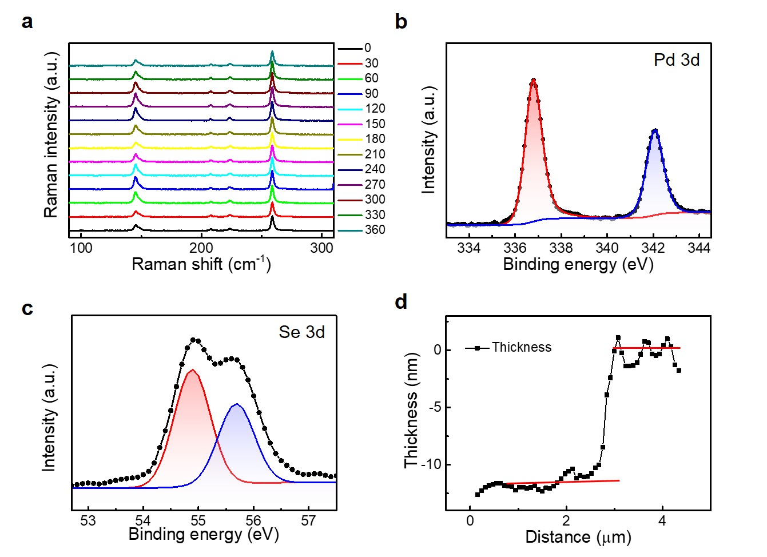
Supplementary Fig. 1 Characteristics of multilayer PdSe₂ flakes. a Raman spectra of a multilayer PdSe₂ flake with optical excitation under different polarization. X-ray photoelectron spectroscopy of Pd 3d (b) and Se 3d (c). d The thickness of a PdSe₂ flake for the ultrafast transient reflectance spectroscopy measurement.

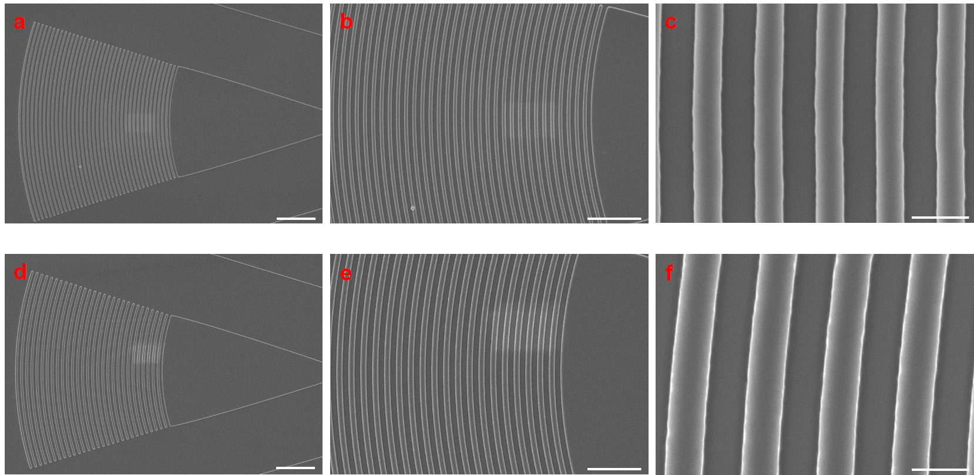
Supplementary Fig. 2 Scanning electron microscope (SEM) images for grating couplers. Grating couplers operating at C-band (a, b, and c) and O-band (d, e, and f) under different magnification. The obtained grating couplers possess a uniform and smooth sidewall. Scale bar: 5 $μ$m in (a) and (d), 3 $μ$m in (b) and (e), 0.5 $μ$m in (c) and (f).
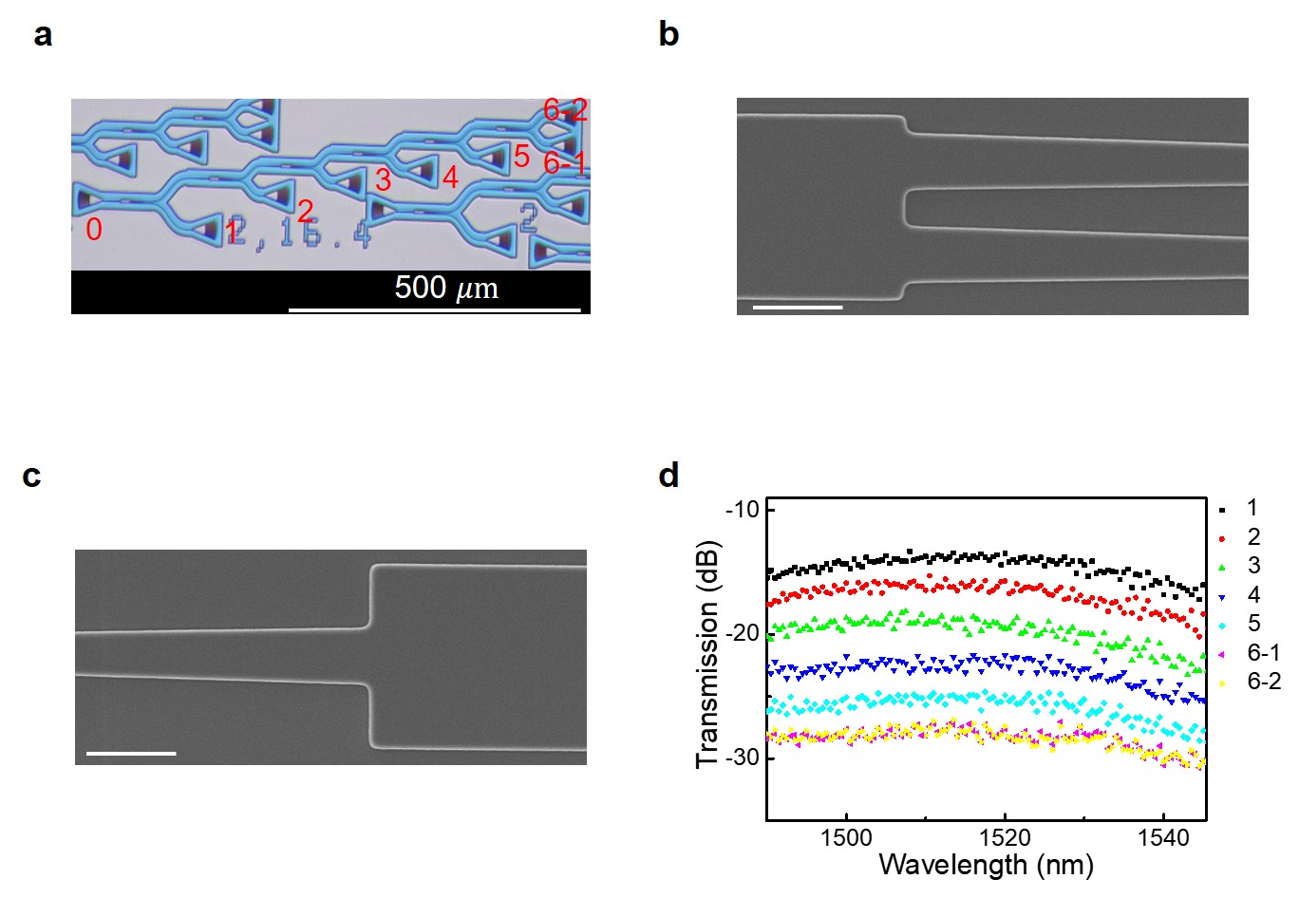
Supplementary Fig. 3 Characteristics of cascaded 1$×$2 MMIs. a Optical image of cascaded 1$×$2 MMIs. b, c SEM images of a 1$×$2 MMI, indicating this device has an ideal size and appearance. d Transmission spectra of the cascaded 1$×$2 MMIs. The input grating coupler is “grating 0”, and the output grating couplers are marked as “1” to “6-2” in Fig. a. These transmission spectra demonstrate that the input optical power can be divided equally by an MMI. Scale bar: 2 $μ$m in (b) and (c).

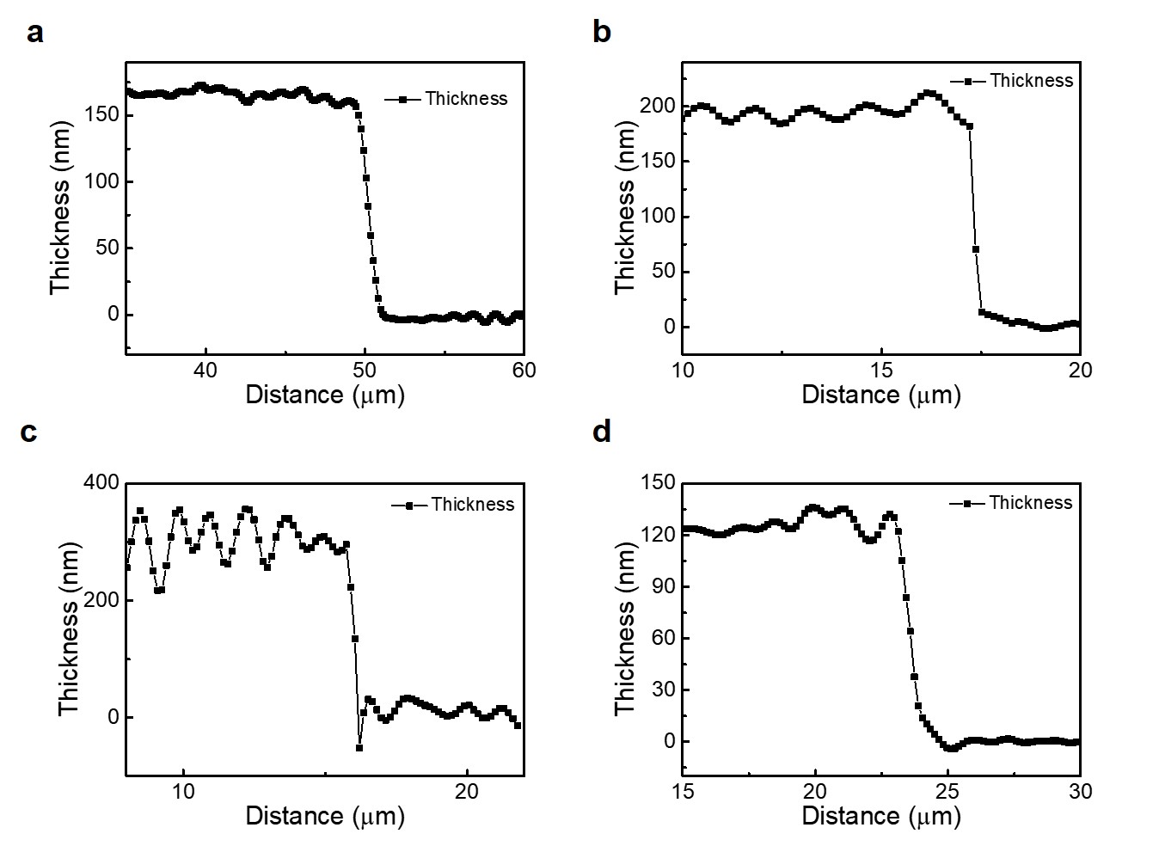Supplementary Fig. 4 The thickness of the multilayer PdSe₂ flakes in S1, S2, S3, and S4, respectively, measured by digital holographic microscopy.

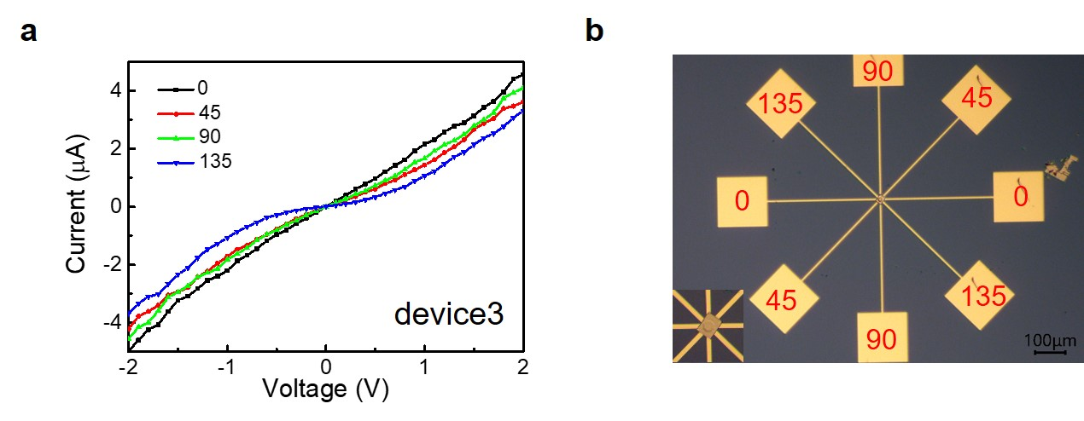
Supplementary Fig. 5 Characterization of the anisotropic electronic transport property. a IV curves of a PdSe₂ field effect transistor (FET) under zero gate voltage. b Optical image of this FET, the marked numbers are matched with the legend in Fig. a. According to the measured IV curves, anisotropic electronic transport (especially for comparing “135” with other three degrees) remained in multilayer PdSe₂ flakes, which is probably induced by the variation of carrier mobility at different directions.

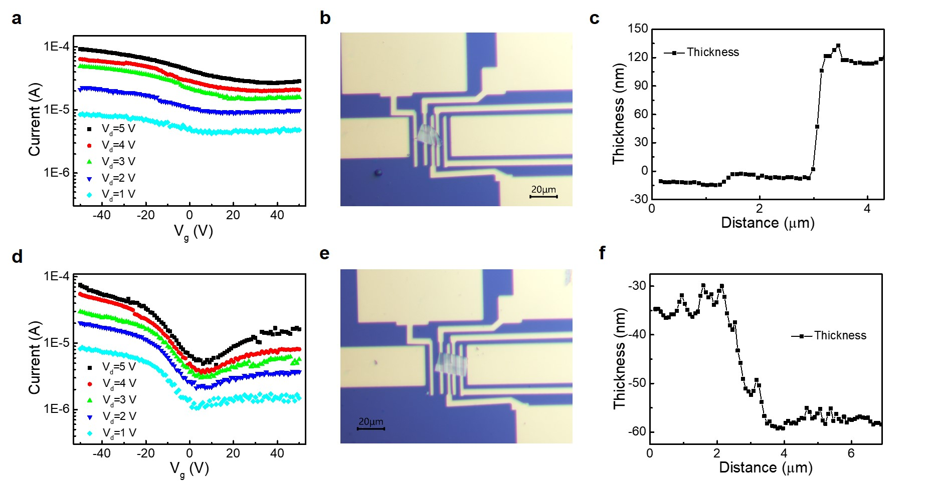
Supplementary Fig. 6 Characterization of the gate-dependent transport properties. a Gate-tunable transfer curves of one PdSe₂ FET under different V_{d}, showing the unipolar transport. An optical image (b) and (c) atomic force microscope (AFM) result of this PdSe₂ FET. d Gate-tunable transfer curves of another PdSe₂ FET under different V_{d}, demonstrating an ambipolar transport. An optical image (e) and (f) AFM result of this PdSe₂ FET.

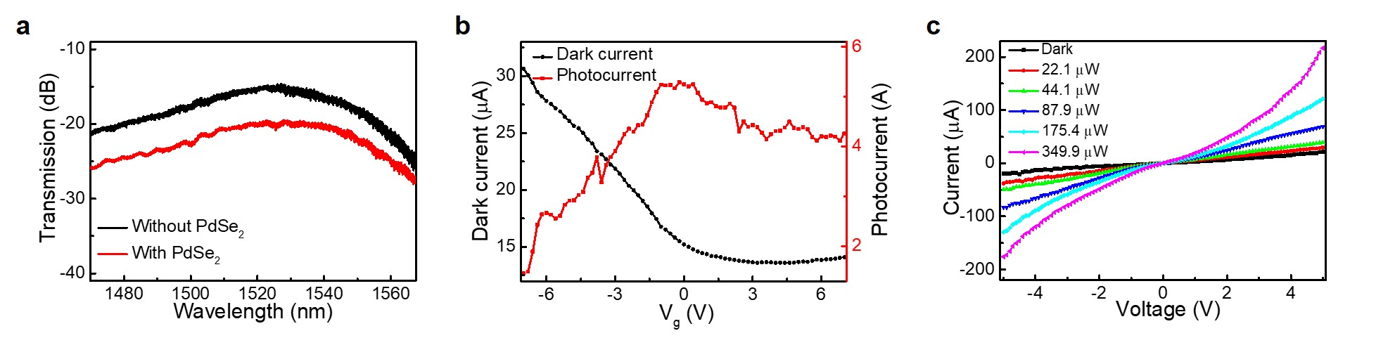
Supplementary Fig. 7 A waveguide-integrated PdSe₂ photodetector. a Transmission spectra of a waveguide without and with a multilayer PdSe₂ flake. b Gate-tunable transport and photoresponse of this PdSe₂ photodetector, the results are consistent with S1 in Fig. 4. c IV curves of this photodetector under different optical power.

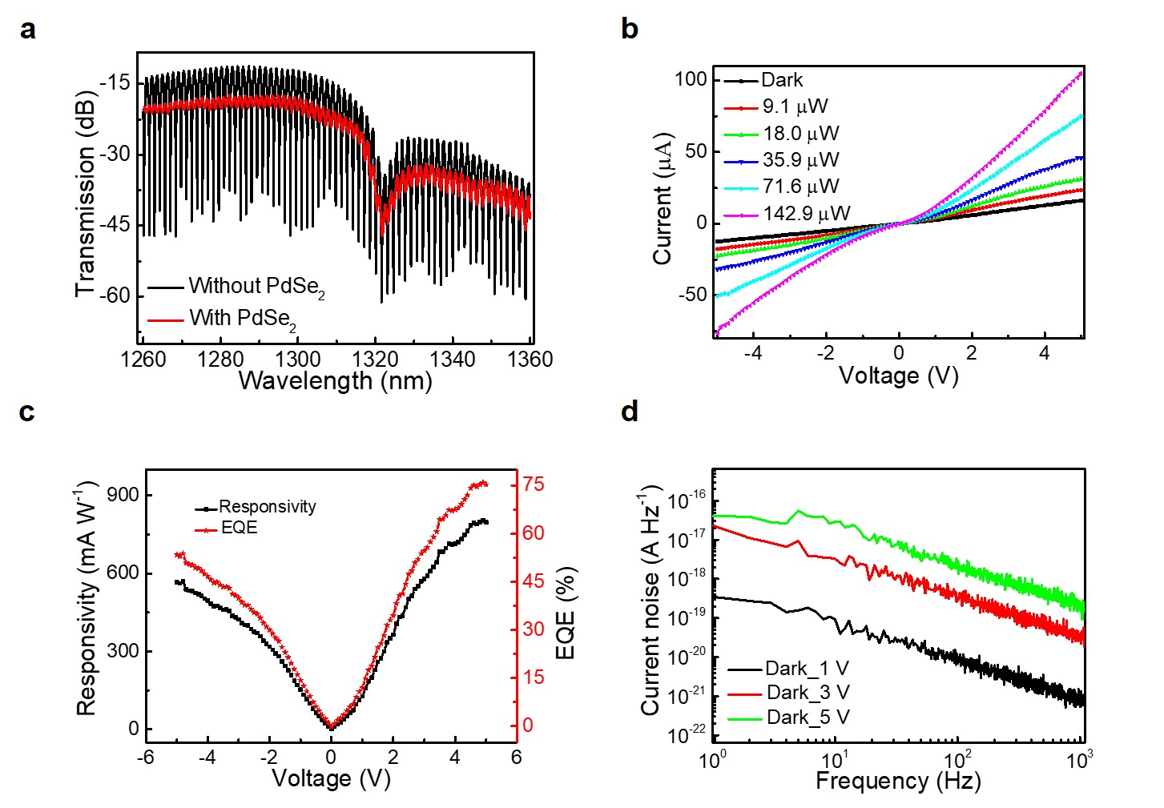
Supplementary Fig. 8 Photodetector performance of S4. This photodetector operates at O-band, which is used for demonstrating broadband spectral photoresponse in Fig. 4c. a Transmission spectra of an unbalanced Mach-Zehnder interferometer (MZI) with and without a multilayer PdSe₂ flake. b IV curves of this PdSe₂ photodetector, current rises gradually with the improving optical power at 1260 nm. c Responsivity and external quantum efficiency of this photodetector under different bias voltages. d The measured 1/f noise spectra under different bias voltages.

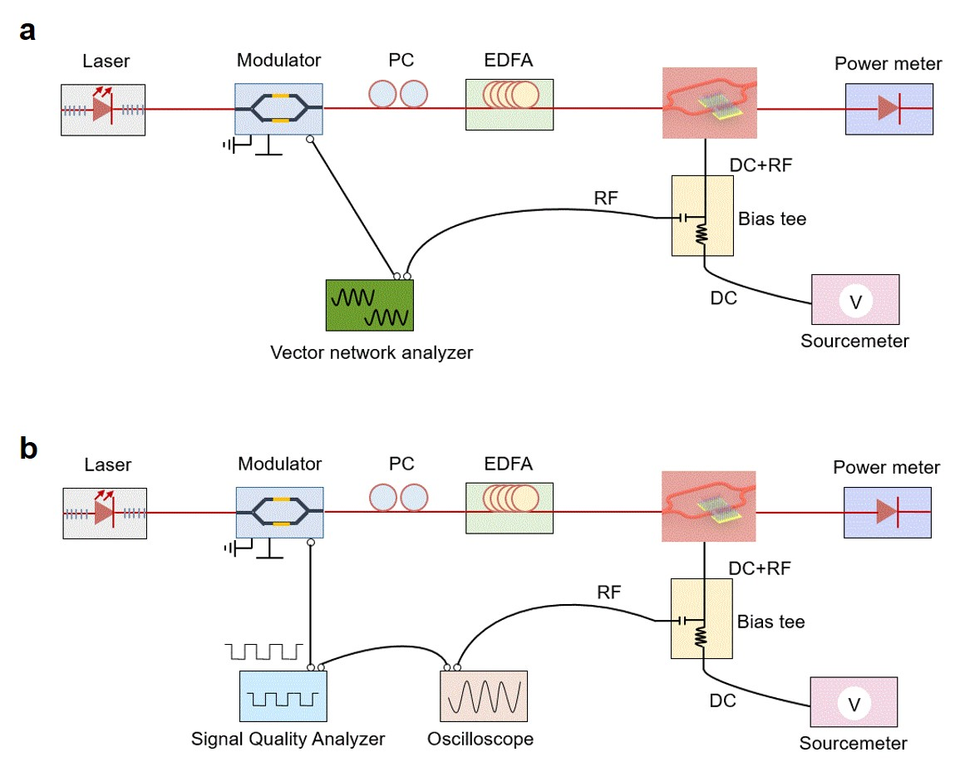
Supplementary Fig. 9 The dynamic measurement setups. a The setups for measuring 3 dB bandwidth. b the setups for measuring eye diagram. The black and red lines in this figure represent the electric and optical connection.

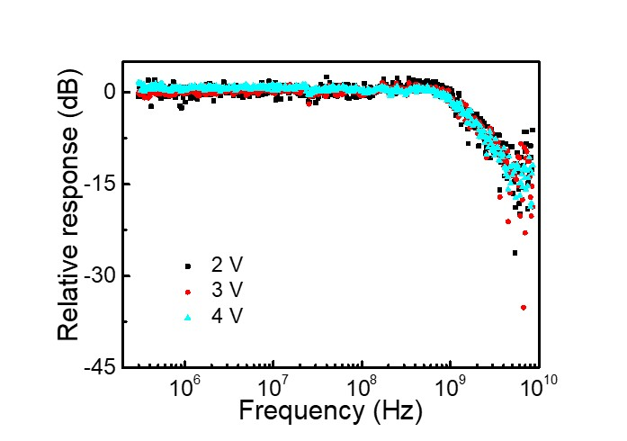
Supplementary Fig. 10 The dynamic response of S3 under different bias voltages. The measured 3 dB bandwidth keeps a same value at 2, 3, and 4 V, indicating that the transit time is not the limiting factor for 3 dB bandwidth.

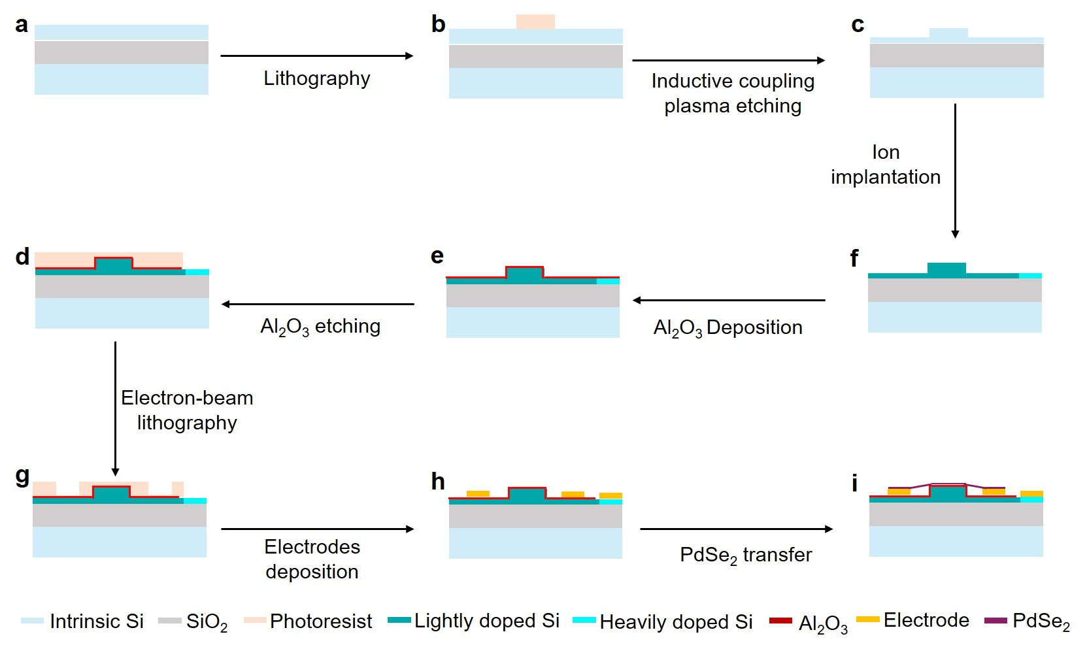
Supplementary Fig. 11 The detailed fabrication process of preparing a waveguide-integrated PdSe₂ photodetector.

Supplementary Table 1. The conclusion of detailed photoresponse of S1, S2, S3, and S4.
Sample | Operational wavelength  (nm) | Dark current  (𝝁A) | Responsivity  (mA$∙$W⁻¹) | EQE  (%) | 3dB bandwidth  (GHz) | NEP  (pW$∙$Hz^{-0.5}) | Thickness/length  (nm/$μ$m)
S1 | 1550 | 79.9@5V  31.5@3V | 1190.2@5V  724.3@3V | 95.2@5V  57.9@3V | 0.2 | 4.0@5V  4.4@3V | 171/22.6
S2 | 1550 | 28.5@5V  14.9@3V | 285.7@5V  161.4@3V | 22.9@5V  12.9@3V | 0.9 | 10.6@5V  13.6@3V | 186/10.4
S3 | 1550 | 68.0@5V  34.0@3V | 191.2@5V  88.1@3V | 15.3@5V  7.0@3V | 1.5 | 43.1@5V  66.4@5V | 284/14.7
S4 | 1310 | 16.2@5V  9.5@3V | 797.6@5V  579.2@3V | 75.3@5V  53.8@3V | NA | 2.9@5V  3.0@3V | 126/16.7

