Supplemental Figure 1. Isolation and characterization of human placental mesenchymal stem cells (hPMSCs)
A, Image of primary hPMSCs, passage (P)5 hPMSCs, and passage 10 hPMSCs. The cells showed homogenous fibroblastic morphology. B, Expression of cell surface markers on hPMSCs. hPMSCs possessed the surface marker profile typical for mesenchymal stem cells, and were positive for the mesenchymal markers CD73, CD90, CD166 and CD105, and negative for the hematopoietic and endothelial markers CD45, CD34, CD11b, and showed almost no expression of HLA-DR. C, Multiple differentiation potential of hPMSCs. Under specific induction conditions, they could differentiate into adipose cells, osteocytes and chondrocytes. Scale bar: 50μm.

Supplemental Figure 2. Experimental conditions for the activation of HSCs by TGF-β1
Representative western blot of α-SMA and GAPDH from HSCs at different groups.
The four samples of HSCs on the left side (column 1-4) were from starved treatment group, cells were pretreated with the starvation medium (DMEM containing 0.2% FBS) for 24 hours and then cultured in human stellate cell medium containing different concentrations of TGF-β1. The four samples of HSCs on the right side (column 5-8) were from the non-starved treatment group, these cells cultured in human stellate cell medium containing different concentrations of TGF-β1.

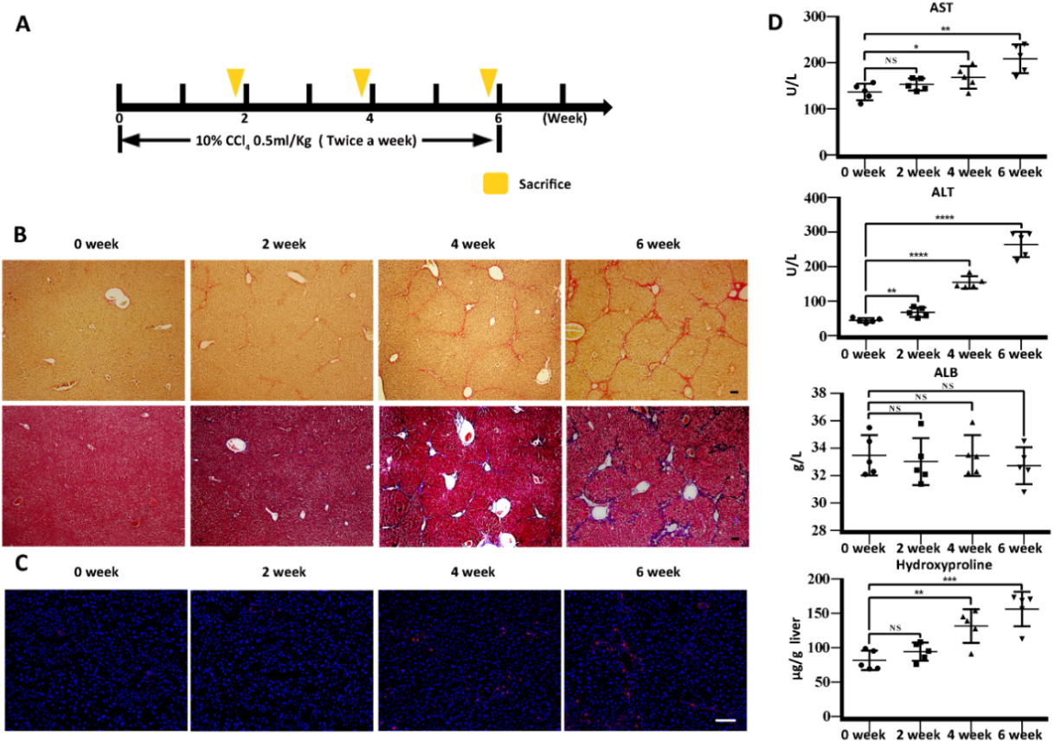

Supplemental Figure 3. The development of CCl₄-injured liver fibrosis in mice.
A Diagram of establishing hepatic fibrosis model in mice. CCl₄ was administered twice a week for 6 weeks. B liver sections stained with Sirius red (upper) and Masson trichome (bottom) on week 0, 2, 4, 6 respectively. C Immunofluorescence staining using anti α-SMA (red) antibodies and DAPI (blue) on week 0, 2, 4, 6 respectively. D
Hepatic function was assessed by serum level of AST, ALT, ALB and hepatic hydroxyproline content in liver tissues were measured in CCl₄-injured mice on week 0, 2, 4, 6. Scale bar: 50μm. ***, p < .001; **, p < .01; *, p < .05; ns, no significance.

