READ ME.
MATLAB File Name: mSMC_Calcium_Influx_2022
MATLAB version: Matlab2020a (or more recent)
Programming language: MATLAB
The code described in this document should be used for research purposes only and is currently available through the following links.
- https://github.com/2022Piezo1/Piezo1_mSMC_Calcium-Influx
- DOI: 10.5281/zenodo.6282081 (MIT License)
Installation and use instructions:
This code was written using a student license for MATLAB 2020a and installation instructions can be found through MathWorks website. The Symbolic Math Toolbox will also need to be downloaded after MATLAB is installed. The file can then be added to MATLAB pathway and opened in editor for use.
Green line commentary text is available for each section of code and variable that needs to be adjusted/changed both at the beginning of every section and for relevant lines. The file referenced by the code must be in “.txt” format and data sorted in the first 2 columns without labels, time and intensity, respectively. Crucial lines to note are listed below.
- The text file’s name must be changed in lines 18-20
- Line 53 for baseline calculation and line 54 for manual input (remember to disable line 54 if you decide to calculate baseline).
- Line 55 to adjust datapoint detection for peak bases (typically between 0-0.1)
- Line 65 to adjust cutoff multiplier to determine threshold for peaks (typically a value between 1.0-1.5)
When everything is ready, the calculated variables and arrays for the time and intensity can be exported as an “.xls” file. Column and sheet number can be changed as needed. There are no labels in exported file, reference Lines 219-229 from MATLAB code for column labels.
Please note, this code has not been submitted for community commenting and input.
Description:
The key operations of the code are identifying peaks in mISMC calcium influx signaling. First, the baseline is identified through manual input or by calculating the lowest average after dividing the curve into small segments, see Installation/use instructions for more details. Next, a multiplier is used to mark a threshold where datapoints above this threshold are filtered using for loops to find peaks. Datapoints left and right of peak datapoint are filtered using for loop conditions to estimate where peak bases are. Peaks, peak bases, and baseline are graphed in a figure for confirmation. All data points are saved in separate arrays where they can be used to calculate the intensity change, time between calcium spikes, time duration of peaks, frequency and roughly estimate the area under the curve. This code is best used for calcium curves with low background noise and relatively cleaner curves. Messier curves or curves with sloping baselines might require manual deletion/manipulation of datapoints from the original curve without biasing the final calculated variables.
Example Data
The following is a sample of our mSMC PiezoWT calcium influx signal data with a figure to demonstrate the primary function of the code. Numerical values calculated based on the arrays generated (visualized in the figure) are exported in a separate “.xls” file.
File name: Example_mSMCs_WT_04.txt (included below)
Adjusted Lines:
- Lines 18-20: Example_mSMCs_WT_04.txt
- Line 54: 556
- Line 55: 0.03
- Line 65: 1.255
Figure:
Blue Curve: Original curve exported from zeiss software
Purple Curve: Baseline
Orange Curve: Identified peak datapoints
Yellow Curve: Identified peak and peak base datapoints

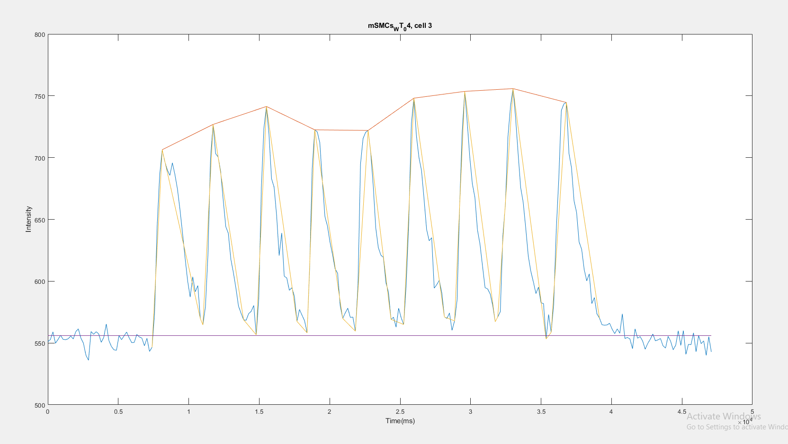

Example_mSMCs_WT_04.txt
0 551.0967742
180.0103 552.7741935
361.0206 558.9677419
541.0309 549.8709677
721.0412 552.8064516
902.0516 556.2903226
1082.0619 552.9354839
1262.0722 552.6774194
1443.0825 553.3870968
1623.0928 555.6451613
1804.1032 553.2903226
1984.1135 559.1935484
2164.1238 561.4516129
2345.1341 553.9677419
2525.1444 549.8709677
2705.1547 540.0322581
2886.1651 536.0967742
3066.1754 559.2580645
3247.1857 557.0322581
3427.196 559.1290323
3607.2063 557.4193548
3788.2167 550.516129
3968.227 554.5806452
4148.2373 565.3548387
4329.2476 552.1290323
4509.2579 547.2258065
4689.2682 544.483871
4870.2786 544.1290323
5050.2889 556.0322581
5231.2992 552.6774194
5411.3095 555.8064516
5591.3198 558.8387097
5772.3302 554.1290323
5952.3404 550.2903226
6132.3507 550.483871
6313.3611 556.9354839
6493.3714 554.9032258
6673.3817 553.9677419
6854.392 547.7419355
7034.4023 553.7741935
7215.4127 543.1612903
7395.423 546.5483871
7575.4333 574.3548387
7756.4436 644.3870968
7936.4539 686.0967742
8116.4642 706.3548387
8297.4746 696.9032258
8477.4849 690
8658.4952 685.6129032
8838.5055 695.8064516
9018.5158 686.2258065
9199.5262 674.4193548
9379.5365 657.6451613
9559.5468 638.5483871
9740.5571 618.6129032
9920.5674 600.1935484
10100.5777 587.1935484
10281.5881 603.5806452
10461.5984 591.4193548
10642.6087 596.4193548
10822.619 569.6774194
11002.6293 564.6774194
11183.6397 579.3548387
11363.65 621.9032258
11543.6603 699.6129032
11724.6706 726.8387097
11904.6809 703.2580645
12085.6913 700.516129
12265.7016 688.6129032
12445.7118 665.4516129
12626.7222 644.1612903
12806.7325 638.7741935
12986.7428 617.7741935
13167.7531 606.8387097
13347.7634 594.2258065
13527.7737 579.9354839
13708.7841 574.0967742
13888.7944 568.8387097
14068.8047 568.3225806
14249.815 573.7419355
14429.8253 575.6129032
14610.8357 580.3225806
14790.846 556.5806452
14970.8563 586.483871
15151.8666 675.7741935
15331.8769 723.7419355
15511.8872 741.3870968
15692.8976 718.4516129
15872.9079 682.9677419
16053.9182 676.1290323
16233.9285 653.2580645
16413.9388 620.7419355
16594.9492 639
16774.9595 604
16954.9698 602.6451613
17135.9801 592.6451613
17315.9904 594.7741935
17496.0007 587.7741935
17677.0111 567.516129
17857.0214 577.1290323
18038.0317 572.4516129
18218.042 567.9677419
18398.0523 558.1935484
18579.0627 611.1612903
18759.0729 691.6129032
18939.0832 722.483871
19120.0936 720.7741935
19300.1039 711.9032258
19481.1142 680.8387097
19661.1245 652.3548387
19841.1348 644.6129032
20022.1452 631.516129
20202.1555 621.5483871
20382.1658 610.0645161
20563.1761 606.3870968
20743.1864 580.3548387
20923.1967 569.9032258
21104.2071 574.3870968
21284.2174 578.1290323
21464.2277 570.7096774
21645.238 570.9677419
21825.2483 559.5483871
22006.2587 596.8387097
22186.269 694.7419355
22366.2793 715.3870968
22547.2896 720.3870968
22727.2999 721.9677419
22907.3102 704.5483871
23088.3206 677.4193548
23268.3309 643.1612903
23449.3412 627.3225806
23629.3515 621.0645161
23809.3618 619.3225806
23990.3722 598.9032258
24170.3825 591.0322581
24350.3928 569.1612903
24531.4031 570.8064516
24711.4134 562.8387097
24892.4238 578.1290323
25072.4341 570.4193548
25252.4443 564.9677419
25433.4547 598.2580645
25613.465 649.0967742
25793.4753 727.4193548
25974.4856 748.0967742
26154.4959 717.4516129
26334.5062 700.0322581
26515.5166 689.5483871
26695.5269 666.483871
26876.5372 641.8709677
27056.5475 632.7096774
27236.5578 635.1935484
27417.5682 594.3870968
27597.5785 597.2258065
27777.5888 600.7419355
27958.5991 590.4193548
28138.6094 571.0645161
28319.6198 569.9354839
28499.6301 574.2580645
28679.6404 560.2580645
28860.6507 567.8709677
29040.661 584.8064516
29220.6713 660.7419355
29401.6817 720.9677419
29581.692 753.5806452
29761.7023 728.1290323
29942.7126 699.9677419
30122.7229 678.7741935
30302.7332 667.8709677
30483.7436 641.5806452
30663.7539 630
30844.7642 612.1935484
31024.7745 594.7419355
31204.7848 593.7741935
31385.7952 589.7419355
31565.8055 580.483871
31745.8157 567.1935484
31926.8261 571.0967742
32106.8364 575.3548387
32287.8468 637
32467.857 662.1290323
32647.8673 716.7096774
32828.8777 741.6451613
33008.888 755.8387097
33188.8983 732.5483871
33369.9086 703.3548387
33549.9189 675.8387097
33729.9292 663.8064516
33910.9396 642.9032258
34090.9499 620.3870968
34271.9602 607.9354839
34451.9705 599.516129
34631.9808 589.9677419
34812.9912 595.1935484
34993.0015 582.6129032
35173.0118 581.8387097
35354.0221 553.2580645
35534.0324 573.0322581
35715.0428 558.6129032
35895.0531 581.5483871
36075.0634 641.1290323
36256.0737 683.0645161
36436.084 738.0967742
36616.0943 743.4193548
36797.1047 744.5806452
36977.115 703.4516129
37157.1253 691.8709677
37338.1356 665
37518.1459 655.6451613
37698.1562 631.6129032
37879.1666 625.8709677
38059.1769 609.4193548
38240.1872 600.2580645
38420.1975 605.9677419
38600.2078 581.8387097
38781.2182 586.8064516
38961.2284 573.6129032
39141.2387 570.1935484
39322.2491 564.7741935
39502.2594 564.4193548
39683.2697 564.6451613
39863.28 565.9677419
40043.2903 561.1290323
40224.3007 557.5806452
40404.311 561.4193548
40584.3213 557.9354839
40765.3316 573.5483871
40945.3419 553.6774194
41125.3522 554.483871
41306.3626 553.2258065
41486.3729 545.3870968
41667.3832 561.4193548
41847.3935 553.8709677
42027.4038 555.1935484
42208.4142 551.5483871
42388.4245 544.9354839
42568.4348 549.6774194
42749.4451 553.0967742
42929.4554 557.2903226
43110.4658 551.7741935
43290.4761 552.5483871
43470.4864 553.6451613
43651.4967 547.7419355
43831.507 545.9032258
44011.5173 555.3870968
44192.5277 551.3225806
44372.538 544.5483871
44552.5483 548.1935484
44733.5586 559.8387097
44913.5689 548.0967742
45094.5793 560.0322581
45274.5896 540.8387097
45454.5998 548.9354839
45635.6102 548.6774194
45815.6205 558.1612903
45995.6308 542.9032258
46176.6411 556.0967742
46356.6514 549.516129
46536.6617 551.7096774
46717.6721 540
46897.6824 555.1290323
47078.6927 542.8064516

