Additional file 1
Molecular anatomy:
A New Multi-Dimensional Hierarchical Scaffold Analysis tool
Candida Manelfiª, Marica Gemeiª, Carmine Talaricoª, Carmen Cerchia^{b} and Andrea Rosario Beccari^{a*}
ª Dompé Farmaceutici SpA, L'Aquila, Via Campo di Pile, 67100, Italy
^{b} Department of Pharmacy, University of Naples “Federico II”, 80131 Napoli, Italy

* To whom correspondence should be sent.
Email: andrea.beccari@dompe.com

Table S1. Dataset of 26092 commercial compounds tested at 10 micromolar concentration against HDAC7, classified on the basis of enzyme activity percent of inhibition.
Activity Class | N. of compounds | % of inhibition
INACTIVE | 23750 | <19
WEAK | 2141 | 19-33
MODERATE | 144 | 33-50
STRONG | 37 | 50-80
VERY STRONG | 20 | >80

Enrichment Factor calculation
The Enrichment Factors (E.F.) were calculated, for each molecular framework (MF), by the following equation
E.F = $\frac{MF ratio}{Total ratio}$
Where:
MF ratio = $\frac{MF actives}{MF actives+MF inactives}$
MF actives = number of active molecules having a specific MF
Total ratio = $\frac{Total actives}{Total actives+Total inactives}$

Figure S1: Cytoscape network visualization of the 819 COX-2 inhibitors subset where nodes include fragments related to the basic wireframe representation, contributing to create a fully connected unique network.

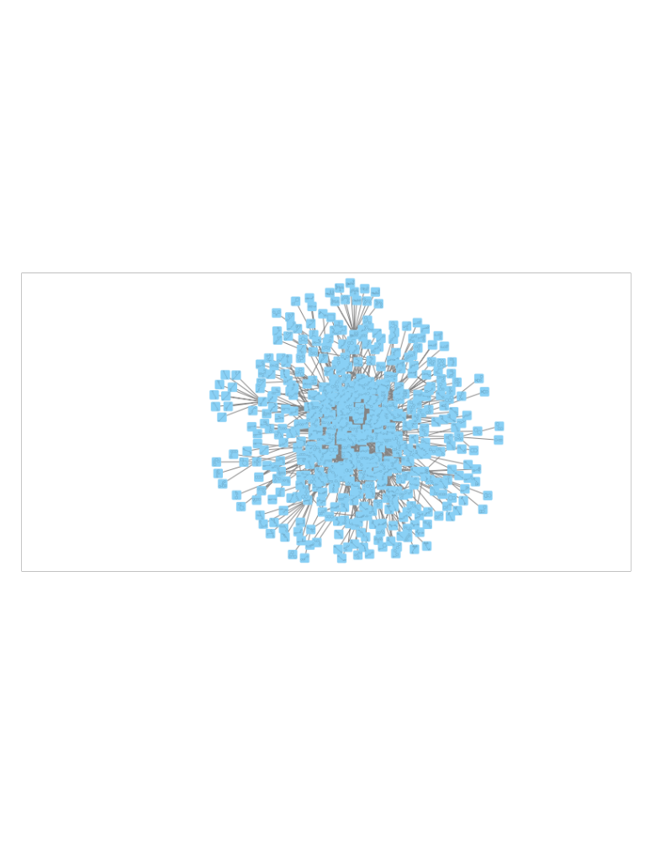

Figure S2. The two fragments (cyclohexane and cyclopentane, shown in the foreground), extracted from the basic wireframe representation, with the highest number of connections (indegree) in the Cytoscape network visualization reported in Figure S1
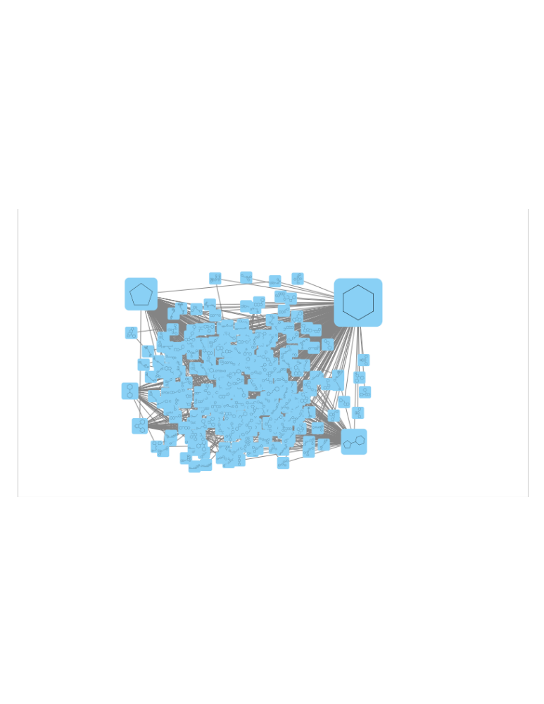

Figure S3: Selection of the most interesting basic wireframe, corresponding to the most abstracted representation in common within each cluster of the network, filtered by the highest values of EF and number of connected active molecules of the corresponding cluster.

