Supporting Information for
A noble-metal-free metal-organic framework for alkane borylation

Zhe Li,¹ Lingzhen Zeng,¹ Yonghua Cao,¹ Bing An,² Jingzheng Zhang,¹ Yige Zhang,¹ Han Li,¹ Wenbin Lin,^{3,}* and Cheng Wang^{1,}*
¹ State Key Laboratory of Physical Chemistry of Solid Surface, College of Chemistry and Chemical Engineering, iCHEM, Innovation Laboratory for Sciences and Technologies of Energy Materials of Fujian Province (IKKEM), Xiamen University, Xiamen 361005, China
² Department of Chemistry, University of Manchester, Manchester, M13 9PL, UK.
³ Department of Chemistry, The University of Chicago, Chicago, Illinois 60637, United States.

Table of Contents
1. Supplementary Methods 2
2. Supplementary Table 6
3. Supplementary Note 1 (Characterization of Zr-BTC-FA MOF, Zr-BTC-OH and Zr-BTC-H) 7
4. Supplementary Note 2 (Catalytic Data on Alkane Borylation Reaction) 12
5. Supplementary Note 3 (Regioselectivity Study of Long Chain Alkane Borylation) 14
6. Supplementary Note 4 (Catalytic Mechanism Study) 17
7. Supplementary Note 5 (Substrate Scope) 22
8. Supplementary Note 6 (NMR Spectrum) 25
9. Reference 36

Supplementary Methods

Chemicals
All of the reactions and manipulations were carried out under N₂ with the use of standard inert atmosphere and Schlenk technique unless otherwise indicated. The following solvents were dry and oxygen-free: N, N-dimethylformamide (DMF; 99.9%, Sinopharm), tetrahydrofuran (THF, 99.9%, Sinopharm), acetone (99.9%, Fisher), cyclohexane (CyH, 99.9%, Sinopharm), formic acid (FA, 99.8%, J&K). The following metals salts were used as received: ZrCl₄ (98%, Acros). The following gas were used as received: methane (CH₄, 99.9%, Xinhang Gas), ethane (C₂H₆, 99.9%, Dalian Kete Gas), propane (C₃H₈, 99.9%, Dalian Kete Gas), deuterium (D₂, 99.9%, Xinhang Gas). The following organic reagents were used as received: Trimesic acid (H₃BTC, 98%, J&K), pinacolborane (HBpin, 99%, TCI), Bis(pinacolato)diboron (B₂pin₂, 99%, Sigma-Aldrich), pentane (99%, J&K), undecane (99%, J&K), n-propylbenzene (99%, Energy-Chemical), n-hexylbenzene (99%, Energy-Chemical), mesitylene (99%, Energy-Chemical), methylcyclopentane (99%, J&K), methylcyclohexane (99%, TCI), 1,3-dimethyladamantane (99%, Sigma-Aldrich), anisole (99%, J&K), dibutyl ether (99%, Meryer), cyclopentyl methyl ether (99%, Meryer). Tetraneopentylzirconium (ZrNp₄) ¹ and ZrO₂ ² were synthesized as previously reported.

General Experiment
Powder X-ray diffraction (PXRD) data was carried out on a Japan Rigaku DMax-γA rotating anode X-ray diffractometer equipped with graphite monochromatized Cu Kα radiation (λ = 1.54 Å). As-synthesized MOF samples in powder form were used for PXRD analysis after washing with DMF and THF. Transmission electron microscopy (TEM) and high-resolution TEM (HRTEM) were carried out on a TECNAI Spirit at 120 kV and an F30 at 300 kV. Samples for TEM were prepared by drop-casting samples from diluted ethanol suspensions onto carbon coated copper grids. X-ray photoelectron spectroscopy (XPS) data were carried out with a Qtac-100 LEISS-XPS spectrometer with a hemispherical electron energy analyser and a home-made reaction chamber. Monochromatic Al Kα X-ray source (1486.6 eV, anode operating at 300 W) was used as the excitation source. The energy analysis error of the measurement was ±0.2 eV for both binding energy and Auger energy. Inductively coupled plasma-mass spectrometry (ICP-MS) data was obtained with an Agilent 7700x ICP-MS and analyzed using ICP-MS MassHunter version B01.03. Samples were diluted in a 2% HNO₃ matrix and analyzed with a ¹⁵⁹Tb internal standard against a 12-point standard curve over the range from 0.1 ppb to 500 ppb. The correlation was >0.9997 for all analyses of interest. Data collection was performed in Spectrum Mode with five replicates per sample and 100 sweeps per replicate. Brunauer-Emmett-Teller (BET) surface areas were calculated from N₂-physisorption experiments on a Micrometrics TriStar II 3020 instrument in liquid nitrogen between 10⁻⁶ and 0.99 relative N₂ pressure. Samples for N₂ sorption were dried beforehand at 100 °C under vacuum (< 10⁻² mmHg) for 12 hours. Thermogravimetric analysis (TGA) was performed in air using a Shimazu TGA-50 equipped with a platinum pan. Approximately 3.5 mg of analyte were charged to this pan and heated to 500 °C at a rate of 1 °C per min. Samples for TGA were dried beforehand at room temperature under vacuum (< 0.1 mbar) for 24 hours. ¹H NMR spectra were recorded on a Bruker NMR 500 DRX spectrometer at 500 MHz and referenced to the proton resonance resulting from incomplete deuteration of DMSO-d₆ (δ = 2.50) or CDCl₃ (δ = 7.26). The following abbreviations are used hereafter: s: singlet, d: doublet, t: triplet, q: quartet, m: multiplet. Gaseous samples were analyzed by gas chromatography (GC) using an SRI 8610C Gas Chromatogram equipped with thermal conductivity (TCD) and flame ionization (FID) detectors, with nitrogen and hydrogen as carrier gases, respectively. Approximately 200 uL of gaseous sample were injected for each measurement. GC-MS analysis was performed on a Shimadzu GCMS-QP2010 Ulta equipped with an SH-Rxi-5Sil MS 30 m × 0.5 mm × 0.25 µm column. Samples for GC-MS were prepared by filtering reaction solutions diluted into DCM through 220-nm hydrophobic filters.

X-Ray Absorption Spectroscopic Analysis

Data collection
X-ray absorption data were collected at Beamline 10-BM-A, B at the Advanced Photon Source (APS) at Argonne National Laboratory. Spectra were collected at the Zr K-edge (17998 eV) in the transmission mode. The X-ray beam was monochromatized by a Si(111) monochromater and detuned by 50% to reduce the contribution of higher-order harmonics below the level of noise. A metallic nickel foil standard was used as a reference for energy calibration and was measured simultaneously with experimental samples. The incident beam intensity (I₀), transmitted beam intensity (I_{t}), and reference (I_{r}) were measured by 20 cm ionization chambers with gas compositions of 10% N₂ and 90% Ar, 5% N₂ and 95% Ar, and 100% N₂, respectively. Data were collected over six regions: -250 to -30 eV (10 eV step size, dwell time of 0.25 s), -30 to -12 eV (5 eV step size, dwell time of 0.5 s), -12 to 30 eV (1.1 eV step size, dwell time of 1 s), 30 eV to 6 Å⁻¹, (0.05 Å⁻¹ step size, dwell time of 2 s), 6 Å⁻¹ to 12 Å⁻¹, (0.05 Å⁻¹ step size, dwell time of 2 s), 12 Å-1 to 15 Å⁻¹, (0.05 Å⁻¹ step size, dwell time of 4 s). Multiple X-ray absorption spectra were collected at room temperature for each sample. Samples were ground and mixed with polyethyleneglycol (PEG) and packed in a 6-shooter sample holder to achieve adequate absorption length.

Data processing
Data were processed using the Athena and Artemis programs of the IFEFFIT package based on FEFF 6.^{3,4} Prior to merging, spectra were calibrated against the reference spectra and aligned to the first peak in the smoothed first derivative of the absorption spectrum, background removed, and spectra processed to obtain a normalized unit edge step.

EXAFS fitting
Fitting of the EXAFS regions were performed using the Artemis program of the IFEFFIT package. Fittings were performed with a k-weight of 3 in R-space. Refinement was performed by optimizing an amplitude factor S₀² and energy shift ΔE_{0,} which are common to all paths, in addition to parameters for bond length (ΔR) and Debye-Waller factor (σ²).

Wavelet transform studies of Zr-BTC-OH and Zr-BTC-H
To further confirm the transformation from Zr-OH to Zr-H species, the continuous Cauchy wavelet transform (CCWT) is applied to the analysis of XAFS spectra by using Larch program⁵ to get the wavelet transformation results of real and imaginary components. The real components of the transformation are used for further analysis.

Catalyst preparation
Preparation of Zr-BTB-MOL-H
In a nitrogen-filled glovebox, Zr-BTC-MOL-OH (50 mg) was washed with dry THF three times and then dispersed in 4 mL of anhydrous THF. 0.49 mL of HBpin solution in THF (5 equiv. w.r.t. Zr) were added to the suspension. The mixture was stirred for 6 h at 150 ºC, and then the MOL was centrifuged and washed with THF three times before freeze-dried in benzene to yield Zr-BTB-MOL-H as a white powder.
Preparation of ZrO₂-H
In a nitrogen-filled glovebox, ZrO₂ (50 mg) was washed with dry THF three times and then dispersed in 4 mL of anhydrous THF. 2 mL of HBpin solution in THF were added to the suspension. The mixture was stirred for 6 h at 150 ºC, and then the ZrO₂ was centrifuged and washed with THF three times before freeze-dried in benzene to yield ZrO₂-H as a white powder.
Preparation of of Zr-H@SiO₂
The synthesis of Zr-H@SiO₂ was carried out by using the method reported in literature with a few modifications. ⁶ ZrNp₄ (2 mmol) in Et₂O (10 mL) was added into a vial containing 400 mesh silica gel (50mg). The mixture was stirred for 6 h at room temperature, and then the silica gel was centrifuged and washed with toluene three times before dried under vacuum to get the Zr-H@SiO₂ as a white powder. ICP-MS characterization results showed that the Zr loading on SiO₂ is 0.87 %.

Computational setup
Density Functional Theory (DFT) calculations were carried out using the Gaussian 09 Program.⁷ The structures of chemical species in solution-phase and gas-phase were fully optimized by using the B3LYP functional.⁸⁻¹⁰ The 6-31G(d) basis set was used for C, H, O, and the LanL2DZ (Lanl-2-double-zeta) was used for Zr. The solvation effect was accounted for using the implicit solvation model, i.e., SMD.¹¹ The model contains a solvent molecule in a cavity surrounded by a continuous polarizable dielectric medium, which responds to the distributed solute charges according to its dielectric constant. The solvent was set as cyclohexane. The structures were optimized using the method described above. For the calculation of solvation free energies, both electrostatic and nonelectrostatic (dispersion, cavitation) energy contributions were considered. No explicit solvent molecule was included in the catalyst models. The corresponding single point energy calculation was based on def2TZVP basis set for accuracy. The catalyst structure was modeled using the Zr₆-SBU with Zn loaded on μ₃-OH. Zr₆ cluster structure was modeled using the Zr₆ species from single crystal structure of MOF-808 and was optimized before use. The transition states (TSs) of methane borylation process were found by using the TS method and further confirmed by the intrinsic reaction coordinate (IRC) method. All of the TSs were validated by imaginary vibrational frequencies along the reaction coordinates and their reasonable geometries bridging the reactants and products.

Supplementary Table
Supplementary Table 1. Comparation of different types of MOF-Based catalysts for C-H borylation.
Catalysts | MOF Type | Loaded Metal | Active Center | Substrate Type | C-H Type | Activity (TON) | Ref.
Zr-BTC-H | MOF-808  (Zr based) | None | Zr-H | Unactive alkane  (Including CH₄) | Primary  sp³ C-H | CH₄: 4990  Pentane: 174 | This work
UiO-67-Mix-Ir | UiO-67  (Zr based) | Ir | Ir(III) | CH₄ | sp³ C-H | CH₄: 67 | ¹²
P1-Ir | P1-MOF  (Zr based) | Ir | Ir(III) | CH₄ | sp³ C-H | CH₄: 127 | ¹³
BPV-MOF-Ir | BPV-MOF  (Zr based) | Ir | Ir(III) | Arene | sp² C-H on arene | Benzene: 1000 | ¹⁴
UiO-CoH | UiO-68  (Zr based) | Co | Co-H | Arene | sp³ C-H on benzylic | Mesitylene: 500 | ¹⁵
Pyrim-​MOF-​Co | Pyrim-​MOF  (Zr based) | Co | Co-H | Arene | C-H on arene (sp²) / benzylic (sp³) | Benzene: 142  Mesitylene: 164 | ¹⁶
Cu₃(BTC)₂ | Cu-BTC-MOF  (Cu Based) | None | Cu | Arene | sp³ C-H on benzylic | Toluene: 3.5 | ¹⁷

In the previous MOF-based catalysts, although the composition of the supporting MOFs are earth abundant metal, such as Zr and Cu, but they still need the presence of Ir to realize the borylation of unactive alkanes. The noble metal free MOF catalysts can only catalyze the borylation of relative active C-H bonds, such as sp² C-H bond on arene and sp³ C-H bond on benzylic. In this work, as an noble metal free catalyst, our Zr-BTC-H catalyst can active the inert C-H bond in alkane through σ-bond metalizes pathway, thus catalyze the borylation process of primary sp³ C-H bond in unactive alkane, including methane. Such catalytic pathway is novel and has its unique advantages.

Supplementary Note 1
Characterization of Zr-BTC-FA MOF, Zr-BTC-OH and Zr-BTC-H
Supplementary Figure 1. Characterization of Zr-BTC-MOF. a) Nitrogen sorption isotherm of Zr-BTC-FA at 77 K. b) BET Pore size distributions of Zr-BTC-FA with a non-local density functional theory (NLDFT). c) Corey-Pauling-Koltun (CPK) model showing the pore size in Zr-BTC-MOF around 1.8 nm d) Corey-Pauling-Koltun (CPK) model of two substrates: 1,3-dimethyladamantane and undecane. The model clearly showed the pore size of Zr-BTC-MOF is enough for the diffusion and reaction of substrates.

Supplementary Figure 2. EXAFS Fitting results. a) Structure of the Zr local coordination environment in Zr-BTC-OH. b) Structure of the Zr local coordination environment in Zr-BTC-H. c) EXAFS fitting of Zr-BTC-OH. d) EXAFS fitting of Zr-BTC-H.

Supplementary Table 2. Summary of EXAFS fitting parameters for Zr-BTC-OH.
Sample | Zr-BTC-OH
Fitting range | k 2.4 – 12.9 Å⁻¹  R 1.1 – 5.0 Å
Independent points | 25
Variables | 15
R-factor | 0.007
S₀² | 0.873
ΔE₀(eV) | -2.01±1.44
R (Zr-O₁) (Å) | 1.975±0.020
σ² (Zr-O₁) (Å²) | 0.005±0.003
R (Zr-O₂) (Å) | 2.097±0.036
σ² (Zr-O₂) (Å²) | 0.002±0.002
R (Zr-O₃) (Å) | 2.218±0.021
σ² (Zr-O₃) (Å²) | 0.0003±0.003
R (Zr-O₄) (Å) | 2.076±0.021
σ² (Zr-O₄) (Å²) | 0.0003±0.003
R (Zr-O₅) (Å) | 2.333±0.021
σ² (Zr-O₅) (Å²) | 0.0003±0.003
R (Zr-H₁) (Å) | 2.790±0.044
σ² (Zr-H₁) (Å²) | 0.005±0.004
R (Zr-H₂) (Å) | 2.874±0.044
σ² (Zr-H₂) (Å²) | 0.005±0.004
R (Zr-C₁) (Å) | 3.219±0.044
σ² (Zr-C₁) (Å²) | 0.013±0.011
R (Zr-C₂) (Å) | 3.287±0.044
σ² (Zr-C₂) (Å²) | 0.013±0.011
R (Zr-Zr₁) (Å) | 3.556±0.049
σ² (Zr-Zr₁) (Å²) | 0.008±0.002
R (Zr-O₆) (Å) | 3.578±0.052
σ² (Zr-O₆) (Å²) | 0.006±0.009
R (Zr-Zr₂) (Å) | 3.607±0.049
σ² (Zr-Zr₂) (Å²) | 0.008±0.002
R (Zr-O₇) (Å) | 3.651±0.052
σ² (Zr-O₇) (Å²) | 0.006±0.009
R (Zr-O₈) (Å) | 3.904±0.052
σ² (Zr-O₈) (Å²) | 0.006±0.009

Supplementary Table 3. Summary of EXAFS fitting parameters for Zr-BTC-H.
Sample | Zr-BTC-H
Fitting range | k 2.4 – 13.4 Å⁻¹  R 1.1 – 4.4 Å
Independent points | 23
Variables | 15
R-factor | 0.005
S₀² | 0.873
ΔE₀(eV) | -4.98±1.43
R (Zr-H₁) (Å) | 1.889±0.023
σ² (Zr-H₁) (Å²) | 0.002±0.009
R (Zr-O₁) (Å) | 2.097±0.045
σ² (Zr-O₁) (Å²) | 0.001±0.002
R (Zr-O₂) (Å) | 2.218±0.085
σ² (Zr-O₂) (Å²) | 0.002±0.001
R (Zr-O₃) (Å) | 2.277±0.085
σ² (Zr-O₃) (Å²) | 0.002±0.001
R (Zr-O₄) (Å) | 2.332±0.046
σ² (Zr-O₄) (Å²) | 0.004±0.003
R (Zr-H₂) (Å) | 2.874±0.023
σ² (Zr-H₂) (Å²) | 0.002±0.009
R (Zr-C₁) (Å) | 3.218±0.049
σ² (Zr-C₁) (Å²) | 0.005±0.006
R (Zr-C₂) (Å) | 3.287±0.049
σ² (Zr-C₂) (Å²) | 0.005±0.006
R (Zr-Zr₁) (Å) | 3.556±0.063
σ² (Zr-Zr₁) (Å²) | 0.006±0.002
R (Zr-O₅) (Å) | 3.578±0.015
σ² (Zr-O₅) (Å²) | 0.0003±0.005
R (Zr-Zr₂) (Å) | 3.607±0.063
σ² (Zr-Zr₂) (Å²) | 0.006±0.002
R (Zr-O₆) (Å) | 3.651±0.015
σ² (Zr-O₆) (Å²) | 0.0003±0.005
R (Zr-O₇) (Å) | 3.904±0.015
σ² (Zr-O₇) (Å²) | 0.0003±0.005

Quantification of Hydrides
In a 10 mL vial, to Zr-BTC-H (10 mg) in 4 mL of THF was added 1 mL of HCl (1M). After reacting at room temperature for 15 mins, the head space was analyzed with GC to quantify the amount of H₂. Consistent results were obtained in three runs. The amount of H₂ was calculated to be three Zr-H species per SBU.

Supplementary Figure 3. GC trace for H₂ quantification by treating Zr-BTC-H with HCl. The peaks from left to right are H₂, O₂ and N₂, respectively.

Supplementary Note 2
Catalytic Data of Alkane Borylation Reaction

Supplementary Figure 4. Recycle experiments for the Zr-BTC-H catalyzed methane borylation reaction.
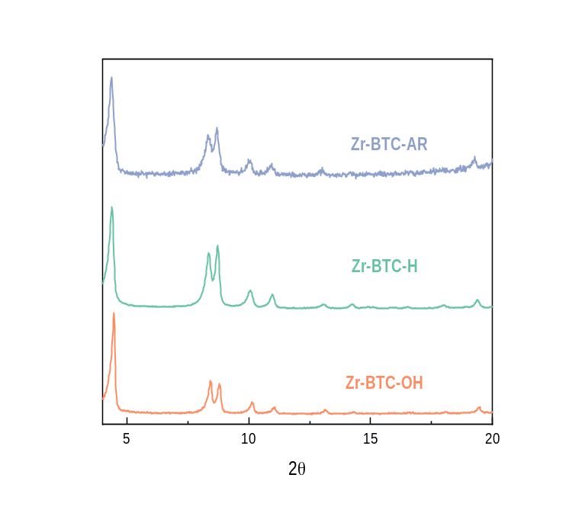
Supplementary Figure 5. PXRD pattern of the Zr-BTC-H catalyst after methane borylation reaction.

Supplementary Note 3
Regioselectivity of Long-Chain Alkane Borylation
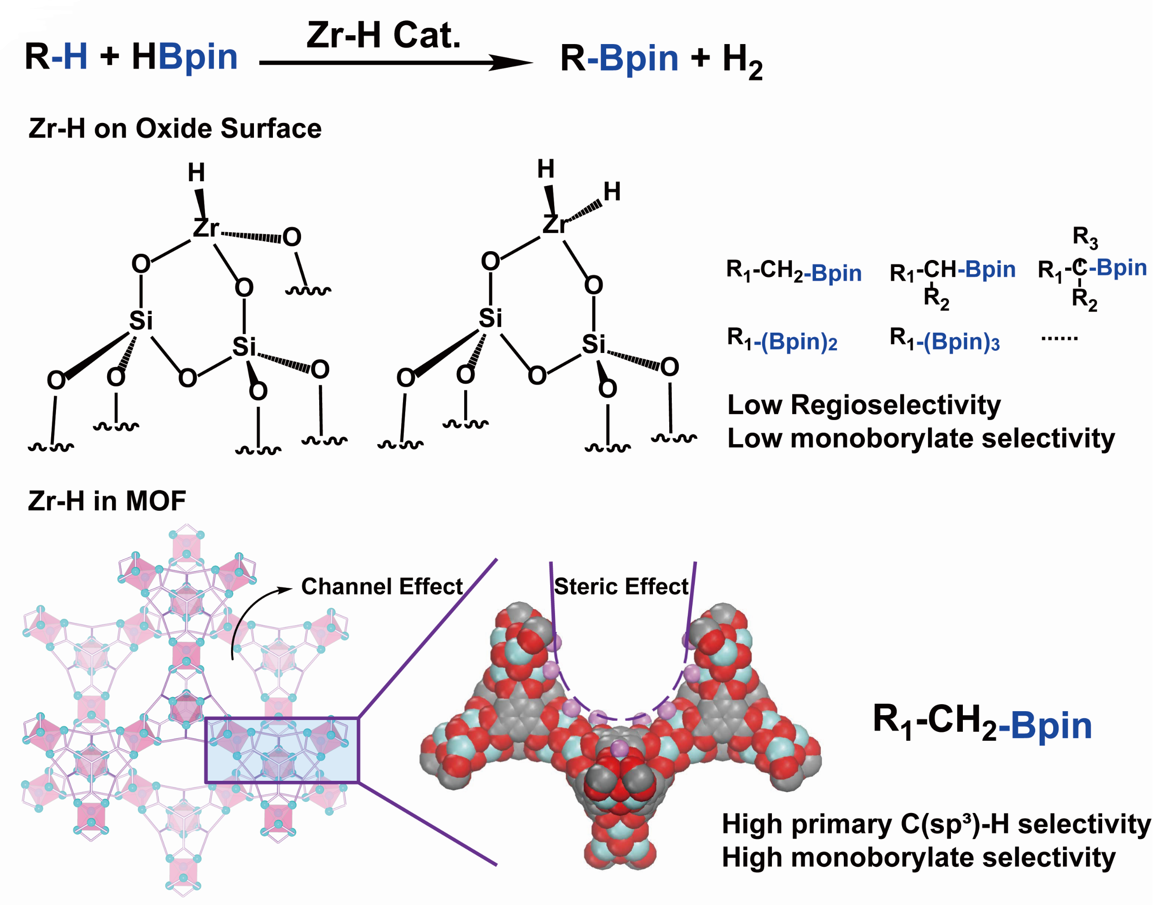
Supplementary Figure 6. Comparison between the catalytic performance of Zr-H species on the oxide surfaces and in the MOF cavity.

Possible origin of regioselectivity
To further probe the origin of the regioselectivity for different C(sp³)-H bonds, the transition states of 1º and 2º C(sp³)-H bond activation on Zr-BTC-H center were studied. From the Corey-Pauling-Koltun (CPK) model of transition states, the terminal C(sp³)-H bond has much lower steric hindrance as compared to the 2º C(sp³)-H bond, which allow the selective activation of primary C(sp³)-H bond to achieve high regioselectivity. Although the model only shows the pentane as substrate, this conclusion is also applicable to other substrates with greater steric.
Supplementary Figure 7. Schematic Figure a) and Corey-Pauling-Koltun (CPK) model (1.0) b) of the intermediate for primary C(sp³)-H bond of pentane active on Zr-H center; Schematic Figure c) and Corey-Pauling-Koltun (CPK) model (1.0) d) of the intermediate for secondary C(sp³)-H bond of pentane active on Zr-H center. Such comparison clearly shows the steric effect resulted regioselectivity.

Catalytic performance of Zr-H on different support.
Supplementary Figure 8. Comparison of the regioselectivity of n-pentane borylation catalyzed by Zr-H species on different supports.

Supplementary Note 4
Mechanistic Study of the Catalytic Cycle
H/D exchange experiment for methane on Zr-H center
20 mg of Zr-BTC-H catalyst and 10 mL of cyclohexane were charged into a high-pressure autoclave in glove box. 10 bar CH₄ and 10 bar D₂ were charged into the reactor. The temperature was increased with a rate of 5 ºC/min to 90 ºC and kept for 12 h. After cooling down to room temperature, the gas phase was collected and analyze with MS and GC-MS.
Supplementary Figure 9. a) The possible chemical change on the catalyst in the H/D exchange experiment; b) GC-MS traces of the mixture of CH₄/D₂ with Zr-BTC-H at 90 ºC for 12h. c) M/Z of the CH₄ peak in the GC-MS trace. The M/Z number of 16, 17, 18 and 20 corresponds to CH₄, CH₃D, CH₂D₂, and CD₄, respectively.
CH₃Bpin quantification experiment
We independently synthesized Zr-BTC-CH₃ intermediate and studied its reaction HBpin.
1. Synthesis of Zr-BTC-CH₃
The synthesis of Zr-BTC-CH₃ was carried out by using the method reported in literature with a few modifications. ¹⁸ In the glove box, the Zr-BTC-OH (50 mg) sample was washed three times with anhydrous THF. The washed sample was then dispersed in anhydrous 4 mL of THF and then added 0.3 mL of trimethylchlorosilane (TMSCl). The mixture was reacted at 80°C for 6 hours to obtain a white solid powder. The product was washed three times with cyclohexane and dispersed again in 10 mL of cyclohexane. While stirring, 2.4 mL of LiCH₃ in n-hexane solution (1M) was added dropwise. The reaction was carried out in the glove box for 1 hour. The methyl group in LiCH₃ will transfer to Zr, cleaving the Zr-Cl bond to form Zr-CH₃.
2. Zr-BTC-CH₃ reacting with HBpin
Different amounts of Zr-BTC-CH₃ (100mg, 200mg and 300mg), excess amount of HBpin (2mL), and cyclohexane as solvent (10 mL) were charged into a high-pressure autoclave in glove box. After carefully sealed, the temperature was increased with a rate of 5 ºC/min to 250 ºC and kept for 12 h. After cooling down to room temperature, the liquid phase was collected and analyze with GC-MS to detect the CH₃Bpin. Results showed that the amounts of Zr-BTC-CH₃ and CH₃Bpin have good linear relationship, indicating that the Zr-CH₃ can react with HBpin to form CH₃Bpin.
Supplementary Figure 10. Quantitative reaction between Zr-BTC-CH₃ and HBpin. a) Preparation of Zr-BTC-CH₃ via Zr-BTC-Cl intermediate; b) Quantitative reaction between Zr-BTC-CH₃ and HBpin to form Zr-BTC-H and CH₃Bpin; c) Relationship between the amounts of Zr-BTC-CH₃ used and the CH₃Bpin generated. The amount of Zr-CH₃ was quantified by using HCl treatment / CH₄ quantification method and the amount of CH₃-Bpin was quantified by GC-MS.

In-situ Raman Spectroscopy
To further confirm the existence of Zr-H species, in-situ Raman was performed. Isotope H-D exchange experiment was used to assign an observed peak to Zr-H stretching vibration, and CH₄ treatment experiment were carried out to probe the reactivity of the Zr-H and formation of Zr-CH₃.

- H-D exchange experiment:
Before the Raman measurement, the Zr-BTC-H sample were heated at 200 ºC for 20 mins under flowing He (50 mL min⁻¹). After the system cooled to room temperature, the first spectrum of Zr-BTC-H was collected. To test the H-D exchange process, under a flow of D₂ (50 mL min⁻¹), the temperature was gradually raised to 200 ºC with a rate of 5 ºC / min and then kept at 200 ºC for 1 h. The system was purged with He for 20 mins to remove unabsorbed D₂. Finally, the samples were cooled to room temperature under the flowing He and subjected to Raman measurements to get the spectrum of Zr-BTC-D. Resulted spectra were shown in Figure S11.

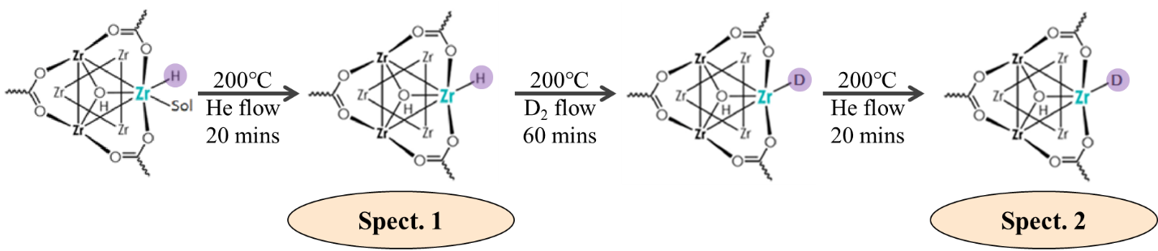
Supplementary Scheme 1. The process of H-D exchange during the in-situ Raman measurement.

The Zr-BTC-H sample showed a small peak at 1072 cm⁻¹, which can be attributed to the stretching vibration of the Zr-H species. This peak disappeared after D₂ treatment at 200 ºC, corresponding to the Zr-H + D₂ = Zr-D + HD process. Compared to Zr-H stretching, the Zr-D vibration should shift to lower wavenumber (~766 cm⁻¹). However, due to weak peak intensity and low signal-to-noise ratio, the Zr-D vibration peak after the exchange was not observed.

- CH₄ treatment experiment:
Before the Raman measurement, the Zr-BTC-H sample were heated at 200 ºC for 20 mins under flowing He (50 mL min⁻¹). After the system cooled to room temperature, the first spectrum of Zr-BTC-H was collected. Then the flow of CH₄ (50 mL min⁻¹) was purge onto the catalyst. The temperature gradually raised to 200 ºC with a rate of 5 ºC / min and then kept at 200 ºC for 1 h. After that, He was used to purge the chamber for 20 mins to remove unabsorbed CH₄. Finally, the samples were cooled to room temperature under flowing He and subjected to Raman measurements as shown in Figure S7B.

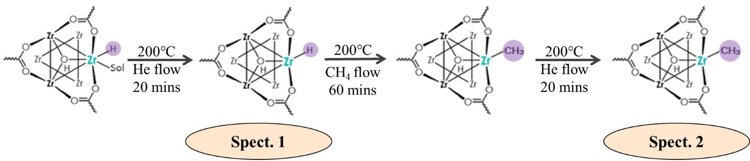
Supplementary Scheme 2. The process of CH₄ activation during the in-situ Raman measurement.

The peak for Zr-H stretching at 1072 cm⁻¹ disappeared after CH₄ treatment under 200 ºC with appearance of a new peak at 2945 cm⁻¹ that can be attributed to the C-H stretching vibration inn Zr-CH₃ species. This suggests the reaction of Zr-H + CH₄ = Zr-CH₃ + H₂. Such a result can be another piece of evidence to support that the Zr-H species can efficiently activate alkane through their strong hydricities.
Supplementary Figure 11. In situ Raman characterization a) Raman spectrum of the Zr-BTC-H sample before and after H-D exchange; b) Raman spectrum of the Zr-BTC-H sample before and after CH₄ treatment at 200 ºC.

Supplementary Note 5
Substrate Scope
(4) 4,4,5,5-tetramethyl-2-pentyl-1,3,2-dioxaborolane
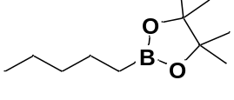
4,4,5,5-tetramethyl-2-pentyl-1,3,2-dioxaborolane was prepared in 87% yield according to the general procedure using Zr-BTC-H (2.5 µmol, 0.5 % loading), HBpin (0.5 mmol) in pentane (5.0 mL). ¹H NMR (500 MHz, CDCl₃) δ = 1.34 (p, J=7.5, 2H), 1.29-1.18 (m, 4H), 1.17 (s, 12H), 0.80 (t, J=6.9, 3H), 0.69 (t, J=7.9, 2H). ¹³C NMR (126 MHz, CDCl₃) δ = 82.82, 34.70, 24.80, 23.68, 22.43, 14.05. The ¹H and ¹³C NMR data are similar to the reported data.¹⁹
(5) 4,4,5,5-tetramethyl-2-undecyl-1,3,2-dioxaborolane
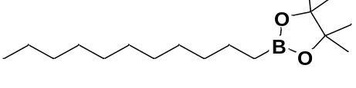
4,4,5,5-tetramethyl-2-undecyl-1,3,2-dioxaborolane was prepared in 82% yield according to the general procedure using Zr-BTC-H (5.0 µmol, 1 % loading), HBpin (0.5 mmol) in undecane (5.0 mL). ¹H NMR (500 MHz, CDCl₃) δ = 1.44-1.37 (m, 2H), 1.24 (m, 28H), 0.88 (t, J=6.4Hz, 3H), 0.77 (t, J=7.6 Hz, 2H); ¹³C NMR (100.6 MHz, CDCl₃): δ = 82.78, 32.27, 31.81, 29.68, 29.62, 29.51, 29.29, 29.23, 24.72, 23.98, 22.72, 14.09. The ¹H and ¹³C NMR data are similar to the reported data.²⁰
(6) 4,4,5,5-tetramethyl-2-(3-phenylpropyl)-1,3,2-dioxaborolane
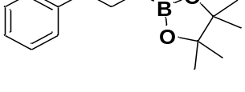
4,4,5,5-tetramethyl-2-(3-phenylpropyl)-1,3,2-dioxaborolane was prepared in 81% yield according to the general procedure using Zr-BTC-H (2.5 µmol, 0.5 % loading), HBpin (0.5 mmol) in propylbenzene (5.0 mL). ¹H NMR (500 MHz, CDCl₃) δ = 0.95 (t, J=7.9 Hz, 2H), 1.36 (s, 12H), 1.36 (s, 12H), 1.85-1.75 (m, 2H), 2.73 (t, J=7.5 Hz, 2H), 7.32-7.24 (m, 3H), 7.41-7.34 (m, 2H). ¹³C NMR (75.5 MHz, CDCl3): δ 142.72, 128.57, 128.18, 125.58, 82.94, 38.62, 26.13, 24.86. The ¹H and ¹³C NMR data are similar to the reported data.²¹
(7) 2-(3,5-dimethylbenzyl)-4,4,5,5-tetramethyl-1,3,2-dioxaborolane
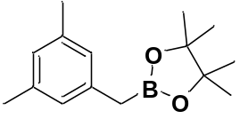
2-(3,5-dimethylbenzyl)-4,4,5,5-tetramethyl-1,3,2-dioxaborolane was prepared in 86% yield according to the general procedure using Zr-BTC-H (2.5 µmol, 0.5 % loading), mesitylene (0.5 mmol), HBpin (0.75 mmol) in cyclohexane (5.0 mL). ¹H NMR (500 MHz, CDCl₃) δ = 1.24 (s, 12 H), 2.23-2.20 (m, 2H), 6.77 (s, 1 H), 6.81 (s, 2 H). ¹³C NMR (75.5 MHz, CDCl₃): δ = 137.94, 137.12, 126.48, 126.20, 82.91, 24.39, 24.25, 21.01. The ¹H and ¹³C NMR data are similar to the reported data.¹⁵
(8) 2-(cyclopentylmethyl)-4,4,5,5-tetramethyl-1,3,2-dioxaborolane
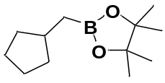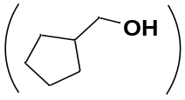
(Oxidized to corresponding alcohol)
2-(cyclopentylmethyl)-4,4,5,5-tetramethyl-1,3,2-dioxaborolane was prepared in 91% yield according to the general procedure using Zr-BTC-H (2.5 µmol, 0.5 % loading), methylcyclopentane (0.5 mmol), HBpin (0.75 mmol) in cyclohexane (5.0 mL). The resulted product was further oxidized to corresponding alcohol under H₂O₂/NaOH for quantification (as previous lecture²²). ¹H NMR (500 MHz, CDCl₃) δ = 1.35-1.15 (m, 2H), 1.67-1.48 (m, 5H), 1.84-1.67 (m, 2H), 2.21-2.00 (m, 1H), 3.51 (d, J=7.0, 2H). ¹³C NMR (75.5 MHz, CDCl₃): δ = 67.40, 42.15, 29.07, 25.44. The ¹H and ¹³C NMR data are similar to the reported data.²³
(9) 2-(cyclohexylmethyl)-4,4,5,5-tetramethyl-1,3,2-dioxaborolane
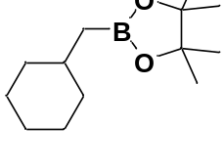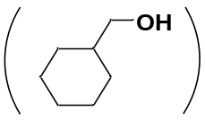
(Oxidized to corresponding alcohol)
2-(cyclohexylmethyl)-4,4,5,5-tetramethyl-1,3,2-dioxaborolane was prepared in 90% yield according to the general procedure using Zr-BTC-H (2.5 µmol, 0.5 % loading), methylcyclohexane (0.5 mmol), HBpin (0.75 mmol) in cyclohexane (5.0 mL). The resulted product was further oxidized to corresponding alcohol under H₂O₂/NaOH for quantification. ¹H NMR (500 MHz, CDCl₃) δ = 0.93 (m, 2H), 1.32-1.10 (m, 3H), 1.55-1.41 (m, 1H), 1.78-1.65 (m, 5H), 1.79 (s, 1H), 3.43 (d, J=6.4, 2H). ¹³C NMR (75.5 MHz, CDCl₃): δ = 68.67, 40.47, 29.57, 26.59, 25.84. The ¹H and ¹³C NMR data are similar to the reported data.²⁴
(10) 4,4,5,5-tetramethyl-2-(phenoxymethyl)-1,3,2-dioxaborolane
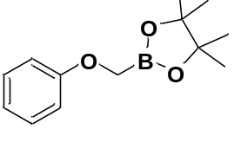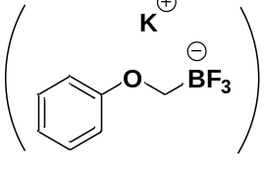
(Converted to corresponding trifluoroborate)
4,4,5,5-tetramethyl-2-(phenoxymethyl)-1,3,2-dioxaborolane was prepared in 77% yield according to the general procedure using Zr-BTC-H (2.5 µmol, 0.5 % loading), anisole (0.5 mmol), HBpin (0.75 mmol) in cyclohexane (5.0 mL). The resulted product was further converted to corresponding trifluoroborate under aqueous KHF₂ for quantification (as previous lecture²⁵). ¹H NMR (500 MHz, CDCl₃) δ = 3.17 (d, J=5.3, 2H), 6.83-6.76 (m, 1H), 6.97-6.91 (m, 2H), 7.23-7.15 (m, 2H). ¹³C NMR (75.5 MHz, CDCl₃): δ = 162.21, 128.83, 118.96, 114.16, 28.93. The ¹H and ¹³C NMR data are similar to the reported data.²⁶
(11) 2-(4-butoxybutyl)-4,4,5,5-tetramethyl-1,3,2-dioxaborolane
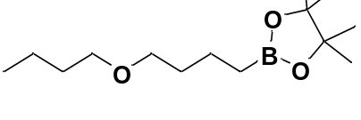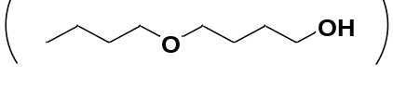
(Oxidized to corresponding alcohol)
2-(4-butoxybutyl)-4,4,5,5-tetramethyl-1,3,2-dioxaborolane was prepared in 86% yield according to the general procedure using Zr-BTC-H (5.0 µmol, 1 % loading), 1-butoxybutane (0.5 mmol), HBpin (0.75 mmol) in cyclohexane (5.0 mL). The resulted product was further oxidized to corresponding alcohol under H₂O₂/NaOH for quantification. ¹H NMR (500 MHz, CDCl₃) δ = 0.90 (t, J=7.4, 1.8, 3H), 1.42-1.29 (m, 2H), 1.72-1.48 (m, 6H), 2.62 (s, 1H), 3.47-3.34 (m, 4H), 3.62 (t, J=5.6, 2H). ¹³C NMR (75.5 MHz, CDCl₃): δ = 70.87, 70.61, 62.69, 31.70, 30.55, 26.90, 19.32, 13.87. The ¹H and ¹³C NMR data are similar to the reported data.²⁷

Supplementary Note 6 (NMR Spectrum)
¹H NMR spectrum (500 MHz, CDCl₃) of 4
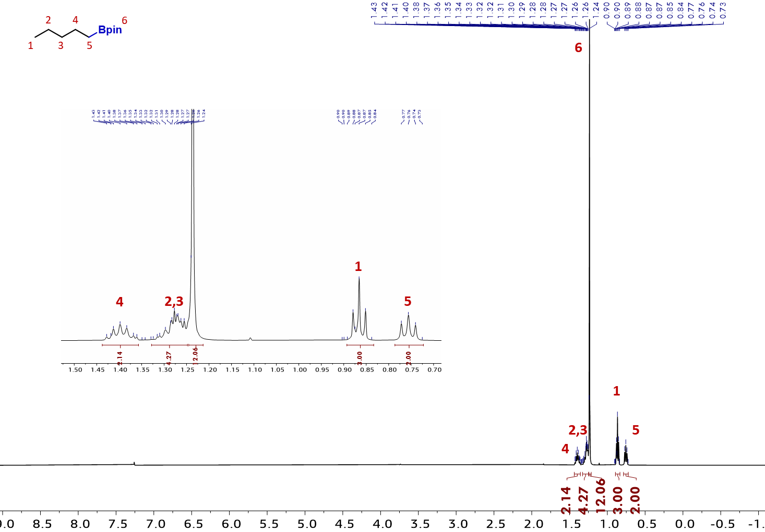
¹³C NMR spectrum (126 MHz, CDCl₃) of 4
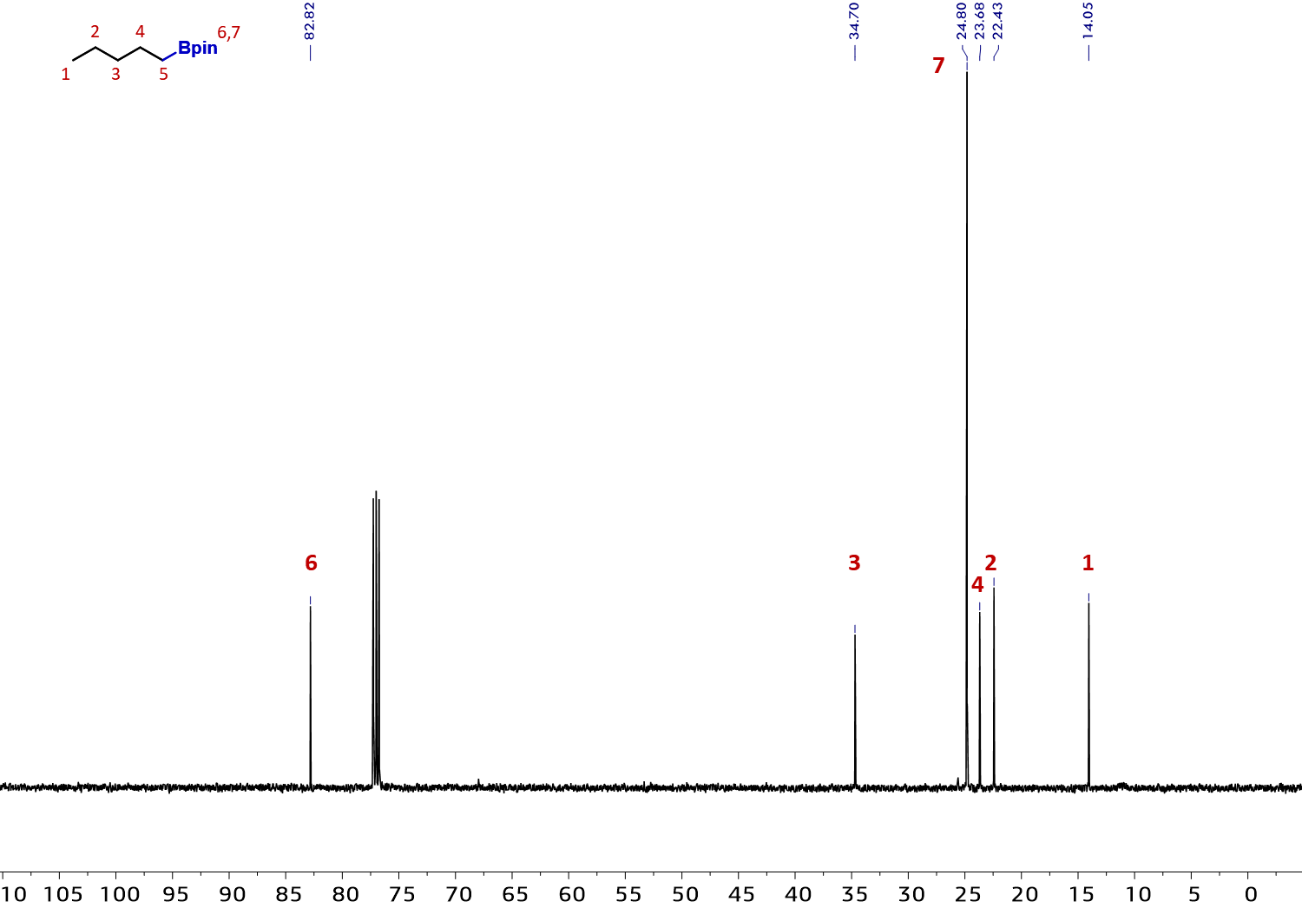

¹¹B NMR spectrum (160 MHz, CDCl₃) of 4
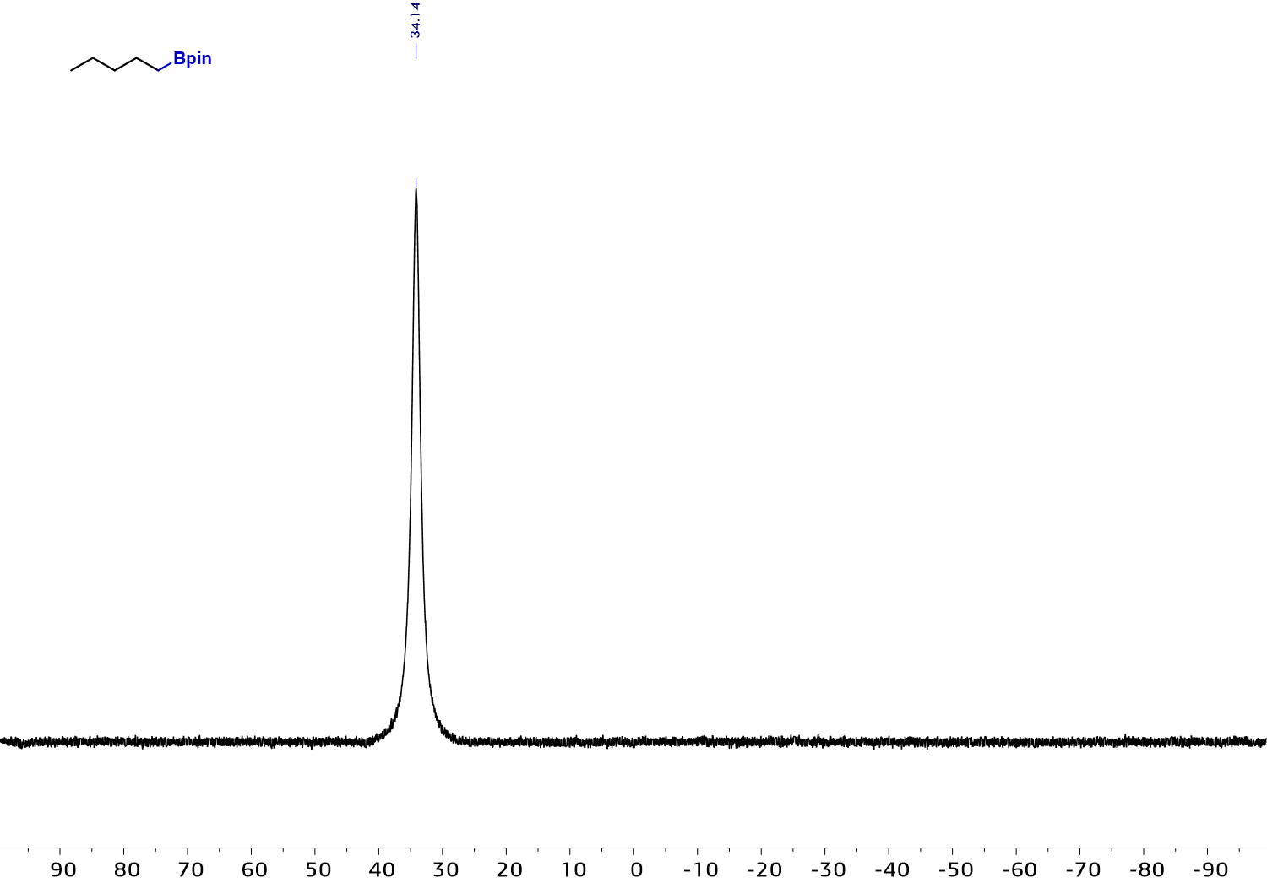
¹H NMR spectrum (500 MHz, CDCl₃) of 5
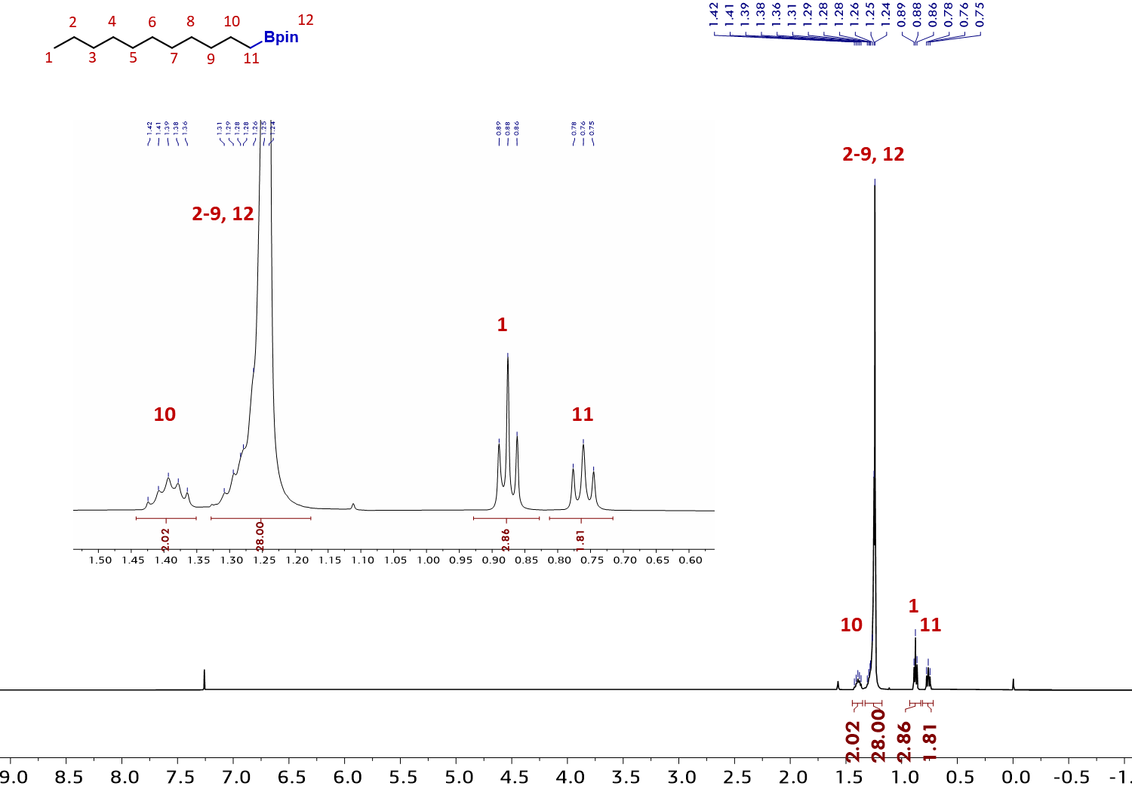

¹³C NMR spectrum (126 MHz, CDCl₃) of 5
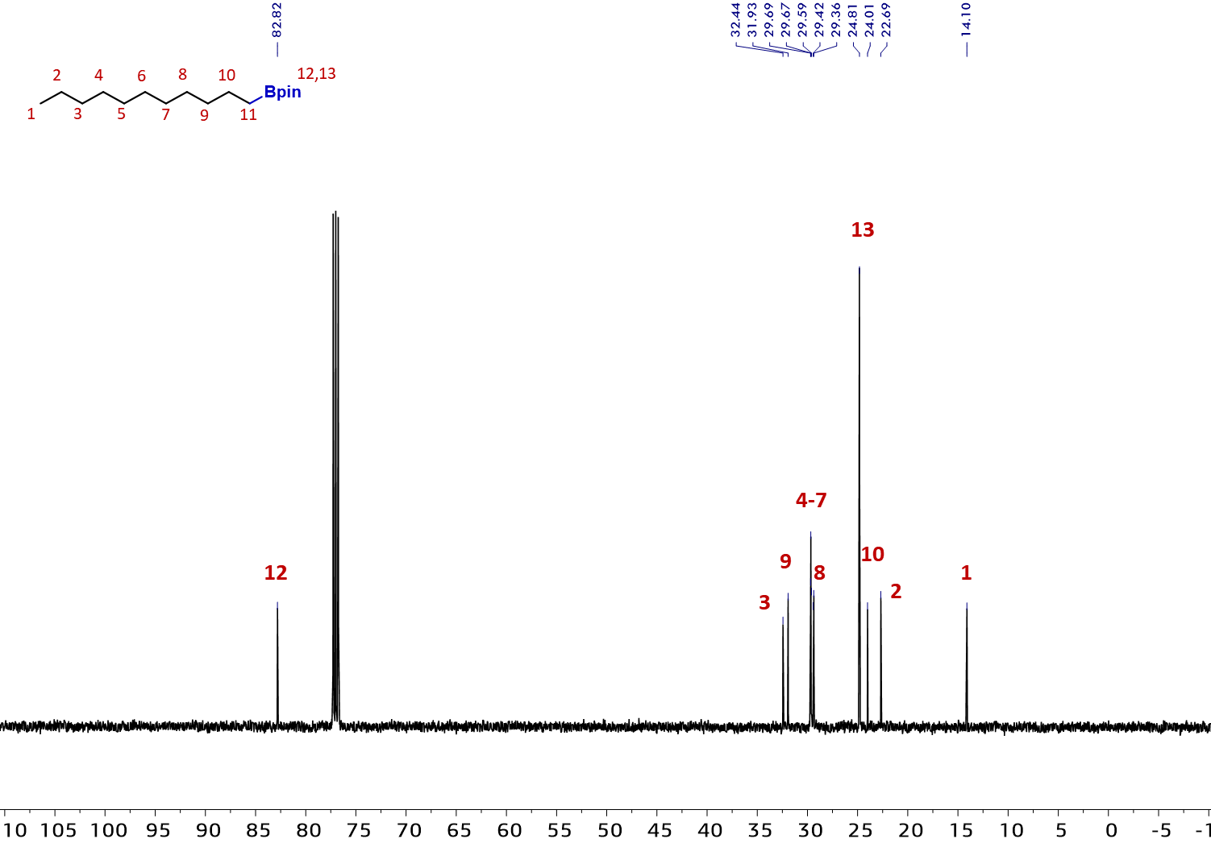
¹¹B NMR spectrum (160 MHz, CDCl₃) of 5
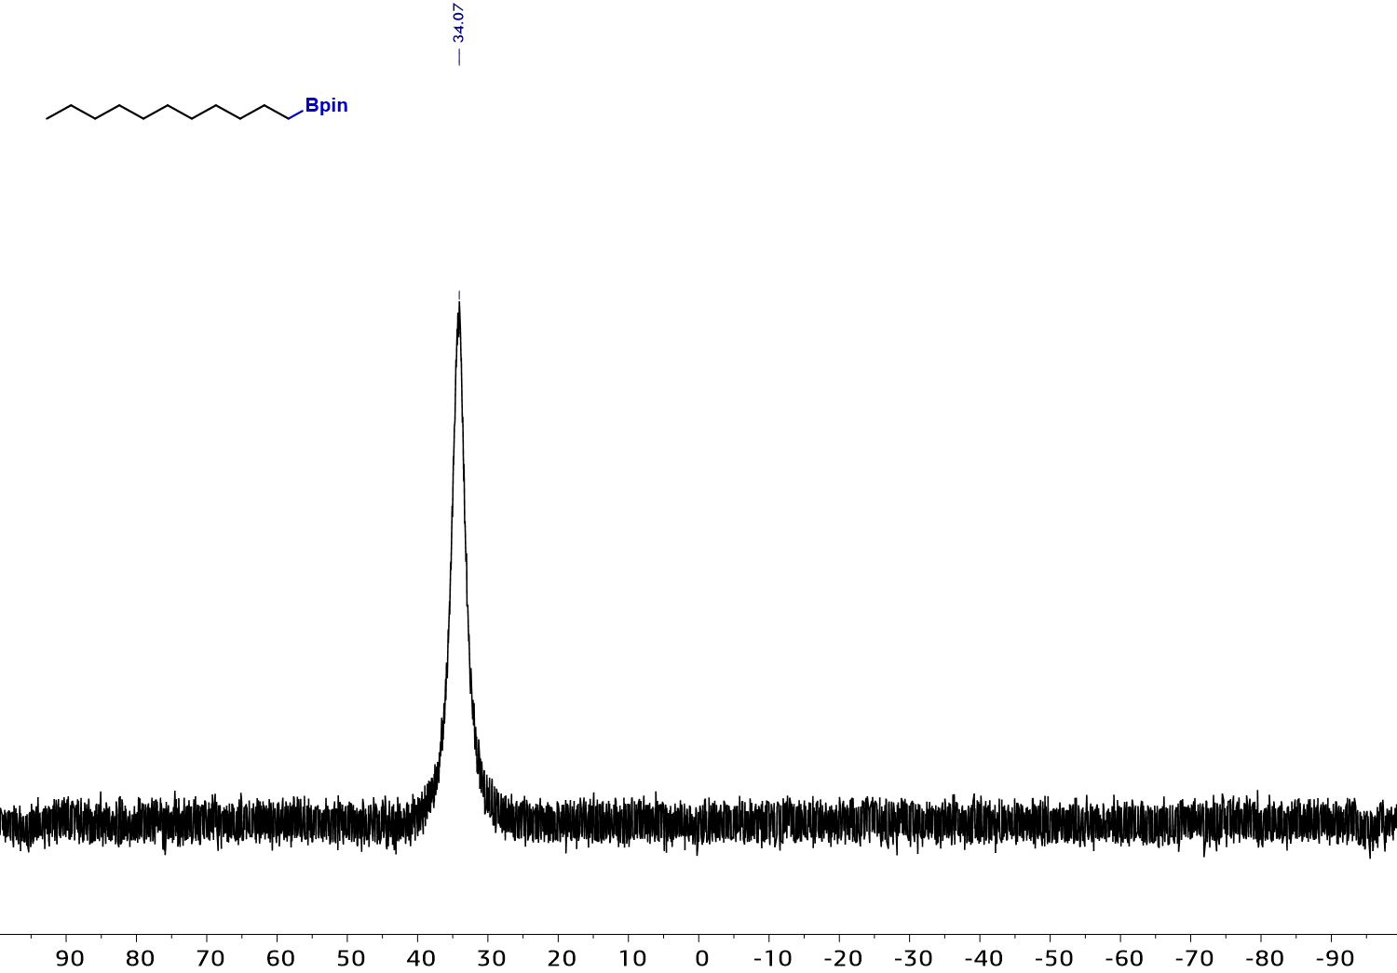

¹H NMR spectrum (500 MHz, CDCl₃) of 6
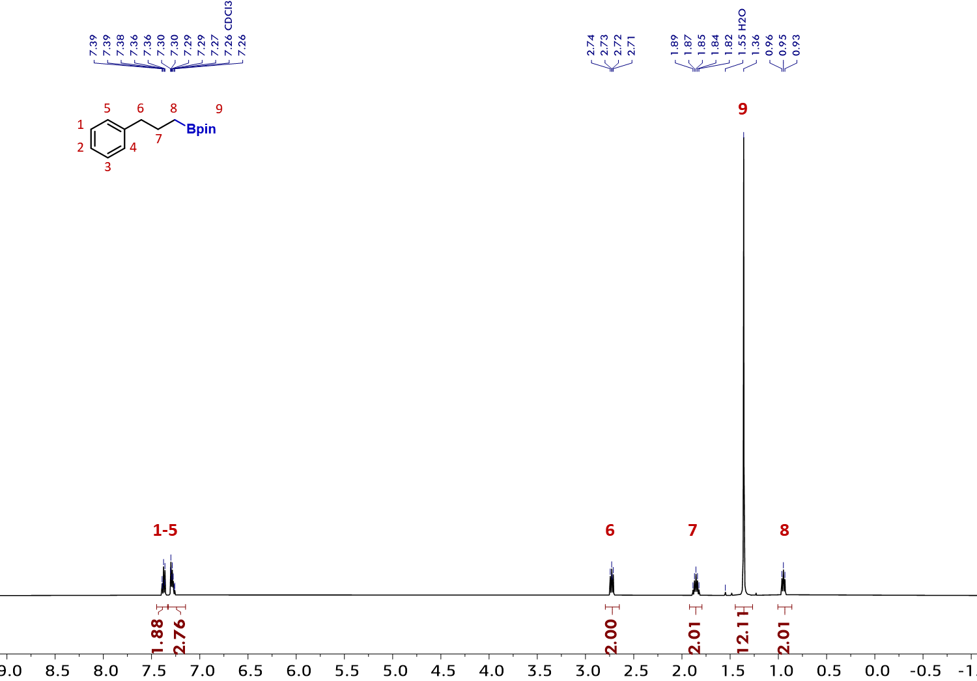

¹³C NMR spectrum (126 MHz, CDCl₃) of 6
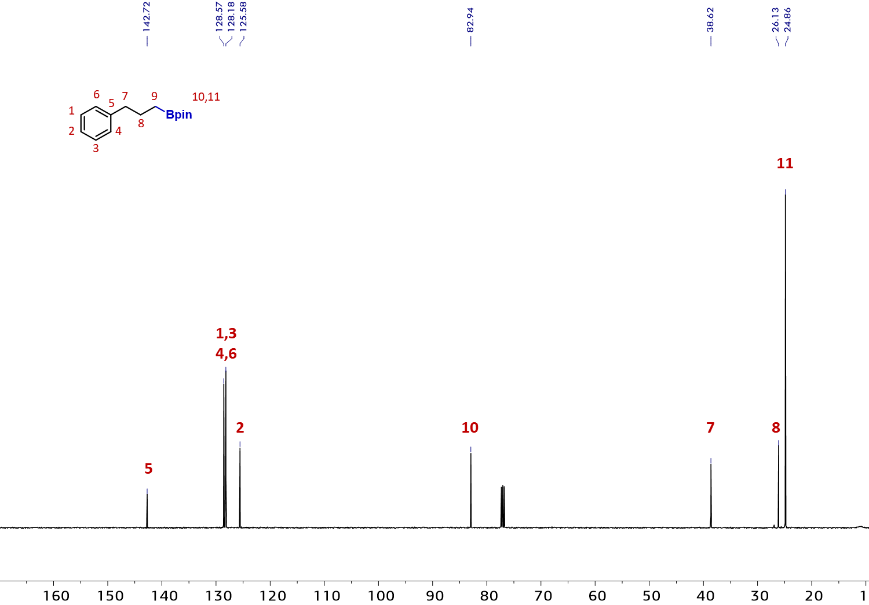

¹¹B NMR spectrum (160 MHz, CDCl₃) of 6
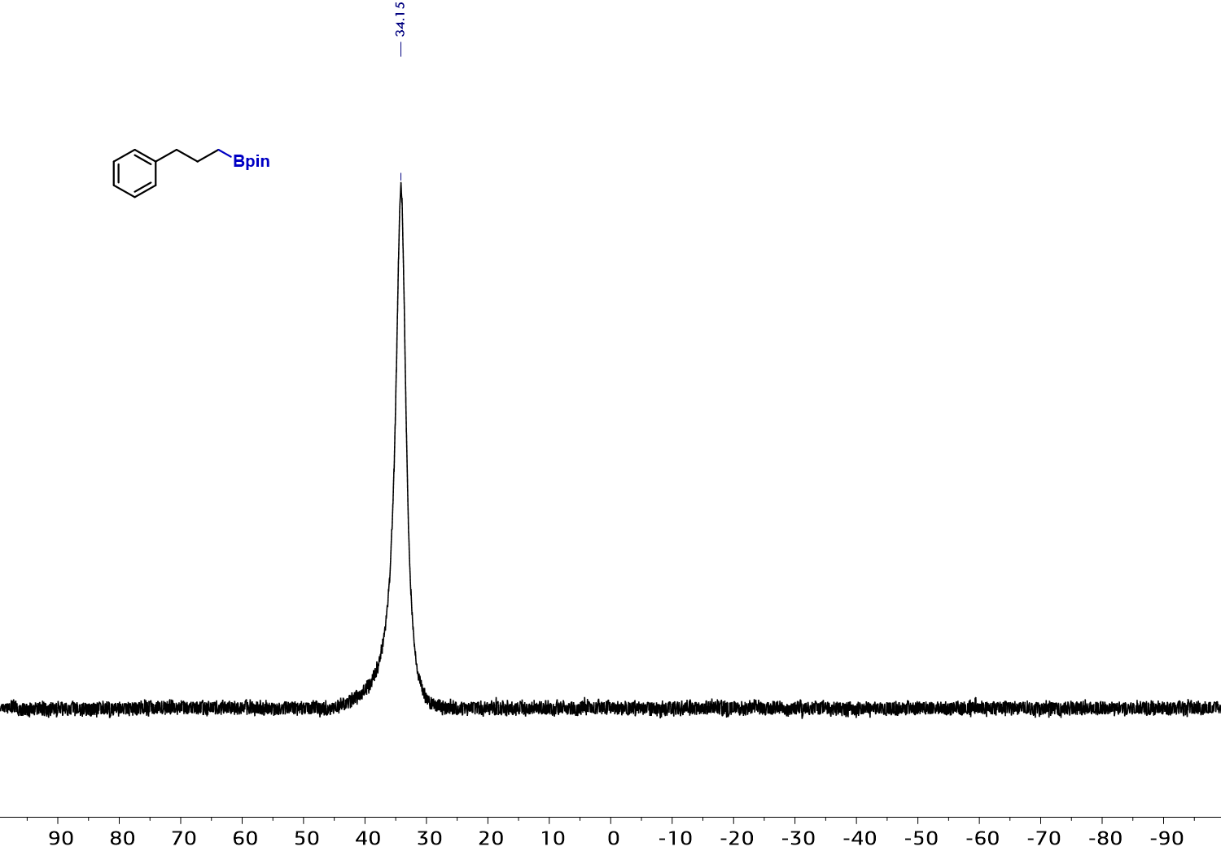

¹H NMR spectrum (500 MHz, CDCl₃) of 7
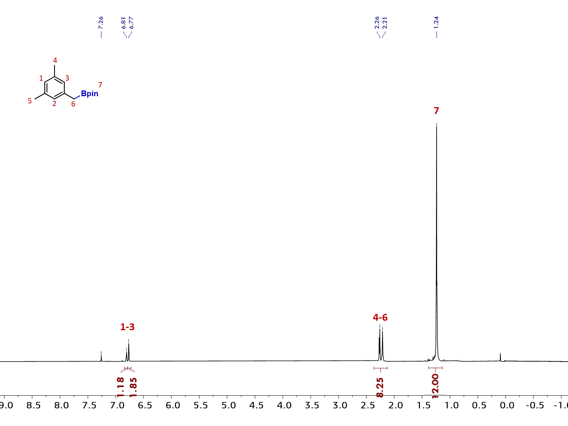

¹³C NMR spectrum (126 MHz, CDCl₃) of 7
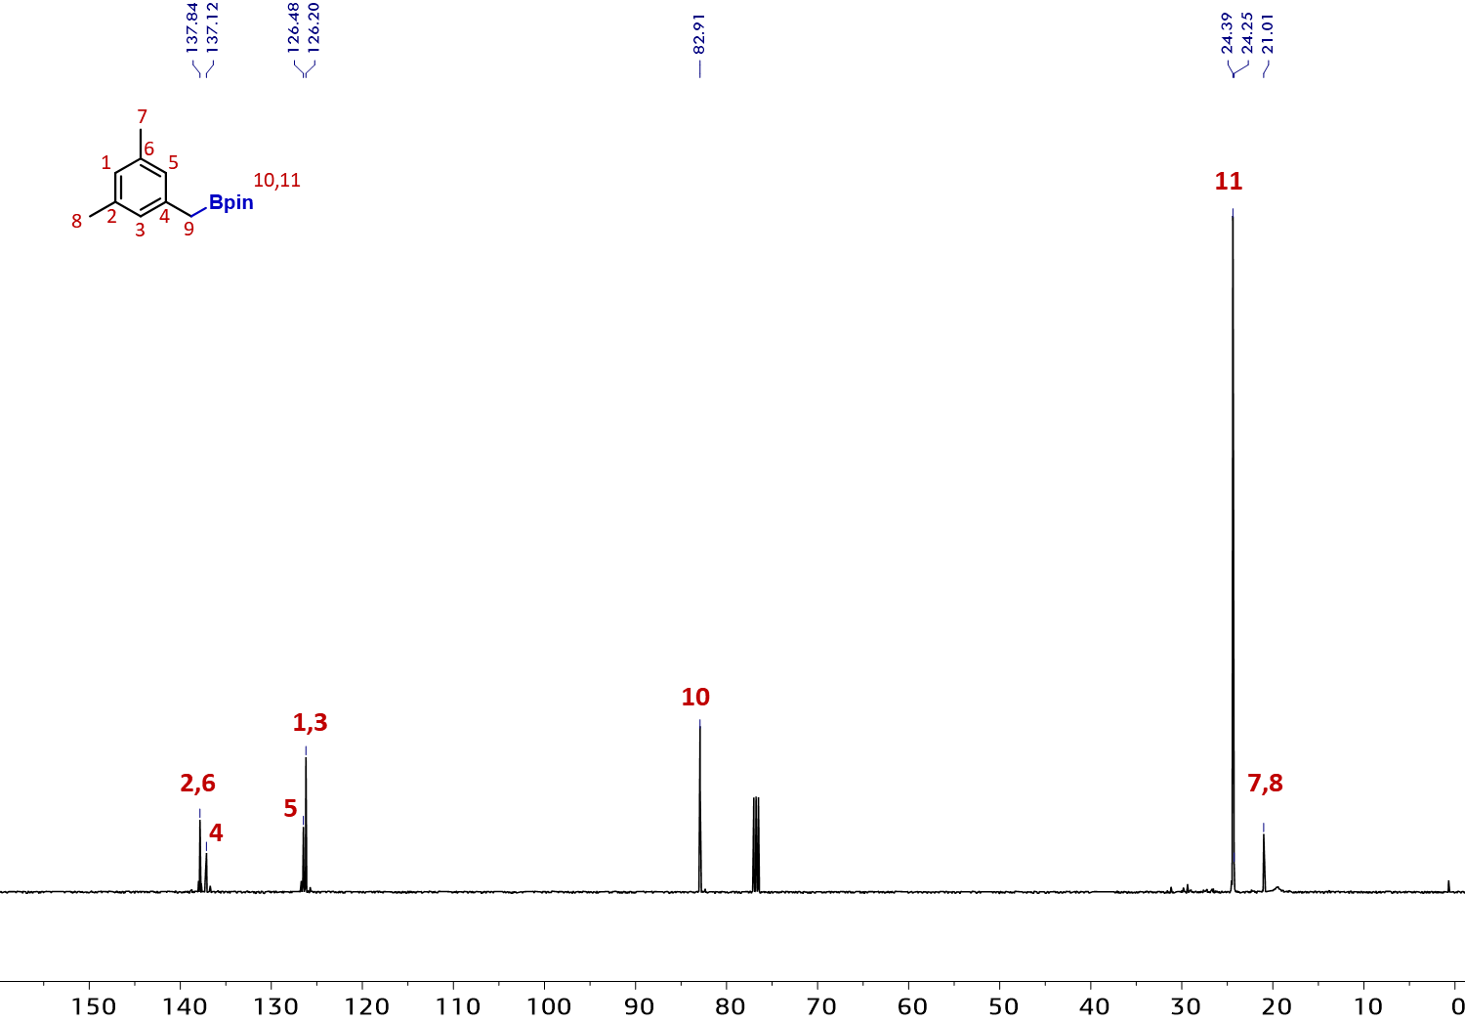
¹¹B NMR spectrum (160 MHz, CDCl₃) of 7
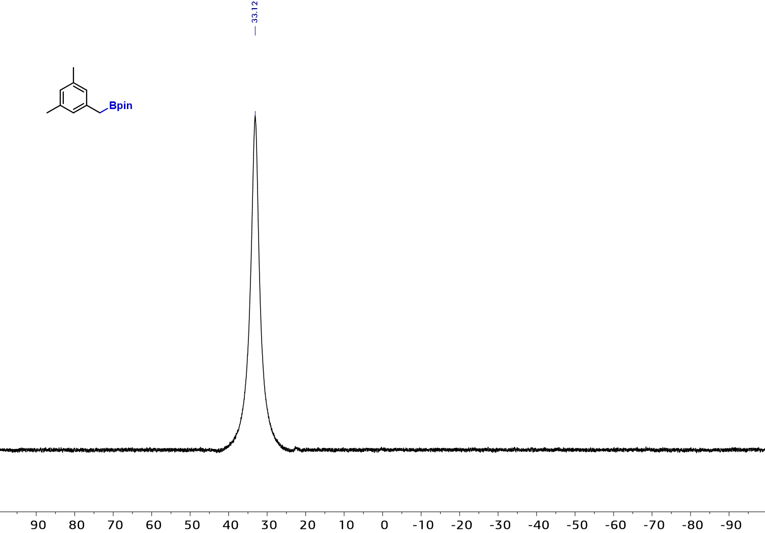

¹H NMR spectrum (500 MHz, CDCl₃) of 8
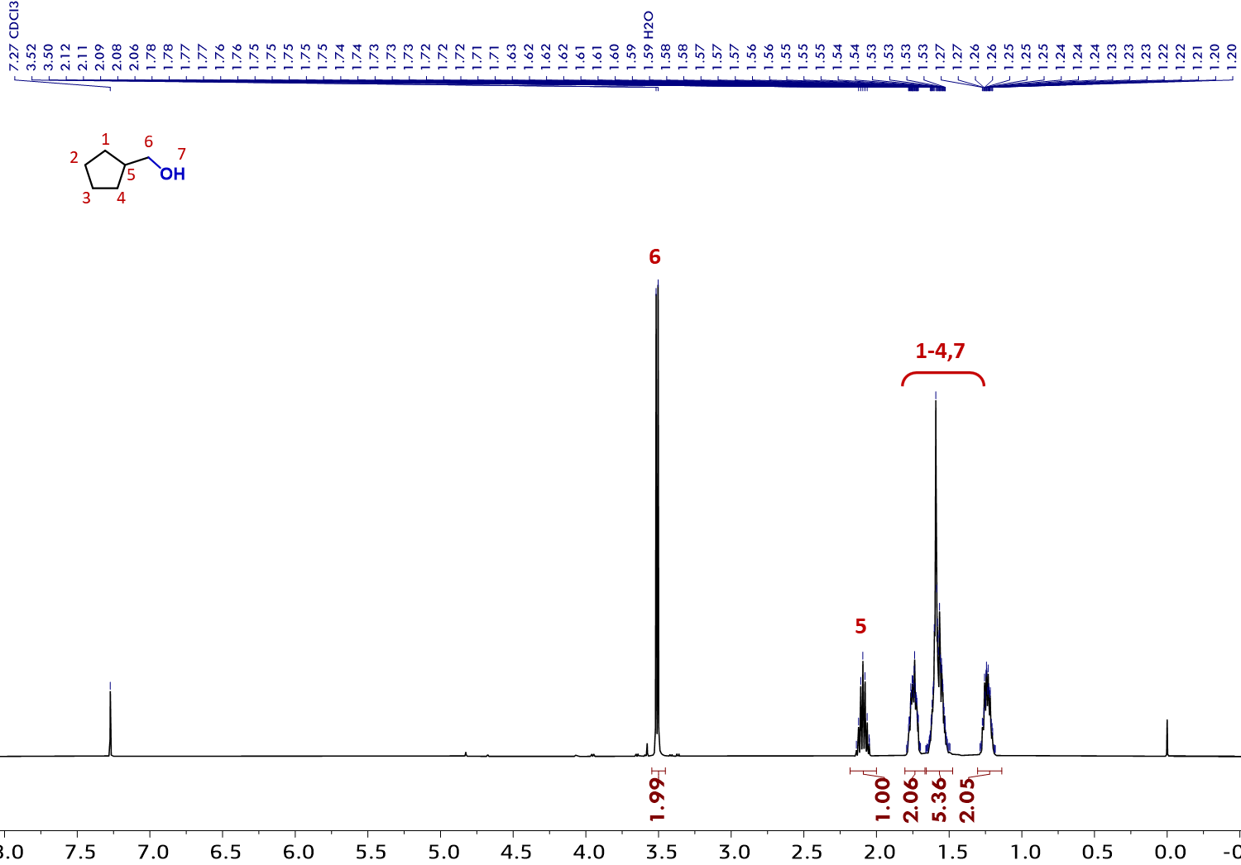

¹³C NMR spectrum (126 MHz, CDCl₃) of 8
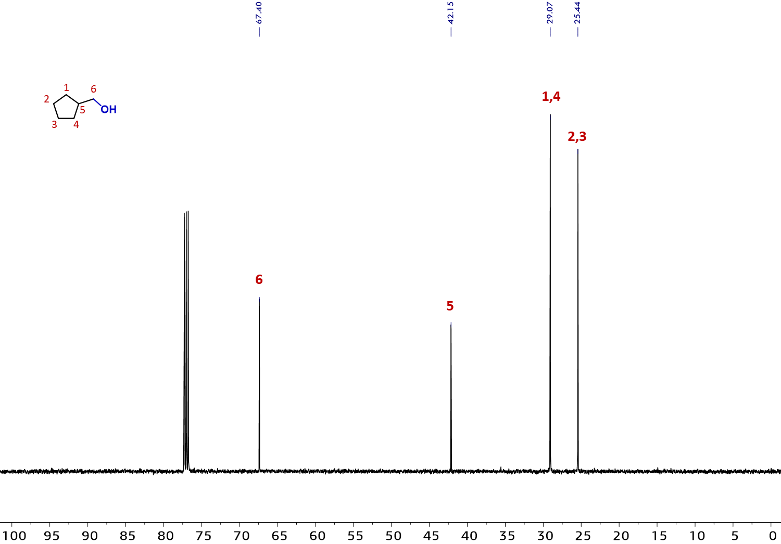

¹H NMR spectrum (500 MHz, CDCl₃) of 9
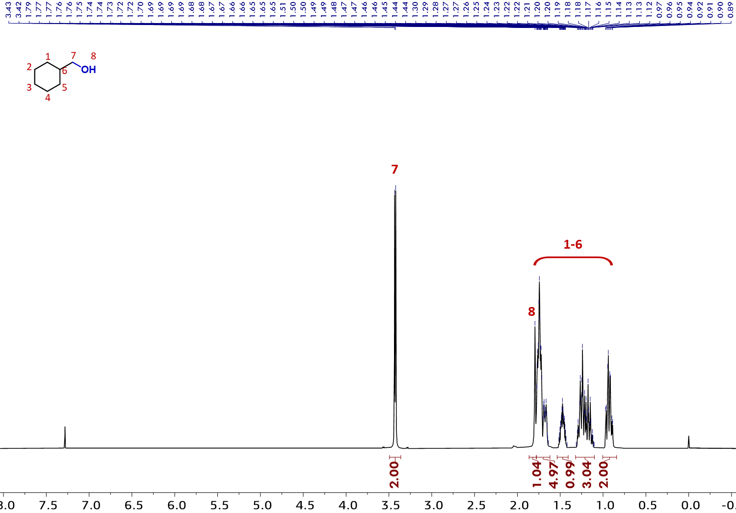

¹³C NMR spectrum (126 MHz, CDCl₃) of 9
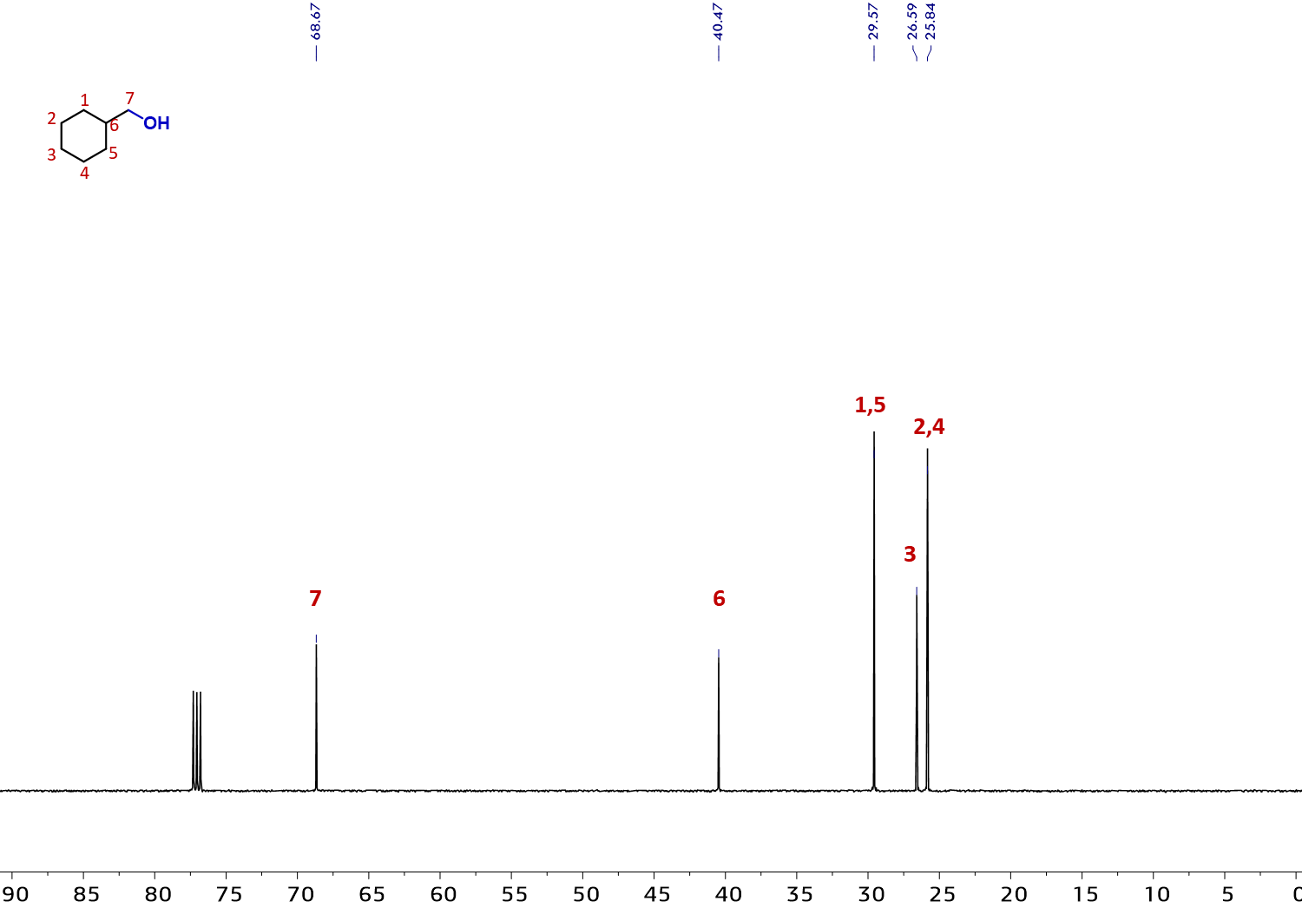

¹H NMR spectrum (500 MHz, acetone-d6) of 10
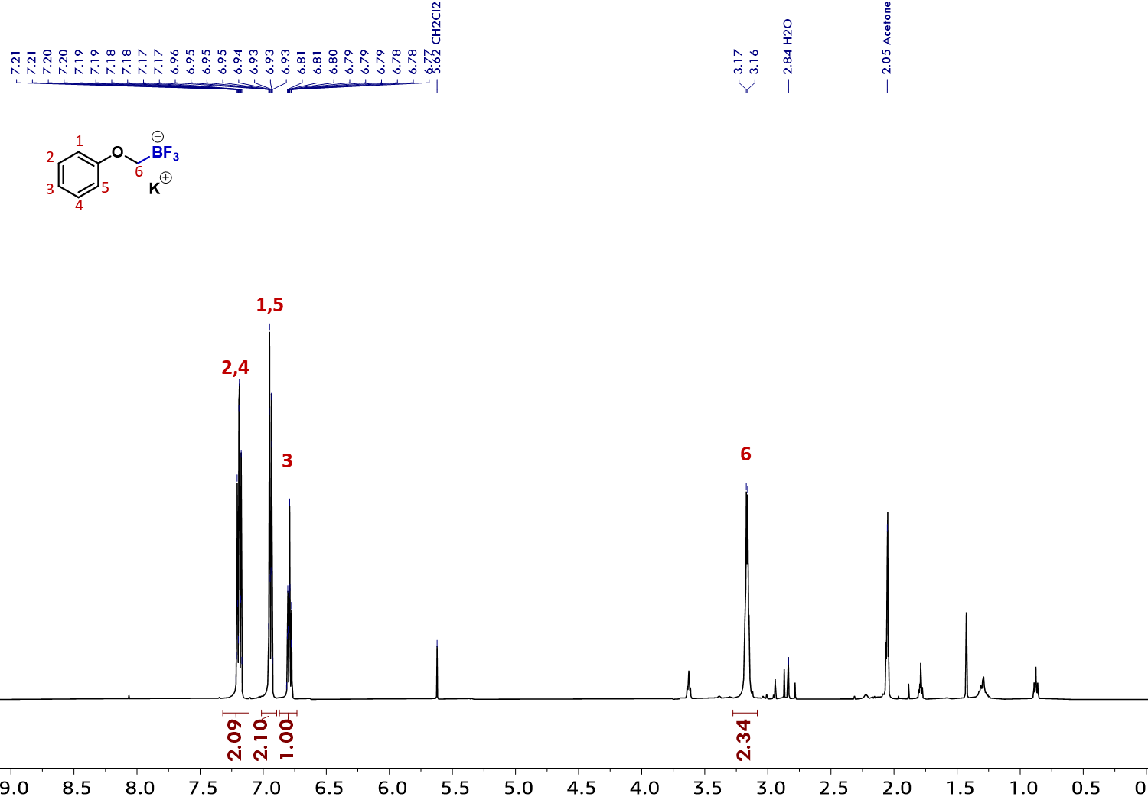

¹³C NMR spectrum (126 MHz, acetone-d6) of 10
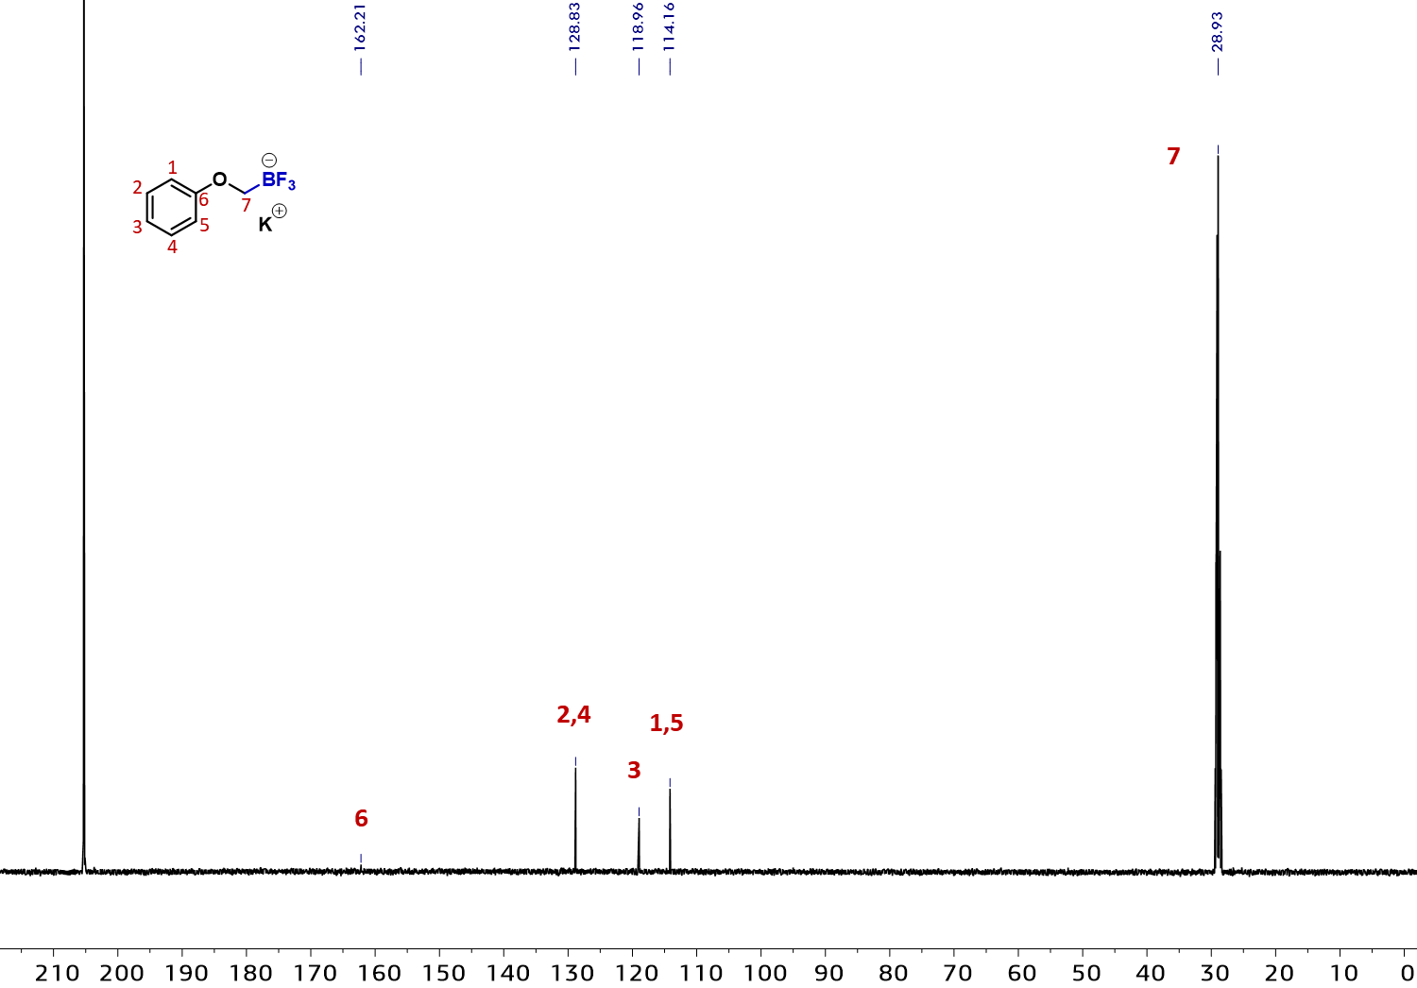

¹¹B NMR spectrum (160 MHz, acetone-d6) of 10
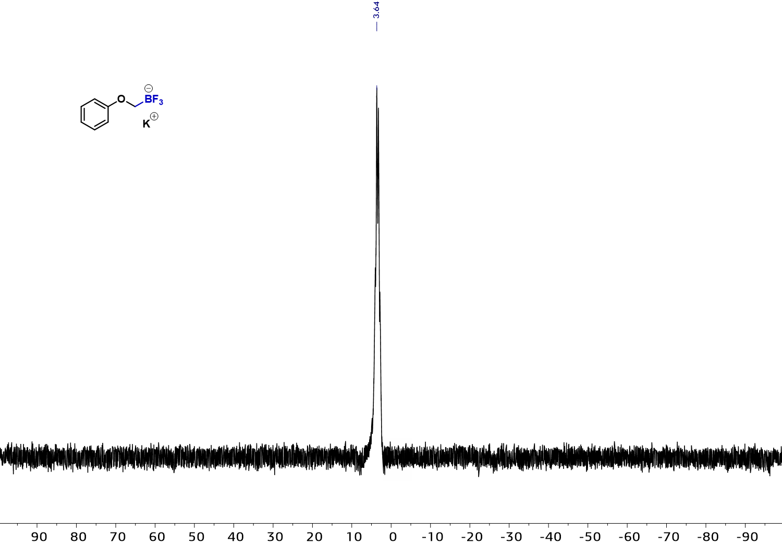

¹H NMR spectrum (500 MHz, CDCl₃) of 11
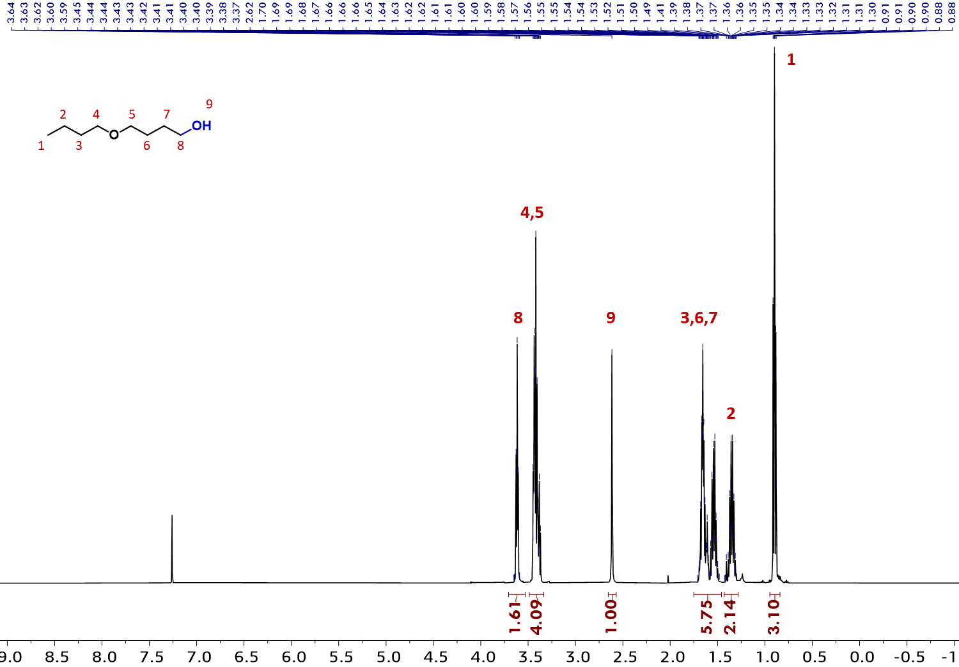

¹³C NMR spectrum (126 MHz, CDCl₃) of 11
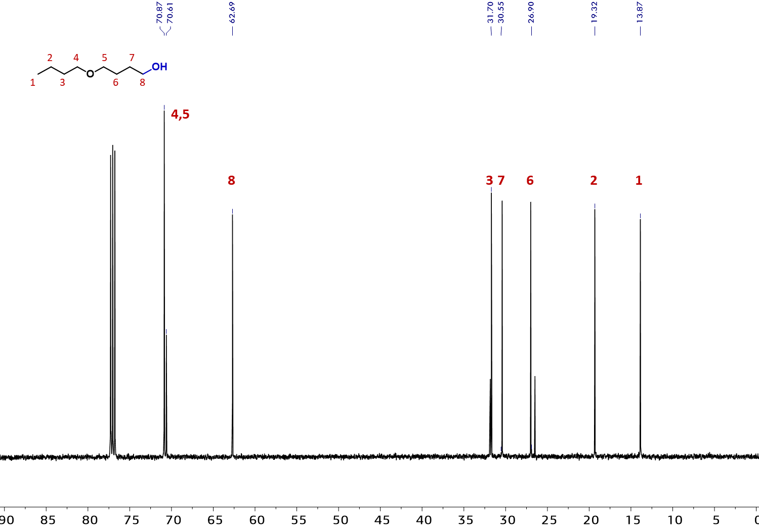

Reference
1 Davidson, P. J., Lappert, M. & Pearce, R. Silylmethyl and related complexes II. Preparation, spectra, and thermolysis of the tetraneopentyls of titanium, zirconium, and hafnium. Journal of Organometallic Chemistry 57, 269-277 (1973).
2 Lorenzano-Porras, C. F., Annen, M. J., Flickinger, M. C., Carr, P. W. & McCormick, A. V. Pore structure and diffusion tortuosity of porous ZrO2 synthesized by two different colloid-aggregation processes. Journal of colloid and interface science 170, 299-307 (1995).
3 Ravel, B. & Newville, M. ATHENA, ARTEMIS, HEPHAESTUS: data analysis for X-ray absorption spectroscopy using IFEFFIT. Journal of Synchrotron Radiation 12, 537-541, doi:doi:10.1107/S0909049505012719 (2005).
4 Rehr, J. J. & Albers, R. C. Theoretical approaches to x-ray absorption fine structure. Reviews of Modern Physics 72, 621-654 (2000).
5 Munoz, M., Argoul, P. & Farges, F. Continuous Cauchy wavelet transform analyses of EXAFS spectra: A qualitative approach. American mineralogist 88, 694-700 (2003).
6 Corker, J. et al. Catalytic cleavage of the CH and CC bonds of alkanes by surface organometallic chemistry: An EXAFS and IR characterization of a Zr-H catalyst. Science 271, 966-969 (1996).
7 Gaussian, Inc., (Wallingford, CT, 2016).
8 Becke, A. D. Density-functional exchange-energy approximation with correct asymptotic behavior. Physical Review A 38, 3098-3100 (1988).
9 Lee, C. T., Yang, W. T. & Parr, R. G. DEVELOPMENT OF THE COLLE-SALVETTI CORRELATION-ENERGY FORMULA INTO A FUNCTIONAL OF THE ELECTRON-DENSITY. Physical Review B 37, 785-789, doi:10.1103/PhysRevB.37.785 (1988).
10 Gupta, M., da Silva, E. F. & Svendsen, H. F. Postcombustion CO2 Capture Solvent Characterization Employing the Explicit Solvation Shell Model and Continuum Solvation Models. J. Phys. Chem., B 120, 9034-9050, doi:10.1021/acs.jpcb.6b04049 (2016).
11 Marenich, A. V., Cramer, C. J. & Truhlar, D. G. Universal Solvation Model Based on Solute Electron Density and on a Continuum Model of the Solvent Defined by the Bulk Dielectric Constant and Atomic Surface Tensions. The Journal of Physical Chemistry B 113, 6378-6396, doi:10.1021/jp810292n (2009).
12 Zhang, X. et al. Catalytic chemoselective functionalization of methane in a metal− organic framework. Nature Catalysis 1, 356-362 (2018).
13 Feng, X. et al. Metal–Organic Framework Stabilizes a Low-Coordinate Iridium Complex for Catalytic Methane Borylation. Journal of the American Chemical Society 141, 11196-11203 (2019).
14 Manna, K., Zhang, T., Greene, F. X. & Lin, W. Bipyridine-and phenanthroline-based metal–organic frameworks for highly efficient and tandem catalytic organic transformations via directed C–H activation. Journal of the American Chemical Society 137, 2665-2673 (2015).
15 Manna, K. et al. Chemoselective single-site Earth-abundant metal catalysts at metal–organic framework nodes. Nature communications 7, 1-11 (2016).
16 Newar, R. et al. Single-Site Cobalt-Catalyst Ligated with Pyridylimine-Functionalized Metal–Organic Frameworks for Arene and Benzylic Borylation. Inorganic Chemistry 59, 10473-10481 (2020).
17 Dhakshinamoorthy, A., García, C. V., Concepcion, P. & Garcia, H. Arene borylation through CH activation using Cu3 (BTC) 2 as heterogeneous catalyst. Catalysis Today 366, 212-217 (2021).
18 Ji, P. et al. Transformation of metal–organic framework secondary building units into hexanuclear Zr-alkyl catalysts for ethylene polymerization. Journal of the American Chemical Society 139, 11325-11328 (2017).
19 Jiao, Z.-F. et al. Visible-light-driven graphene supported Cu/Pd alloy nanoparticle-catalyzed borylation of alkyl bromides and chlorides in air. Journal of Catalysis 395, 258-265 (2021).
20 Wei, D., Liu, T.-M., Zhou, B. & Han, B. Decarboxylative Borylation of m CPBA-Activated Aliphatic Acids. Organic letters 22, 234-238 (2019).
21 Zhong, M. et al. Copper‐Photocatalyzed Hydroboration of Alkynes and Alkenes. Angewandte Chemie International Edition (2021).
22 Oeschger, R. et al. Diverse functionalization of strong alkyl C–H bonds by undirected borylation. Science 368, 736-741 (2020).
23 Cano, R., Yus, M. & Ramon, D. J. Impregnated palladium on magnetite as catalyst for multicomponent reductive amination reactions and other related reducing processes. Tetrahedron 67, 8079-8085 (2011).
24 Kobayashi, S., Kawamoto, T., Uehara, S., Fukuyama, T. & Ryu, I. Black-light-induced radical/ionic hydroxymethylation of alkyl iodides with atmospheric CO in the presence of tetrabutylammonium borohydride. Organic letters 12, 1548-1551 (2010).
25 Jones, M. R., Fast, C. D. & Schley, N. D. Iridium-Catalyzed sp3 C–H Borylation in Hydrocarbon Solvent Enabled by 2, 2′-Dipyridylarylmethane Ligands. Journal of the American Chemical Society 142, 6488-6492 (2020).
26 Press, L. P., Kosanovich, A. J., McCulloch, B. J. & Ozerov, O. V. High-turnover aromatic C–H borylation catalyzed by POCOP-type pincer complexes of iridium. Journal of the American Chemical Society 138, 9487-9497 (2016).
27 Li, Q., Liskey, C. W. & Hartwig, J. F. Regioselective borylation of the C–H bonds in alkylamines and alkyl ethers. Observation and origin of high reactivity of primary C–H bonds beta to nitrogen and oxygen. Journal of the American Chemical Society 136, 8755-8765 (2014).

