The datasets supporting the conclusions of this article are included within the article：
Figure.1: Oncomine (https://www.oncomine.org)
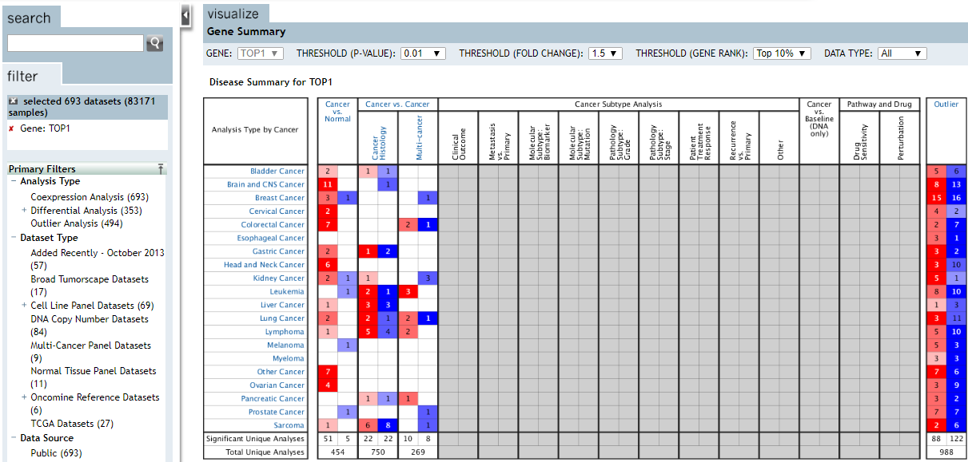
TOP1:
https://www.oncomine.org/resource/main.html#a%3A1799%3Bcso%3AsizeSmallLarge%3Bcv%3Adetail%3Bd%3A60460007%3Bdso%3AgeneOverex%3Bdt%3ApredefinedClass%3Bec%3A%5B2%2C1%2C3%5D%3Bepv%3A150001%2C2937%2C3508%2C3519%2C4018%3Bet%3Aover%3Bf%3A60775447%3Bg%3A7150%3Bp%3A200001268%3Bpg%3A1%3Bpvf%3A37780%3Bscr%3Asummary%3Bss%3Aanalysis%3Bth%3Ag10.0%2Cp0.010%2Cfc1.5%3Bv%3A18
TOP1MT: https://www.oncomine.org/resource/main.html#cso%3AsizeSmallLarge%3Bcv%3Adetail%3Bdso%3AgeneOverex%3Bec%3A%5B2%2C1%2C3%5D%3Bepv%3A150001%2C2937%2C3508%2C3519%2C4018%3Bet%3Aover%3Bg%3A116447%3Bp%3A200001268%3Bpg%3A1%3Bpvf%3A37781%3Bscr%3Asummary%3Bss%3Aanalysis%3Bth%3Ag10.0%2Cp0.010%2Cfc1.5%3Bv%3A18
TOP2A:
https://www.oncomine.org/resource/main.html#cso%3AsizeSmallLarge%3Bcv%3Adetail%3Bdso%3AgeneOverex%3Bec%3A%5B2%2C1%2C3%5D%3Bepv%3A150001%2C2937%2C3508%2C3519%2C4018%3Bet%3Aover%3Bg%3A7153%3Bp%3A200001268%3Bpg%3A1%3Bpvf%3A37784%3Bscr%3Asummary%3Bss%3Aanalysis%3Bth%3Ag10.0%2Cp0.010%2Cfc1.5%3Bv%3A18
TOP2B:
https://www.oncomine.org/resource/main.html#cso%3AsizeSmallLarge%3Bcv%3Adetail%3Bdso%3AgeneOverex%3Bec%3A%5B2%2C1%2C3%5D%3Bepv%3A150001%2C2937%2C3508%2C3519%2C4018%3Bet%3Aover%3Bg%3A7155%3Bp%3A200001268%3Bpg%3A1%3Bpvf%3A37785%3Bscr%3Asummary%3Bss%3Aanalysis%3Bth%3Ag10.0%2Cp0.010%2Cfc1.5%3Bv%3A18
TOP3A:
https://www.oncomine.org/resource/main.html#cso%3AsizeSmallLarge%3Bcv%3Adetail%3Bdso%3AgeneOverex%3Bec%3A%5B2%2C1%2C3%5D%3Bepv%3A150001%2C2937%2C3508%2C3519%2C4018%3Bet%3Aover%3Bg%3A7156%3Bp%3A200001268%3Bpg%3A1%3Bpvf%3A37786%3Bscr%3Asummary%3Bss%3Aanalysis%3Bth%3Ag10.0%2Cp0.010%2Cfc1.5%3Bv%3A18
TOP3B:
https://www.oncomine.org/resource/main.html#cso%3AsizeSmallLarge%3Bcv%3Adetail%3Bdso%3AgeneOverex%3Bec%3A%5B2%2C1%2C3%5D%3Bepv%3A150001%2C2937%2C3508%2C3519%2C4018%3Bet%3Aover%3Bg%3A8940%3Bp%3A200001268%3Bpg%3A1%3Bpvf%3A37787%3Bscr%3Asummary%3Bss%3Aanalysis%3Bth%3Ag10.0%2Cp0.010%2Cfc1.5%3Bv%3A18

Figure 2.
Figure 2(A). GEPIA(http://gepia.cancer-pku.cn/)
TOP1: http://gepia.cancer-pku.cn/detail.php?gene=TOP1###
TOP1MT: http://gepia.cancer-pku.cn/detail.php?gene= TOP1MT ###
TOP2A: http://gepia.cancer-pku.cn/detail.php?gene= TOP2A ###
TOP2B: http://gepia.cancer-pku.cn/detail.php?gene= TOP2B ###
TOP3A: http://gepia.cancer-pku.cn/detail.php?gene= TOP3A ###
TOP3B: http://gepia.cancer-pku.cn/detail.php?gene= TOP3B ###
Figure 2(B). GEPIA(http://gepia.cancer-pku.cn/)
Expression DIY→BOXPLOT→Gene→|Log2FC| Cutoff:(1) →p -value Cutoff：（0.01）→datasets selection(SARC) →Log Scale（Yes）→Jitter Size（0.4）→Matched Normal data （Match TCGA normal and GTEx data）
TOP1: http://gepia.cancer-pku.cn/detail.php?gene=TOP1###
TOP1MT: http://gepia.cancer-pku.cn/detail.php?gene= TOP1MT ###
TOP2A: http://gepia.cancer-pku.cn/detail.php?gene= TOP2A ###
TOP2B: http://gepia.cancer-pku.cn/detail.php?gene= TOP2B ###
TOP3A: http://gepia.cancer-pku.cn/detail.php?gene= TOP3A ###
TOP3B: http://gepia.cancer-pku.cn/detail.php?gene= TOP3B ###
Figure2(C) http://gepia.cancer-pku.cn/detail.php?gene=TOP1###
Expression DIY→Multiple Gene Comparison→gene list(TOP1/TOP1MT/TOP2A/TOP2B/TOP3A/TOP3B)
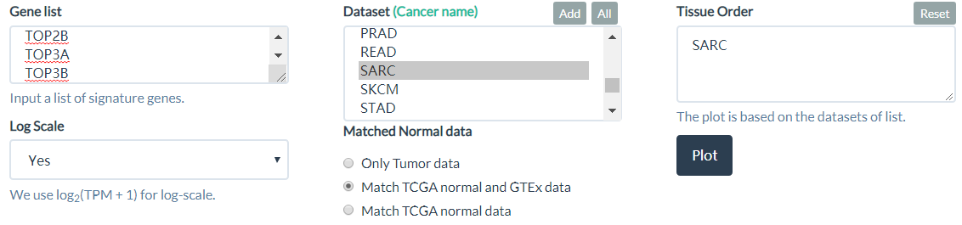

Figure3(A) tcgaportal( http://tcgaportal.org)
TOP1:
http://tcgaportal.org/TCGA/SoftTissue_TCGA_SARC/process.php?geneName=TOP1&devidePatientN=median&LowVal=&HighVal=&subtype=All
TOP1MT: http://tcgaportal.org/TCGA/SoftTissue_TCGA_SARC/process.php?geneName=TOP1MT&devidePatientN=median&LowVal=&HighVal=&subtype=All
TOP2A: http://tcgaportal.org/TCGA/SoftTissue_TCGA_SARC/process.php?geneName=TOP2A&devidePatientN=median&LowVal=&HighVal=&subtype=All
TOP2B: http://tcgaportal.org/TCGA/SoftTissue_TCGA_SARC/process.php?geneName=TOP2B&devidePatientN=median&LowVal=&HighVal=&subtype=All
TOP3A: http://tcgaportal.org/TCGA/SoftTissue_TCGA_SARC/process.php?geneName=TOP3A&devidePatientN=median&LowVal=&HighVal=&subtype=All

TOP3B: http://tcgaportal.org/TCGA/SoftTissue_TCGA_SARC/process.php?geneName=TOP3B&devidePatientN=median&LowVal=&HighVal=&subtype=All
Figure 3B:
https://www.cbioportal.org/results/oncoprint?genetic_profile_ids_PROFILE_MUTATION_EXTENDED=sarc_tcga_pub_mutations&genetic_profile_ids_PROFILE_COPY_NUMBER_ALTERATION=sarc_tcga_pub_gistic&genetic_profile_ids_PROFILE_MRNA_EXPRESSION=sarc_tcga_pub_rna_seq_v2_mrna_median_Zscores&cancer_study_list=sarc_tcga_pub&Z_SCORE_THRESHOLD=2.0&RPPA_SCORE_THRESHOLD=2.0&data_priority=0&profileFilter=0&case_set_id=sarc_tcga_pub_3way_complete&gene_list=TOP1%252CTOP1MT%252CTOP2A%252CTOP2B%252CTOP3A%252CTOP3B&geneset_list=%20&tab_index=tab_visualize&Action=Submit
Clinical→Months to Distant Recurrence

Figure 4(A) (B): cBioPortal (https://www.cbioportal.org)
Short histology:
https://www.cbioportal.org/results/comparison?genetic_profile_ids_PROFILE_MUTATION_EXTENDED=sarc_tcga_pub_mutations&genetic_profile_ids_PROFILE_COPY_NUMBER_ALTERATION=sarc_tcga_pub_gistic&genetic_profile_ids_PROFILE_MRNA_EXPRESSION=sarc_tcga_pub_rna_seq_v2_mrna_median_Zscores&cancer_study_list=sarc_tcga_pub&Z_SCORE_THRESHOLD=2.0&RPPA_SCORE_THRESHOLD=2.0&data_priority=0&profileFilter=0&case_set_id=sarc_tcga_pub_3way_complete&gene_list=TOP1%252CTOP1MT%252CTOP2A%252CTOP2B%252CTOP3A%252CTOP3B&geneset_list=%20&tab_index=tab_visualize&Action=Submit&comparison_subtab=clinical&comparison_selectedGroups=%5B%22TOP1%22%2C%22TOP1MT%22%2C%22TOP2A%22%2C%22TOP2B%22%2C%22TOP3A%22%2C%22TOP3B%22%5D&mutations_gene=TOP1
DNA methylation cluster:

https://www.cbioportal.org/results/comparison?genetic_profile_ids_PROFILE_MUTATION_EXTENDED=sarc_tcga_pub_mutations&genetic_profile_ids_PROFILE_COPY_NUMBER_ALTERATION=sarc_tcga_pub_gistic&genetic_profile_ids_PROFILE_MRNA_EXPRESSION=sarc_tcga_pub_rna_seq_v2_mrna_median_Zscores&cancer_study_list=sarc_tcga_pub&Z_SCORE_THRESHOLD=2.0&RPPA_SCORE_THRESHOLD=2.0&data_priority=0&profileFilter=0&case_set_id=sarc_tcga_pub_3way_complete&gene_list=TOP1%252CTOP1MT%252CTOP2A%252CTOP2B%252CTOP3A%252CTOP3B&geneset_list=%20&tab_index=tab_visualize&Action=Submit&comparison_subtab=clinical&comparison_selectedGroups=%5B%22TOP1%22%2C%22TOP1MT%22%2C%22TOP2A%22%2C%22TOP2B%22%2C%22TOP3A%22%2C%22TOP3B%22%5D&mutations_gene=TOP1

Figure 4(C):TCGAportal ( http://tcgaportal.org)
TOP1:
http://tcgaportal.org/TCGA/SoftTissue_TCGA_SARC/process.php?geneName=TOP1&devidePatientN=median&LowVal=&HighVal=&subtype=All
TOP1MT: http://tcgaportal.org/TCGA/SoftTissue_TCGA_SARC/process.php?geneName=TOP1MT&devidePatientN=median&LowVal=&HighVal=&subtype=All
TOP2A: http://tcgaportal.org/TCGA/SoftTissue_TCGA_SARC/process.php?geneName=TOP2A&devidePatientN=median&LowVal=&HighVal=&subtype=All
TOP2B: http://tcgaportal.org/TCGA/SoftTissue_TCGA_SARC/process.php?geneName=TOP2B&devidePatientN=median&LowVal=&HighVal=&subtype=All
TOP3A: http://tcgaportal.org/TCGA/SoftTissue_TCGA_SARC/process.php?geneName=TOP3A&devidePatientN=median&LowVal=&HighVal=&subtype=All

TOP3B: http://tcgaportal.org/TCGA/SoftTissue_TCGA_SARC/process.php?geneName=TOP3B&devidePatientN=median&LowVal=&HighVal=&subtype=All

Figure 5(A)(B): cBioPortal(https://www.cbioportal.org)
cancer type summary
https://www.cbioportal.org/results/comparison?genetic_profile_ids_PROFILE_MUTATION_EXTENDED=sarc_tcga_pub_mutations&genetic_profile_ids_PROFILE_COPY_NUMBER_ALTERATION=sarc_tcga_pub_gistic&genetic_profile_ids_PROFILE_MRNA_EXPRESSION=sarc_tcga_pub_rna_seq_v2_mrna_median_Zscores&cancer_study_list=sarc_tcga_pub&Z_SCORE_THRESHOLD=2.0&RPPA_SCORE_THRESHOLD=2.0&data_priority=0&profileFilter=0&case_set_id=sarc_tcga_pub_3way_complete&gene_list=TOP1%252CTOP1MT%252CTOP2A%252CTOP2B%252CTOP3A%252CTOP3B&geneset_list=%20&tab_index=tab_visualize&Action=Submit&comparison_subtab=mutations&comparison_selectedGroups=%5B%22Altered%20group%22%2C%22Unaltered%20group%22%5D&mutations_gene=TOP1

Figure 5(C) TIMER→SCNA
https://cistrome.shinyapps.io/timer/
Figure 7: TIMER→Gene
https://cistrome.shinyapps.io/timer/
Figure 7: TIMER→Survival
https://cistrome.shinyapps.io/timer/
Figure 8: Kaplan-Meier Plotter
RNAseq ID: | TOP1 | -
Survival: | OS/DFS
Auto select best cutoff: | checked
Follow up threshold: | all
Censore at threshold: | checked
Compute median over entire database: | false
Cutoff value used in analysis: | 2021
Cancer type : | sarcoma
http://kmplot.com/analysis/index.php?p=service
Figure 9 Figure 10 Figure 11:
：metascape(https://metascape.org/gp/index.html) 

