Metformin ameliorates scleroderma via inhibiting Th17 cells and reducing mTOR-STAT3 signaling in skin fibroblasts
Jeonghyeon Moon¹*, Seon-yeong Lee²*, Jeong Won Choi², Aram Lee², Jin Hee Yoo², Su-Jin Moon³, Sung-Hwan Park⁴, Mi-La Cho^{1, 2, 5}†

Figure S1
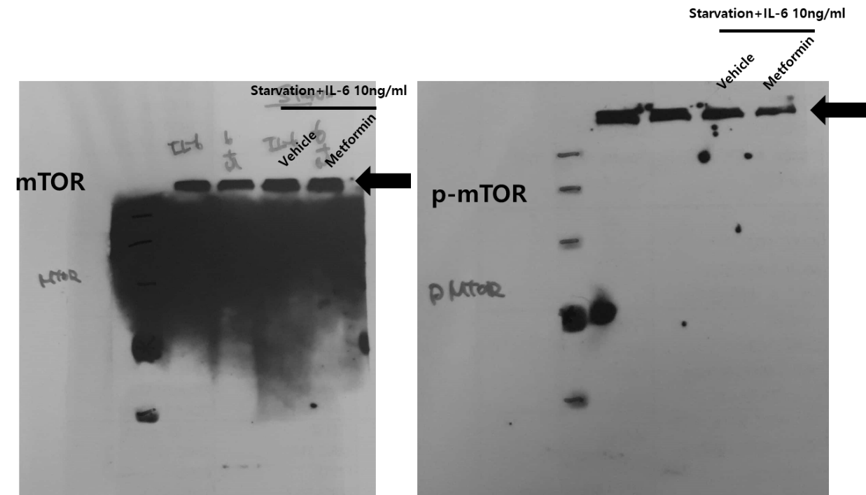
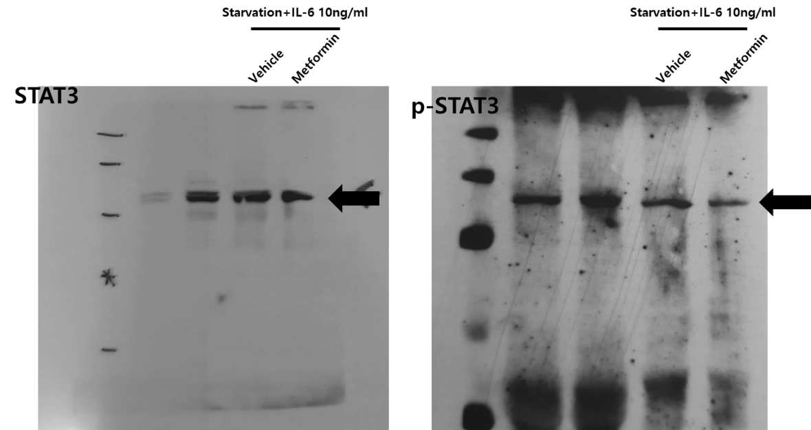
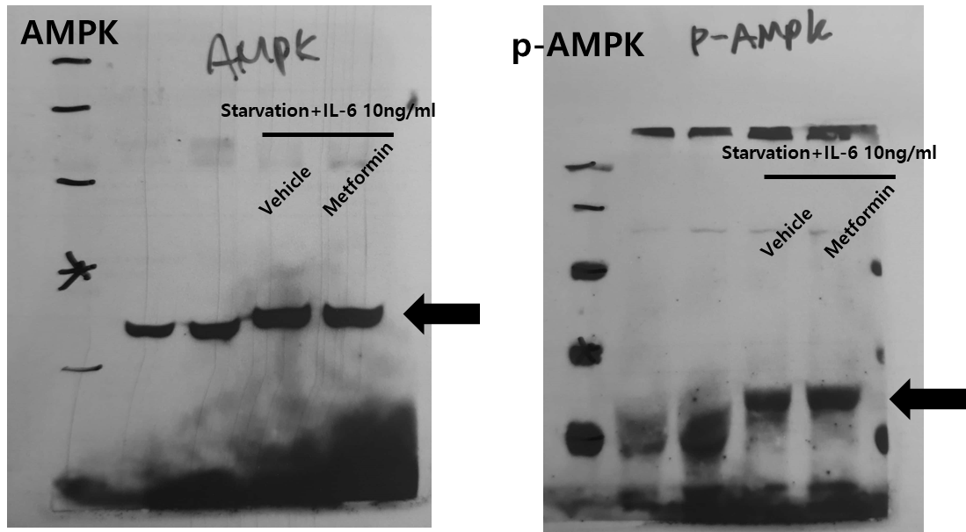
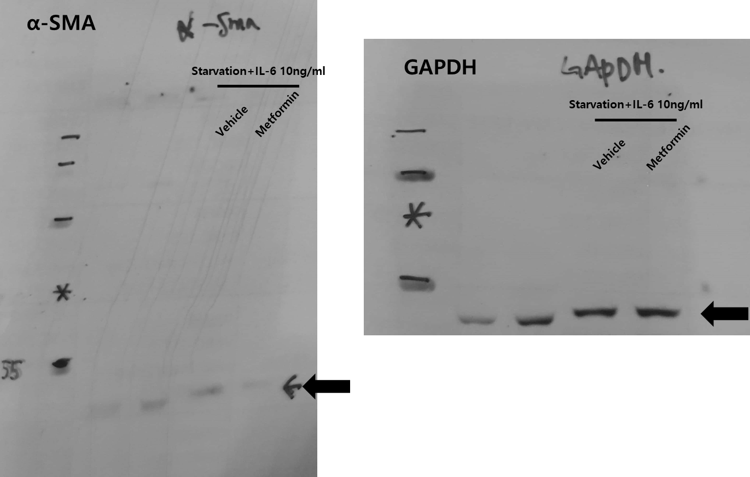
Figure S1. Gel data

