Microbiome analysis of bile samples in patients with choledocholithiasis and hepatobiliary disorders
Additional files
Supplementary Figure 1: relative abundance of bacterial genera in bile samples of symptomatic patients with CBD vs non-CBD stone formers.

Legend of supplementary Figure 1: Patients with CBD stone: P1, P2, P4, P5, P7, P8, P13, P14, P15; Patients with no CBD stone: P3, P6, P9-P12. The analysis was done using Mothur.

Supplementary Figure 2: Differences in relative abundances of bacterial genera between symptomatic patients with common bile duct stone and non-CBD stone formers.
F test, p value= 0.0001 T test, p value= 0.18

t test, p value=0.08 F test, p value= 0.026

t test, p value=0.083; f test p value=0.013 t test, p value= 0.26; F test p value=0.01

Klebsiella: p values for Unpaired t test: 0.17, F test: 0.0001
Achromobacter: p values for Unpaired t test: 0.36, F test: 0.0007
Cronobacter: p values for Unpaired t test: 0.24, f test: not significant
Helicobacter: p values for Unpaired t test: 0.25, F test: 0.0001
Enterobacter: p values for Unpaired t test: 0.24, F test: 0.0001
Stenotrophomonas: p values for Unpaired t test: 0.25, F test: 0.0007

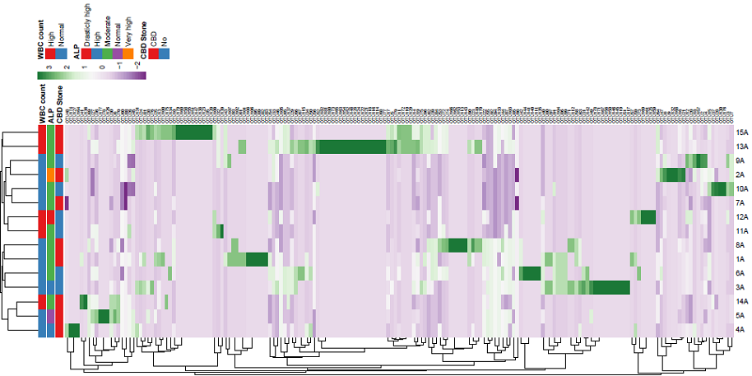
Supplementary Figure 3. Heatmap and cluster analysis of OTU in bile samples of patients with biliary diseases. ID of patients is shown in Y axis. Presence of CBD stone, and levels of ALP and WBC counts are shown for each sample. Diversity in No. of each OUT is shown by different color range. Average method was used for cluster analysis.

