Supplementary Information – Sources of Variation in Cell-Type RNA-Seq Profiles

This document contains supplementary information for “Sources of Variation in Cell-Type RNA-Seq Profiles”.

Number of Cells in each Single-Cell Profile Used for Deconvolution
Table S2 The number of cells used for each single-cell profile pair used in figure 7 in the main text.
Profile | No. B Cells | No. T Cells
Pooled SC HCA CB | 35,910 | 167,612
Pooled SC LC | 4,806 | 23,170
SC PBMC68k | 5,908 | 48,657
SC Melanoma | 512 | 2,040
SC LC Tumor | 4,509 | 18,306
SC LC Healthy Tissue | 297 | 4864
SC HCA CB | 35,910 | 167,612

Additional Plots for Explained Variance
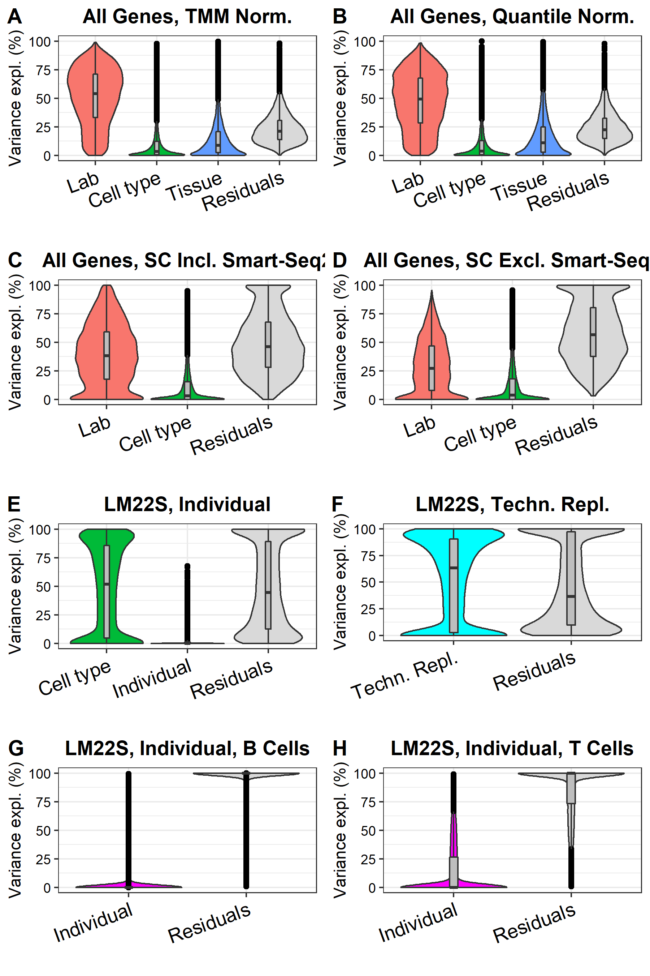
Fig. S1 A, B: Comparison between TMM and Quantile Normalization. C-D: The effect of including Smart-Seq2 samples. E. Variance explained by having samples from different individuals compared to samples from the same individual, but taken at different time points. F. Variance explained by having different samples compared to technical replicates, where the same sample has been sequenced several times. G, H. Same data as E, but separated on cell type into two groups to make individual factor more comparable to the technical replicates shown in F.

The Dependency between UMICF and Gene Expression
The UMI copy fraction covariate used in the main text is correlated with gene expression, likely due to sampling effects on lowly expressed genes (Fig. S3). However, there are also many genes with high expression and low UMICF, ruling out the possibility that this effect has its origin in sampling effects only.
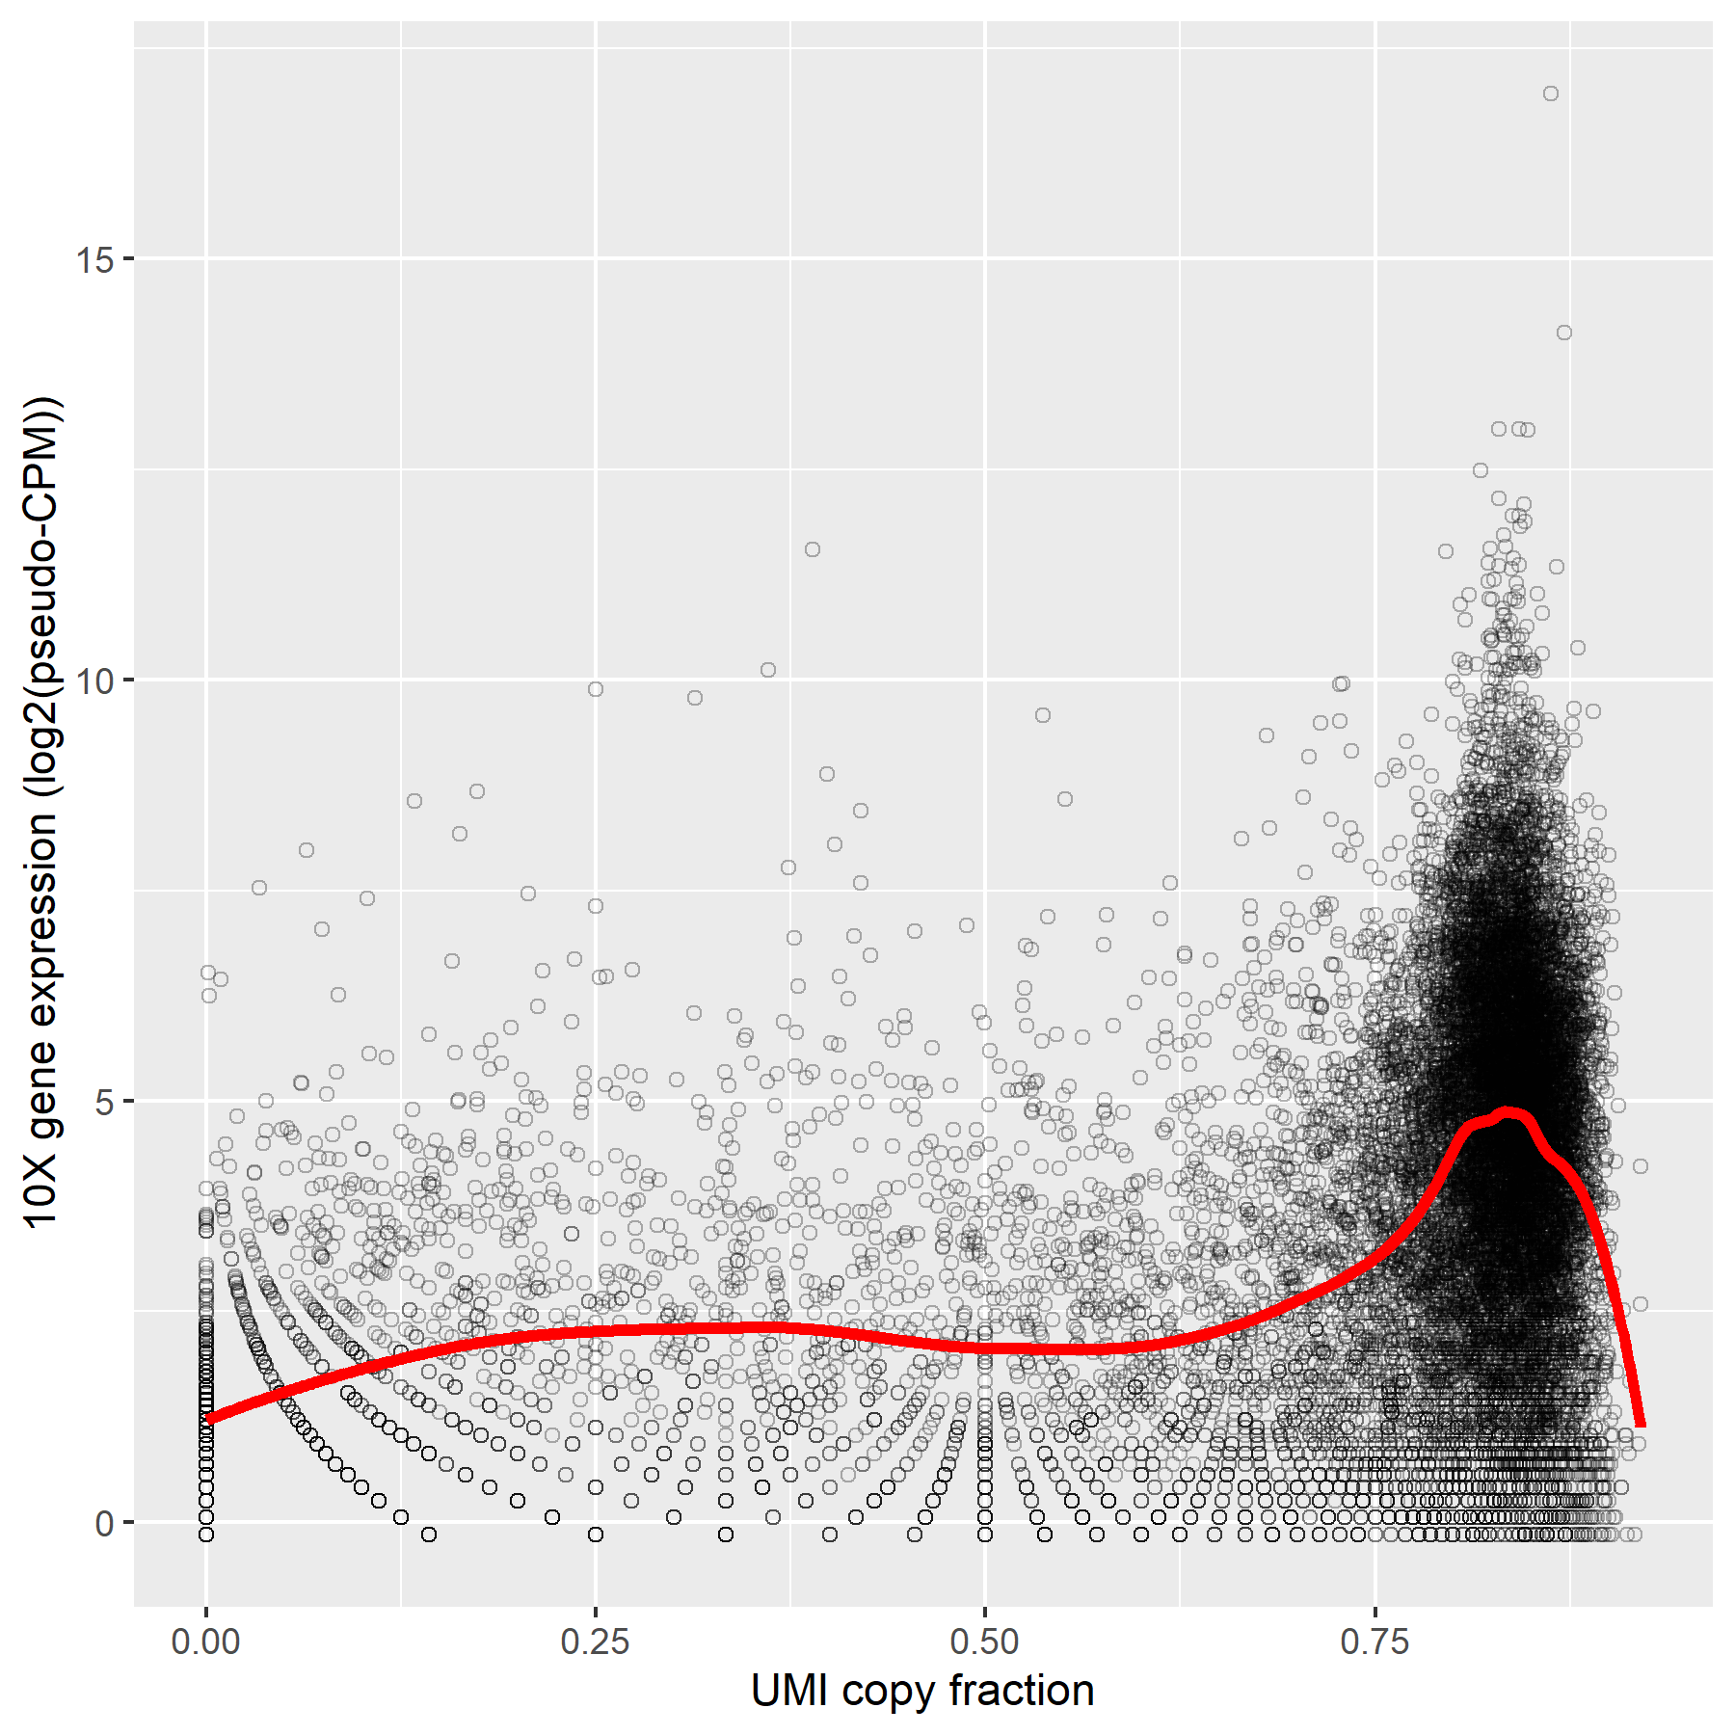
Fig. S2 Average gene expression per gene vs the UMICF covariate. The gene expression is from Cortex1, while UMICF is calculated from Cortex2, both from the EVAL dataset, 10x single-cell data, normalized using TMM. Only genes with 5 molecules or more in Cortex2 is shown.
Since the UMICF variable is correlated with gene expression, we investigated if that could explain the improvement in correlation between single-cell and bulk RNA-Seq from regressing out the UMICF variable. We reasoned that systematic differences in gene expression over the gene expression range between single-cell and bulk could indirectly be regressed out when regressing out UMICF and consequently make the sample data more similar. If this would be the case, regressing out UMICF could be replaced by quantile normalization, which effectively removes any such differences. To test this, we performed the same analysis as in the main text (i.e. comparing 10x single-cell data with bulk from the EVAL dataset) but using quantile normalization instead of TMM (Fig. S4). Compared to the case for TMM normalization, regressing out the UMICF covariate is slightly less effective, but the results are still similar. This suggests that systematic differences in gene expression over the gene expression range between single-cell and bulk can only explain a small part of the improvement in correlation of gene expression between single-cell and bulk resulting from regressing out the UMICF covariate.
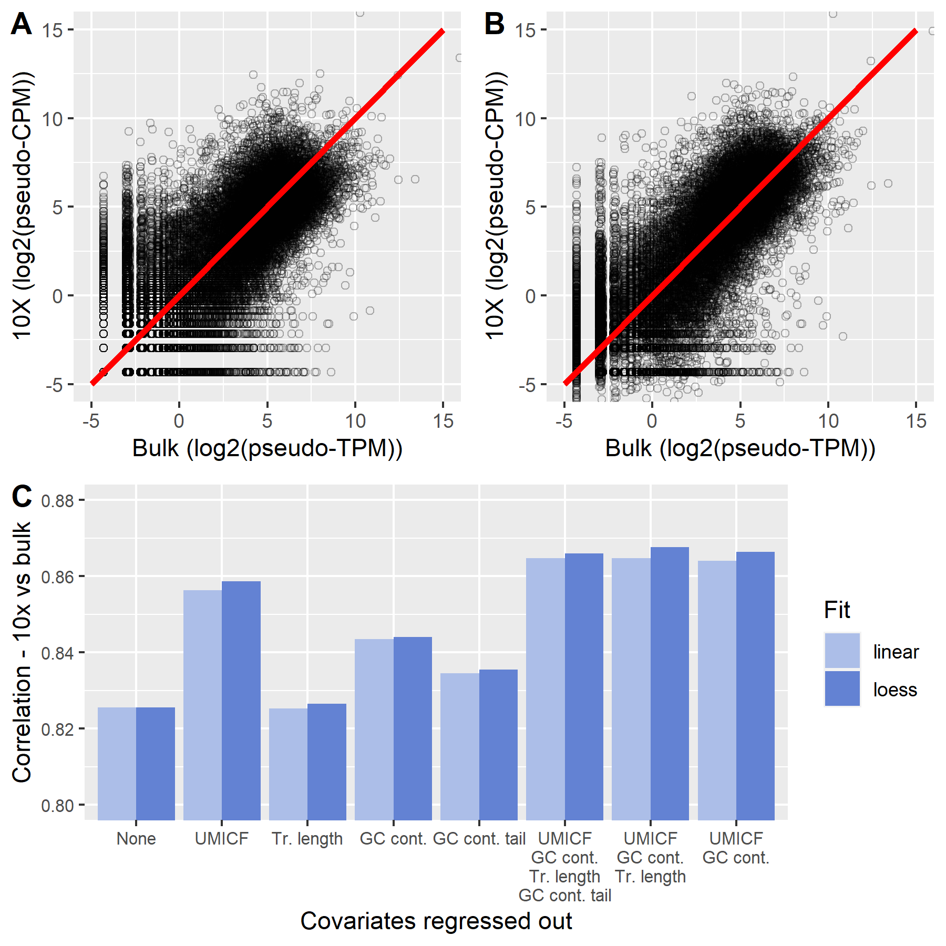
Fig. S3 Identical to main figure 6 but calculated on quantile normalized data. A. Gene expression for cortex 1 from the EVAL dataset plotted as 10x vs bulk. The red line represents a perfect correlation. B. Gene expression for cortex 1 from the EVAL dataset after regressing out the differences in UMICF and GC content between 10x and bulk using a loess fit, which improves the correlation. C. Average Pearson correlation coefficient between 10x data and bulk in log scale after regressing out technical covariates (UMI copy fraction, transcript length, GC content and GC content tail), using linear or loess regression. The correlation shown is the average of the correlations from cortex 1 and 2 of the EVAL dataset, using quantile normalization.

Additional Plots for Deconvolution Performance

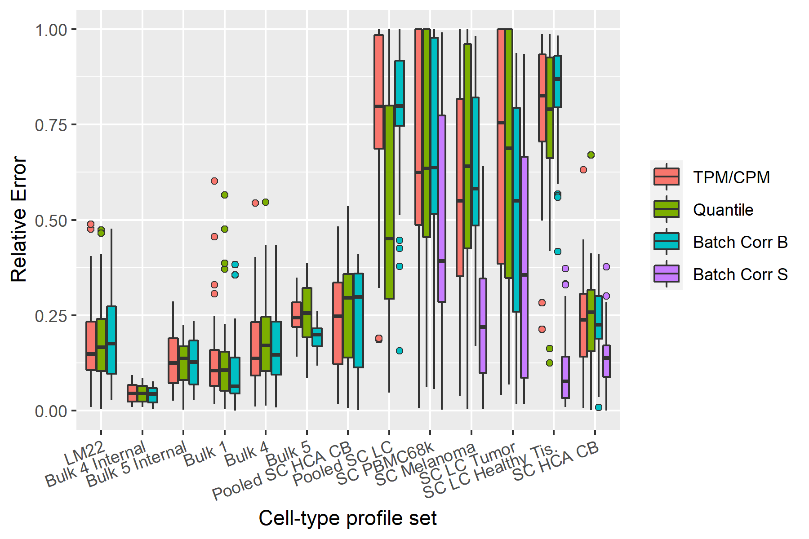
Fig. S4 Identical to figure 7 in the main text but including whiskers and outliers.

Software Verification/Validation
To ensure the quality of our analyses, we verified and validated the code using a combination of test cases, reasoning around expected outcome of a function and code review. The details of this activity are available in the verification matrix that is available together with the code at: doi.org/10.5281/zenodo.3900226.

