Supporting Information

Non-aliphatic Protic Ammonia Molecules for Post Healing of Formamidinium-containing Perovskite Films

Experimental Section
Materials Synthesis: All the raw liquid reagents were purchased from Sinopharm and/or Sigma-Aldrich without further purification. Methylammonium iodide (MAI), Formamidine hydroiodide (FAI), Lead iodide (PbI₂), Cesium iodide (CsI), and Spiro-OMeTAD (99.8%) were purchased from Xi’an Polymer Light Technology Corp. (PLT). The SnO_{x}-Cl colloidal solution was synthesized via mixing the SnCl₄ solution with deionized water in a ratio of 1:75, then the solution aged at 25℃ for about two weeks to obtain a white colloidal solution.
Device Fabrication: Fluorine doped tin oxide (FTO)-coated glass (7Ω sq⁻¹) was patterned by etching with Zn powder and 1 M HCl diluted in distilled water. The etched substrate was then cleaned with via sequential sonication with saturated KOH solution in isopropanol, deionized (DI) water, acetone, and isopropanol for 25 min each. The compact TiO₂ layer was deposited by atomic layer deposition (ALD) and annealed in ambient air at 500 °C for 30 min. On top of the c-TiO₂ layer, SnO_{x}-Cl layer was deposited by spin-coating at a speed of 3000 rpm for 30 s from an aged SnCl₄ aqueous solution (1:75 with deionized water by volume), followed by a sintering heat-treatment of 200 °C for 30 min in air and then transferred to the glove box. The perovskite solution was prepared by mixing PbI₂: FAI: CsI (1:0.9:0.1molar ratio) in DMSO and DMF mixed solvents (1.33 M, and the ratio of DMSO to DMF is 7:3). After complete dissolution, 40 μL of perovskite solution was spin-coated on the SnO_{x}-Cl substrates in a two-step at 1000 rpm and 4000 rpm for 10 s and 30 s, respectively. During the second step, 800 μL ether was drop-casted quickly 10 seconds before the end of the second step. The perovskite films were then heated at 140 ℃ for 20 min. For the NGPH method, the as-prepared films were transferred to a homemade device to complete the healing process. The Spiro-OMeTAD hole-transporting layer was prepared by dissolving 72.3 mg of Spiro-OMeTAD in 1 mL of chlorobenzene, to which 28.8 μL of 4-tert-butylpyridine (96%, Aldrich-Sigma) and 17.5 μL of lithium bis(trifluoro-methanesulfonyl) imide (Li-TSFI, Aldrich-Sigma) solution (520 mg Li-TSFI (98%) in 1 mL acetonitrile (99.8%, Aldrich-Sigma)) were added. After complete dissolution, 40 μL of spiro-MeOTAD solution was deposited by spin-coating (3000 rpm, 30 s). Finally, 100 nm thick Au electrodes were thermally evaporated under vacuum to complete the device fabrication.
Modules Fabrication:
As for fabricating modules, P1 etching process was pre-patterned on FTO glass with a 1064 nm fiber laser (HAN’S LASER SCIENCE & TECHNOLOGY CO., LTD.). The laser power ratio, laser duty cycle, and laser frequency were 30%, 5%, and 50 kHz, respectively. The patterned FTO substrate was cleaned using the method mentioned above in device fabrication section. Then, patterned FTO substrates were treated by UV treatment for 15 min. The SnO₂, perovskite, and spiro-OMeTAD were prepared with the same procedure. For P2 etching process, the laser used was a 532 nm laser, and laser power ratio, laser duty cycle, and laser frequency were 65%, 5%, and 100 kHz, respectively. 60 nm thick Au electrodes were thermally evaporated under vacuum to complete the modules fabrication. Finally, P3 etching used the same laser with P2, and the laser power ratio, laser duty cycle, and laser frequency were 50%, 5%, and 100 kHz, respectively. P4 is an etching procedure for cleaning the edge of the modules, the laser used in P4 is the same with P1, and the laser power ratio, laser duty cycle, and laser frequency were 40%, 10%, and 100 kHz, respectively.
Materials and Device Characterization. Solution ¹H NMR spectra were measured with a Bruker AVANCE III 600 instrument operating at 600 MHz at 298 K. Chemical shifts d (ppm) were referenced to the internal solvent signals. XRD spectra were measured by Ultima IV of Rigaku with Cu Kα radiation (1.5406Å). The UV-vis absorbance spectra were measured by Ocean Optics. Top view, cross-section SEM images were obtained with a field-emission scanning electron microscope (S-4800, Hitachi). Steady photoluminescence (PL) spectra were recorded on Ocean Optics excited at 460 nm. Transient photovoltage decay (TPV) measurements were done on a homemade system. AFM measurements were performed in contact mode using AFM microscope (5400, Agilent, USA). EQE measurement was calculated using certified incident photon to current conversion efficiency equipment from Enlitech (Taiwan). J-V curves of the as-fabricated PSCs with different scanning directions were measured using a 2400 Sourcemeter (Keithley, USA) under simulated one-sun AM 1.5G 100 mW cm⁻² intensity (Oriel Sol3A Class AAA, Newport, USA). The typical active area of PSCs is 0.09 cm² defined by a metal mask. The intensity of the one-sun AM 1.5G illumination was calibrated using a Si-reference cell certified by the National Renewable Energy Laboratory.
Theoretical calculation. All quantum chemical calculations were performed by applying the density functional theroy (DFT) method with the B3LYP level and def2-TZVP basis set using Gaussian 09 program package. The structural optimization was determined by minimizing the energy without imposing molecular symmetry constraints.

Additional Experimental Details
Gas preparation experiments.
Methylamine (MA^{g}), was produced by Methylamine hydrochloride (MACl) powder and Sodium hydroxide (NaOH) powder, ethylamine (EA^{g}) was produced by Ethylamine hydrochloride (EACl) powder and NaOH powder, propylamine (PA^{g}) and butylamine (BA^{g}) were produced by n-Propylaminwe and n-Butylamine which were used as received without further purification, FA^{g} was produced by Formamidine hydrochloride (FACl) powder and NaOH powder.
The low temperature NH₃ gas post healing process.
The starting raw FAPbI₃ perovskite films were deposited using the conventional one-step method. Here, a 40 wt% PbI₂: FAI (molar ratio 1:1) solution in N,N-dimethylformamide (DMF; 99.8%) was spin-coated (3000 rpm, 30 s), followed by a heat-treatment at 140 °C for 20 min.
For the low temperature ammonia healing experiments, the source of ammonia (NH₃) gas is a liquid ammonia gas cylinder. The NH₃ gas comes out of the cylinder and is imported into a homemade device for direct use without other treatment. The starting raw FAPbI₃ perovskite films were placed in the NH₃ gas environment for 2-3 s at -15 ℃, and then transferred to the ambient quickly for subsequent annealing treatment.

Supplementary Data

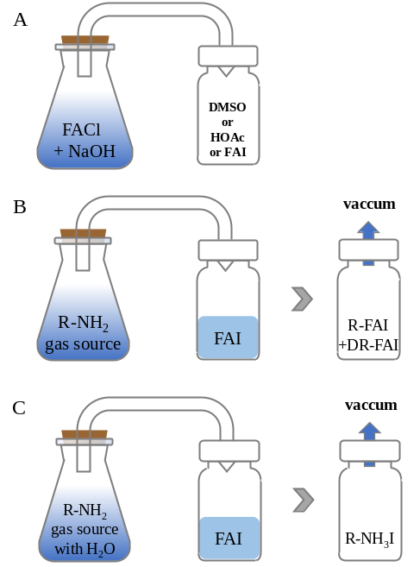
Figure S1 Schematic illusion of the chemical reaction between FACl (s) and NaOH (s) under different condition (A), the chemical reaction between amines gases and FAI salts and the reaction products after degassing in waterless (B) or water condition (C).

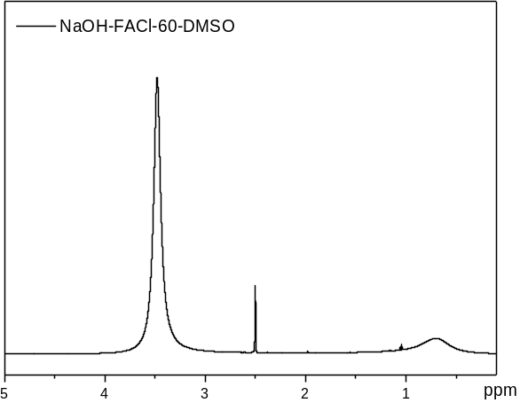
Figure S2 The ¹H NMR spectra of reaction product between FACl (s) and NaOH (s) under 60℃ in DMSO-d₆.
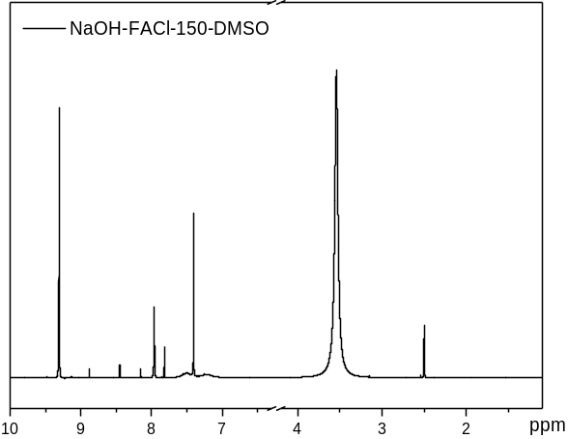
Figure S3 The ¹H NMR spectra of reaction product between FACl (s) and NaOH (s) under 150℃ in DMSO-d₆.

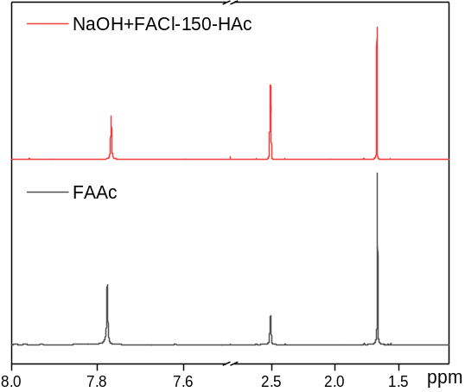
Figure S4 The ¹H NMR spectra of reaction product between FACl (s) and NaOH (s) under 150℃ in HOAc and FAAc standard sample.
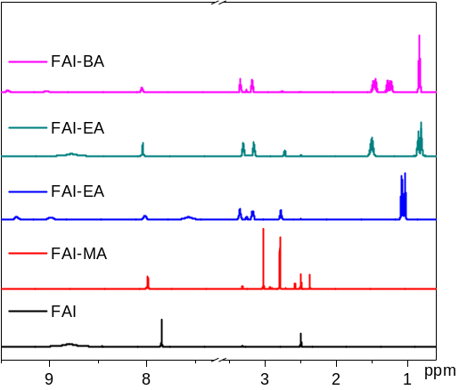
Figure S5 The ¹H NMR spectra of reaction product between FAI (s) and MA-BA(g).

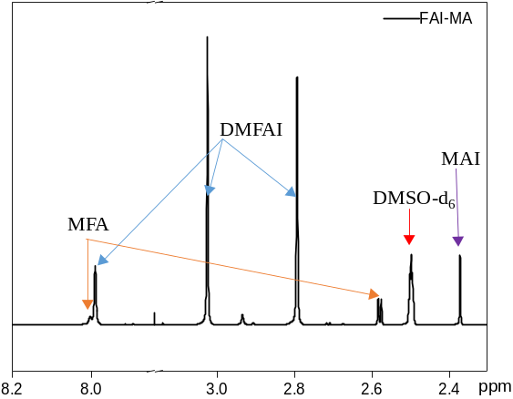
Figure S6 The ¹H NMR spectra of reaction product between FAI (s) and MA (g).

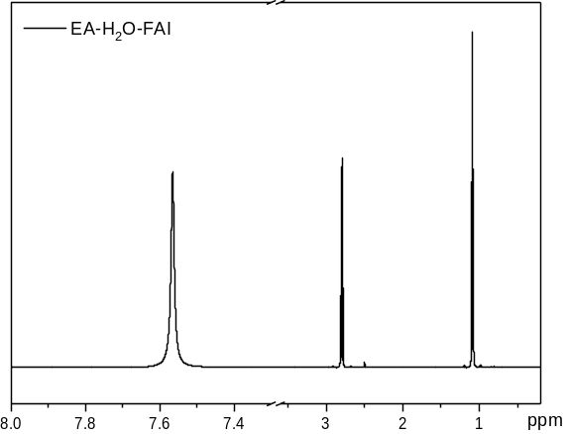
Figure S7 The ¹H NMR spectra of reaction product between FAI (s) and EA (g) with the presence of water.
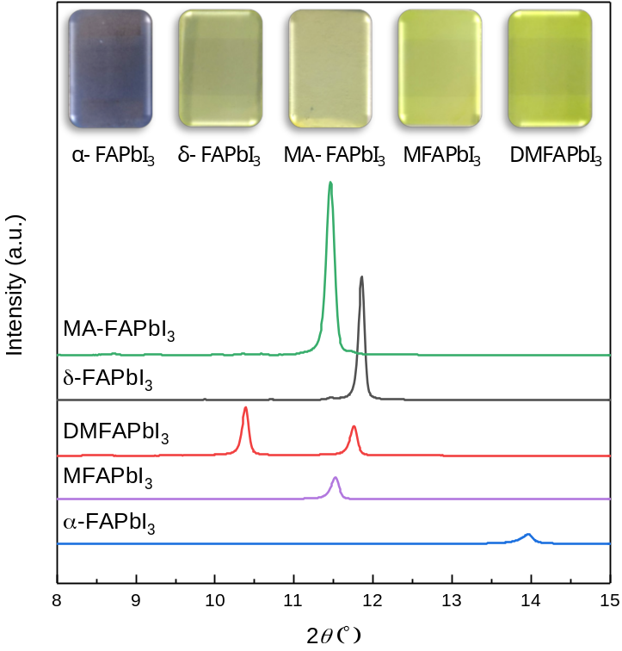
Figure S8 The XRD spectra of α-FAPbI₃, δ-FAPbI₃, MFAPbI₃, DMFAPbI₃ and MA-FAPbI₃ (MA-FAPbI₃ refers to the α-FAPbI₃ treated with MA gas; the inset are the optical photographs of the corresponding films).

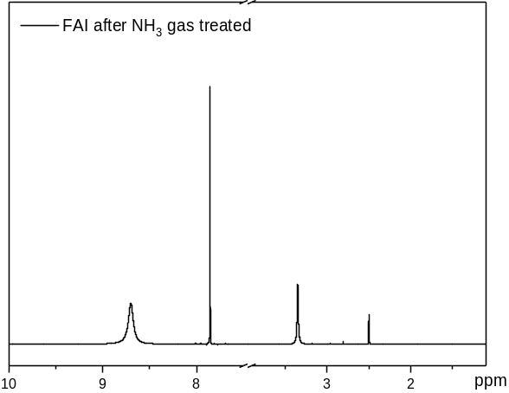
Figure S9 The ¹H NMR spectra of reaction product between FAI (s) and NH₃ (g).
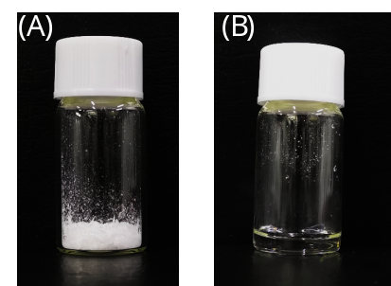
Figure S10 Photographs of: (A) FAI powder, (B) FAI powder under NH₃ gas, forming a liquid phase of FAI•xNH₃.

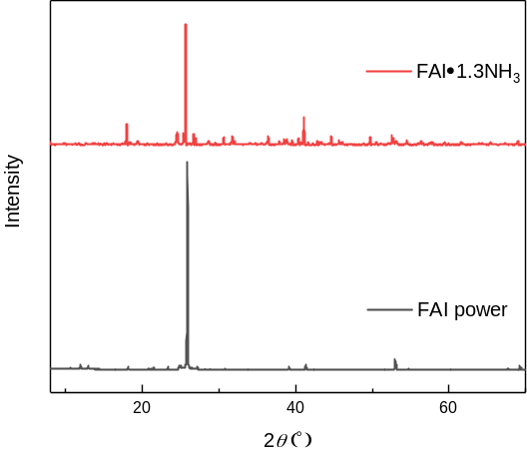
Figure S11 The XRD spectra of FAI·1.3NH₃ and FAI powder.

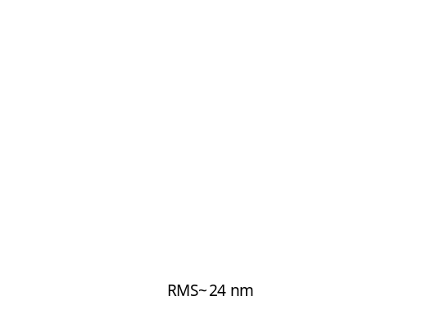
Figure S12 AFM images of top surfaces of FA_{0.9}Cs_{0.1}PbI₃ perovskite thin films (antisolvent).

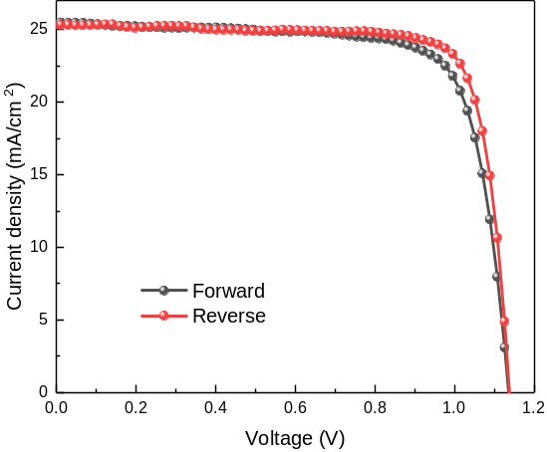
Figure S13 J-V curves of the champion PSC prepared by NGPH measured in both reverse and forward directions.

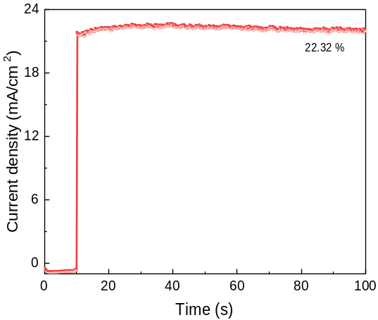
Figure S14 Stable power output of the NGPH-FACsPbI₃ perovskite solar cell.

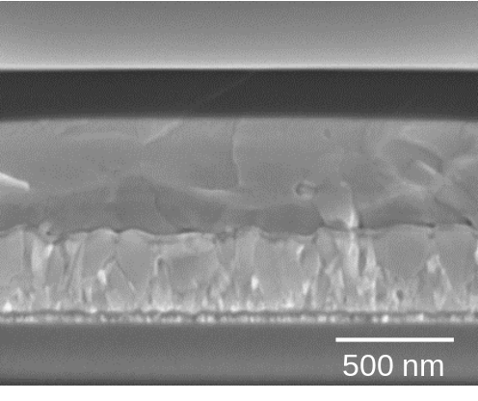
Figure S15 Cross-sectional SEM image of the healed FACsPbI₃ perovskite solar cell.
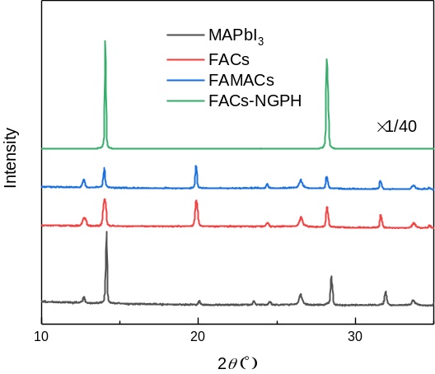
Figure S16 XRD patterns of the devices stored for 300 days.

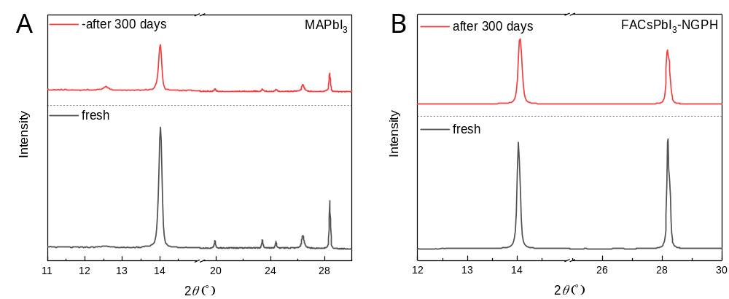
Figure S17 XRD patterns of the fresh films and the devices stored for 300 days (A is MAPbI₃ system and B is FACsPbI₃-NGPH system).

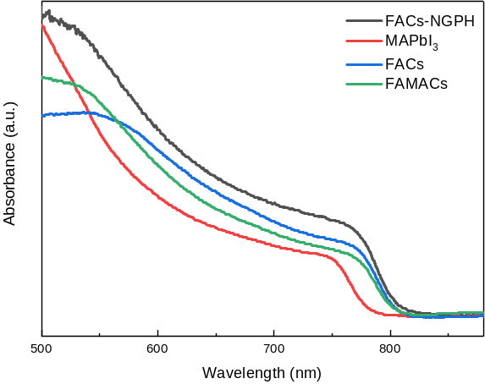
Figure S18 UV-vis spectra of the devices stored for 300 days.
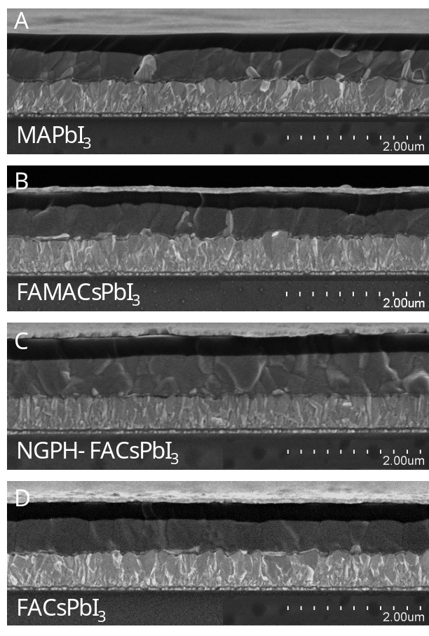
Figure S19 Cross-sectional SEM images of the devices stored for 300 days.

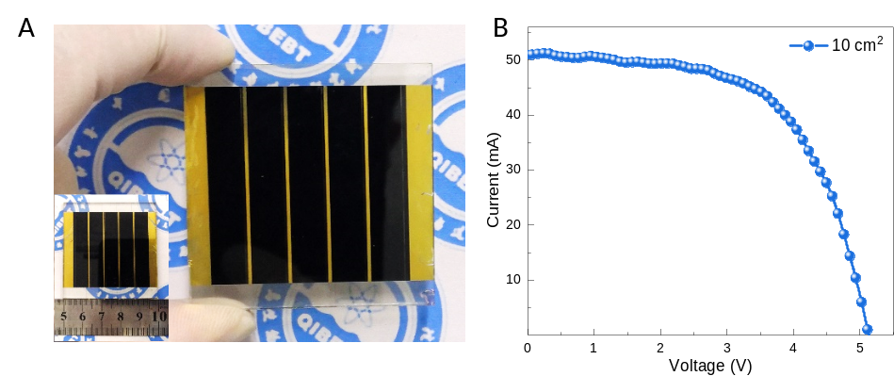
Figure S20 (A) Photograph and (B) current-voltage curve of the 5 cm × 5 cm PSM (series connection of 5 cells).

Scheme S1 The decomposition reaction of formamidine in the presence of NaOH.

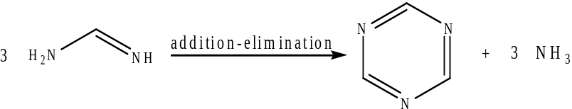
Scheme S2 The addition-elimination reaction of formamidine produces s-triazine and ammonia.

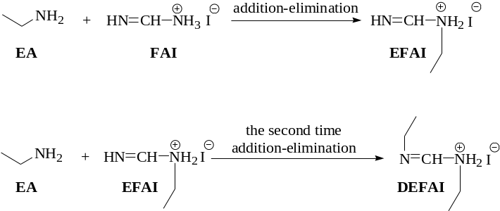

Scheme S3 The addition-elimination reaction between FAI and EA molecules to form the EFAI and DEFAI.

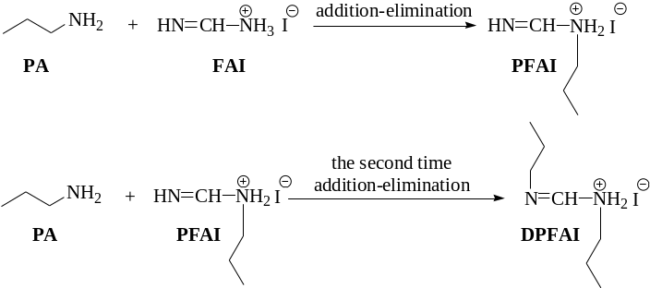

Scheme S4 The addition-elimination reaction between FAI and PA molecules to form the PFAI and DPFAI.

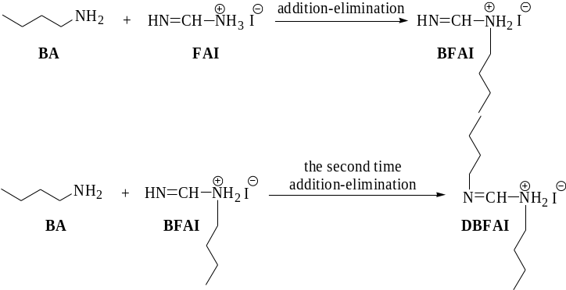
Scheme S5 The addition-elimination reaction between FAI and PA molecules to form the BFAI and DBFAI.

Table S1 Parameters of the champion PSC prepared by NGPH measured in both reverse and forward directions

Scan  direction | V_{OC}  (V) | J_{SC}  (mA/cm²) | FF  (%) | PCE  (%)
Forward | 1.138 | 25.35 | 76.58 | 22.10
Reverse | 1.140 | 25.36 | 80.61 | 23.31

Table S2 Parameters of the different active areas of PSC prepared by NGPH measured in reverse directions

Active area  (cm²) | Voc  (V) | Jsc  (mA/cm²) | Fill Factor  (%) | Efficiency  (%) | R_{s}  (Ω) | R_{sh}  (Ω)
0.16 | 1.02 | 25.19 | 77.37 | 19.88 | 9.93 | 6877.6
0.36 | 1.04 | 25.17 | 74.39 | 19.47 | 10.85 | 10474.1
0.64 | 1.06 | 25.18 | 70.85 | 18.91 | 13.20 | 17971.8
1.00 | 1.07 | 25.17 | 68.13 | 18.47 | 19.98 | 27007.5

