Supplementary Fig 1 Hierarchical clustering analysis of GEO and TCGA datasets. hclust clustering map of GEO (a) and TCGA (c) datasets; t-distributed Stochastic Neighbor Embedding (tSNE) cluster map of GEO (b) and TCGA (d) datasets.

Supplementary Fig 2 Correlation heat map of immune cells of GEO (a) and TCGA (b) datasets.

Supplementary Fig 3 Boxplot of ESTMATEScores of alive and dead patients in GEO (a) and TCGA (b) datasets.

Supplementary Fig 4 Kaplan-Meier plots of the immune high and immune low subtypes in GEO (a), gse13507 (b), and TCGA-BLCA (c) datasets.

Supplementary Fig 5 Kaplan-Meier plots of the immune high and immune low subtypes among the female (a, c) and male (b, d) patients in GEO (a, b) and TCGA (c, d) datasets.
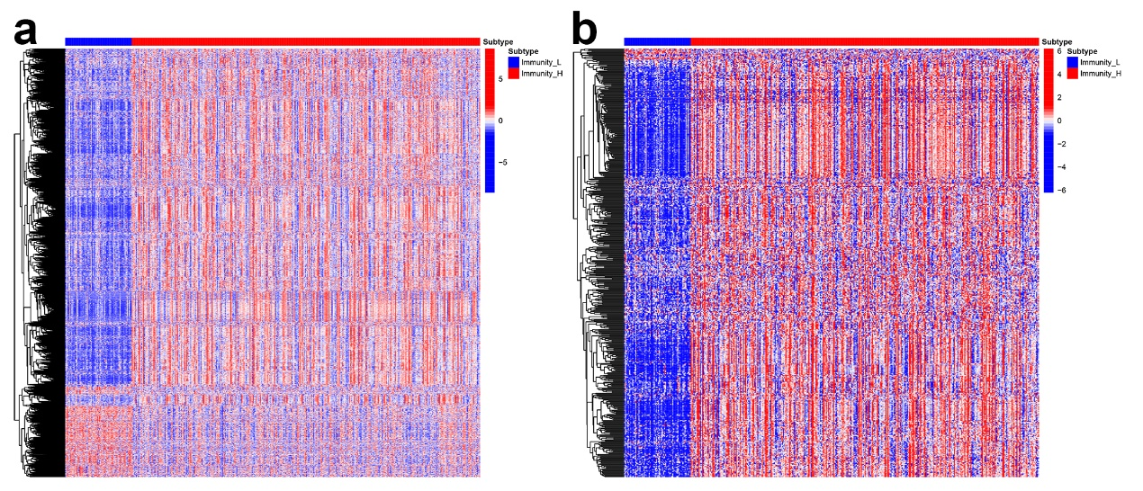
Supplementary Fig 6 Heatmaps of differential expression genes (a) and differential expression immune-related genes (b).

Supplementary Fig 7 Riskplot (a), scatterplot (b), and correlation scatterplot (c) of the validating cohort.

Supplementary Fig 8 Box-and-scatter plot of TMBs of the high-risk and low-risk subgroups.

