Additional file 1
Vancomycin-conjugated polydopamine-coated magnetic nanoparticles for molecular diagnostics of Gram-positive bacteria in whole blood
Abdurhaman Teyib Abafogi¹⁺, Tepeng Wu²⁺, Daekyu Lee¹, Jinyeop Lee^{1,2}, Gyoujin Cho^{3,4}, Luke P. Lee^{3,4,5}, Sungsu Park ^{1,4,*}
¹School of Mechanical Engineering, Sungkyunkwan University (SKKU), Suwon 16419, Korea
²KingoBio Inc., 31 Digital-ro 30-gil, Guro-gu, Seoul 08390, Korea
³Department of Biophysics, Sungkyunkwan University (SKKU), Suwon 16419, Korea
⁴Institute of Quantum Biophysics (IQB), Sungkyunkwan University (SKKU), Suwon 16419, Korea
⁵Renal Division, Department of Medicine, Brigham and Women’s Hospital, Harvard Medical School, MA 02139, USA
⁺Each author contributed equally to this work

*Corresponding authors: S. Park, School of Mechanical Engineering, Sungkyunkwan University (SKKU), Seobu-ro 2066, Jangan-gu, Suwon 16419, Korea. Tel: +82-31-290-7431. E-mail: nanopark@skku.edu

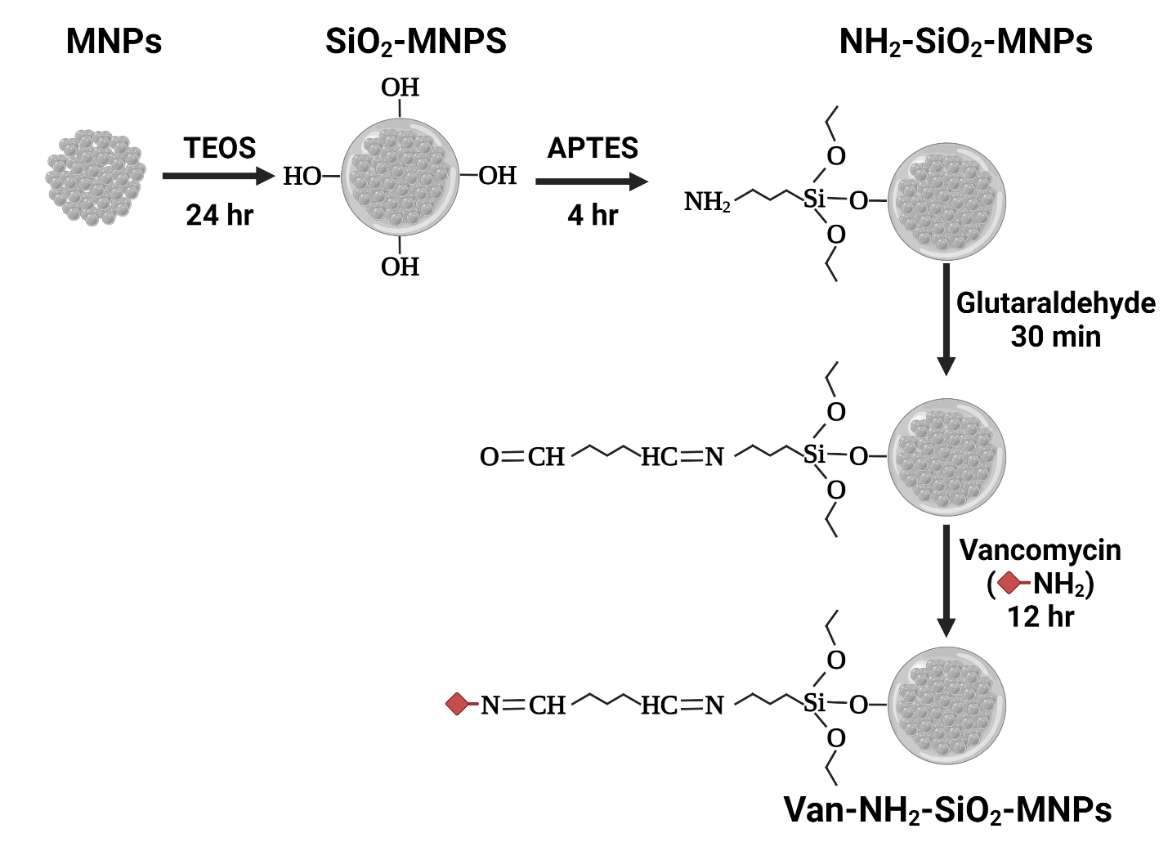
Fig. S1. Schematic representing the synthesis of vancomycin-conjugated silica oxide-coated magnetic nanoparticles (van-SiO₂-MNPs). Freshly prepared MNPs form larger MNPs through SiO₂ coating. SiO₂-MNPs are conjugated with van after amino group functionalization [1]. Tetraethyl orthosilicate (TEOS; Sigma-Aldrich). 3-Aminopropyltriethoxysilane (APTES; Sigma-Aldrich).

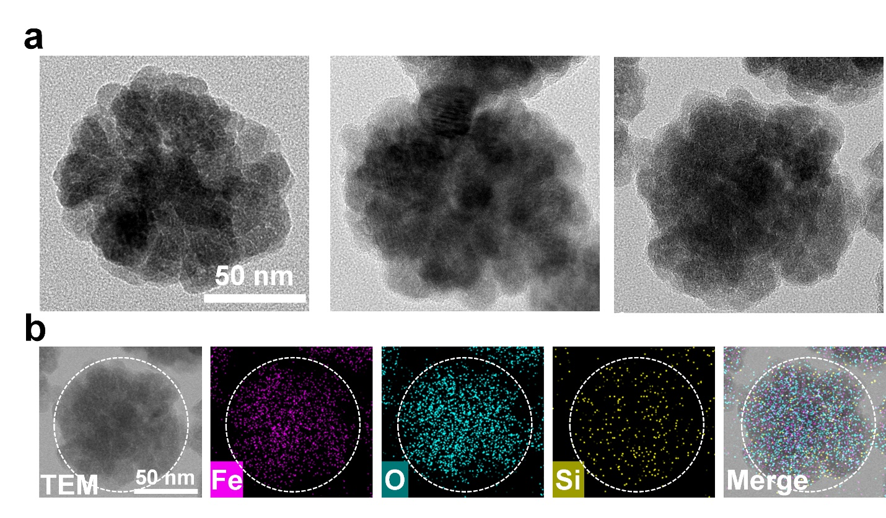Fig. S2. (a) Transmission electron microscopy images and (b) energy dispersive spectroscopy (EDS) mapping of van-SiO₂-MNPs.

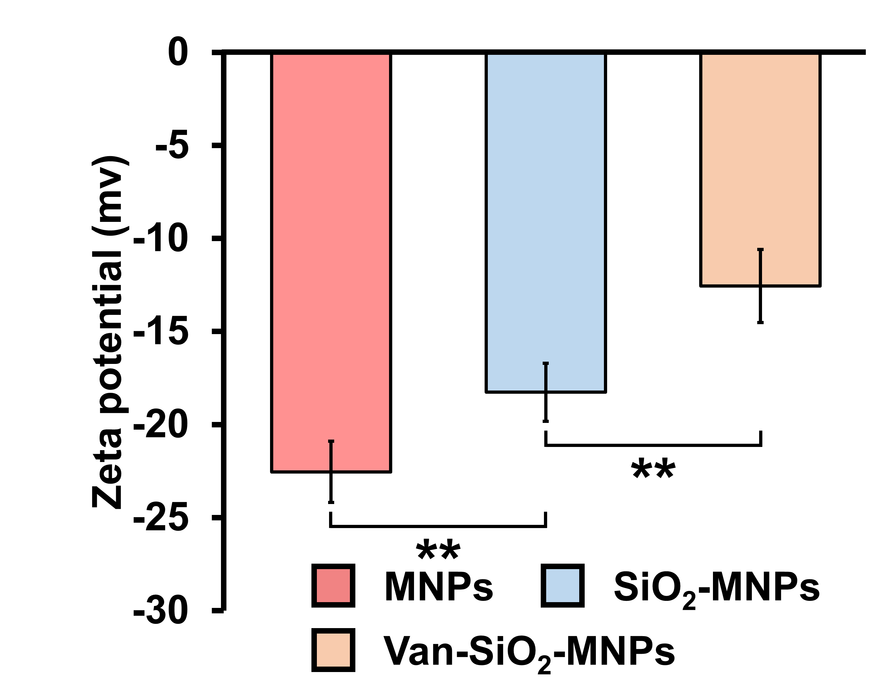
Fig. S3. Zeta potential of MNPs, SiO₂-MNPs and van-SiO₂-MNPs. The potential was measured using Zetasizer Nano ZS (Malvern Instruments, Malvern, UK). Student’s t-test. **: P < 0.01. *: P < 0.05. n = 3.

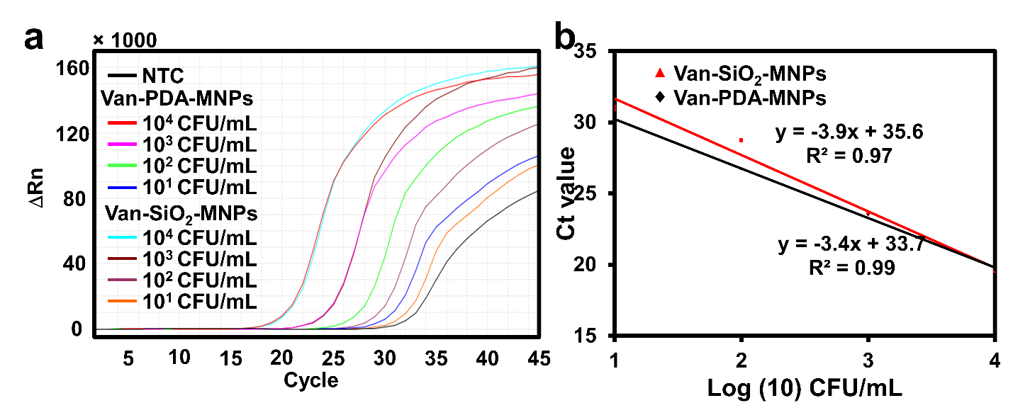
Fig. S4. (a) qPCR and (b) the standard curve (Ct value vs bacterial concentration) of S. aureus at different concentrations (10-10⁴ CFU/mL) in PBS preconcentrated by van-SiO₂-MNPs and van-PDA-MNPs. Forward (5'-ACACCTGAAACAAAGCATCC-3') and reverse (5'-TAGCCAAGCCTTGACGAACT-3') primers were used, to amplify a 207-bp of nuc gene from S. aureus [2].

References
1.
2. L.E. O'Donnell, K. Smith, C. Williams, C.J. Nile, D.F. Lappin, D. Bradshaw, M. Lambert, D.P. Robertson, J. Bagg, V. Hannah. Dentures are a reservoir for respiratory pathogens. J. Prosthodont. 2016; 25: 99-104.

