Supplementary Information

Title:
Disruption of gastric mucous granule exocytosis by Helicobacter pylori virulence factor CagA

Authors:
Ryo Ninomiya, Shuichi Kubo, Tooru Kajiwara, Hiroko Koizumi, Akinori Tokunaga, Tomohisa Uchida, Hiroaki Nabeka, Takuya Doihara, Cheng Li, Tetsuya Shimokawa, Seiji Matsuda, Naoto Kobayashi, Kazunari Murakami, Toshiro Aigaki, Mitsunori Fukuda, Yoshio Yamaoka, Fumihiko Hamada*

*Correspondence:
hamadaf1@oita-u.ac.jp

Supplementary Figures 1 to 4
Supplementary Table 1

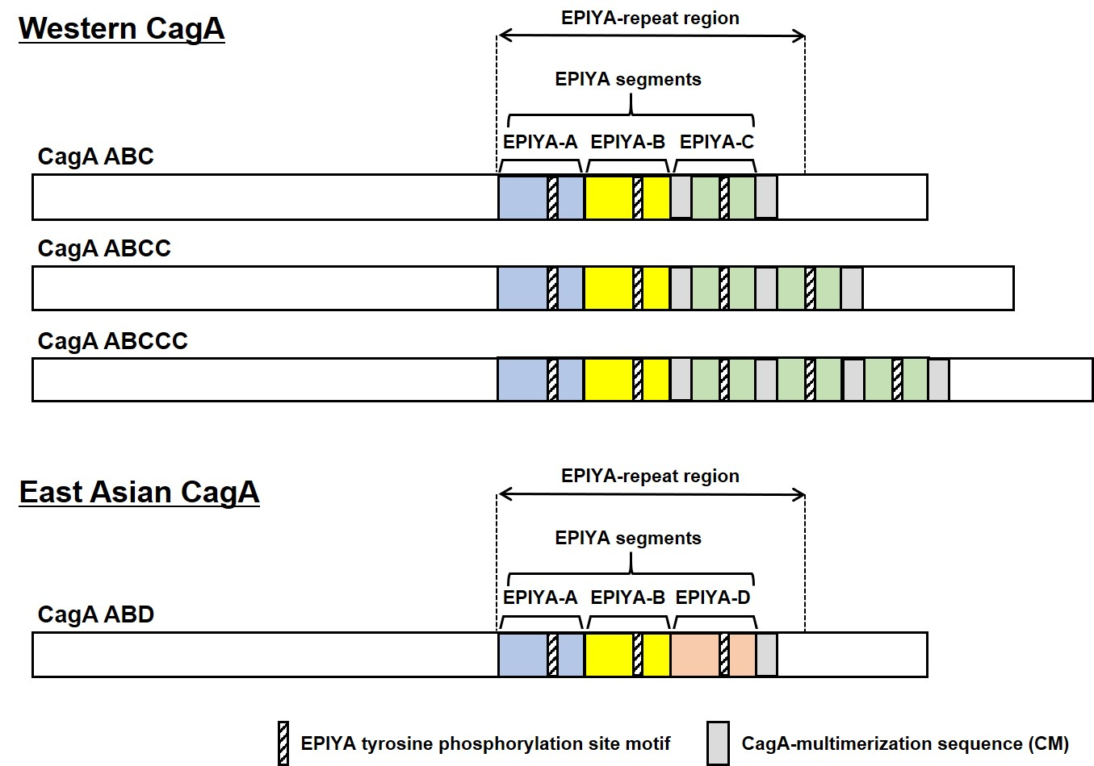
Supplementary Fig. 1

Structural polymorphism in H. pylori CagA.
Schematic representation of CagA. Western CagA contains EPIYA-A, EPIYA-B and EPIYA-C segments, while East Asian CagA contains EPIYA-A, EPIYA-B and EPIYA-D segments. Western CagA possesses at least two CagA-multimerization sequence (CM), whereas East Asian CagA possesses a single CM.

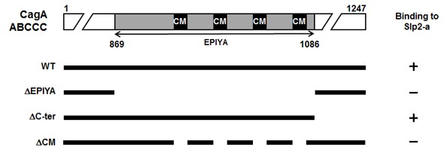
Supplementary Fig. 2

A schematic diagram of the CagA ABCCC deletion mutants used in co-immunoprecipitation with Slp2-a and the results of binding.

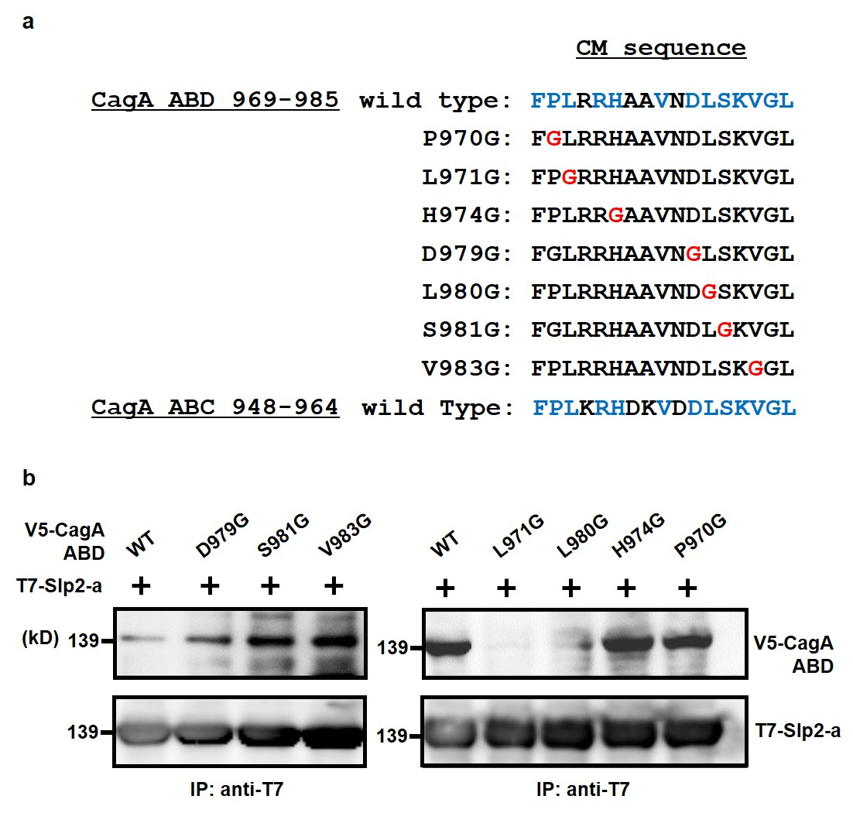
Supplementary Fig. 3

Mutation of L971 in the CM sequence of CagA ABD abolishes its binding to Slp2-a.
a, Amino acid sequence alignment of the CM sequence of CagA ABD (H. pylori strain TN) and ABC (H. pylori strain 26695). Conserved residues are in blue type. b, Glycine substitution at L971 of CagA ABD abolishes binding of Slp2-a to CagA ABD. V5-tagged full-length (WT) and a series of substitution mutant forms of CagA ABD shown in (a) were co-expressed with T7-tagged Slp2-a in COS-7 cells. Lysates were immunoprecipitated (IP) with anti-T7 antibodies and associated V5-CagA ABD was detected by immunoblotting with anti-V5 antibodies.

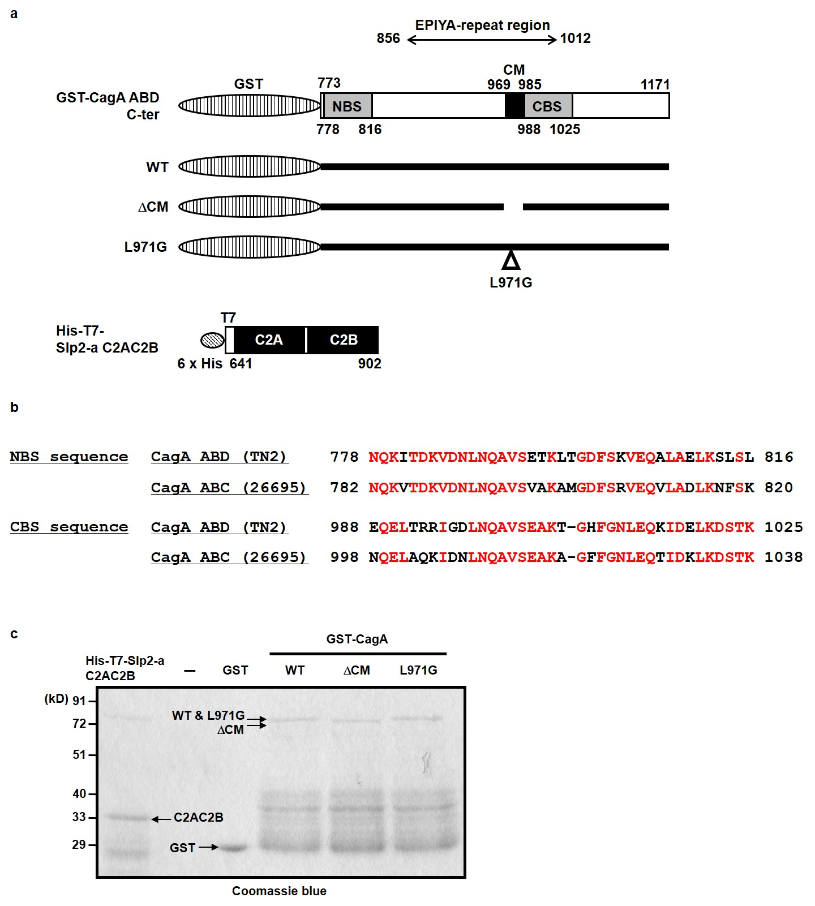
Supplementary Fig. 4
The recombinant proteins used in protein-lipid overlay assays.
a, Schematic representation of the recombinant proteins used in Protein-lipid overlay assays. GST and 6xHis tags were used for the purification. NBS (N-terminal Binding Sequence) and CBS (C-terminal Binding Sequence) are conserved structural domains present in the CagA protein. b, Amino acid sequence alignment of the NBS and CBS sequence of CagA ABD (H. pylori strain TN) and ABC (H. pylori strain 26695). Conserved residues are in red type. c, Coomassie blue staining of purified recombinant proteins.

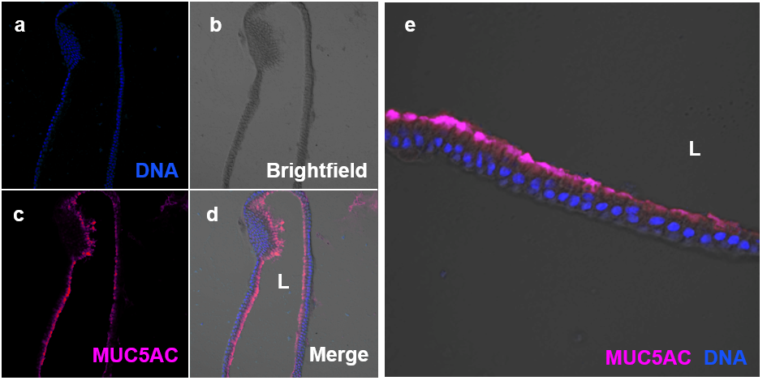
Supplementary Fig. 5

Immunofluorescence of fundic organoid-derived monolayers of polarized surface mucous cells.
a-d, Immunofluorescence shows magenta staining for a gel-forming mucin MUC5AC and blue staining for nuclei. e, Higher magnification views. L, lumen

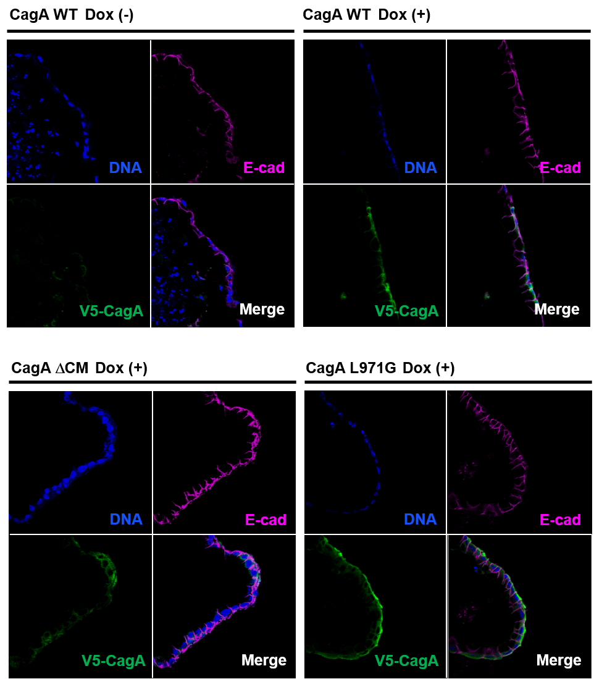
Supplementary Fig. 6

Dox-induced expression of V5-CagA WT, ΔCM, or L971G in the fundic organoid-derived monolayers of polarized surface mucous cells.
Immunofluorescence shows green staining for V5-CagA WT, ΔCM, or L971G, magenta staining for E-cadherin and blue staining for nuclei.
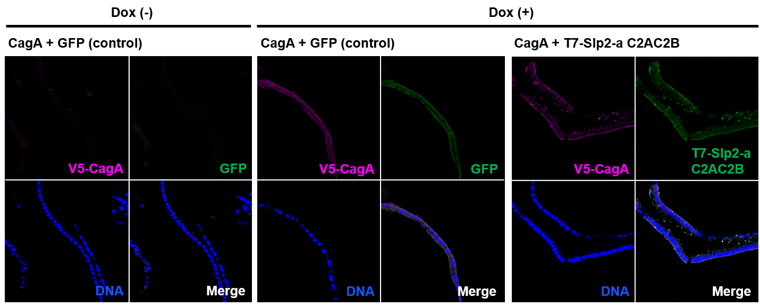
Supplementary Fig. 7

Dox-induced co-expression of V5-CagA WT + GFP or + T7-Slp2-a C2AC2B in the fundic organoid-derived monolayers of polarized surface mucous cells.
Immunofluorescence shows green staining for GFP or T7-Slp2-a C2AC2B, magenta staining for V5-CagA WT and blue staining for nuclei.

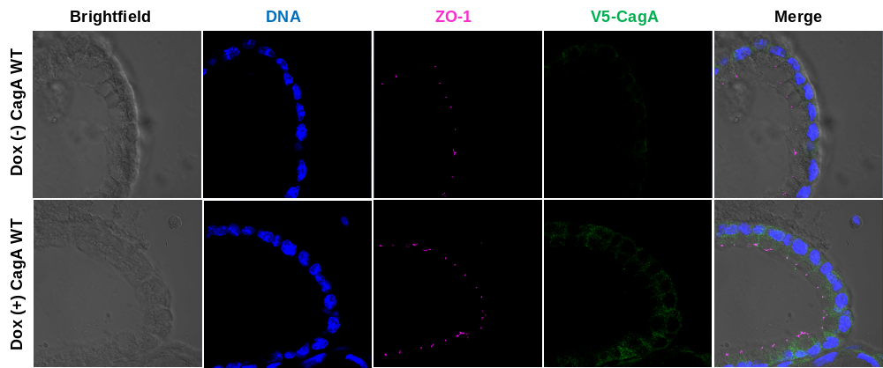
Supplementary Fig. 8

Subcellular localization of ZO-1 in the fundic organoid-derived monolayers of CagA WT-expressing surface mucous cells and control cells.
Immunofluorescence shows magenta staining for ZO-1, green staining for V5-CagA WT and blue staining for nuclei.

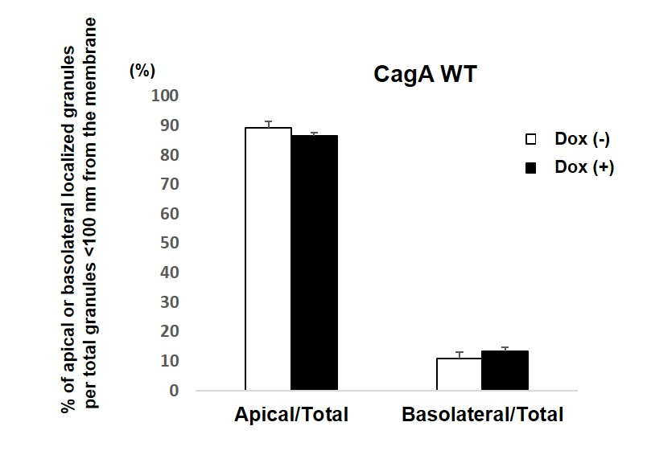
Supplementary Fig. 9

Percentages of apically- or basolaterally-sorted granules in the total granules localized < 100 nm from the plasma membrane in the fundic organoid-derived monolayers of CagA WT-expressing surface mucous cells and control cells.
Tight junctions define the boundary between apical and basolateral domains of the plasma membrane. 155 granules (control cells) or 112 granules (CagA WT-expressing cells) were counted (n = 3 cells in 3 organoids). Error bars indicate standard deviations.

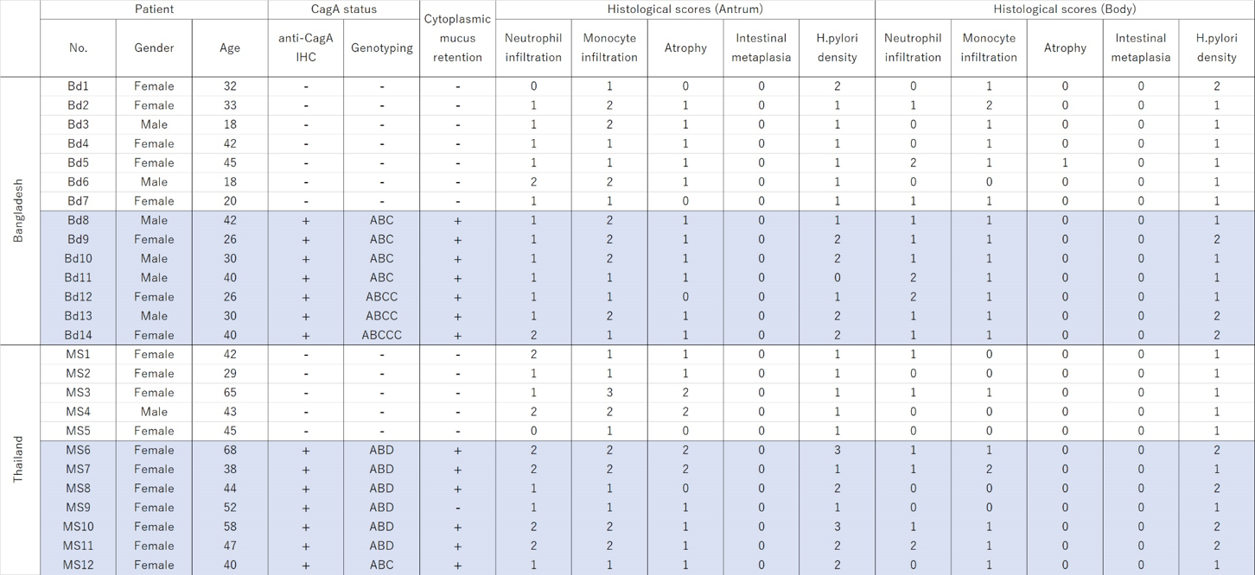
Supplementary Table 1
Histological scores, CagA status and mucus retention phenotypes of the gastric biopsy specimens.
Histological scores were classified into four grades according to the updated Sydney system: 0, ‘normal’; 1, ‘mild’; 2, ‘moderate’; and 3, ‘marked’. Mucus retention phenotypes were classified into two categories, negative (-), ‘low levels of mucus can be observed in the apical surface of the cells’; positive (+), ‘high levels of mucous accumulation can be observed in the cytoplasm of the cells’. Patients were renumbered for this article.

