Supplementary Fig. 1. Histogram of quantile-quantile plots for test of association between each pair of human host and Mtb variants. A histogram summarizing all genomic inflation factors over 1,267 genome-wide association studies. The distribution ranges between 0.97 and 1.07 with median 1.01 (red vertical line).

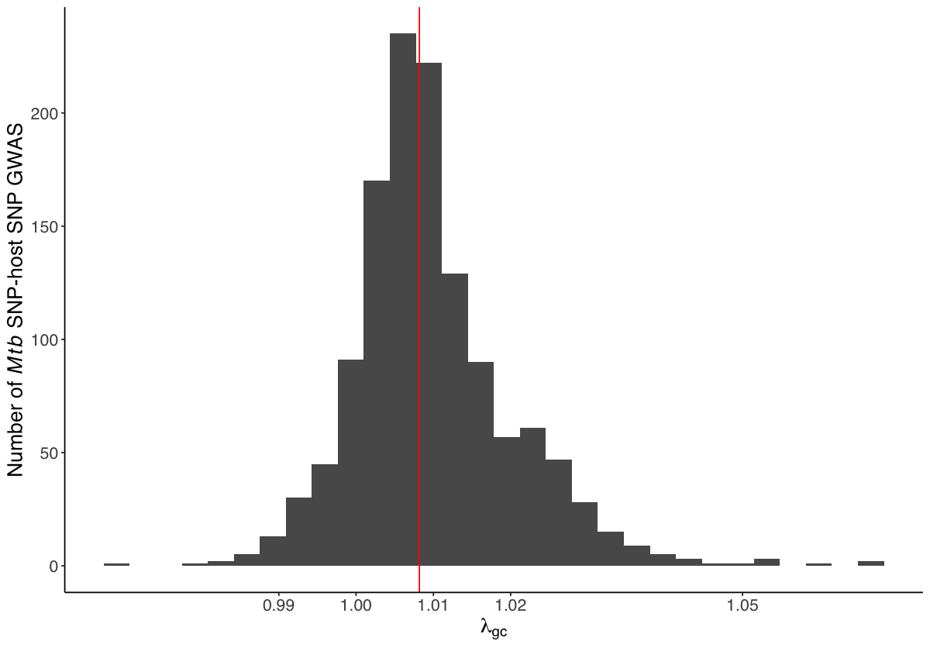

Supplementary Fig. 2. Empirical estimation of genome-wide significance threshold for the genome-to-genome analysis. The -log₁₀P_{min} distribution from 200 permuted genome-to-genome analyses. For each interaction, we randomly assign the presence/absence status of the Mtb variant for each individual. The vertical bar in the panel represents the top five percentile of -log₁₀P_{min} (that is, the estimated empirical genome-wide significance -log₁₀P_{sig}). The dotted gray and black vertical bar represents the common genome-wide significance threshold of 5 ⨉ 10⁻⁸ and the Bonferroni corrected significance threshold after multiple testing (5 ⨉ 10⁻⁸ /1,267 = 3.95 ⨉ 10⁻¹¹).

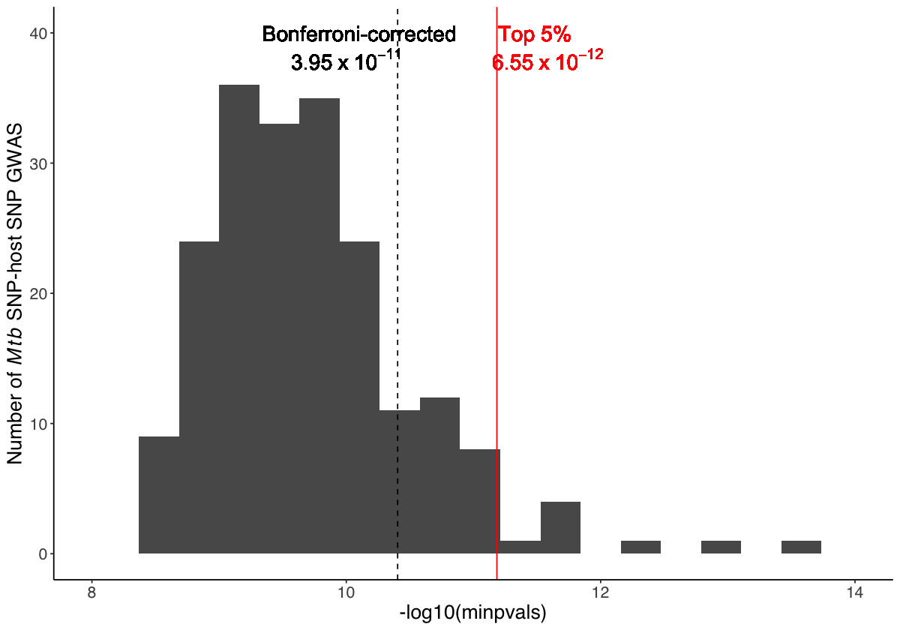

Supplementary Fig. 3. eQTL effect of rs3130660 for FLOT1. Violin plot of FLOT1 expression level in a adipose visceral tissue and b lung tissue included in the GTEx project, where rs3130660-A is associated with increased FLOT1 expression. Y-axis shows the normalized gene expression between samples. Boxplots show median (horizontal white bar), 25th and 75th percentiles (lower and upper bounds of the box, respectively). P-value is obtained using FastQTL. Number of individuals included in the analysis for each genotype are in brackets. The figures are modified based on raw data downloaded from the GTEx portal (https://gtexportal.org/).

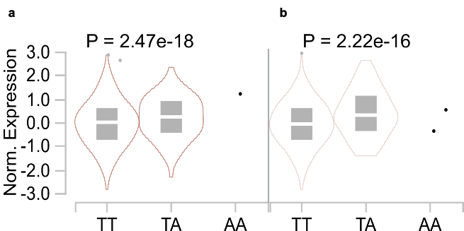

Supplementary Fig. 4. Correlation between g2g and eQTL p-values in the human FLOT1 locus. A correlation plot between -log₁₀(p-value) of the g2g and FLOT1 eQTL (in lung, GTEx) analyses. The correlation coefficient (Pearson r = 0.88) and the p-value of correlation (P = 1 ⨉ 10⁻³⁹¹⁷) is obtained from a linear regression weighted by the effect size of both g2g and eQTL study. The LD r² is obtained using the enrolled Peruvian dataset.
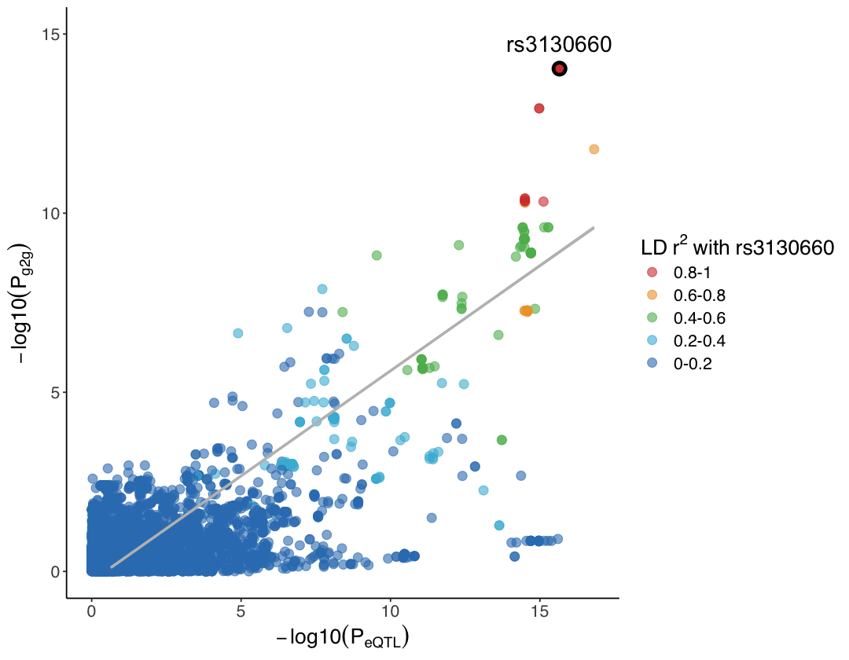

Supplementary Fig. 5. Colocalization analysis of the host genomic locus that is significantly associated with the Mtb genome. Each grid represents the posterior probability using coloc. The color gradient represents from low (posterior probability = 0, gray) to high (posterior probability = 1, red) probability of shared causal variants between the host g2g associations and eQTL among 69 distinct cell types and tissues (108 bulk RNA sequencing datasets) and 49 genes in a ±700kb window of the most significant g2g SNP (rs3130660). The eQTL summary statistics are downloaded from eQTL catalog release 4. Source data are provided in Supplementary Table 3.
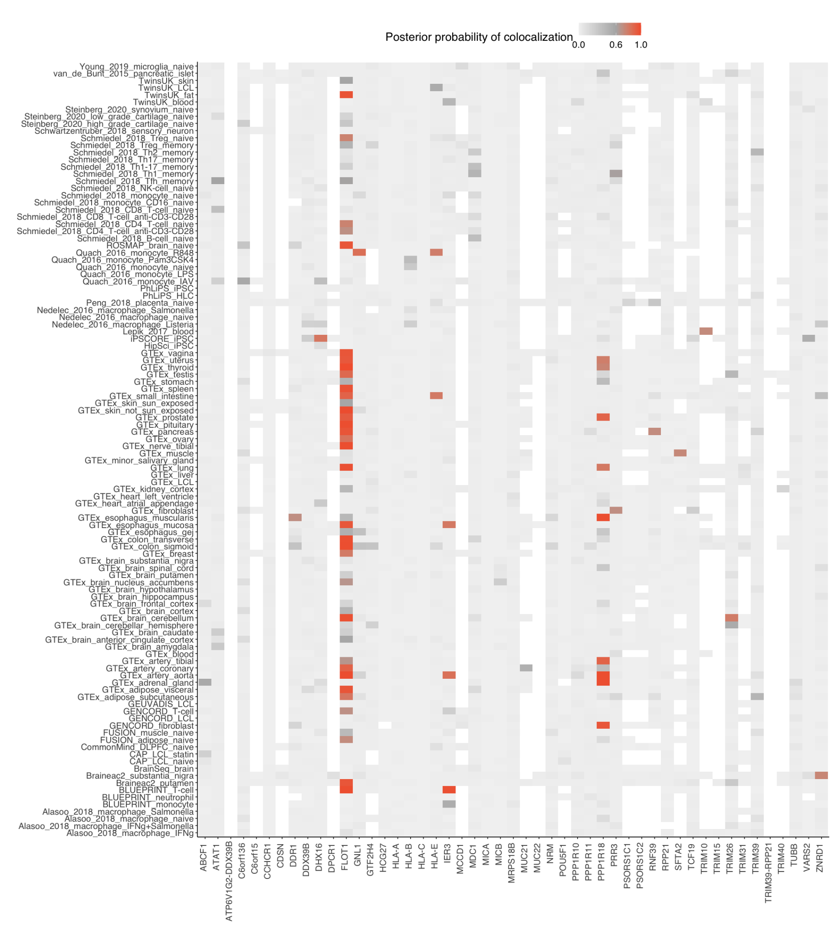

Supplementary Fig. 6. Odds ratios for association of host variant rs3130660 with the Mtb variant (Position 271640) in 1,556 TB patients. Plot shows parameter estimates (odds ratios, points) and 95% confidence interval (horizontal line segment) for the association of host and Mtb genotype at the most significant association site. We run a mixed effect logistic regression where we assume an additive model and correct for various covariates (rows). GRM represents a genetic relationship matrix to account for cryptic relatedness and population structure. First 10 principal components of the Mtb genome were constructed using all 2,298 common Mtb variants. We constructed 10 alternative Mtb principal components of the Mtb genome by using all common Mtb variants, but excluding the 79 g2g-L2 Mtb variants that are significantly associated with the human genome.
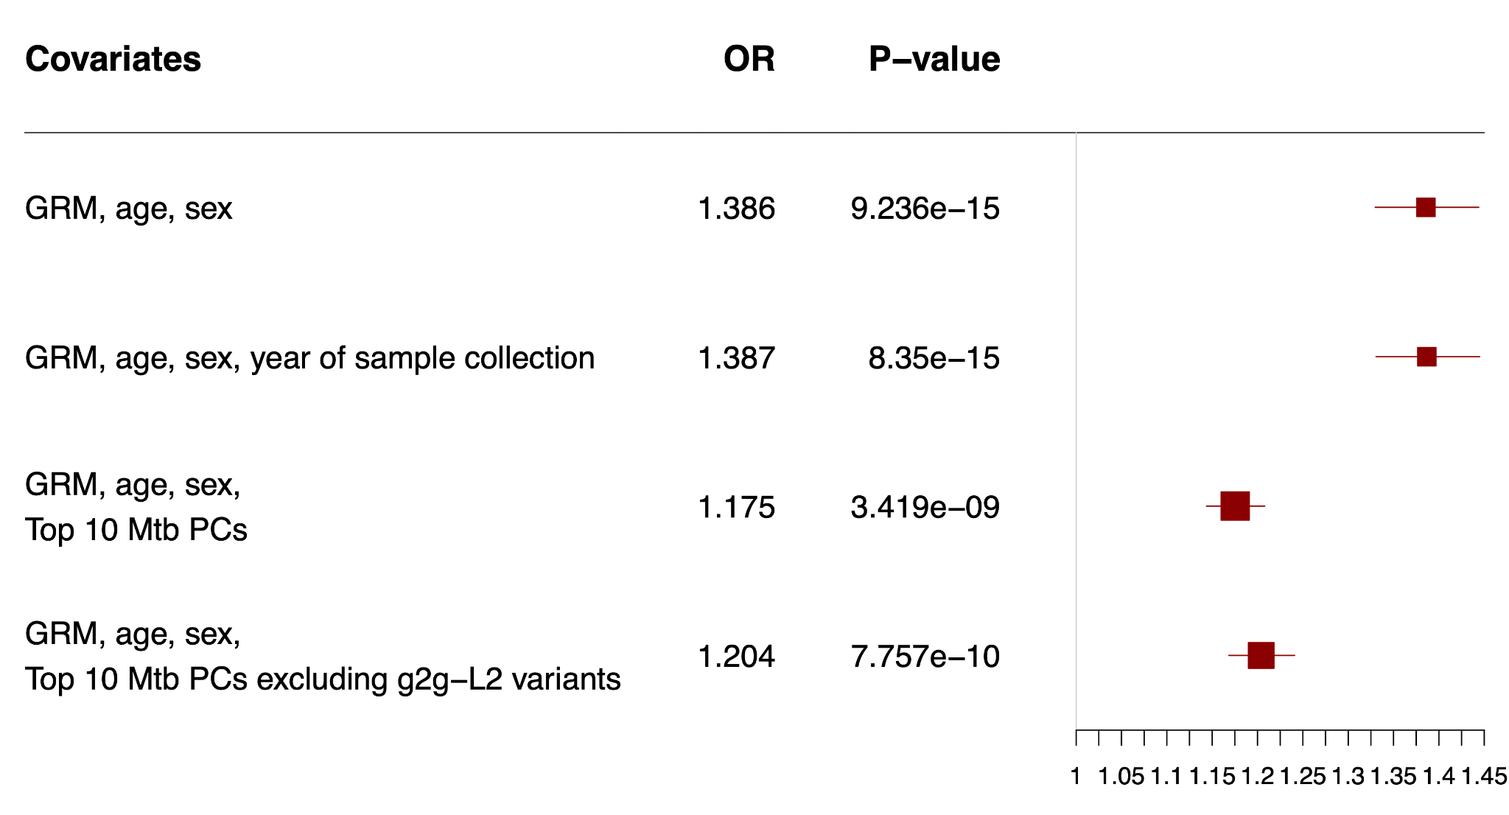

Supplementary Fig. 7. The constitution of different sublineages for each of the four year of collection (2009 - 2012). Each color represents different inferred lineages. g2g-L2 (red) represents the unique clade of lineage 2 (other non-g2g L2 sublineages in dark red) identified in this study.

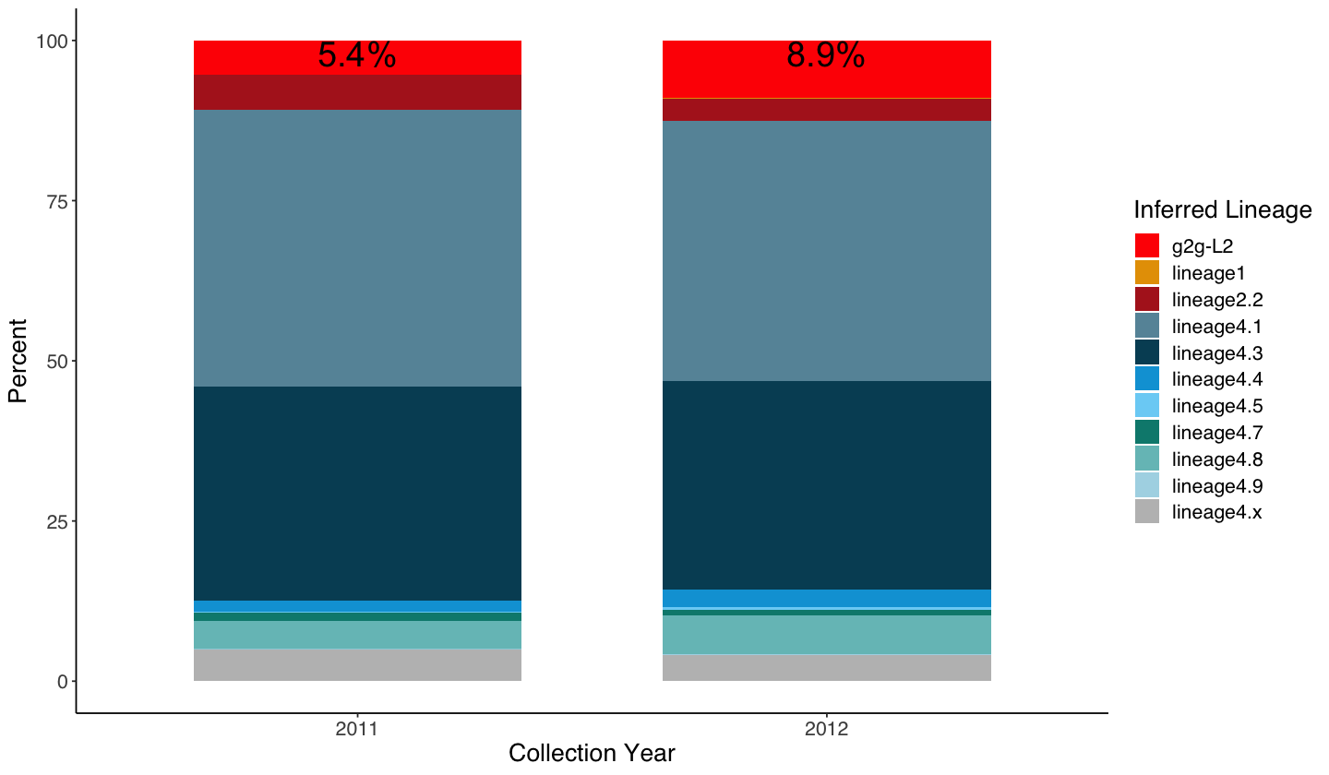

Supplementary Fig. 8. Geographic distribution of enrolled Mtb isolates. Each point on the map represents the clinic where the Mtb sample is collected, and is colored by its inferred lineage. g2g-L2 lineages are defined by the phylogenetic marker (Position 271640). This map shows collected Mtb sublineages were randomly distributed geographically.
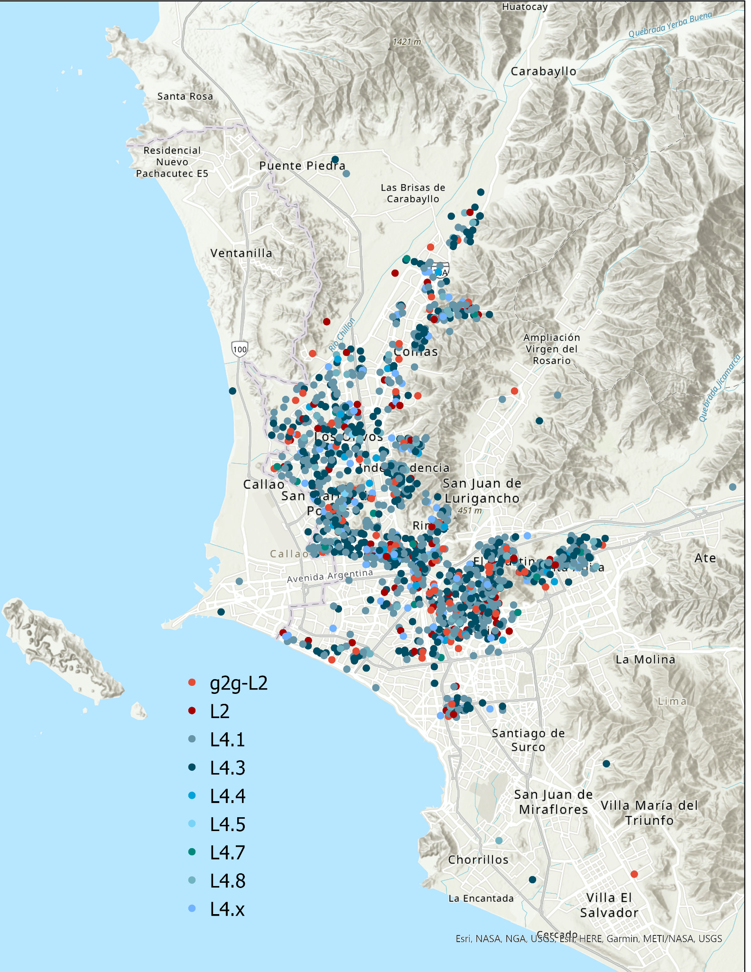

Supplementary Fig. 9. Genetic ancestry analysis of the 1,556 Peruvian human host genomes. a. First and second principal components of the Peruvian genomes merged with samples included in the 1000 Genomes Project covering five global populations. b. ADMIXTURE plot of the Peruvian genomes and other global populations (K=5). Each individual is represented as a thin vertical bar. The colors represent the proportion of ancestry assigned to each cluster for each individual. Reference panels are from the 1000 Genomes Project. SAS represents South Asian; EAS represents East Asian; AFR represents African; EUR represents European; LIMA represents Peruvians collected from this cohort, from Lima, Peru.
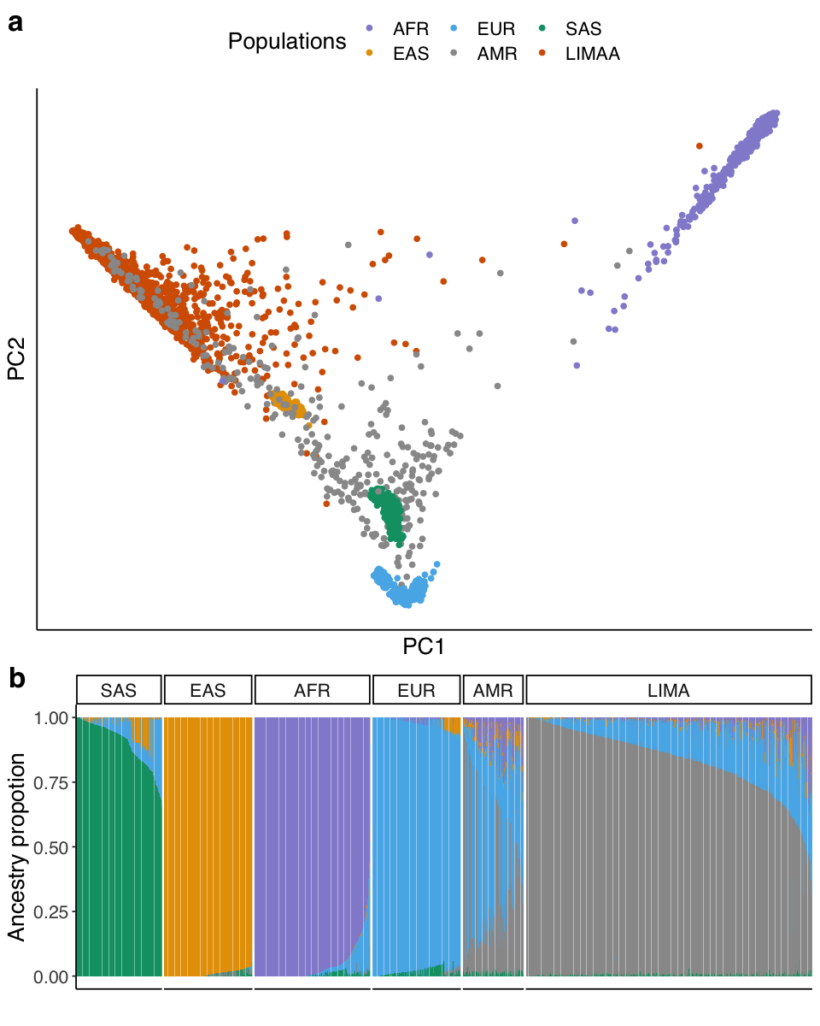

Supplementary Fig. 10. Genetic structure of Peruvian Mtb isolates. a. A maximum likelihood phylogenetic tree of the collected 1,556 Peruvian Mtb isolates. The branches of the tree were colored according to the sublineages. b. Pie chart shows the proportion of different sublineages collected in the study.
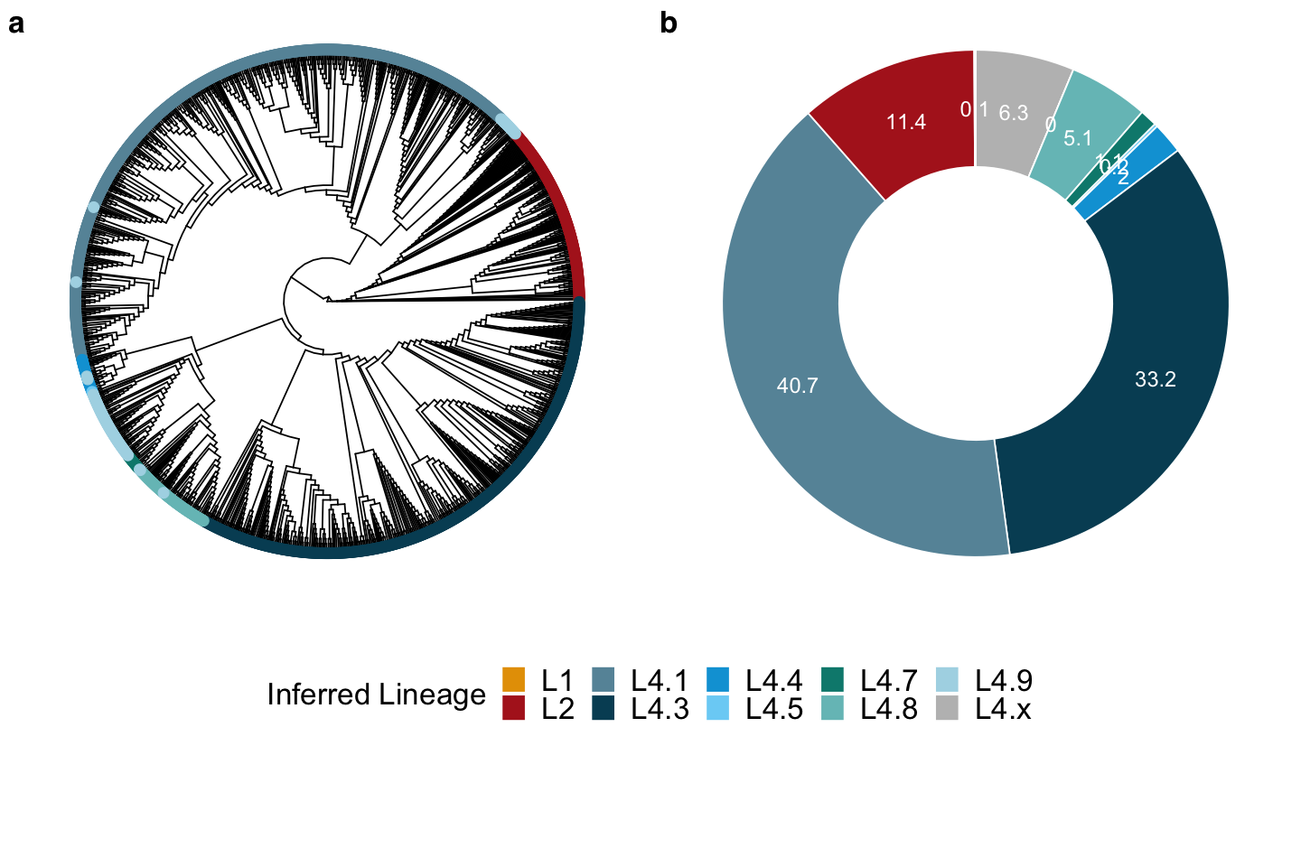

Supplementary Fig. 11. Human variant-to-Mtb lineage genome-wide association study in 1,556 tuberculosis patients. We tested genomic interplay between Mtb lineage and host variants. We performed mixed effects logistic regression assuming an additive model and correcting for host cryptic relatedness, population structure, age and sex. a. Manhattan plot of the GWAS analysis when treating two main Mtb lineages as outcome variable (i.e., a binary trait with L2 = 1 and L4=0) prior to imputation. The x-axis denotes the human genomic positions with alternating colors for each chromosome (1-22, X). The y-axis denotes the -log₁₀(P) value from the logistic regression. The red dotted line denotes the genome-wide significance threshold (5 x 10⁻⁸). b. Q-Q plot of the GWAS p-values shown in a. c. Regional plot of the MHC region after imputing using a multi-ancestry MHC reference panel. The most significant association is at an intron variant rs3130660 of FLOT1. Variants lying within the six classical HLA genes are highlighted in red (HLA-A), blue (HLA-B), green (HLA-C), purple (HLA-DQA1), orange (HLA-DQB1) and yellow (HLA-DRB1). All variants that are not in the classical HLA genes are in gray.
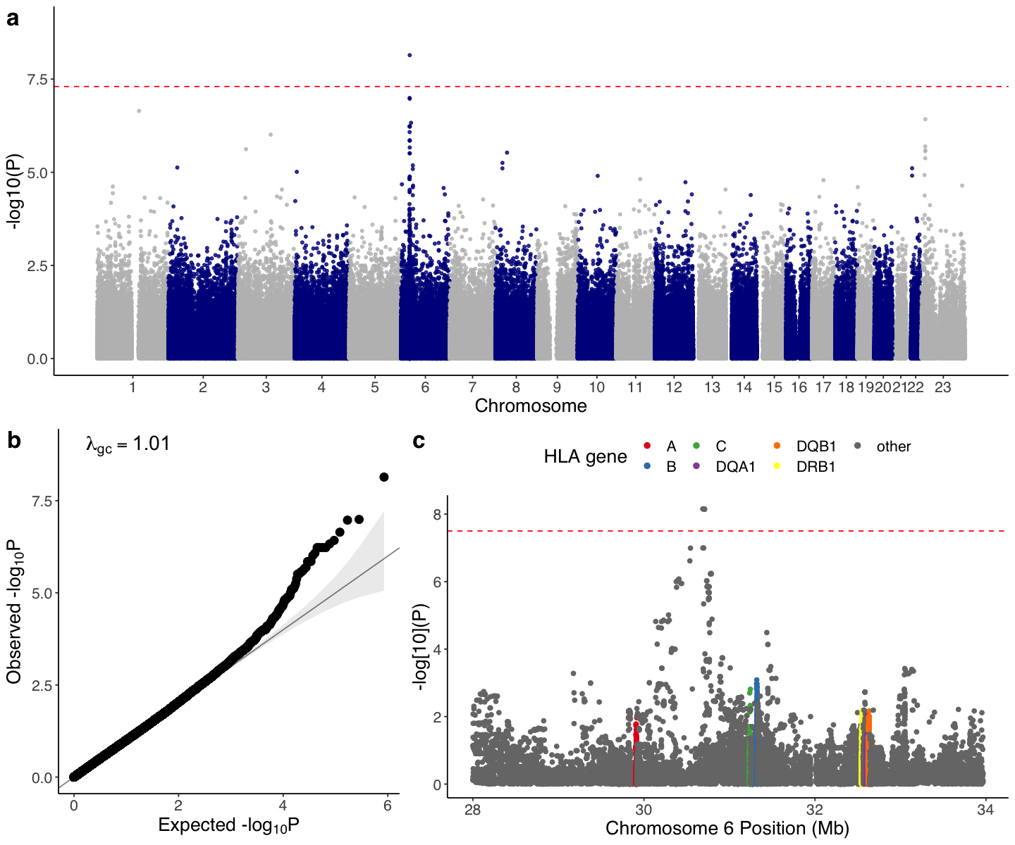

Supplementary Fig. 12. Peruvian L2 isolates and their global neighbors. A maximum likelihood phylogenetic tree of Peruvian L2 and 1,000 L2 isolates obtained globally (shown in gray). A total of three Peruvian L2 clades (g2g-L2 in red, clade-B in blue and clade-C in green) are marked. Other Peruvian L2 isolates that do not belong to the three marked clades are shown in pale orange.
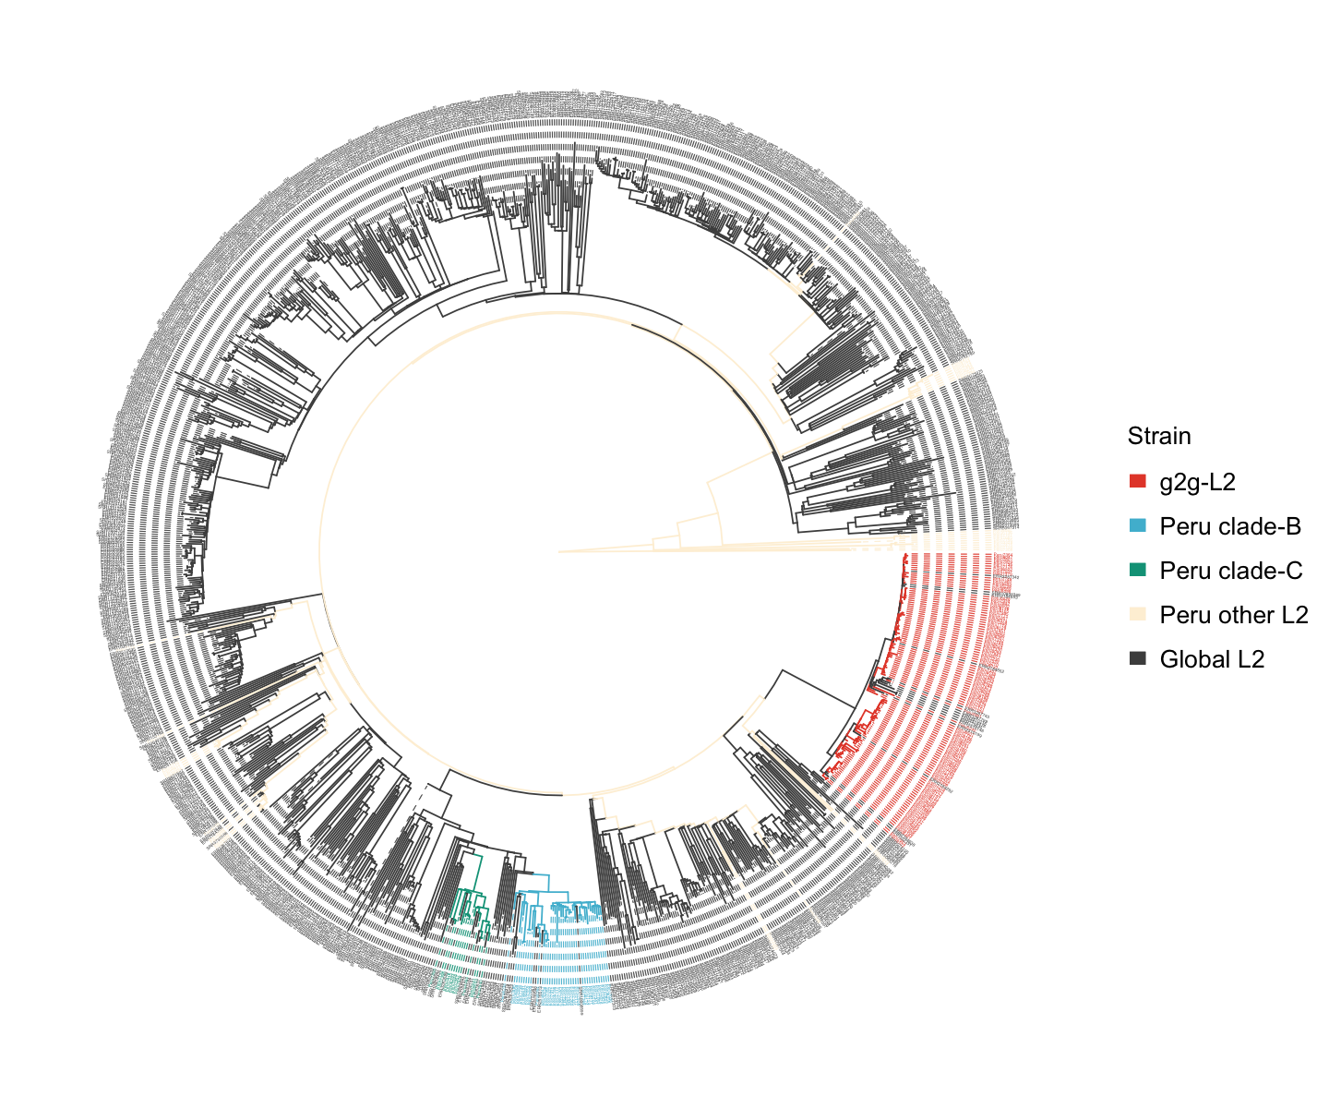

Supplementary Fig. 13. Geographic distribution of Peruvain L2 Mtb isolates. Each point on the map represents the clinic where the Mtb isolate was collected, and is colored by its inferred lineage. g2g-L2 lineages are defined by the phylogenetic marker (Position 271640).
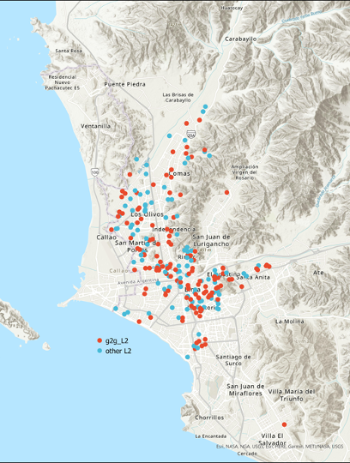

Supplementary Fig. 14. High degree of correlation between biological replicates assayed via microscopy platform. Independent biological replicates were assessed through the microscopy platform for each g2g-L2 and non g2g-L2 strain. For each of the seven features [cell length, median cell width, cell area, Nile Red (TRITC), NADA incorporation (FITC), CFP (F₄₂₀-ox) and DNA staining (DAPI)], the Pearson correlation between replicates of each strain are shown. Each point represents a different Mtb strain.
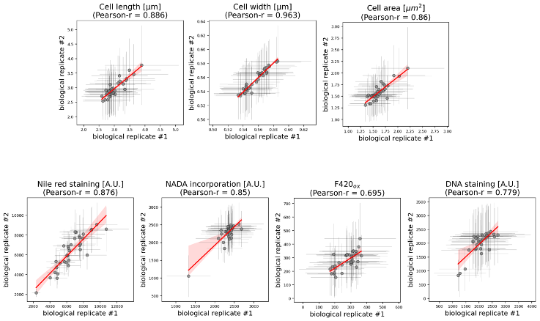

Supplementary Fig. 15. Functional annotation clustering of Mtb genes with nonsynonymous mutations defining g2g-L2 subclade. Two enriched functional annotation clusters generated by DAVID (https://david-d.ncifcrf.gov/) using 48 Mtb genes with nonsynonymous changes in g2g-L2 defining variants (Supplementary Table 2). a shows g2g-L2 genes overlap with ATP binding pathways; and b shows g2g-L2 genes overlap with redox-related pathways.
​​