Supplementary information
Anticipating the occurrence and type of critical transitions

Florian Grziwotz, Chun-Wei Chang, Vasilis Dakos, Egbert van Nes, Markus Schwarzländer, Martin Hess, Oliver Kamps, Isao Tokuda, Arndt Telschow, Chih-hao Hsieh

This file includes:
Supplementary Information Text
Additional analysis on the meta-population model using multivariate DEV
Limitations of DEV method in analyzing atypical transitions

Figures S1 to S16
Tables S1 to S2
SI References

Supplementary Information Text

Additional analysis on the meta-population model using multivariate DEV
To evaluate the efficacy of DEV approach on a complex model, we investigated a stochasticity-driven, patch dynamics model that exhibited no early warning signal (quantified as variance) prior to critical transition¹. The meta-population model was implemented based on a set of difference equations, modeling the dispersal among eight connected local patches. Each difference equation consisted of two parts. The first part modelled the population growth, , wherein the growth rate $a$ was a bifurcation parameter that gradually increased through time. In addition, a process error (z_{t}) was added at each time step using white noise sampled from a uniform distribution between (-0.001, 0.001). The second part depicted the dispersal among eight patches after population growth, , in which the dispersal rates α_{ij} were uniformly distributed between (0.02, 0.03) when z_{t}>0, and distributed in (0.01, 0.02) when z_{t}<0. Based on this model, we generated a time series for each patch.
We applied our DEV method to forecast the critical transition of local populations. First, we used univariate approach for each patch time series (as explained in the section of DEV analysis). Then, we also used multivariate approach² to combine information from the eight patches. That is, instead of taking lags to reconstruct the attractor, we used the time series of all patches to parameterize the Jacobian:
Here, the i-th column of the Jacobian consisted of the coefficients from the multivariate S-map of patch $N_{i}$. Afterwards, DEV was derived by calculating the eigen-values of the parameterized matrix. Here, when calculating the S-map coefficients (i.e., the Jacobian), we used the moving window approach (see Fig. S2). This step was critically different from Ushio et al.’s method³ that carries out the S-map analysis using the whole time series data at once (no moving time window). The advantage of using moving window is that we acknowledged that the system dynamic changed with time (Fig. S14).
Limitations of DEV method in analyzing atypical transitions
Although we have demonstrated efficacy of the DEV approach proposed in this study, some caveats and limitation warrant discussion. The DEV approach cannot detect some abrupt transitions without crossing a bifurcation point (e.g., strong stepwise change in driver⁴). The identification of bifurcation using the DEV approach relies on examining the dominant eigen-value near the tipping point, at which bifurcation parameters reached the threshold |DEV|. Owing to the limited data of moving time window, the estimated DEV may fail to reach the threshold indicating transition occurrence. To avoid this problem, we suggest applying the DEV approach following the regular contexts as applying generic EWS⁴. Moreover, application of DEV analysis shall also avoid the conditions that abrupt shifts of system states were not caused by bifurcation but by nonlinear responses of system states to changed drivers (e.g., Fig. 1b in a previous review⁵) or processes dominated by noise⁶. In these situations, we expect DEV showing no early warning signal even if an obvious regime shift can be observed in time series. It is also noteworthy that we assumed a linear change in the bifurcation parameters (or drivers). Based on this assumption, the timing for transition might be determined based on linear extrapolation before a transition occurs. However, in real-world situations, the driver for critical transition and thus the DEV might not approach linearly to the tipping point. Thus, exactly determining the timing of critical transition needs further investigations. Nevertheless, our DEV method based on bifurcation theory still established a quantitative condition indicating the occurrence of critical transition, wherein the theoretical threshold of DEV was exactly reached in the models (Fig. 1) and almost reached throughout empirical examples (Fig. 2).

Figure S1. Demonstration of common resilience indicators, autocorrelation and variance using three types of bifurcation model examples: Noy-Meir model (a & b), Henon map (c & d) and Rosenzweig-MacArthur model (e & f). The model implementation is explained in Methods.

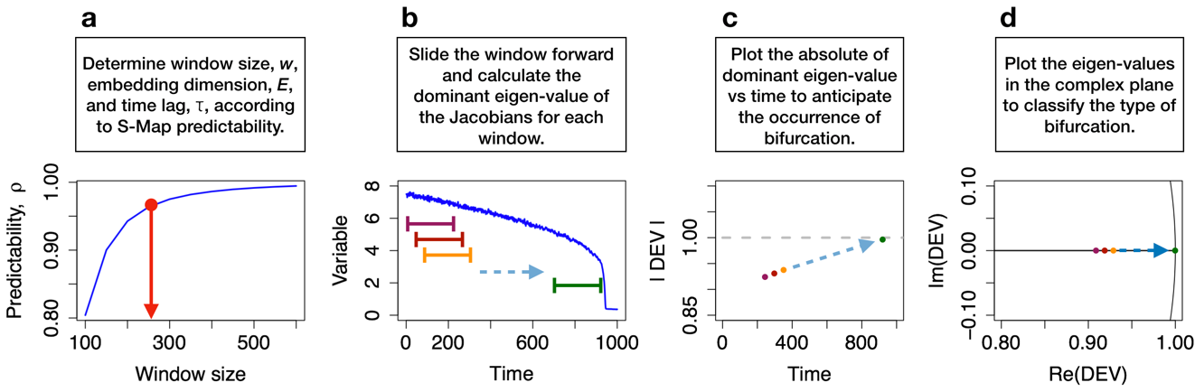
Figure S2. Schematic illustrating procedures to estimate the time-varying dominant eigen-values that anticipate critical transition and classify types of bifurcation. See Box 1 for the theory, and Methods for details of computation. To determine the optimal window size for computation, we screened various window sizes. For each, we evaluated S-map skill (predictability, $ρ$) for various combinations of embedding dimensions E (1 to 12) and time lags $τ$ (1 to 12) and obtained the highest $ρ$ ($ρ_{max}$). The optimal window size (w) close to the plateau was determined visually (a), beyond which increasing the window size lead to very minor improvement of predictability. The best E and $τ$ associated with the optimal window size resulting in best $ρ$ were used throughout the analysis. We then slid the window forward in time (b), and calculated and visualized DEV (c & d). Then, sensitivity analysis for various E, $τ$, and w should be conducted to ensure that results are robust.

Figure S3. Demonstration of efficacy of the DEV as early warning signal for the continuous Noy-Meir model (ordinary differential equation). (a) Exemplary time series of the continuous Noy-Meir model. (b) Time series of |DEV| for the model. The continuous Noy-Meir model displays the pattern that |DEV| increases over time and reaches 1 at the bifurcation point. (c) DEV of the model in the complex plane. The DEV moves from interior of the unit circle toward the border through time, signaling critical transition. Results of the continuous model behaved consistently as the discrete model. The color gradients from light to dark present time progression from initial time to the time right before critical transitions. The continuous-time model is solved numerically using the Runge-Kutta-method, and thus the resulting time series is discrete (even with very small integration time step).

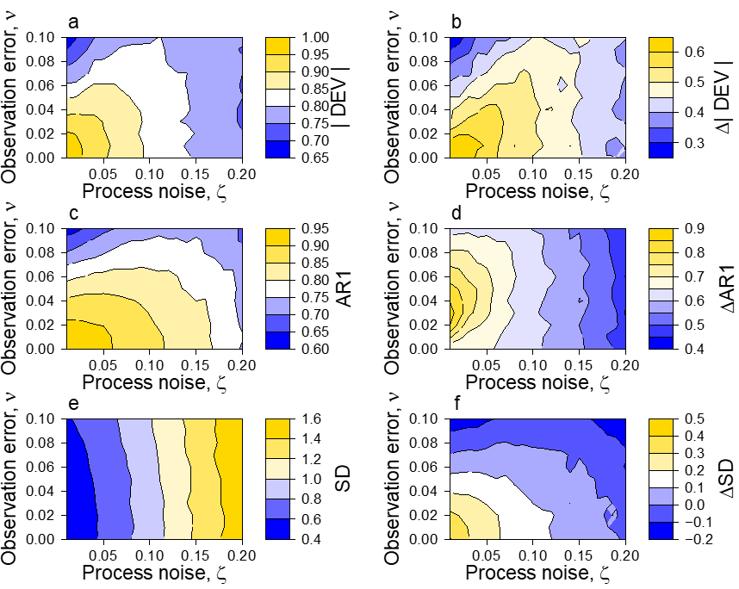
Figure S4. DEV as quantitative and qualitative early warning signal in the presence of noise in comparison to variance and AR1 for Noy-Meir model. (a) DEV prior to the bifurcation point as a function of process noise and observation error. |DEV| reaches values close to 1 prior to bifurcation if noise levels are low or intermediate. As the true dominant eigen-value is 1 at the bifurcation point, these results indicated that |DEV| is a quantitative early warning signal under low to intermediate levels of noise. The quantitative predictability was lost for high noise levels. (b) Difference in the |DEV| (∆|DEV|=|DEV|_{@bifurcation}-|DEV|_{@beginning of time series}) is positive for all analyzed noise combinations. Consistent with the expectation that dominant eigen-value increased prior to bifurcation, results indicated that DEV is a robust qualitative early warning signal that makes correct qualitative predictions even under high levels of noise. (c-d) Autoregression as early warning signal. Difference in the AR1 (∆AR1=AR1_{@bifurcation}-AR1_{@beginning of time series}) was positive for all analyzed noise combinations. Therefore, AR1 is a robust early warning signal that makes correct predictions even under high levels of noise. (e-f) Variance as early warning signal. Difference in the SD (∆SD|=SD_{@bifurcation}-SD_{@beginning of time series}) is 0 or negative; that is, when approaching bifurcation, SD actually declined. These results suggested that SD is not a robust early warning signal under noisy data sets.
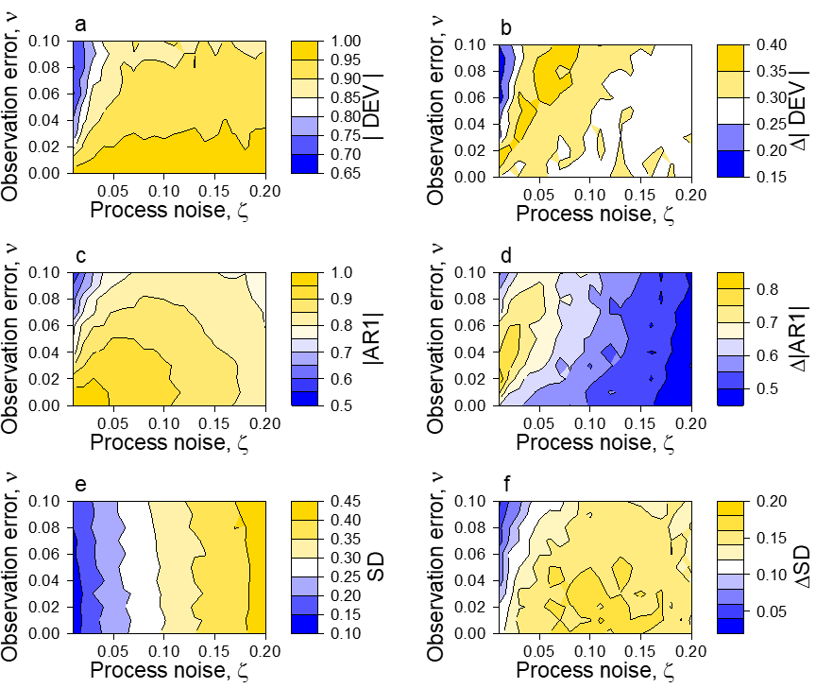
Figure S5. DEV as quantitative and qualitative early warning signal in the presence of noise in comparison to variance and AR1 for Henon map. (a) DEV prior to the bifurcation point as a function of process noise and observation error. |DEV| reached values close to 1 prior to bifurcation if noise levels were low or intermediate. As the true dominant eigen-value is 1 at the bifurcation point, results indicated that DEV is a quantitative early warning signal under low to intermediate levels of noise. However, quantitative predictability was lost for high noise levels. (b) Difference in the |DEV| (∆|DEV|=|DEV|_{@bifurcation}-|DEV|_{@beginning of time series}) was positive for all analyzed noise combinations. Consistent with the expectation that dominant eigen-value increases prior to the bifurcation, results indicated that |DEV| is a robust qualitative early warning signal that makes correct qualitative predictions even under high levels of noise. (c-d) Autoregression as early warning signal. Difference in the AR1 (∆AR1=AR1_{@bifurcation}-AR1_{@beginning of time series}) was positive for all analyzed noise combinations. The results indicated that AR1 is a robust early warning signal that makes correct predictions even under high levels of noise. (e-f) Variance as early warning signal. Difference in the SD (∆SD|=SD_{@bifurcation}-SD_{@beginning of time series}) was positive for all analyzed noise combinations. The results indicated that SD is a robust early warning signal that made correct predictions even under high levels of noise.
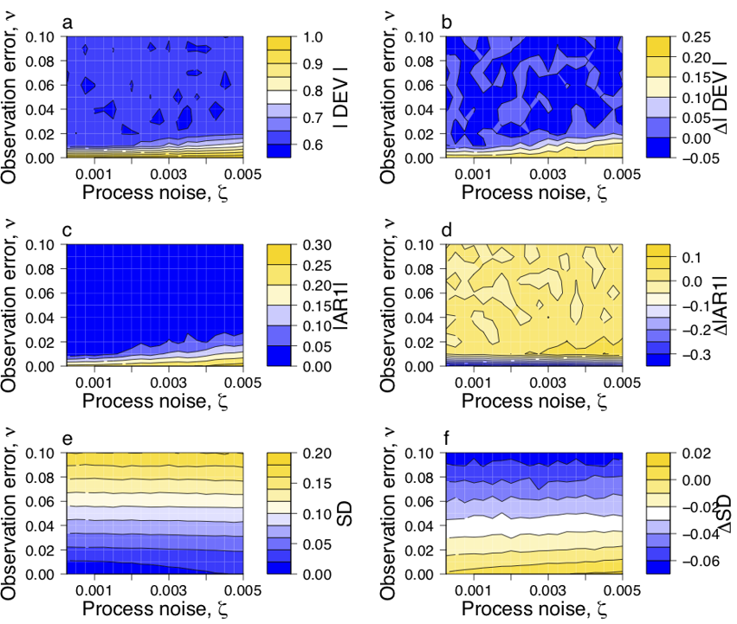
Figure S6. DEV as quantitative and qualitative early warning signal in the presence of noise in comparison to variance and AR1 for Rosenzweig-MacArthur model. (a) DEV prior to the bifurcation point as a function of process noise and observation error. |DEV| reached values close to 1 prior to bifurcation if noise levels were low or intermediate. As the true dominant eigen-value is 1 at the bifurcation point, the results indicated that DEV is a quantitative early warning signal under low to intermediate levels of noise. Quantitative predictability was lost for high noise levels. (b) Difference in the |DEV| (∆|DEV|=|DEV|_{@bifurcation}-|DEV|_{@beginning of time series}) was positive for all analyzed noise combinations. Consistent with the expectation that dominant eigen-value increases prior to the bifurcation, the results indicate that |DEV| is a robust qualitative early warning signal that makes correct qualitative predictions even under high levels of noise. (c-d) Analysis of autoregression as early warning signal. Difference in the AR1 (∆AR1=AR1_{@bifurcation}-AR1_{@beginning of time series}) was positive for intermediate to high observation errors, but failed to predict the bifurcation for low observation error. Results were independent of the level of process noise. The results indicated that AR1 had a confusing declining trend when approaching the tipping point in the Rosenzweig-MacArthur model. (e-f) Analysis of variability as early warning signal. Difference in the SD (∆SD|=SD_{@bifurcation}-SD_{@beginning of time series}) was positive under low level of observations error but negative under high level of observations errors. The results indicated that SD was not a robust early warning signal under observation errors.
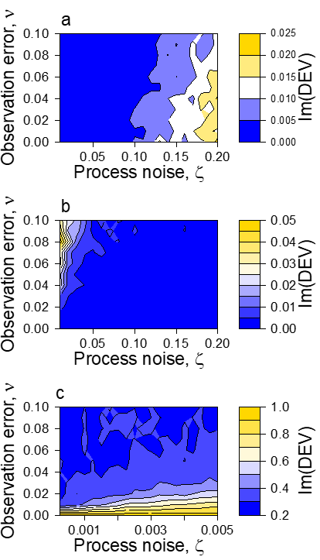
Figure S7. Robustness of DEV in predicting the bifurcation type against noises. For all combinations of noises, (a) the imaginary part of the DEV of the Noy-Meir model was 0 (or close to 0); Im(DEV)=0 and Re(DEV) $→$ 1 indicated a fold bifurcation. (b) The imaginary part of the DEV of the Henon map was 0 (or close to 0); Im(DEV)=0 and Re(DEV) $→$ -1 indicated a period-doubling bifurcation. (c) The imaginary part of the MacArthur-Rosenzweig of the DEV is significantly different from 0; Im(DEV)≠0 and |DEV| $→$ 1 indicates a Neimark-Sacker bifurcation. Therefore, for all three models, DEV can correctly distinguish types of bifurcation under reasonable levels of noise.
Figure S8. Robustness of the DEV signal against other embeddings for the microcosm experiment. (a) Empirical data of the microcosm experiment. (b) The absolute value of the real part of the dominant eigen-value (|DEV|) is a function of time for the optimal embedding of $E=6$ and $τ=2$. (c-d) |DEV| is a function of time with changing dimensionality $E$. (e-f) |DEV| is a function of time with changing $τ$. (g-h) |DEV| is a function of time for smaller and larger sizes of the moving window. Early warning signals given by DEV were robust against changes in the state space reconstruction parameters E and τ, as well as window size.
Figure S9. Robustness of the DEV signal against other embeddings for the voice experiment. (a) Empirical data of the voice experiment. (b) The absolute value of dynamic dominant eigen-value (|DEV|) was a function of time for the optimal embedding of $E=6$ and $τ=6$. (c-d) |DEV| was a function of time with changing dimensionality $E$. (e-f) |DEV| was a function of time with changing $τ$. (g-h) |DEV| was a function of time for smaller and larger sizes of the moving window. Early warning signals given by DEV were robust against changes in the state space reconstruction parameters $E$ and $τ,$ as well as window size.
Figure S10. Robustness of the DEV signal against other embeddings for cellular ATP experiment. (a) Empirical data of the cellular ATP experiment. (b) The absolute value of dynamic dominant eigen-value (|DEV|) was a function of time for the optimal embedding of $E=3$ and $τ=10$. (c-d) |DEV| was a function of time with changing dimensionality $E$. (e-f) |DEV| was a function of time with changing $τ$. (g-h) |DEV| was a function of time for smaller and larger sizes of the moving window. Early warning signals given by DEV were robust against changes in the state space reconstruction parameters $E$ and $τ,$ as well as window size.
Figure S11. Robustness of the DEV signal against other embeddings for the end of greenhouse earth climate data. (a) Empirical climate data. (b) The absolute value of dynamic dominant eigen-value (|DEV|) was a function of time for the optimal embedding of $E=5$ and $τ=2$. (c-d) |DEV| was a function of time with changing dimensionality $E$. (e-f) DEV was a function of time with changing $τ$. (g-h) |DEV| was a function of time for smaller and larger sizes of the moving window. Early warning signals given by DEV were robust against changes in the attractor dimensionality $E$ and changes in window sizes, but were sensitive to $τ.$
Figure S12. Robustness of the DEV signal against suboptimal embeddings for the electricity data. (a) Empirical data of the “1996 Western North America blackouts.” (b) The absolute value of dynamic dominant eigen-value (|DEV|) was a function of time for the optimal embedding of $E=5$ and $τ=1$. (c-d) |DEV| was a function of time with changing dimensionality $E$. (e-f) |DEV| was a function of time with changing $τ$. Note that for state space reconstruction $τ>0$ is needed. Thus, S-map coefficients could not be calculated for $τ=0$. (g-h) |DEV| was a function of time for smaller and larger sizes of the moving window. Early warning signals given by DEV were robust against changes in the state space reconstruction parameter $E,$ as well as window size.
Figure S13. Results of resilience indicators, autocorrelation (AR1) and variance (SD), for the empirical data. (a-b) Resilience indicators for the microcosm experiment: autocorrelation (a) detects bifurcation in advance, while variance (b) failed. (c-d) Resilience indicators for the voice experiment: autocorrelation and variance detected bifurcation in advance. (e-f) Resilience indicators for the cellular ATP experiment: both indicators failed to detect bifurcation as they did not increase in advance. (g-h) Resilience indicators for the climate data: autocorrelation (g) detected bifurcation in advance, whereas variance (h) failed. (i-j) Resilience indicators for the electricity data: autocorrelation and variance detected bifurcation in advance.
Figure S14. Multivariate DEV results of the stochasticity-driven patch dynamics model. (a) Exemplary time series of one patch. (b) Based on the univariate approach, DEV displayed limited increase over time and did not reach 1 at the bifurcation point. (c) In contrast, the multivariate approach indicated that |DEV| increased over time and reached 1 at the bifurcation point. (d) The DEV moved from interior (light blue) of the unit circle toward the border (dark blue) through time, signaling period-doubling bifurcation. Shown are the average results of 100 simulations. The color gradients from light to dark present time progression from initial time to the time right before critical transitions.

Figure S15. Multivariate DEV results of the Henon map. (a) Exemplary time series of variable x. (b) The multivariate approach indicates that |DEV| increased over time and reaches 1 at the bifurcation point. (c) The DEV moves from interior (light blue) of the unit circle toward the border (dark blue) through time, signaling period-doubling bifurcation. Shown are the average results of 100 simulations. The color gradients from light to dark present time progression from initial time to the time right before critical transitions.
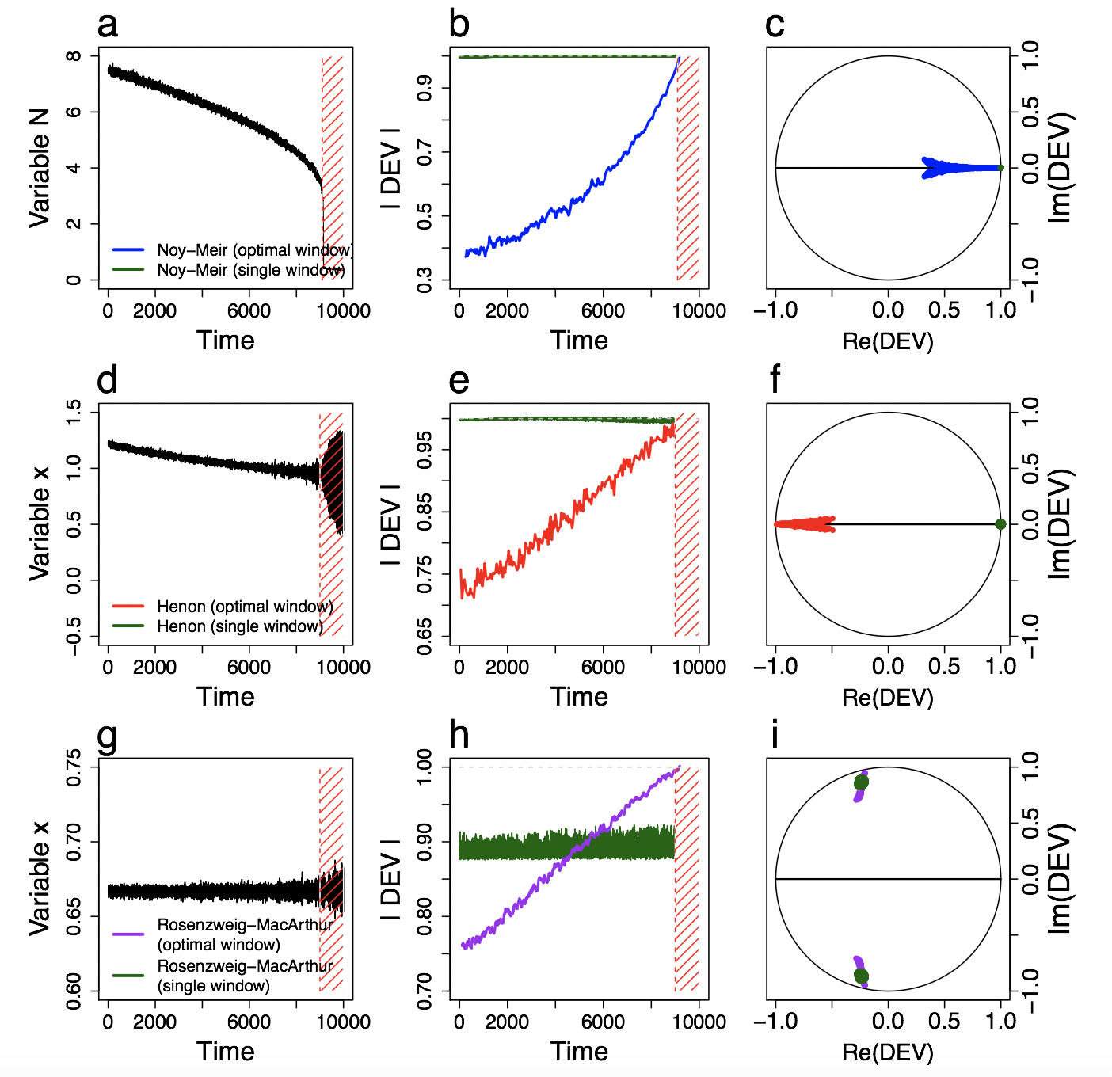
Figure S16. Comparison between eigen-value estimates using the optimal window size and single window in the mathematical models. For all three mathematical models, the single window approach (Ushio et al. 2019) (green color) did not provide correct early warning signal for the dynamical systems. Results of DEV (see Fig. 2 for explanation) are also shown for comparison.
Table S1 | Bifurcation parameters for the models and the selected optimal embedding dimension, time lag, and window size for DEV analyses.
Dataset | Bifurcation parameter | Embedding dimension, E | Time lag, $τ$ | Window size, w | Length of data set
Noy-Meir model | 0 ≤ $F$ ≤ 2 | 2 | 1 | 250 | 10000
Henon model | 0.1 ≤ $α$ ≤ 0.4 | 3 | 1 | 100 | 10000
Rosenzweig-MacArthur model | 3.48 ≤ $l$ ≤ 3.78 | 6 | 1 | 100 | 10000
Microcosm experiment | Light intensity | 6 | 2 | 200 | 6*250
Voice experiment | Air pressure | 6 | 6 | 200 | 7501
Cellular ATP experiment | O₂ level in air | 3 | 10 | 125 | 271
Greenhouse earth | CO₂ level in atmosphere | 5 | 2 | 150 | 462
Electricity | Unknown | 5 | 1 | 1250 | 23393

Table S2 | Information and sources of the empirical datasets
Data set | Reference | Data holder | Email address
Microcosm experiment | ⁷ | Egbert H. van Nes | egbert.vannes@wur.nl
Voice experiment | original data, unpublished | Isao Tokuda | isao@fc.ritsumei.ac.jp
Cellular ATP experiment | ⁸ | Markus Schwarzländer | Markus.schwarzländer@uni-muenster.de
Greenhouse earth | ⁹ | Vasilis Dakos | vasilis.dakos@umontpellier.fr
Electricity | ¹⁰ | Oliver Kamps | okamp@uni-muenster.de

SI References
1 Hastings, A. & Wysham, D. B. Regime shifts in ecological systems can occur with no warning. Ecology Letters 13, 464-472 (2010).
2 Deyle, E. R., May, R. M., Munch, S. B. & Sugihara, G. Tracking and forecasting ecosystem interactions in real time. Proc. R. Soc. Lond. B. Biol. Sci. 283, 20152258 (2016).
3 Ushio, M. et al. Fluctuating interaction network and time-varying stability of a natural fish community. Nature 554, 360-363 (2018).
4 Dakos, V., Carpenter, S. R., Nes, E. H. v. & Scheffer, M. Resilience indicators: prospects and limitations for early warnings of regime shifts. Philosophical Transactions of the Royal Society B: Biological Sciences 370, 20130263 (2015).
5 Scheffer, M., Carpenter, S., Foley, J. A., Folke, C. & Walker, B. Catastrophic shifts in ecosystems. Nature 413, 591-596 (2001).
6 Hsieh, C.-h., Glaser, S. M., Lucas, A. J. & Sugihara, G. Distinguishing random environmental fluctuations from ecological catastrophes for the North Pacific Ocean. Nature 435, 336-340 (2005).
7 Veraart, A. J. et al. Recovery rates reflect distance to a tipping point in a living system. Nature 481, 357-359 (2012).
8 Wagner, S. et al. Multiparametric real-time sensing of cytosolic physiology links hypoxia responses to mitochondrial electron transport. New Phytol. 224, 1668-1684 (2019).
9 Dakos, V. et al. Slowing down as an early warning signal for abrupt climate change. Proc. Natl. Acad. Sci. USA, - (2008).
10 Council, W. S. C. Western Systems Coordinating Council disturbance report for the power system outages that occurred on the Western Interconnection on July 2, 1996 and July 3, 1996. (1996).

