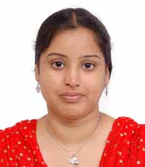

J.Priyanka is a senior research fellow at Madurai Kamaraj University's Department of Computer Applications, School of Information Technology, Madurai-625021. She graduated from Texcity arts and science college in Coimbatore, which is affiliated with Bharathiyar University, with a B.Sc (Computer Science) degree. Avinashilingam University for Women awarded her an MCA degree. She completed her M.Phill and began her career as a researcher, working full-time on her Ph.D. at Madurai Kamaraj University under the auspices of the UGC-RGNF Madurai Kamaraj University. Her research interests include cryptography, cloud computing, network security, and the Internet of Things for Smart Intelligent Transportation Systems. She has written one book and four articles in various journals, including one in a Scopus-indexed journal on cloud security.

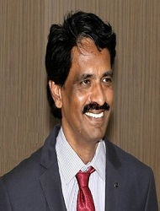

Dr.M.Ramakrishnan, is a versatile educator as well as an internationally recognised researcher with a focus on cryptography and network security. He is currently working as a Professor and Head, Chairperson in the School of Information Technology and Department of Computer Applications at Madurai Kamaraj University in India. he has also been entrusted with a number of additional positions, including University Syndicate Member, authoring two books, publishing over 100 research papers in reputable international journals, contributing about many book chapters, and presenting at least 150 technical papers at international/national conferences. He has received a number of national and international awards in recognition of his academic and research achievements.

