Supplementary Figures
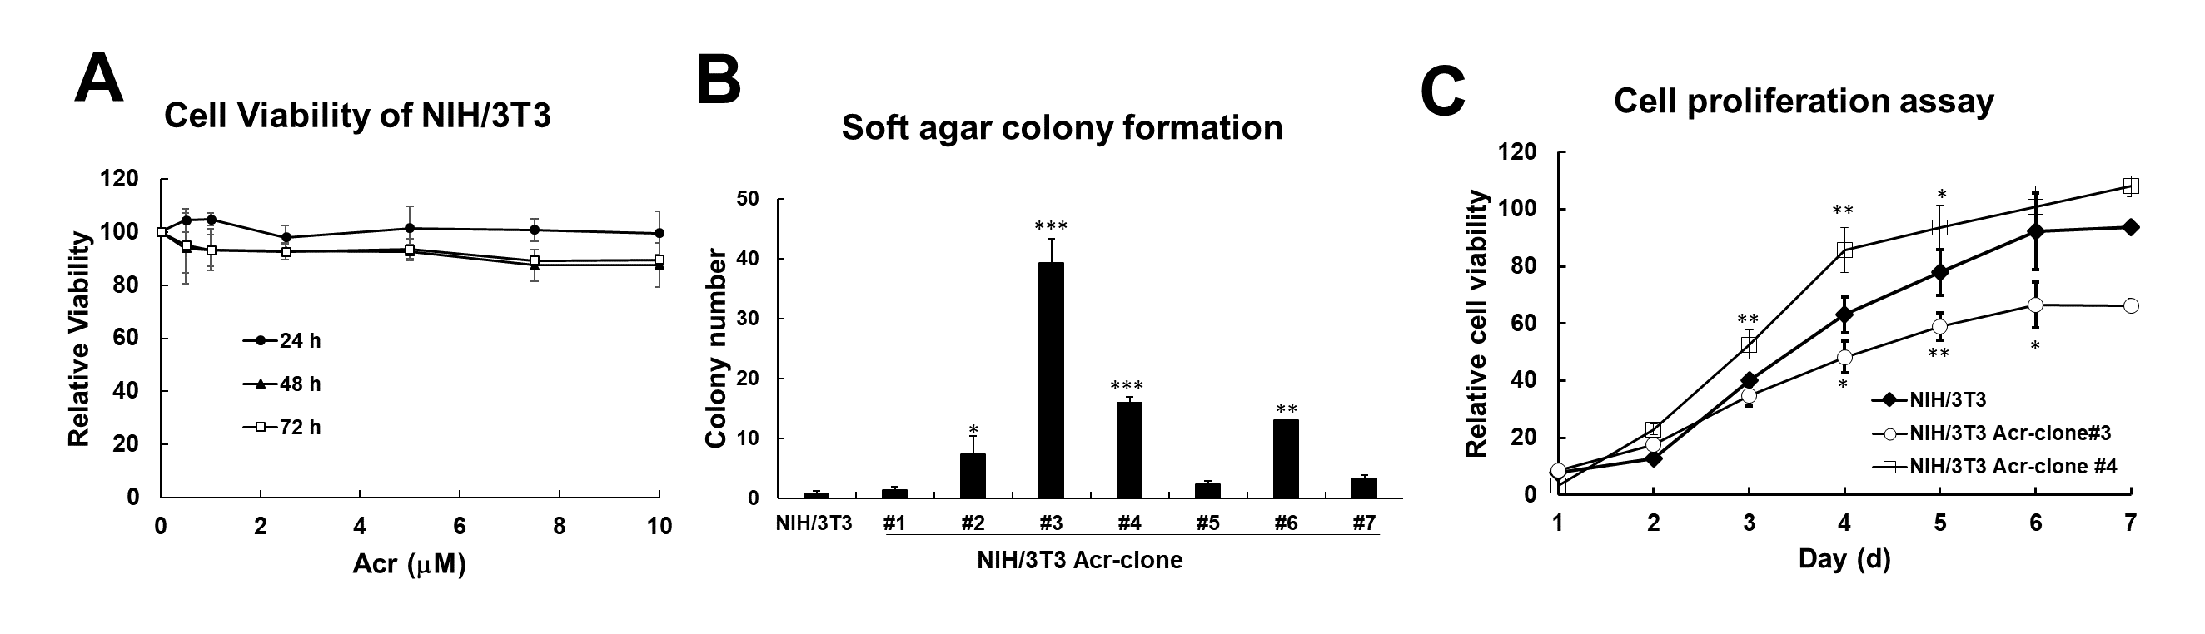
Supplementary Figure 1. Selection of NIH/3T3 Acr-clones using low dose of acrolein treatment for 1 months. NIH/3T3 cells were treated acrolein (Acr, 7.5 μM) for one month and named as NIH/3T3 Acr-clone#. (A) Cell viability of NIH/3T3 under low dose of acrolein (0-10 μM) treatment for 1-3 days was analyzed using MTT assays. (B) Anchorage independent cell growth of NIH/3T3 Acr-clone #1-7 was analyzed using soft agar assay. (C) Cell proliferation of NIH/3T3 Acr-clone #3 and #4 compared with parental cells was analyzed using MTT assays.

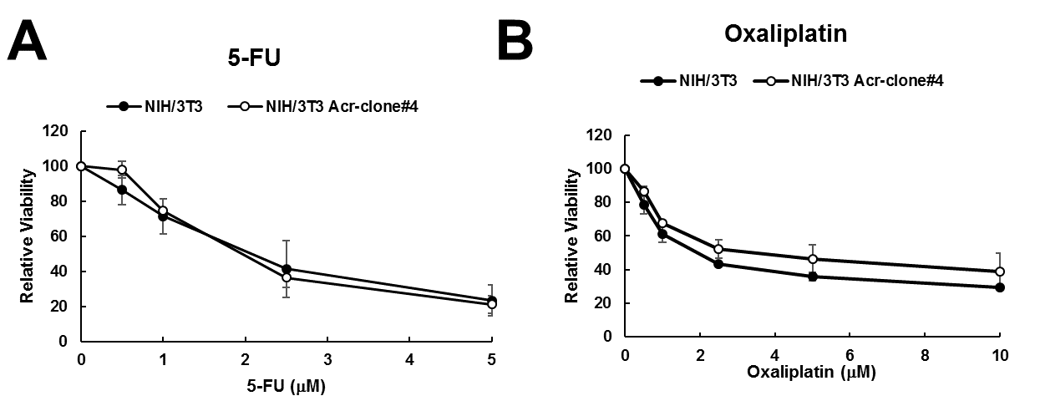
Supplementary Figure 2. Cytotoxicity of 5-FU and Oxaliplatin in NIH/3T3 parental and NIH/3T3 Acr-clone#4. Cells were treated with 5-FU (0-5 μM) and oxaliplatin (0-10 μM) for 24 h followed by MTT analysis as described in Materials and methods.

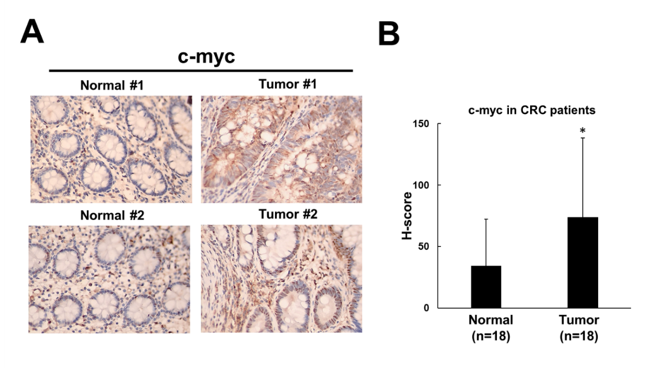

Supplementary Figure 3. Immunohistochemical staining for c-myc in eighteen CRC patients. (A) Representative image of c-myc in normal epithelial cells adjacent to the CRC tumor tissues. (B) quantification of c-myc in normal epithelial cells adjacent to the CRC tumor tissues (magnification, ×400).

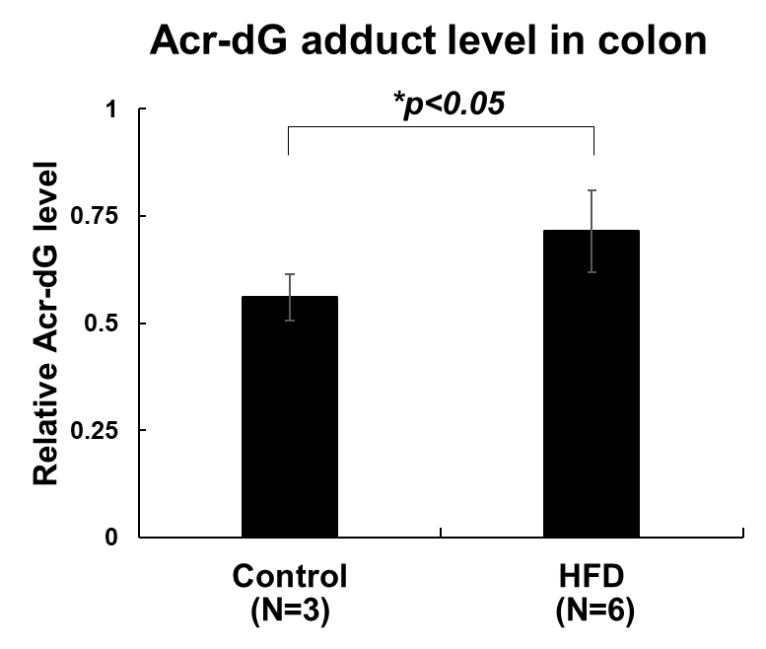
Supplementary Figure 5. Slot blot analysis for Acr-dG adducts in colon tissues of mice with high fat diet (HFD). Relative Acr-DNA adduct levels in colon DNA of mice fed with HFD for 24 weeks (n=6) and normal diet (n=3) using slot blot analysis as described previously (1). 6-week-old male Balb/c nude mice, weighing 25-30 g, were fed with high fat diet for 24 weeks and colon tissues were collected after sacrifice. All animal experiments were approved by the Institutional Animal Care and Use Committee of National Yang-Ming University.

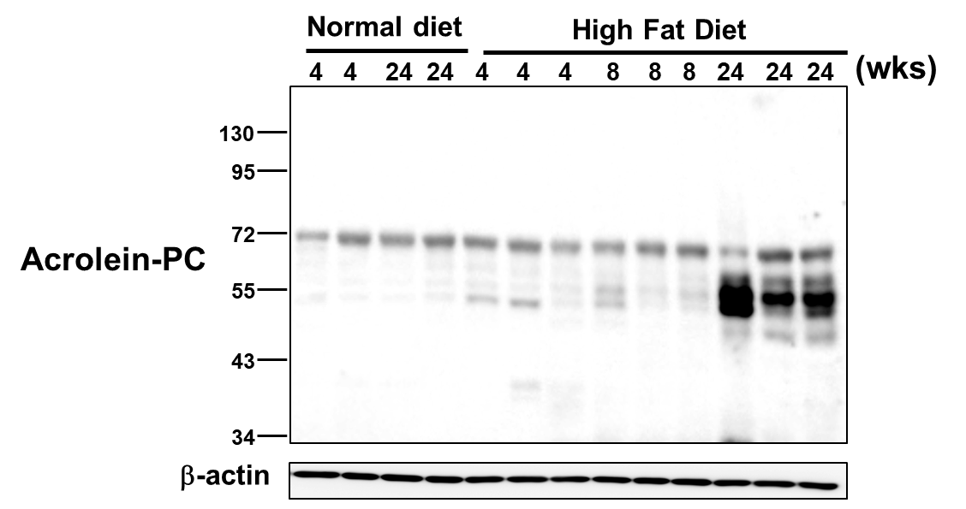

Supplementary Figure 5. Expression of acrolein-protein conjugates in colon tissues of mice fed with high fat diet (HFD). Western blot analysis of acrolein-protein conjugates (Acr-PC) in mixed colon tissues of mice fed with HFD for 4-24 weeks (n=3) compared to mice fed with normal diet (n=2). Animal studies were performed as described in Supplementary Figure 4.

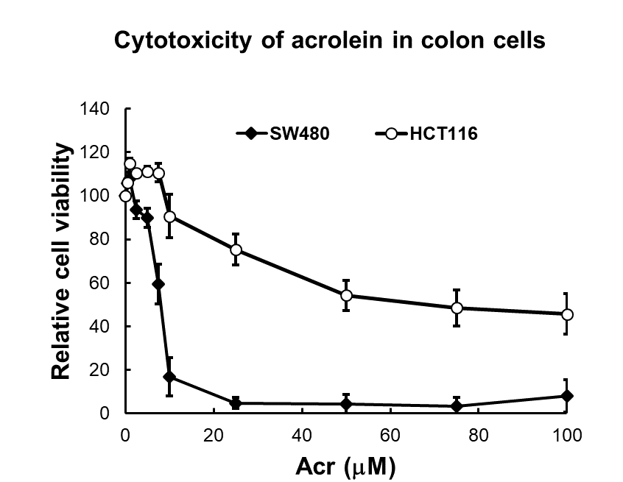
Supplementary Figure 6. Cytotoxicity of acrolein in human colon cancer cell lines, SW480 and HCT116. Cells were treated with acrolein (0-100 μM) for 24 h followed by MTT analysis as described in Materials and methods.

References
1. Tsou HH, Hu CH, Liu JH, Liu CJ, Lee CH, Liu TY, et al. Acrolein Is Involved in the Synergistic Potential of Cigarette Smoking- and Betel Quid Chewing-Related Human Oral Cancer. Cancer Epidemiol Biomarkers Prev 2019;28:954-62

