Supporting information
In silico studies of M^{pro} and PL^{pro} from SARS-CoV-2 and a new class of Cephalosporin drugs containing 1,2,4-thiadiazole

Cássia Pereira Delgado^{[a]}, João Batista Teixeira Rocha^{[a]}, Laura Orian^{[b]}, Marco Bortoli^{[c]} andPablo Andrei Nogara^{[a]*}

ªDepartamento de Bioquímica e Biologia Molecular, Universidade Federal de Santa Maria (UFSM), Santa Maria, 97105-900, RS, Brazil; *Corresponding author: pbnogara@gmail.com.
^{b}Dipartimento di ScuenzeChimiche, UniversitàdegliStudi di Padova, Via Marzolo 1 35131 Padova, Italy; *Corresponding author: laura.orian@unipd.it
^{c}Institut de QuímicaComputacionaliCatàlisi (IQCC) iDepartament de Química, Facultat de Ciències, Universitat de Girona, C/M. A. Capmany 69,17003 Girona, Spain: marco.bortoli@udg.edu

Summary
Figure S1 | ……………………………………………………………………… | 2
Table S1 | ……………………………………………………………………… | 2
Figure S2 | ……………………………………………………………………… | 3
Figure S3 | ……………………………………………………………………… | 4
Figure S4  Table S2  Figure S5  Table S3  Figure S6 | ………………………………………………………………………  ………………………………………………………………………  ………………………………………………………………………  ………………………………………………………………………  ……………………………………………………………………… | 5  5  6  6  7
Figure S7 | ……………………………………………………………………… | 7
Figure S8 | ……………………………………………………………………… | 8
Figure S9 | ……………………………………………………………………… | 9
Figure S10  Figure S11  Figure S12  Figure S13 | ………………………………………………………………………  ………………………………………………………………………  ………………………………………………………………………  …………………………………………………………………… | 9  10  11  11
Figure S14 | ……………………………………………………………………… | 12
Figure S15 | ……………………………………………………………………… | 13
Figure S16 | ……………………………………………………………………… | 14
Figure S17  Table S18  Figure S19  Table S4 | ………………………………………………………………………  ………………………………………………………………………  ………………………………………………………………………  ……………………………………………………………………… | 15  16  17  18

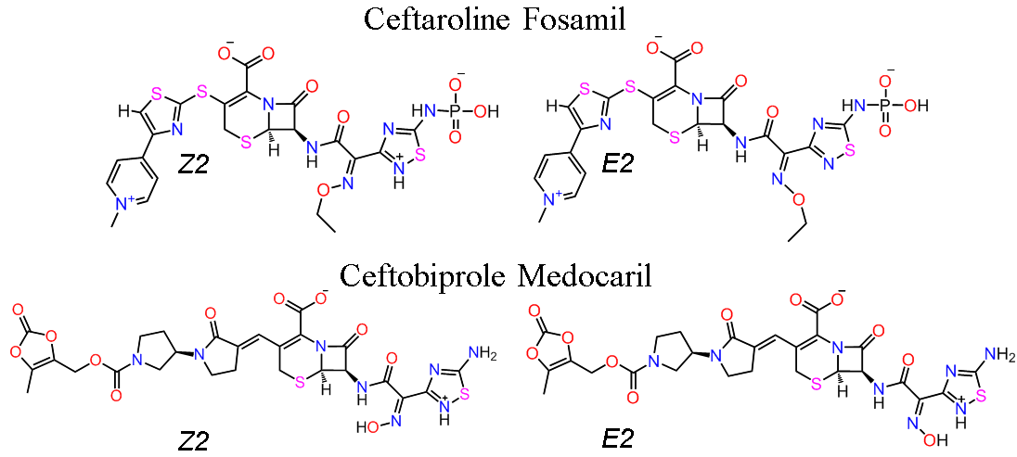
Figure S1. Chemical structure of Ceftaroline Fosamil and Ceftobiprole Medocaril isomers (Z, E)2 drugs, approved and experimental, respectively. The lowest populous isomers, according to the Marvin Skecth simulations.

Table S1. Marvin Sketch pKa simulations with 1,2,4-thiadiazoles drugs in the pH between 7,0 -7,4. The (Z,E)1 and (Z,E)2 isomers showed the percentage (%) of etch pH status.
Molecule (Z,E)1 | pH 7,0 (%) | pH 7,2 (%) | pH 7,4 (%) | Molecule (Z,E)2 | pH 7  (%) | pH 7,2 (%) | pH 7,4 (%)
Ceftaroline Fosamil | 60.50 | 70.82 | 79.34 | Ceftaroline Fosamil | 39.36 | 29.06 | 20.55
Ceftobiprole Medocaril | 93.31 | 95.67 | 97.22 | Ceftobiprole Medocaril | 6.67 | 4.31 | 2.76

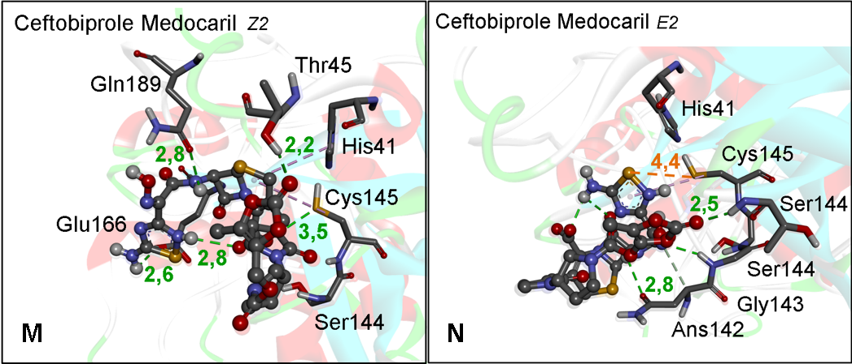
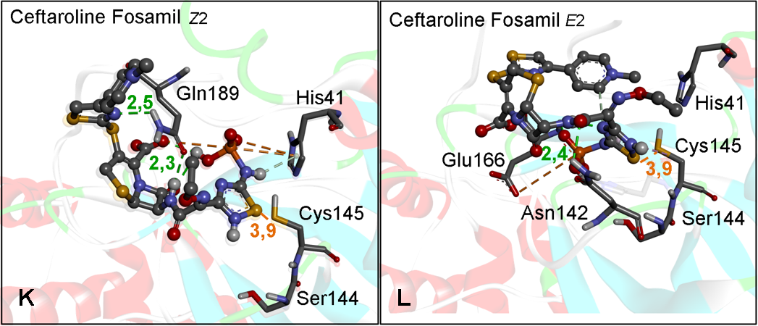
Figure S2. M^{pro} docking with 1,2,4-thiadiazole drugs in the (Z,E)2 isomers in the best distance conformer. K) Ceftaroline Fosamil isomer Z2. L) Ceftaroline Fosamil isomer E2. M) Ceftobiprole Medocaril Z2. N) Ceftobiprole Medocaril E2. Distances are shown in Å.

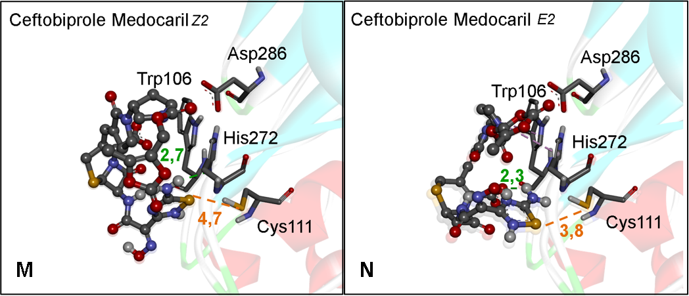
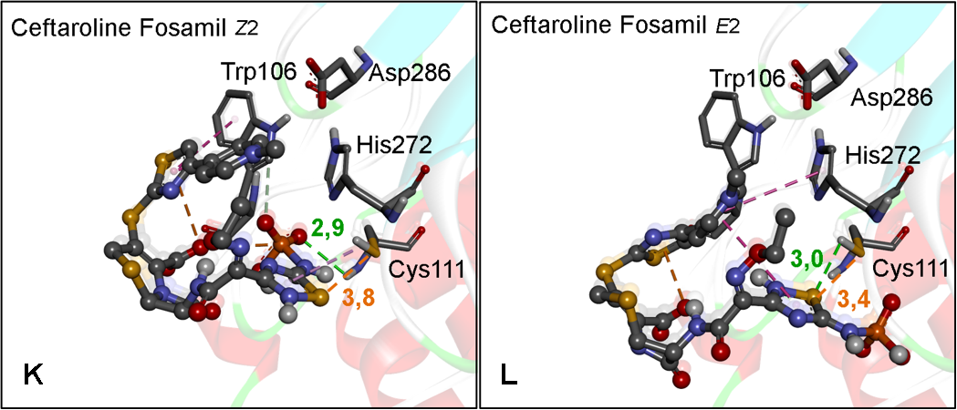
Figure S3. PL^{pro} docking with 1,2,4-thiadiazole drugs in the (Z,E)2 isomers in the best distance conformer. K) Ceftaroline Fosamil isomer Z2. L) Ceftaroline Fosamil isomer E2. M) Ceftobiprole Medocaril Z2. N) Ceftobiprole Medocaril E2. Distances are shown in Å

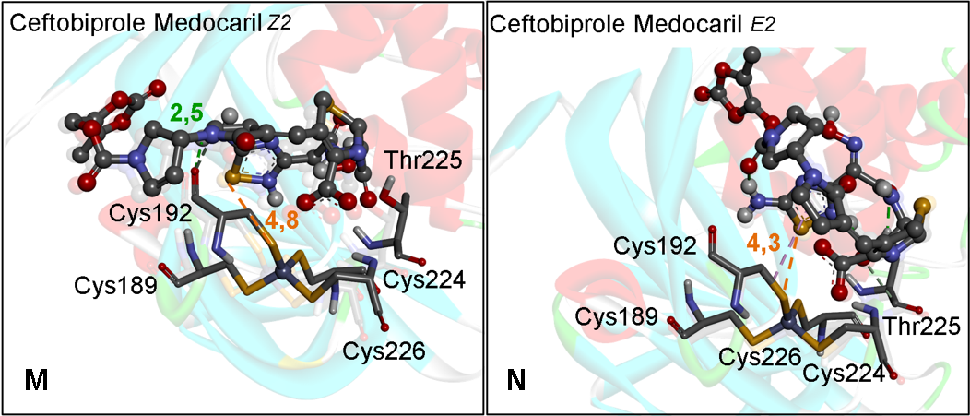
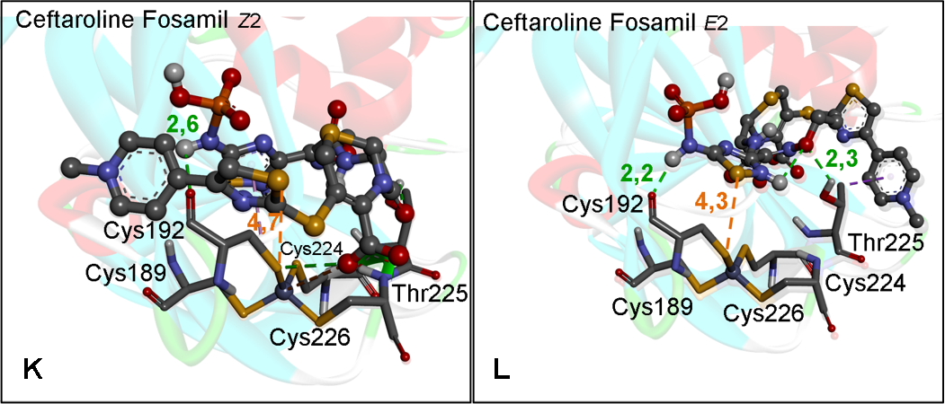
Figure S4.PL^{pro} Zn binding site docking with 1,2,4-thiadiazole drugs in the (Z,E)2 isomers in the best distance conformer. K) Ceftaroline Fosamil isomer Z2. L) Ceftaroline Fosamil isomer E2. M) Ceftobiprole Medocaril Z2. N) Ceftobiprole Medocaril E2. Distances are shown in Å.

Table S2. Predicted binding free energies (∆G, kcal∙mol⁻¹) between Mpro and PLpro and PLpro Zn biding site, with 1,2,4-thiadiazoles drugs (Z, E)2 isomers, Ceftaroline Fosamil and Ceftobiprole Medocaril, respectively.
 | ªM^{pro} |  | ^{b}PL^{pro} |  | ^{c}PL^{pro} | Zn
Molecule | ∆G | dist. (Å)  S*∙∙∙S (Cys145) | ∆G | dist. (Å)  S*∙∙∙S (Cys111) | ∆G | dist. (Å)  S*∙∙∙S (Cys192)
Ceftaroline Fosamil Z2 | -7.4 | 3.9 | -5.7 | 3.8 | -4.7 | 4.7
Ceftaroline Fosamil E2 | -7.0 | 3.9 | -5.8 | 3.4 | -5.4 | 4.3
Ceftobiprole Medocaril Z2 | -7.2 | - | -6.1 | 4.7 | -5.5 | 4.8
Ceftobiprole Medocaril E2 | -7.0 | 4.4 | -5.9 | 3.8 | -5.6 | 4.3

Interact: electrophile center of the ligand, S*∙∙∙S of the 1,2,4 thiadiazole heterocycle; Distance (in Å) of the thiol from ªCys145, ^{b}Cys111, and ^{c}Cys192 to the ligand; Green, yellow, and red colors indicate a favorable, intermediate, and less favorable interaction, respectively.

Table S3. Predicted binding free energies (∆G, kcal∙mol⁻¹) between Mpro and PLpro and PLpro Zn biding site, with 1,2,4-thiadiazoles drugs (Z, E)2 isomers in the best conformer, Ceftaroline Fosamil and Ceftobiprole Medocaril, respectively.
 |  | ªM^{pro} |  |  |  | ^{b}PL^{pro} |  |  |  | ^{c}PL^{pro} |  | Zn
Molecule |  | ∆G |  | dist. (Å) |  | ∆G |  | dist. (Å) |  | ∆G |  | dist. (Å)
 |  |  |  | S*∙∙∙S |  |  |  | S*∙∙∙S |  |  |  | S*∙∙∙S
 |  |  |  | (Cys145) |  |  |  | (Cys111) |  |  |  | (Cys192)
Ceftaroline Fosamil Z2 |  | -7.5 |  | - |  | -6.9 |  | - |  | -4.9 |  | 5.0
Ceftaroline Fosamil E2 |  | -7.3 |  | 3,9 |  | -6.4 |  | - |  | -5.8 |  | 4.9
Ceftobiprole Medocaril Z2 |  | -7.7 |  | - |  | -6.4 |  | - |  | -5.9 |  | -
Ceftobiprole Medocaril E2 |  | -7.2 |  | - |  | -6.3 |  | - |  | -6.0
Interact: electrophile center of the ligand, S*∙∙∙S of the 1,2,4 thiadiazole heterocycle; Distance (in Å) of the thiol from ªCys145, ^{b}Cys111, and ^{c}Cys192 to the ligand; Green, yellow, and red colors indicate a favorable, intermediate, and less favorable interaction, respectively.
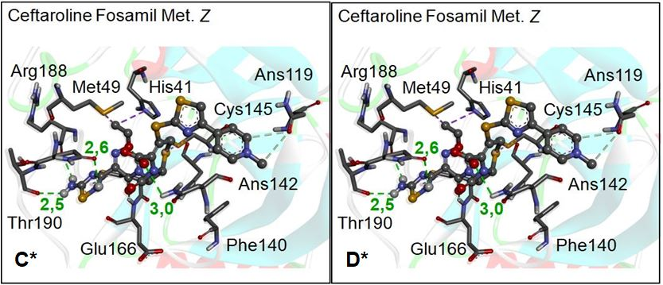
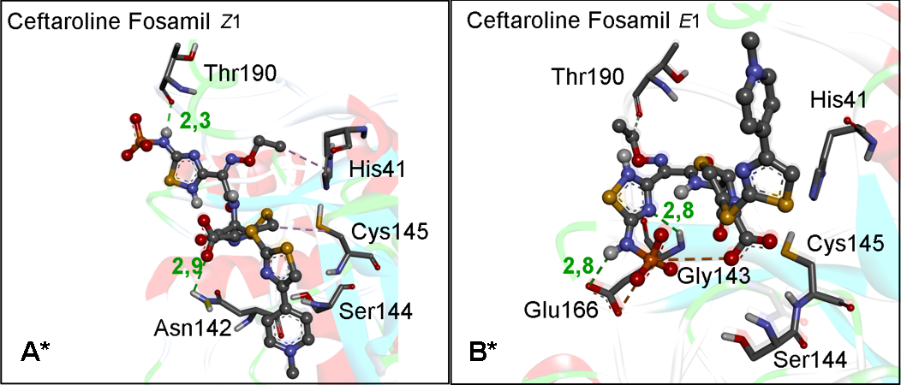
Figure S5. M^{pro} docking with 1,2,4-thiadiazole drugs and its metabolites in the larger negative binding energy conformer. A*) Ceftaroline Fosamil isomer Z1. B*) Ceftaroline Fosamil isomer E1. C*) Ceftaroline Fosamil Metabolite isomer Z. D*) Ceftaroline Fosamil Metabolite isomer E. Distances are shown in Å.

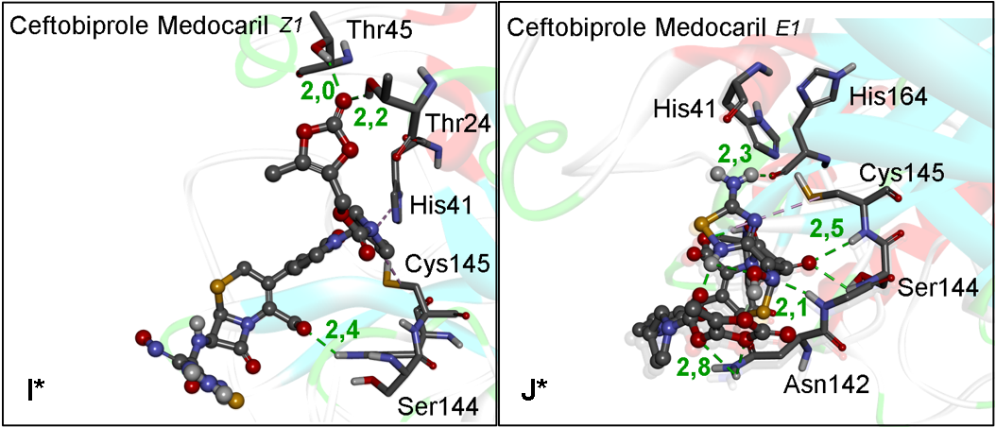
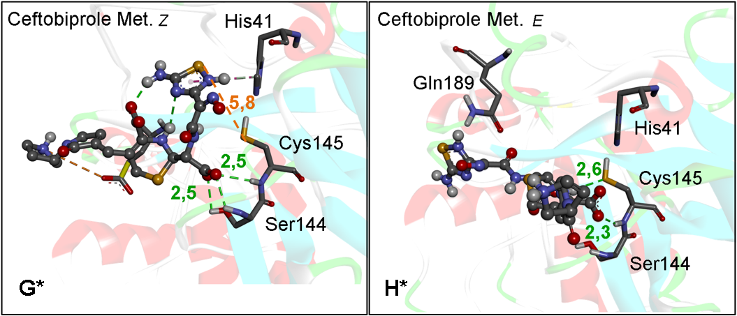
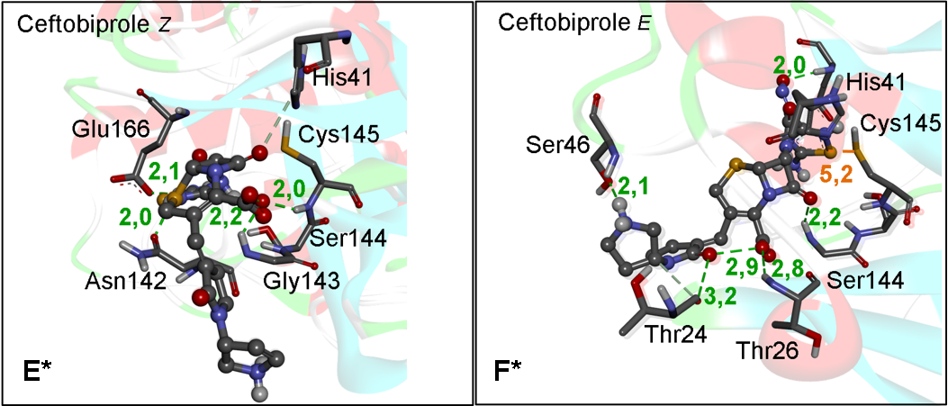
Figure S6. M^{pro} docking with 1,2,4-thiadiazole drugs and its metabolites in thelarger negative binding energy conformer. E*) Ceftobiprole isomer Z. F*) Ceftobiprole isomer E. G*) Ceftobiprole Metabolite isomer Z. H*) Ceftobiprole Metabolite isomer E. Distances are shown in Å.
Figure S7. M^{pro} docking with 1,2,4-thiadiazole drugs and its metabolites in the larger negative binding energy conformer. I*) Ceftobiprole Medocaril isomer Z1. J*) Ceftobiprole Medocaril isomer E1. Distances are shown in Å.

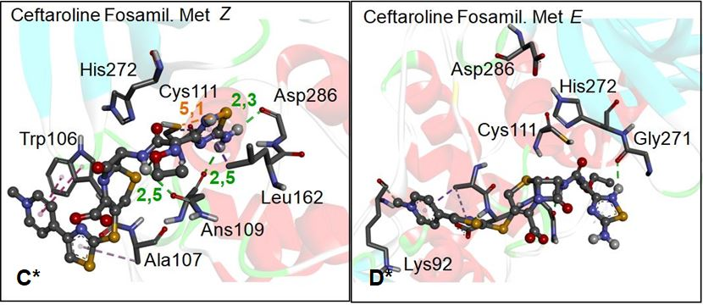
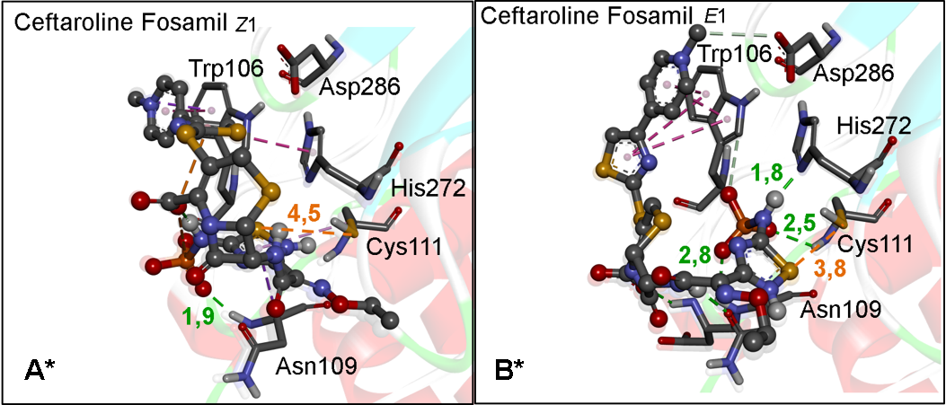
Figure S8. PL^{pro} docking with 1,2,4-thiadiazole drugs and its metabolites in the larger negative binding energyconformer. A*) Ceftaroline Fosamil isomer Z1. B*) Ceftaroline Fosamil isomer E1. C*) Ceftaroline Fosamil Metabolite isomer Z. D*) Ceftaroline Fosamil Metabolite isomer E. Distances are shown in Å.

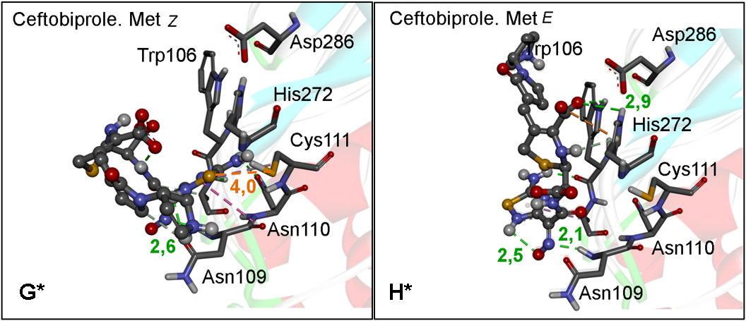
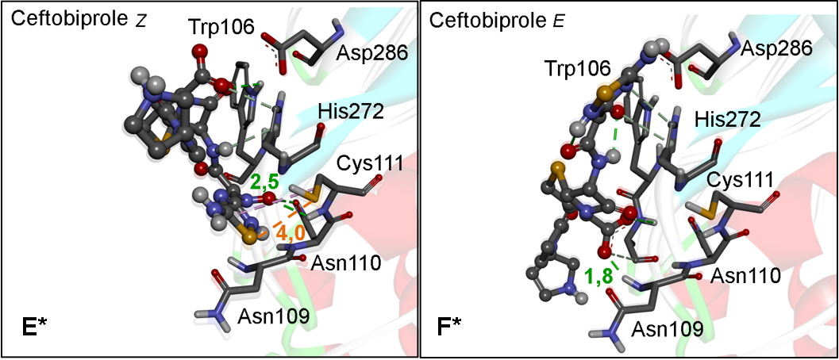
Figure S9. PL^{pro} docking with 1,2,4-thiadiazole drugs and its metabolites in the larger negative binding energyconformer. E*) Ceftobiprole isomer Z. F*) Ceftobiprole isomer E. G*) Ceftobiprole Metabolite isomer Z. H*) Ceftobiprole Metabolite isomer E. Distances are shown in Å.
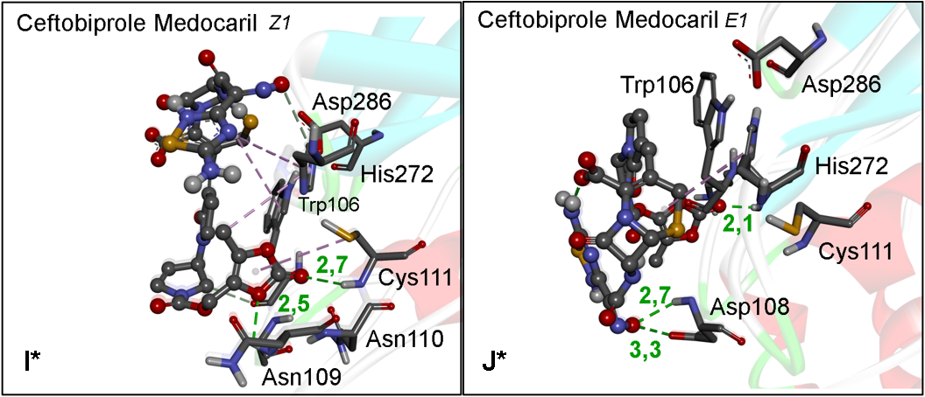
Figure S10. PL^{pro} docking with 1,2,4-thiadiazole drugs and its metabolites in thelarger negative binding energyconformer. I*) Ceftobiprole Medocaril isomer Z1. J*) Ceftobiprole Medocaril isomer E1. Distances are shown in Å.

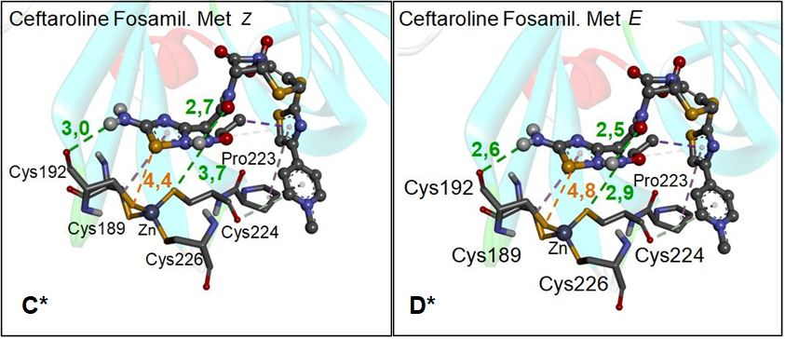
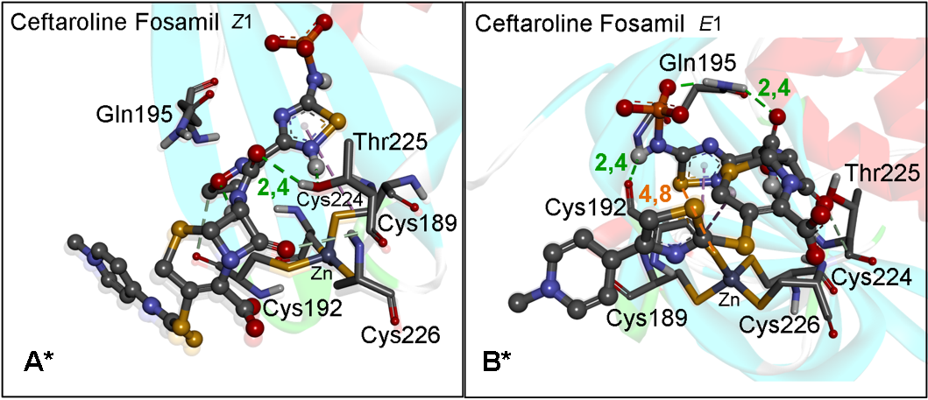
Figure S11. PL^{pro}Zn site docking with 1,2,4-thiadiazole drugs and its metabolites in the best energy conformer. A*) Ceftaroline Fosamil isomer Z1. B*) Ceftaroline Fosamil isomer E1. C*) Ceftaroline Fosamil Metabolite isomer Z. D*) Ceftaroline Fosamil Metabolite isomer E. Distances are shown in Å.

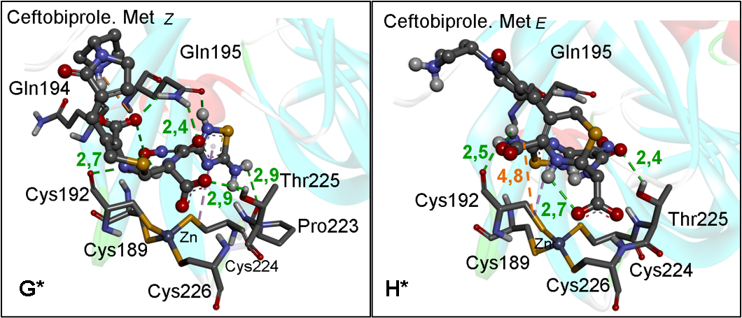
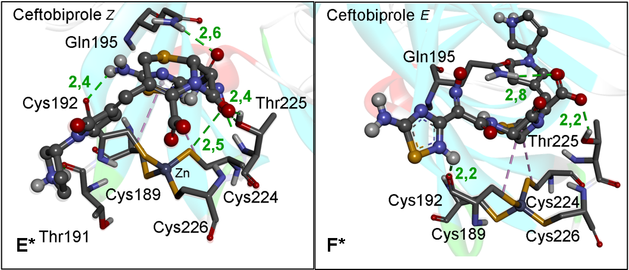
Figure S12. PL^{pro} Zn binding site docking with 1,2,4-thiadiazole drugs and its metabolites in the larger negative binding energyconformer. E*) Ceftobiprole isomer Z. F*) Ceftobiprole isomer E. G*) Ceftobiprole Metabolite isomer Z. H*) Ceftobiprole Metabolite isomer E. Distances are shown in Å.
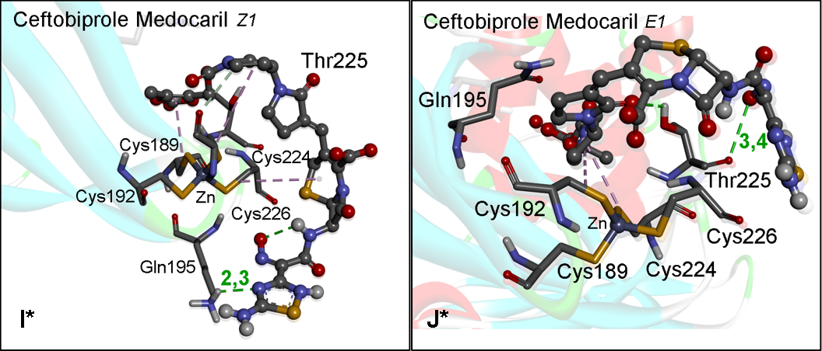
Figure S13. PL^{pro} Zn site docking with 1,2,4-thiadiazole drugs and its metabolites in the larger negative binding energyconformer. I*) Ceftobiprole Medocaril isomer Z1. J*) Ceftobiprole Medocaril isomer E1. Distances are shown in Å.

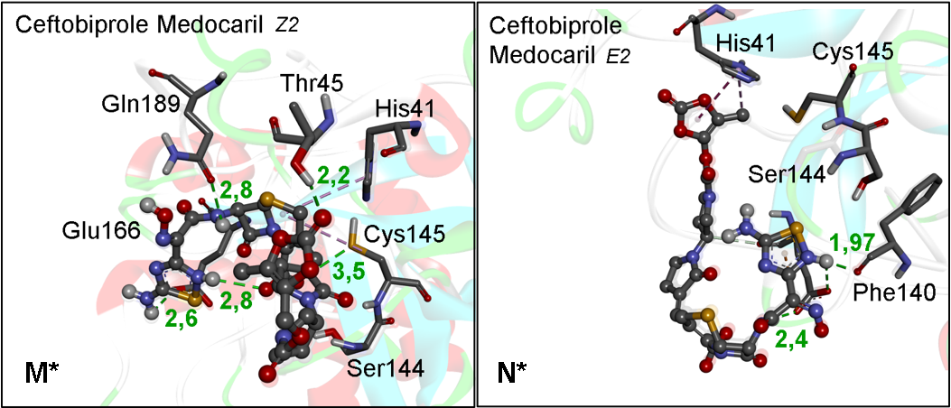
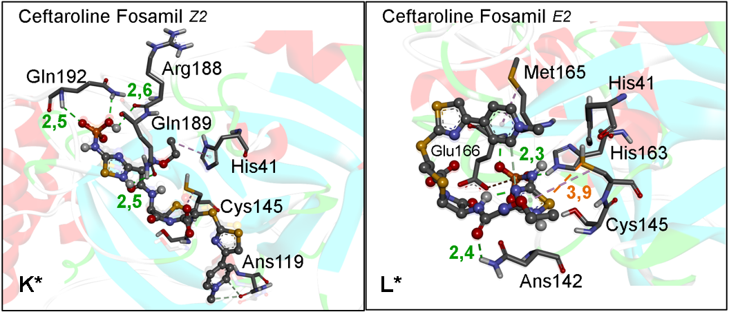
Figure S14. M^{pro} docking with 1,2,4-thiadiazole drugs in the (Z,E)2 isomers in the larger negative binding energyconformer. K*) Ceftaroline Fosamil isomer Z2. L*) Ceftaroline Fosamil isomer E2. M*) Ceftobiprole Medocaril Z2. N*) Ceftobiprole Medocaril E2. Distances are shown in Å.

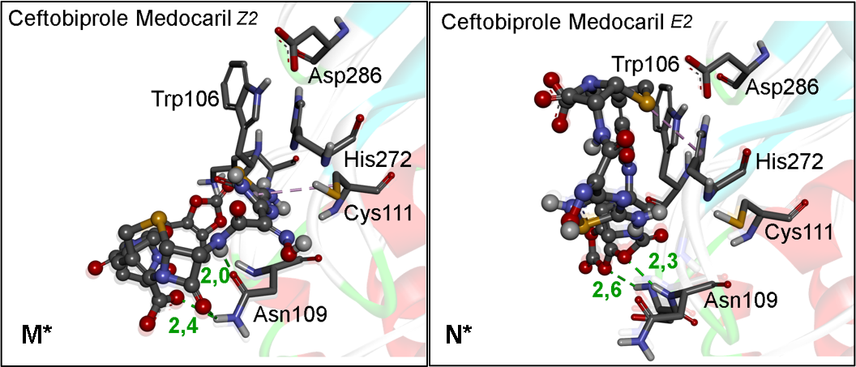
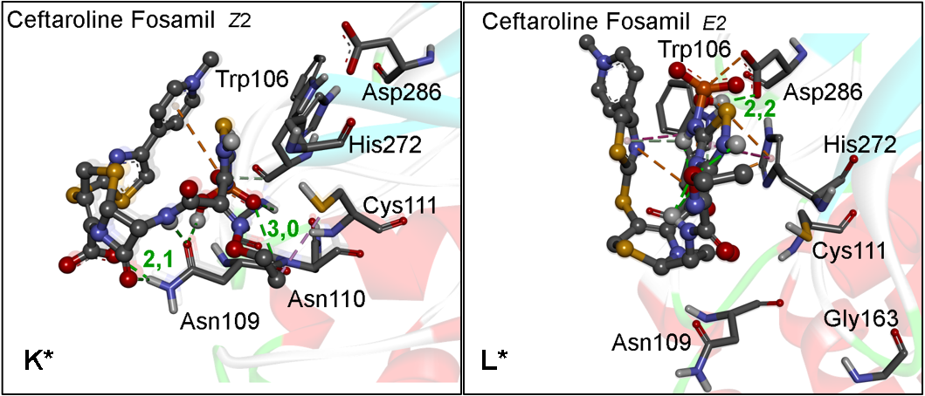
Figure S15. PL^{pro} docking with 1,2,4-thiadiazole drugs in the (Z,E)2 isomers in the larger negative binding energyconformer. K*) Ceftaroline Fosamil isomer Z2. L*) Ceftaroline Fosamil isomer E2. M*) Ceftobiprole Medocaril Z2. N*) Ceftobiprole Medocaril E2. Distances are shown in Å
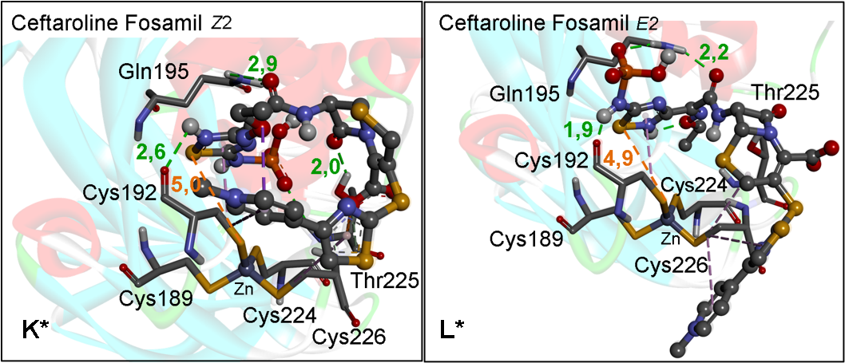

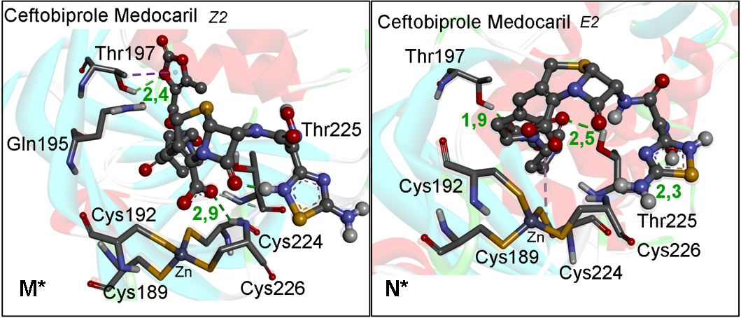
Figure S16. PL^{pro} Zn biding site docking with 1,2,4-thiadiazole drugs in the (Z,E)2 isomers in the larger negative binding energyconformer. K*) Ceftaroline Fosamil isomer Z2. L*) Ceftaroline Fosamil isomer E2. M*) Ceftobiprole Medocaril Z2. N*) Ceftobiprole Medocaril E2. Distances are shown in Å.
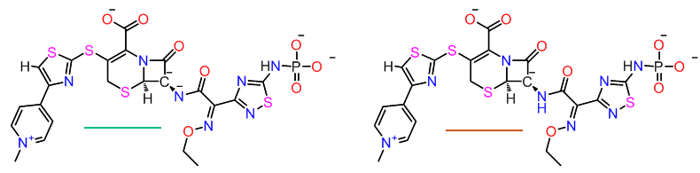
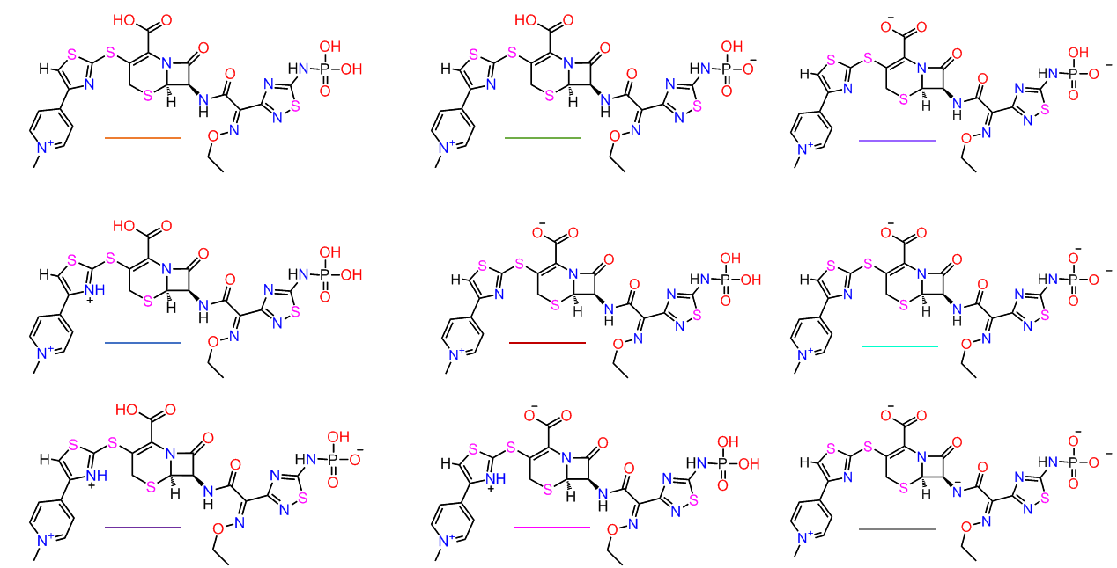
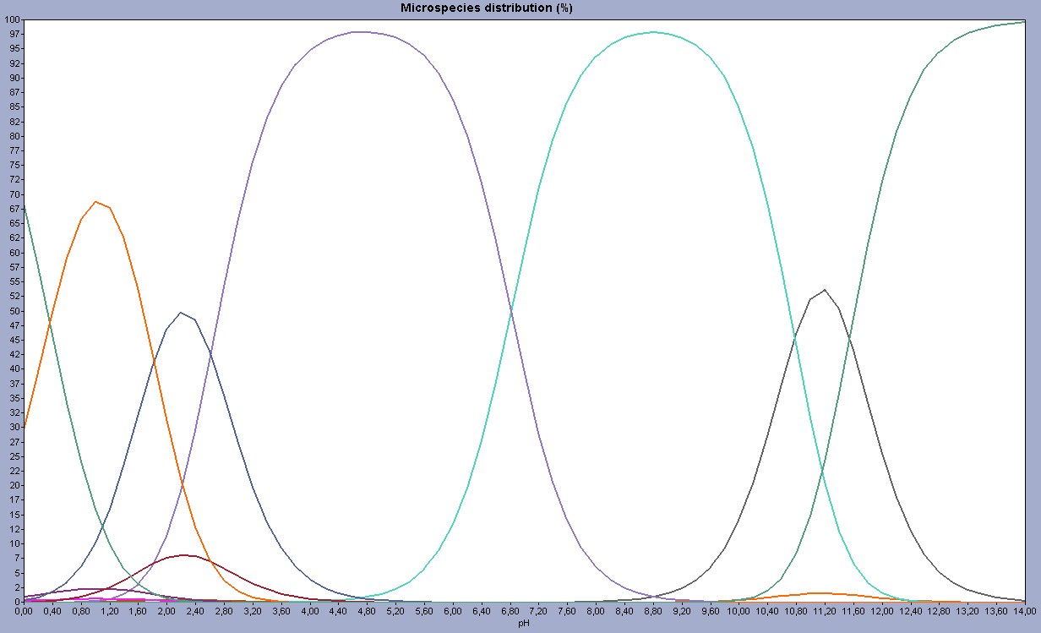

Figure S17. Marvin Sketch pKa simulations with Ceftaroline Fosamil approved drug in the pH between 0,0 -14. The pH equilibrium are show in %.

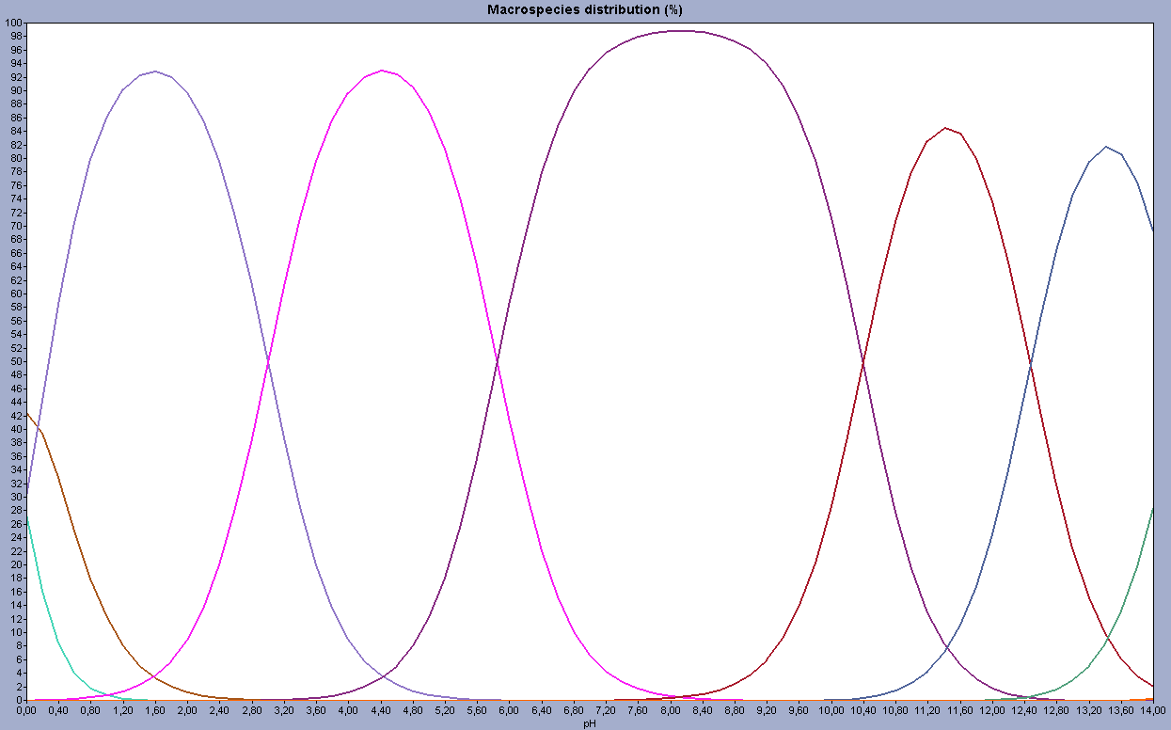
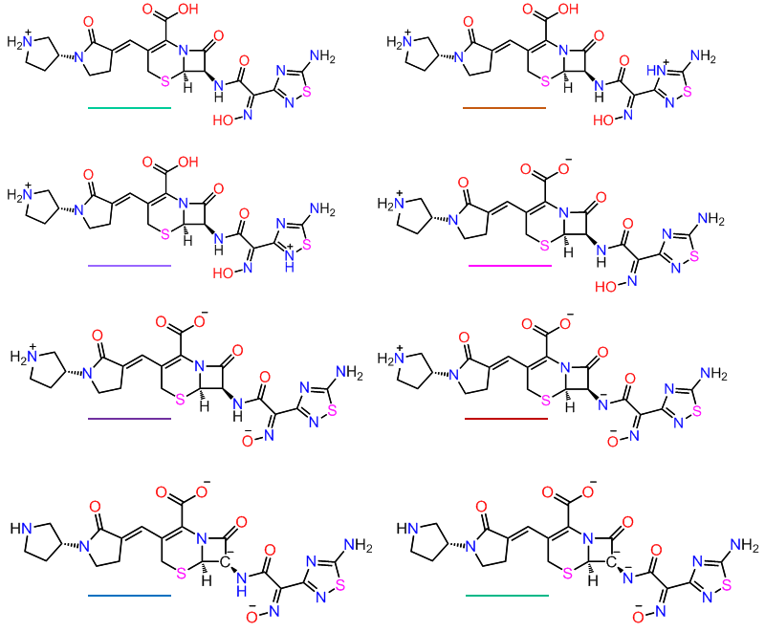

Figure S18. Marvin Sketch pKa simulations with Ceftobiprole approved drug in the pH between 0,0 -14. The pH equilibrium is show in %.

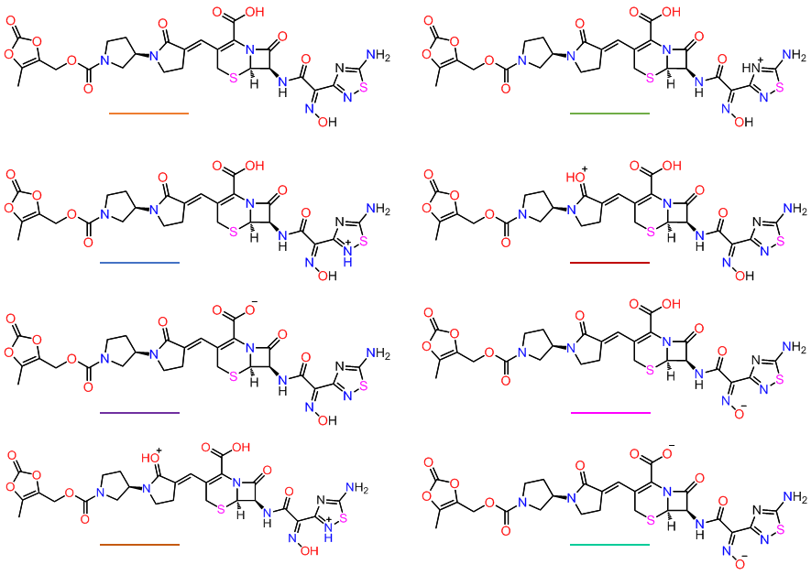
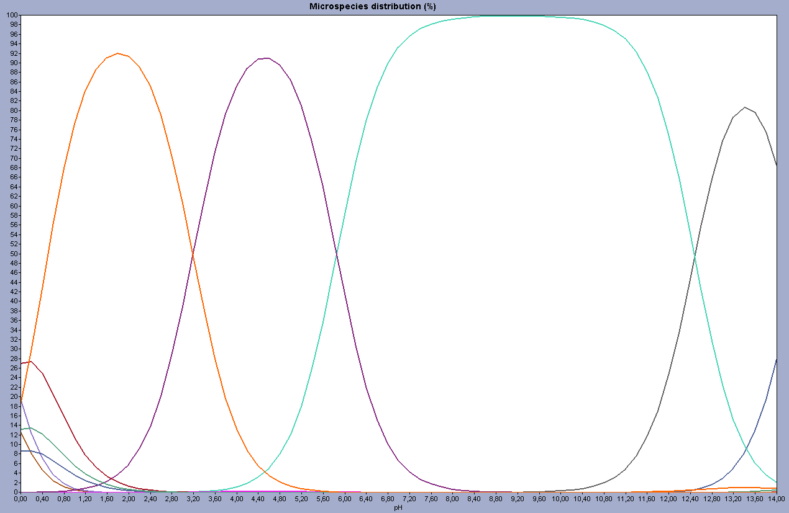
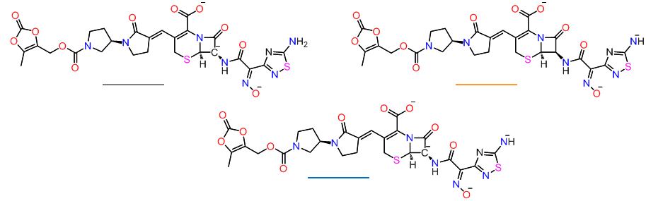

Figure S19. Marvin Sketch pKa simulations with Ceftobiprole Medocaril experimental drug in the pH between 0,0 -14. The pH equilibrium is show in %.
Table S4. Coordinates and energies (Ha) of optimized molecules. Level of theory ZORA-OLYP/TZ2P.

MeS⁻ (gasphase)
E = -0.86001875
S -1.297868 0.612914 0.055954
C -0.892902 0.526119 -1.727900
H 0.129454 0.152005 -1.906805
H -0.957126 1.511562 -2.219835
H -1.573599 -0.144760 -2.279064

[tdzHMe₂]⁺ (gasphase)
E = -2.67337609
S -7.194778 1.851047 0.000000
C -7.639024 3.523754 0.000000
N -8.944108 3.713288 0.000000
C -9.621674 2.558941 0.000000
N -8.828722 1.472602 0.000000
H -9.147080 0.507689 0.000000
C -11.102983 2.475201 0.000000
H -11.465112 1.446320 0.000000
H -11.489828 2.999399 -0.880794
H -11.489828 2.999399 0.880794
C -6.625944 4.607810 0.000000
H -5.602792 4.228901 0.000000
H -6.779863 5.239810 0.882139
H -6.779863 5.239810 -0.882139

tdzHMe₂-SMe (gasphase)
E = -3.74126805
S -3.324099 1.955655 -0.570193
C -3.954585 0.499217 -1.463871
N -5.203687 0.345715 -1.627054
C -6.231869 1.189564 -1.186139
N -6.440364 2.303715 -1.780551
H -7.284184 2.740155 -1.404189
C -7.076188 0.556885 -0.099566
H -7.890710 1.219964 0.199098
H -6.462964 0.329086 0.779339
H -7.495559 -0.390245 -0.454765
C -2.984527 -0.487619 -2.046542
H -2.382011 -0.965896 -1.269692
H -2.288450 0.011414 -2.727223
H -3.548178 -1.248094 -2.588515
S -1.358792 1.634817 -0.110304
C -1.396913 0.788227 1.502654
H -0.349425 0.713258 1.812646
H -1.821074 -0.214926 1.421290
H -1.949233 1.378041 2.236577

Cys⁻ (gasphase)
E = -2.70512220
S -1.409996 1.852500 -0.119407
C -1.203072 0.881588 1.407861
C 0.283778 0.765301 1.881818
N 1.085712 1.955478 1.542086
H 0.516229 2.411443 0.788621
H 1.121649 2.594849 2.330703
H 0.283705 0.618287 2.971587
C 1.020461 -0.481488 1.337705
O 0.621429 -1.624526 1.452303
O 2.207185 -0.174618 0.779414
H 2.203455 0.830215 0.892826
H -1.589537 -0.136177 1.293854
H -1.766798 1.348148 2.231730

tdzHMe₂-Cys (gasphase)
E = -5.55371882
S -2.894904 1.518082 -0.956163
C -4.026396 0.229550 -1.577470
N -5.282459 0.393969 -1.499659
C -5.970143 1.497252 -0.978679
N -5.919373 2.625838 -1.580809
H -6.558176 3.285007 -1.131649
C -6.828961 1.131776 0.213364
H -7.373423 2.001679 0.586206
H -6.211061 0.725102 1.021808
H -7.544662 0.351723 -0.066365
C -3.457025 -1.001150 -2.220657
H -2.869780 -1.589121 -1.509950
H -2.787578 -0.735267 -3.043935
H -4.282284 -1.607057 -2.596633
S -1.024364 0.699379 -0.817768
C -0.929778 -0.011255 0.883701
C 0.154070 0.641276 1.757686
N 0.082008 2.093546 1.930920
H -0.250449 2.531752 1.074720
H -0.557247 2.350203 2.675363
H 0.056789 0.185295 2.753255
C 1.588919 0.231338 1.313997
O 1.867326 -0.871135 0.905744
O 2.495276 1.206925 1.487370
H 1.959769 1.975336 1.804946
H -0.716074 -1.077631 0.782855
H -1.913195 0.118104 1.339038

tdzMe₂ (gasphase)
E = -2.78504704
S -3.315506 0.843079 0.000000
C -3.677716 2.533602 0.000000
N -4.974769 2.730881 0.000000
C -5.624479 1.523186 0.000000
N -4.910143 0.407797 0.000000
C -7.121165 1.475473 0.000000
H -7.469089 0.442184 0.000000
H -7.516740 1.991044 -0.881468
H -7.516740 1.991044 0.881468
C -2.652842 3.621032 0.000000
H -1.635770 3.223007 0.000000
H -2.781137 4.255855 0.882996
H -2.781137 4.255855 -0.882996

[tdzMe₂-SMe]⁻ (TCI) (gas phase)
E = -3.66468410
S -3.760106 1.494944 -0.621478
C -3.899653 2.994310 0.245204
N -5.149672 3.293573 0.545542
C -5.973253 2.304706 0.069398
N -5.448936 1.281513 -0.566691
C -7.457985 2.418513 0.288831
H -7.969667 1.557662 -0.145995
H -7.849865 3.335644 -0.168234
H -7.690412 2.469147 1.359808
C -2.749648 3.865691 0.620782
H -2.187045 4.169527 -0.267585
H -2.036752 3.318894 1.246037
H -3.124548 4.744538 1.152731
S -0.781098 1.627964 -0.859390
C -0.815735 0.053663 -1.770754
H -0.234310 -0.725852 -1.258694
H -0.404190 0.160937 -2.784197
H -1.846286 -0.323513 -1.875285

[tdzHMeN]⁺(gasphase)
E = -2.52925933
S -3.686859 1.303745 1.355569
C -3.740086 2.607496 0.180111
N -4.743637 2.503844 -0.686436
C -5.477078 1.421921 -0.452405
N -5.058949 0.677641 0.587128
H -5.488466 -0.180193 0.916178
C -6.666301 1.049610 -1.262647
H -7.128838 0.122180 -0.922795
H -6.366642 0.944785 -2.310499
H -7.400069 1.861040 -1.214177
N -2.861699 3.602390 0.158766
H -2.100700 3.679753 0.815521
H -2.960238 4.316527 -0.550640

tdzHMeN-SMe (gasphase)
E = -3.59947657
S -3.443237 1.952609 -0.530239
C -4.073768 0.343647 -1.076205
N -5.343365 0.044930 -1.147998
C -6.275248 0.990132 -0.788271
N -5.900321 2.165781 -0.416538
H -6.665660 2.790490 -0.168552
C -7.705585 0.513933 -0.880621
H -8.411792 1.294324 -0.590256
H -7.849286 -0.359834 -0.236326
H -7.924964 0.192851 -1.904269
N -3.168547 -0.595146 -1.414565
H -2.197471 -0.329145 -1.511785
H -3.518906 -1.437793 -1.841758
S -1.337149 1.696974 -0.646830
C -0.895655 1.099461 1.017396
H 0.197750 1.067947 1.047007
H -1.292101 0.099218 1.203865
H -1.255497 1.794449 1.778637

MeS⁻ (waterphase)
E = -0.97168186
S 0.000000 0.0000000 -10.347921
C 0.000000 0.0000000 -8.504375
H 0.511102 0.8852540 -8.109939
H -1.022203 0.0000000 -8.109939
H 0.511102 -0.8852540 -8.109939

[tdzHMe₂]⁺ (waterphase)
E = -2.76872196
S -7.210716 1.870197 0.000000
C -7.643351 3.526572 0.000000
N -8.951680 3.731802 0.000000
C -9.624114 2.569166 0.000000
N -8.834510 1.493332 0.000000
H -9.151592 0.530102 0.000000
C -11.103922 2.470278 0.000000
H -11.437012 1.432836 0.000000
H -11.498273 2.980457 -0.883866
H -11.498273 2.980457 0.883866
C -6.622708 4.604918 0.000000
H -5.608343 4.205906 0.000000
H -6.763553 5.233974 0.884703
H -6.763553 5.233974 -0.884703

tdzHMe₂-SMe (waterphase)
E = -3.75455273
S -3.444759 1.881847 -0.400465
C -3.987559 0.501699 -1.441112
N -5.226167 0.386534 -1.713391
C -6.283561 1.192138 -1.276354
N -6.615219 2.225277 -1.965808
H -7.459066 2.637814 -1.563826
C -7.028761 0.631715 -0.088160
H -7.834927 1.301610 0.215622
H -6.350444 0.475161 0.756175
H -7.453742 -0.343849 -0.347284
C -2.983949 -0.464741 -1.989963
H -2.476090 -1.001176 -1.183735
H -2.215807 0.058619 -2.565769
H -3.496522 -1.183274 -2.630991
S -1.443003 1.716728 -0.031058
C -1.328037 0.724698 1.490170
H -0.262378 0.728475 1.739057
H -1.659222 -0.300944 1.321547
H -1.893599 1.190602 2.298345

Cys⁻ (waterphase)
E = -2.80647130
S -1.455212 1.458005 -0.285975
C -1.205830 0.871689 1.437090
C 0.267431 0.764038 1.874093
N 1.082885 1.956956 1.602332
H 0.621111 2.498346 0.869482
H 1.175532 2.540991 2.426256
H 0.282351 0.566818 2.954186
C 0.999695 -0.445261 1.251056
O 0.573734 -1.590543 1.235393
O 2.198688 -0.117033 0.764169
H 2.205617 0.886799 0.962524
H -1.668932 -0.109991 1.570988
H -1.702871 1.560186 2.129507

tdzHMe₂-Cys (waterphase)
E = -5.58088294
S -2.912200 1.399157 -0.863713
C -4.058364 0.161650 -1.533277
N -5.301241 0.431750 -1.555204
C -5.946981 1.587956 -1.101901
N -6.096938 2.580044 -1.905141
H -6.669413 3.293742 -1.450458
C -6.545698 1.452954 0.277919
H -7.032536 2.381245 0.581499
H -5.776340 1.191158 1.010824
H -7.284354 0.644395 0.281124
C -3.536786 -1.139523 -2.057878
H -3.049170 -1.712714 -1.264249
H -2.793803 -0.973336 -2.842589
H -4.369594 -1.718833 -2.458640
S -1.013049 0.652117 -0.914218
C -0.770660 -0.220405 0.692397
C 0.155171 0.500092 1.681587
N -0.240377 1.837792 2.121899
H -0.740575 2.334862 1.390543
H -0.840523 1.797837 2.938267
H 0.196708 -0.142666 2.570872
C 1.627986 0.559174 1.207569
O 2.206835 -0.343875 0.629285
O 2.229478 1.700373 1.548629
H 1.476083 2.212332 1.980518
H -0.354149 -1.198693 0.443033
H -1.752684 -0.368069 1.142540

tdzMe₂ (waterphase)
E = -2.79380495
S -3.306264 0.856981 0.000000
C -3.674820 2.536384 0.000000
N -4.978754 2.730934 0.000000
C -5.628890 1.524403 0.000000
N -4.904562 0.414024 0.000000
C -7.124946 1.473830 0.000000
H -7.476272 0.441501 0.000000
H -7.521818 1.986337 -0.882636
H -7.521818 1.986337 0.882636
C -2.650024 3.620201 0.000000
H -1.636493 3.216050 0.000000
H -2.776286 4.253529 0.884310
H -2.776286 4.253529 -0.884310

[tdzMe₂-SMe]⁻ (waterphase)
E = -3.69570014
S -3.797804 0.159167 0.755098
C -4.393217 -0.650103 -0.797132
N -5.484036 -0.260154 -1.305884
C -6.306473 0.885627 -0.777313
N -6.080096 2.065265 -1.108751
C -7.473580 0.311111 0.034000
H -8.102249 1.126311 0.400895
H -7.124272 -0.283511 0.887045
H -8.085846 -0.353111 -0.590264
C -3.522512 -1.700043 -1.426371
H -3.382267 -2.557639 -0.762515
H -2.527953 -1.301592 -1.654200
H -3.994094 -2.040623 -2.350244
S -2.200487 -0.870217 1.515793
C -2.929284 -2.152741 2.583375
H -2.074591 -2.640949 3.061928
H -3.485088 -2.886475 1.996849
H -3.567714 -1.703692 3.346169

[tdzHMeN]⁺ (waterphase)
E = -2.62544960
S -5.254224 2.727143 1.031485
C -3.733861 2.630390 0.181184
N -3.547066 1.470469 -0.457689
C -4.592874 0.662841 -0.279575
N -5.571354 1.168359 0.473774
H -6.436407 0.700693 0.715126
C -4.684672 -0.698198 -0.869704
H -5.598311 -1.207323 -0.563813
H -3.817342 -1.286499 -0.557501
H -4.661470 -0.619885 -1.960840
N -2.853568 3.620258 0.174622
H -1.989638 3.508533 -0.334743
H -3.014818 4.484096 0.666508

tdzHMeN-SMe(water phase)
E = -3.61180454
S -3.302266 2.016547 -0.663162
C -4.008356 0.448840 -1.261836
N -5.287604 0.180284 -1.264873
C -6.255515 1.091043 -0.896116
N -6.023259 2.361569 -0.826126
H -6.864359 2.860488 -0.531792
C -7.599113 0.450931 -0.628144
H -8.352378 1.195155 -0.363936
H -7.512718 -0.276164 0.186738
H -7.934825 -0.099273 -1.513522
N -3.139799 -0.464912 -1.707484
H -2.146340 -0.287286 -1.676444
H -3.479355 -1.368591 -1.999577
S -1.262599 1.677572 -0.517886
C -1.030124 0.983870 1.149423
H 0.053241 0.886617 1.266021
H -1.495748 0.000966 1.235969
H -1.419684 1.667171 1.905438

tdzMeN(waterphase)
E = -2.64447836
S -3.717439 1.264174 1.259194
C -3.709401 2.595907 0.134037
N -4.702469 2.495946 -0.735399
C -5.423571 1.363661 -0.469145
N -5.067629 0.582823 0.536295
C -6.609110 1.022789 -1.319639
H -7.070939 0.093625 -0.984080
H -6.306594 0.913799 -2.366517
H -7.351601 1.826686 -1.275646
N -2.780230 3.574059 0.118317
H -2.188109 3.707962 0.922675
H -2.978655 4.397748 -0.431145

[tdzMeN-SMe]⁻ (waterphase)
E = -3.54828303
S -3.513213 2.166042 -0.870607
C -3.997740 0.481008 -1.458203
N -5.209514 0.110305 -1.391208
C -6.318378 1.004630 -0.909958
N -6.887288 1.843918 -1.636099
C -6.680302 0.580308 0.521975
H -7.509534 1.188512 0.892040
H -5.827761 0.685275 1.204943
H -6.978659 -0.476242 0.547823
N -2.966007 -0.311868 -1.903941
H -2.140243 0.169588 -2.236992
H -3.256510 -1.087175 -2.485887
S -1.480786 2.361229 -0.996906
C -0.832993 1.699150 0.570908
H 0.245479 1.880181 0.529080
H -1.021138 0.627441 0.650774
H -1.261458 2.234665 1.419643

