Appendix
Exposure to pathogens induced microscopic changes in colon explants
For evaluation of the screening method used in this study, the findings below represent the comparison between all explants from the pathogen control group (PCG) and compound control group (CCG) groups for a given pathogen.
Brachyspira hyodysenteriae
No significant difference was observed for the percentage of healthy epithelium between PCG and CCG (Supplementary Figure 1; A). In contrast, a significantly thicker mucus layer was found in the PCG (early time-point and late time-point, Supplementary Figure 1; B) and significant higher levels of tumor necrosis factor-α (TNF-α), interleukin-1α (IL-1α) and interferon-γ (INF-γ) mRNA expression were found at the late time-point (Supplementary Figure 1 A).
Lawsonia intracellularis
No differences between groups in epithelial coverage or gene expression were observed at either time-point (Supplementary Figure 1; C, and Supplementary Figure 2; B).
Salmonella enterica serovar Typhimurium
CCG explants had significant more healthy epithelial coverage than the PCG samples at both time-points (Supplementary Figure 1; D). Late time-point PCG samples had increased IL-1α mRNA expression (Supplementary Figure 2; C).

Supplementary Figure 1. Microscopic explant health comparison between the compound control group (CCG), including all compound groups combined, and pathogen control group (PCG) for evaluation of screening method used in current study. Percentage of healthy epithelium (A) and mucus layer thickness (B) in explants harvested from pigs and exposed to B. hyodysenteriae (PCG) or controls (CCG). C) Percentage of healthy epithelium on explants from pigs exposed to L. intracelullaris (PCG) or controls (CCG). D) Percentage of healthy epithelium on explants from pigs exposed to S. Typhimurium (PCG) or controls (CCG). Boxplots depict the median ± standard deviation of the median. Whiskers depict the minimum and maximum values. Stars denote significant difference between groups (P ≤ 0.05).
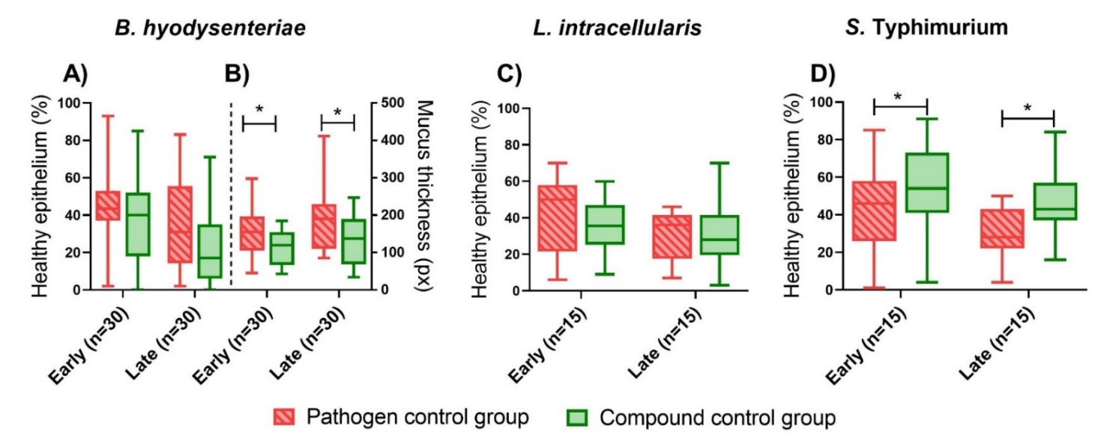

Supplementary Figure 2. Change in mRNA levels between the compound control group (CCG), including all compound groups combined, and pathogen control group (PCG) for evaluation of screening method used in current study. CCG was used as the reference group. A) Gene expression levels for explants from pigs exposed to B. hyodysenteriae. B) Gene expression levels for explants from pigs exposed to L intracellularis. C) Gene expression levels for explants from pigs exposed to S. Typhimurium. Each bar represents mean fold-change, whiskers represent the standard deviation from the mean. Star denotes significant difference (P ≤ 0.05).
