SMRT- and Illumina‑based RNA‑seq analyses unveil triterpenoid saponin biosynthesis and related key genes in Platycodon grandiflorus (Jacq.) A. DC.
Hanwen Yu¹, Mengli Liu¹, Minzhen Yin¹, Tingyu Shan¹, Huasheng Peng^{1,3}, Jutao Wang¹, Xiangwei Chang¹, Daiyin Peng¹, Liangping Zha^{1,2*} and Shuangying Gui^{1*}
* Correspondence: zlp_ahtcm@126.com; guishy0520@126.com
¹College of Pharmacy, Anhui University of Chinese Medicine, Hefei, 230012, China
Full list of author information is available at the end of the article
²Institute of Conservation and Development of Traditional Chinese Medicine Resources, Anhui Academy of Chinese Medicine, Hefei 230012, China
³Chinese Academy of Medical Sciences Research Unit (No. 2019RU057), National Resource Center for Chinese Materia Medica, China Academy of Chinese Medical Sciences, Beijing 100700, China

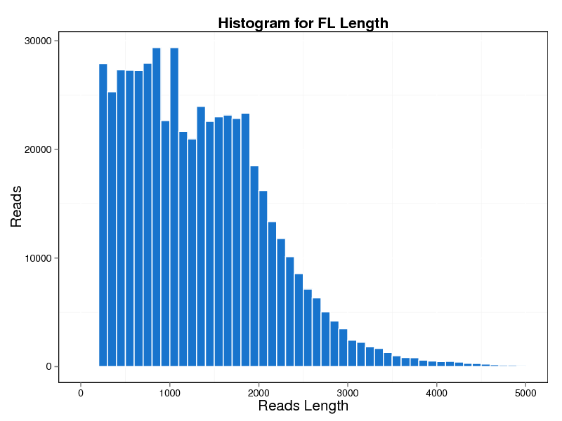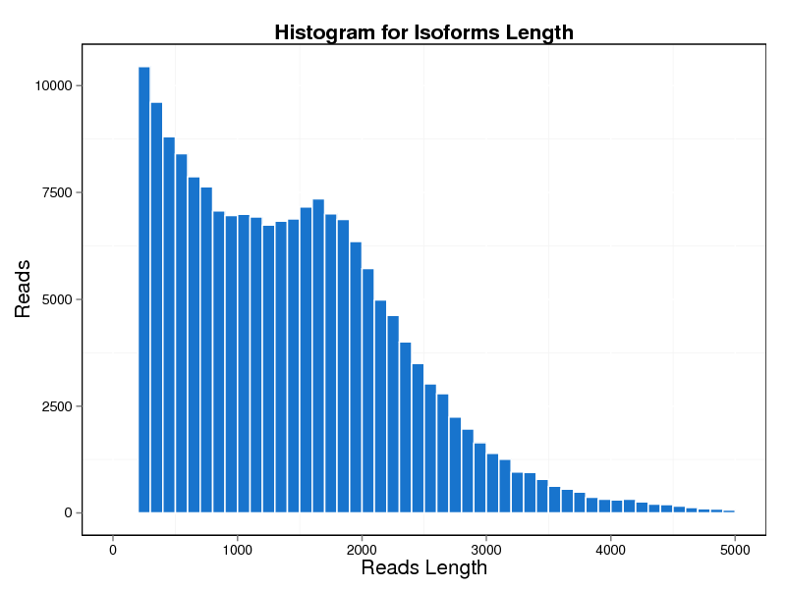
A
B
Figure S1. Summary of Iso-Seq. a. The number and length distributions of full-length non-chimeric transcripts. b. The number and length distributions of full-length consensus sequence transcripts.

Figure S2. KEGG and GO annotation of DEGs. a. KEGG enrichment analysis of DEGs in Leaf vs. Stem. b. GO enrichment analysis of DEGs in Leaf vs. Root. c. GO enrichment analysis of DEGs in Leaf vs. Stem. d. GO enrichment analysis of DEGs in Stem vs. Root.

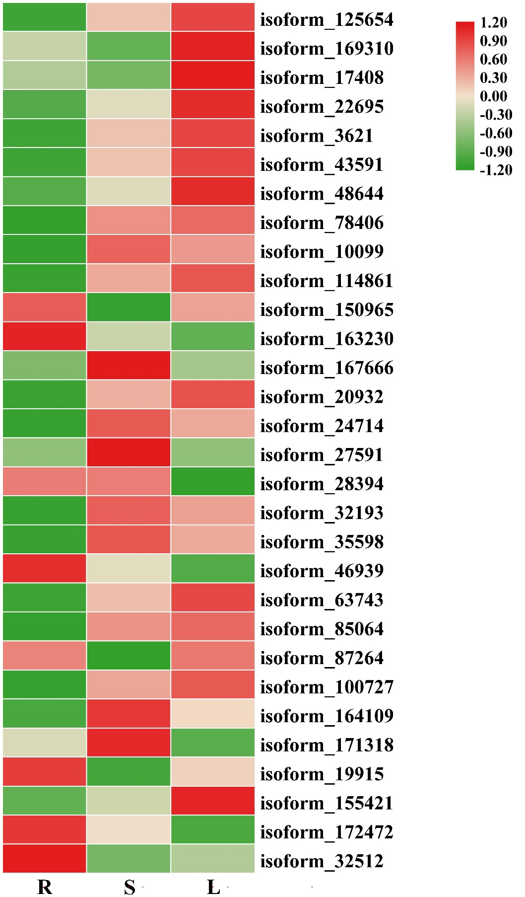

Figure S3. Heatmap of TFs related to metabolism.

Figure S4. Pathways based on KEGG analysis. a. Map of terpenoid backbone biosynthesis. b. Map of sesquiterpenoid and triterpenoid biosynthesis.

Figure S5. Conserved domain search of three β-AS sequences. (a-c) isoform_10598, isofprm_71380 and isoform_102853.

Figure S6. Complete alignment information of three isoforms and OSCPNY1 and OSCPNY2.

