Supplementary Materials
Table of Contents
S1: Details about the Systematic Search 2
Figure S1.1: PRISMA chart of the systematic review process 3
Table S1.2: PRISMA Main Checklist 7
Table S1.3: PRISMA Abstract Checklist 8
S2: Citation Networks 9
Figure S2.1: Coupling (upper) and Direct-Citation (lower) Networks of Studies on IDS. 10
S3: Imputation Process 11
Table S3.1: An overview of the extent to which imputation has influenced the overall estimation of effect sizes for each acoustic measure 11
S4: Comparison of f_{o} range and f_{o} standard deviation 12
Figure S4.1: A plot showing the distribution of effect sizes for f_{o} range and f_{o} standard deviation. The similar distributions speak in favor of our choice to combine the measures into one measure of f_{o} variability. 12
Figure S4.2: A correlation scatter plot showing the distribution of average effect sizes for the studies reporting both measures (left) and a plot of the effect sizes as a function of measure (right). A Bayesian multivariate model with range and standard deviation as separate outcomes shows a strong correlation between the two measures 0.73 [0.38; 0.98] (without Kondaurova et al., 2013), as these authors report f_{o} range in semitones and f_{o} standard deviation in Hz). 12
S5: Choice of Priors, Prior and Posterior Predictive Checks, Prior-Posterior Update Plots, Prior Robustness Checks 13
S5.1: Choice of Priors 13
S5.2: Prior & Posterior Predictive Checks 14
Figure S5.2.1: Plot of the prior and posterior predictive checks (grey) and observed meta-analytic data (black) for the acoustic measures. 14
S5.3: Prior-Posterior Update Plots 15
Figure S5.3.1: Panel of prior-posterior update plots for the intercept, slope, standard deviation, and nu for each of the acoustic variables under investigation. 15
S5.4: Prior Sensitivity Analysis for Intercept & Slope 16
Figure S5.4.1: Panel of plots showing how the intercept and age estimates for each acoustic variable change with different standard deviations for the priors. 16
S6: Age Distributions Across Languages 17
Figure S6: Plots showing the age distribution by language of the effect sizes for each of the acoustic variables under investigation. 17
S7: Cross-Tab for Task & Environment 18
Figure S7: Cross-tab for the predictors of task and environment with age on the x-axis. 18
S8: Parameter Estimates for Best Models 19
Table S8.1: Model parameter estimates for f_{o} 20
Table S8.2: Model parameter estimates for f_{o} variability 21
Table S8.3: Model parameter estimates for vowel space area 22
Table S8.5: Model parameter estimates for vowel duration 24
S9: Publication Bias Sensitivity Plots 25
Figure S9.1: Sensitivity plots for each acoustic variable, showing the effect size estimate as a function of severity of publication bias. 25
Figure S9.2: Significance funnel plots for each acoustic variable. 26
S10: Overview of Languages and Sample Sizes 27
Table S10.1 Overview of total sample size (i.e., number of speakers) according to language 27

S1: Details about the Systematic Search

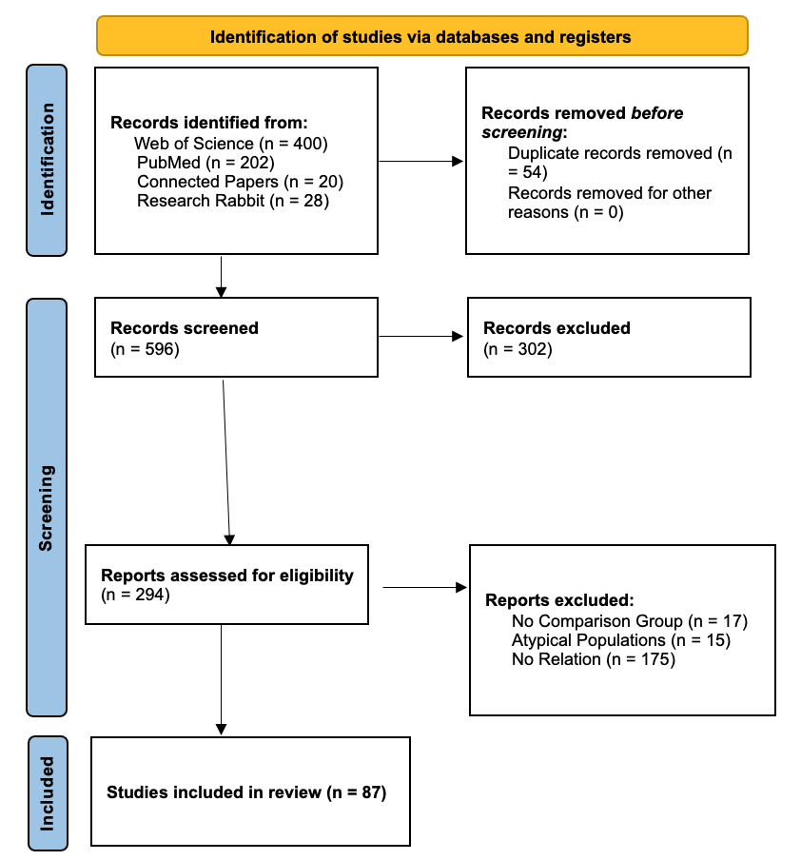

Figure S1.1: PRISMA chart of the systematic review process

Topic | No. | Item | Location where item is reported
TITLE
Title | 1 | Identify the report as a systematic review. | Section 0
ABSTRACT
Abstract | 2 | See the PRISMA 2020 for Abstracts checklist
INTRODUCTION
Rationale | 3 | Describe the rationale for the review in the context of existing knowledge. | Section 1
Objectives | 4 | Provide an explicit statement of the objective(s) or question(s) the review addresses. | Section 1.5
METHODS
Eligibility criteria | 5 | Specify the inclusion and exclusion criteria for the review and how studies were grouped for the syntheses. | Section 2.0
Information sources | 6 | Specify all databases, registers, websites, organisations, reference lists and other sources searched or consulted to identify studies. Specify the date when each source was last searched or consulted. | Section 2.0
Search strategy | 7 | Present the full search strategies for all databases, registers and websites, including any filters and limits used. | Section 2.0
Selection process | 8 | Specify the methods used to decide whether a study met the inclusion criteria of the review, including how many reviewers screened each record and each report retrieved, whether they worked independently, and if applicable, details of automation tools used in the process. | Section 2.0
Data collection process | 9 | Specify the methods used to collect data from reports, including how many reviewers collected data from each report, whether they worked independently, any processes for obtaining or confirming data from study investigators, and if applicable, details of automation tools used in the process. | Section 2.0
Data items | 10a | List and define all outcomes for which data were sought. Specify whether all results that were compatible with each outcome domain in each study were sought (e.g. for all measures, time points, analyses), and if not, the methods used to decide which results to collect. | Section 2.0
 | 10b | List and define all other variables for which data were sought (e.g. participant and intervention characteristics, funding sources). Describe any assumptions made about any missing or unclear information. | Section 2.0
Study risk of bias assessment | 11 | Specify the methods used to assess risk of bias in the included studies, including details of the tool(s) used, how many reviewers assessed each study and whether they worked independently, and if applicable, details of automation tools used in the process. | Section 2.0
Effect measures | 12 | Specify for each outcome the effect measure(s) (e.g. risk ratio, mean difference) used in the synthesis or presentation of results. | Section 2.1
Synthesis methods | 13a | Describe the processes used to decide which studies were eligible for each synthesis (e.g. tabulating the study intervention characteristics and comparing against the planned groups for each synthesis (item 5)). | Section 2.1
 | 13b | Describe any methods required to prepare the data for presentation or synthesis, such as handling of missing summary statistics, or data conversions. | Section 2.1
 | 13c | Describe any methods used to tabulate or visually display results of individual studies and syntheses. | Section 2.2
 | 13d | Describe any methods used to synthesize results and provide a rationale for the choice(s). If meta-analysis was performed, describe the model(s), method(s) to identify the presence and extent of statistical heterogeneity, and software package(s) used. | Section 2.2-2.3
 | 13e | Describe any methods used to explore possible causes of heterogeneity among study results (e.g. subgroup analysis, meta-regression). | Section 2.2
 | 13f | Describe any sensitivity analyses conducted to assess robustness of the synthesized results. | Section 2.2
Reporting bias assessment | 14 | Describe any methods used to assess risk of bias due to missing results in a synthesis (arising from reporting biases). | Section 2.0
Certainty assessment | 15 | Describe any methods used to assess certainty (or confidence) in the body of evidence for an outcome. | Section 2.3
RESULTS
Study selection | 16a | Describe the results of the search and selection process, from the number of records identified in the search to the number of studies included in the review, ideally using a flow diagram. | Section 3.1-5.1
 | 16b | Cite studies that might appear to meet the inclusion criteria, but which were excluded, and explain why they were excluded. | NA
Study characteristics | 17 | Cite each included study and present its characteristics. | NA
Risk of bias in studies | 18 | Present assessments of risk of bias for each included study. | NA
Results of individual studies | 19 | For all outcomes, present, for each study: (a) summary statistics for each group (where appropriate) and (b) an effect estimate and its precision (e.g. confidence/credible interval), ideally using structured tables or plots. | Sections 3.1-5.1
Results of syntheses | 20a | For each synthesis, briefly summarise the characteristics and risk of bias among contributing studies. | Sections 3.1-5.2-4
 | 20b | Present results of all statistical syntheses conducted. If meta-analysis was done, present for each the summary estimate and its precision (e.g. confidence/credible interval) and measures of statistical heterogeneity. If comparing groups, describe the direction of the effect. | Sections 3.1-5.2-4
 | 20c | Present results of all investigations of possible causes of heterogeneity among study results. | Sections 3.1-5.1
 | 20d | Present results of all sensitivity analyses conducted to assess the robustness of the synthesized results. | Sections 3.1-5.5
Reporting biases | 21 | Present assessments of risk of bias due to missing results (arising from reporting biases) for each synthesis assessed. | Section 2.0
Certainty of evidence | 22 | Present assessments of certainty (or confidence) in the body of evidence for each outcome assessed. | Sections 3.1-5.2-4
DISCUSSION
Discussion | 23a | Provide a general interpretation of the results in the context of other evidence. | Section 4.0
 | 23b | Discuss any limitations of the evidence included in the review. | Section 4.0
 | 23c | Discuss any limitations of the review processes used. | Section 4.0
 | 23d | Discuss implications of the results for practice, policy, and future research. | Section 4.0
OTHER INFORMATION
Registration and protocol | 24a | Provide registration information for the review, including register name and registration number, or state that the review was not registered. | NA
 | 24b | Indicate where the review protocol can be accessed, or state that a protocol was not prepared. | Section 2.0
 | 24c | Describe and explain any amendments to information provided at registration or in the protocol. | NA
Support | 25 | Describe sources of financial or non-financial support for the review, and the role of the funders or sponsors in the review. | Section 6.0
Competing interests | 26 | Declare any competing interests of review authors. | Section 6.0
Availability of data, code and other materials | 27 | Report which of the following are publicly available and where they can be found: template data collection forms; data extracted from included studies; data used for all analyses; analytic code; any other materials used in the review. | Section 2.1

Table S1.2: PRISMA Main Checklist

Topic | No. | Item | Reported?
TITLE
Title | 1 | Identify the report as a systematic review. | Yes
BACKGROUND
Objectives | 2 | Provide an explicit statement of the main objective(s) or question(s) the review addresses. | Yes
METHODS
Eligibility criteria | 3 | Specify the inclusion and exclusion criteria for the review. | Yes
Information sources | 4 | Specify the information sources (e.g. databases, registers) used to identify studies and the date when each was last searched. | Yes
Risk of bias | 5 | Specify the methods used to assess risk of bias in the included studies. | No
Synthesis of results | 6 | Specify the methods used to present and synthesize results. | Yes
RESULTS
Included studies | 7 | Give the total number of included studies and participants and summarise relevant characteristics of studies. | Yes
Synthesis of results | 8 | Present results for main outcomes, preferably indicating the number of included studies and participants for each. If meta-analysis was done, report the summary estimate and confidence/credible interval. If comparing groups, indicate the direction of the effect (i.e. which group is favoured). | Yes
DISCUSSION
Limitations of evidence | 9 | Provide a brief summary of the limitations of the evidence included in the review (e.g. study risk of bias, inconsistency and imprecision). | Yes
Interpretation | 10 | Provide a general interpretation of the results and important implications. | Yes
OTHER
Funding | 11 | Specify the primary source of funding for the review. | No
Registration | 12 | Provide the register name and registration number. | No

Table S1.3: PRISMA Abstract Checklist

S2: Citation Networks
The upper network shows the co-citation coupling strength (i.e., the number of times two studies are cited together by a new article as well as bibliographic similarity) for only the journal articles of the final sample of cited studies. The colour and thickness of the lines represent clusters of strong citation links. The lower direct-citation network shows which studies cite each other. The colours represent clusters of strong direct-citation links. In the below direct-citation plot, the colours of the nodes represent the acoustic measures under investigation; specifically, dark green is f_{o}, light green is f_{o} variability, orange is vowel space area, purple is articulation rate, and light orange is vowel duration.

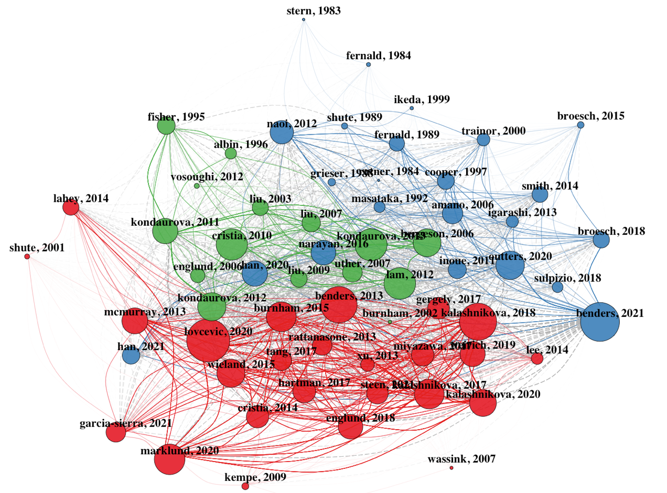

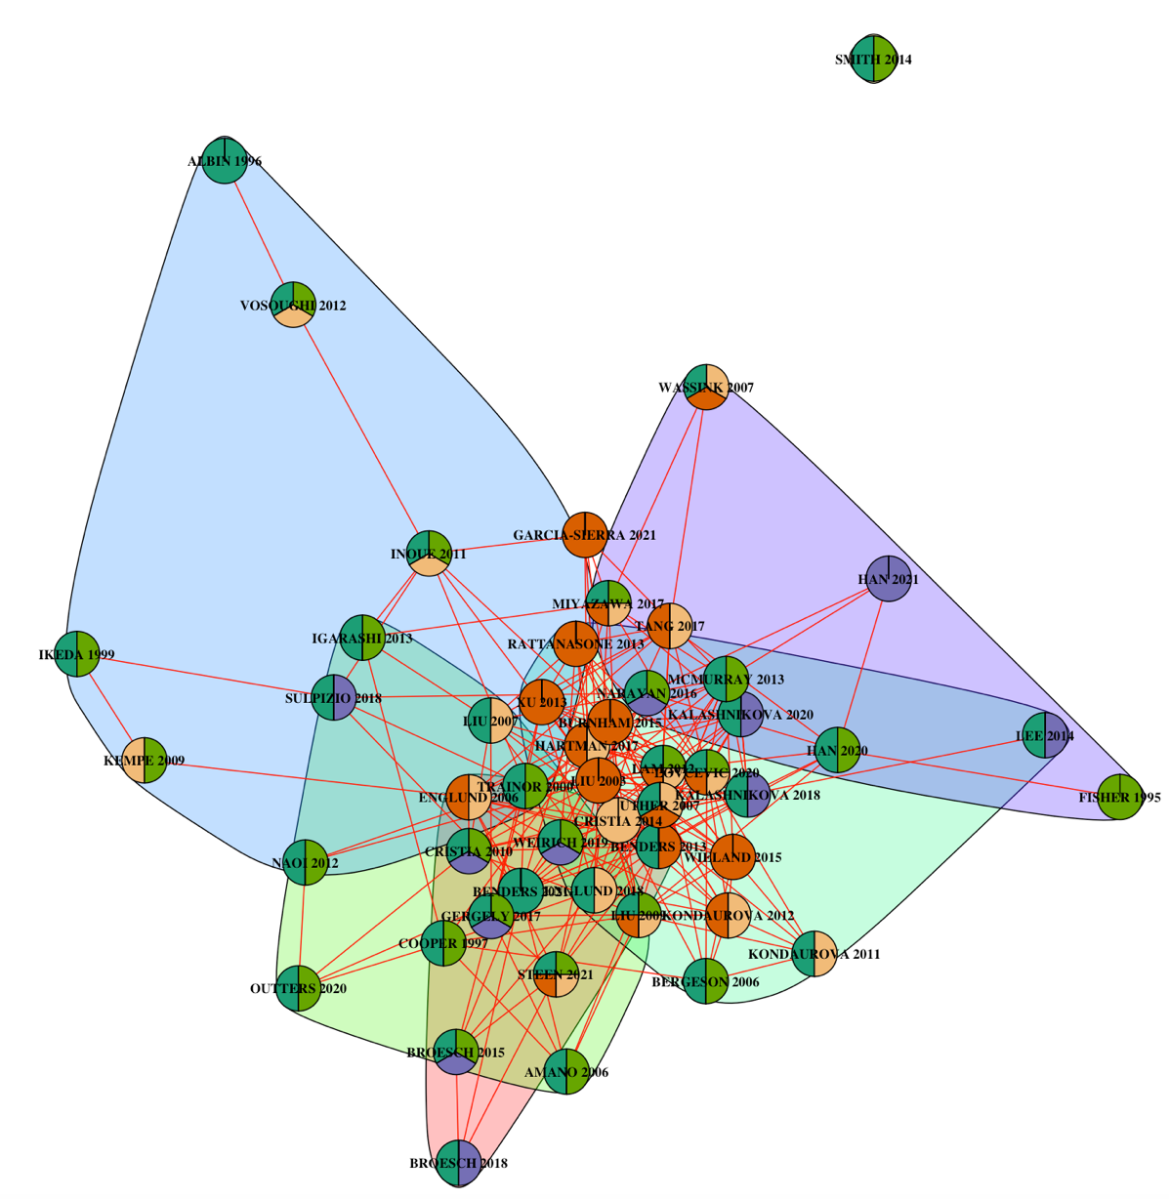
Figure S2.1: Coupling (upper) and Direct-Citation (lower) Networks of Studies on IDS.

S3: Imputation Process
In order to incorporate the statistical uncertainty associated with the partially stochastic nature of this imputation process (Azur et al., 2011; Sterne et al., 2009), we constructed 20 datasets with sample size, mean values for each acoustic variable, and existing standard deviation values as predictors. The standard deviation values of the imputed datasets were checked for similarity to the reported standard deviations and post-processed to include only values within the range of the existing standard deviation values. In order to check that this process of multiple imputation did not bias the estimation of the overall effect size for each acoustic measure, we compared the estimates of the intercepts-only models for the imputed and non-imputed datasets, as shown in Table S3.1 below. There does not appear to be evidence of bias, as the effect size estimate of the models with the imputed datasets lies within the credible interval of the non-imputed datasets in each case.
Acoustic Measure | Intercept Estimate Without Imputation (n = total observations) | Effect Size Estimate With Imputation (n = total observations)
f_{o} | 1.33 [1.06; 1.60] (n = 230) | 1.47 [1.17; 1.78] (n = 242)
f_{o} Variability | 0.98 [0.70; 1.27] (n = 188) | 0.96 [0.70; 1.24] (n = 202)
Vowel Space Area | 0.50 [0.05; 0.98] (n = 51) | 0.65 [0.34; 0.97] (n = 84)
Articulation Rate | -0.90 [-1.42; -0.42] (n = 56) | -1.03 [-1.53; -0.56] (n = 60)
Vowel Duration | 0.52 [0.18; 0.89] (n = 72) | 0.55 [0.27; 0.92] (n = 81)

Table S3.1: An overview of the extent to which imputation has influenced the overall estimation of effect sizes for each acoustic measure

S4: Comparison of f_{o} range and f_{o} standard deviation
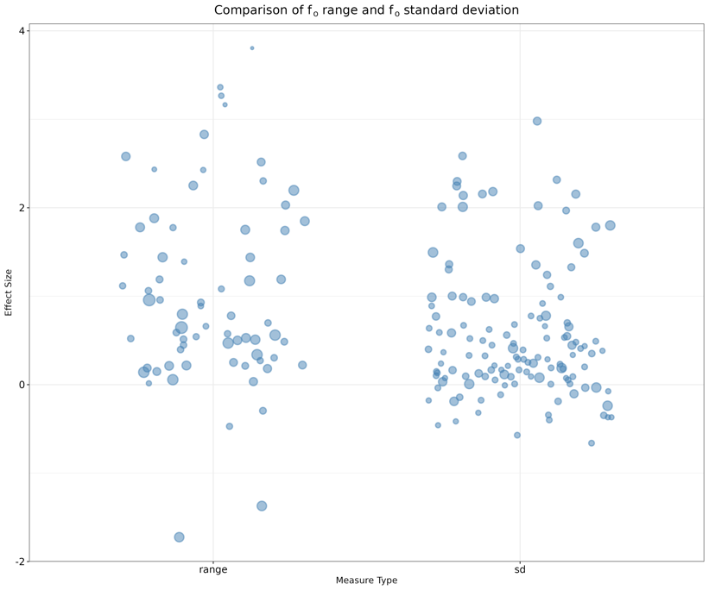

Figure S4.1: A plot showing the distribution of effect sizes for f_{o} range and f_{o} standard deviation. The similar distributions speak in favor of our choice to combine the measures into one measure of f_{o} variability.

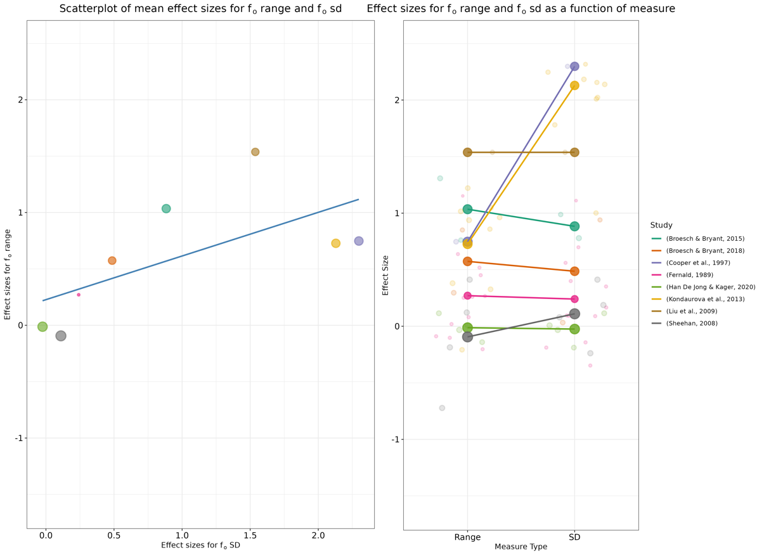

Figure S4.2: A correlation scatter plot showing the distribution of average effect sizes for the studies reporting both measures (left) and a plot of the effect sizes as a function of measure (right). A Bayesian multivariate model with range and standard deviation as separate outcomes shows a strong correlation between the two measures 0.73 [0.38; 0.98] (without Kondaurova et al., 2013), as these authors report f_{o} range in semitones and f_{o} standard deviation in Hz).

S5: Choice of Priors, Prior and Posterior Predictive Checks, Prior-Posterior Update Plots, Prior Robustness Checks

S5.1: Choice of Priors
We chose weakly informative priors in order to ensure that their influence on the meta-analytic estimates were small and to discount extreme effect sizes as unlikely (cf. Lemoine, 2019; Gelman, Simpson & Betancourt, 2017); for the overall effect size, we chose a Gaussian distribution with a mean of 0 and standard deviation of 2.5 based on our prior expectations for effect sizes (cf. Cohen, 1988). This prior implies that we expect approximately 95% of the effect size distribution to be between -5 and 5. For the slope of the model, we encoded our expectations with a Gaussian prior with a mean of 0 and a standard deviation of 1, which implies that we expect the vast majority of values for the coefficient of the effect size difference between ADS and IDS to be between -2 and 2. For the heterogeneity of the effects (i.e., the standard deviation of random effects), we chose a positive truncated normal distribution with a mean of 1 and standard deviation of 1. For the degrees of freedom parameter, ν, of the Student’s t-distribution, a gamma distribution with a shape parameter of 2 and a scale parameter of 0.1 was chosen. This ensures that the model remains robust to the influence of outliers (cf. McElreath, 2020; Kruschke, 2015). Prior predictive checks were performed to ensure that model predictions for plausible values of effect sizes would only exclude implausibly high or low values on the basis of the priors (cf. Gelman et al., 2020).
The models were fitted with Hamiltonian Monte Carlo samplers with 2 parallel chains with 5,000 iterations each, an adapt delta of 0.99 and a maximum tree depth of 20 in order to ensure no divergence in the estimation process. The quality of the models was assessed by i) ensuring Rhat statistics to be lower than 1.1, ii) carrying out prior and posterior predictive checks, iii) plotting prior against posterior estimates and assessing whether the posteriors had lower variance than the priors, iv) ensuring no divergences in the process of estimation, v) checking that the number of effective bulk and tail samples was above 200, vi) conducting prior sensitivity analyses.

S5.2: Prior & Posterior Predictive Checks

As noted above, we performed quality checks of the models by carrying out prior and posterior predictive checks. The below prior predictive checks (on the left) indicate that our priors predict values within the order of magnitude of the distribution. The posterior predictive checks (on the right) indicate that the models have captured the distributions of data for each of the acoustic measures. These plots provide reassurance that our models capture relevant aspects of the overall distributions of dependent variables.

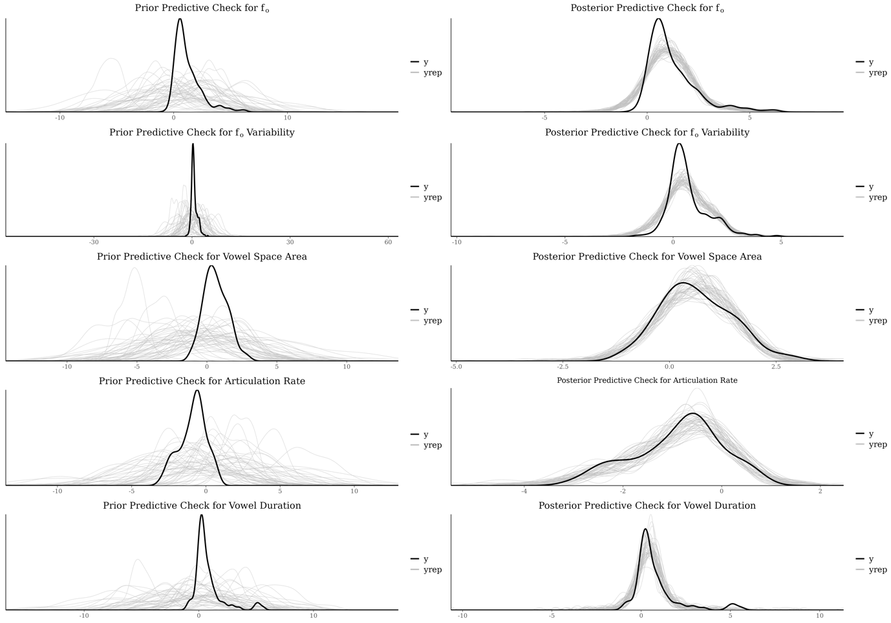

Figure S5.2.1: Plot of the prior and posterior predictive checks (grey) and observed meta-analytic data (black) for the acoustic measures.

S5.3: Prior-Posterior Update Plots
A second quality check of the models was carried out by plotting the prior distributions against the posterior estimates of the model. As shown in the below plots, the posteriors exhibit lower variance than the priors. These plots thus indicate that the models have learned from the data and provide additional reassurance that our models have captured relevant information.

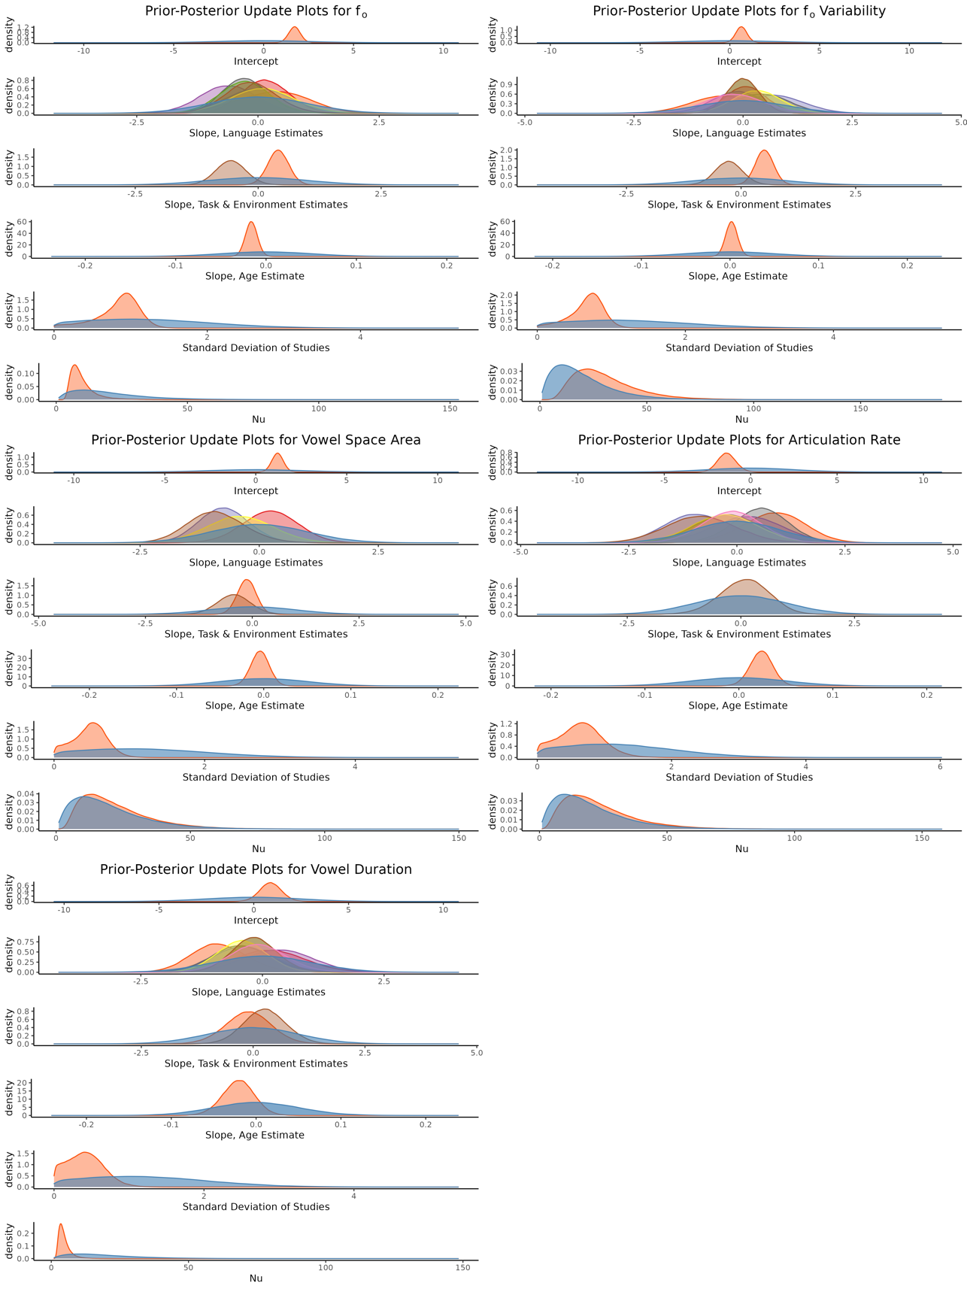
Figure S5.3.1: Panel of prior-posterior update plots for the intercept, slope, standard deviation, and nu for each of the acoustic variables under investigation. The prior distributions are represented in blue. In the plots of task and environment, task is represented by orange and environment is represented by brown.

S5.4: Prior Sensitivity Analysis for Intercept & Slope
A third quality check of the models was performed by assessing the extent to which the uncertainty of our priors affected posterior estimates. Because the posterior estimates (on the y-axis) exhibit stability at our choices of priors (i.e., the dashed vertical line), these plots provide reassurance that our choice of priors did not unduly affect model estimations.
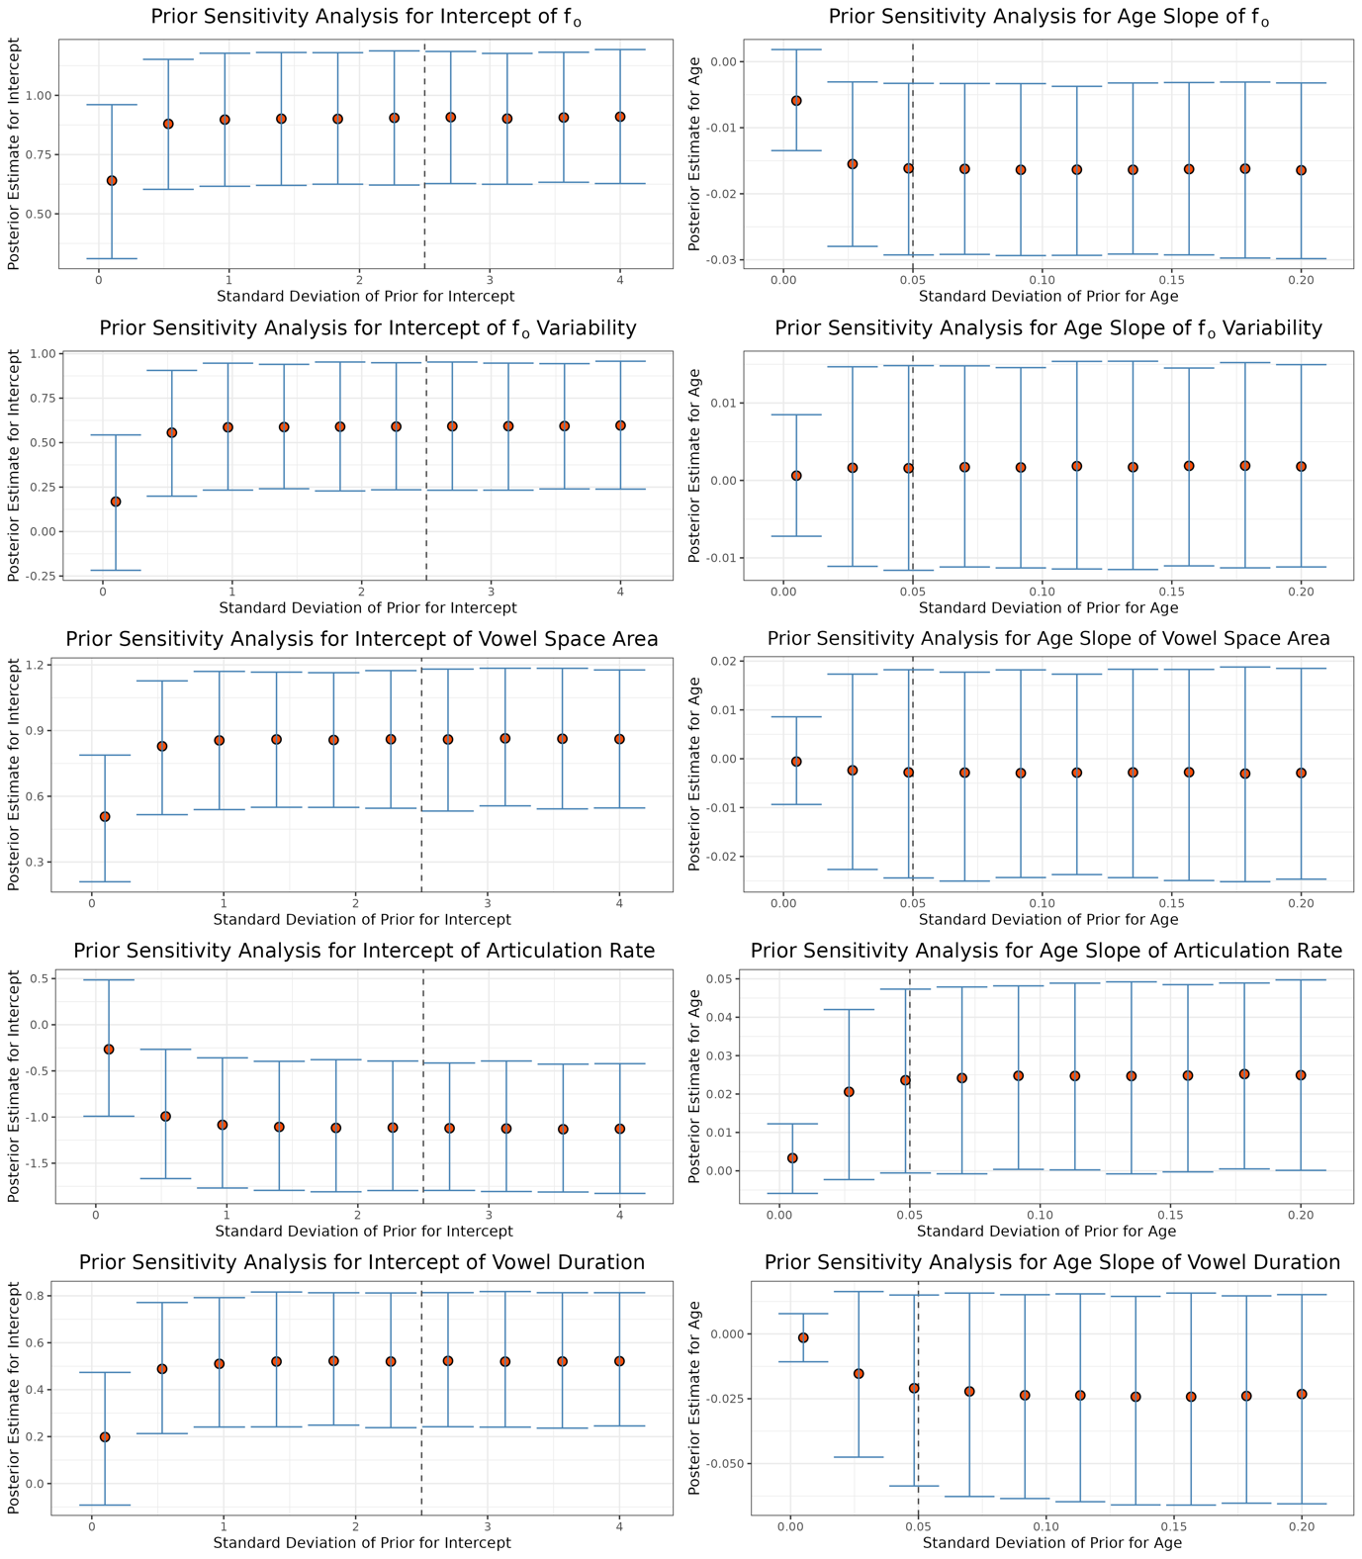
Figure S5.4.1: Panel of plots showing how the intercept and age estimates for each acoustic variable change with different standard deviations for the priors. The vertical dashed line indicates the standard deviation of the prior chosen for the models.

S6: Age Distributions Across Languages

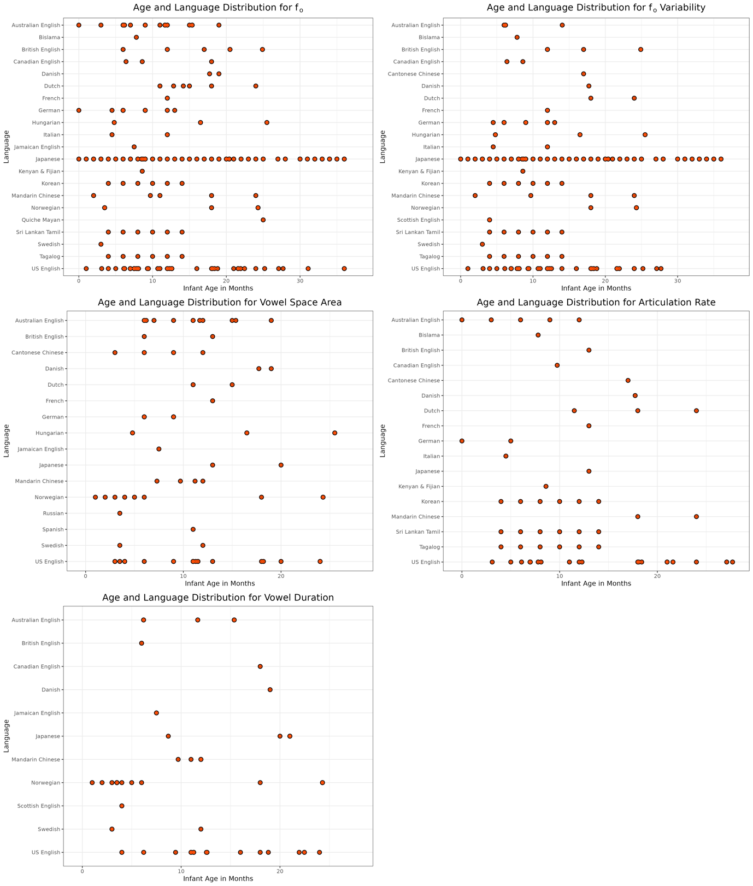

Figure S6: Plots showing the age distribution by language of the effect sizes for each of the acoustic variables under investigation.

S7: Cross-Tab for Task & Environment

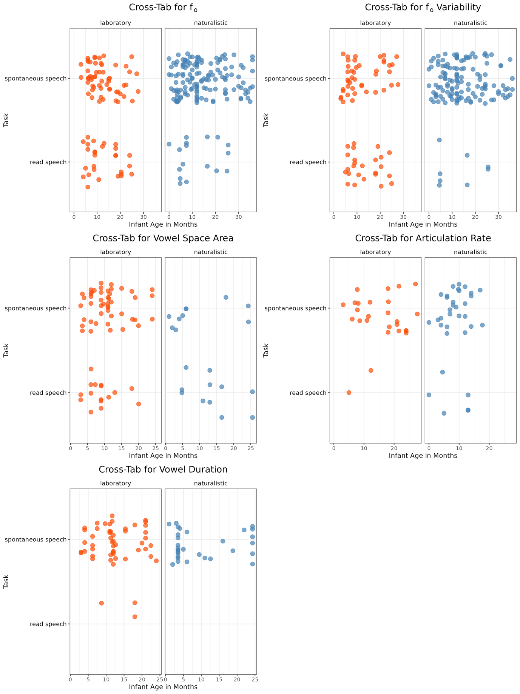
Figure S7: Cross-tab for the predictors of task and environment with age on the x-axis.
The colors are purely for aesthetic purposes: blue denotes recordings in a naturalistic environment, orange signifies recordings done in the lab.

S8: Parameter Estimates for Best Models
Model Parameters for f_{o} | Estimate
Standard Deviation of Studies | 0.84 [0.14; 1.27]
Standard Deviation of Participant Groups within Studies | 0.51 [0.03; 1.09]
Standard Deviation of Measurements | 0.07 [0.00; 0.20]
Age (months) | -0.02 [-0.03 0.00]
Australian English | 1.49 [0.87; 2.11]
Bislama | 1.81 [0.11; 3.23]
British English | 1.64 [0.65; 2.64]
Canadian English | 0.89 [-0.21; 1.99]
Danish | 1.5 [0.14; 2.85]
Dutch | 1.22 [0.16; 2.23]
French | 1.58 [0.18; 2.98]
German | 1.23 [0.33; 2.15]
Hungarian | 1.3 [-0.21; 2.81]
Italian | 1.34 [0.23; 2.45]
Jamaican English | 0.83 [-0.72; 2.41]
Japanese | 1.13 [0.37; 1.87]
Kenyan & Fijian | 1.14 [-0.28; 2.46]
Korean | 1.26 [-0.15; 2.64]
Mandarin Chinese | 1.23 [0.24; 2.21]
Norwegian | 0.94 [-0.2; 2.09]
Quiche Mayan | 1.03 [-0.61; 2.69]
Sri Lankan Tamil | 1.41 [-0.03; 2.78]
Swedish | 2.22 [0.37; 3.99]
Tagalog | 1.31 [-0.1; 2.69]
US English | 1.82 [1.18; 2.47]
Naturalistic Environment | -0.55 [-1.15; 0.05]
Spontaneous Speech | 0.41 [-0.01; 0.83]
Nu | 10.02 [4.40; 24.56]

Table S8.1: Model parameter estimates for f_{o}

Model parameters for f_{o} variability | Estimate
Standard Deviation of Studies | 0.68 [0.15; 1.05]
Standard Deviation of Participant Groups within Studies | 0.41 [0.03; 0.86]
Standard Deviation of Measurements | 0.10 [0.01; 0.23]
Age (months) | 0.00 [-0.01; 0.02]
Australian English | 0.6 [0.02; 1.18]
Bislama | 1.03 [-0.38; 2.29]
British English | 0.64 [-0.28; 1.55]
Canadian English | 0.52 [-0.58; 1.63]
Cantonese Chinese | 0.53 [-0.94; 2]
Danish | 1.18 [-0.25; 2.57]
Dutch | 0.45 [-0.76; 1.59]
French | 0.46 [-0.79; 1.68]
German | 0.4 [-0.44; 1.21]
Hungarian | 0.34 [-0.95; 1.66]
Italian | 0.32 [-0.62; 1.29]
Japanese | 0.58 [-0.03; 1.16]
Kenyan & Fijian | 0.78 [-0.49; 1.97]
Korean | 0.42 [-0.83; 1.66]
Mandarin Chinese | 0.58 [-0.38; 1.53]
Norwegian | 0.87 [-0.22; 1.94]
Scottish English | 0.46 [-0.89; 1.79]
Sri Lankan Tamil | 0.48 [-0.78; 1.73]
Swedish | 0.2 [-1.27; 1.68]
Tagalog | 0.35 [-0.91; 1.6]
US English | 0.85 [0.29; 1.4]
Spontaneous Speech | 0.47 [0.09; 0.85]
Nu | 30.87 [10.57; 68.26]

Table S8.2: Model parameter estimates for f_{o} variability

Model Parameters for Vowel Space Area | Estimate
Standard Deviation of Studies | 0.49 [0.05; 0.90]
Standard Deviation of Participant Groups within Studies | 0.38 [0.02; 0.82]
Standard Deviation of Measurements | 0.11 [0.00; 0.30]
Age (months) | -0.01 [-0.02; 0.02]
Australian English | 1.03 [0.48; 1.57]
British English | 1.07 [-0.05; 2.19]
Cantonese Chinese | 0.18 [-0.99; 1.47]
Danish | 0.19 [-0.84; 1.3]
Dutch | -0.29 [-1.5; 1.06]
French | 0.5 [-0.88; 1.9]
German | 0.68 [-0.46; 1.88]
Hungarian | 0.87 [-0.28; 2.03]
Jamaican English | 0.67 [-0.65; 2.02]
Japanese | 1.17 [0.09; 2.24]
Mandarin Chinese | 1.06 [0.2; 1.93]
Norwegian | 0.02 [-0.79; 0.91]
Russian | 0.9 [-0.38; 2.19]
Spanish | 0.87 [-0.36; 2.11]
Swedish | 1.7 [0.61; 2.8]
US English | 0.6 [-0.03; 1.25]
Nu | 22.44 [5.83; 57.13]

Table S8.3: Model parameter estimates for vowel space area

Model parameters for articulation rate | Estimate
Standard Deviation of Studies | 0.48 [0.03; 1.06]
Standard Deviation of Participant Groups within Studies | 0.40 [0.02; 0.92]
Standard Deviation of Measurements | 0.20 [0.01; 0.43]
Age (months) | 0.02 [0.00; 0.04]
Australian English | -1.73 [-2.64; -0.71]
Bislama | -0.96 [-2.45; 0.55]
British English | -1.81 [-3.34; -0.22]
Canadian English | -1.54 [-3.28; 0.36]
Cantonese Chinese | -2.76 [-4.42; -0.87]
Danish | -2.93 [-4.49; -1.16]
Dutch | -1.55 [-2.78; -0.18]
French | -1.51 [-3.02; 0.04]
German | -1.35 [-2.38; -0.32]
Italian | -1.31 [-2.52; -0.09]
Japanese | -1.95 [-3.47; -0.36]
Kenyan & Fijian | -2.02 [-3.47; -0.47]
Korean | -2 [-3.38; -0.46]
Mandarin Chinese | -1.32 [-2.66; 0.18]
Sri Lankan Tamil | -1.3 [-2.68; 0.24]
Tagalog | -2.29 [-3.69; -0.71]
US English | -1.64 [-2.56; -0.58]
Spontaneous Speech | 0.91 [-0.18; 1.86]
Nu | 23.33 [5.44; 59.85]
Table S8.4: Model parameter estimates for articulation rate

Model parameters for vowel duration | Estimate
Standard Deviation of Studies | 0.38 [0.02; 0.86]
Standard Deviation of Participant Groups within Studies | 0.38 [0.03; 0.86]
Standard Deviation of Measurements | 0.15 [0.01; 0.34]
Age (months) | -0.02 [-0.06; 0.02]
Australian English | 0.59 [0.02; 1.14]
British English | 0.85 [-0.55; 2.2]
Canadian English | 0.96 [-0.37; 2.21]
Danish | 0.15 [-0.99; 1.39]
Jamaican English | 0.1 [-1.02; 1.3]
Japanese | 0.4 [-0.36; 1.19]
Mandarin Chinese | 1.05 [0.21; 1.91]
Norwegian | 0.32 [-0.31; 0.97]
Scottish English | 0.45 [-0.65; 1.55]
Swedish | -0.38 [-1.34; 0.76]
US English | 0.89 [0.36; 1.5]
Nu | 4.82 [2.12; 11.34]

Table S8.5: Model parameter estimates for vowel duration

S9: Publication Bias Sensitivity Plots
The plot indicates what happens to the effect size if the publication probability is x times higher for significant studies than for non-significant studies. An effect size estimate of 0.0 is indicated by the orange dotted line, and the worst-case point estimate (see below) is indicated by the dashed red line.

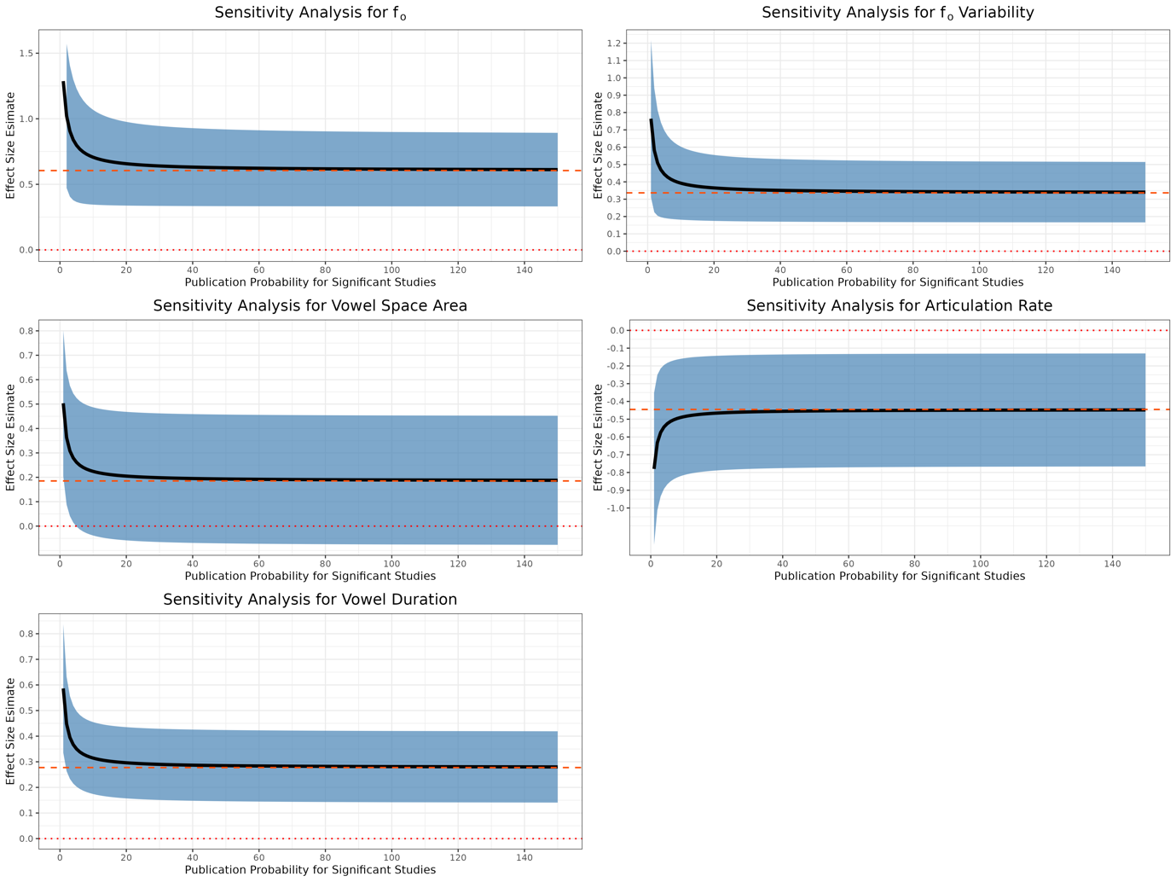
Figure S9.1: Sensitivity plots for each acoustic variable, showing the effect size estimate as a function of severity of publication bias.

Studies on the diagonal line have exactly p = 0.05. Black diamond: worst-case estimate of effect size based only on non-significant studies. Blue diamond: estimate of effect size for all studies. These plots help to determine the extent to which the non-affirmative studies’ point estimates are systematically smaller than the entire set of point estimates. As a simple heuristic, when the diamonds are close to one another, our quantitative sensitivity analyses will typically indicate that the meta-analysis is fairly robust to publication bias. When the diamonds are distant or if the grey diamond represents a negligible effect size, then our sensitivity analyses may indicate that the meta-analysis is not robust.

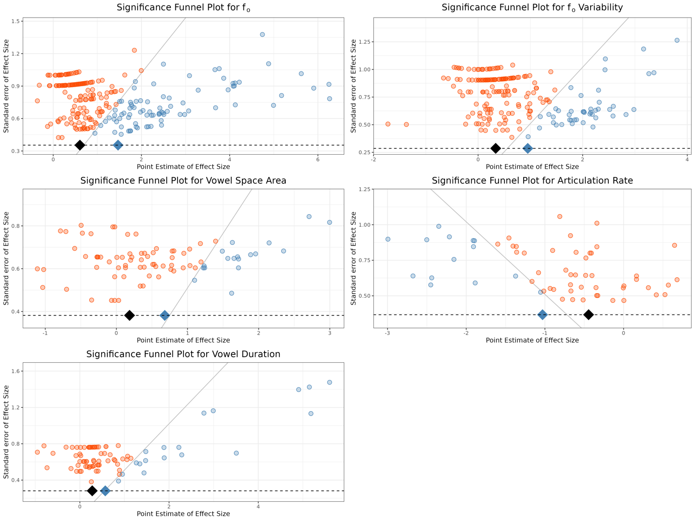
Figure S9.2: Significance funnel plots for each acoustic variable.

S10: Overview of Languages and Sample Sizes
Language | Total Sample Size
Australian English | 1049
Bislama | 36
British English | 156
Canadian English | 94
Cantonese Chinese | 80
Danish | 170
Dutch | 326
French | 30
German | 710
Hungarian | 234
Italian | 110
Jamaican English | 40
Japanese | 1433
Kenyan & Fijian | 45
Korean | 87
Mandarin Chinese | 373
Norwegian | 924
Quiche Mayan | 3
Russian | 10
Scottish English | 380
Spanish | 17
Sri Lankan Tamil | 84
Swedish | 86
Tagalog | 87
US English | 2942

Table S10.1 Overview of total sample size (i.e., number of speakers) according to language

